ITP 250: Final Project Answer Sheet

|  |  |
| --- | --- |
| 100 points | Due: Friday April 28th, 11:59 pm |

# Student Name: Javier Jesús Macossay Hernández

# Part I: Teradata data warehouse

# Show a breakdown, by state, of the number of stores.

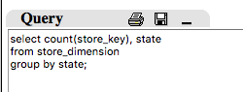

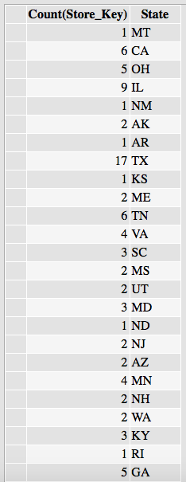

# List the top 5 shoppers who spent the most on Martin Luther King Jr. Day in 2000. (Hint: Use SELECT TOP 5….)

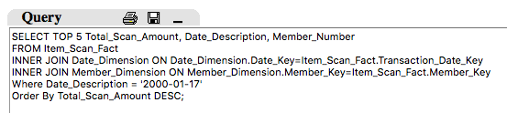

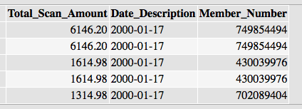

# List the customers who visited 2 or more stores in year 2000.

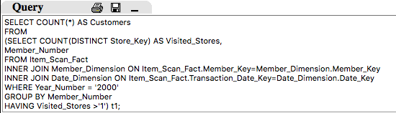

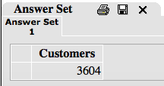

# Count the number of items that have never sold.

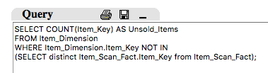

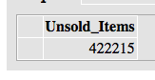

# By store, list the maximum number of store visits made by a customer.

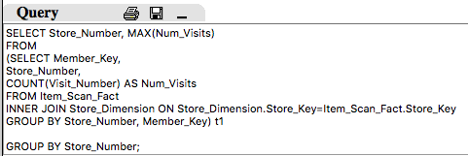

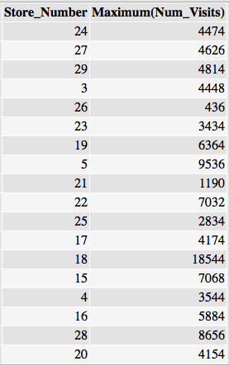

# Part II: MongoDB

Question 1)

query 1.png

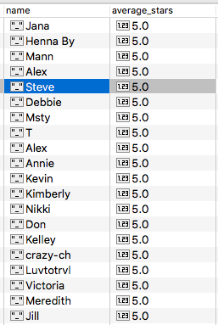

Question 2)

query for 2.png

answer for query 2.png

Question 3)

query 3.png

answer for query 3.png

Question 4)

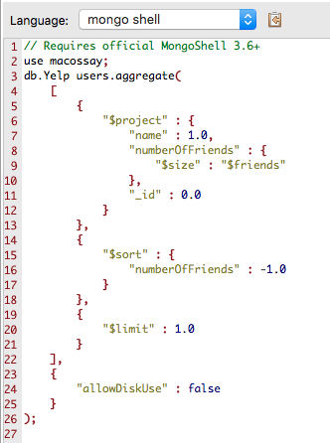

answer for query 4.png

Question 5)

use macossay**;**

db.Yelp users.aggregate**(**

**[**

**{**

"$project" **:** **{**

"name" **:** 1.0**,**

"_id" **:** 0.0**,**

"totalscore" **:** **{**

"$add" **:** **[**

"$compliment_hot"**,**

"$compliment_more"**,**

"$compliment_profile"**,**

"$compliment_cute"**,**

"$compliment_list"**,**

"$compliment_note"**,**

"$compliment_plain"**,**

"$compliment_cool"**,**

"$compliment_funny"**,**

"$compliment_writer"**,**

"$compliment_photos"

**]**

**}**

**}**

**},**

**{**

"$sort" **:** **{**

"totalscore" **:** -1.0

**}**

**},**

**{**

"$limit" **:** 1.0

**}**

**],**

**{**

"allowDiskUse" **:** false

**}**

**);**

answer for query 5.png