GIT

# Parte 1:

1. 
2. 
3. 
4. 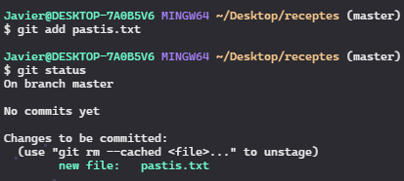
5. 
6. 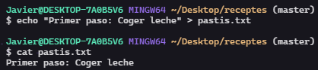
7. 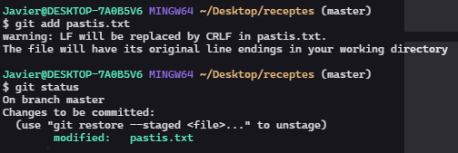
8. 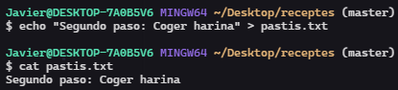
9. 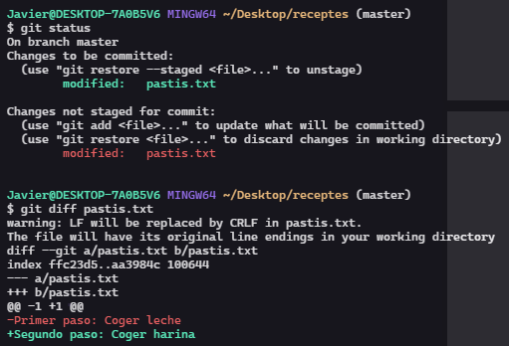
10. 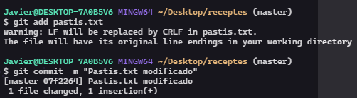
11. 
12. 
13. 
14. 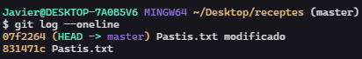
15. 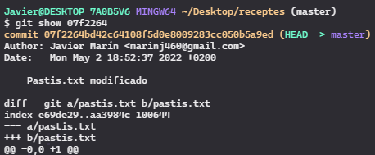

# Parte 2:

1. 
2. 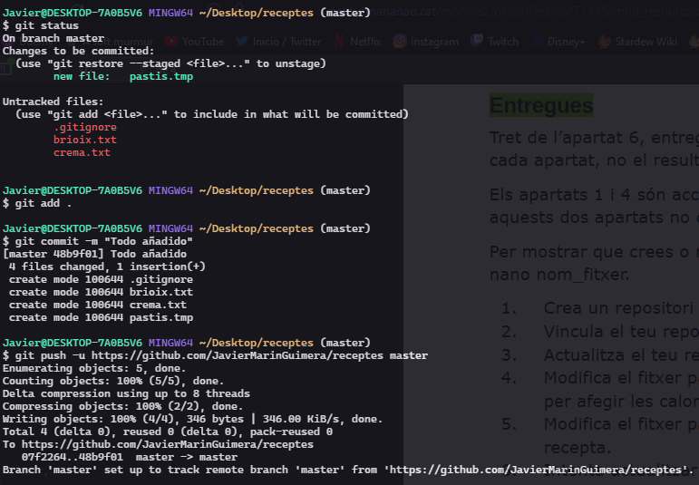
3. Punto 2 también.
4. 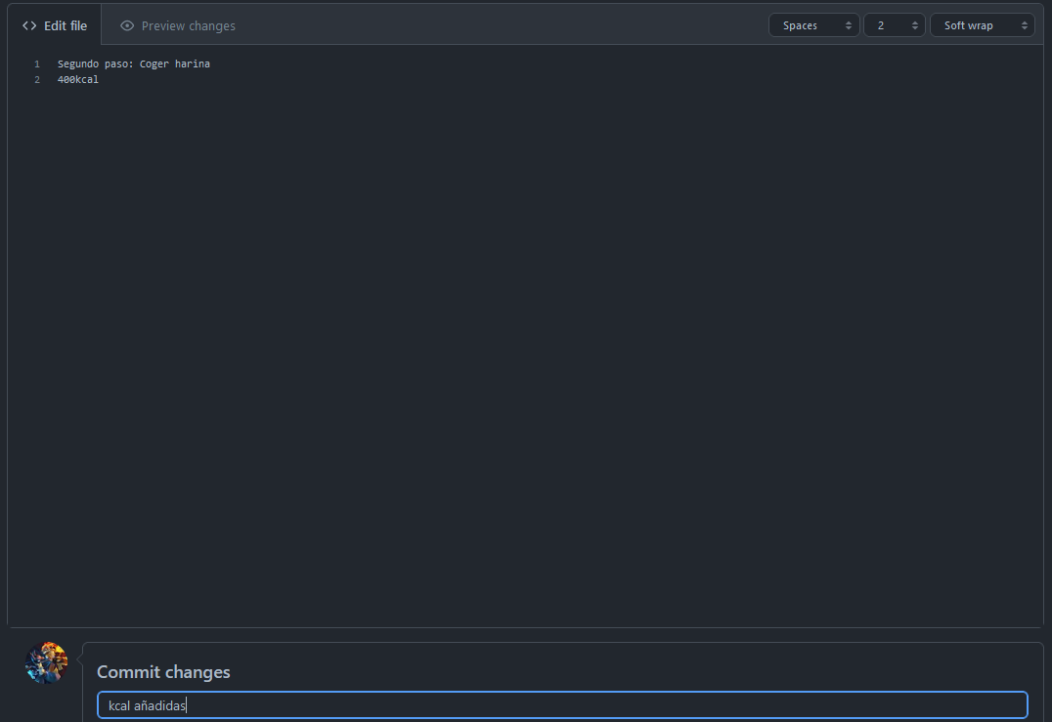
5. 
6. 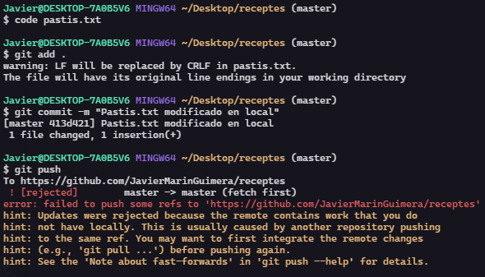  
   $ git push

To <https://github.com/JavierMarinGuimera/receptes>

! [rejected] master -> master (fetch first)

error: failed to push some refs to '<https://github.com/JavierMarinGuimera/receptes>'

hint: Updates were rejected because the remote contains work that you do

hint: not have locally. This is usually caused by another repository pushing

hint: to the same ref. You may want to first integrate the remote changes

hint: (e.g., 'git pull ...') before pushing again.

hint: See the 'Note about fast-forwards' in 'git push --help' for details.

1. 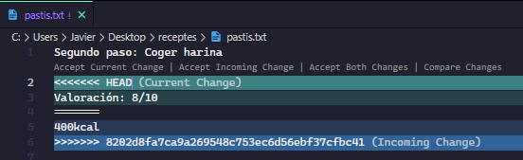  
   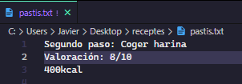
2. 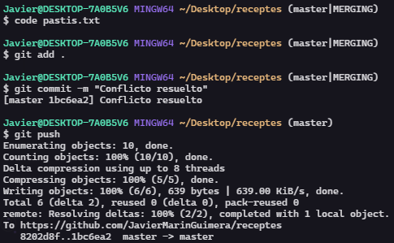

# Parte 3:

1. 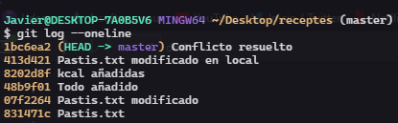
2. 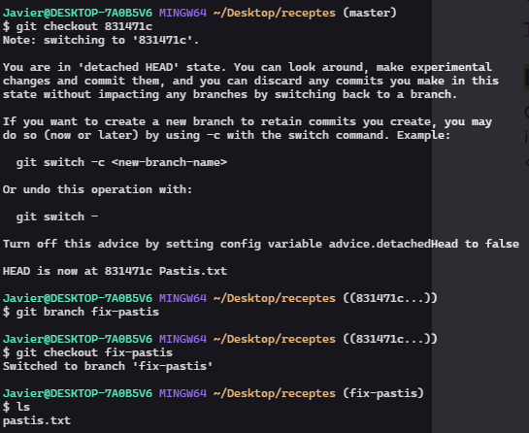
3. 
4. 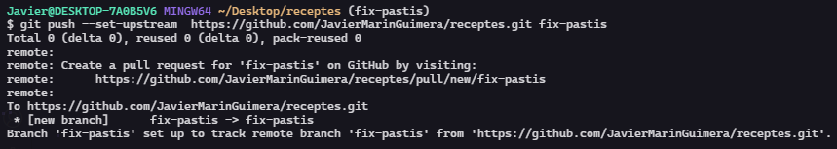  
   
5. 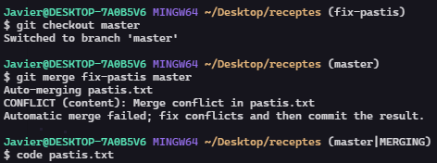  
   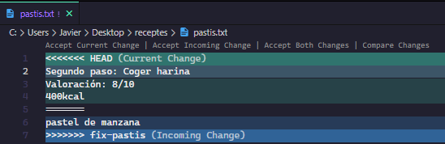
6. 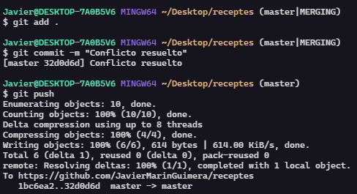
7. 
8. 