
CURRICULUM VITAE
Name: Javier Alejandro Oramas López
Birth: 25/02/2000
Email: javiale2000@gmail.com
Github: https://github.com/JavierOramas
Linkedin: https://www.linkedin.com/in/javier-alejandro-oramas-l%C3%B3pez-7ab47b160/

Education
from Sept 2018 | Bachelors Degree in Computer Science, Universidad de La Habana. Forth Year Student.
Sept 2015 – May 2018 | Vocational Institute of Exact Sciences Ernesto Guevara, Provincial Training Center for Knowledge Contests. Science Bahelor

Projects
June 2023 | Academic Project: Distribute AutoGOAL (self discovery, failure tolerance, replication)
May 2023 | Academic Project: Development of a Model to infer Cuba’s contact matrix using  Transformers’s self-attention on simulated scenarios  https://github.com/geeksLabTech/epidemic-classification-ml-project
Jan 2023 | Academic Project: Development of a DSL for Michaelson’s language,  Parser,lexer,syntax and semantic checkers.  https://github.com/geeksLabTech/compilation-dsl-project
Dec 2022 | Acadmic Project: FIFA World Cup prediction using AI planification,  data driven-agent based simulation.  https://github.com/geeksLabTech/FIFA_World_Cup_2022
Jan 2022 | Academic Project: Development of a Web Server in C for Linux  https://github.com/geeksLabTech/web_server
Dec 2021 | Academic Project: Development of a Linux Shell in C  https://github.com/geeksLabTech/SO_Shell
Jun 2021 | Academic Project: Development of a Functional MIPS Microprocessor  https://github.com/JavierOramas/MIPS-Micro  https://github.com/JavierOramas/MIPS-Micro/blob/master/informe.pdf
May 2021 | Academic Project: TicTacToe game using Minimax in Python  https://github.com/JavierOramas/TicTacToe_AI
Apr 2021 | Development of a Bot for FAQ automation with a knowledge base for a website, Using Euclidean dot Product.  https://github.com/JavierOramas/FAQ-Chat-Bot-Nous
Jan 2021 | Development of LaLuu app for estimation of Energy consumption based on the Devices and its use time, using Dart/Flutter  https://github.com/geeksLabTech/LaLuu  Menciones sobre la apk LaLuu en la prensa cubana
Nov 2020 | Development of a tool for video/audio compression (video-diet, forked as diet-video for furthe development after original project being abandoned)  https://pypi.org/project/diet-video/  https://github.com/JavierOramas/video-diet
Aug 2020 | Development of a Server with web and mobile clients for microprocessor and Drives temperatures remotely. Using Python fo API development, Streamlit for WebApp and Dart/Flutter for Mobile client.  https://github.com/JavierOramas/temperatureMonitor  https://github.com/JavierOramas/temperatureMonitor-app
July 2020 | Development of Covid19CubaData for analysis of the COVID-19 data in Cuba  (Dev Team Member), with Python  https://github.com/covid19cuba/covid19cuba-action
Feb 2020 | Development of a Model to predict Dengue infections based on metheorological data using Machine Learning and Deep Learning, with Jupyter Notebook and Python  https://github.com/JavierOramas/DengAI
Jul 2019 | Development of Lima 2019 Panamerican Games prediction, using Machine Learning, Python with SKLearn tools.  https://github.com/JavierOramas/PanamericanPredictor
Feb 2019 | Development of “El Origen” videogame, using Unity with C#.

Events
May 2023 | Delegate presenting the project “Predicting Qatar 2023 World Cup, a data driven agent based approach” on the 1st Artificial Intelligence and Data Science Workshop. SaberUH Event. Math and Computation faculty. Havana University.
Dec 2022 | Forum UH, presenting Qatar 2023 ppredictions. Havana University.
Nov 2020 | Python Pizza Holguín 2020, Conference: Video-Diet: poniendo a dieta tu almacenamiento  https://youtu.be/c--NOwM5W-0
Feb 2020 | Driven Data competition Predicting Dengue Cases based on metheorological variables using Machine Learning and Deep Learning  https://www.drivendata.org/competitions/44/dengai-predicting-disease-spread
Jul 2019 | International contest Prediction Model for the Lima 2019 Panamerican Games results, using Machine Learning  https://github.com/JavierOramas/PanamericanPredictor/blob/master/panamerican_predictor_paper.pdf  http://www.postdata.club/issues/201907/el-medallero-de-lima-2019-que-se-puede-esperar.html
Feb 2019 | MATCOM Game Festival 2019, videogame “El Origen” (The Origin)
Oct 2018 | ACM-ICPC 2018 National Contest, UH-KEJ (Participating as a team representing Havana University)  https://icpc.global/regionals/finder/cnc-2018/standings
Sept 2018 | ACM-ICPC 2018 Local Contest, UH-KEJ (Participating as a team representing Havana University)  https://matcomgrader.com/post/5179/resultados-del-concurso-local-caribeno-2018
Nov 2017 | ACM-ICPC 2017 Caribbean Final, Team3C-1 (Participating as Invited Team from pre-universitary schools)  Invitation Letter from the General Director, Caribbean Final ACM – ICPC 2017  https://matcomgrader.com/post/5167/the-2017-acm-icpc-caribbean-finals  https://coj-forum.uci.cu/viewtopic.php?t=3315
Oct 2017 | ACM-ICPC 2017 Cuban Final, Team3C-1 (Participating as Invited Team from pre-universitary schools)
Jun 2017 | IV Programming Cup Universidad Central de Las Villas (UCLV), Team3C-1 (Participating as Invited Team from pre-universitary schools)
Mar 2017 | Cuban Olimpiad in Informatics 2016-2017, for pre-universitary students in Cuba.
Jul 2016 | Ibero-american Computer Correspondence Contest , México 2016, representing Cuba.
Apr – Jun 2016 | National pre-selection for International Olimpiad in Informatics.
Jan 2016 | Lenin Cup, Computer Contest for pre-universitary Students in Cuba.
Dec 2015 | Copa Regional de Concurso de Informática, Camagüey 2015 for pre-universitary students in Cuba
Oct 2015 | ACM-ICPC National Contest 2015-2016, Team3C-1 (Participating as Invited Team from pre-universitary schools)
Sep 2015 | ACM-ICPC Local Contest 2015-2016, Team3C-1 (Participating as Invited Team from pre-universitary schools)
Feb 2014 | Cuban Olimpiad in Informatics 2013-2014, for pre-universitary students in Cuba.

Awards and Distinctions
Dec 2022 | Best Prediction in the world at FIFA World Cup  https://www.postdata.club/suplementos/mundial-qatar/pronosticando-qatar.html
Jul 2019 | Best preditction int the world (for cuban delegation results) at Lima 2019 Panamerican Games, using Machine Learning  http://www.postdata.club/issues/201907/el-medallero-de-lima-2019-que-se-puede-esperar.html  https://github.com/JavierOramas/PanamericanPredictor
Feb 2019 | 3rd place MATCOM Game Festival 2019, Videogame “El Origen”
Oct 2018 | 13th place in the Caribbean, ACM-ICPC 2018 national Contest, UH-KEJ (Participating as a team representing Havana University)  https://icpc.global/regionals/finder/cnc-2018/standings
Sep 2018 | 7th place ACM-ICPC 2018 Local Contest, UH-KEJ (Participating as a team representing Havana University)  https://matcomgrader.com/post/5179/resultados-del-concurso-local-caribeno-2018
Jun 2018 | Granted directly, by resolution of the Ministry of Education the career: Computer Science at Universidad de La Habana, According to the achievents in the ACM-ICPC 2017 Caribbean Finals.
Nov 2017 | 26th place in the Caribbean y 200th in LATAM, ACM-ICPC Caribbean Finals, Team3C-1 (Participating as Invited Team from pre-universitary schools)  https://matcomgrader.com/media/posts/5167/ranking/caribbean.png  https://matcomgrader.com/media/posts/5167/ranking/general.png
Oct 2017 | Quinto Lugar en la Final Cubana ACM-ICPC, Team3C-1 (participación como equipo invitado de la enseñanza preuniversitaria)
Jun 2017 | Tercer Lugar en la IV Copa de Programación de la Universidad Central de Las Villas, Team3C-1 (participación como equipo invitado de la enseñanza preuniversitaria)
Jun 2016 | Reconocimiento del Ministerio de Educación de la República de Cuba por resultados obtenidos como integrante de la Preselección Nacional a las Olimpiadas Internacionales de Informática
Jan 2016 | Cuarto Lugar en la Copa Lenin, Concurso de Informática para estudiantes de la enseñanza preuniversitaria en Cuba
Dec 2015 | Tercer Lugar en la Copa Regional inter IPVCE, Concurso de Informática para estudiantes de la enseñanza preuniversitaria en Cuba
Oct 2015 | 1st place at UCLV site ACM-ICPC National Finals 2015-2016 Participating as Invited Team from pre-universitary schools)
Sep 2015 | 3rd place at UCLV site ACM-ICPC Local Finals 2015-2016 (Participating as Invited Team from pre-universitary schools)
Feb 2014 | Second place Cuban Olimpiad in Informatics for pre-universitary students in Cuba.

Memberships
since 2019 | Research Group in Artifitial Intelligence at Facultad de Matemática y Computación de la Universidad de La Habana (Computer Science and Mathematics Faculty, Havana University)
Apr – Jun 2016 | Cuban National pre-selection to the Intenational Olimpiad in Informatics
2015 – 2018 | Provincial Contest Center, Villa Clara, Cuba

Technologies
Programming Languages: | Other Technologies:
• C  • C++  • C#  • Python  • SQL  • Rust  • Go  • Dart  • Haskell  • Javascript | • Sklearn  • Transformers  • Tensorflow  • Pytorch  • Git/Github  • LaTeX  • HTML/CSS  • Flutter  • Jupyter Notebook  • Fastapi  • Typer  • Beautiful soup  • Streamlit  • Pandas  • Numpy
https://profile.codersrank.io/user/javieroramas

Languages
Spanish | Native Language
English | Full professional

APPENDICES
Science Bachelor Certificate
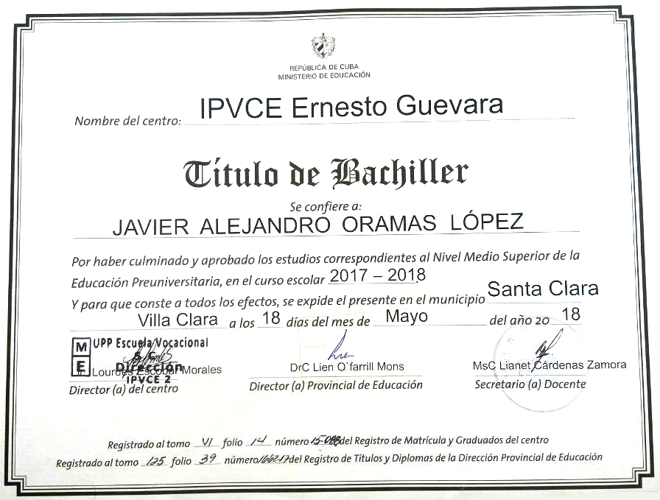
Official program of the AI, DS and CA workshop.
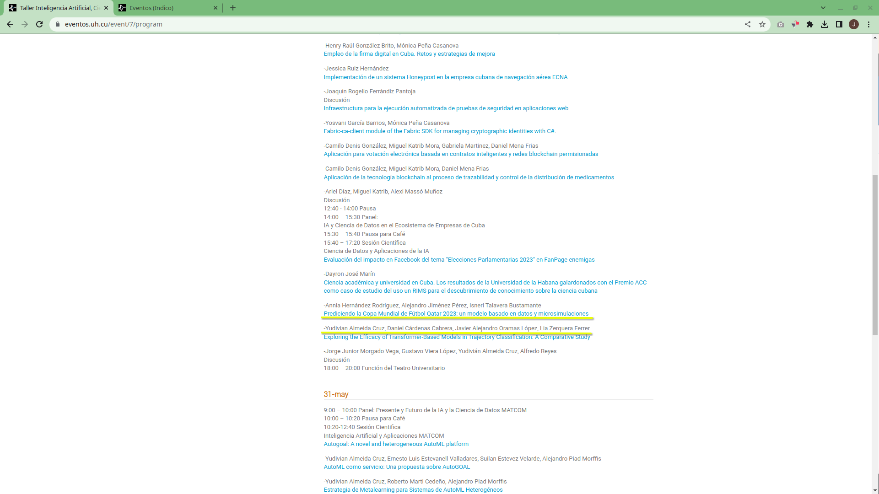
Source: Havana University events webpage (https://eventos.uh.cu/event/7/program), screenshot 01/06/2023
Predicting FIFA World Cup 2022
LaLuu app for estimation of Energy consumption . Available in Apklis, Cuban android app store.
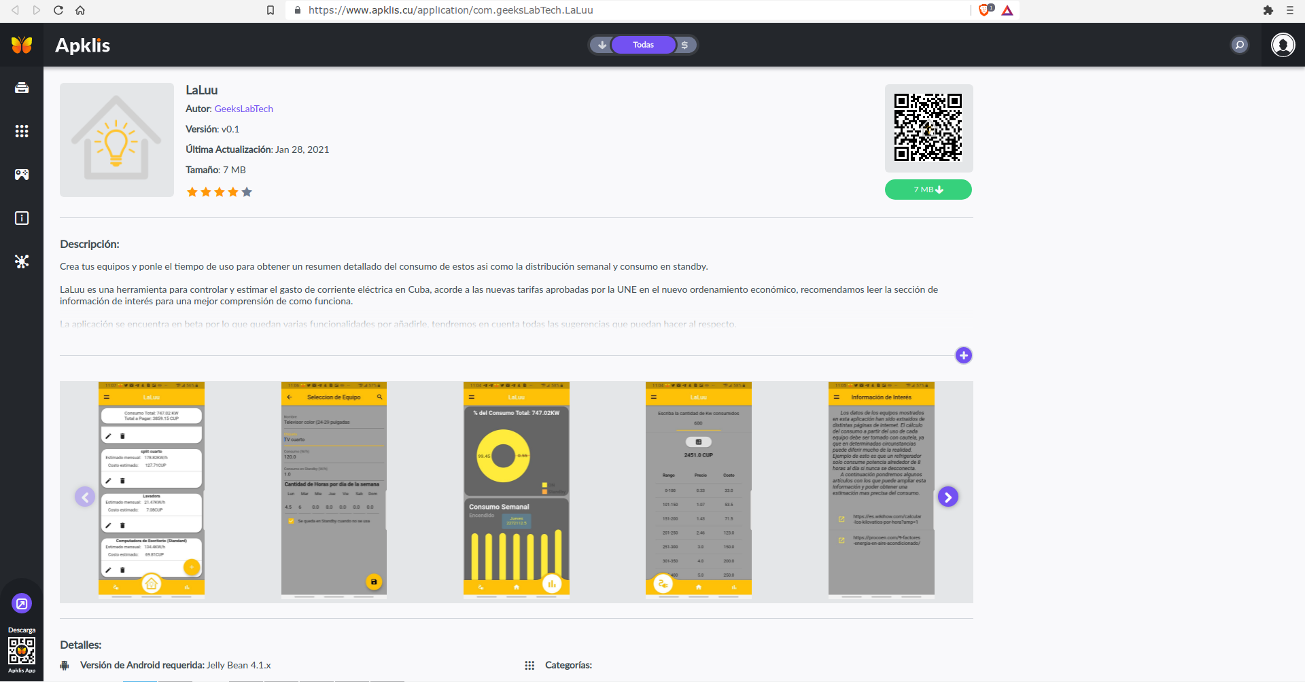
Source: Apklis (https://www.apklis.cu/application/com.geeksLabTech.LaLuu), screenshot 25/01/2022
LaLuu app cited in cuban press
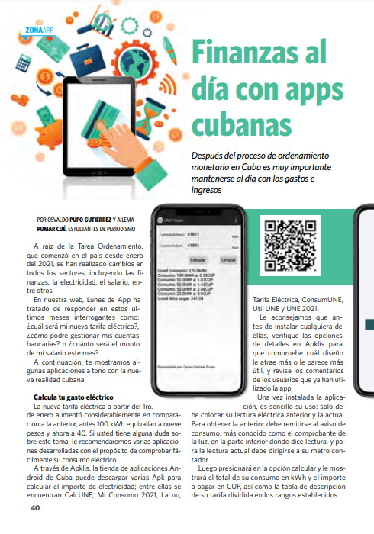

Source: Red Artemisa (february 2nd 2021). Llegó febrero: calcula tu gasto eléctrico con esta apps. https://www.artemisa.gob.cu/es/actualidad/noticias/9806-llego-febrero-calcula-tu-gasto-electrico-con-esta-apps, screenshot 25/01/2022
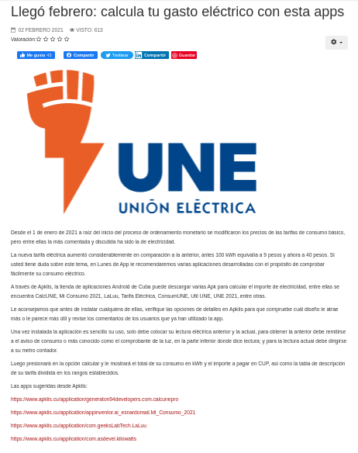
Source: Pupo, Gutiérrez O. y Pumar, Cué A. (may-jun 2021). Finanzas al día con apps cubanas. Juventud Técnica 420 (40-41), http://www.juventudtecnica.cu/sites/default/files/jt_420.pdf, ISSN: 0449-4555, screenshot 25/01/2022
Covid19CubaData app COVID-19 data analisys in Cuba
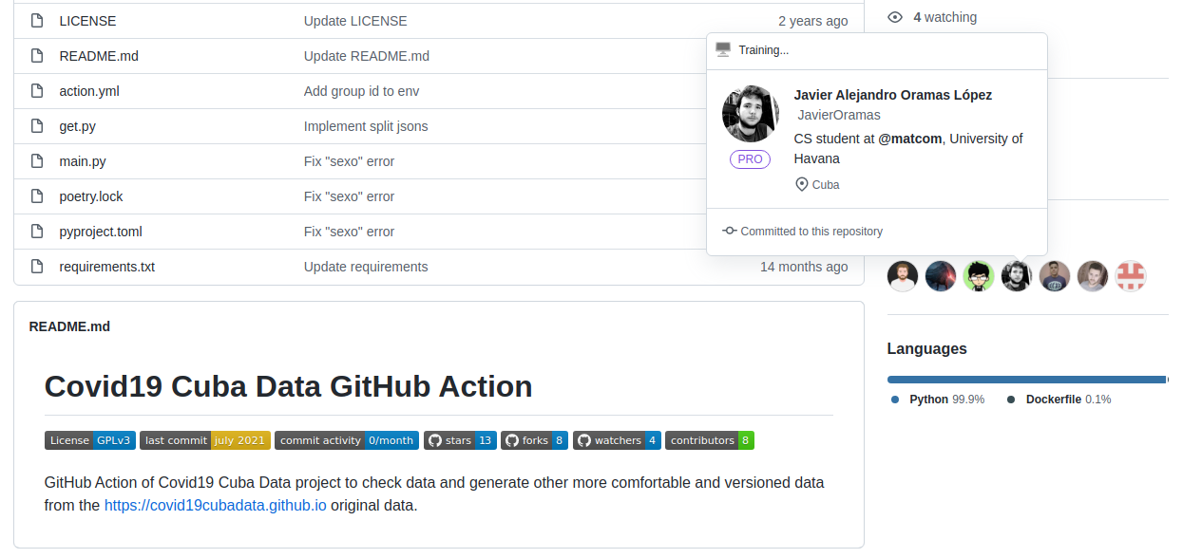
Source: GitHub (https://github.com/covid19cuba/covid19cuba-action), screenshot 25/01/2022
Driven competition Predicting Dengue Cases based on metheorological variables, using Machine Learning and Deep Learning
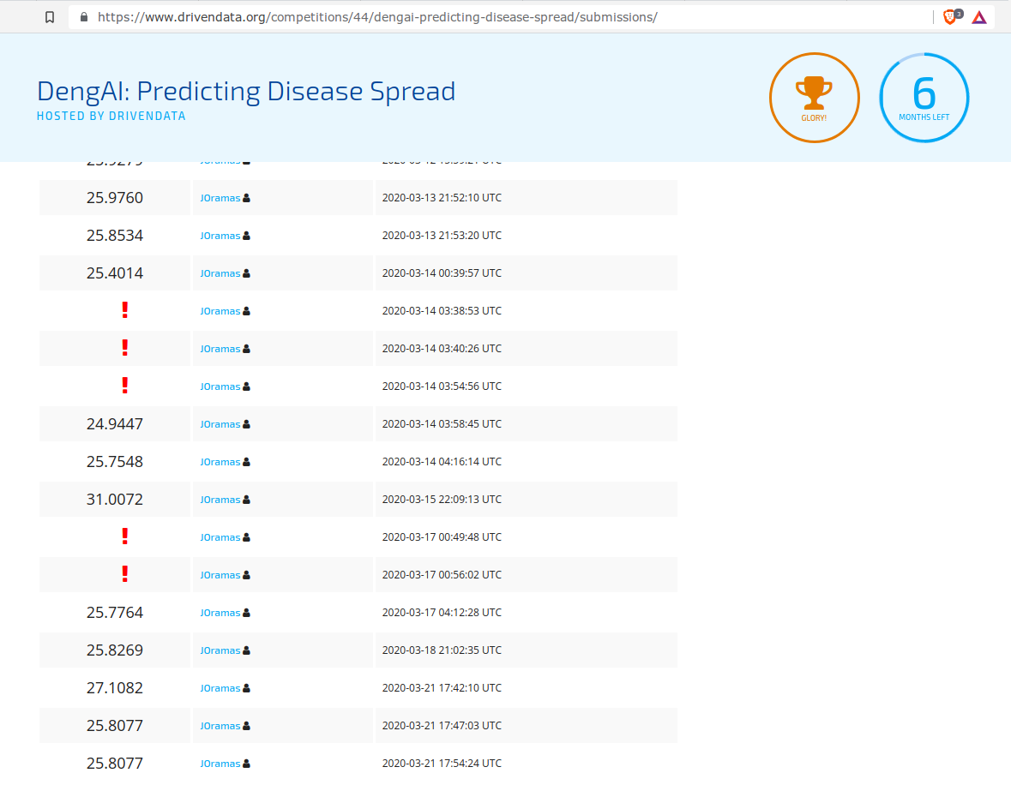
Source: DrivenData (https://www.drivendata.org/competitions/44/dengai-predicting-disease-spread), screenshot 25/01/2022

Python Pizza Holguín 2020, Conference: Video-Diet: poniendo a dieta tu almacenamiento
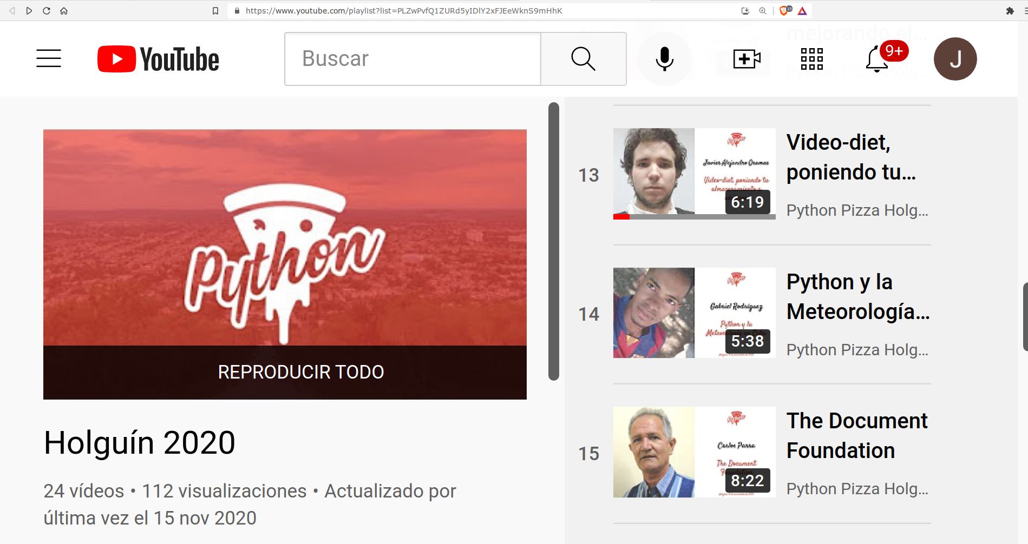
Source: Oramas, J. [Python Pizza Holguín]. (nov 15th 2020). Video-Diet: poniendo a dieta tu almacenamiento [Video]. YouTube https://youtu.be/c--NOwM5W-0, screenshot 25/01/2022
Results Prediction Models, Lima 2019 Panamerican Games
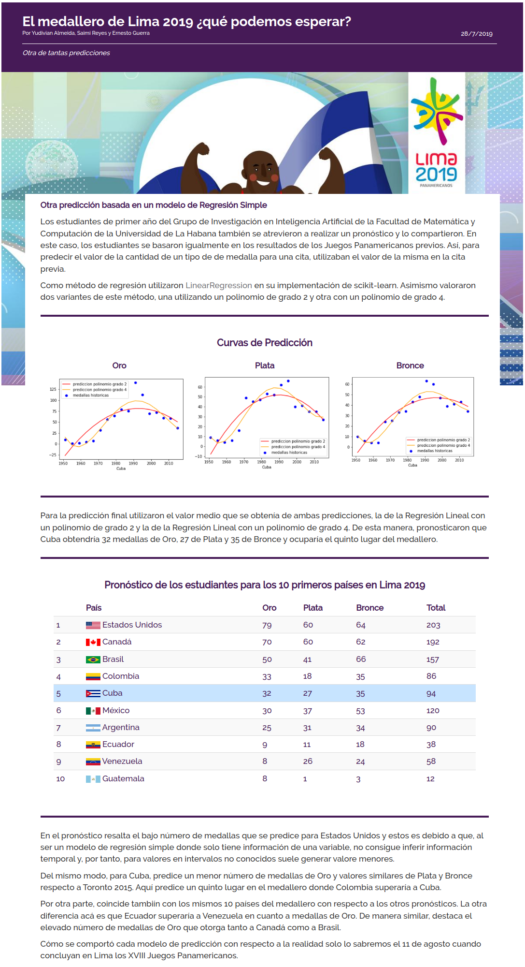

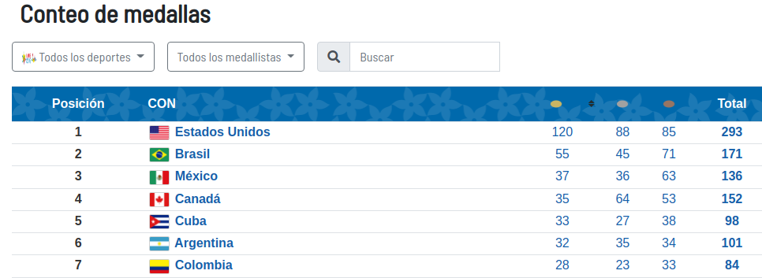
Source: Lima 2019, Juegos Paramericanos y Parapanamericanos (Aug 11th 2019). Conteo de Medallas https://www.lima2019.pe/medallero-panamericanos, screenshot 25/01/2022
Source: Almeida, Y. , Reyes, S. y Guerra, E. (jul 28th 2019). El medallero de Lima 2019 ¿qué podemos esperar? PostData.club Periodismo de Datos. http://www.postdata.club/issues/201907/el-medallero-de-lima-2019-que-se-puede-esperar.html, screenshot 25/01/2022
Ranking Caribeño basado en resultados de los Concursos Nacionales del ACM-ICPC 2018, team UH-KEJ ocupando el puesto 13
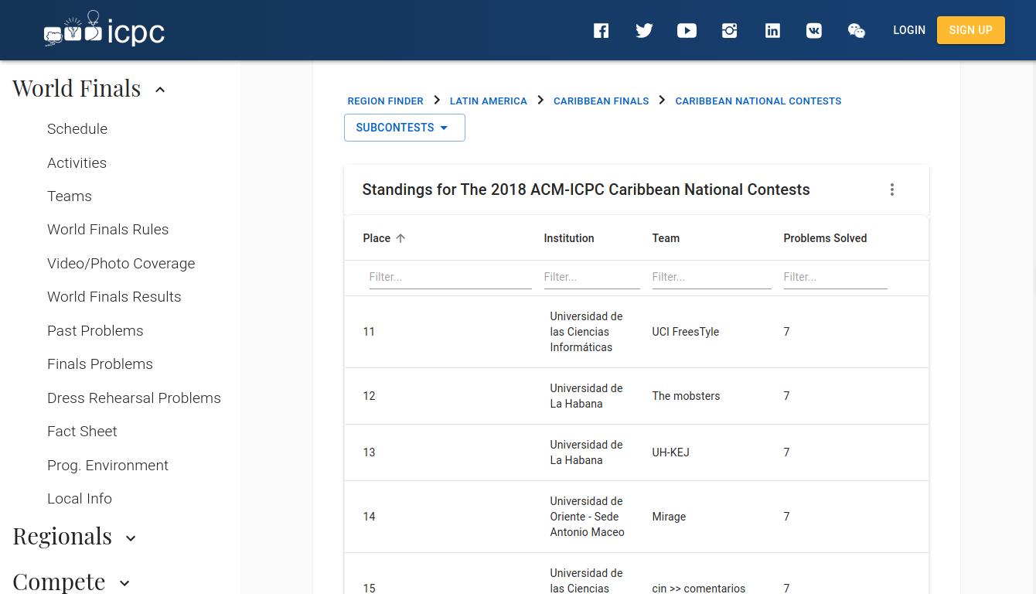
Source: International Collegiate Programming Contest (oct 2018). Standings for The 2018 ACM-ICPC Caribbean National Contests. https://icpc.global/regionals/finder/cnc-2018/standings, screenshot 25/01/2022
ACM-ICPC 2018 Local Contest, UH-KEJ 7th place
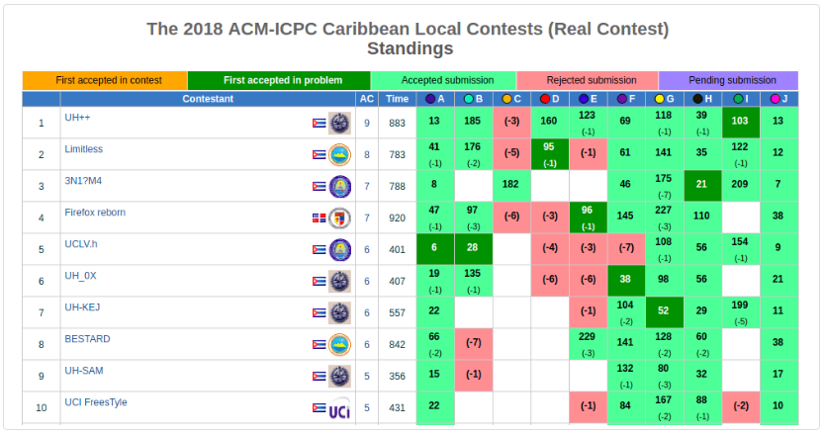
Source: Matcom Online Grader (sept 2018). Resultados del Concurso Local Caribeño 2018. Facultad de Matemática y Ciencia de la Computación, Universidad de La Habana. https://matcomgrader.com/post/5179/resultados-del-concurso-local-caribeno-2018, screenshot 25/01/2022
General Director invitation letter, Caribbean Finals ACM – ICPC 2017
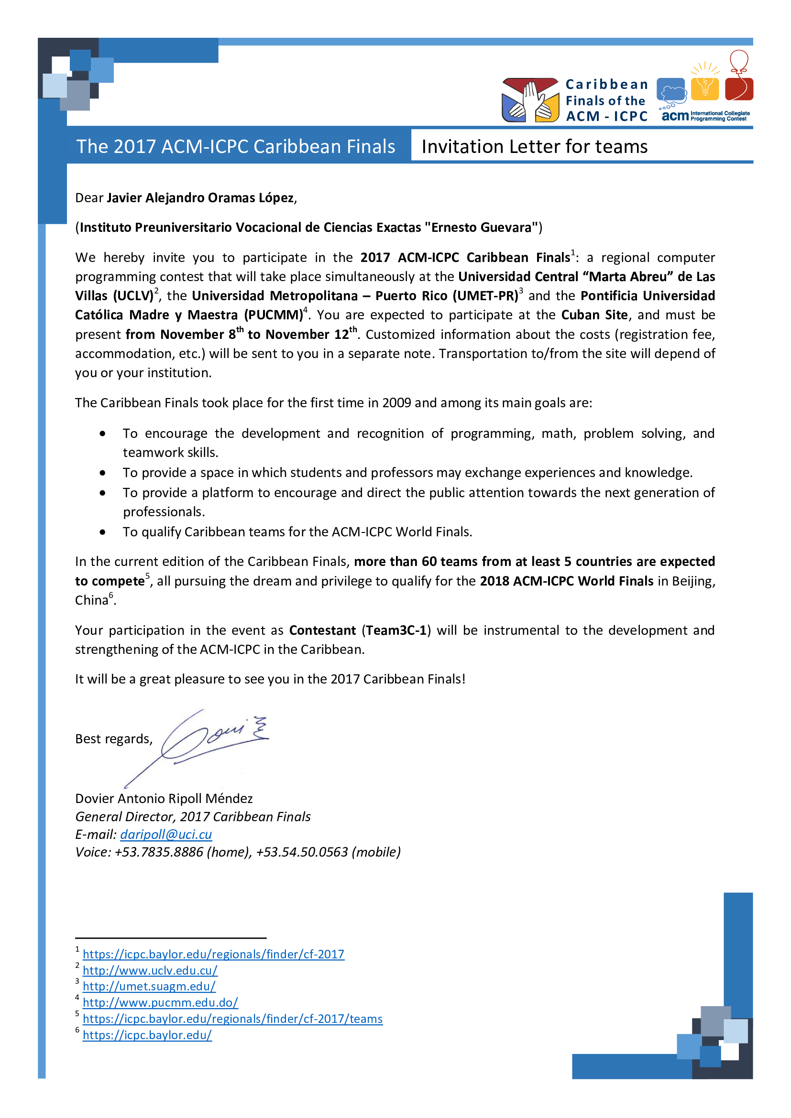
Team3C-1, IPVCE Ernesto Guevara from Villa Clara’s team, invited to the ACM-ICPC 2017 Caribbean Finals
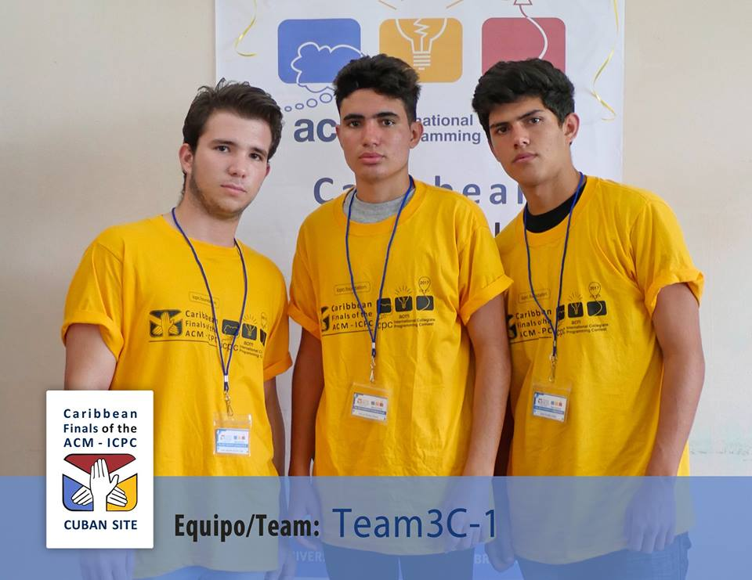
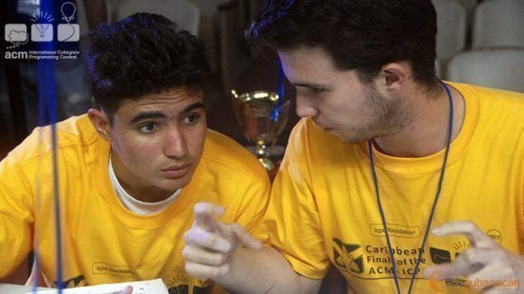
Source: Matcom Online Grader (oct 2017). The 2017 ACM-ICPC Caribbean Finals. Facultad de Matemática y Ciencia de la Computación, Universidad de La Habana. https://matcomgrader.com/post/5167/the-2017-acm-icpc-caribbean-finals, screenshot 25/01/2022
Classified teams to ACM – ICPC 2017 Caribbean Finals, Team3C-1 invited due to the achievements in the ACM-ICPC 2017 National Finals.
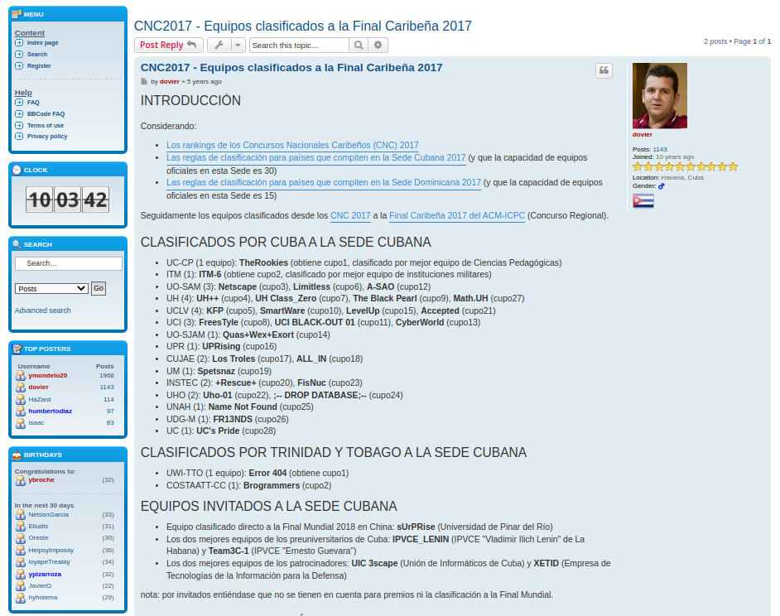
Source: Caribbean Online Judge (nov 2017). Final Caribeña del ACM – ICPC 2017. https://coj-forum.uci.cu/viewtopic.php?t=3315, screenshot 25/01/2022
Participation Certificate, ACM-ICPC 2017 Cuban Finals
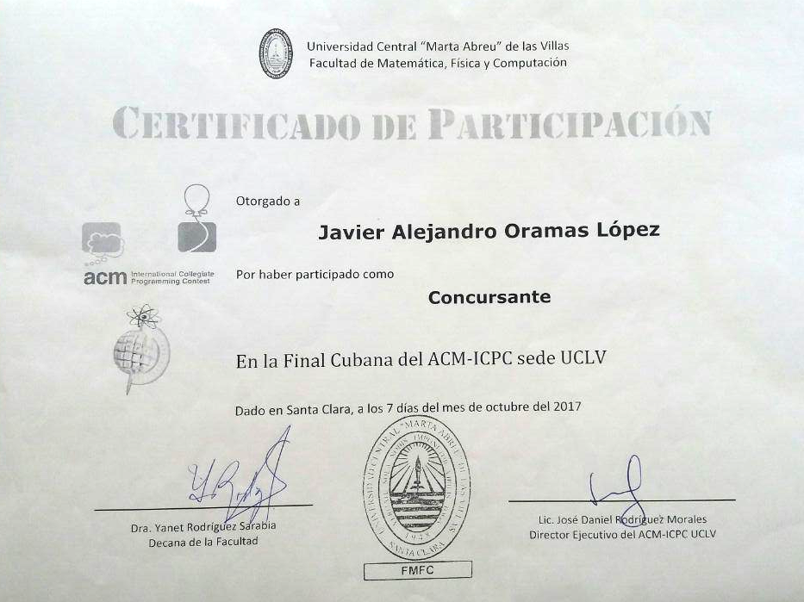
Participation Certificate, IV Programming Cup, Universidad Central de Las Villas
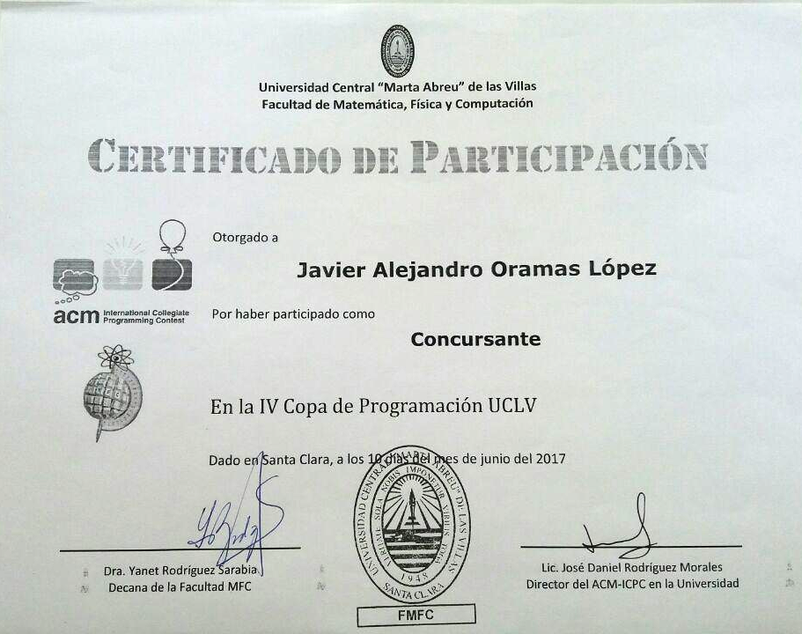
Certificate for Relevant Results obtained in the National Informatics Competition, Mach 2017
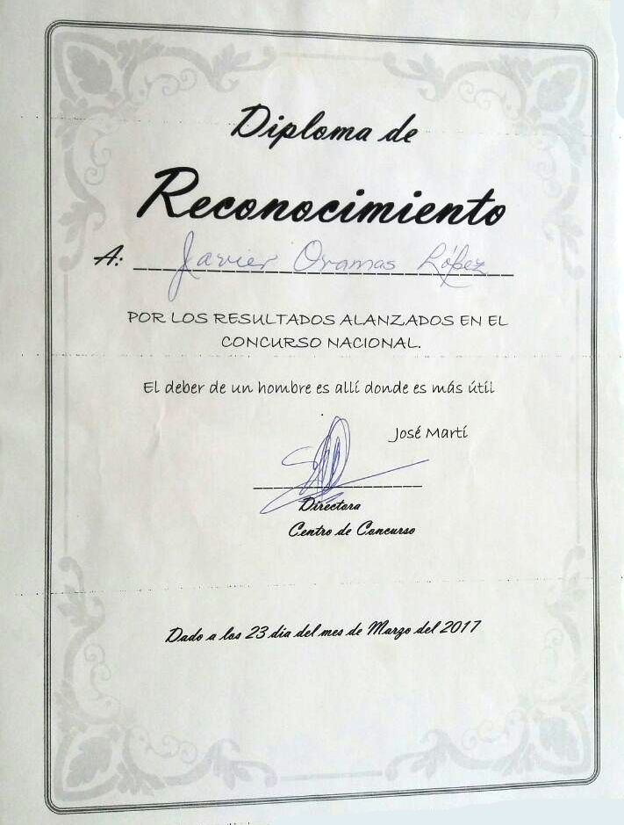
Certificate of Participation, Iberoamerican Computer Correspondence Competition, México 2016
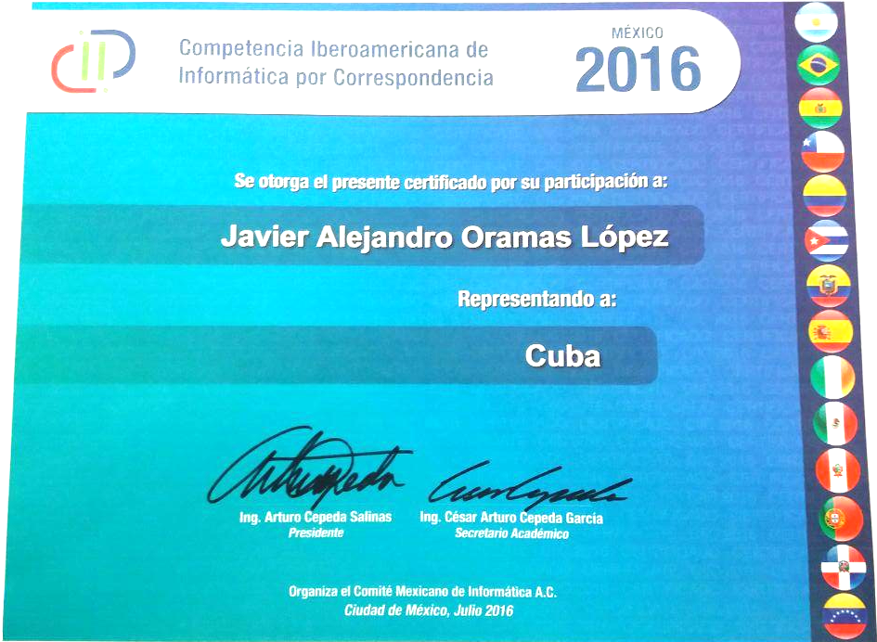
Certificate from the Ministry of Education of Cuba for having integrated the National Preselection to the International Olympiads of Informatics. 2016
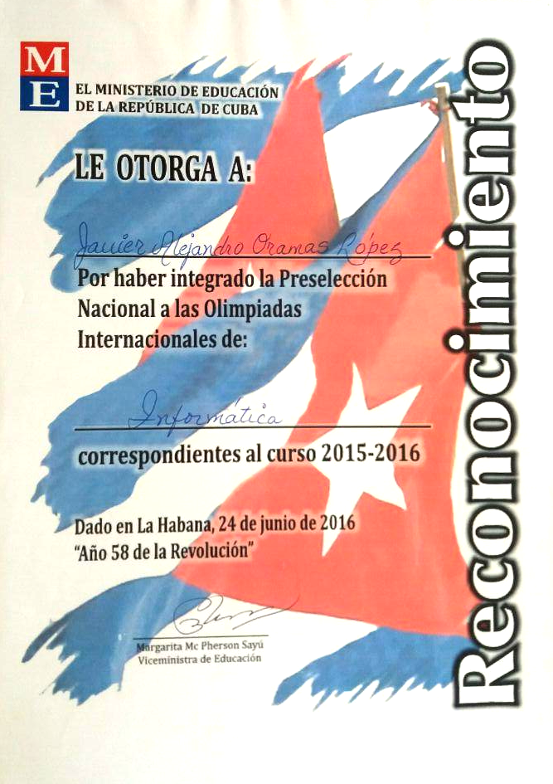
Certificate for Third place obtained in the Regional Cup of Computer Science Competition, Camagüey 2015
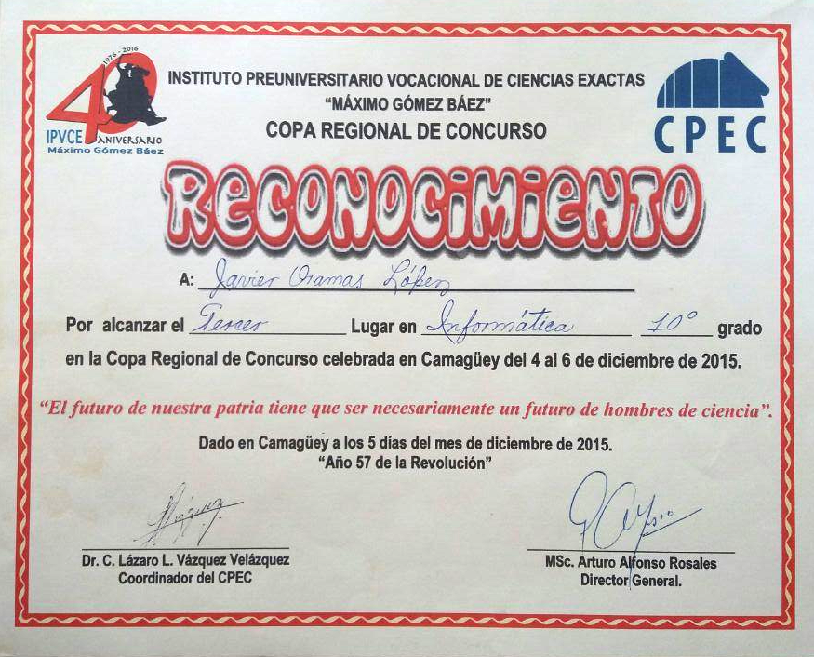
Certificate of participation in the National Competition of the ACM-ICPC, Universidad Central de Las Villas, October 2015
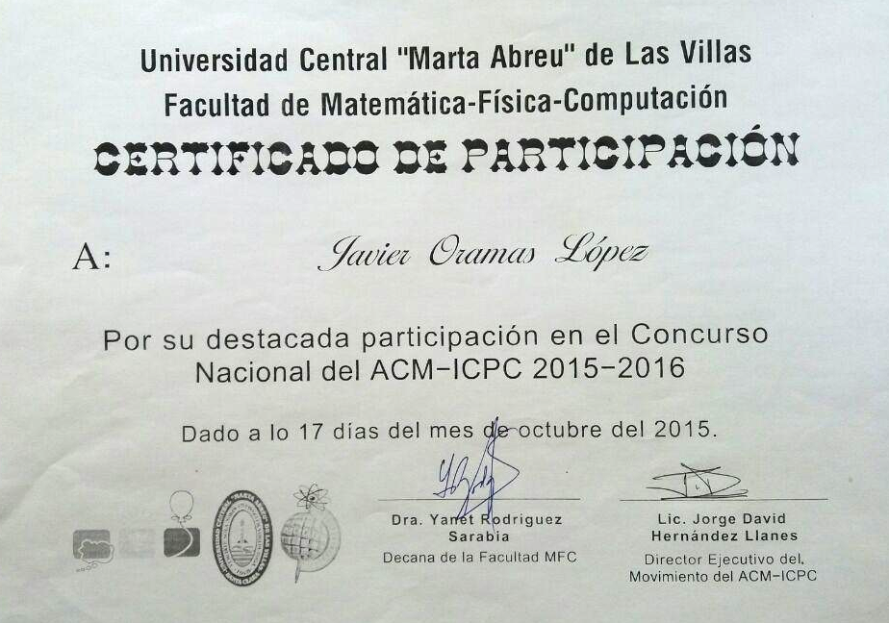
Certificate of participation in the Local Competition of the ACM-ICPC, Universidad Central de Las Villas, Septiembre 2015
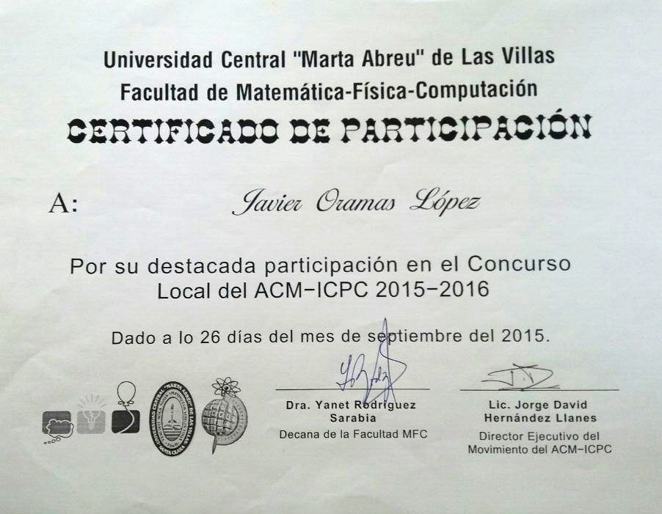
Recognition for second place obtained in the National Computer Science Competition, Marzo 2014


