Analysis of Prindex 2020 data

Javier Parada Gómez Urquiza

24 Sep 2020

## Introduction

Prindex data is collected in 137 countries through interviews with randomly selected individuals over the age of 18. Some of the countries where Prindex **has not** been collected are Angola, Democratic Republic of Congo, Central African Republic, Sudan, South Sudan, Syria, Oman, North Korea, and Papua New Guinea as shown in Map 1. More information on coverage is available at [Prindex.net](https://prindex.net).

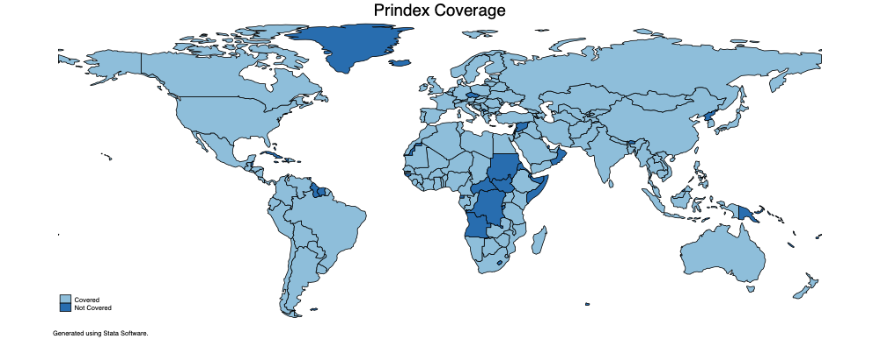

Map 1: Prindex Coverage

## Reasons for Tenure Insecurity

Prindex provides reasons for which individuals feel tenure insecure. In particular, the survey asks the following question:

Please tell me whether each of the following is a reason why you previously said it is likely you could lose the right to use some or all of this home or property against your will in the next 5 years:

rs_1. The owner may ask you to leave **YES/NO/Don’t Know/Refuse**

rs_2. The person paying rent may ask you to leave **YES/NO/Don’t Know/Refuse**

rs_3. Disagreements with family or relatives **YES/NO/Don’t Know/Refuse**

rs_4. Death of a household member **YES/NO/Don’t Know/Refuse**

rs_5. Companies may seize this property **YES/NO/Don’t Know/Refuse**

rs_6. Lack of money or other resources needed to live on this property **YES/NO/Don’t Know/Refuse**

rs_7. Government may seize **YES/NO/Don’t Know/Refuse**

rs_8. Issues with customary authorities **YES/NO/Don’t Know/Refuse**

The answers to Reason 7 are missing for some countries. The answers to Reason 8 are missing for all countries. Some individuals provided a reason for tenure insecurity even though they previously declared in the questionnaire that they were tenure secure. For that reason, we have only focused on the reasons for tenure insecurity of the tenure insecure. A better description of our procedure is provided in the following code:

2. qui gen rs_`i'=.  
 3. qui replace rs_`i'=1 if reason_`i'==1 & mainprop_security==0  
 4. qui replace rs_`i'=0 if reason_`i'==2 & mainprop_security==0  
 5. qui replace rs_`i'=0 if reason_`i'==3 & mainprop_security==0  
 6. qui replace rs_`i'=. if reason_`i'==4 & mainprop_security==0  
 7. }

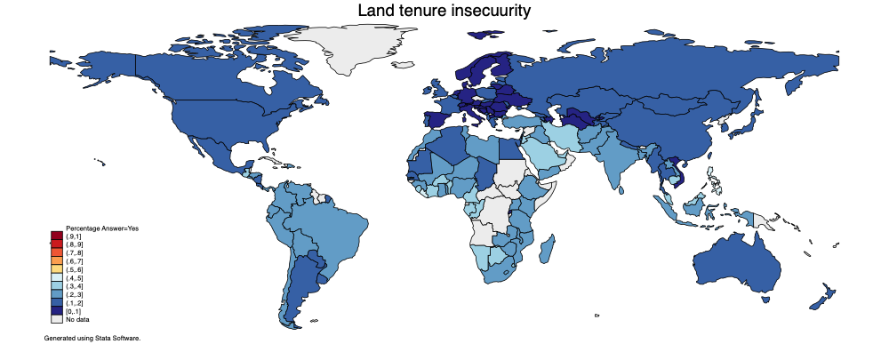

Map 2: Land Tenure Insecurity

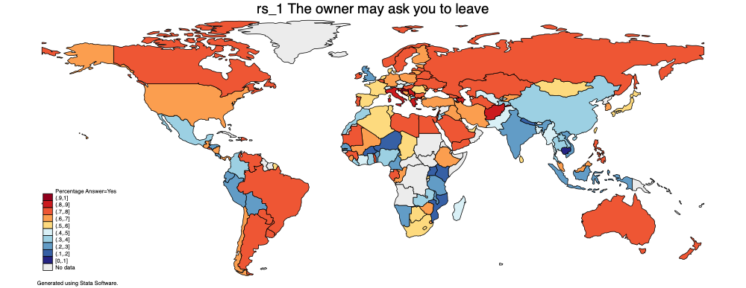

Map 3.1: Reason 1

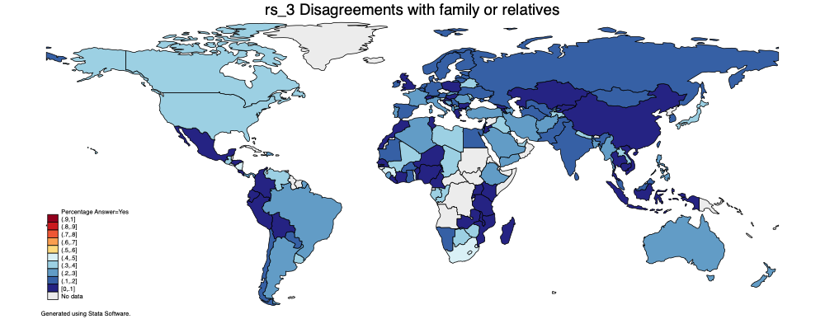

Map 3.2: Reason 2



Map 3.3: Reason 3

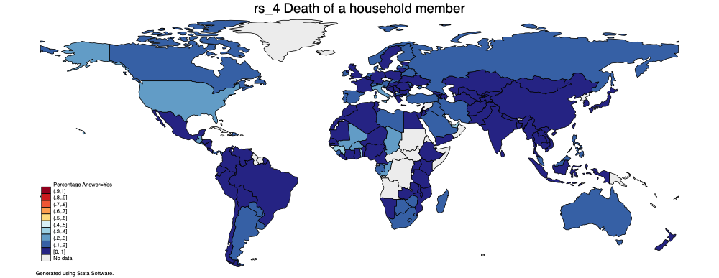

Map 3.4: Reason 4

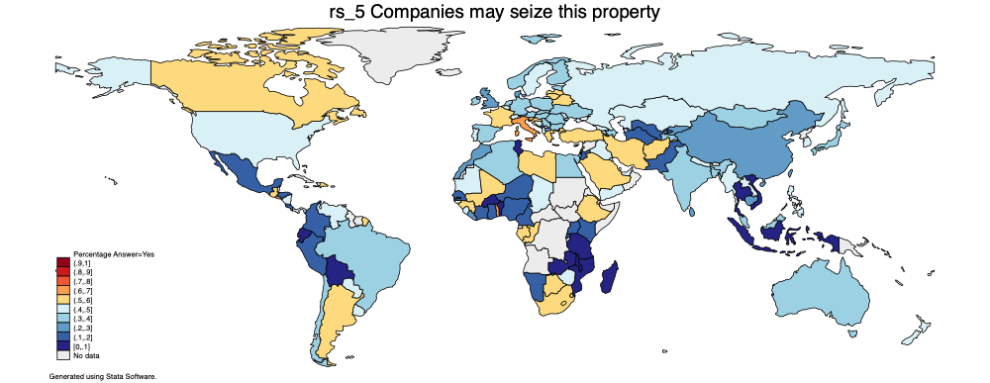

Map 3.5: Reason 5

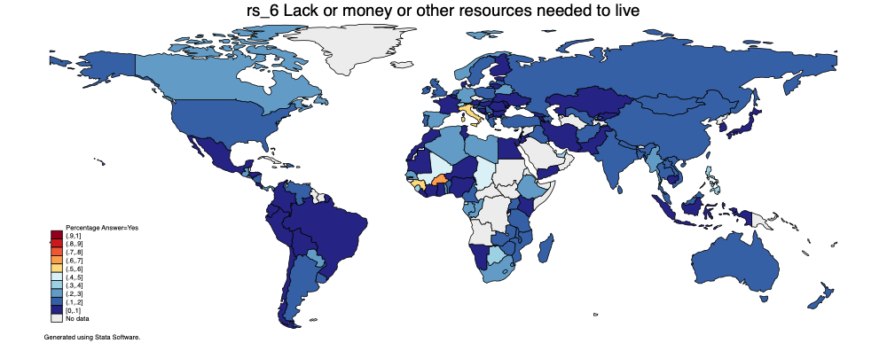

Map 3.6: Reason 6

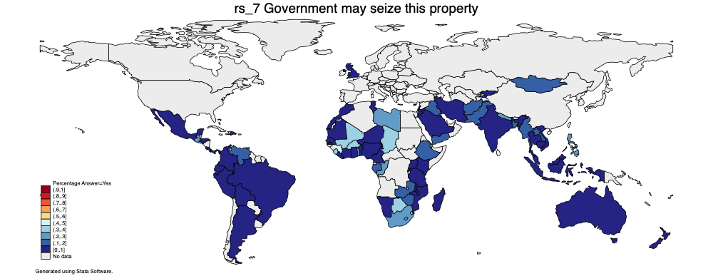

Map 3.7: Reason 7

## Appendix

|  |  |  |  |  |  |  |  |
| --- | --- | --- | --- | --- | --- | --- | --- |
| Country | rs_1 | rs_2 | rs_3 | rs_4 | rs_5 | rs_6 | rs_7 |
| Afghanistan | 89.61% | 34.48% | 25.57% | 8.35% | 55.30% | 16.87% | 16.68% |
| Albania | 56.66% | 38.52% | 23.44% | 4.11% | 44.69% | 17.81% |  |
| Algeria | 56.14% | 32.84% | 26.72% | 7.67% | 36.34% | 20.60% |  |
| Argentina | 78.24% | 41.98% | 26.63% | 10.27% | 52.98% | 14.58% | 6.95% |
| Armenia | 45.68% | 10.22% | 6.25% | 2.25% | 34.77% | 5.67% |  |
| Australia | 78.72% | 12.44% | 22.49% | 11.32% | 38.52% | 10.77% | 3.51% |
| Austria | 40.67% | 17.66% | 15.21% | 10.85% | 33.69% | 8.76% |  |
| Azerbaijan | 82.31% | 43.02% | 27.76% | 9.63% | 36.28% | 10.05% |  |
| Bangladesh | 46.94% | 34.76% | 21.50% | 6.54% | 30.69% | 14.87% | 16.49% |
| Belarus | 78.88% | 50.04% | 39.55% | 12.20% | 52.24% | 27.55% |  |
| Belgium | 71.77% | 12.12% | 14.96% | 7.51% | 40.98% | 9.30% |  |
| Benin | 20.36% | 16.71% | 5.61% | 3.13% | 9.08% | 10.85% | 1.54% |
| Bolivia | 28.45% | 18.59% | 2.22% | 0.34% | 4.59% | 4.86% | 1.19% |
| Bosnia and Herzegovina | 64.72% | 26.13% | 27.40% | 4.56% | 41.86% | 4.30% |  |
| Botswana | 57.48% | 42.34% | 39.86% | 18.05% | 52.22% | 30.57% | 30.45% |
| Brazil | 70.77% | 28.61% | 22.36% | 4.67% | 30.90% | 6.17% | 0.71% |
| Bulgaria | 79.49% | 34.13% | 8.68% | 5.20% | 32.80% | 7.35% |  |
| Burkina Faso | 14.09% | 31.73% | 11.83% | 20.16% | 8.30% | 62.13% | 31.28% |
| Cambodia | 7.42% | 8.69% | 6.37% | 4.08% | 21.40% | 7.67% | 2.66% |
| Cameroon | 23.40% | 9.74% | 4.32% | 2.93% | 12.52% | 10.11% | 5.00% |
| Canada | 70.30% | 28.97% | 34.68% | 15.61% | 57.01% | 22.90% |  |
| Chad | 52.60% | 48.30% | 37.28% | 30.00% | 44.60% | 43.80% | 37.52% |
| Chile | 68.28% | 31.59% | 19.31% | 6.23% | 35.34% | 6.41% |  |
| China | 39.00% | 16.52% | 8.99% | 7.42% | 26.82% | 12.95% |  |
| Colombia | 38.71% | 10.20% | 4.00% | 1.82% | 17.28% | 4.45% | 0.21% |
| Comoros | 49.12% | 43.31% | 33.76% | 15.63% | 45.59% | 17.34% | 31.25% |
| Costa Rica | 26.33% | 13.31% | 6.22% | 2.58% | 15.58% | 2.24% | 0.76% |
| Cote d’Ivoire | 41.92% | 12.01% | 2.74% | 2.45% | 18.04% | 6.14% | 0.79% |
| Croatia | 92.17% | 7.84% | 3.82% | 1.15% | 58.83% | 12.64% |  |
| Cyprus | 67.75% | 20.01% | 15.69% | 29.30% | 64.69% | 16.83% |  |
| Denmark | 53.72% | 6.90% | 15.61% | 17.77% | 20.64% | 5.40% |  |
| Dominican Republic | 79.36% | 41.66% | 28.17% | 12.53% | 58.26% | 14.83% | 9.11% |
| Ecuador | 24.15% | 10.43% | 5.79% | 0.62% | 4.96% | 0.62% | 0.00% |
| Egypt | 71.72% | 35.26% | 18.50% | 0.55% | 31.85% | 2.13% |  |
| El Salvador | 77.31% | 38.08% | 42.44% | 18.55% | 66.11% | 26.24% | 24.24% |
| Estonia | 62.07% | 22.93% | 10.89% | 5.30% | 34.46% | 5.32% |  |
| Ethiopia | 68.31% | 28.69% | 22.37% | 9.82% | 51.50% | 27.25% | 13.13% |
| Finland | 60.94% | 9.37% | 16.54% | 12.79% | 32.25% | 7.20% |  |
| France | 56.22% | 29.56% | 20.58% | 5.35% | 54.51% | 8.86% |  |
| Gabon | 74.89% | 42.79% | 31.16% | 17.16% | 54.74% | 25.40% | 16.64% |
| Gambia | 59.56% | 38.33% | 24.13% | 13.88% | 39.14% | 23.95% | 15.76% |
| Georgia | 77.75% | 11.69% | 3.38% | 6.38% | 43.41% | 9.07% |  |
| Germany | 67.11% | 25.21% | 17.13% | 5.96% | 36.78% | 21.18% |  |
| Ghana | 34.54% | 27.59% | 13.98% | 5.40% | 13.97% | 5.12% | 4.78% |
| Greece | 86.79% | 12.34% | 6.67% | 8.68% | 55.97% | 10.75% |  |
| Guatemala | 60.73% | 37.11% | 37.96% | 21.88% | 54.50% | 20.75% | 24.89% |
| Guinea | 74.51% | 43.59% | 44.70% | 31.67% | 59.13% | 51.10% | 43.06% |
| Honduras | 28.32% | 7.01% | 1.14% | 0.00% | 13.68% | 0.00% | 1.11% |
| Hungary | 70.38% | 16.34% | 9.54% | 3.97% | 31.24% | 5.00% |  |
| India | 27.78% | 16.59% | 15.73% | 5.39% | 32.54% | 10.90% | 7.47% |
| Indonesia | 22.36% | 19.18% | 8.88% | 2.27% | 6.63% | 4.36% | 0.69% |
| Iran | 64.35% | 27.63% | 29.02% | 10.35% | 54.10% | 9.15% | 3.93% |
| Iraq | 66.40% | 36.26% | 31.87% | 12.68% | 49.85% | 13.51% | 18.12% |
| Ireland | 73.75% | 25.34% | 14.56% | 12.87% | 33.03% | 14.80% |  |
| Israel | 75.93% | 29.84% | 14.64% | 9.27% | 32.00% | 10.48% |  |
| Italy | 86.21% | 8.60% | 28.67% | 20.73% | 63.69% | 57.06% |  |
| Japan | 54.38% | 18.60% | 32.10% | 6.17% | 34.50% | 7.85% |  |
| Jordan | 39.14% | 14.03% | 6.31% | 1.09% | 18.39% | 0.00% | 1.14% |
| Kazakhstan | 77.39% | 10.22% | 6.65% | 6.20% | 49.43% | 7.41% |  |
| Kenya | 18.35% | 9.78% | 0.89% | 2.03% | 19.91% | 9.24% | 0.75% |
| Kuwait | 69.01% | 20.83% | 21.15% | 27.16% | 43.57% |  | 19.70% |
| Kyrgyzstan | 68.51% | 12.29% | 8.34% | 3.55% | 21.62% | 4.81% | 2.76% |
| Laos | 39.09% | 31.31% | 35.10% | 9.18% | 48.22% | 15.53% | 17.67% |
| Latvia | 71.51% | 29.51% | 13.67% | 11.53% | 52.41% | 17.73% |  |
| Lebanon | 73.02% | 24.38% | 18.38% | 2.21% | 52.29% | 3.04% | 2.97% |
| Liberia | 37.24% | 31.06% | 4.97% | 3.97% | 20.68% | 6.19% | 1.54% |
| Libya | 74.11% | 30.82% | 32.32% | 16.09% | 54.99% | 25.38% | 22.18% |
| Lithuania | 69.13% | 32.94% | 15.88% | 1.90% | 50.67% | 4.23% |  |
| Luxembourg | 60.16% | 27.14% | 25.45% | 10.64% | 37.59% | 36.38% |  |
| Macedonia | 34.25% | 44.11% | 27.98% | 10.73% | 24.43% | 8.06% |  |
| Madagascar | 49.12% | 5.58% | 0.96% | 12.81% | 9.11% | 12.12% | 2.03% |
| Malawi | 26.16% | 20.52% | 3.31% | 5.13% | 9.85% | 18.63% | 5.55% |
| Malaysia | 65.79% | 11.51% | 16.22% | 16.44% | 37.14% | 19.77% | 5.68% |
| Mali | 68.58% | 37.37% | 32.84% | 25.96% | 50.91% | 45.71% | 38.74% |
| Malta | 63.19% | 21.77% | 27.35% | 5.07% | 30.92% | 11.65% |  |
| Mauritania | 70.37% | 24.42% | 15.93% | 5.41% | 43.37% | 8.51% | 8.10% |
| Mauritius | 48.34% | 47.41% | 46.50% | 6.16% | 32.52% | 13.99% |  |
| Mexico | 30.43% | 22.27% | 7.35% | 1.39% | 13.09% | 2.25% | 1.28% |
| Moldova | 60.28% | 44.63% | 31.84% | 14.49% | 43.18% | 9.71% |  |
| Mongolia | 59.01% | 30.19% | 19.95% | 9.06% | 37.64% | 12.12% | 13.93% |
| Montenegro | 62.27% | 19.39% | 8.51% | 6.55% | 19.88% | 9.43% |  |
| Morocco | 38.30% | 28.81% | 8.86% | 0.26% | 25.53% | 5.52% | 1.03% |
| Mozambique | 18.33% | 19.38% | 5.67% | 4.55% | 4.13% | 11.44% | 1.31% |
| Myanmar | 47.39% | 25.38% | 26.76% | 4.65% | 40.84% | 21.58% | 10.99% |
| Namibia | 29.50% | 21.16% | 12.02% | 5.98% | 14.89% | 9.75% | 6.40% |
| Nepal | 18.87% | 43.37% | 32.96% | 5.81% | 41.31% | 16.11% | 21.18% |
| Netherlands | 52.64% | 27.42% | 14.42% | 14.48% | 31.12% | 14.66% |  |
| New Zealand | 71.36% | 17.73% | 25.91% | 5.46% | 41.87% | 10.56% | 2.63% |
| Nicaragua | 61.83% | 40.10% | 41.01% | 6.97% | 44.96% | 13.59% |  |
| Niger | 14.77% | 12.56% | 7.79% | 0.06% | 13.22% | 2.85% | 0.32% |
| Nigeria | 30.54% | 15.20% | 8.68% | 6.55% | 16.33% | 9.66% | 6.71% |
| Norway | 77.30% | 29.01% | 19.99% | 12.09% | 39.49% | 26.42% |  |
| Pakistan | 41.95% | 14.72% | 17.52% | 7.09% | 19.52% | 4.62% | 10.05% |
| Panama | 61.27% | 36.02% | 28.62% | 19.67% | 48.99% | 24.73% | 9.88% |
| Paraguay | 72.15% | 34.37% | 13.53% | 17.80% | 48.97% | 23.36% |  |
| Peru | 25.45% | 18.09% | 3.78% | 1.18% | 18.64% | 3.20% | 4.48% |
| Philippines | 77.29% | 39.28% | 24.50% | 18.64% | 41.85% | 36.84% | 23.75% |
| Poland | 62.34% | 18.38% | 8.74% | 6.32% | 37.72% | 16.88% |  |
| Portugal | 76.17% | 27.24% | 26.44% | 11.20% | 43.96% | 12.56% |  |
| Republic of Congo | 68.52% | 45.99% | 32.54% | 22.24% | 55.15% | 28.02% | 28.04% |
| Romania | 59.83% | 42.67% | 21.44% | 2.36% | 31.12% | 1.56% |  |
| Russia | 77.22% | 24.42% | 17.14% | 15.54% | 48.15% | 17.94% |  |
| Rwanda | 54.13% | 10.48% | 0.00% | 2.19% | 18.76% | 5.88% | 0.00% |
| Saudi Arabia | 74.59% | 17.62% | 20.05% | 19.35% | 51.77% |  | 5.08% |
| Senegal | 23.57% | 18.37% | 5.59% | 1.10% | 11.90% | 20.60% | 5.26% |
| Serbia | 82.50% | 25.86% | 11.34% | 2.28% | 39.25% | 10.76% |  |
| Sierra Leone | 67.86% | 51.84% | 23.96% | 17.55% | 44.26% | 34.79% | 36.78% |
| Singapore | 34.17% | 6.81% | 9.52% | 0.00% | 39.24% | 19.23% |  |
| Slovakia | 41.06% | 35.30% | 23.51% | 16.10% | 31.63% | 10.39% |  |
| Slovenia | 77.49% | 31.48% | 46.77% | 11.89% | 55.02% | 16.60% |  |
| South Africa | 59.85% | 46.94% | 48.95% | 18.93% | 51.92% | 23.08% | 24.24% |
| South Korea | 66.83% | 11.30% | 10.26% | 2.96% | 40.78% | 6.42% |  |
| Spain | 53.37% | 22.68% | 19.09% | 15.93% | 37.65% | 21.94% |  |
| Sri Lanka | 50.81% | 31.15% | 16.42% | 9.10% | 24.39% | 16.85% |  |
| Swaziland | 65.47% | 55.69% | 47.57% | 16.76% | 53.82% | 23.28% | 38.01% |
| Sweden | 78.90% | 16.58% | 15.12% | 7.84% | 48.53% | 13.19% |  |
| Switzerland | 40.44% | 10.31% | 0.00% | 12.07% | 41.02% | 33.72% |  |
| Taiwan | 55.26% | 21.03% | 12.51% | 4.40% | 26.85% | 17.72% |  |
| Tajikistan | 38.63% | 33.73% | 36.26% | 4.47% | 35.45% |  |  |
| Tanzania | 25.29% | 16.99% | 7.04% | 7.46% | 8.47% | 18.37% | 2.07% |
| Thailand | 31.65% | 4.69% | 2.81% | 1.50% | 5.55% | 13.92% | 0.31% |
| Togo | 77.65% | 38.30% | 41.53% | 37.28% | 61.94% | 28.88% | 29.88% |
| Tunisia | 55.14% | 22.43% | 5.67% | 2.24% | 9.34% | 3.50% | 2.31% |
| Turkey | 67.62% | 28.45% | 29.04% | 10.32% | 50.75% | 19.01% |  |
| Turkmenistan | 76.77% | 6.88% | 18.86% | 4.79% | 18.96% |  |  |
| Uganda | 19.47% | 15.92% | 6.33% | 2.79% | 12.55% | 14.94% | 1.72% |
| Ukraine | 71.66% | 29.16% | 15.55% | 8.94% | 30.39% | 8.67% |  |
| United Arab Emirates | 55.70% | 23.63% | 30.92% | 30.26% | 47.83% | 30.78% |  |
| United Kingdom | 28.99% | 23.38% | 6.51% | 2.23% | 27.73% | 14.21% | 3.69% |
| United States | 68.48% | 20.93% | 34.10% | 22.21% | 47.15% | 18.56% |  |
| Uruguay | 72.98% | 43.45% | 30.04% | 11.20% | 44.87% | 14.76% |  |
| Uzbekistan | 42.28% | 23.39% | 14.34% | 8.42% | 12.72% | 18.16% |  |
| Venezuela | 74.94% | 47.02% | 32.02% | 8.51% | 49.11% | 19.56% | 11.83% |
| Vietnam | 21.44% | 19.61% | 8.90% | 3.04% | 8.83% | 10.82% | 3.72% |
| Yemen | 75.32% | 48.75% | 29.84% | 3.54% | 47.77% | 5.47% | 12.62% |
| Zambia | 37.20% | 12.19% | 5.42% | 4.89% | 9.89% | 12.20% | 11.86% |
| Zimbabwe | 65.08% | 32.05% | 33.68% | 11.30% | 43.16% | 14.26% | 14.29% |