CASTILLO, Javier Cirilo S.

2ECE-C

Problem #1

import pandas as pd

cars=pd.read_csv('cars.csv')

y = (cars.head(5))

z = (cars.tail(5))

print(y)

print(z)

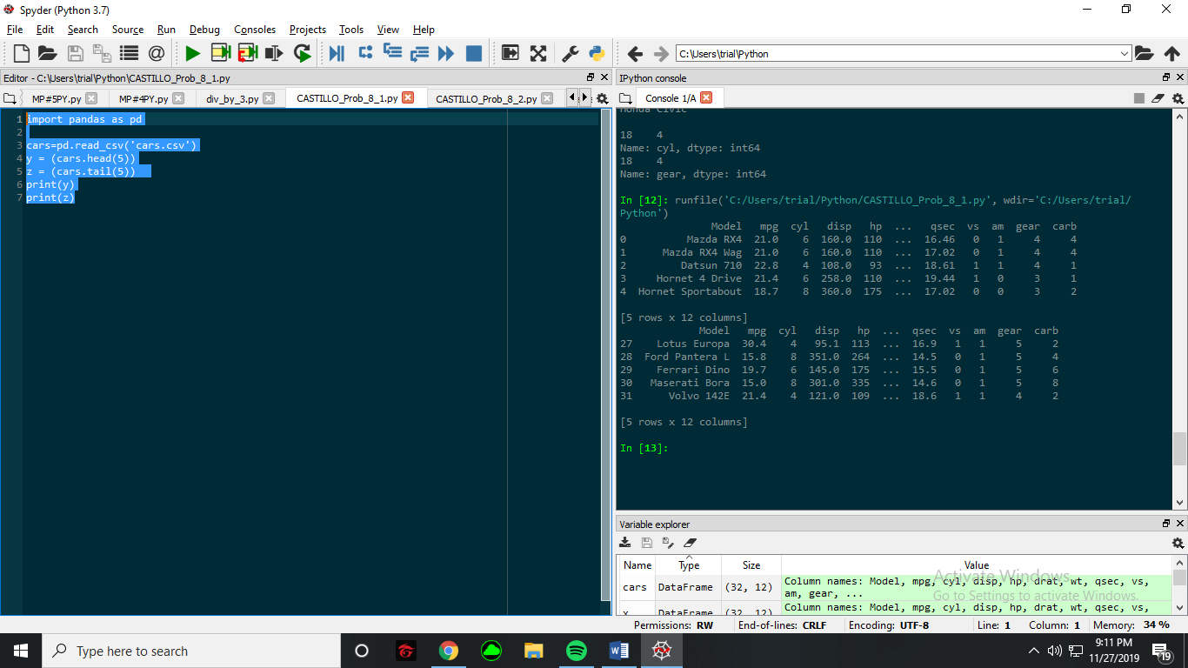

Problem #2

import pandas as pd

cars=pd.read_csv('cars.csv')

print(cars.iloc[0:5,0:12:2])

print(cars.loc[cars['Model']=='Mazda RX4'])

print(cars.loc[cars['Model']=='Camaro Z28']['cyl'])

print('\n')

print('Mazda RX4 Wag\n')

print(cars.loc[cars.Model=='Mazda RX4 Wag']['cyl'])

print(cars.loc[cars.Model=='Mazda RX4 Wag']['gear'])

print('\n')

print('Ford Panera\n')

print(cars.loc[cars.Model=='Ford Pantera L']['cyl'])

print(cars.loc[cars.Model=='Ford Pantera L']['gear'])

print('\n')

print('Honda Civic\n')

print(cars.loc[cars.Model=='Honda Civic']['cyl'])

print(cars.loc[cars.Model=='Honda Civic']['gear'])

