CASTILLO, Javier Cirilo S.

2ECE-C

PROOF

Prob 1

import pandas as pd

BearESAT = pd.DataFrame({'Student':['Ice Bear', 'Panda', 'Grizzly'], 'ESAT': [93,89,88]})

BearGeas = pd.DataFrame({'Student':['Ice Bear', 'Panda', 'Grizzly'], 'GEAS': [90,79,93]}).merge(BearESAT,on='Student')

BearElec = pd.DataFrame({'Student':['Ice Bear', 'Panda', 'Grizzly'], 'Electronics': [85,81,83]}).merge(BearGeas,on='Student')

BearMath = pd.DataFrame({'Student':['Ice Bear', 'Panda', 'Grizzly'], 'Math': [80,95,79]}).merge(BearElec,on='Student')

long=pd.melt(BearMath,id_vars=['Student'],var_name='Subject',value_name='Grades')

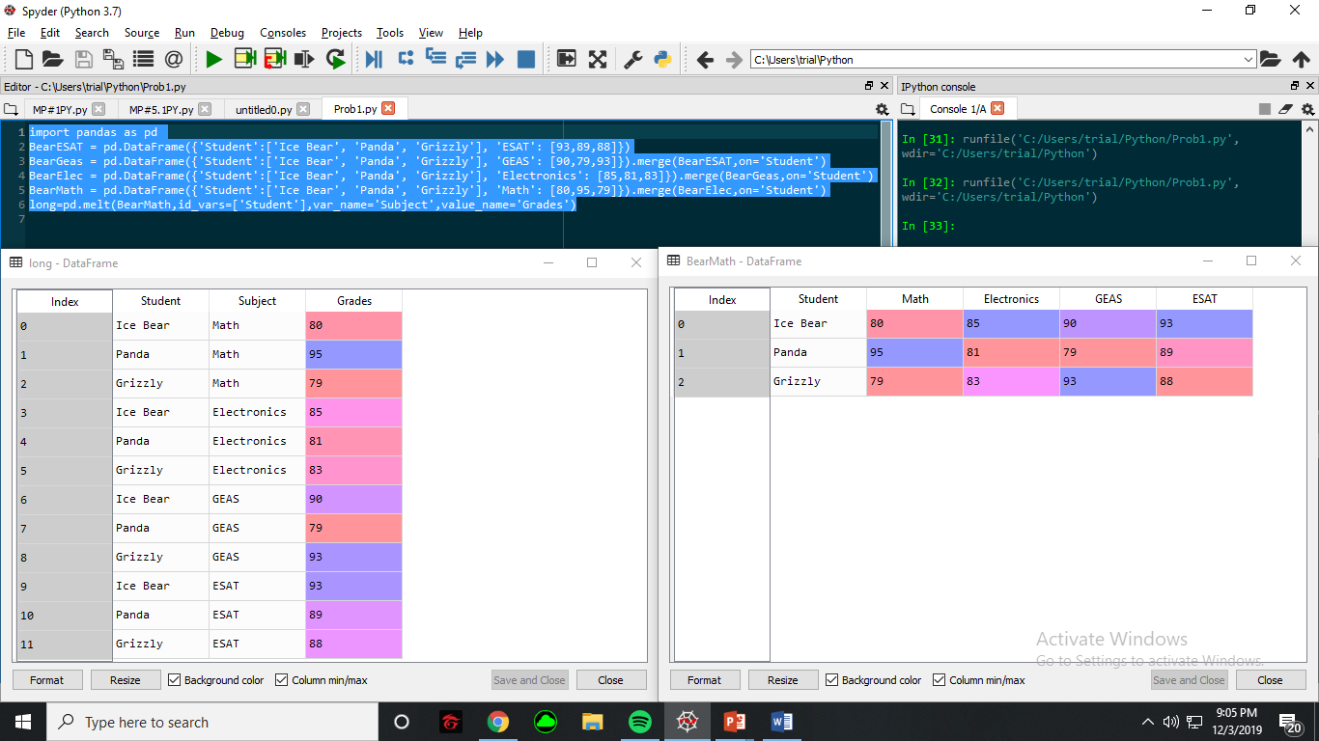

Prob 2

import pandas as pd

box = pd.DataFrame({'Box': ['Box1', 'Box1', 'Box1', 'Box2', 'Box2', 'Box2'],'Dimension':['Length','Width','Height','Length','Width','Height'

],'Value':[6,4,2,5,3,4]})

tidy=box.pivot_table(index='Box', columns='Dimension', values='Value')

l = tidy.Length

w = tidy.Width

h = tidy.Height

v = l * w * h

tidy['Volume']= v

