CASTILLO, Javier Cirilo S.

2ECE-C

Problem 1:

import numpy as np

x=np.random.random(5)

for q in range (1,5):

x = np.vstack((x,np.random.random(5)))

y = (x-x.mean())/x.std()

print(y)

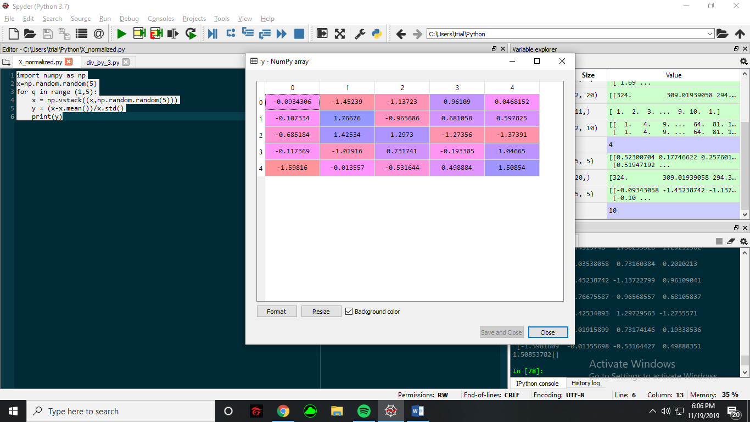

Problem 2:

import numpy as np

x = (np.linspace(1,100,100)\*\*2).reshape((10,10))

y = x%3 == 0

z = x[x%3==0]

