**Revision´s manual:**

**Note**: At this point the applicant thinks that all the necessary features to pass the test are already developed, including the Front in a simple enough way to show Full Stack skills, however there are some details that should be highlighted and other features that could be improved. These can be improvements to validations, counters, re-renders or Snackbar component.

- Regarding the image of the medicines: although Next.js (from Vercel) has a very good optimization for static images, it does not have the advantage of rendering dynamically loaded images without an extra server for it, so it was decided not to put them, it is clarified although it does not affect the operation of the application.

**Note 2**: some similar functionalities are done in a different way (such as the case of saving a medicine in the database and the case of saving a drone). This has been done intentionally with the idea of ​​showing different abilities.

* The application prevents that more than 10 drones cannot be inserted, launching a message when preventing to open the dialog to insert a new drone.
* The following fields are validated in the Registering a drone form:
  + serial_number (TextField, required, non-zero or "", and less than or equal to 100)
  + model (Autocomplete, required)
  + weight (TextField of type number, required, greater than 0 and less than or equal to 500)
  + battery_capacity (TextField of type number, required, greater than 0 and less than or equal to 100)
  + state (Autocomplete, required)
* In the **AddMedications** form, the following fields are validated: (you must paste the content of a JSON object, if it does not have a simple one in medications.json)
  + name (required, letters, numbers, “-“ y “_”)
  + weight (required, float)
  + code (required, letters in uppercase, “_” and numbers)
  + image (not required)

**Load data (variant: no commandline no scripts)**

1. Edit .env file and set your settings to connect to the database
2. Copy the content of the file musala.sql “*/src/pages/api/musala.sql*”
3. Open the MySQL DMS you prefer and paste the code
4. Run script

**For technique details as run, test or build the app please go to the READ.me file**

**Drone´s list**

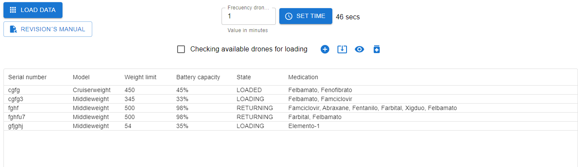

**Registering a drone**

1. Click on the button with the plus symbol

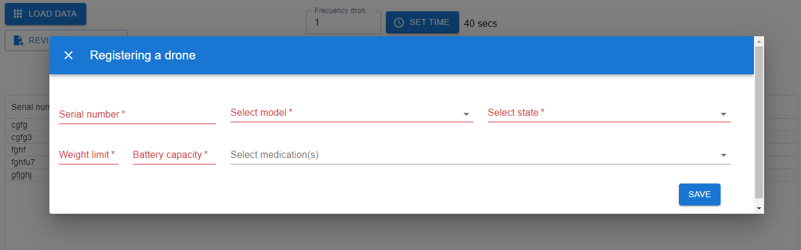

**Loading a drone with medication items**

1. Click on the button with the symbol of a rectangle with an arrow pointing down. (It can also be done when registering a drone)

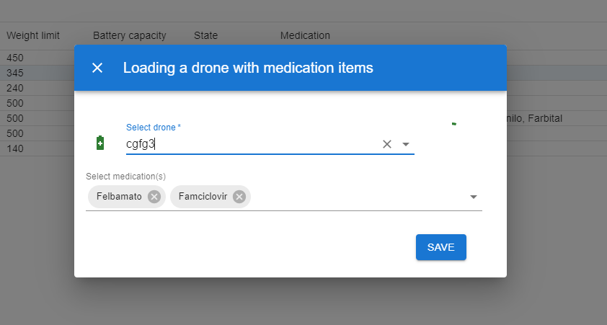

**Checking loaded medication items for a given drone**

1. Click on the button with the icon of an eye (This can be seen in the list, and also in the Loading medications dialog)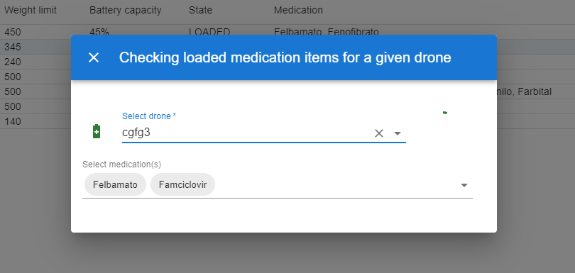

**Checking available drones for loading**

1. Check or uncheck the checkbox “Checking available drones for loading”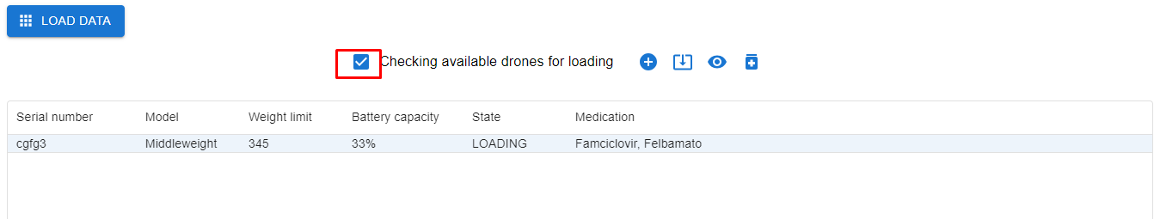

**Check drone battery level for a given drone**

1. There are three ways to do this: a) See Battery capacity column in the list of drones b) In the Loading medications dialog click on the battery icon. c) In the Checking loaded medication item dialog, click on the battery.

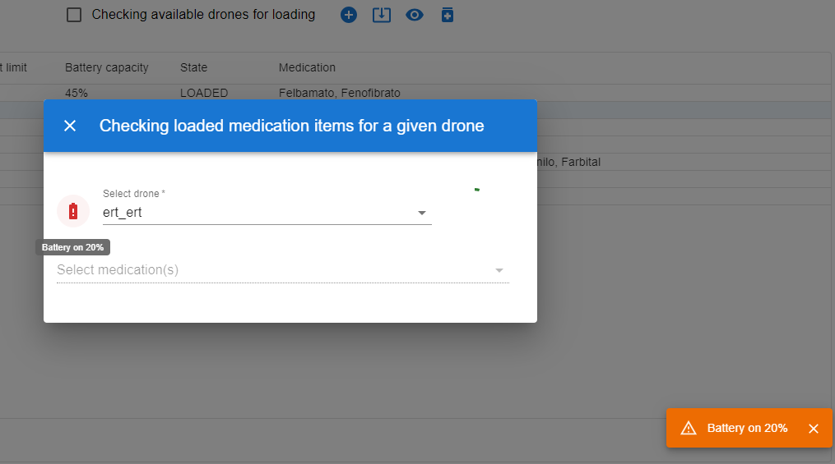

**Testing with Jest**

