**计算机组成课程设计**

P3 课下测试 – Logisim单周期

周美廷-76066002

*由于本人是留学生，随最终文档依然使用中文写但为了本人无需翻来覆去看英文版和中文版，于是将文档写成两种语言

# **顶层设计 (The Basic Idea)**

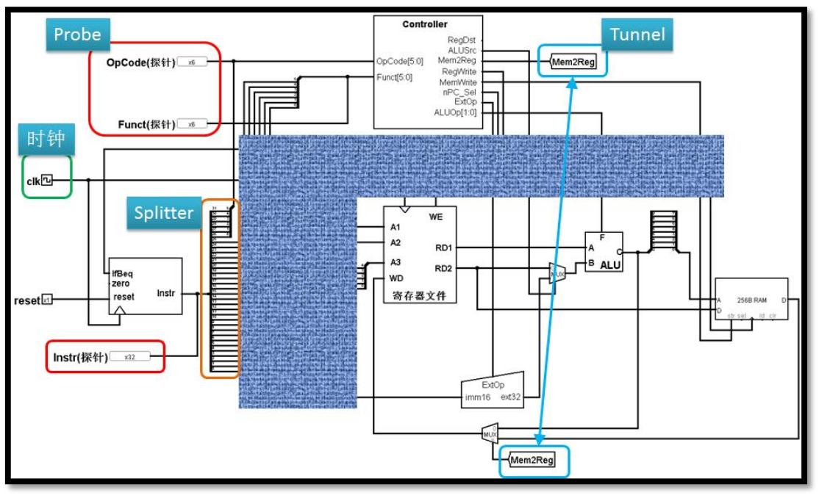以下便是整个CPU的顶层设计图（Below is the design pic of the outer layer of the CPU）

**图1 顶层设计图**

以下图片便是本人在Logisim设计出的CPU（Below is the actual design that I implemented in Logisim）

**图2 Logisim中的顶层设计**

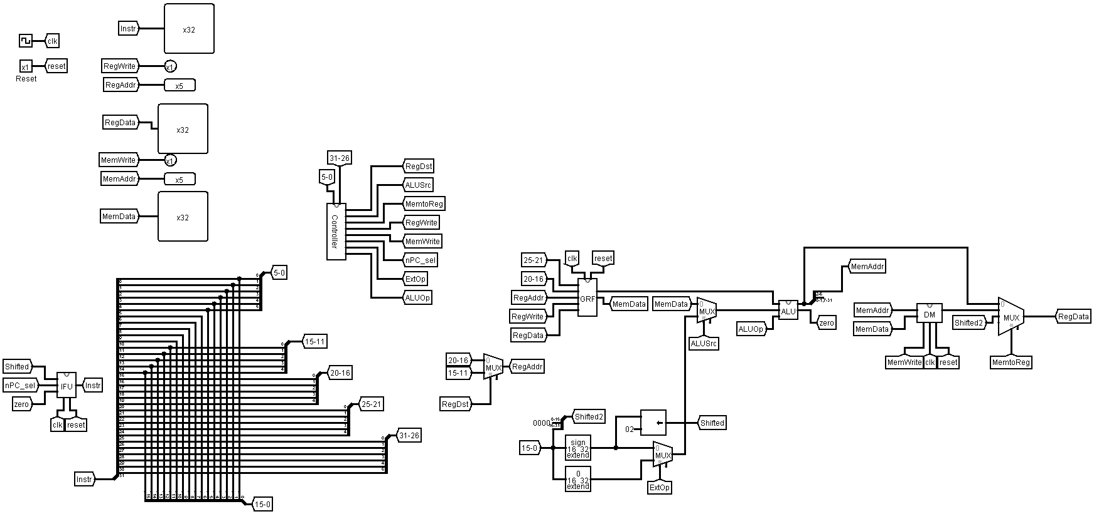

That’s it for the overview of the CPU, next is the specifications of each module.

# **模块规格 (Module Specifications)**

这种单周期CPU应采用模块化设计，因此它包含多个具有不同用途的模块。

This single-cycle CPU is meant to be modularly designed and therefore it consists of several modules with different purposes.

## **IFU（取指令单元 / Instruction Fetch Unit）**

**图3 IFU模块设计图**

It is already clear from the name that this module is meant to generate the instruction code (later named opcode in the overall design). To implement this module, there are two main modules, PC (Program Counter) and IM (Instruction Memory).

设计说明/Design Details:

* PC 用寄存器实现，应具有复位功能（PC is implemented by using **Registers**, it should have **Reset** feature）
* 起始地址/Starting address: 0x00000000
* IM用 ROM 实现，容量为 32bit * 32（IM is implemented by using **ROM**, the capacity is **32bit * 32**）
* 因 IM 实际地址宽度仅为 5 位，故需要使用恰当的方法将 PC 中储存的地址同 IM 联系起来(The Address Bit Width of the IM is 5, therefore there should be a way to connect the address saved in PC with IM)。

模块流程/Design Workflow:

* 来自PC的地址将被处理进行下一个操作，首先它将 +4（常量），这是为了实现PC + 4

Address from PC will be processed for the next process, it will be first added by 4 (constant), this is to implement the PC+4

* 然后PC + 4（地址）的结果将被带到多路复用器，因为如果它是跳转指令之类的指令，这将不起作用，因为跳转指令将直接跳转到相应的地址/标签。 这就是为什么多路复用器由Beq指令的bool信号和Zero bool的AND逻辑判断的（零bool是从ALU产生的，如果两个ALU数据输入相等则它将为TRUE）。

The result of PC+4 (the address) will then be brought to a Multiplexer, because this wouldn’t work if it’s instructions such as jump instructions because jump instructions will directly jump to the corresponding address/label. And this is why the multiplexer is decided by an AND logic input of Beq instruction bool and Zero bool (the zero bool is generated from the ALU, it will be TRUE if both of the ALU inputs are equal).

* 那么多路复用器的第一个输入是普通PC + 4，而第二个输入是PC + 4和移位地址的总和（相应标签所在的地址）

So then the first input of the Multiplexer is the normal PC+4 while the second input is the sum of PC+4 and the shifted address (the address of where the corresponding label is)

* 指令代码（MIPS指令的机器代码）保存在IM（ROM）中，并将根据PC的结果进行访问（判断是否使用PC + 4访问下一个地址还是PC + X）

Instruction codes (The machine code of MIPS instructions) are saved in the IM (ROM) and will be accessed according to the result of the PC (whether just using the PC+4 which means accessing the next address or PC+X)

* PC访问的指令代码将被传送到名为操作码的输出

The instruction code that’s accessed by the PC will be transferred to the output called opcode

**表1 IFU规格**

|  |  |  |
| --- | --- | --- |
| 功能名称 | 方向 | 功能描述 |
| IfBeq | I | 当前置零是否为beq  1：指令为beq  0：指令不为beq |
| Shifted | I | 第0-15指令被Extend后移植 |
| zero | I | ALU计算是否为0  1：为0  0：不为0 |
| clk | I | 时钟信号 |
| reset | I | 复位信号 |
| opcode[31:0] | O | 32位MIPS指令 |

## **GRF（通用寄存器组/General Register File）**

**图4 GRF模块设计图**

This module is meant to ‘turn’ the MIPS instruction code into several parts to be able to do further operations of different instructions. Then data of previous operations will be stored to one of the 32 registers. These 32 registers represent the 32 registers in MIPS. The MIPS instruction code itself consists of several structure parts, and each type of instructions have different structures. For example, for ADD instruction, the format is **addu rd, rs, rt**. This could be explained as rs (25-21) + rt (20-16) = rd (15-11). In case of BEQ instruction, the format is **beq rs, rt, offset**, this could be explained as if rs (25-21) == rt (20-16), the jump to offset (15-0).

设计说明/Design Details:

* 用具有写使能的寄存器实现，寄存器总数为 32 个（This is implemented with write-enabled registers, in total there are 32 registers）
* 0 号寄存器的值始终保持为 0。其他寄存器初始值均为 0，无需专门设置（The value of Register No. 0 is always 0. The other registers have an initial value of 0 so they don’t require special settings）

模块流程/Design Workflow:

* In total, there are 5 different inputs in this GRF module:
* The first two inputs are taken from the instruction code generated by IFU (Address no. 25-21 (rs/base/offset) and 20-16 (rt))
* The third one is either Address no 20-16 (rt) in case of **ori, lw, sw, beq, lui** or 15-11 (rd) in case of **addu** and **subu**
* The fourth one is the RegWrite signal (this will be TRUE if the current instruction isn’t **sw** nor **beq**)
* The fifth one is Register Data (RegData)
* The very obvious part of this module is the number of registers that it has (32 registers), so let’s start from this part. The RegData will be loaded to each register.
* The RegAddr (third input) will be decoded into 32 bit, and transferred to an AND logic. The other input for the AND logic is the signal of whether the instruction is **sw/beq** or not. This combination basically just decides which register should have the write function enabled therefore allowing data to be written to the corresponding register
* The result of the registers will then be the content of Output 1 and Output 2, as for which register result will be used it will be decided by the first 2 inputs

**表2 GRF规格**

|  |  |  |
| --- | --- | --- |
| 功能名称 | 方向 | 功能描述 |
| RegData[31:0] | I | 写入数据 |
| RegWrite | I | 读写控制信号  1：写  0：读 |
| clk | I | 时钟信号 |
| reset | I | 复位信号 |
| RegAddr[4:0] | I | 写寄存器地址 |
| Reg1[4:0] | I | 读寄存器地址1 |
| Reg2[4:0] | I | 读寄存器地址2 |
| RData1[31:0] | O | 32位数据1 |
| RData2[31:0] | O | 32位数据2 |

## **ALU（算术逻辑单元/Arithmetic Logic Unit）**

**图5 ALU模块设计图**

ALU is the most common module, this module is meant to perform arithmetic operations such as addition, subtraction, comparation, etc.

设计说明/Design Details:

* 提供 32 位加、减、或运算及大小比较功能（Provides 32-bit addition, subtraction, OR operation and size comparison）
* 可以不支持溢出（不检测溢出）（Overflow may not be supported (no overflow detected)）

模块流程/Design Workflow:

* According to the instruction that’s through ALUctr input (this instruction is generated by the Controller module), the module will perform corresponding operation. The **ori** instruction will cause ALU to perform OR operation (10), the **subu** will cause ALU to perform subtraction operation (01), and the other instructions will simply cause ALU to perform addition operation.
* At the same time, both data inputs A and B will be checked, if the values are equal, then the Zero signal will be TRUE

**表3 ALU规格**

|  |  |  |
| --- | --- | --- |
| 功能名称 | 方向 | 功能描述 |
| A[31:0] | I | 输入数据A |
| B[31:0] | I | 输入数据B |
| ALUctr[1:0] | I | ALU控制信号  00：加法运算  01：减法运算  10：或运算  11：比较 |
| zero | O | 计算结果是否为0 |
| Output[31:0] | O | 输出结果32位 |

## **DM（数据存储器/Data Memory）**

**图6 DM模块设计图**

The DM module is meant to save data generated from previous operations.

设计说明/Design Details:

* 使用 RAM 实现，容量为 32bit * 32（Implemented by using RAM with a capacity of 32bit * 32）
* 起始地址/Starting Address: 0x00000000
* RAM 应使用双端口模式，即设置 RAM 的 Data Interface 属性为 Separate load and store ports（The RAM should use dual port mode, which sets the **Data Interface** property of RAM to **Separate load and store ports**）

模块流程/Design Workflow:

* This is just a simple module to store data to the RAM, whether the CPU will write the data is decided by the MIPS instruction sent to MemWrite. If the instruction is **sw**, MemWrite will be TRUE, therefore storing the data to the RAM.
* For later uses, the data will be chosen by the input A, this input is generated by the ALU module, which means if the operation doesn’t include any data that were stored to the RAM, the output of this module would be 0

**表4 DM规格**

|  |  |  |
| --- | --- | --- |
| 功能名称 | 方向 | 功能描述 |
| A[4:0] | I | MemAddr地址 |
| WData[31:0] | I | 输入数据32位 |
| MemWrite | I | 读写控制信号 |
| clk | I | 时钟信号 |
| reset | I | 复位信号 |
| RData[31:0] | O | 输出结果32位 |

## **EXT（Extender）**

在本人的设计中正是使用Logisim内置的Bit Extender （In this design, I’m using the Logisim built-in Bit Extender plugin）

## **Controller（控制器）**

**图7 控制器模块设计图**

As mentioned in the requirements, this module is divided into two parts: AND logic and OR logic. The AND logic will identify the input machine code as the corresponding instruction while the OR logic will generate different control according to the input instruction.

模块流程/Design Workflow:

* The input of this module is the 5-0 and 31-26 address bit of the instruction code generated from IFU. While most MIPS instruction opcode are located in the 31-26 bit of the instruction code, it works differently for **addu** and **subu**. The opcode for both **addu** and **subu** are 000000 but they got function code in the 5-0 bit of the instruction code. The complete code is listed in the table below.
* RegDst means that the register that will be used is the rd register, this is used by **addu** and **subu** while the other instructions will just use the rt register.
* MemtoReg literally means loading data from the memory to the register. Of course, this signal will be true if the instruction code is a loading instruction such as **lw** or **lui**
* RegWrite signal is to let the CPU write the data into a register. This will be used by instructions that cause changes to data so that it needs to be written (saved) in the register such as **lui, ori, lw, addu, subu**
* MemWrite is a signal to let the CPU write the data into memory. This is only used by instructions that will store data such as **sw**
* The nPC_sel signal basically is just a bool to see if it’s a branch instruction. Since in this project there’s only one branch instruction **beq**, therefore only **beq** uses this signal. This signal will then be used in the IFU module to decide whether to use PC+4 or PC+X for the address movements

**表5 控制器指令真值表**

|  |  |  |  |  |  |  |  |  |
| --- | --- | --- | --- | --- | --- | --- | --- | --- |
| funct | 100001 | 100011 | n/a | | | | | 000000 |
| opcode | 000000 | 000000 | 001101 | 100011 | 101011 | 000100 | 001111 | 000000 |
|  | addu | subu | ori | lw | sw | beq | lui | nop |
| RegDst | 1 | 1 | 0 | 0 | x | x | 0 | x |
| ALUSrc | 0 | 0 | 1 | 1 | 1 | 0 | x | x |
| MemtoReg[1:0] | 00 | 00 | 00 | 01 | xx | xx | 10 | xx |
| RegWrite | 1 | 1 | 1 | 1 | 0 | 0 | 1 | 0 |
| MemWrite | 0 | 0 | 0 | 0 | 1 | 0 | 0 | 0 |
| nPC_sel | 0 | 0 | 0 | 0 | 0 | 1 | 0 | 0 |
| ExtOp | x | x | 1 | 0 | 0 | x | 0 | x |
| ALUctr[1:0] | Add | Subtract | Or | Add | Add | xx | xx | xx |

**表6 控制器规格**

|  |  |  |
| --- | --- | --- |
| 功能名称 | 方向 | 功能描述 |
| funct[5:0] | I | Function 6位 |
| opcode[5:0] | I | Opcode 6位 |
| RegDst | O | 写地址控制 |
| ALUSrc | O | 控制ALU |
| MemtoReg[1:0] | O | DM读控制 |
| RegWrite | O | GRF读写控制 |
| MemWrite | O | DM写控制 |
| nPC_sel | O | beq指令标志 |
| ExtOp | O | Ext扩展控制 |
| ALUctr[1:0] | O | ALU运算操作控制 |

# **测试程序说明 (Testing Program)**

测试指令集：

.data

testarr: .space 8

.text

lui $t0, 0x1234 #Load upper immediate (of high-order 16-bit),write 0x12340000 to $t0

ori $t1, $t0, 0x0001 #Set $t1 to bitwise OR of $t0 and 0x12340001

lui $t0, 0x0000 #Load upper immediate (of high-order 16-bit),write 0x00000000 to $t0

ori $t1, $t0, 0x0000 #Set $t1 to bitwise OR of $t0 and 0x0000000

nop #Null op

addu $t2, $t1, 3 #Set $t2 to 0x10000003

subu $t3, $t1, $t2 #Set $t3 to (ALU operation $t1 - $t2 = 0xfffffffd), no overflow (nothing changed)

nop #Null op

sw $t3, testarr($zero) #Write $t3’s value to DM[testarr+$zero] 0xfffffffd

beq $t3, $t2, any #ALU checks if GRF[t3]==GRF[t2], if yes then goto any, else PC+4

lw $t3, testarr($zero) #Load DM[testarr+$zero] to GRF[t2] 0xfffffffd

nop #Null op

any: ori $t0, $t0, 0x1010 #Set $t0 to bitwise OR of itself ($t0) and 0x1000001 -> 0x10001010

机器码：

00000000

3c081234

35090001

3c080000

35090000

00000000

00000000

3c010000

34210003

01215021

012a5823

00000000

ac0b0000

116a0002

8c0b0000

00000000

35081010

# **思考题**

## **(L0.T2)**

1. 若PC（程序计数器）位数为30位，试分析其与32位PC的优劣。

**优势：**32位PC可以访问PC+4，比30位的访问的空间多。

**劣势：**32位PC的设计比30位PC的更复杂。由于32位PC的低两位都是0，如果用30位PC的话，每次PC+1即可，相当于32位PC的高30位

1. 现在我们的模块中 IM使用ROM， DM使用RAM， GRF使用寄存器，这种做法合理吗？ 请给出分析，若有改进意见也请一并给出。

合理。

IM里的值是不能被改变的，所以IM应该用ROM

DM存储操作数据，有可能会有更新，所以用RAM

GRF是临时存储单元，所以用寄存器。

## **(L0.T3)**

1. 结合上文给出的样例真值表，给出RegDst， ALUSrc， MemtoReg，RegWrite, nPC_Sel, ExtOp与op和func有关的布尔表达式（表达式中只能使用“与、或、非”3 种基本逻辑运算。）

𝑅𝑒𝑔𝐷𝑠𝑡 = 𝐹𝑢𝑛𝑐5 𝐹𝑢𝑛𝑐0

𝑅𝑒𝑔𝑊𝑟𝑖𝑡𝑒 = 𝐹𝑢𝑛𝑐5 𝐹𝑢𝑛𝑐0 + 𝑂𝑝3 𝑂𝑝2 𝑂𝑝1 𝑂𝑝0

+ 𝑂𝑝5 𝑂𝑝1 𝑂𝑝0

𝐴𝐿𝑈𝑆𝑟𝑐 = 𝑂𝑝3 𝑂𝑝2 𝑂𝑝0 + 𝑂𝑝5 𝑂𝑝1 𝑂𝑝0

𝑀𝑒𝑚𝑡𝑜𝑅𝑒𝑔 = 𝑂𝑝5 𝑂𝑝1 𝑂𝑝0

𝑛𝑃𝐶__𝑆𝑒𝑙 = 𝑂𝑝2

𝐸𝑥𝑡𝑂𝑝 = 𝑂𝑝5 𝑂𝑝1 𝑂𝑝0

1. 充分利用真值表中的 X 可以将以上控制信号化简为最简单的表达式， 请给出化简后的形式。

𝑅𝑒𝑔𝐷𝑠𝑡 = 𝐹𝑢𝑛𝑐5 𝐹𝑢𝑛𝑐0

𝑅𝑒𝑔𝑊𝑟𝑖𝑡𝑒 = 𝐹𝑢𝑛𝑐5 𝐹𝑢𝑛𝑐0 + 𝑂𝑝3 𝑂𝑝2 𝑂𝑝1 𝑂𝑝0

+ 𝑂𝑝5 𝑂𝑝1 𝑂𝑝0

𝐴𝐿𝑈𝑆𝑟𝑐 = 𝑂𝑝3 𝑂𝑝2 𝑂𝑝0 + 𝑂𝑝5 𝑂𝑝1 𝑂𝑝0

𝑀𝑒𝑚𝑡𝑜𝑅𝑒𝑔 = 𝑂𝑝5 𝑂𝑝1 𝑂𝑝0

𝑛𝑃𝐶__𝑆𝑒𝑙 = 𝑂𝑝2

𝐸𝑥𝑡𝑂𝑝 = 𝑂𝑝5 𝑂𝑝1 𝑂𝑝0

1. 事实上，实现nop空指令，我们并不需要将它加入控制信号真值表，为什么？请给出你的理由。

因为nop的机器码是0x00000000（全0）。所以nop执行的时候，MemWrite,WriteEn等要么是0，要么是x。

## **(L0.T4)**

1. 前文提到，“可能需要手工修改指令码中的数据偏移”，但实际上只需再增加一个 DM片选信号,就可以解决这个问题。请阅读相关资料并设计一个 DM 改造方案使得无需手工修改数据偏移。

假设DM为256MB，在0x30000000~0x3FFFFFFF区间，在做选择时，只需要当前指令取出来。ALU运算后得到的地址的高4位与0x3作比较(无符号)，大于则片选信号为1，小于则为0。

1. 除了编写程序进行测试外，还有一种验证CPU设计正确性的办法——形式验证。 形式验证的含义是根据某个或某些形式规范或属性，使用数学的方法证明其正确性或非正确性。请搜索“形式验证（Formal Verification)"了解相关内容后，简要阐述相比与测试，形式验证的优劣。

**优势：**

1. 形式验证是用数学方法将待验证电路和功能描述或参考设计直接进行比较，所以测试者不必考虑如何获得测试向量
2. 形式验证对指定描述所有可能的情况进行验证，而不仅仅对其中的一个子集进行多次试验，因此有效地克服了模拟验证的不足。
3. 形式验证可以短时间内进行从系统级到门级的验证，所以可以尽快发现和改正电路设计中的一些错误。

**劣势：**

形式验证还不能有效的验证电路的性能（电路的时延和功耗等）。