**关系数据库管理系统**

设计报告

周美廷-76066002

# 系统需求分析，最终给出数据流图与数据元素表

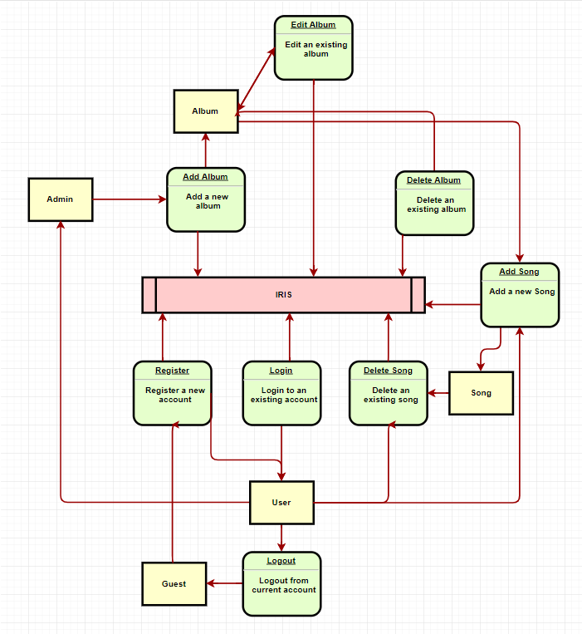数据流图：

数据元素表：

1. Genre

|  |  |
| --- | --- |
| id | genre_name |
| 1 | Pop |
| 2 | Classical |
| 3 | Jazz |
| 4 | Country |

1. Song

|  |  |  |  |  |
| --- | --- | --- | --- | --- |
| id | file_type | song_title | album_id | is_favorite |
| 4 |  | You Belong With Me | 1 | 0 |
| 6 |  | Give Your Heart A Break | 13 | 0 |
| 7 |  | Stitches | 14 | 0 |
| 8 |  | Love Story | 1 | 0 |

1. Artist

|  |  |  |
| --- | --- | --- |
| id | gender | artist_name |
| 1 | Female | Taylor Swift |
| 2 | Female | Demi Lovato |
| 3 | Male | Charlie Puth |
| 4 | Male | Shawn Mendes |

1. Album

|  |  |  |  |  |  |  |
| --- | --- | --- | --- | --- | --- | --- |
| id | artist_id | album_title | genre_id | album_logo | is_favorite | user_id |
| 1 | 1 | Fearless | 1 | https://upload.wikimedia.org/wikipedia/en/thumb/8/86/Taylor_Swift_-_Fearless.png/220px-Taylor_Swift_-_Fearless.png | 0 | 1 |
| 5 | 1 | 1989 | 1 | https://upload.wikimedia.org/wikipedia/en/thumb/f/f6/Taylor_Swift_-_1989.png/220px-Taylor_Swift_-_1989.png | 0 | 1 |
| 13 | 2 | Give Your Heart a Break | 1 | https://upload.wikimedia.org/wikipedia/en/thumb/f/f6/Taylor_Swift_-_1989.png/220px-Taylor_Swift_-_1989.png | 0 | 1 |
| 14 | 4 | Stitches | 1 | https://t2.genius.com/unsafe/220x220/https%3A%2F%2Fimages.rapgenius.com%2F3b4e501efa5af6642e9f15e1452b8026.600x600x1.jpg | 0 | 1 |
| 15 | 1 | Red | 1 | https://upload.wikimedia.org/wikipedia/en/thumb/c/c0/Taylor_Swift_-_Red_%28Single%29.png/220px-Taylor_Swift_-_Red_%28Single%29.png | 0 | 1 |
| 17 | 3 | Nine Track Mind | 1 | https://direct.rhapsody.com/imageserver/images/Alb.243008322/500x500.jpg | 0 | 1 |

1. Users

|  |  |  |  |  |  |
| --- | --- | --- | --- | --- | --- |
| id | password | is_superuser | username | email | is_staff |
| 1 | Admin123456 | 1 | admin | admin@example.com | 1 |
| 2 | 123456 | 0 | test | test@example.com | 0 |
| 3 | 123456 | 0 | JavieraStephanie | javierastephanie@yahoo.com | 0 |

1. Permissions

|  |  |  |  |
| --- | --- | --- | --- |
| id | content_type_id | codename | Name |
| 1 | 1 | add_logentry | Can add log entry |
| 2 | 1 | change_logentry | Can change log entry |
| 3 | 1 | delete_logentry | Can delete log entry |
| 4 | 1 | view_logentry | Can view log entry |
| 5 | 2 | add_permission | Can add permission |
| 6 | 2 | change_permission | Can change permission |
| 7 | 2 | delete_permission | Can delete permission |
| 8 | 2 | view_permission | Can view permission |
| 9 | 3 | add_group | Can add group |
| 10 | 3 | change_group | Can change group |
| 11 | 3 | delete_group | Can delete group |
| 12 | 3 | view_group | Can view group |
| 13 | 4 | add_user | Can add user |
| 14 | 4 | change_user | Can change user |
| 15 | 4 | delete_user | Can delete user |
| 16 | 4 | view_user | Can view user |
| 17 | 5 | add_contenttype | Can add content type |
| 18 | 5 | change_contenttype | Can change content type |
| 19 | 5 | delete_contenttype | Can delete content type |
| 20 | 5 | view_contenttype | Can view content type |
| 21 | 6 | add_session | Can add session |
| 22 | 6 | change_session | Can change session |
| 23 | 6 | delete_session | Can delete session |
| 24 | 6 | view_session | Can view session |
| 25 | 7 | add_song | Can add song |
| 26 | 7 | change_song | Can change song |
| 27 | 7 | delete_song | Can delete song |
| 28 | 7 | view_song | Can view song |
| 29 | 8 | add_album | Can add album |
| 30 | 8 | change_album | Can change album |
| 31 | 8 | delete_album | Can delete album |
| 32 | 8 | view_album | Can view album |
| 33 | 9 | add_genre | Can add genre |
| 34 | 9 | change_genre | Can change genre |
| 35 | 9 | delete_genre | Can delete genre |
| 36 | 9 | view_genre | Can view genre |
| 37 | 10 | add_artist | Can add artist |
| 38 | 10 | change_artist | Can change artist |
| 39 | 10 | delete_artist | Can delete artist |
| 40 | 10 | view_artist | Can view artist |

# 数据库系统的概念模式（E-R图）

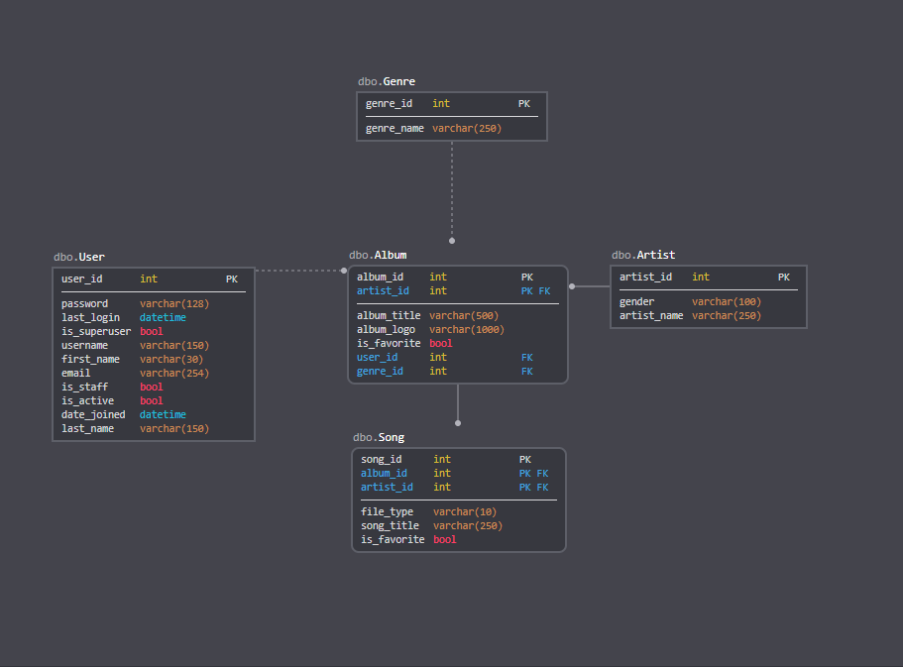

# 数据库系统的逻辑模式：分析关系模式的范式等级，将所有关系规范到3NF

1. Artist -> Album -> Song
2. Genre -> Album -> Song
3. User -> Album -> Song