Code will run in any server that has access to visual studio code



If not visual studio code will be used.

<https://code.visualstudio.com/> 🡨 Link for visual studio code

* 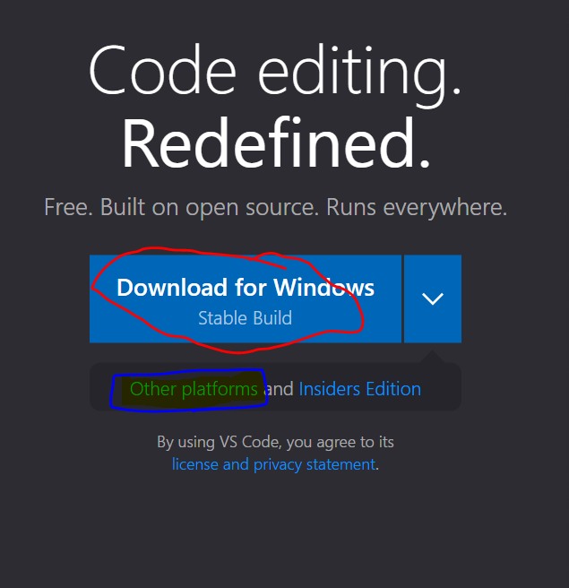Click on other platforms if not using windows

Once open click on extensions

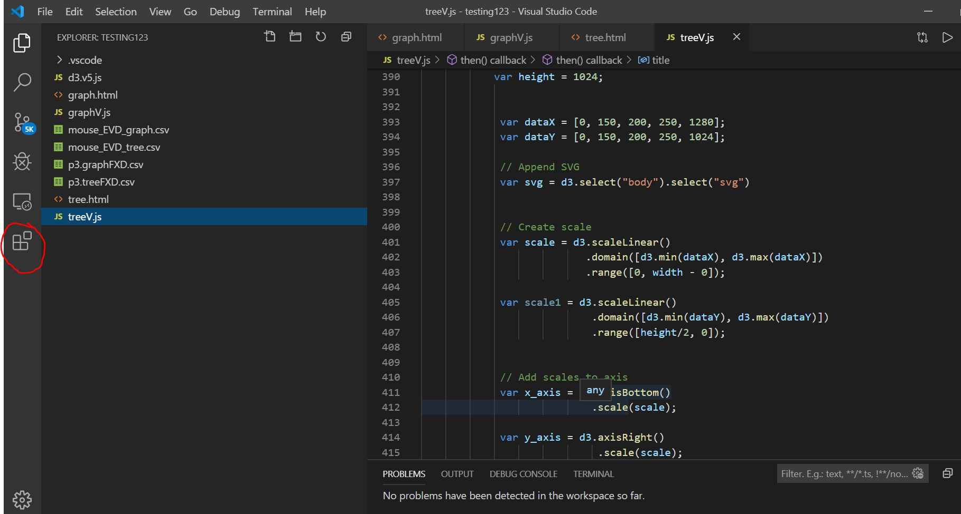

Download the live server extension

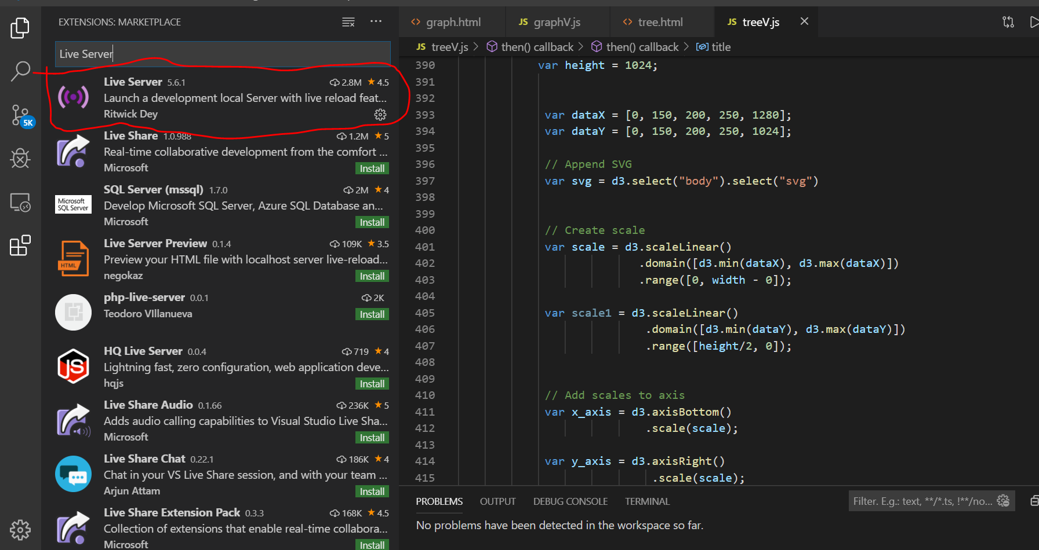

Open the files

Then click on “Go live”

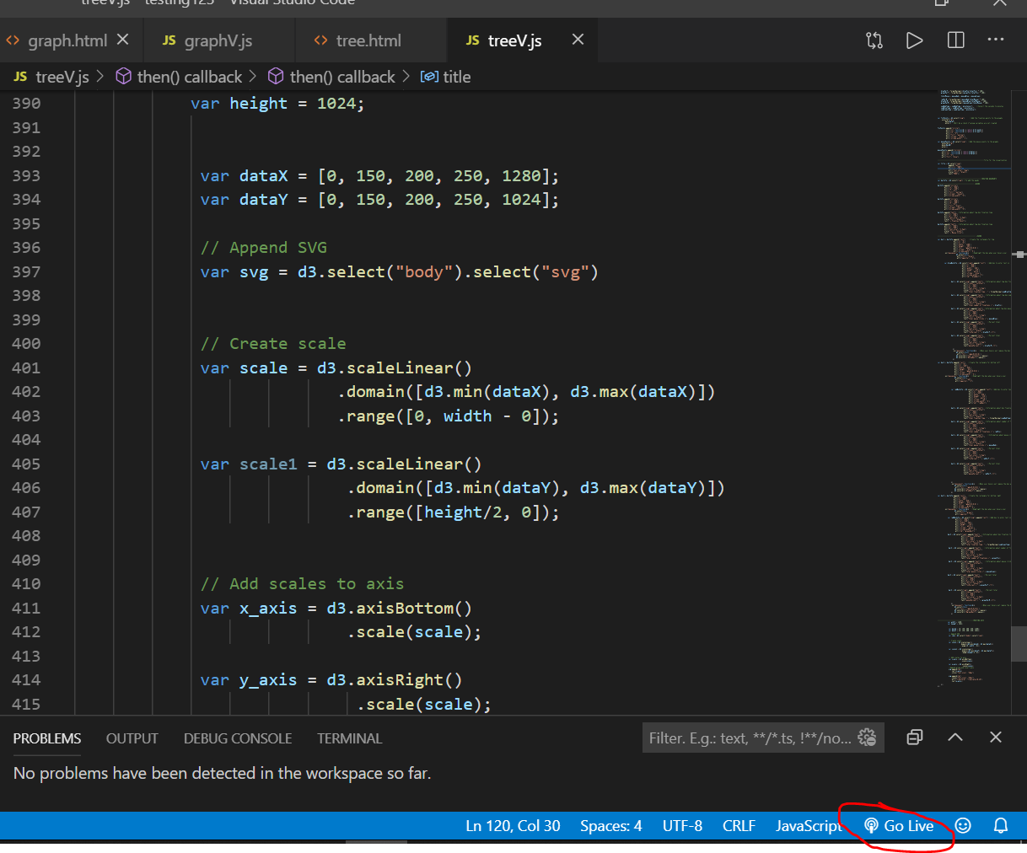

Click on the html files to view the visualizations. Go back the previous page after viewing visualization to return to this screen to view the next visualization.

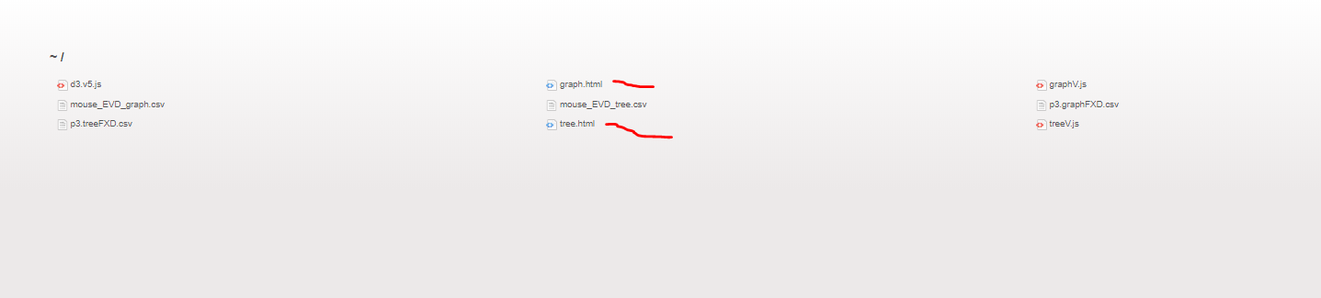

Graph

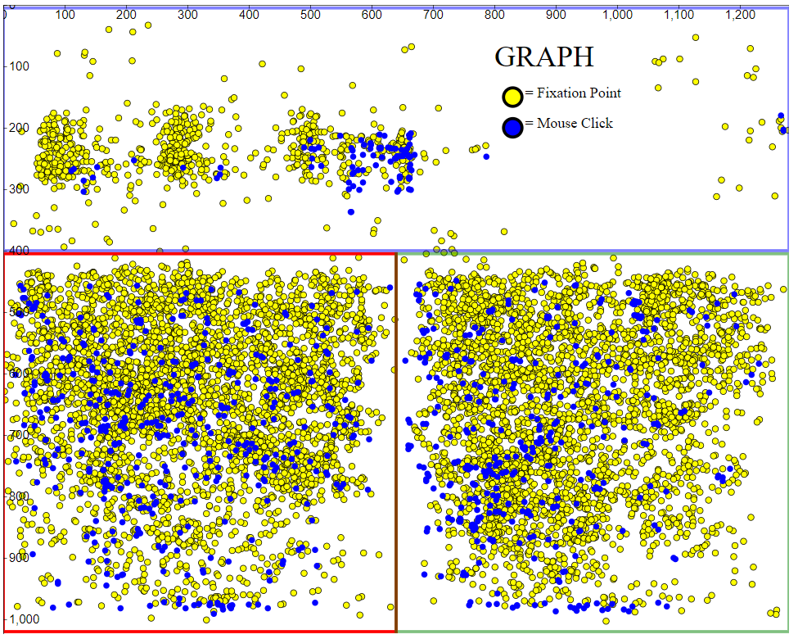

Tree

