**Workshop #2: Class and Object**

**Learning Outcomes:**

Upon successful completion of this workshop, you will have demonstrated the abilities to:

* Design and implement a class.
* Create an object from a class
* Describe to your instructor what you have learned in completing this workshop.

**Requirements:**

**Part 1: Find classes and use UML to draw class structure [2 points]**

Problem: Mr. Hung is the owner of the shop that sells guitars. He wants you to build him a shop management app. This app is used for keeping track of guitars. Each guitar contains serialNumber, price, builder, model, back Wood, top Wood. The guitar can create a melodious sound. The shop will keep guitars in the inventory. The owner can add a new guitar to it, he search also the guitar by the serialNumber.

Requirement: Write your paper down classes in the problem and use UML draw class structure.

***Note***: show members of a class: fields and methods

Do it yourself before getting help

Guideline**:**

Apply design guideline :

* Main nouns: Guitar
* Auxiliary nouns describe details of the guitar:serialNumber, price, builder, model, back Wood, top Wood.
* Verbs describe behaviors of the guitar: create Sound

Continue finding other nouns

* Main nouns: Inventory
* Auxiliary nouns describe details of the inventory: the list(array) of guitars
* Verbs describe behaviors of the inventory: add a new guitar, search the guitar by serialNumber.

Using UML to draw a class diagram

**Part 2: Implement the Guitar [3 points].**

Step by step workshop instructions:

* Create a new project named “**workshop2**”
* In the project, create a new file named “**Guitar.java”**
  + Declare fields with access modifier as private: String serialNumber, int price, String builder, String model, String backWood, String topWood
  + Declare and implement methods with access modifier as public:
    - public Guitar() {…} : to assign all fields to empty values
    - public Guitar( String serialNumber, int price, String builder, String model, String backWood, String topWood) {…}: to assign all fields by input parameters
    - public String getSerialNumber(){…}: return the value of the field serialNumber.
    - public void setSerialNumber(String serialNumber){…}: if the input parameter is not empty then assign it to the field serialNumber.
    - Implement getter/setter of all other fields
    - public void createSound(){…}: in the method, invoke all getters and use System.out to print out values after getting.
* In the project, create a new file named “**Tester.java.** Createthe method main in here, you type:

public class Tester {

public static void main(String[] args) {

Guitar obj1=new Guitar();

Guitar obj2=new Guitar("G123",2000,"Sony","Model123","hardWood","softWood");

System.out.println("State of obj1:");

obj1.createSound();

System.out.println("State of obj2:");

obj2.createSound();

System.out.println("set price = 3000 of obj1");

obj1.setPrice(3000);

System.out.println("get price of obj1:" + obj1.getPrice() );

}

}

The output is:

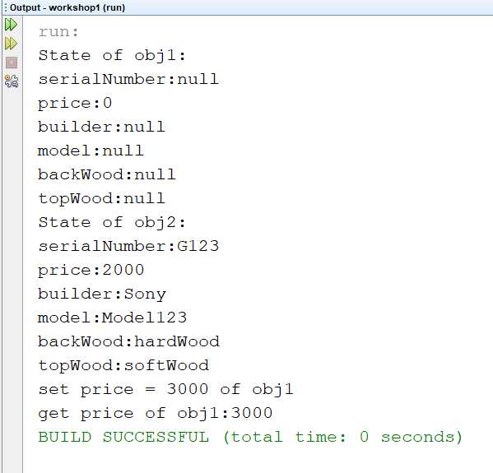

**Part 3: Implement Employee management program** **[5 point]**

* Write an employee management program for Fsoft according to the following description:
* Employee information: Code, Fullname, Phone, Salary, Salary coefficient, department.
* The program allows the user to enter the number of employees.
* Print out the list of employees.
* Print out the total salary of the employees.
* Update employee salary(setsalary) based on the employee code(getCode) entered by the user.
* Remove an employee based on the employee code entered by the user.