R Programming Notes for Absolute Beginners
Part 2: Data Structures, starting with Vectors (with pictures, comments, good habits and common errors)
Written in plain language for people who are new to programming. Every code line is explained, every concept has a picture, and every common mistake comes with a fix.

Contents

(If the contents list looks empty, right-click it in Word and choose Update Field.)

1. Data Structures: The Big Picture

1.1 What is a data structure?
In Part 1 you learnt that every value in R has a type: number, text, TRUE/FALSE and so on. But real life rarely hands you one lonely value. You have the marks of thirty students, the prices of twenty products, a table of customers. You need a way to keep many values together and tidy.
A data structure is simply a container for holding many values. Different containers suit different jobs, just like in your kitchen: a rack for plates, a drawer for cutlery, a jar for spices.
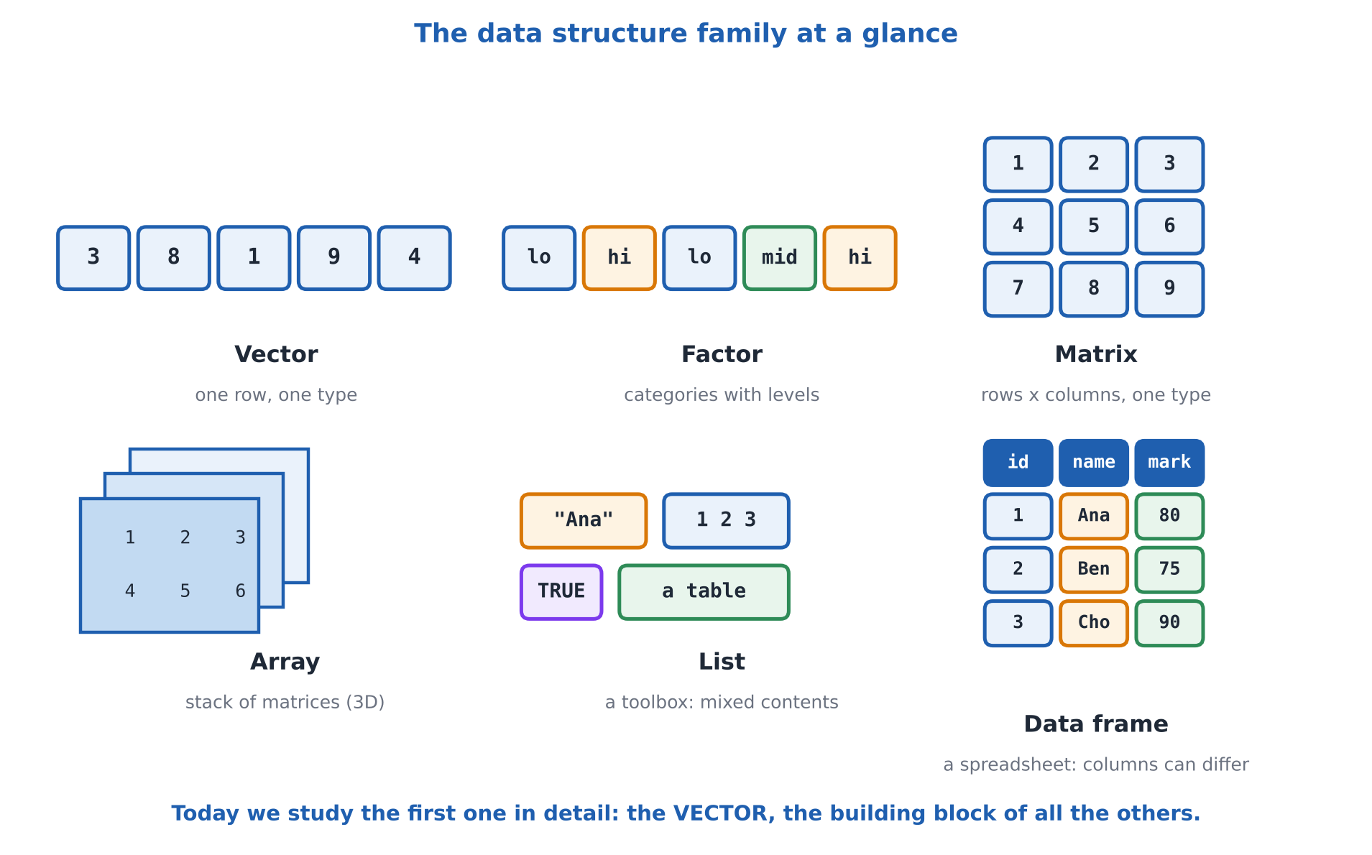
Figure 1: R's main data structures. We start with the simplest, the vector.
Structure | Shape | In everyday words
Vector | One row | A row of boxes, all holding the same type of thing (all numbers, or all text)
Factor | One row | A vector for categories, such as low / medium / high
Matrix | Rows and columns | A grid of values, all the same type (like a chessboard of numbers)
Array | 3 or more dimensions | A stack of matrices (like a book of grids)
List | A bundle | A toolbox: each compartment can hold a different kind of thing
Data frame | Rows and columns | A spreadsheet: each column can have a different type

In plain words: Vectors come first because they are the building block of everything else. A matrix is a vector arranged in a grid. A data frame is a bundle of vectors standing side by side. Even a single number in R, like 10, is secretly a vector with just one item. Learn vectors well and the rest becomes much easier.

1.2 How to read the pictures in these notes
- Each box is one value. The row of boxes is the vector.
- The small grey numbers under the boxes are positions (also called indexes): 1, 2, 3 and so on.
- Yellow boxes show what has just been picked or changed.
- Green shows items we keep or the final result; grey with a red cross shows an item that was removed.
Tip: Draw your own boxes on paper while you learn. Seeing a vector as a row of numbered boxes makes indexing, changing and sorting feel natural.

2. Writing Comments: Notes to Yourself
Before we write more code, let us learn the most useful habit of all: leaving notes in your code. A comment is a note for humans. R completely ignores it. You will see comments in every example in these notes, because code is read far more often than it is written, mostly by your future self, who will have forgotten what you meant.

2.1 Single-line comments
In R, a comment starts with the hash symbol #. Everything from the # to the end of that line is ignored by R.
Code (type this) | What it does, in simple words | What you will see
# This whole line is a comment | The # tells R to ignore this line. Nothing happens, nothing is shown. | (nothing is shown)
x <- 5 # a comment at the end of a line | R runs the part before the #, and ignores the part after it. Great for a short explanation next to the code. | (nothing is shown)
x | Look inside x. The comment did not affect it. | [1] 5
# x <- 10 | Putting # in front of real code switches it off. Programmers call this "commenting out" a line. It is a safe way to disable code without deleting it. | (nothing is shown)
x | x is still 5, because the line that would have changed it was switched off. | [1] 5
# ---- My section title ---- | A comment written like this becomes a section heading in RStudio's outline, helping you jump around long scripts. | (nothing is shown)

2.2 Multi-line comments
Here is something that surprises many learners: R has no special symbol for a multi-line comment, unlike some other languages. In R, every comment line needs its own #. The good news is that RStudio has a shortcut that adds or removes the # for you on many lines at once.
Code (type this) | What it does, in simple words | What you will see
# Line one of my note  # Line two of my note  # Line three of my note | Three lines, three # symbols. This is how a multi-line comment is written in R. | (nothing is shown)
if (FALSE) {  x <- 100  y <- 200  } | A trick for switching off a whole block: the condition FALSE means R never goes inside the curly brackets, so the code in them is skipped. Be aware this is not a true comment: the code inside must still be written correctly. | (nothing is shown)
x | x is still 5. The block was skipped. | [1] 5

Handy RStudio shortcuts for comments
What you want to do | Windows / Linux | Mac
Comment or uncomment all selected lines | Ctrl + Shift + C | Cmd + Shift + C
Insert a section heading comment (# Title ----) | Ctrl + Shift + R | Cmd + Shift + R
Run the current line | Ctrl + Enter | Cmd + Enter
Type the assignment arrow <- | Alt + - (minus) | Option + - (minus)

How to use the multi-line shortcut: click and drag to select several lines of code, then press Ctrl + Shift + C. Every selected line gets a # at the front. Press the same shortcut again on the same lines and the # symbols disappear. It toggles on and off like a light switch.

2.3 What makes a good comment?
- Explain why, not just what. x <- x + 1 # add 1 is useless; # count one more student tells a story.
- Keep them short and clear, written as if explaining to a friend.
- Update them when the code changes. An old, wrong comment is worse than none.
- Do not comment the obvious. Save comments for anything that took you time to figure out.

3. Vectors

3.1 What is a vector?
A vector is a row of boxes. All the boxes hold the same type of thing (all numbers, or all text, or all TRUE/FALSE), and every box has a position number starting from 1. That is really all there is to it.
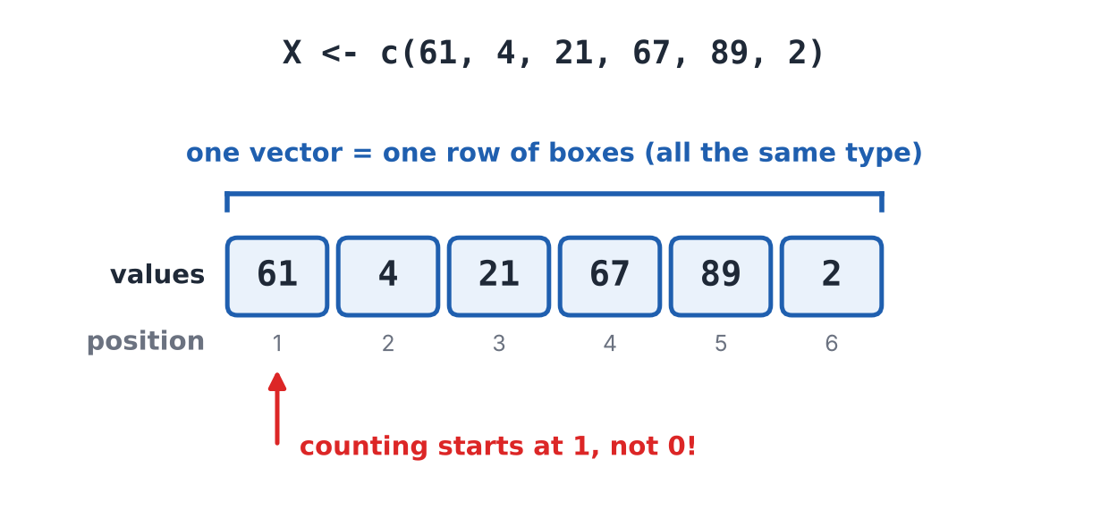
Figure 2: A vector is a numbered row of boxes.
Code (type this) | What it does, in simple words | What you will see
a <- 10 | Store the number 10 in a box called a. | (nothing is shown)
length(a) | length() counts how many items are in a. Just one, so a is a vector of length 1. | [1] 1
a[1] | Square brackets pick an item by its position. Item 1 is the 10. | [1] 10
a[2] | There is no second item, so R answers NA (missing) instead of giving an error. | [1] NA

3.2 Creating a vector
There are three common ways to create a vector. The most popular is the c() function. The letter c stands for combine: you hand R a list of values and it joins them into one vector. You can also use seq() to make a sequence of numbers, or the colon : to make a quick run of whole numbers.
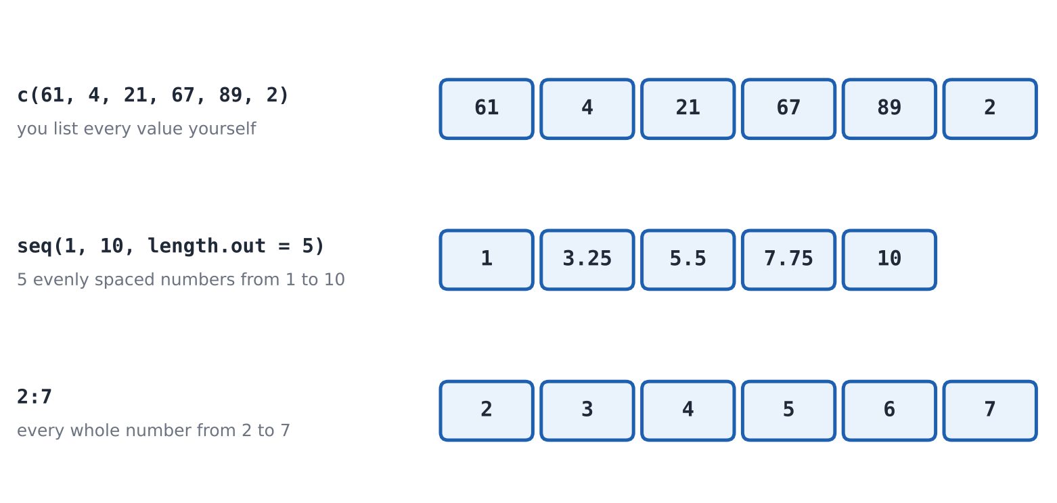
Figure 3: Three ways to build a vector: c(), seq() and the colon.
Code (type this) | What it does, in simple words | What you will see
X <- c(61, 4, 21, 67, 89, 2) | c() combines the six numbers into one vector and stores it in the box named X. Commas separate the values. | (nothing is shown)
cat("using c function", X, "\n") | cat() prints things as plain text on one line. It prints the words, then every item of X, then \n which means "go to a new line". | using c function 61 4 21 67 89 2
X | Typing the name shows the vector the way R sees it, with [1] at the start. | [1] 61 4 21 67 89 2
Y <- seq(1, 10, length.out = 5) | seq() makes a sequence. Here: start at 1, end at 10, and give me exactly 5 numbers, evenly spaced. | (nothing is shown)
cat("using seq() function", Y, "\n") | Print the words and the sequence. | using seq() function 1 3.25 5.5 7.75 10
Z <- 2:7 | The colon means "from 2 to 7, counting up by one." A very quick way to get a run of whole numbers. | (nothing is shown)
cat("using colon", Z) | Print them. | using colon 2 3 4 5 6 7
5:1 | The colon also counts backwards when the first number is bigger. | [1] 5 4 3 2 1
seq(0, 20, by = 5) | This time we say "go up in steps of 5" using by. | [1] 0 5 10 15 20
seq_len(4) | A neat shortcut for 1, 2, 3, 4. You will see it a lot in loops. | [1] 1 2 3 4
rep("ha", times = 3) | rep() means repeat. Here the text "ha" is repeated 3 times. | [1] "ha" "ha" "ha"
rep(c(1, 2), times = 2) | Repeat the whole vector twice. | [1] 1 2 1 2
rep(c(1, 2), each = 2) | Repeat each item twice before moving on. | [1] 1 1 2 2
numeric(3) | Make an empty-looking numeric vector with three zeros, ready to be filled later. | [1] 0 0 0
character(2) | A text vector with two empty pieces of text. | [1] "" ""
logical(2) | A logical vector with two FALSE values. | [1] FALSE FALSE
c(c(1, 2), c(3, 4)) | c() can also join vectors together. The result is one flat vector, not a vector inside a vector. | [1] 1 2 3 4
c() | An empty c() gives NULL, which means nothing at all. | NULL

Tip: The sequence made by seq(1, 10, length.out = 5) is 1, 3.25, 5.5, 7.75, 10. R works out the step size (2.25) for you. Use length.out when you know HOW MANY numbers you want, and by when you know the STEP size.

3.3 Types of vectors
A vector can hold numbers, text, or TRUE/FALSE, but only one kind at a time. That gives us four everyday types of vector.
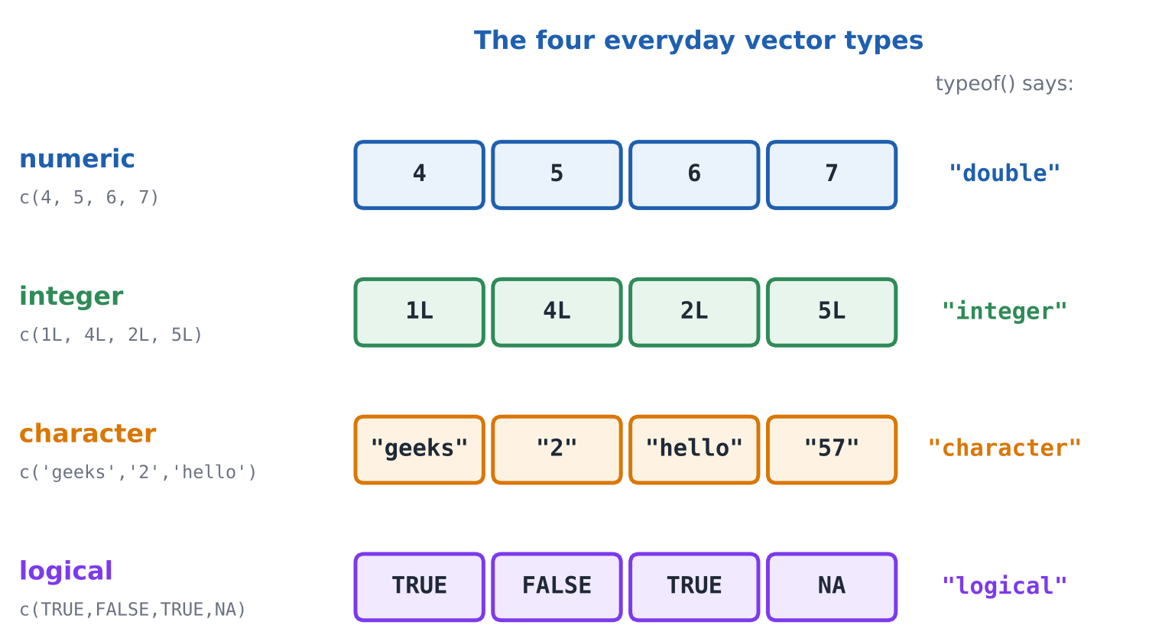
Figure 4: The four everyday vector types and what typeof() reports for each.

Numeric and integer vectors
Numeric vectors hold numbers. By default R stores them as doubles, which means decimals are allowed (even if the number looks whole, like 4). If you want true whole numbers (integers), put an L after each one.
Code (type this) | What it does, in simple words | What you will see
v1 <- c(4, 5, 6, 7) | A vector of four ordinary numbers. | (nothing is shown)
typeof(v1) | typeof() reveals how R stores them. "double" means numbers with decimals allowed. | [1] "double"
class(v1) | class() gives the friendlier name: numeric. | [1] "numeric"
v2 <- c(1L, 4L, 2L, 5L) | The L after each number means "make this a true integer". | (nothing is shown)
typeof(v2) | Now R stores them as integers. | [1] "integer"

Character vectors
Character vectors hold text (also called strings). Text always goes inside quotation marks. A number inside quotes is text too.
Code (type this) | What it does, in simple words | What you will see
v3 <- c("geeks", "2", "hello", 57) | Text, a number written as text, more text, and a real number. They are all in one vector. What will R do with the mix? | (nothing is shown)
typeof(v3) | R quietly turned everything into text. When types are mixed, R picks the most flexible type, and text beats everything. (More on this in 3.4.) | [1] "character"
v3 | See the quote marks around every item, even the 57. | [1] "geeks" "2" "hello" "57"

Logical vectors
Logical vectors hold TRUE and FALSE. They can also hold NA, which means a value is missing or unknown. NA is not the same as NULL: NA is a box that exists but whose contents we do not know, while NULL means there is no box at all.
Code (type this) | What it does, in simple words | What you will see
v4 <- c(TRUE, FALSE, TRUE, NA) | Three yes/no answers and one unknown. | (nothing is shown)
typeof(v4) | The type is logical. | [1] "logical"
v4 | Printed the way R shows logical values, lined up neatly. | [1] TRUE FALSE TRUE NA
is.na(v4) | Asks of each box: "is it missing?" Only the last one is. | [1] FALSE FALSE FALSE TRUE
sum(v4, na.rm = TRUE) | TRUE counts as 1 and FALSE as 0. na.rm = TRUE tells R to ignore the NA. Two TRUEs, so the answer is 2. | [1] 2
is.numeric(v1) | Yes/no tests for type: is v1 numeric? | [1] TRUE
is.character(v1) | Is v1 text? No. | [1] FALSE

3.4 When types mix: coercion
A vector can hold only one type. If you put different types in c(), R does not complain. Instead it quietly converts everything to the most flexible type so that all the boxes match. The order of flexibility, from least to most, is: logical, then integer, then numeric, then character. Text always wins.
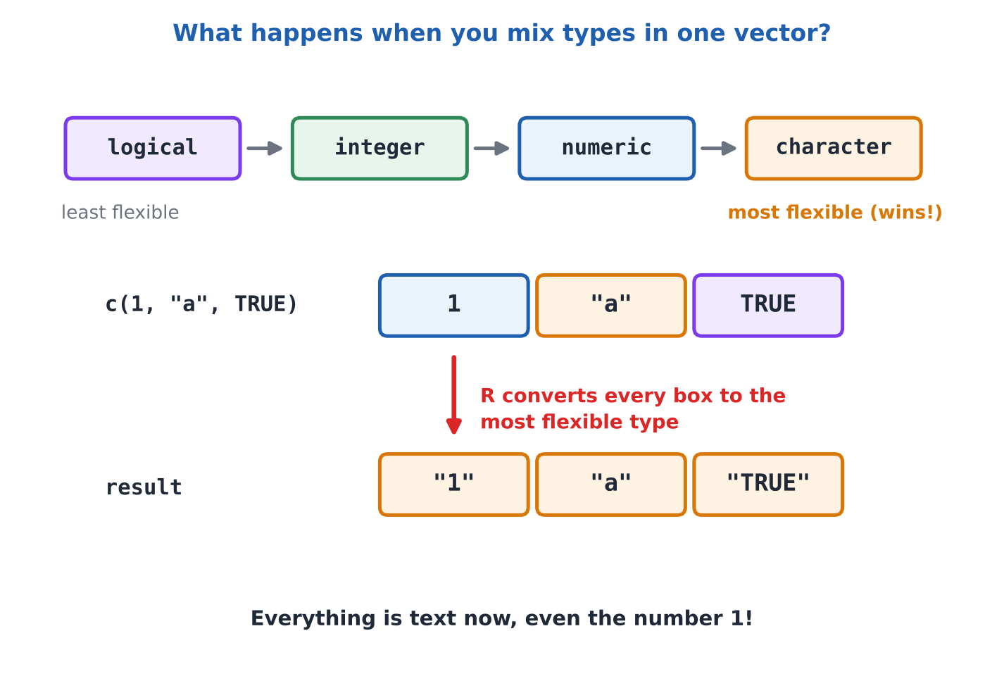
Figure 5: Mixed types are converted to the most flexible type.
Code (type this) | What it does, in simple words | What you will see
c(1, 2, "three") | Numbers mixed with text. Everything becomes text, so you see quotes around the 1 and the 2. | [1] "1" "2" "three"
c(TRUE, FALSE, 3, 5) | Logical mixed with numbers. TRUE becomes 1 and FALSE becomes 0. | [1] 1 0 3 5
c(1L, 2.5) | An integer mixed with a decimal. Everything becomes numeric. | [1] 1.0 2.5
class(c(TRUE, 2L)) | A logical mixed with an integer becomes integer. | [1] "integer"
as.numeric(c("10", "20", "30")) | Converting on purpose: text that looks like numbers becomes real numbers. | [1] 10 20 30
as.numeric(c("10", "hello", "30")) | "hello" cannot be a number, so R puts NA there and warns you (Warning: NAs introduced by coercion). | [1] 10 NA 30
as.character(c(1, 2)) | Numbers converted to text. | [1] "1" "2"

Watch out: One stray piece of text, such as "N/A" or an accidental space, can turn a whole column of numbers into text, and then your maths stops working. When results look wrong, check the type first with class() or str().

3.5 The length of a vector
The length of a vector is just the number of items (boxes) it holds. The function length() tells you. Do not confuse it with nchar(), which counts the letters inside a piece of text.
Code (type this) | What it does, in simple words | What you will see
x <- c(1, 2, 3, 4, 5) | A vector of five numbers. | (nothing is shown)
length(x) | How many items? Five. | [1] 5
y <- c("apple", "banana", "cherry") | A vector of three pieces of text. | (nothing is shown)
length(y) | Three items. | [1] 3
z <- c(TRUE, FALSE, TRUE, TRUE) | A vector of four logical values. | (nothing is shown)
length(z) | Four items. | [1] 4
nchar(y) | nchar() counts the letters in each piece of text: apple has 5, banana has 6, cherry has 6. | [1] 5 6 6
length("hello") | One piece of text is one item, so the length is 1 (not 5). | [1] 1
length(numeric(0)) | An empty vector has length 0. | [1] 0

3.6 Accessing vector elements
Accessing an element means picking out one or more items from a vector. We use square brackets [ ] and put the position number inside. This is called indexing or subsetting.
Watch out: R counts from 1. The first item is x[1], not x[0]. If you have used Python or C before, this is different.
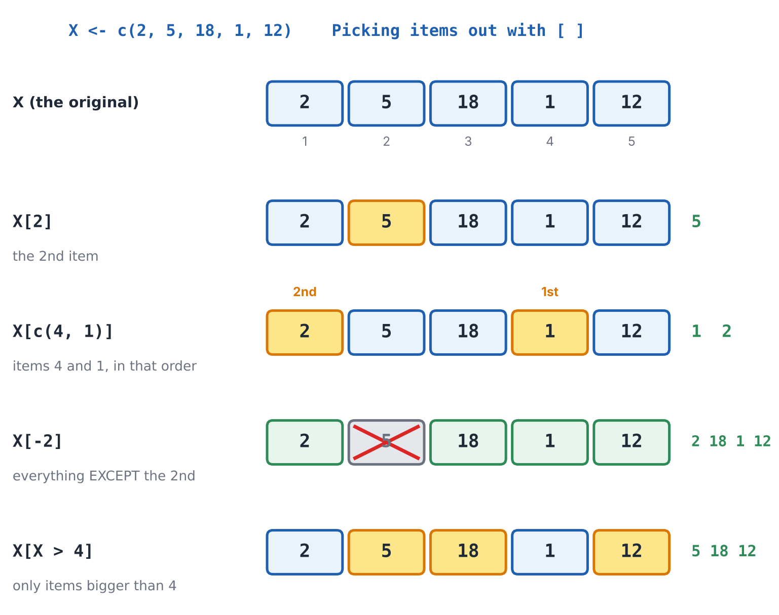
Figure 6: Four ways to pick items out of X using square brackets.
Code (type this) | What it does, in simple words | What you will see
X <- c(2, 5, 18, 1, 12) | The vector we will pick items from. | (nothing is shown)
cat("Using subscript operator", X[2], "\n") | X[2] picks the 2nd item, which is 5. cat() prints the words and the item. | Using subscript operator 5
Y <- c(4, 8, 2, 1, 17) | Another vector. | (nothing is shown)
cat("Using combine() function", Y[c(4, 1)], "\n") | To pick several items at once, put their positions inside c(). The 4th item (1) comes first, then the 1st item (4). | Using combine() function 1 4
X[1:3] | A range of positions: items 1 to 3. | [1] 2 5 18
X[-2] | A minus sign means "everything EXCEPT". All items except the 2nd. | [1] 2 18 1 12
X[-c(1, 2)] | Everything except items 1 and 2. | [1] 18 1 12
X[X > 4] | Pick by condition. X > 4 gives TRUE/FALSE for each item, and X[...] keeps only the TRUE ones. | [1] 5 18 12
X[X > 4 & X < 15] | Two conditions joined by & (and): bigger than 4 AND smaller than 15. | [1] 5 12
X[c(TRUE, FALSE, TRUE, FALSE, TRUE)] | You can also give a TRUE/FALSE for each box by hand. TRUE keeps the item, FALSE drops it. | [1] 2 18 12
X[length(X)] | The last item. length(X) is 5, so this is X[5]. | [1] 12
head(X, 2) | The first 2 items. | [1] 2 5
tail(X, 2) | The last 2 items. | [1] 1 12
which(X > 4) | which() tells you the POSITIONS where the condition is TRUE. | [1] 2 3 5
which.max(X) | The position of the biggest value (18 is in position 3). | [1] 3
5 %in% X | %in% asks "is this value somewhere inside the vector?" | [1] TRUE
X %in% c(5, 12) | For each item of X: is it one of 5 or 12? | [1] FALSE TRUE FALSE FALSE TRUE
X[10] | Asking beyond the end does not crash. You just get NA. | [1] NA
X[0] | Position 0 does not exist, so you get an empty numeric vector. | numeric(0)

3.7 Modifying a vector
Modifying means changing the value of one or more boxes. The idea is simple: point to the box with [ ] and use the arrow <- to put a new value in it.
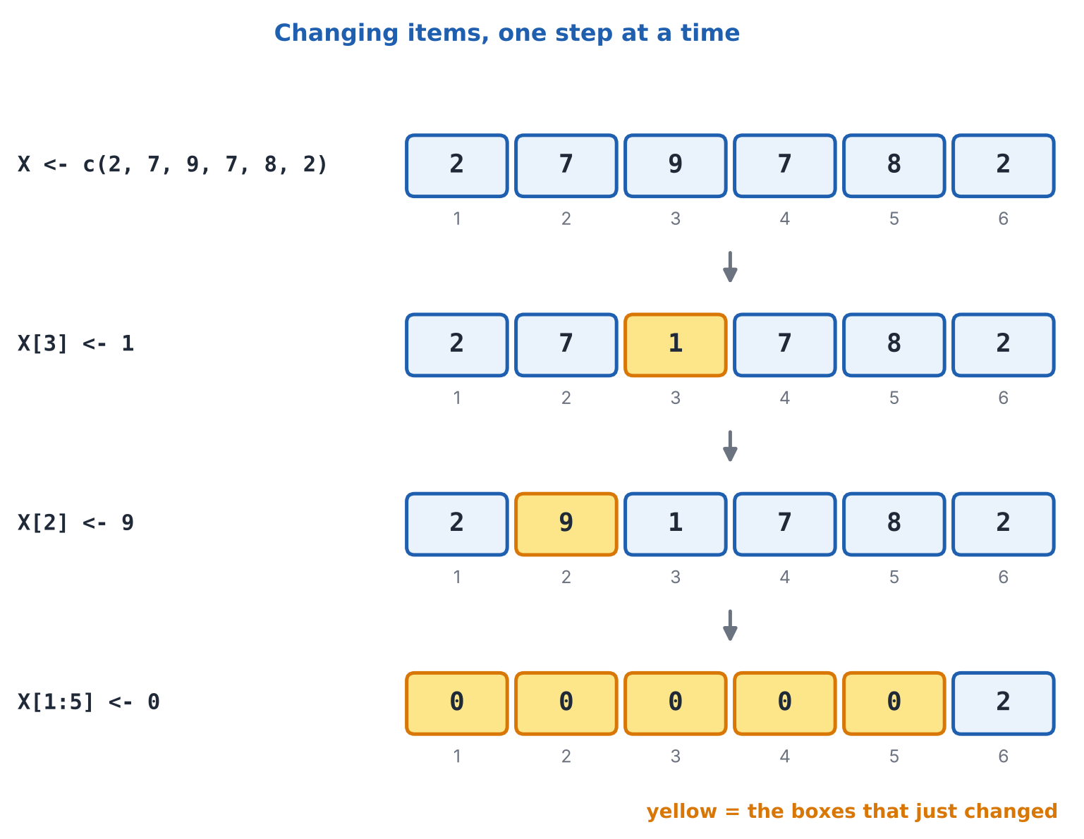
Figure 7: Changing items step by step. Yellow boxes are the ones that just changed.
Code (type this) | What it does, in simple words | What you will see
X <- c(2, 7, 9, 7, 8, 2) | Start with this vector. | (nothing is shown)
X[3] <- 1 | Put 1 into the 3rd box. The old 9 is replaced. | (nothing is shown)
X[2] <- 9 | Put 9 into the 2nd box. The old 7 is replaced. | (nothing is shown)
cat("subscript operator", X, "\n") | Show the vector after the two changes. | subscript operator 2 9 1 7 8 2
X[1:5] <- 0 | Change a whole range at once: boxes 1 to 5 all become 0. Only the last box is left alone. | (nothing is shown)
cat("range of positions", X, "\n") | Show the result. | range of positions 0 0 0 0 0 2
X <- X[c(3, 2, 1)] | This does not change values. It picks items 3, 2 and 1 and saves just those as the new X. So X now has only three items. | (nothing is shown)
cat("picking with c()", X) | Show the three items. | picking with c() 0 0 0
scores <- c(55, 82, 47, 90) | A fresh vector for more ways of changing things. | (nothing is shown)
scores[scores < 50] <- 50 | Change by condition: every score below 50 becomes 50. | (nothing is shown)
scores | Look at the result. Only 47 was below 50. | [1] 55 82 50 90
scores <- c(scores, 77) | Add to the end: join the old vector and 77 into a new vector, then save it under the same name. | (nothing is shown)
scores | Now five items. | [1] 55 82 50 90 77
append(scores, 60, after = 2) | append() inserts a value in the middle: here a 60 after the 2nd item. We did not save it, so scores itself is unchanged. | [1] 55 82 60 50 90 77
v <- c(1, 2, 3) | A short vector. | (nothing is shown)
v[5] <- 9 | Writing past the end makes the vector longer. Box 4 had no value, so R fills it with NA. | (nothing is shown)
v | Look at the result. | [1] 1 2 3 NA 9
s2 <- c(1, 2, 3) | A numeric vector. | (nothing is shown)
s2[2] <- "two" | Putting text into a numeric vector forces everything to become text. | (nothing is shown)
s2 | All items are text now. | [1] "1" "two" "3"

In plain words: You may see examples that call X[1:5] <- 0 "logical indexing" or X[c(3, 2, 1)] "the combine function". Those labels are a bit loose. The first uses a range of positions, and the second uses c() to list positions to pick. The ideas matter more than the names.

3.8 Deleting from a vector
There are two kinds of deleting: removing some items, and emptying the whole vector. To remove items we use a minus sign inside the brackets. To empty everything we assign NULL.
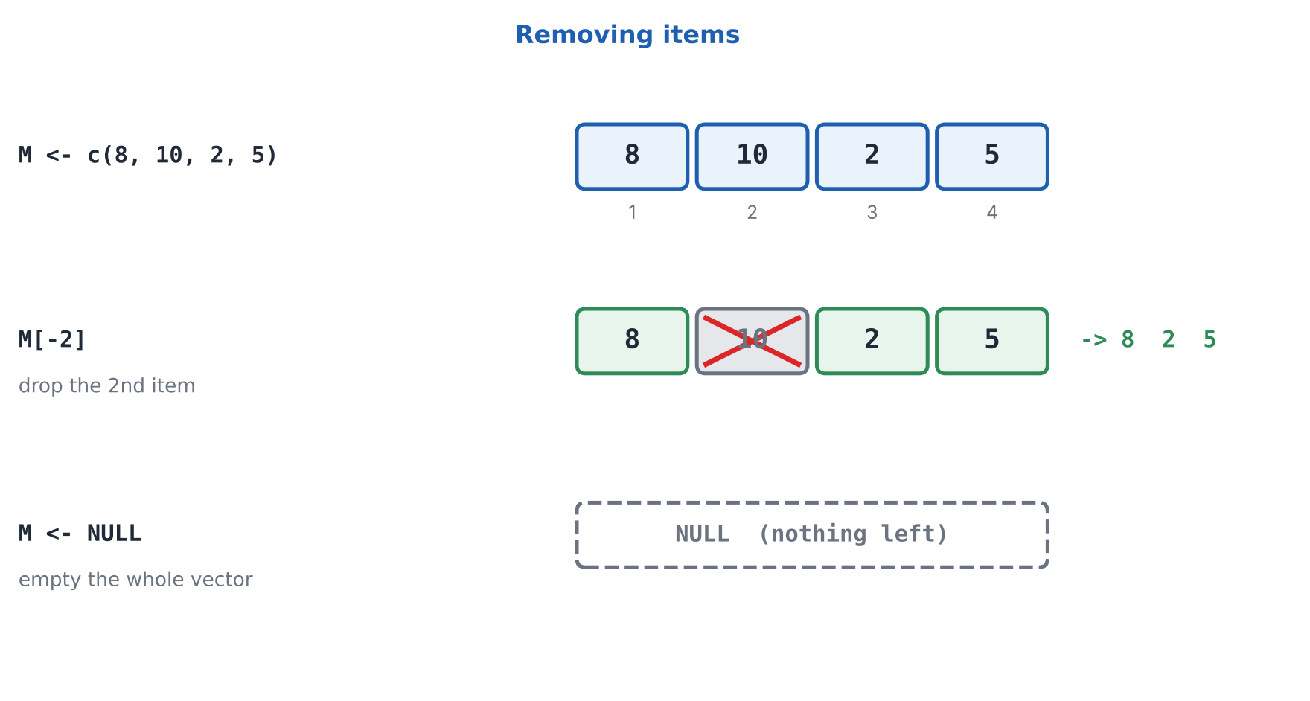
Figure 8: Removing one item with a minus sign, and emptying a vector with NULL.
Code (type this) | What it does, in simple words | What you will see
M <- c(8, 10, 2, 5) | Start with four numbers. | (nothing is shown)
M[-2] | Show M without its 2nd item. | [1] 8 2 5
M | M itself is untouched! M[-2] only SHOWED a smaller vector. Nothing was deleted yet. | [1] 8 10 2 5
M <- M[-2] | To really remove the item, save the smaller vector back into M. | (nothing is shown)
M | Now M has three items. | [1] 8 2 5
M[M != 2] | Remove by value: keep only the items that are not equal to 2. (!= means "not equal".) | [1] 8 5
M <- NULL | Empty the whole vector. M now holds nothing at all. | (nothing is shown)
M | R shows NULL, which means "nothing". | NULL
length(M) | An empty vector has length 0. | [1] 0
is.null(M) | A yes/no test: is it NULL? | [1] TRUE
w <- c(1, 2, 3) | Make another vector. | (nothing is shown)
rm(w) | rm() removes the whole box from R's memory, name and all. This is different from making it NULL. | (nothing is shown)
exists("w") | Does a box called w exist any more? No. | [1] FALSE
h <- c(5, NA, 7) | A vector with a missing value. | (nothing is shown)
h[!is.na(h)] | Remove the missing values. is.na(h) marks them, ! flips it, and the brackets keep the rest. | [1] 5 7

Tip: You may also see this example in books: print(cat("Output vector", M, "\f")). It prints the word NULL at the end only because cat() itself returns NULL. For clearer output, just type M or use length(M).

3.9 Sorting a vector
The sort() function puts the items in order. By default it goes from smallest to biggest (ascending). Add decreasing = TRUE to go from biggest to smallest (descending).
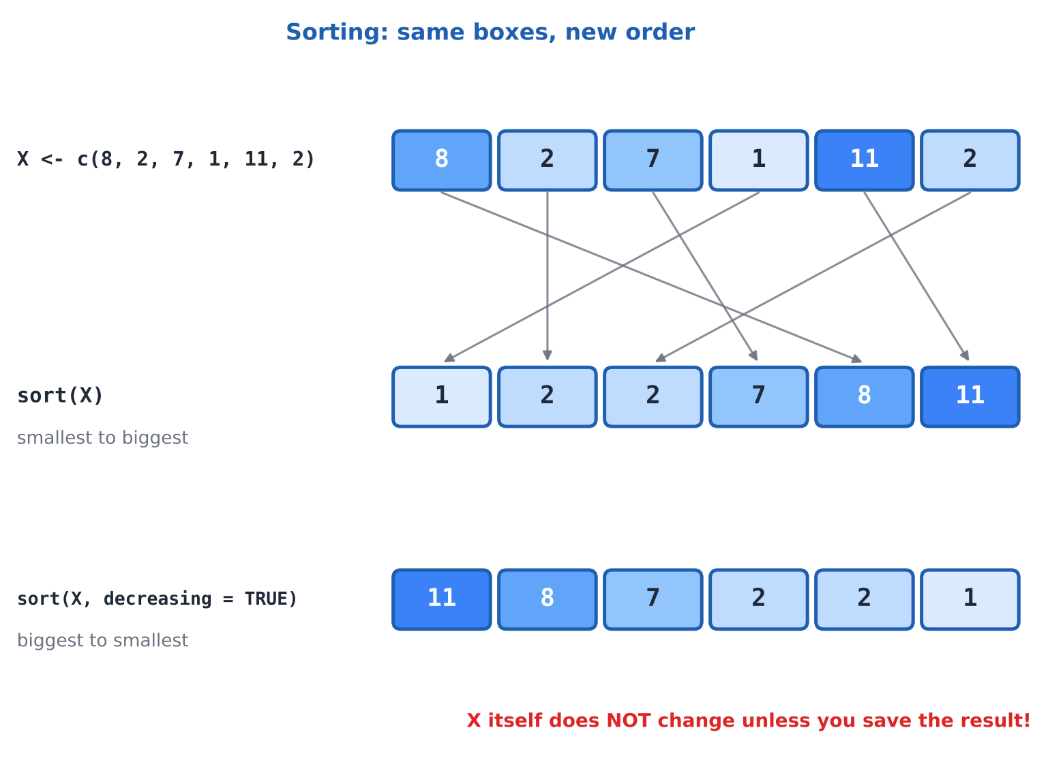
Figure 9: Sorting rearranges the boxes. Each arrow shows where an item moves to.
Code (type this) | What it does, in simple words | What you will see
X <- c(8, 2, 7, 1, 11, 2) | A jumbled vector. | (nothing is shown)
A <- sort(X) | Sort from smallest to biggest and save the result in A. | (nothing is shown)
cat("ascending order", A, "\n") | Show it. | ascending order 1 2 2 7 8 11
B <- sort(X, decreasing = TRUE) | Biggest first. decreasing = TRUE is the switch. | (nothing is shown)
cat("descending order", B) | Show it. | descending order 11 8 7 2 2 1
X | The original X did not change. sort() gives you a sorted copy. | [1] 8 2 7 1 11 2
rev(X) | rev() just reverses the order. It does not sort. | [1] 2 11 1 7 2 8
order(X) | order() does not give you the sorted values. It gives the POSITIONS that would sort them: first the item at position 4 (the 1), then position 2, and so on. | [1] 4 2 6 3 1 5
X[order(X)] | Use those positions to pick the items: the same as sort(X). order() is very useful for sorting one vector by another. | [1] 1 2 2 7 8 11
rank(X) | rank() gives each item its place in the sorted order. The two 2s share places 2 and 3, so each gets 2.5. | [1] 5.0 2.5 4.0 1.0 6.0 2.5
sort(c("pear", "apple", "mango")) | Text is sorted alphabetically. | [1] "apple" "mango" "pear"
sort(c(3, NA, 1)) | By default sort() throws missing values away. | [1] 1 3
sort(c(3, NA, 1), na.last = TRUE) | Keep the NA but put it at the end. | [1] 1 3 NA
X <- sort(X) | To actually change X, save the sorted result back into X. | (nothing is shown)
X | Now X is sorted for good. | [1] 1 2 2 7 8 11

3.10 Maths on whole vectors (vectorised operations)
Here is one of R's best features. When you do maths on a vector, R does it to every box at once. You do not need to write a loop. Multiply a vector by 2 and every item is doubled. Add two vectors of the same length and R adds them item by item: first with first, second with second.
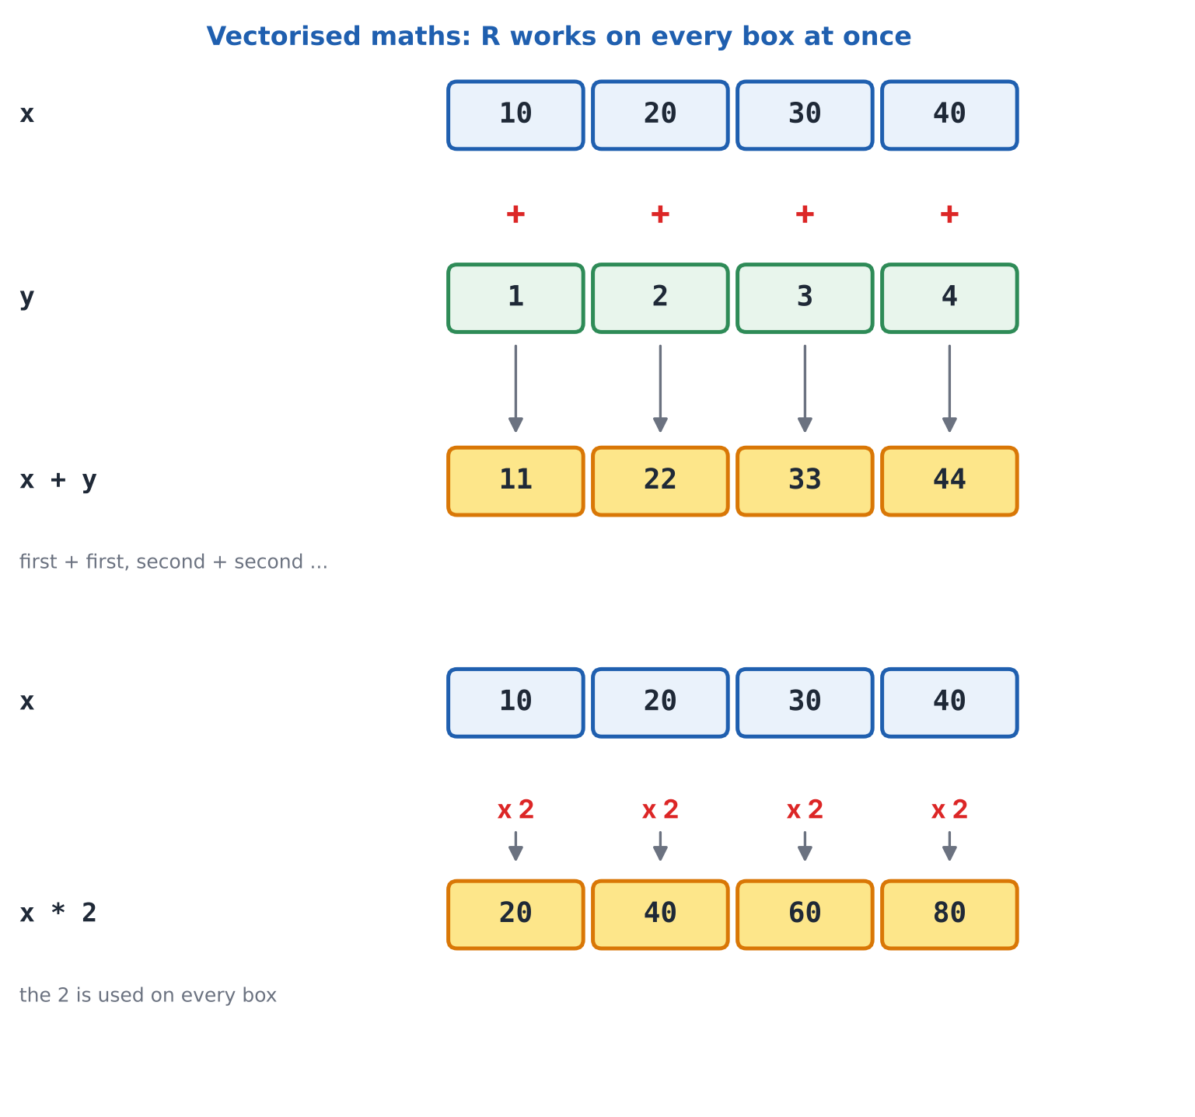
Figure 10: R applies the operation to every box, in one step.
Code (type this) | What it does, in simple words | What you will see
x <- c(10, 20, 30, 40) | A vector of four numbers. | (nothing is shown)
y <- 1:4 | Another vector of four numbers: 1, 2, 3, 4. | (nothing is shown)
x + y | Add item by item: 10+1, 20+2, 30+3, 40+4. | [1] 11 22 33 44
x * 2 | Multiply every item by 2. The single 2 is applied to each box. | [1] 20 40 60 80
x / 10 | Divide every item by 10. | [1] 1 2 3 4
x ^ 2 | Square every item. | [1] 100 400 900 1600
x > 20 | Compare every item with 20. The answer is a vector of TRUE/FALSE. | [1] FALSE FALSE TRUE TRUE
sqrt(c(4, 16, 9)) | Functions work on every item too. Square roots of 4, 16 and 9. | [1] 2 4 3
round(c(1.234, 5.678), 1) | Round each number to one decimal place. | [1] 1.2 5.7
sum(x) | Add up all the items to get one number. | [1] 100
mean(x) | The average. | [1] 25
median(x) | The middle value. | [1] 25
min(x); max(x) | The smallest and the biggest. A semicolon lets us put two commands on one line. | [1] 10  [1] 40
range(x) | Gives the minimum and the maximum together. | [1] 10 40
max(x) - min(x) | The spread of the data: biggest minus smallest. | [1] 30
cumsum(x) | Running total: 10, then 10+20, then 10+20+30, and so on. | [1] 10 30 60 100
summary(x) | A quick overview of the vector in one go. | Min. 1st Qu. Median Mean 3rd Qu. Max.  10.0 17.5 25.0 25.0 32.5 40.0

Recycling: when the vectors have different lengths
If you add a short vector to a longer one, R reuses the short one from the start until it has filled every box. This is called recycling. It works neatly when the long length is a multiple of the short length.
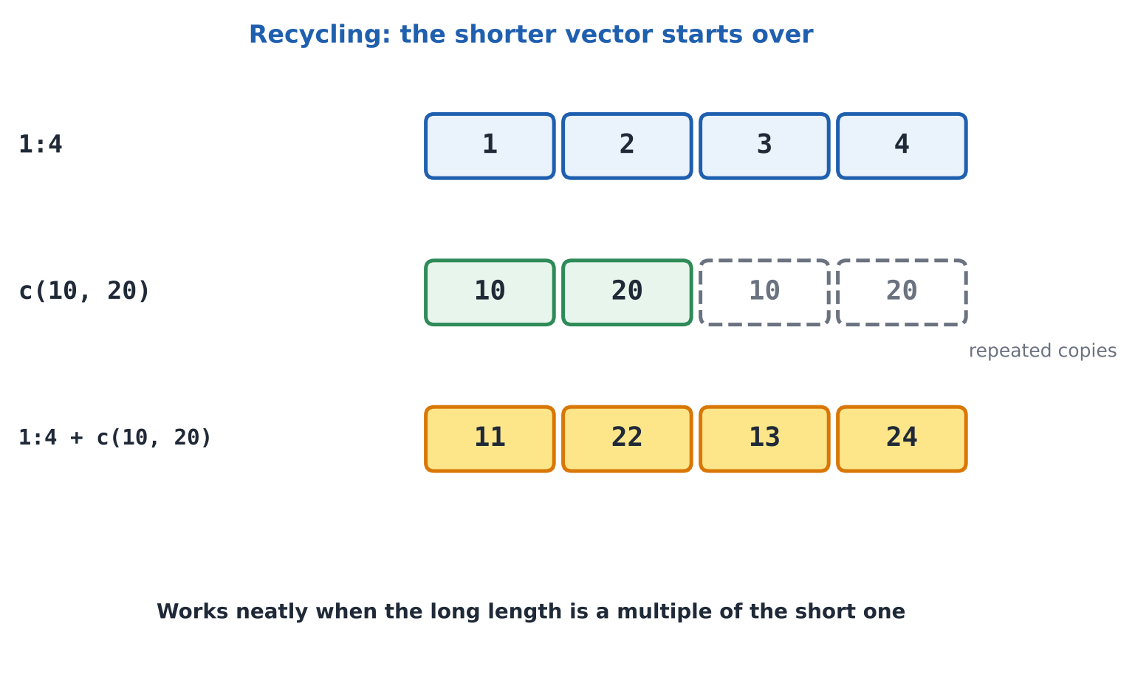
Figure 11: The shorter vector is repeated to match the longer one.
Code (type this) | What it does, in simple words | What you will see
1:4 + c(10, 20) | The short vector (10, 20) is used twice: 1+10, 2+20, 3+10, 4+20. | [1] 11 22 13 24

3.11 Naming the items in a vector
Each box in a vector can also wear a name tag. Then you can ask for an item by name instead of by position, which makes your code much easier to read.
Code (type this) | What it does, in simple words | What you will see
marks <- c(Ana = 80, Ben = 75, Chao = 90) | Build the vector and give each box a name at the same time. Names do not need quotes here. | (nothing is shown)
marks | R shows the names above the values. | Ana Ben Chao  80 75 90
marks["Ben"] | Pick an item by name. The name goes inside quotes. | Ben  75
marks[c("Ana", "Chao")] | Pick several by name. | Ana Chao  80 90
marks[["Ben"]] | Double brackets give just the value, without the name tag. | [1] 75
names(marks) | See all the names. | [1] "Ana" "Ben" "Chao"
marks[marks > 78] | Conditions work with names too: who scored above 78? | Ana Chao  80 90
sort(marks) | Sorting keeps each name with its value. | Ben Ana Chao  75 80 90
names(sort(marks, decreasing = TRUE)) | Sort from highest, then ask for just the names: a ranking of students. | [1] "Chao" "Ana" "Ben"
marks["Dan"] <- 60 | Add a new named item at the end. | (nothing is shown)
marks | Dan has joined the vector. | Ana Ben Chao Dan  80 75 90 60
scores2 <- c(70, 85, 60) | A vector with no names yet. | (nothing is shown)
names(scores2) <- c("A", "B", "C") | Attach names to an existing vector by assigning to names(). | (nothing is shown)
scores2 | Names appear. | A B C  70 85 60
unname(scores2) | Take the names away again. | [1] 70 85 60

3.12 Missing values (NA)
Real data has holes: a student who missed a test, a customer who skipped a question. R marks a hole with NA. The important rule: because NA means "unknown", any calculation involving NA gives NA. One unknown poisons the answer.
Code (type this) | What it does, in simple words | What you will see
x <- c(10, NA, 30) | A vector with one missing item in the middle. | (nothing is shown)
is.na(x) | For each item: is it missing? | [1] FALSE TRUE FALSE
mean(x) | R cannot average with an unknown in the list, so it answers NA. | [1] NA
mean(x, na.rm = TRUE) | na.rm = TRUE means "remove the NAs first". Now the average of 10 and 30. | [1] 20
sum(is.na(x)) | How many items are missing? (TRUE counts as 1.) | [1] 1
x[!is.na(x)] | Keep only the items that are not missing. | [1] 10 30
x == NA | Never test for NA with ==. Comparing with an unknown always gives unknown. | [1] NA NA NA
x[is.na(x)] <- 0 | Replace every missing item with 0. | (nothing is shown)
x | The hole is filled. | [1] 10 0 30
c(1, NA, 3) | NA is a real item that holds a place in the vector. | [1] 1 NA 3
c(1, NULL, 3) | NULL is different: it means nothing, so it simply vanishes and leaves no gap. | [1] 1 3
0 / 0 | NaN means "Not a Number", a maths result with no sense. | [1] NaN
is.nan(0 / 0) | Test for NaN specifically. | [1] TRUE

3.13 A quick look at factors (vectors for categories)
A factor is a special vector for categories: groups like small / medium / large. R remembers the list of groups, called levels. You met factors in Part 1; here is a short reminder of how they behave as vectors.
Code (type this) | What it does, in simple words | What you will see
size <- factor(c("small", "large", "small")) | Make a factor from three pieces of text. R spots the two different groups. | (nothing is shown)
size | Shows the values and the levels (alphabetical by default). | [1] small large small  Levels: large small
levels(size) | List only the groups. | [1] "large" "small"
table(size) | Count how many items are in each group. | size  large small  1 2
as.integer(size) | Underneath, each group is stored as a number code: large = 1, small = 2. | [1] 2 1 2

3.14 Your vector toolbox
Function | What it does
c(...) | Combines values into a vector
seq(from, to, by =) / seq(..., length.out =) | Builds a sequence by step size or by count
from:to | Quick run of whole numbers
rep(x, times =, each =) | Repeats values
length(x) | How many items
x[i], x[-i], x[condition] | Pick, exclude or filter items
head(x, n), tail(x, n) | First or last n items
which(cond), which.max(x), which.min(x) | Positions of matches, biggest, smallest
x %in% y | Is each item of x found in y?
sort(x), order(x), rev(x), rank(x) | Sorting tools
sum, mean, median, min, max, range, cumsum | Summaries and running totals
unique(x), table(x) | Distinct values, and counts of each
any(cond), all(cond) | Is at least one / every item TRUE?
is.na(x), na.rm = TRUE | Find missing values, or ignore them
names(x) | See or set the name tags
class(x), typeof(x), str(x) | Inspect the type
as.numeric(x), as.character(x) | Convert the type

4. Putting It Together: Two Mini Cases

4.1 Cleaning a vector of exam marks
A teacher typed in six marks, but two of them are impossible: -4 and 103 (marks must be between 0 and 100). Let us clean the vector and find the average of the good marks.
Code (type this) | What it does, in simple words | What you will see
marks <- c(67, 81, -4, 55, 103, 72) | The raw data, including two mistakes. | (nothing is shown)
marks[marks < 0 | marks > 100] <- NA | Find the impossible marks (below 0 OR above 100, the | means "or") and replace them with NA, meaning "unknown". | (nothing is shown)
marks | The two bad values are now NA. | [1] 67 81 NA 55 NA 72
mean(marks, na.rm = TRUE) | The average of the four valid marks: (67 + 81 + 55 + 72) / 4. | [1] 68.75
range(marks, na.rm = TRUE) | Lowest and highest valid marks. | [1] 55 81
marks[!is.na(marks) & marks >= 70] | Which valid marks are 70 or more? We first rule out NA, otherwise R cannot compare it. | [1] 81 72

4.2 A week of temperatures
Code (type this) | What it does, in simple words | What you will see
temps <- c(24, 27, 22, 30, 28, 26, 25) | Daily temperatures in degrees Celsius for seven days. | (nothing is shown)
names(temps) <- c("Mon", "Tue", "Wed", "Thu", "Fri", "Sat", "Sun") | Attach the day names to the seven values. | (nothing is shown)
mean(temps) | The average temperature for the week. | [1] 26
max(temps) | The hottest temperature. | [1] 30
names(which.max(temps)) | which.max() finds the position of the maximum, and names() turns that into the day name. | [1] "Thu"
names(temps)[temps > mean(temps)] | Which days were hotter than average? Pick the day names where the test is TRUE. | [1] "Tue" "Thu" "Fri"
unname(temps) * 9 / 5 + 32 | Convert every temperature to Fahrenheit in one line. unname() removes the day labels so the output stays tidy. | [1] 75.2 80.6 71.6 86.0 82.4 78.8 77.0

5. Good Practice Techniques
Good habits formed now will save you hours later. These are the habits of experienced R programmers, explained simply.
Instead of this | Do this | Why
x <- c(5,10,15) | x <- c(5, 10, 15) | A space after each comma is much easier to read
a <- c(55, 82, 47) | scores <- c(55, 82, 47) | Meaningful names tell the story; a means nothing
Typing 1, 2, 3, ... 100 by hand | 1:100 | Let R do the repetitive work
Writing a loop to double each value | x * 2 | Vectorised code is shorter and faster
x[5] when the length may change | x[length(x)] | Works however long the vector grows
Mixing numbers and text in one vector | Keep one type per vector | Mixing silently turns everything to text
Calling a vector c, sum or mean | Pick another name, e.g. my_sum | Those names are R functions; reusing them causes confusion
Writing T and F | Write TRUE and FALSE | T and F can be overwritten by accident
x == NA | is.na(x) | Comparing with NA always gives NA
sort(x) and hoping x changes | x <- sort(x) | Most functions give a result; they do not edit the original

More habits to build
- Check after every change. Type the vector's name, or use length(x), class(x) and str(x), to see what actually happened.
- Experiment on a copy. Before a risky edit, save a backup: backup <- x. Then if you slip, you can go back.
- Start small. Test an idea on a vector of three or four numbers before using it on thousands.
- Comment as you go. A short # note while you work is far easier than remembering later.
- Keep your scripts tidy. One idea per line, blank lines between steps, consistent naming (snake_case).
- Read error messages slowly. They usually name the exact problem, such as an unexpected symbol or a missing object.
- Use na.rm = TRUE on purpose. Know whether you want to ignore missing values or investigate them first.
- Save your script, not just your console. Code in the Console vanishes; code in a saved script stays.

6. Common Beginner Errors and How to Fix Them
Everyone makes these mistakes, including professionals. In the tables below, red output means an error. The line after each mistake shows the fix. (The lines that cause errors are left commented out in the ready-made R file so the file still runs from start to finish.)
Code (type this) | What it does, in simple words | What you will see
nums <- 1, 2, 3 | MISTAKE: forgetting c(). Commas cannot join values on their own. | Error: unexpected ',' in "nums <- 1,"
nums <- c(1, 2, 3) | FIX: wrap the values in c(). | (nothing is shown)
fruits <- c(apple, banana) | MISTAKE: forgetting quotes around text. R thinks apple and banana are names of boxes that do not exist. | Error: object 'apple' not found
fruits <- c("apple", "banana") | FIX: put text inside quotes. | (nothing is shown)

Code (type this) | What it does, in simple words | What you will see
nums(2) | MISTAKE: round brackets ( ) are for calling functions. R looks for a function called nums. | Error in nums(2) : could not find function "nums"
nums[2] | FIX: use square brackets [ ] to pick an item. | [1] 2
Nums[2] | MISTAKE: R is case sensitive. Nums is not nums. | Error: object 'Nums' not found
nums[2] | FIX: use exactly the same capital letters you used when creating the vector. | [1] 2
nums[nums > 1 & < 3] | MISTAKE: each side of & needs a complete condition, so the vector name must be repeated. | Error: unexpected '<' in "nums[nums > 1 & <"
nums[nums > 1 & nums < 3] | FIX: write the full condition on both sides. | [1] 2

Code (type this) | What it does, in simple words | What you will see
nums[0] | MISTAKE: counting from 0. R starts at 1, and position 0 gives an empty result, not the first item. | numeric(0)
nums[1] | FIX: the first item is position 1. | [1] 1
nums[5] | SURPRISE: asking past the end gives NA, with no error. Check length(nums) if you are unsure. | [1] NA
1:5-1 | MISTAKE: the colon is done BEFORE the minus, so this is (1:5) - 1, giving 0 to 4, when you meant 1 to 4. | [1] 0 1 2 3 4
1:(5-1) | FIX: use brackets so the subtraction happens first. | [1] 1 2 3 4

Code (type this) | What it does, in simple words | What you will see
ages <- c(25, "30", 41) | MISTAKE: one stray piece of text. | (nothing is shown)
ages | Everything became text. | [1] "25" "30" "41"
sum(ages) | Maths on text fails. | Error in sum(ages) : invalid 'type' (character) of argument
sum(as.numeric(ages)) | FIX: convert to numbers first, or better, avoid putting text in the vector. | [1] 96

Code (type this) | What it does, in simple words | What you will see
mean(c(5, NA, 7)) | MISTAKE: forgetting about the NA. The answer is NA. | [1] NA
mean(c(5, NA, 7), na.rm = TRUE) | FIX: ask R to ignore the missing value. | [1] 6
c(5, NA, 7) == NA | MISTAKE: testing for NA with ==. You always get NA. | [1] NA NA NA
is.na(c(5, NA, 7)) | FIX: use is.na(). | [1] FALSE TRUE FALSE

Code (type this) | What it does, in simple words | What you will see
vals <- c(3, 1, 2) | A vector to experiment with. | (nothing is shown)
sort(vals, decreasing = TRUE) | MISTAKE: thinking this changes vals. It only SHOWS a sorted copy. | [1] 3 2 1
vals | The order is unchanged. | [1] 3 1 2
vals <- sort(vals, decreasing = TRUE) | FIX: save the result back into vals. | (nothing is shown)
tmp <- c(10, 20, 30) | Another vector. | (nothing is shown)
tmp[2] <- NULL | MISTAKE: trying to delete an item by assigning NULL to it. That only works for the whole vector (or for lists). | Error in tmp[2] <- NULL : replacement has length zero
tmp <- tmp[-2] | FIX: use a minus sign and save the result. | (nothing is shown)
tmp | Look at the result. | [1] 10 30
a <- c(1, 2, 3) | A vector. | (nothing is shown)
b <- a | Make a copy of a. | (nothing is shown)
b[1] <- 99 | Change the first item of b only. | (nothing is shown)
a | NOT A BUG: a is unchanged, because b is its own separate copy. Many beginners expect both to change. | [1] 1 2 3

Code (type this) | What it does, in simple words | What you will see
1:3 + 1:2 | MISTAKE: recycling with lengths that do not fit. R still answers, but warns you (Warning message: longer object length is not a multiple of shorter object length). | [1] 2 4 4
1:4 + 1:2 | FIX: use lengths that fit (4 is a multiple of 2), or make the vectors the same length. | [1] 2 4 4 6

Another very common one: forgetting to close a bracket or a quote. R shows a + at the start of the next line instead of the usual > prompt. That means "I am still waiting for more." Finish the missing bracket, or press Esc to cancel and try again.

7. Practice Time
Try these on your own first, then check the answers on the next page. Do not worry if you need several attempts.
- Exercise 1: Use seq() to make the even numbers from 2 to 20. Find how many there are and their sum.
- Exercise 2: ages <- c(15, 22, 17, 30, 12). Show only the ages that are 18 or more, and count them.
- Exercise 3: Using the same ages, replace every age below 18 with 18.
- Exercise 4: Show the first five capital letters (LETTERS) in reverse order.
- Exercise 5: v <- c(3, 8, 1, 9, 4). Sort it from biggest to smallest, then use order() to find the positions of the two biggest values.
- Exercise 6: Predict the class of c(1L, 2.5, "3") and of c(TRUE, 2L). Then check.
- Exercise 7: prices <- c(120, NA, 80, 100). Find the average ignoring NA, then replace the NA with that average.
- Exercise 8: Convert the temperatures c(18, 25, 30) from Celsius to Fahrenheit (F = C x 9/5 + 32).
- Exercise 9: Build c(1, 1, 2, 2, 3, 3) and c(1, 2, 3, 1, 2, 3) using rep().
- Exercise 10: Remove the 3rd item from c(10, 20, 30, 40).

Answers to the exercises
Code (type this) | What it does, in simple words | What you will see
# Exercise 1  evens <- seq(2, 20, by = 2)  length(evens)  sum(evens) | Steps of 2 from 2 to 20 give ten numbers that add up to 110. | [1] 10  [1] 110
# Exercise 2  ages <- c(15, 22, 17, 30, 12)  ages[ages >= 18]  sum(ages >= 18) | Keep ages of 18 or more; count the TRUEs. | [1] 22 30  [1] 2
# Exercise 3  ages[ages < 18] <- 18  ages | Every age below 18 becomes 18. | [1] 18 22 18 30 18
# Exercise 4  rev(LETTERS[1:5]) | Take the first five capitals, then reverse them. | [1] "E" "D" "C" "B" "A"
# Exercise 5  v <- c(3, 8, 1, 9, 4)  sort(v, decreasing = TRUE)  order(v, decreasing = TRUE)[1:2] | The biggest values are 9 (position 4) and 8 (position 2). | [1] 9 8 4 3 1  [1] 4 2
# Exercise 6  class(c(1L, 2.5, "3"))  class(c(TRUE, 2L)) | Text wins in the first; integer wins in the second. | [1] "character"  [1] "integer"
# Exercise 7  prices <- c(120, NA, 80, 100)  avg <- mean(prices, na.rm = TRUE)  avg  prices[is.na(prices)] <- avg  prices | The average of 120, 80 and 100 is 100. The NA is replaced by it. | [1] 100  [1] 120 100 80 100
# Exercise 8  c(18, 25, 30) * 9 / 5 + 32 | One line converts all three temperatures. | [1] 64.4 77.0 86.0
# Exercise 9  rep(1:3, each = 2)  rep(1:3, times = 2) | each repeats item by item; times repeats the whole vector. | [1] 1 1 2 2 3 3  [1] 1 2 3 1 2 3
# Exercise 10  c(10, 20, 30, 40)[-3] | A minus sign leaves out the 3rd item. | [1] 10 20 40

8. One-Page Revision Sheet
I want to ... | Write this
Make a vector from values | x <- c(5, 10, 15)
Make a number sequence | 1:10 or seq(0, 1, by = 0.25) or seq(1, 10, length.out = 5)
Repeat values | rep(c(1, 2), times = 3) or rep(c(1, 2), each = 3)
Count the items | length(x)
Pick the 3rd item | x[3]
Pick items 2 and 4 | x[c(2, 4)]
Pick items 1 to 3 | x[1:3]
Pick everything except the 2nd | x[-2]
Pick items bigger than 5 | x[x > 5]
Change the 2nd item | x[2] <- 99
Add an item to the end | x <- c(x, 77)
Sort smallest to biggest | x <- sort(x)
Sort biggest to smallest | x <- sort(x, decreasing = TRUE)
Remove all items | x <- NULL
Find missing values | is.na(x)
Average, ignoring missing | mean(x, na.rm = TRUE)
Write a one-line comment | # my note
Comment out many lines | Select them, then press Ctrl + Shift + C (Cmd + Shift + C on Mac)

Where to go next
You now understand the most important data structure in R. Next in this series come matrices and arrays (vectors arranged in grids), lists (toolboxes for mixed contents) and data frames (spreadsheets). You will find that most of what you learnt about vectors, such as picking items with [ ], using minus signs, filtering with conditions and handling NA, works in very similar ways for all of them.
Practise a little every day. Fifteen minutes of typing and experimenting beats a long session once a week. You are doing wonderfully.

