

|  |
| --- |
| **south east asian institute of technology, inc.**  **fundamentals of database system**  **of**  **Library Archiving System** |

**PROPONENT NAMES:**

ARMODIA, FRANK LEIMBERGH D.

EGONIO, PRINCESS JEVONNE S.

TAMAYOR, ANGELA A.

ORRICA, JOHN KENNETH M.

DIMAGEL, JOHN PAUL D.

JALANDO-ON, NATHANIEL C.

SORIANO, DEWEY C.

**TABLE OF CONTENTS**

INTRODUCTION……………………………………………………….

Rationale of the Study………………………………………………….

Area of Investigation …………………………………………………..

Function of the Study ……………………………………………….....

Objective of the Study …………………………………………………

General Objectives……………………………………………………..

Specific Objectives …………………………………………………….

Scope and Limitation of the Study ……………………………………

Scope of the Study ……………………………………………………..

Features of the Study …………………………………………………..

Limitation of the Study …………………………………………………

Significance of the Study………………………………………………

Flow of the Study ………………………………………………………

**INTRODUCTION**

**Rationale of the Study**

SEAIT Library Archiving System is a web-based system created to provide an online platform where students can upload and view the research study. The study aims to address these limitations by implementing a web archiving system that offers improved accessibility to users and enables them to remotely access archived articles. The archiving system is designed to organize, manage, and preserve various types of archiving materials such as research documents and articles. It facilitates access to archival materials for students and future researchers, enabling them to study and interpret historical records, and primary sources, and quick and easy retrieval of deleted data. It provides searching capabilities, tagging, and indexing functionalities, allowing users to locate and access specific information efficiently, saving time and effort. SEAIT Library Archiving System systematically manages information ensuring its preservation, accessibility, compliance, and strategic value to the school. this system contributes to the School documentation of the institution. By preserving records and documents over time, they capture the institutional memory, milestones, and evolution of the organization, which can be valuable for historical research, audits, or retrospective analysis.

SEAIT Library Archiving System ensures the long-term preservation and accessibility of valuable information and resources to develop a systematic and efficient system that can store and organize archived materials such as Thesis and/or Capstone projects that are taken in South East Asian Institute of Technology, Inc.

The system is intended for the students, library, and library personnel of the South East Asian Institute of Technology. Library Archiving System also revolves around preserving information, enhancing accessibility, improving management efficiency, promoting collaboration, and leveraging technology to create a sustainable and user-friendly system for archiving libraries.

These are the problems the library of SEAIT is currently experiencing: (1) There is a lack of study verification in the library that allows unrestricted submission and access to research studies by any student. (2) Mandatory submission of hardbound research documents results in inadequate storage of article information. (3) Having trouble organizing hardbound studies due to the lack of category information and category misconception. (4) Hard copy submission of research documents prevents students from altering or updating the information in their articles. (5) Research document scouting takes a lot of time due to the absence of a system.

SEAIT Library Archiving System will help the library personnel and students have less workload. It will provide reliable storage and preservation of the research studies. It will give confidence to the user because it is accurate, secure, and efficient, where uploading of research study is accessible. This system also helps students and library personnel on keeping research studies as it can retrieve deleted data.

**Area of Investigation**

**South East Asian Institute of Technology, Inc. 4th floor MST Building.**

**Functions of the proposed system**

The Library Archiving System will be developed to provide a platform where students can upload and view the abstract of the study that they took at the South East Asian Institute of Technology. It has a real-time process of uploading and previewing abstracts of the articles.

**Objectives of the Study**

**General Objectives**

The researchers aim to study and develop an archiving system at South East Asian Institute, Inc.

**Specific Objectives**

* To be able to create a system that can register and store students’ information.
* To be able to create a system that allows verified students to upload and store their research documents article.
* To be able to create a system that sorts research documents.
* To be able to create a system that allows verified students to update the description of the article they’ve uploaded.
* To be able to create a system that helps students to lessen their time searching for articles.

**Scope and Limitation of the Study**

**Scope of the Study**

The scope of this system focuses on uploading and previewing articles. This system provides online use, registration of the user, uploading and abstract previewing of articles, verifying students’ registration, restricting user, article approval of the admin, and retrieving of the deleted data.

**Features of the proposed system**

For archiving of the articles:

* Student registration and account verification.
* Provide a module for uploading research documents and articles.
* Provide tags for sorting articles.
* Allow students to edit and update the article they’ve uploaded.
* Allow students to view the archive list of articles.

**Limitation of the Study**

The proposed system is designed for online use. Only students and library personnel of the South East Asian Institute of Technology can access the system through browsers of desktops, laptops, cellphones, and any other gadget that can connect to the internet. This system also will rely on the availability of resources, time, and constraints which may limit the extent to which this system can be fully developed and implemented

**Significance of the Study**

This study intends to benefit not only the users but also the school that has a Library that will use the system. The proposed system makes the work easy, fast and reliable, decreased time in the sorting of articles per department and course, and it is also user-friendly. This study will hope to benefit the following:

**Librarian**

This study will help them sort the articles per department and course easily, and monitor articles and users.

**Students**

Students can upload their own articles and research-related topics of their study for reference.

**School Library**

The school will have a Library Archiving System where all of the studies of its students that are conducted at the school will be compiled and sorted per department and/or course accurately.

**Researchers**

Researchers can practice their skills and use their collective knowledge for this research. It is an opportunity for the researchers to gain and expand their knowledge and use it for future studies.

**Future Researchers**

This system would be a great help for the future researchers. The documentation and the system will serve as their literature or prior art and the system can be upgraded based on the new requirement.

**Flow of the Study**

**Input Process Output**

* View student information
* View Article
* Display articles by tags
* View updated article
* Display article
* Verify Student information
* Verify Article
* Sort articles
* Update article
* Generate article list
* Student registration
* Upload article
* Filter topics
* Select article
* Search for specific article

*Figure 1.0 SEAIT Library Archiving System Flow of the Study.*

**Functional Decomposition Diagram**

*Figure 1.1 SEAIT Library Archiving System Functional Decomposition Diagram.*

**System design**

**User Interface Design**

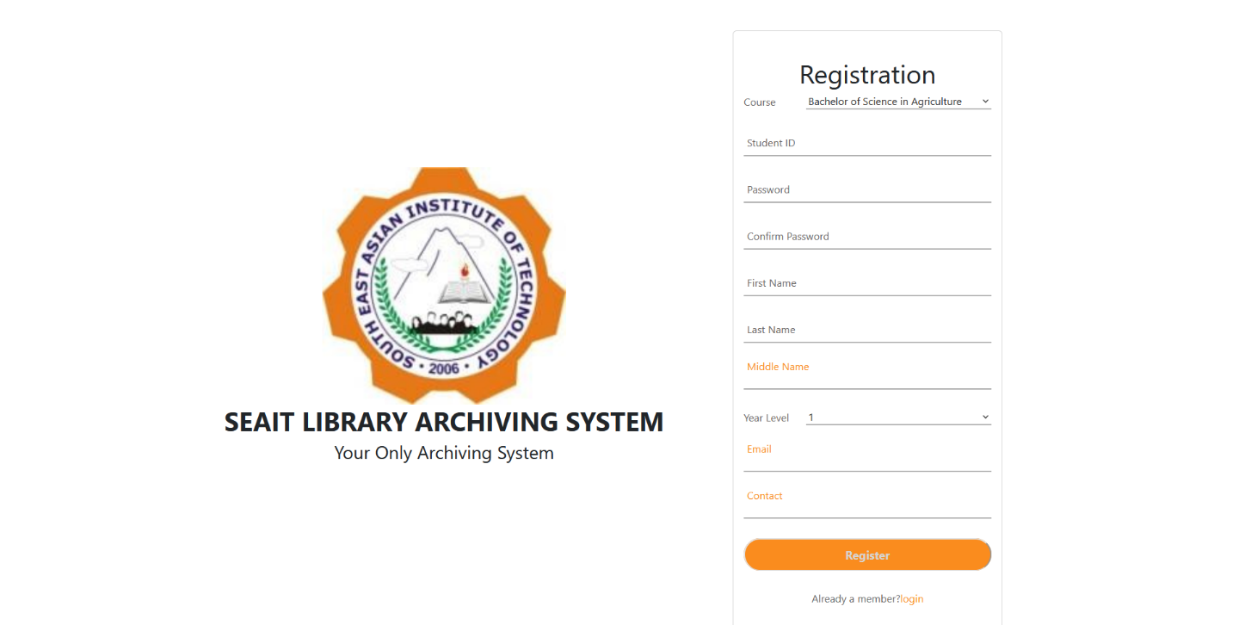**Sign up page**

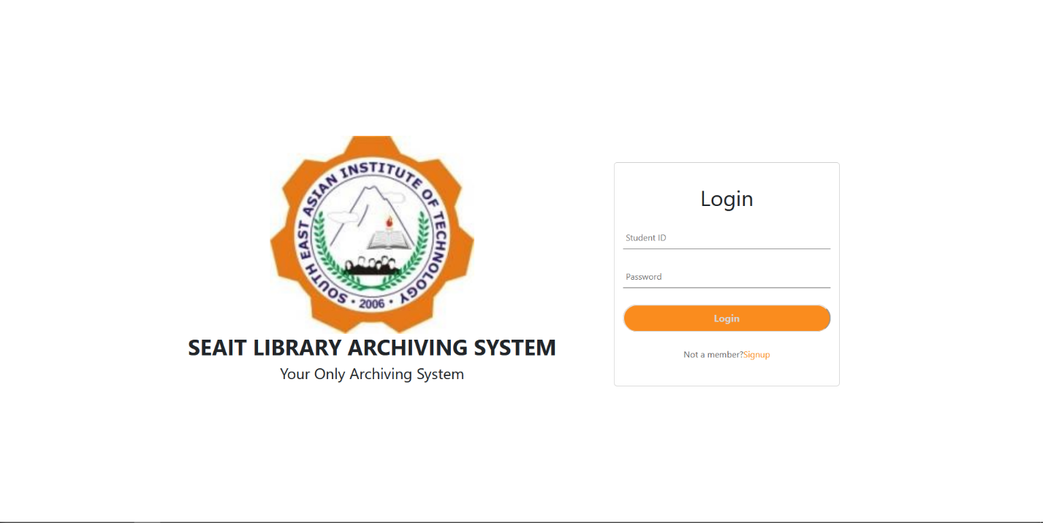**Log in page**

**ADMIN PANEL**

**Manage Article**

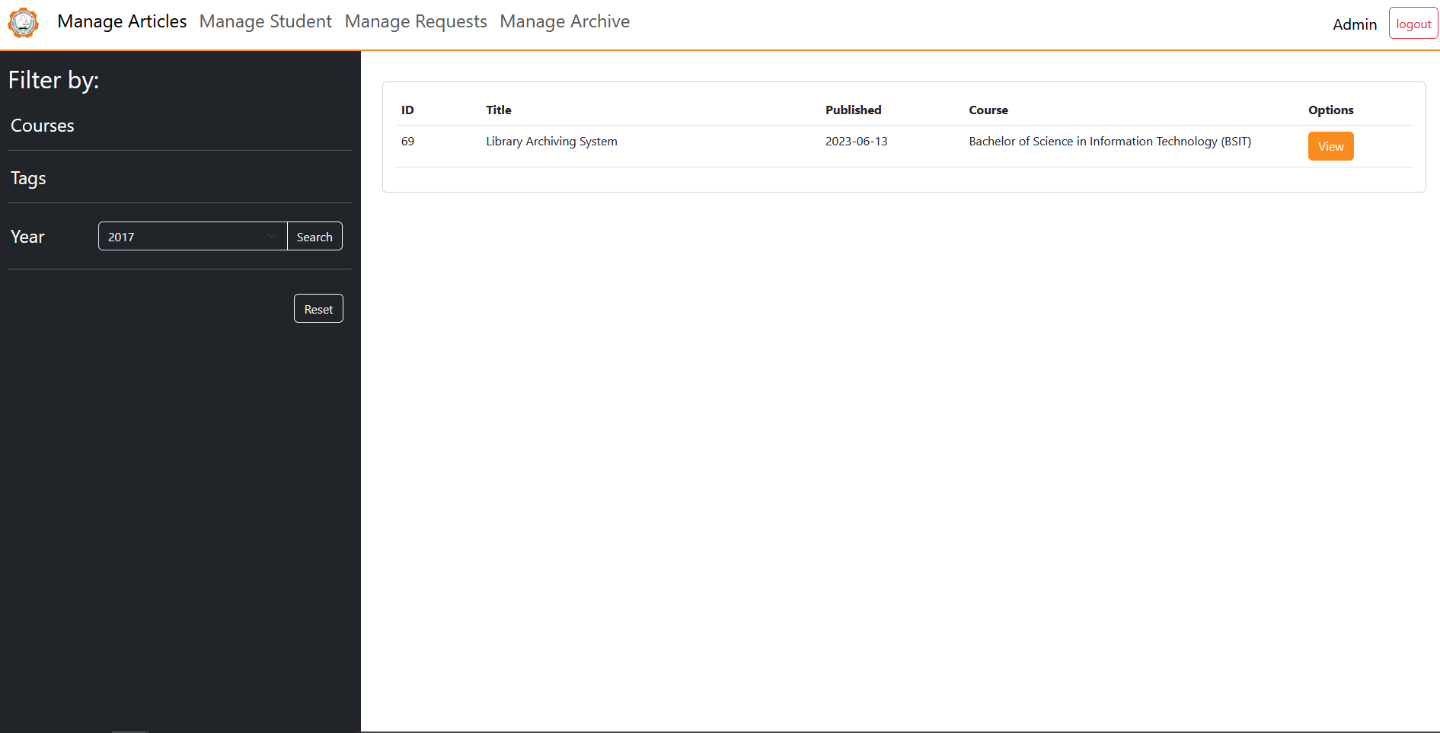

**View Article**

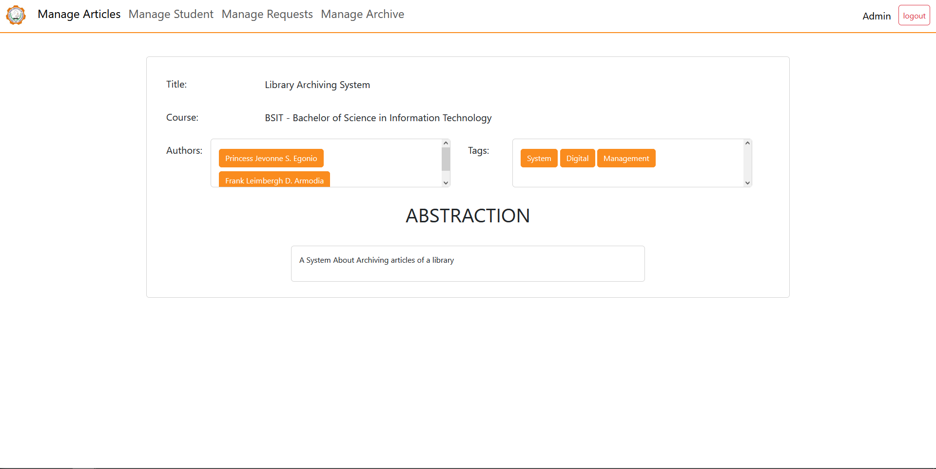

**Manage Student**

**active**

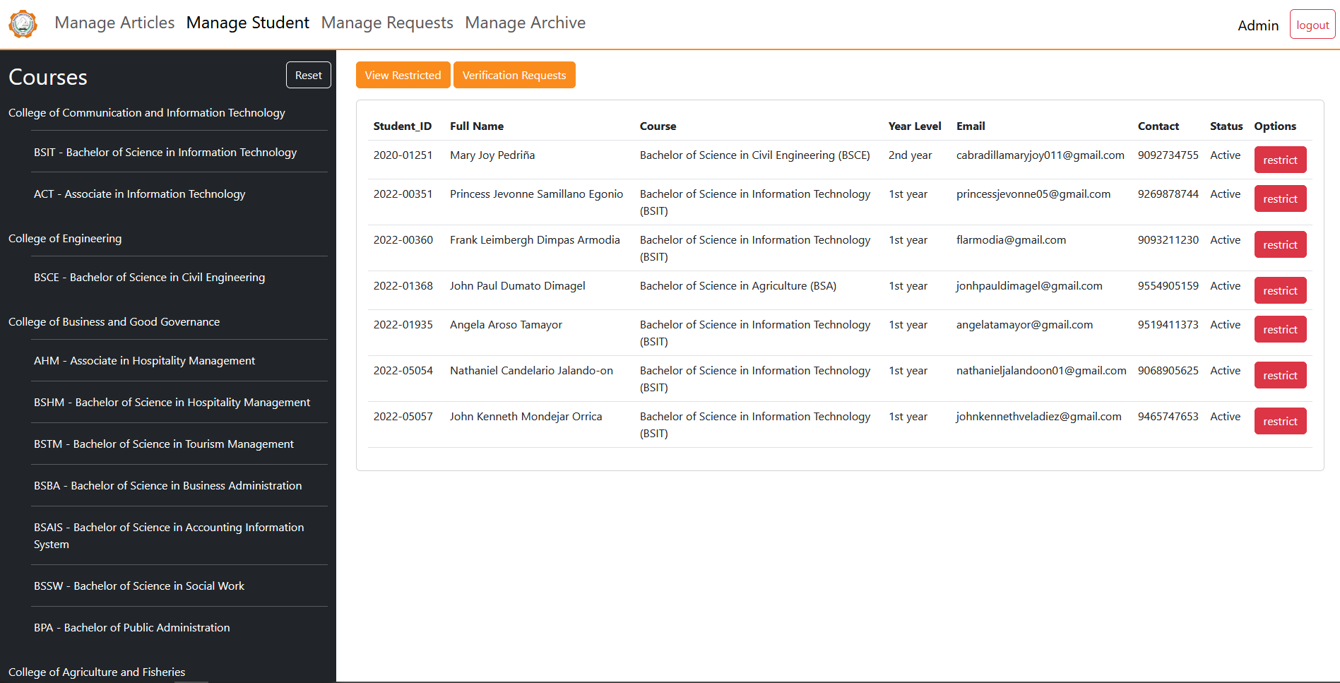

**restricted**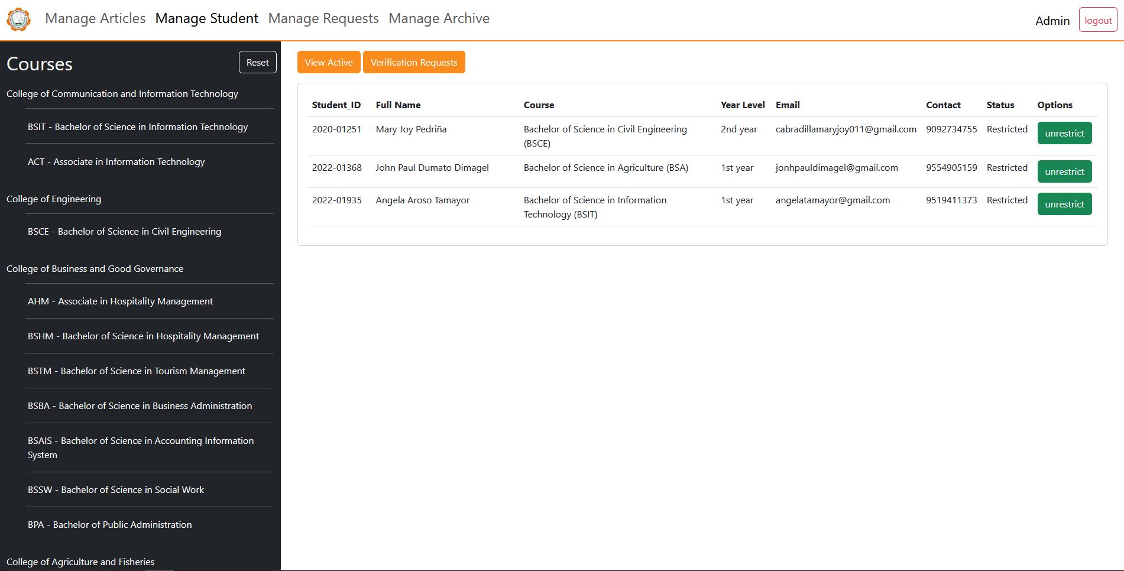

**verification requests**

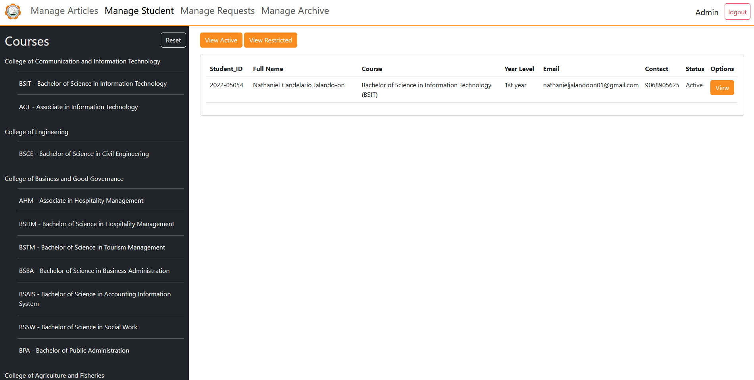

**Confirm Verification**

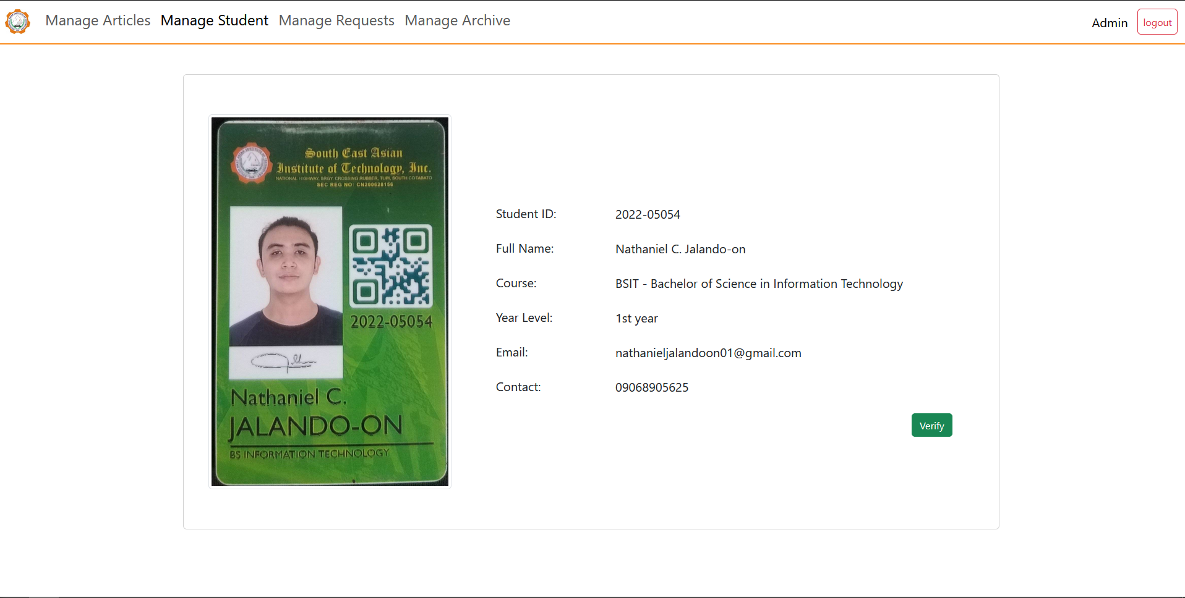

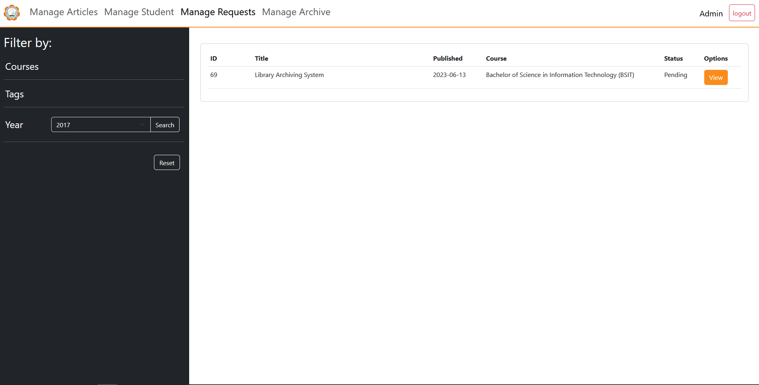**Manage Requests**

**View Upload Request**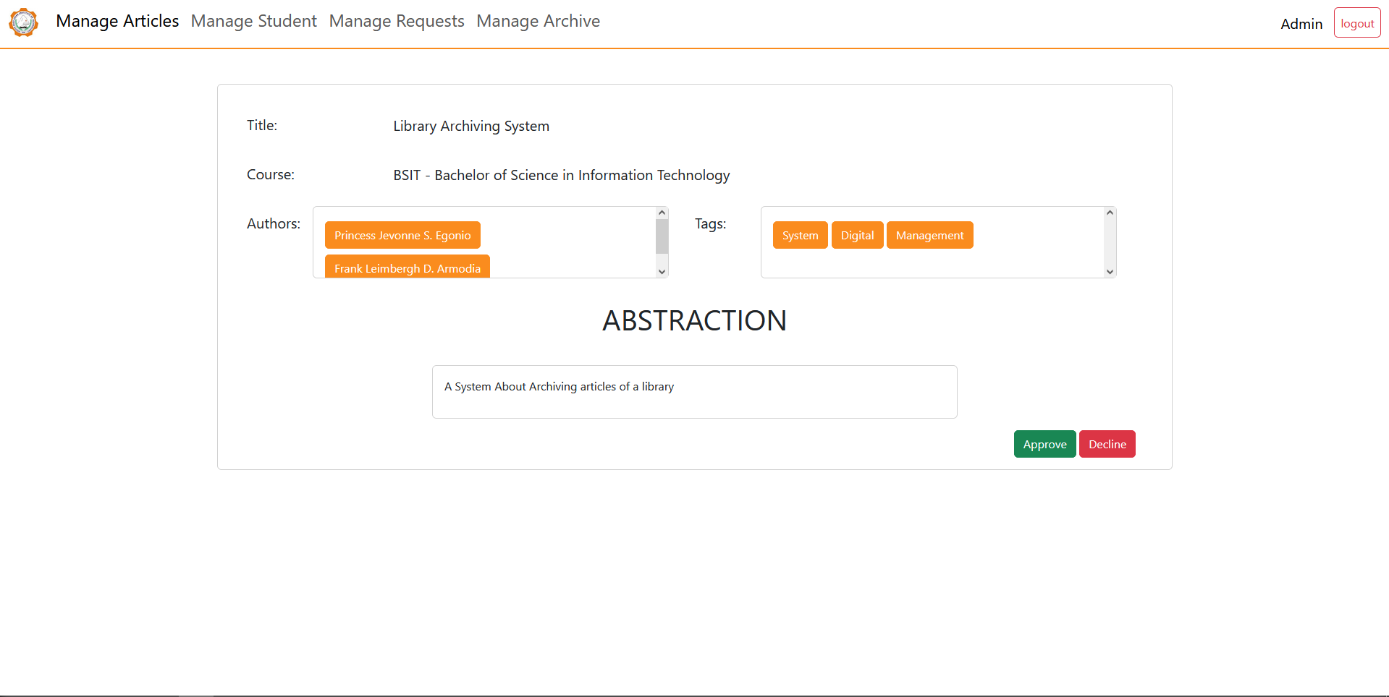

**Manage Archive**

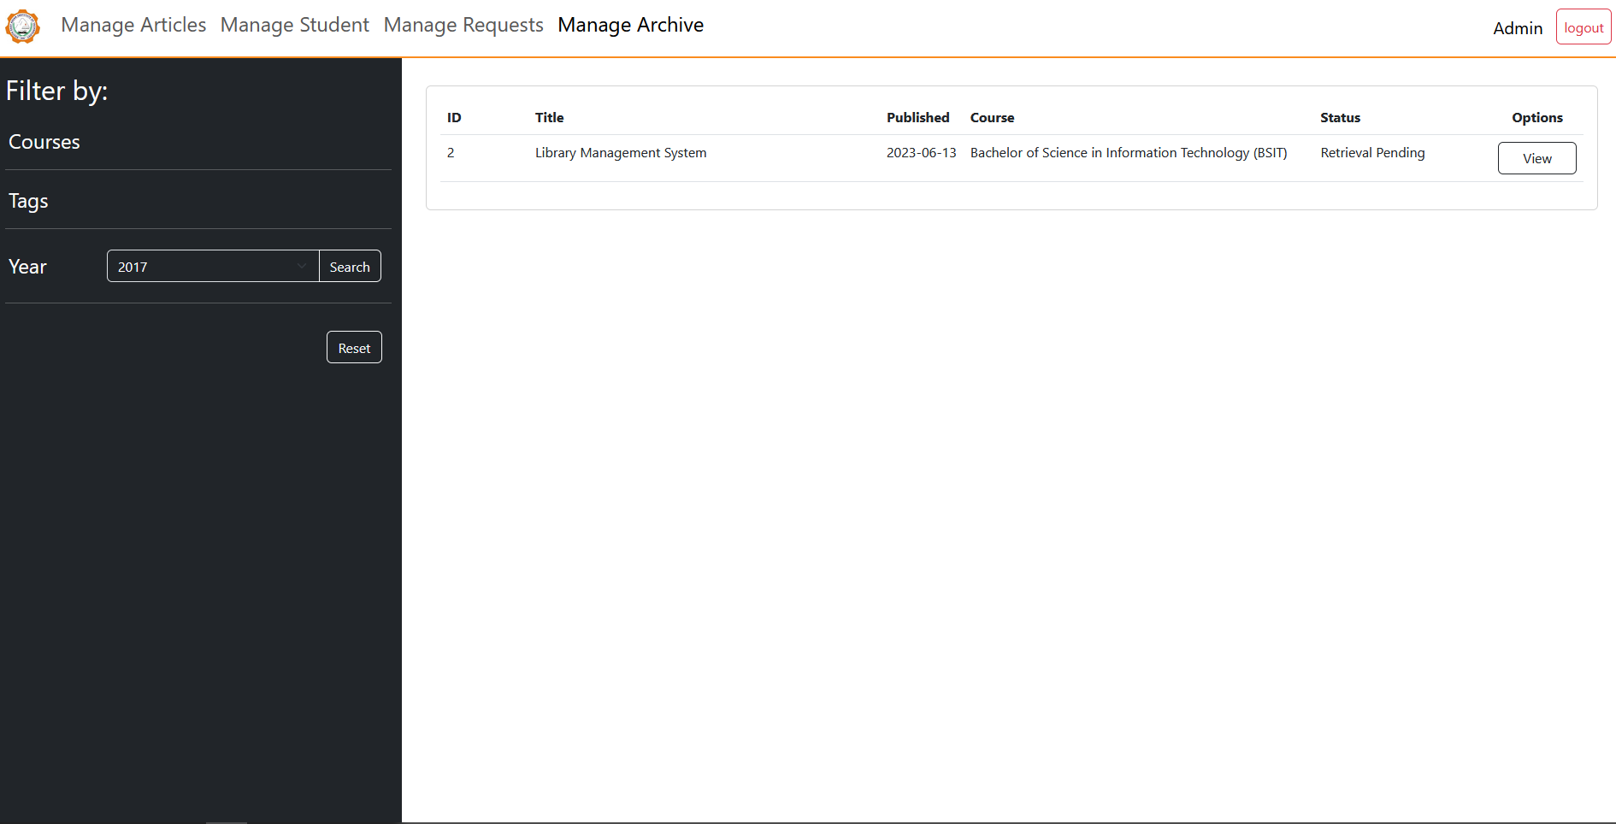

**View / Retrieve Archive**

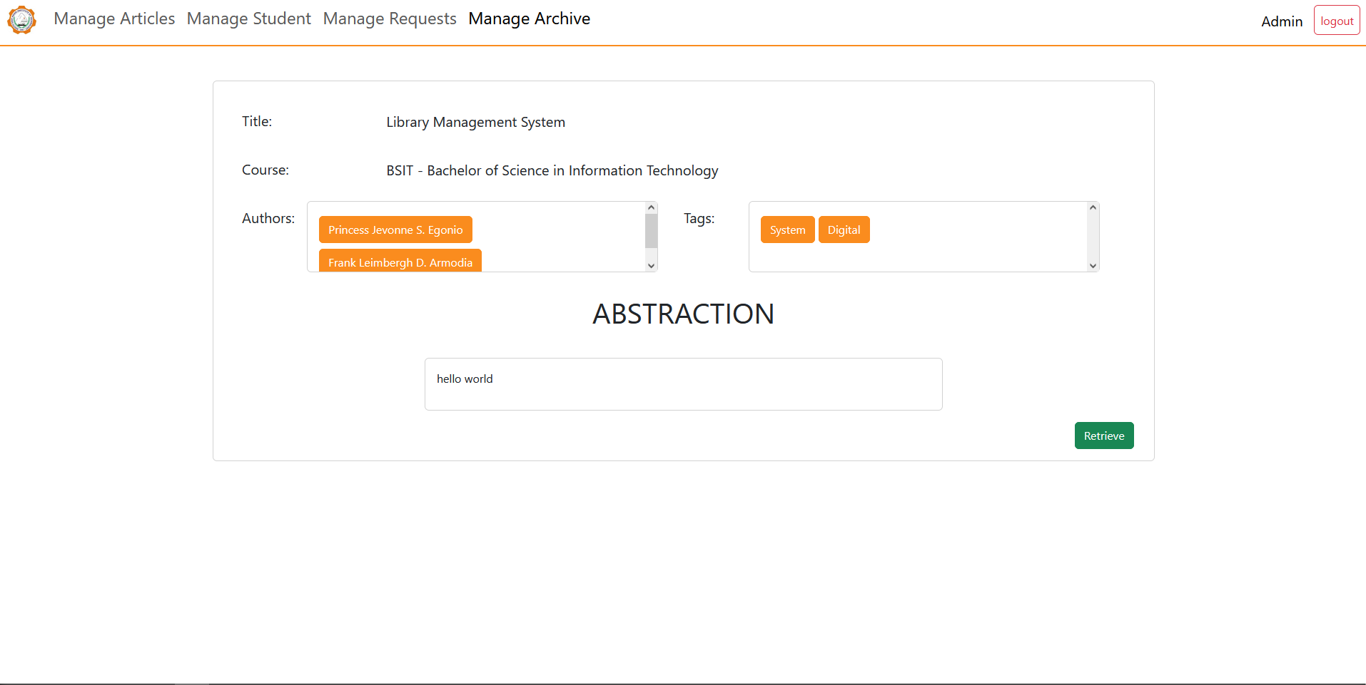

**STUDENT PANEL**

**Articles**

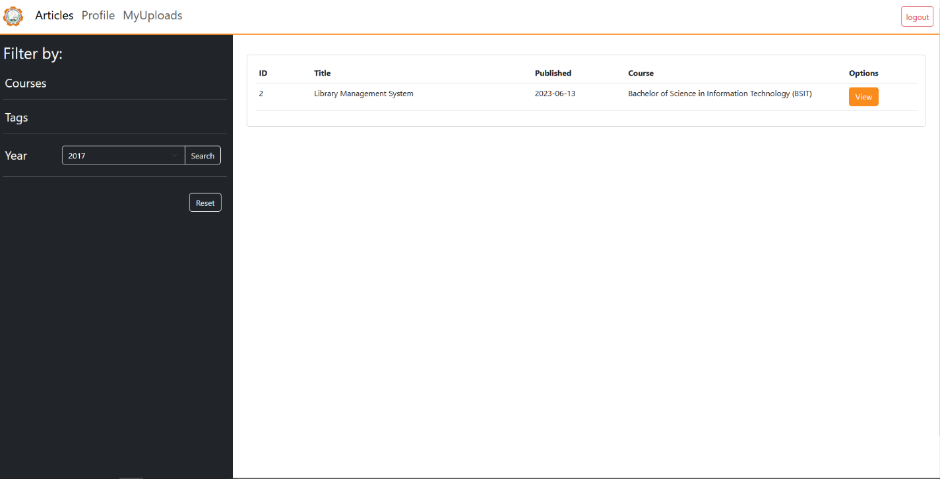

**View Article**

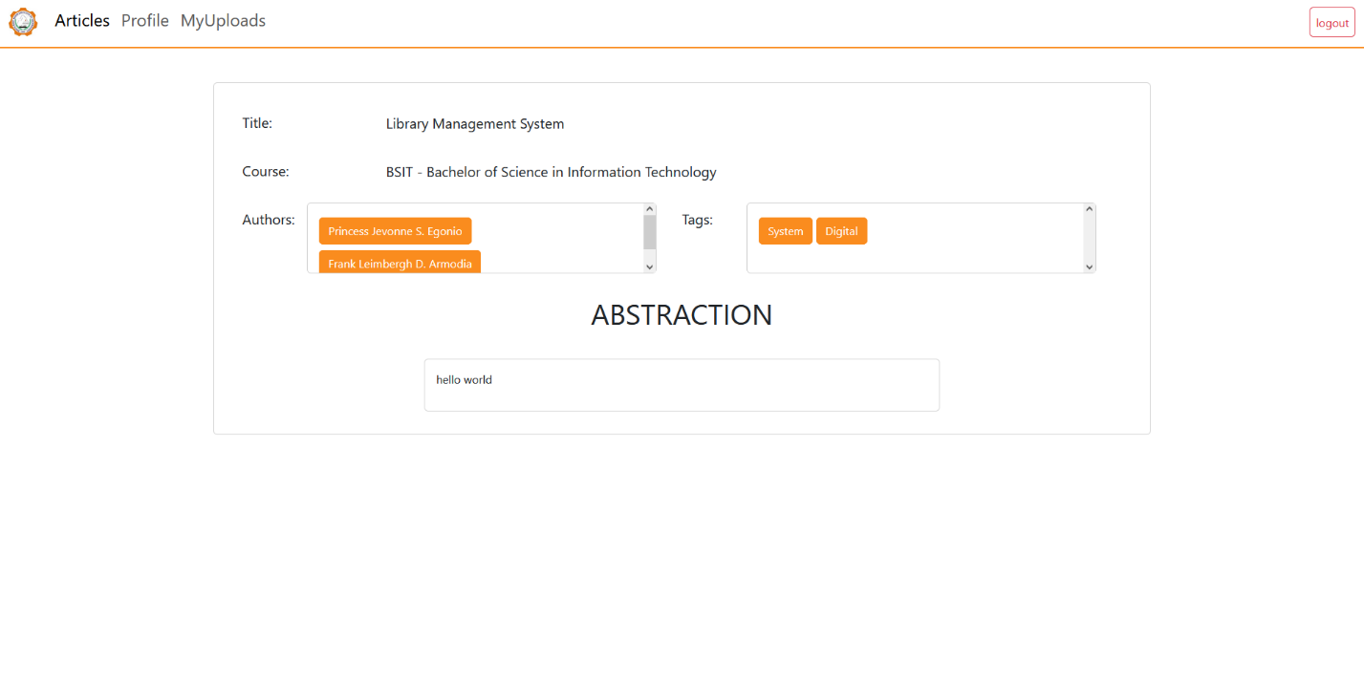

**Profile**

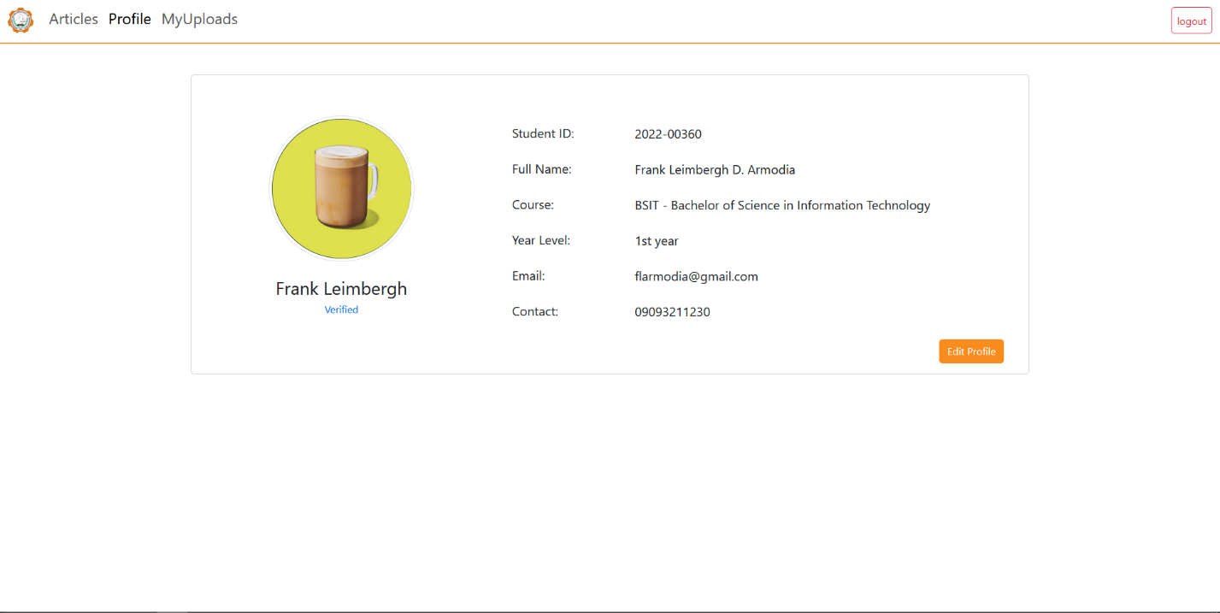

**Edit Profile Info**

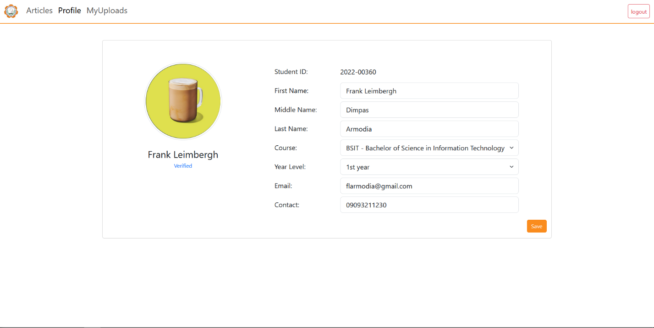

**Edit Profile Photo**

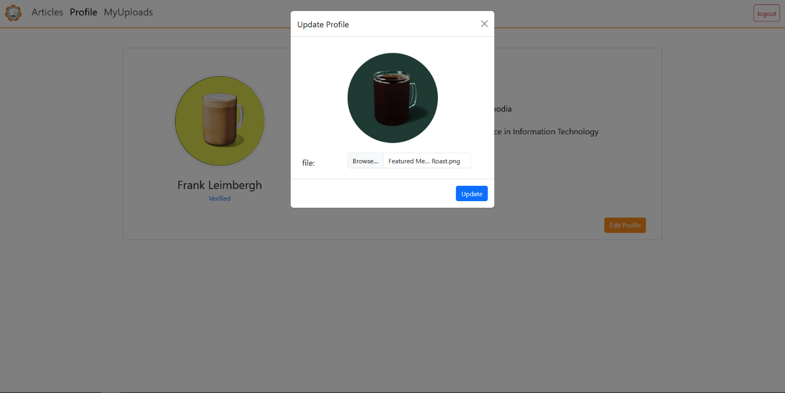

**Upload Verification**

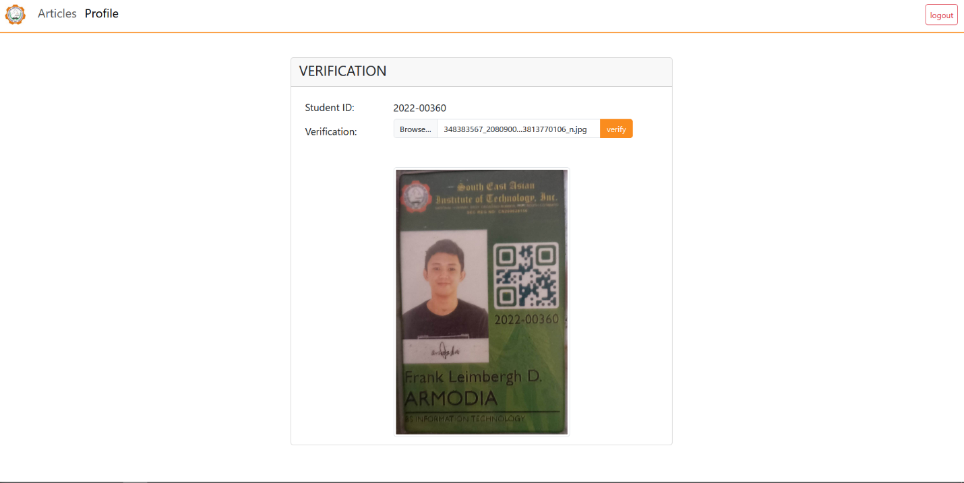

**My Uploads**

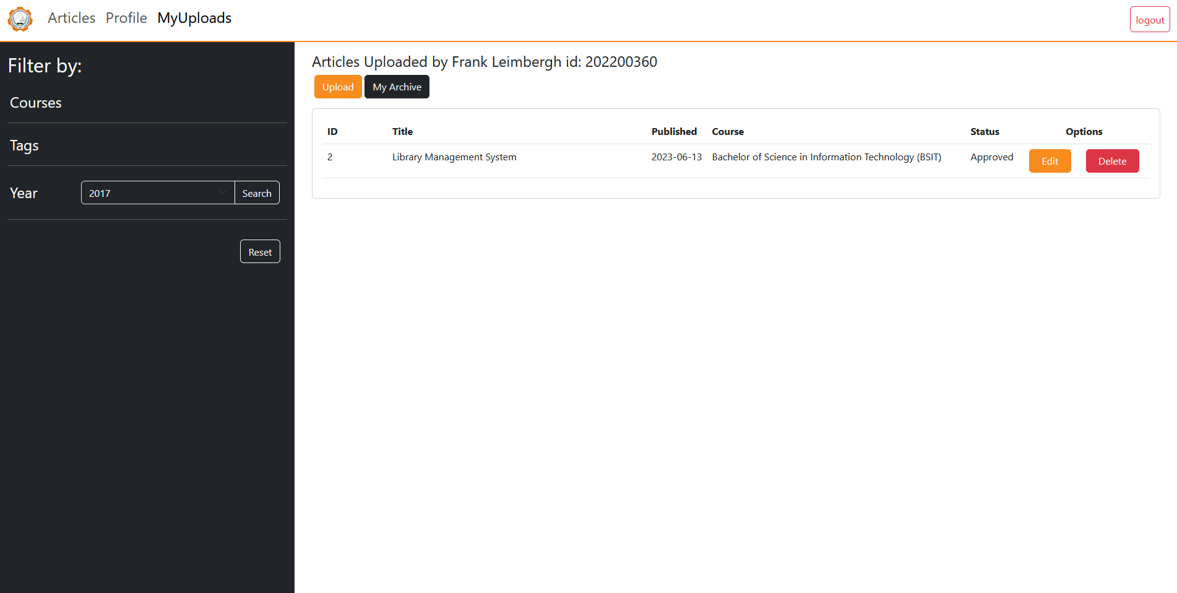

**Upload Article**

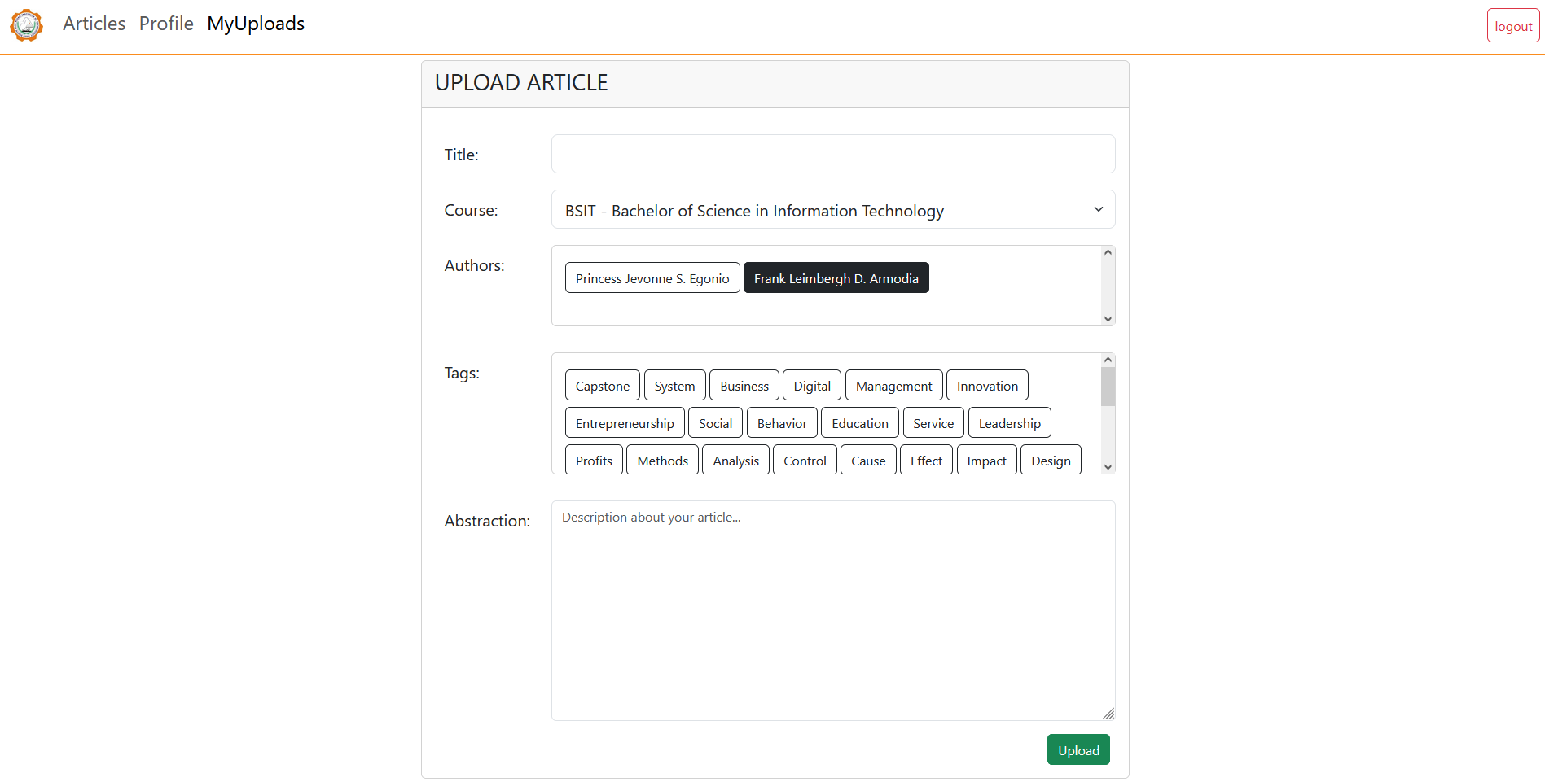

**User Archive**

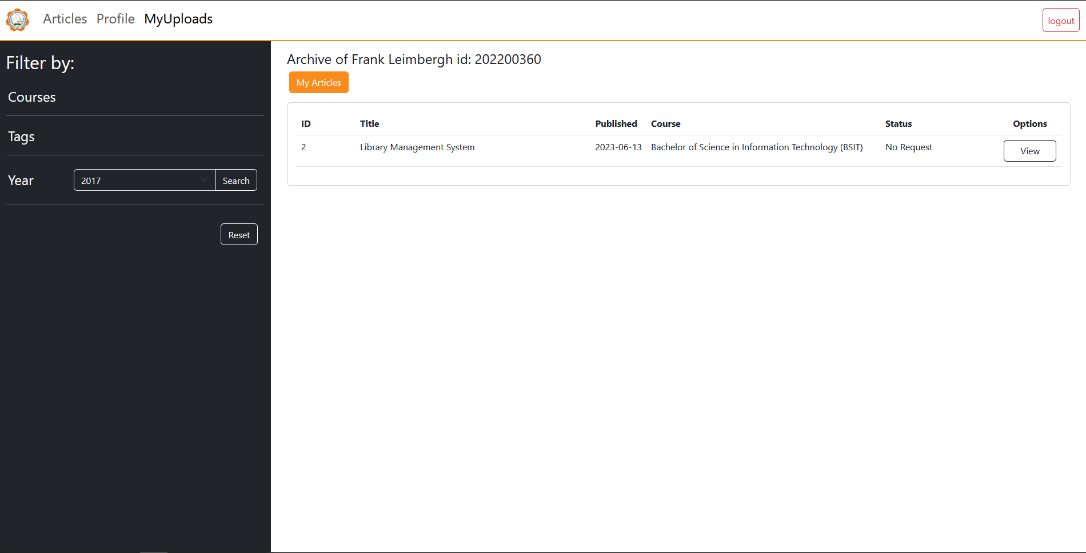

**View Archive For Request**

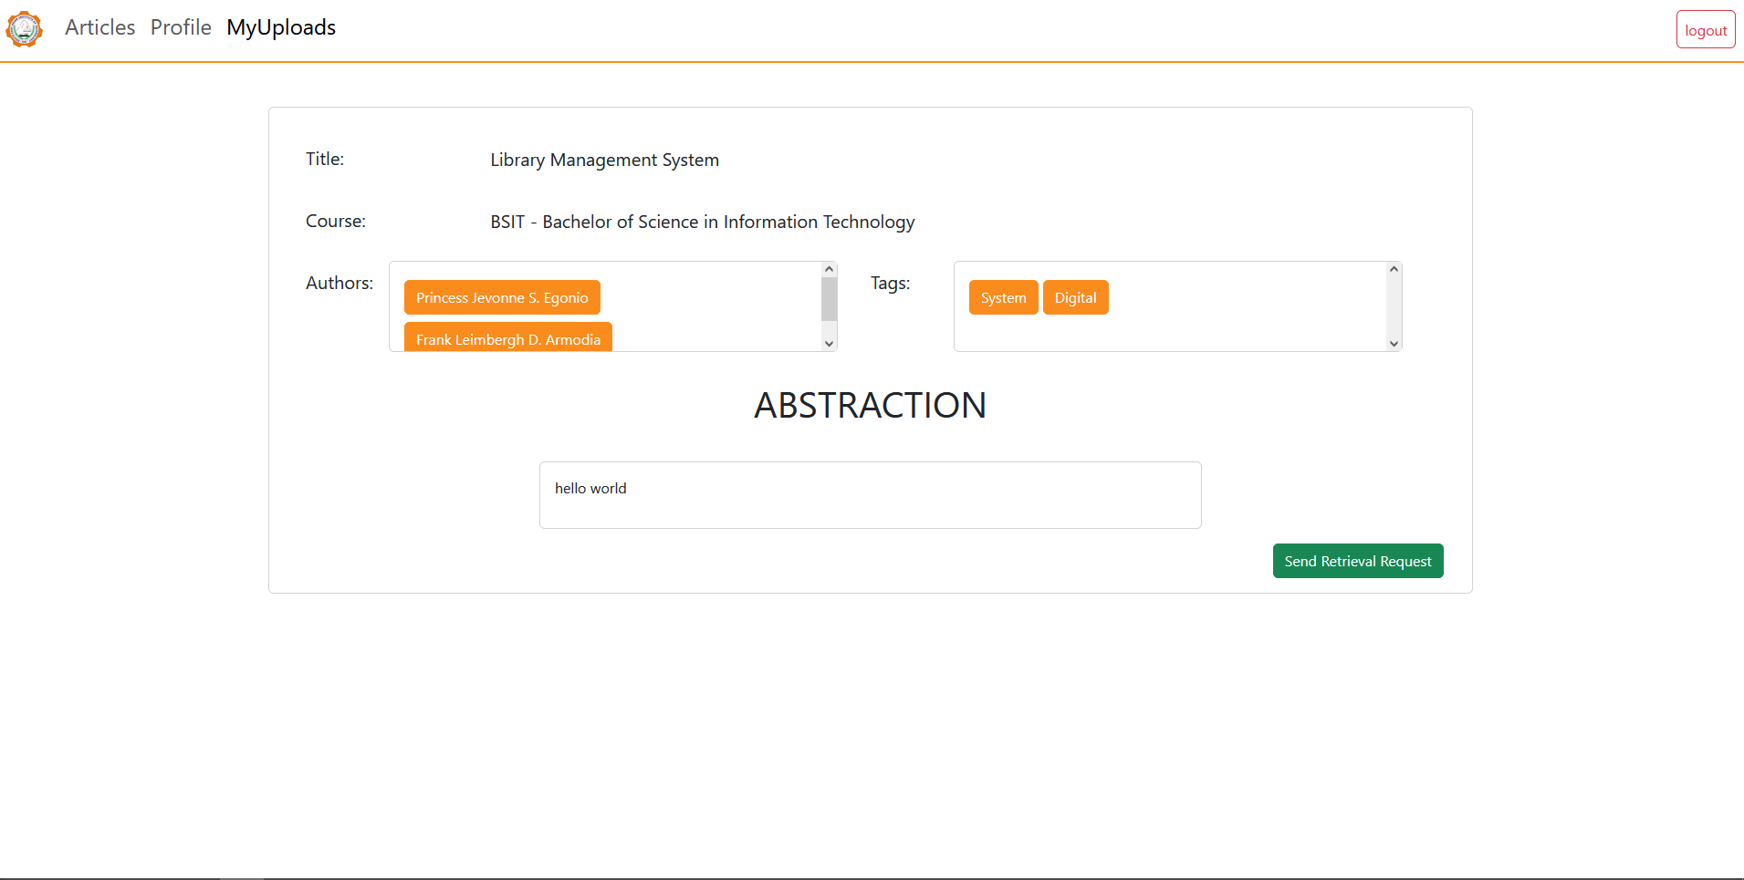

**RESTRICTED**

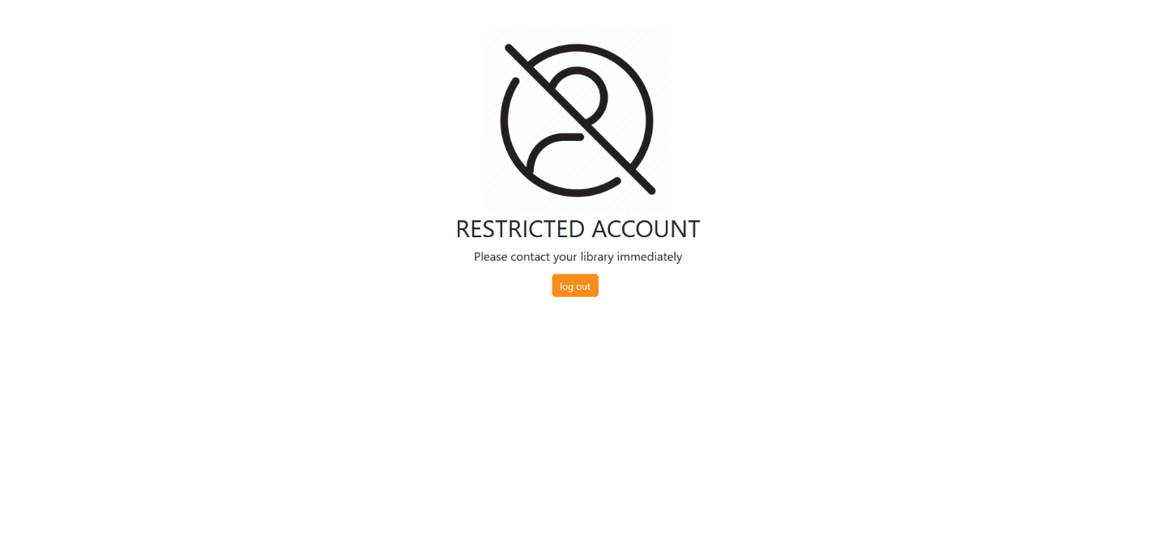

**Definition of Terms**

* **Librarian-** a personthatsorts and manage student’s information and articles per department and/or course.
* **Article-** a documentation of Thesis and/or Capstone project.
* **Archiving-** Is the process of collecting, organizing, preserving, and providing access to records, documents, and other research materials.
* **Library Archiving-** a process that ensures the long-term preservation and accessibility of valuable information and resources to develop a systematic and efficient system that can store and organize archived materials such as Thesis and/or Capstone.
* **Research-** a systematic process of investigation that aims to generate new knowledge, insights or understanding of a particular topic or problem.

**Database Design**

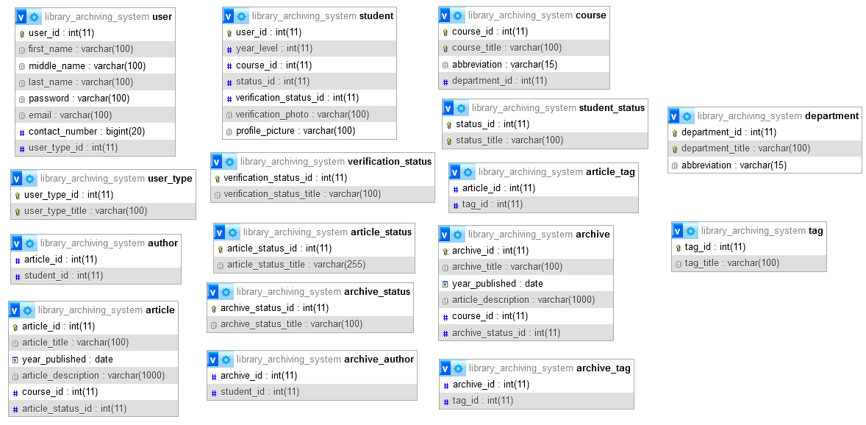

**Entity Relationship Diagram**

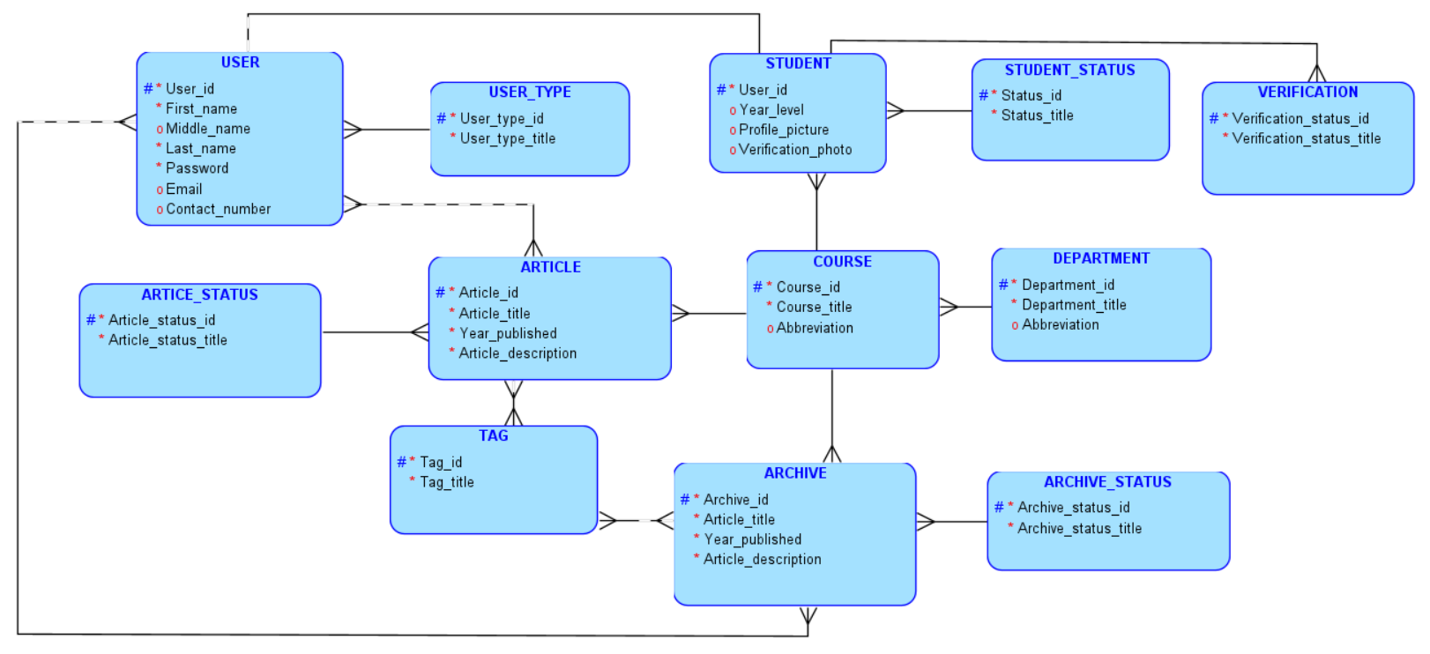

**Relational Database**

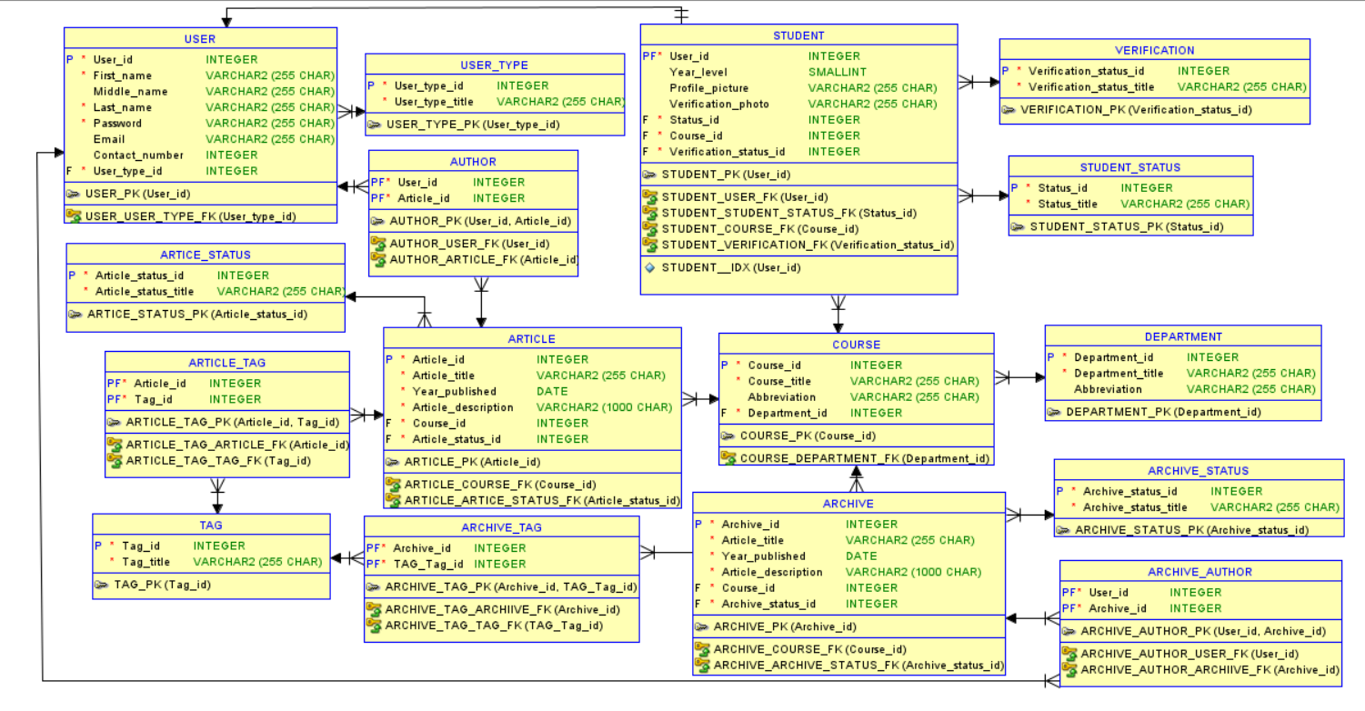

**Data Dictionary**

|  |  |  |  |  |
| --- | --- | --- | --- | --- |
| **Table name** |  |  | **USER** |  |
| **Attribute** | **Type** | **Null** | **Default** | **Description** |
| User_id | int(11) | No | PK | Indicates the ID of the user |
| First_name | varchar(255) | No |  | Indicates the first name of the user |
| Last_name | varchar(255) | No |  | Indicates the last name of the user |
| Middle_name | varchar(255) | Yes |  | Indicates the middle name of the user |
| Password | varchar(255) | No |  | Indicates the password of the user |
| Email | varchar(255) | Yes |  | Indicates the email address of the user |
| Contact_number | int(11) | Yes |  | Indicates the contact number of the user |
| User_type_id | Int(11) | No | (FK) | Indicates the user type ID of the user |

*Table 1.0 Data Dictionary of user table of the Library Archiving System*

|  |  |  |  |  |
| --- | --- | --- | --- | --- |
| **Table name** | **USER_TYPE** | | | |
| **Attribute** | **Type** | **Null** | **Default** | **Description** |
| User_type_id | int(11) | No | PK | Indicates the user type ID of the user |
| User_type_title | varchar(255) | No |  | Indicates the status type of the user |

*Table 1.1 Data Dictionary of user_type table of the Library Archiving System*

|  |  |  |  |  |
| --- | --- | --- | --- | --- |
| **Table name** | **STUDENT** | | | |
| **Attribute** | **Type** | **Null** | **Default** | **Description** |
| User_id | int(11) | No | PK/FK | Indicates the ID of the user |
| Verification_photo | varchar(255) | Yes |  |  |
| Year_level | smallint | Yes |  | Indicates the year level of the student |
| Status_id | int(11) | No | (FK) | Indicates the status ID of the student |
| Course_id | int(11) | No | (FK) | Indicates the course ID of the student |

*Table 1.2 Data Dictionary of student of the Library Archiving System*

|  |  |  |  |  |
| --- | --- | --- | --- | --- |
| **Table name** | **STUDENT_STATUS** | | | |
| **Attribute** | **Type** | **Null** | **Default** | **Description** |
| Status_id | int(11) | No | PK | Indicates the status ID of the student |
| Status_title | varchar(255) | No |  | Indicates the status of the student |

*Table 1.3 Data Dictionary of student_status of the Library Archiving System*

|  |  |  |  |  |
| --- | --- | --- | --- | --- |
| **Table name** | **COURSE** | | | |
| **Attribute** | **Type** | **Null** | **Default** | **Description** |
| Course_id | int(11) | No | PK | Indicates the tag ID of the article |
| Course_title | varchar(255) | No |  | Indicates the course of the student |
| Abbreviation | varchar(255) | Yes |  | Indicates the abbreviation of the course |
| Department_id | int(11) | No | (FK) | Indicates the ID of the department |

*Table 1.4 Data Dictionary of course table of the Library Archiving System*

|  |  |  |  |  |
| --- | --- | --- | --- | --- |
| **Table name** | **DEPARTMENT** | | | |
| **Attribute** | **Type** | **Null** | **Default** | **Description** |
| Department_id | int(11) | No | PK | Indicates the tag ID of the article |
| Department_title | varchar(255) | No |  | Indicates the department of the course and/or student |
| Abbreviation | varchar(255) | Yes |  | Indicates the abbreviation of the department |

*Table 1.5 Data Dictionary of department table of the Library Archiving System*

|  |  |  |  |  |
| --- | --- | --- | --- | --- |
| **Table name** | **AUTHOR** | | | |
| **Attribute** | **Type** | **Null** | **Default** | **Description** |
| Author_id | int(11) | No | PK | Indicates the author ID of the article |
| First_name | int(11) | No |  | Indicates the first name of the author |
| Middle_name | varchar(255) | Yes |  | Indicates the middle name of the author |
| Last_name | varchar(255) | No |  | Indicates the last name of the author |

*Table 1.6 Data Dictionary of author table of the Library Archiving System*

|  |  |  |  |  |
| --- | --- | --- | --- | --- |
| **Table name** | **ARTICLES** | | | |
| **Attribute** | **Type** | **Null** | **Default** | **Description** |
| Article_id | int(11) | No | PK | Indicates the ID of the user |
| Article_title | varchar(255) | No |  | Indicates the title of the article |
| Year_published | date | No |  | Indicates the publishing year of the article |
| Article_description | varchar(1000) | No |  | Indicates the article description |
| Course_id | int(11) | No | (FK) | Indicates the course ID of the researcher/uploader |

*Table 1.7 Data Dictionary of articles table of the Library Archiving System*

|  |  |  |  |  |
| --- | --- | --- | --- | --- |
| **Table name** | **ARCHIVE_AUTHOR** | | | |
| **Attribute** | **Type** | **Null** | **Default** | **Description** |
| Archive_id | int(11) | No | PK/FK | Indicates the archive ID of the deleted article |
| Author_id | int(11) | No | PK/FK | Indicates the author ID of the article |

*Table 1.8 Data Dictionary of archive_author table of the Library Archiving System*

|  |  |  |  |  |
| --- | --- | --- | --- | --- |
| **Table name** | **ARCHIVE** | | | |
| **Attribute** | **Type** | **Null** | **Default** | **Description** |
| Archive_id | int(11) | No | PK | Indicates the archive ID of the deleted article |
| Archive_title | varchar(255) | No |  | Indicates the title of the deleted article |
| Year_published | date | No |  | Indicates the publishing year of the article |
| Article_description | varchar(1000) | No |  | Indicates the description of the article |
| Course_id | int(11) | No | FK | Indicates the course ID of the article |

*Table 1.9 Data Dictionary of archive table of the Library Archiving System*

|  |  |  |  |  |
| --- | --- | --- | --- | --- |
| **Table name** | **ARTICLE_TAG** | | | |
| **Attribute** | **Type** | **Null** | **Default** | **Description** |
| Article_id | int(11) | No | PK/FK | Indicates the ID of the article |
| Tag_id | int(11) | No | PF/FK | Indicates the tag ID of the article |

*Table 2.0 Data Dictionary of article_tag table of the Library Archiving System*

|  |  |  |  |  |
| --- | --- | --- | --- | --- |
| **Table name** | **TAG** | | | |
| **Attribute** | **Type** | **Null** | **Default** | **Description** |
| Tag_id | int(11) | No | PK | Indicates the tag ID of the article |
| Tag_title | varchar(255) | No |  | Indicates the tag title of the article |

*Table 2.1 Data Dictionary of tag table of the Library Archiving System*

|  |  |  |  |  |
| --- | --- | --- | --- | --- |
| **Table name** | **ARTICLE_AUTHOR** | | | |
| **Attribute** | **Type** | **Null** | **Default** | **Description** |
| Article_id | int(11) | No | PK/FK | Indicates the ID of the article |
| Author_id | int(11) | No | PK/FK | Indicates the author ID of the article |

*Table 2.2 Data Dictionary of article_author table of the Library Archiving System*

|  |  |  |  |  |
| --- | --- | --- | --- | --- |
| **Table name** | **ARCHIVE_TAG** | | | |
| **Attribute** | **Type** | **Null** | **Default** | **Description** |
| Tag_id | int(11) | No | PK/FK | Indicates the tag ID of the article |
| Archive_id | int(11) | No | PK/FK | Indicates the archive ID of the deleted article |

*Table 2.3 Data Dictionary of archive_tag table of the Library Archiving System*