**Oʻzbekiston Respublikasi Axborot Texnologiyalari va**

**Kommunikatsiyalarini Rivojlantirish Vazirligi**

**Muhammad al-Xorazmiy nomidagi**

**Toshkent Axborot Texnologiyalari Universiteti**



**411-20 guruh talabasining**

**Komputer tarmoqlari fanidan**

**tayyorlagan 11-12 laboratoriya ishi**

**Mavzu:** **RIP, EIGRP, OSPF VA BGP PROTOKOLLARI ASOSIDA DINAMIK MARSHRUTLASHNI SOZLASH**

Bajardi:Qayumov Javohir

Tekshirdi:Xasanov Orifjon

**11-12 - LABORATORIYA ISHI**

**RIP, EIGRP, OSPF VA BGP PROTOKOLLARI ASOSIDA DINAMIK MARSHRUTLASHNI SOZLASH**

**Ishdan maqsad**

Dinamik marshrutizatsiya RIP, EIGRP, OSPF, BGP protokollari asosida qurilgan tarmoqda xavfsizlikni ta’minlash bo`yicha amaliy ko`nikmaga ega bo`lish.

**Topshiriq**

* Dinamik marshrutizatsiya protokollari (RIP, EIGRP, OSPF, BGP) asosida yaratilgan tarmoq topologiyasini yarating.
* R1, R2 va R3 marshrutizatorlarining interfeyslarini sozlang va tekshiring.
* Har-bir dinamik marshrutizatsiya protokoli doirasida axborot oqimlarining autentifikatsiya masalalarini sozlang
* Har bir marshrutizatorning marshrutizatsiya jadvalini o‘rganing.

**EIGRP**. Cisco Systems kompaniyasining EIGRP protokoli IGRP protokolining dastlabki versiyasining takomillashtirilgan ko‘rinishi hisoblaniladi. Protokol gibrid hisoblanadi va Diffusing-Update Algorithm (DUAL) algoritmiga asoslangan. EIGRP ning oxirgi versiyasi marshrutizatsiya jadvali elementlarini buzg‘unchilar yozib olishga imkon bermaydigan va MD5 kaliti asosida autentifikatsiyalaydigan himoyalash vositasiga ega.

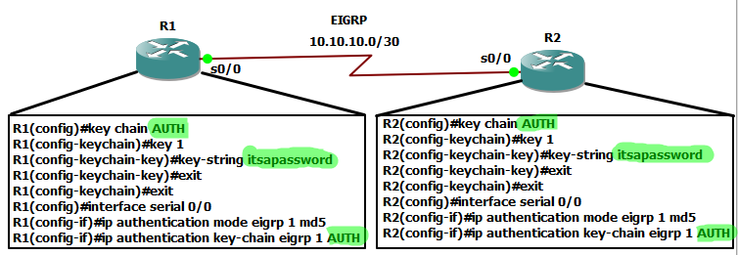

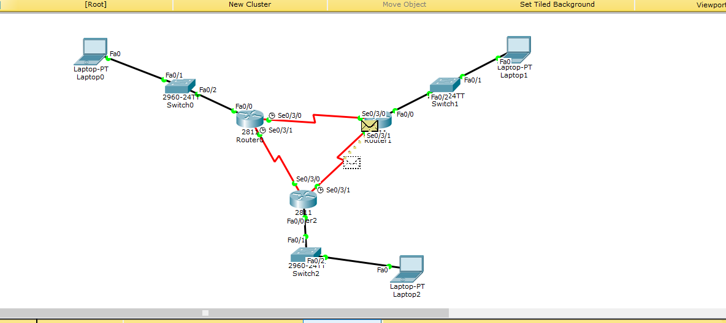

EIGPR protokoli bo’yicha yasalgan topologik sxema

**EIGRP protokol bo`yicha qurilgan tarmoq uchun ishni bajarish tartibi**

**R1 konfiguratsiyasi**

Router(config)#hostname R1

R1(config)#router eigrp 1

R1(config-router)#eigrp router-id 1.1.1.1

R1(config-router)#network 192.168.10.0 0.0.0.255

R1(config-router)#network 10.10.10.0 0.0.0.3

R1(config-router)#network 11.11.11.0 0.0.0.3

R1(config-router)#no auto-summary

R1(config-router)#exit

R1(config)#key chain EIGRP_KEY

R1(config-keychain)#key 1

R1(config-keychain-key)#key-string cisco

R1(config-keychain-key)#exit

R1(config-keychain)#exit

R1(config)#interface serial 0/3/0

R1(config-if)#ip authentication mode eigrp 1 md5

R1(config-if)#ip authentication key-chain eigrp 1 EIGRP_KEY

R1(config-if)#exit

**R2 konfiguratsiyasi**

Router(config)#hostname R2

R2(config)#router eigrp 1

R2(config-router)#eigrp router-id 2.2.2.2

R2(config-router)#network 192.168.20.0 0.0.0.255

R2(config-router)#network 10.10.10.0 0.0.0.3

R2(config-router)#network 12.12.12.0 0.0.0.3

R2(config-router)#no auto-summary

R2(config-router)#exit

R2(config)#key chain EIGRP_KEY

R2(config-keychain)#key 1

R2(config-keychain-key)#key-string cisco

R2(config-keychain-key)#exit

R2(config-keychain)#exit

R2(config)#interface serial 0/3/0

R2(config-if)#ip authentication mode eigrp 1 md5

R2(config-if)#ip authentication key-chain eigrp 1 EIGRP_KEY

R2(config-if)#exit

**R3 konfiguratsiyasi**

Router(config)#hostname R3

R3(config)#router eigrp 1

R3(config-router)#eigrp router-id 3.3.3.3

R3(config-router)#network 192.168.30.0 0.0.0.255

R3(config-router)#network 12.12.12.0 0.0.0.3

R3(config-router)#network 11.11.11.0 0.0.0.3

R3(config-router)#no auto-summary

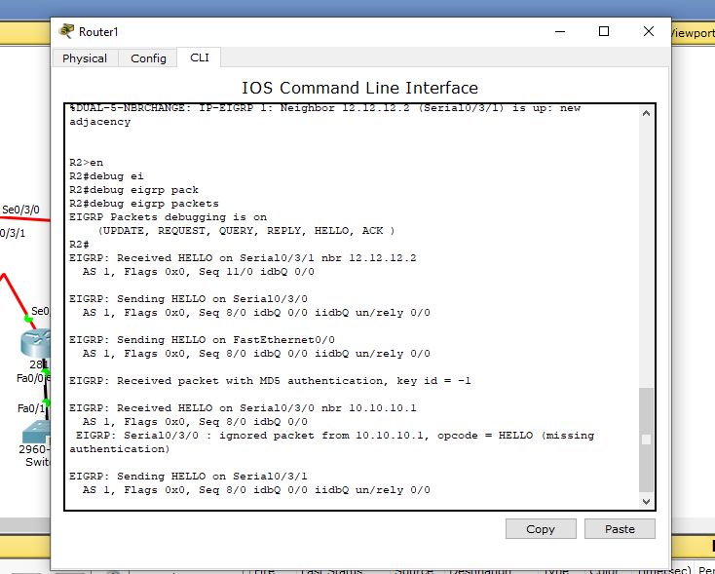

Routerlar o`rtasida autentifikatsiya asosida axborot almashinuvi

**OSPF**. Hozirda korporativ tarmoqlarda sozlash nisbatan universal va qulay bo`lgan dinamik marshrutizatsiya protokoli birinchi qisqa yo‘lni tanlash ochiq protokoli Open Short-est Path First Protocol — OSPF) hisoblanadi. Dastlab protokol murakab topologiyali katta tarmoqlar (65536 tagacha marshrutizator) da ishlashga mo‘ljallangan. U aloqa kanali holati algoritmiga asoslangan va tarmoq holati o‘zgarishiga yuqori chidamlikka ega.

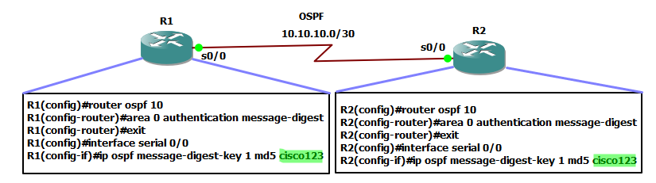

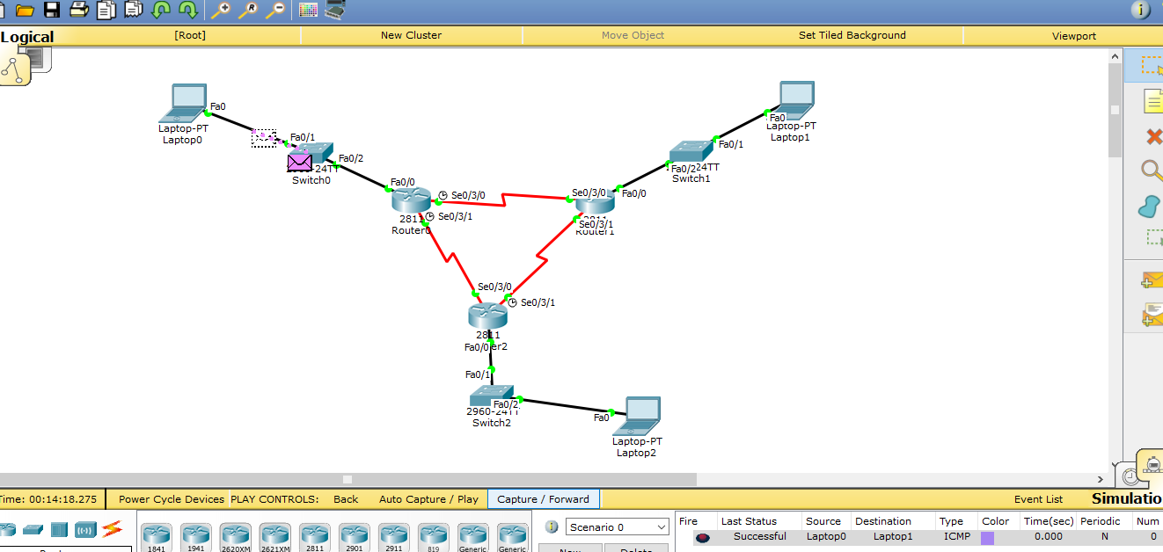

OSPF protokoli topologiyasi

**R2 konfiguratsiyasi**

R2(config)#router ospf 10

R2(config-router)#router-id 2.2.2.2

R2(config-router)#network 10.10.10.0 0.0.0.3 area 0

R2(config-router)#network 12.12.12.0 0.0.0.3 area 0

R2(config-router)#network 192.168.20.0 0.0.0.255 area 2

R2(config-router)#exit

R2(config)#router ospf 10

R2(config-router)#area 0 authentication message-digest

R2(config-router)#exit

R2(config)#interface serial 0/3/0

R2(config-if)#ip ospf message-digest-key 1 md5 cisco123

R2(config-if)#exit

**R1 konfiguratsiyasi**

R1(config)#router ospf 10

R1(config-router)#router-id 1.1.1.1

R1(config-router)#network 192.168.10.0 0.0.0.255 area 1

R1(config-router)#network 11.11.11.0 0.0.0.3 area 0

R1(config-router)#network 10.10.10.0 0.0.0.3 area 0

R1(config-router)#exit

R1(config)#router ospf 10

R1(config-router)#area 0 authentication message-digest

R1(config-router)#exit

R1(config)#interface serial 0/3/0

R1(config-if)#ip ospf message-digest-key 1 md5 cisco123

R1(config-if)#exit

**R3 konfiguratsiyasi**

R3(config)#router ospf 10

R3(config-router)#router-id 3.3.3.3

R3(config-router)#network 192.168.30.0 0.0.0.255 area 3

R3(config-router)#network 12.12.12.0 0.0.0.3 area 0

R3(config-router)#network 11.11.11.0 0.0.0.3 area 0

R3(config-router)#exit

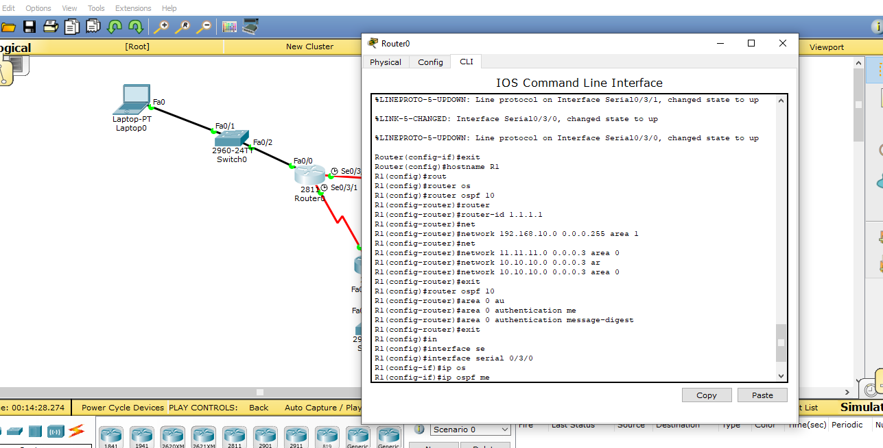

Routerni programmalash

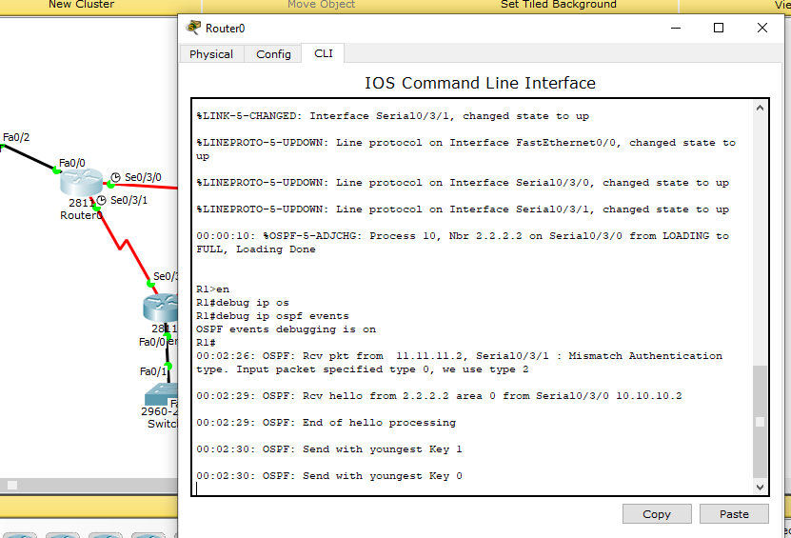

Routerlar orasida aloqa

**BGP** (ing. Border Gateway Protocol, chegaraviy shlyuz protokoli) Internetdagi asosiy dinamik marshrutlash protokoli hisoblanadi.

BGP protokoli boshqa dinamik marshrutlash protokollaridan farqli o‘laroq, marshrut ma’lumotlarini alohida marshrutlagichlar o‘rtasida emas, balki butun avtonom tizimlar o‘rtasida almashish uchun mo‘ljallangan va shu sababli, tarmoqdagi marshrutlar haqida ma’lumotlardan tashqari, avtonom tizimlarga yo‘nalishlar to‘g‘risida ham ma’lumot olib boradi.

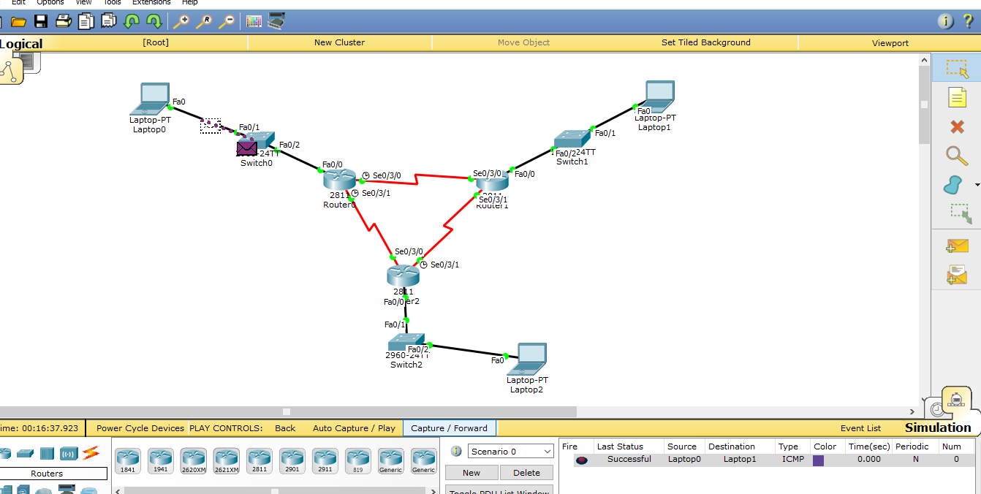

BGP protokoli topologiyasi

a) R1 marshrutizatorning konfiguratsiyasini sozlaymiz.

R1(config)#router bgp 65100

R1(config-router)#bgp router-id 1.1.1.1

R1(config-router)#neighbor 172.16.0.2 remote-as 65200

R1(config-router)#neighbor 172.16.13.2 remote-as 65300

R1(config-router)#network 192.168.1.0 mask 255.255.255.0

R1(config-router)#exit

b) R1 marshrutizatorning konfiguratsiyasini sozlaymiz

R2(config)#router bgp 65200

R2(config-router)#bgp router-id 2.2.2.2

R2(config-router)#neighbor 172.16.0.1 remote-as 65100

R2(config-router)#neighbor 172.16.23.2 remote-as 65300

R2(config-router)#network 192.168.2.0 mask 255.255.255.0

R2(config-router)#exit

s) R1 marshrutizatorning konfiguratsiyasini sozlaymiz

R3(config)#router bgp 65300

R3(config-router)#bgp router-id 3.3.3.3

R3(config-router)#neighbor 172.16.13.1 remote-as 65100

R3(config-router)#neighbor 172.16.23.1 remote-as 65200

R3(config-router)#network 192.168.3.0 mask 255.255.255.0

R3(config-router)#exit

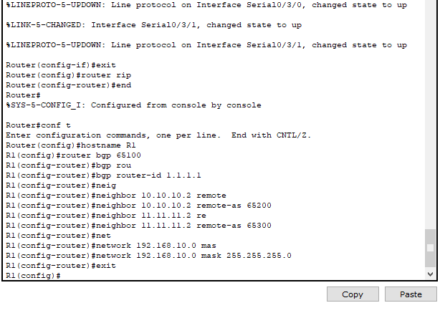

Routerni programmalash

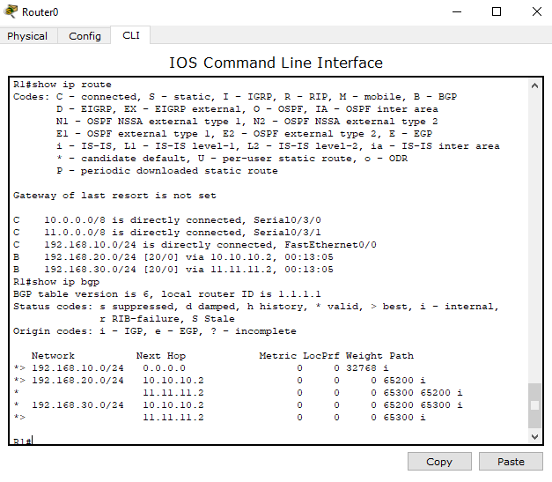

Tarmoq elementlari konfiguratsiyalari listinglari