this is a document that includes a picture taken in Dublin

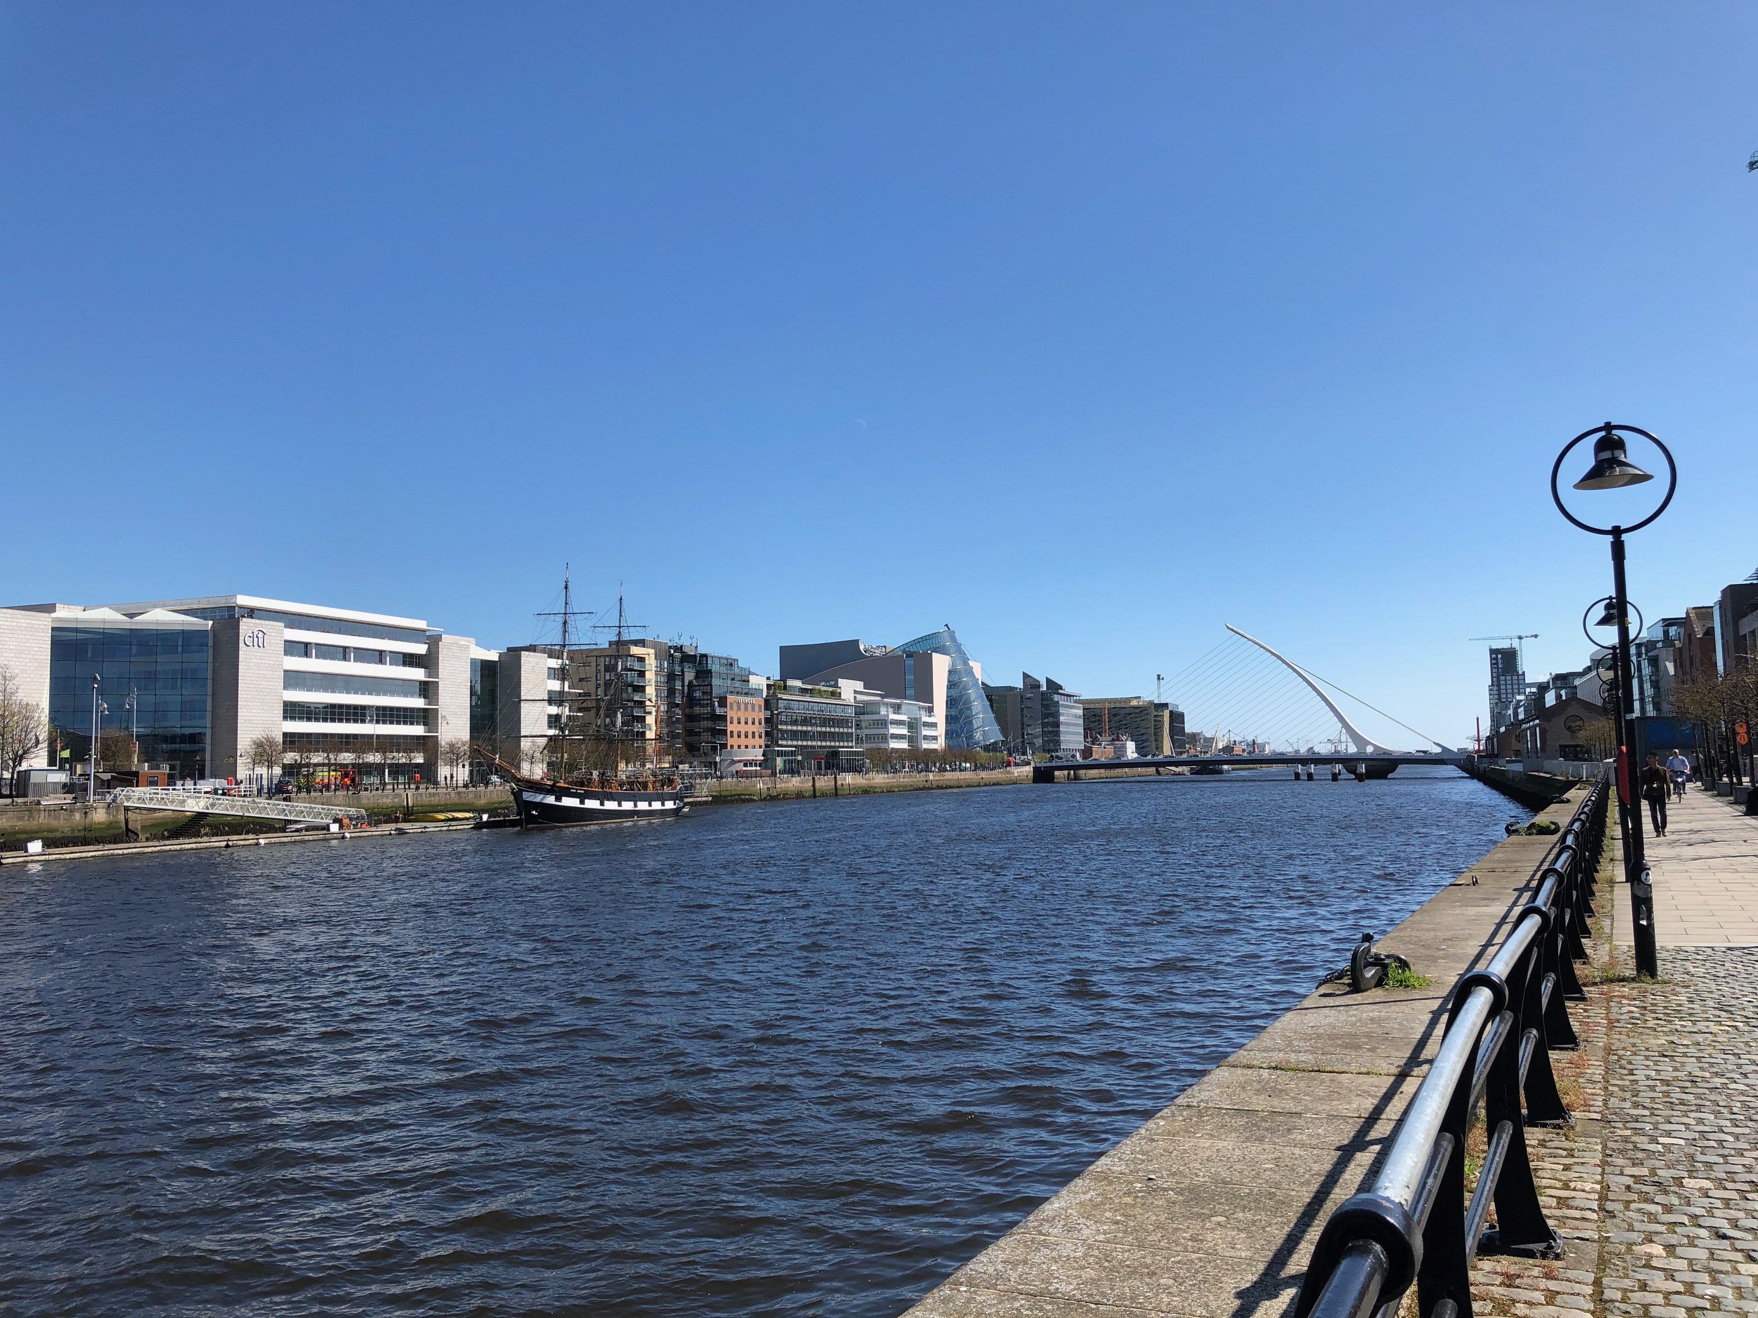  
A picture of Dublin

Keep adding text after the image