Database Design for "FORYOU AGENCY- A classic travel agency"
Student Name: Tursunaliyev Javohir
Student Number: 2427229
Module: 5CI022 Databases
Part A – Business Analysis :
1. Business Overview
FORYOU Agency is a classic travel agency that specializes in providing travel planning services, including booking flights, hotels, car rentals, and offering tour packages. The agency caters to both individual travelers and corporate clients, aiming to deliver seamless and customized travel experiences.
2. Business Rules
The following business rules define how the agency operates:
- Customer Management: Each customer (individual or corporate) must have a unique profile, including personal details (name, contact information) and preferences (e.g., travel destinations, budget).
- Booking Management: Every booking (flights, hotels, or packages) must be associated with a customer profile and include booking details such as travel dates, destinations, costs, and payment status.
- Service Providers: The agency collaborates with multiple service providers, such as airlines, hotels, and car rental companies. Each provider must be registered in the system with detailed information (name, services offered, pricing, and contact details).
- Payments: Payments must be tracked for every transaction, specifying the payment method, amount, and status (pending, completed, or refunded).
- Feedback and Reviews: Customers can leave feedback for services rendered, which must be linked to their profile and booking history.
4. Importance of Data
The data is crucial for the following reasons:
- Efficient Operations: Centralized data enables seamless coordination between customers, service providers, and the agency.
- Customer Satisfaction: Storing customer preferences allows for personalized travel experiences.
- Revenue Tracking: Payment data ensures accurate financial records and facilitates audits.
- Service Quality: Feedback helps identify areas for improvement and maintain high service standards.
- Compliance: Accurate records ensure compliance with legal and regulatory requirements.
5. Legal and Ethical Issues
Managing data for a travel agency involves addressing several legal and ethical considerations:
Legal Issues
- Data Protection Laws: Compliance with regulations like GDPR (General Data Protection Regulation) or CCPA (California Consumer Privacy Act) to ensure customer data privacy.
- Data Retention: Ensuring data is stored only for the legally permitted duration.
- Security Breaches: Implementing robust security measures to prevent unauthorized access to sensitive data.
Ethical Issues
- Privacy: Collecting only necessary customer data and obtaining explicit consent for its use.
- Transparency: Clearly communicating how customer data will be used and stored.
- Non-Discrimination: Avoiding biases in service delivery based on customer data.

Part B – Entity Relationship Diagram:
Entities
- Customer Data: Name, contact information, Status.
- Booking : Booking ID, TD(Travel Details) ID, cost.
- Travel Details: ID, Period, fly date, destination.
- Payment: Booking ID, amount, payment method.
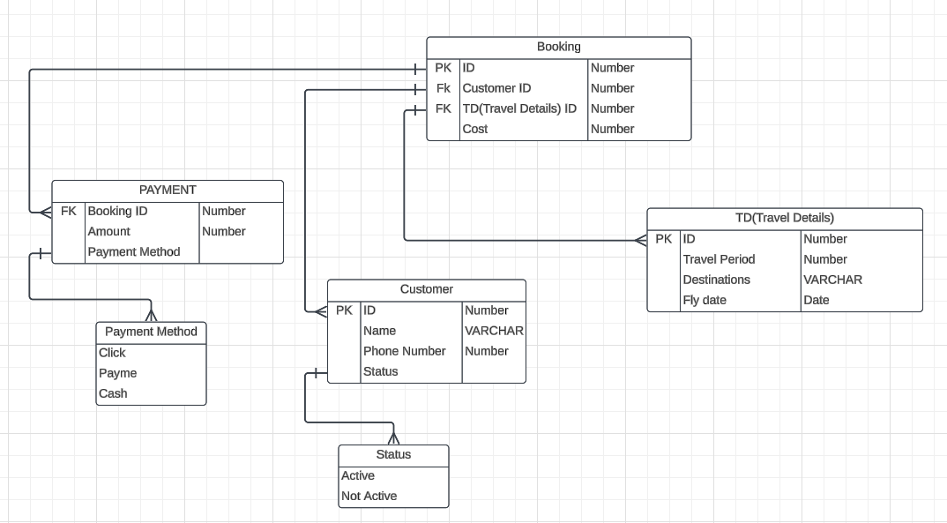

Part C – Relational Table Headings:
- Customer Data: Name, contact information, Status.
- Booking : Booking ID, TD(Travel Details) ID, cost.
- Travel Details: ID, Period, fly date, destination.
- Payment: Booking ID, amount, payment method.

Part D – SQL Script:
CREATE TABLE Customer (
ID NUMBER PRIMARY KEY,
Name VARCHAR2(100),
PhoneNumber NUMBER,
Status VARCHAR2(20)
);
CREATE TABLE Status (
Status VARCHAR2(20) PRIMARY KEY
);
CREATE TABLE TD (
ID NUMBER PRIMARY KEY,
TravelPeriod NUMBER,
Destinations VARCHAR2(255),
FlyDate DATE
);
CREATE TABLE Booking (
ID NUMBER PRIMARY KEY,
CustomerID NUMBER,
TD_ID NUMBER,
Cost NUMBER,
CONSTRAINT FK_Booking_Customer FOREIGN KEY (CustomerID) REFERENCES Customer(ID),
CONSTRAINT FK_Booking_TD FOREIGN KEY (TD_ID) REFERENCES TD(ID)
);
CREATE TABLE Payment (
BookingID NUMBER,
Amount NUMBER,
PaymentMethod VARCHAR2(50),
CONSTRAINT FK_Payment_Booking FOREIGN KEY (BookingID) REFERENCES Booking(ID)
);

CREATE TABLE PaymentMethod (
PaymentMethod VARCHAR2(50) PRIMARY KEY
);

Part E – Populating Tables:
SELECT * FROM Customer;
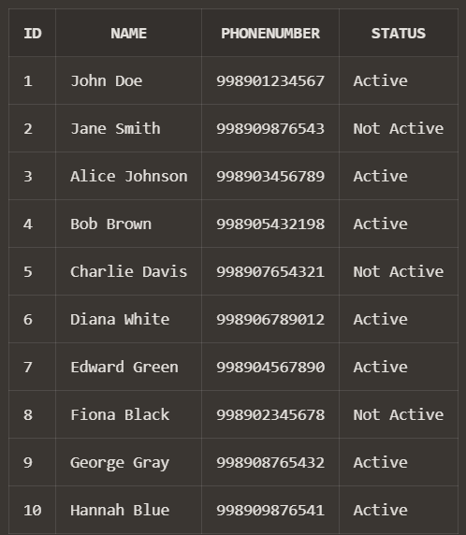
SELECT * FROM TD;
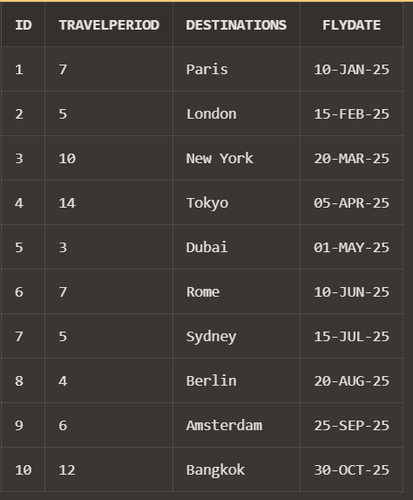
SELECT * FROM Booking;
