How do Cloud systems and solutions compare with traditionally hosted systems (either in-house or out-sourced), in terms of performance, security, cost and reliability?

Introduction
In the current circumstances where businesses are being operated in a digital manner, there is now more than ever a need for flexible, secure and cheap means of support of the IT department. In the modern-day world, corporate ventures, learning institutions and even governmental bodies rely so much on data storage, software relays and networking services. One major divided for any firm in today’s world is to decide on whether to go for cloud computing solutions or to go in for the conventional hosting services either adopting internal infrastructures or outsourced those to some third party data centers.
Cloud computing, which is a new or relatively new method in the management and supply of IT services, has recently emerged as a dominant business trend. In the current world, organizations do not have to invest in physical servers within their buildings to host their applications (traditional hosting); there are options such as AWS, Microsoft Azure, Google Cloud Platform among others, which offer stronger cloud platforms. These are Web-based solutions where users could access computers, storage, applications and other IT resources from anywhere and on an as-needed basis, a feature that most traditional IT systems cannot offer.
Another good example is Netflix; this company migrated their IT systems to AWS to manage traffic, content streaming, and personalized content for the global markets. Prior to this migration, Netflix used conventional structured data centers that were highly inefficiency in irregular traffic volume that may be experienced particularly during major series release episodes. Only by entering the cloud services, Netflix received an opportunity to scale the resources and improve performance and user satisfaction with a minimum of risks for constructing the downtime.
However, various companies such as; financial establishments and government bodies, persist with the traditional hosting solutions due to compliance and regulatory laws and policies, and full control of the resources used. As of now, numerous banks face certain limitations since many of them utilize vast numbers of legacy systems hosted in the on-premise data centers caused by the concerns of data sovereignty, compliance, and security. Such systems are mostly complex, costly with respect to maintenance, posses incredible difficulties in expansion and cannot easily incorporate new requirements from the business environment.
Another relevant example includes the British Airways IT failure that occurred in 2017 and was associated with a power supply problem of one of its traditional data center. This disrupted the operations in the whole world it caused cancellation of flights and impacted thousands of passengers. This was a lesson on the consequences of planning information technology infrastructure strictly with no redundancy or even cloud infrastructure failover contingency measures.
It is not just a technology decision as it influences business processes’ efficiency, security threat, costs, and opportunities to develop new solutions. As the business becomes more competitive and the demands of customers are higher, it is crucial to realize the advantages and drawbacks of both methods. This paper shall also compare and contrast between cloud systems and traditional hosting under four factors namely performance, security, cost and reliability and highlight real life effects of the options chosen.

Performance
Performance is central in measuring IT infrastructure since it defines options for the speed of applications, customer satisfaction, and the flexibility of service delivery in relation to clientele increase. Cloud systems tend to be better prepared for this aspect when compared to the conventional hosting since they offer the agility of resizing resources as the need arises or allocating the load across geographical regions or automatically scaling up during a particular period of high traffic. AWS, Google Cloud, and Microsoft Azure are some of the cloud service providers, which make use of auto-scaling, load balancing as well as geographically dispersed server networks, making it possible to deliver response time to these users around the world. A great example of this is Netflix – a company that migrated from hundreds of on-premise data centers to complete dependence on Amazon Web Services. Before the migration, Netflix had problems with the performance of the website during the peak client visits such as during the release of new series. As a result of the adoption of cloud services, big viewership can be met on demand, meaning that the company can easily adapt according to the amount of the traffic by adjusting the capacity in response to more than 200 million subscribers by location or hours of the day.
However, many of the known traditional hosted systems particularly the ones managed within organizations’ infrastructure lack scalability and flexibility. Such systems are usually implemented subject to the confines of the available basic hardware installations of the site. For instance, at this time, most of the university IT departments still use conventional means of hosting. Those are normally periods that a university may receive thousands of students who attempt to login to the system, and this may lead to breakdown of the site, or slow internet connection. Traditionally, there is typically no capability to dynamically add more computing capacity in response to user needs since it is often a manual process and known in advance. Outsourced traditional hosting, which with certain degree of scalability is more than in-house systems, still lacks the real time scale and flexibility of cloud environments.
Also, cloud platforms also have continuous upgrades in their hardware by the providers by insisting their clients to take the updates at their end so that the client does not have to invest on new apparatus. In case of traditional hosting, organizations have to factor their budget and schedules for the hardware refresh, which may last for every few years to retain the performance and this a task that may be time consuming as well as costly at the same time.
To sum up, there is no doubt and qualm about cloud systems’ performance dominance over the traditional client-server systems. In light of this, they are favorable for any organization with performance-intensive applications because of their physical scale on demand, means of handling global traffic and incorporating new technologies. Enterprise hosting can still be relevant in certain cases where the loads are not very dynamic or constantly arising in the case of small or more stable projects.
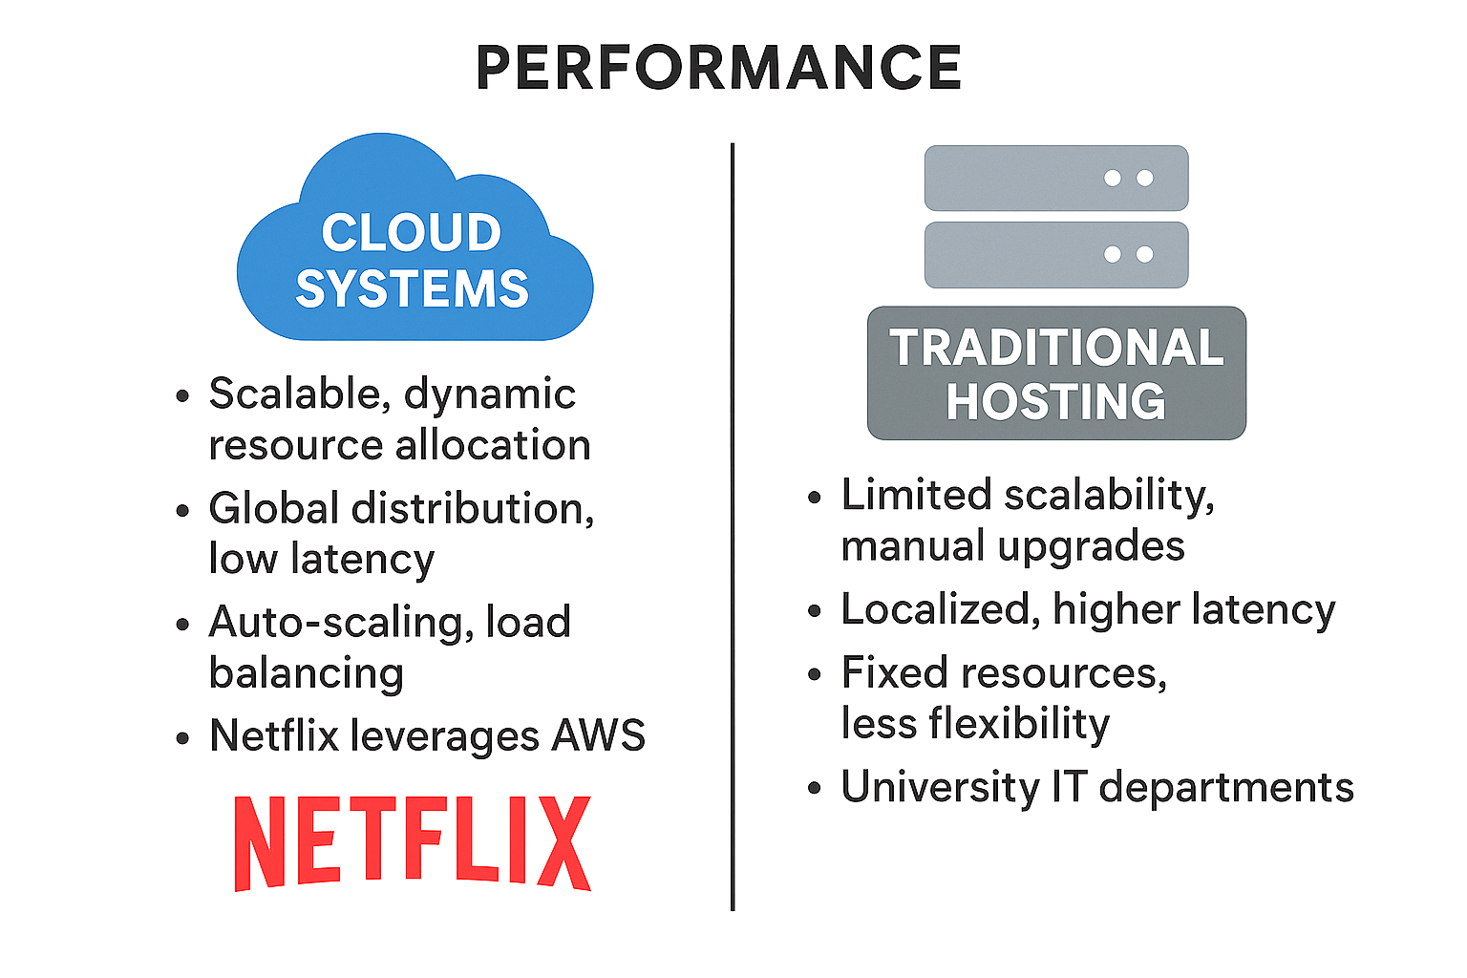

Security
Security is a valuable aspect that many organizations consider especially those businesses that deal with customer or business information. Cloud services often come with elaborate structures of security that are corporate-level and managed by personnel. AWS, Microsoft Azure, and Google Cloud are providers that possess end-to-end encryption; multi-factor authentication (MFA); firewalls; data loss prevention (DLP); and identity and access management (IAM). These platforms also meet High Level Regulations like ISO 27001, SOC 2, HIPAA, and GDPR. For example, Capital One, a major U.S. bank, leverages AWS’s cloud security tools like Amazon GuardDuty and Macie for threat detection and data protection. Despite having a breach in 2019 due to a misconfigured firewall, the consumer of the shared responsibility model of cloud security has enabled them to detect, respond and remediate the problem much faster than other traditional systems.
On the other hand, traditional Hosting systems- particularly those hosted within organizations premises offer complete control over physical as well as logical security but they require more accountability. Organizations have to deploy firewalls and monitoring systems, backup copies and schedule for patches as well. This requires having dedicated staff focused on information security and this has to remain a continuous process. Concerning traditional systems, one can recall the spectacular attack on Sony picture in 2014 when the attackers were able to infiltrate through the poorly protected local servers and make public extensive information. Studies showed that the attack could have been avoided if there was a proper segmentation of their networks and better monitoring which is currently offered by many cloud service providers as standard offerings.
While, the pure-play information systems offer the client/NAS complete control over all parameters, leaves no loopholes as known to the cloud shared responsibility model where while the cloud service provider ensures the infrastructure their side customer ensure the configurations on their side are stronger and updated. Generally, cloud systems are safer and easier to manage for such small organizations that do not have to hire a cybersecurity team.
Cost
Costs form a major consideration when comparing cloud systems to traditional hosting since the two concepts have different impacts on employee and enterprise costs. Cloud computing is On Demand as its costing model means that it uses subscription or direct costing which really minimizes the capital expenditures (Capex). Suppliers can charge according to what the businesses consume; it could be storage, time to compute, or bandwidth among others; businesses can expand or reduce on the services they get as required. A notable example is Airbnb that relays on AWS to manage infrastructure expenditure real time with The614 in accordance with the travel rate. In cases of high demand, the use of the system increases to accommodate the high levels of traffic; during low activities, the system also reduces its capacity to avoid accruing costs that Airbnb cannot afford. This flexibility means that the cost and operations of businesses running such systems are well contained.
Instead, traditional hosting systems cost substantial money in investing in hardware, software and physical server premises. They also always have costs like power consumption, cooling expenses, costs of maintaining the hardware, and IT personnel’s costs of service. This can be rather problematic for small businesses or start-ups that are not able to afford such capital-intensive adjustment during most of the time but are forced to because of increased traffic. For instance, most of the Banking and insurance industries nowadays still align their mainframe systems either offshore or by co-location. Nevertheless, these systems may provide stable performance for the small repetitive, high but occasional throughput rate batch jobs with relatively high costs, maintenance fees and lack of freedom for frequently changing or extending the components.
Further, the conventional systems undergo hardware renewal every 3-5 years regarding operations, which contributes to the long-run expenses. On the other hand, cloud users are relieved from automatically upgraded hardware and all it entails that are undertaken by the cloud provider solely. When it comes to cost efficiency for people who aim to change from IT capital-intensive levels to operational models, cloud systems are much more cost effective in the long run.

Reliability
Reliability has to do with a system’s availability, frequency and duration of its failure, as well as its ability to resume operation as soon as possible. Clouds are integrated with mechanical redundancy, liability, and failover capabilities. Most of the major providers provide SLAs that promise to provide and service uptime of 99.9% and above and this they achieve through having different data centers all over the world and an auto failover system. For instance, Dropbox was initially built 100% for AWS to leverage on the cloud solution’s service in offering high availability since it has distribution centers all over the world. Also, from its recent move to a dedicated cloud infrastructure, Dropbox also follows principles of the cloud, including data replication and data replication by regions to provide almost uninterrupted service in case of outages.
On the other hand, the traditionally hosted systems especially those that are internally managed are more vulnerable to localized calamities like power failures, hardware crashes, and data corruptions. While with regular backup and restore scenarios require manual intervention, the failover systems involve the use of extra facilities that may be costly. A popular example in this regard which happened to British Airways in 2017 was a power failure that occurred at one of its main data center and led to cancellation of flights and its impact was all across the world as it affected over 75,000 passengers. This proved to be very costly to the company, as they lost millions of pounds and pointed to the lack of utilizing cloud infrastructures whether secondary or standby.
In case one server or region, in particular, goes down then the traffic is automatically redirected to a new healthy region; hence, continuity in business. This highlight proves that the traditional hosting, that lacks the above characteristics, is much more complex and resource consuming to achieve the same degree of reliability. For many organizations of the present generation especially those that operate around the clock cloud system proves more reliable and tolerant of faults.

Summary
This paper aims at comparing cloud systems with traditional hosting services which can be either self-hosted or hosted through third-party service providers. The paper covers four important categories: performance, security, cost, and reliability and uses examples to explain the benefits and practical applicability of each method.
In the aspect of performance, cloud systems are quite distinct because of the fact that they are scalable and are available in many places around the globe. AWS, Google Cloud, as well as, Azure employs auto-scaling, global CDN, and load balancing to guarantee that applications are fast when faced with various traffic loads. One of the good examples is the company Netflix which switched to AWS to deal with the fluctuating and sudden increase of its users all over the world. These are not easily handled by traditional systems, especially those in-house data centers, because they are rigid in terms of the resource configurations because they are built using hardware infrastructures, as is evident with university student portal during admission or exam time.
In security perspective cloud providers have well equipped secure and up to date solutions with well-coordinated security teams and compliance to ISO, SOC, GDPR and others. There is availability and real time tracking, automated backups and controllers of the access to Networks and files constituting cloud. For example, threat detection and data protection in Capital One incorporates AWS built-in security features. However, it is imperative to understand that, cloud security only provides security measures for the customers and deployments are shared responsibility security model, customers have to configure their environment properly. Traditional hosting on the other hand gives organizations full control over the security setup; this is handy for a company dealing with sensitive data such as banks though it might prove to be a disadvantage in the end since IT is fully responsible for security monitoring and management, as epitomized by Sony Pictures’ cyberattack.
Concerning the cost, the cloud systems are very agile and work on an operational expense (OpEx) mode where the customer is billed based on the resources consumed. A company such as Airbnb has been served well with this model as it is able to scale up or down infrastructure as convenient depending on need thus cutting down on costs that cannot be incurred. Conventional architectures however are based on the capital expenditure (CapEx) model where they have to invest heavily on centralized hardware, their maintenance and real estate infrastructure. While the traditional models of products may still be adequate for organizations that do not experience a lot of fluctuations in the amount of work done, the opportunities offered by cloud platforms are more flexible and, in the long term, more cost-effective.
Last but not the least in the discussion on reliability, cloud platform is designed to consider physical maintenance, high availability, and disaster recovery. Some providers provide an assurance of uptimes of 99.9 percent and most of them have auto failover systems that can redirect services in case of outages. A firm such as Dropbox employs such cloud architecture for the delivery of services in various parts of the globe. Traditional systems are highly exposed to the problem of hardware breakdowns and data loss if no large amounts to money is spent on making copies. The British Airways IT failure in the year 2017 clearly depicted the impact of outages that occurred in the non-cloud environments resulting into major service disruptions and monetary losses.
In conclusion, cloud consists of high viability, functionality, and efficiency than other IT solutions especially for organizations with flexibility demands, global access, and better security featuresCurrently, it is noticeable that many companies seek to use both private and public clouds as complementary to build a well-balanced IT system. Of course, the decision depends on the size, objectives and risk characteristic, but in most of the cases, contemporary usage advise cloud solutions.

