**INHA UNIVERSITY TASHKENT**

**DEPARTMENT OF CSE & ICE**

**FALL SEMESTER 2022**

**NTS4090 - BLOCKCHAIN BASICS & PLATFORMS**

**HOME ASSIGNMENT1/**

**TERM PROJECT 1**

**Submitted by**

**Mirzaakbarov Javokhirbek U1910279 001**

**Gulomov Shokhrukhmirzo U1910272 001**

**Mukhammadjonov Samandar U1910249 001**

**Urmonov Azizbek U1910288 001**

**Khalimetov Mukhiddin U1910274 001**

**Yangiboev Komiljon U1910221 001**

**Group : SENIOR TEAM 24**

**INSTRUCTIONS :**

* **ALL HOME ASSIGNMENTS/TERMPROJECTS ARE TO BE COMPLETED IN GROUPS OF 4 TO 8 MEMBERS**
* **SCREEN SHOTS ARE TO BE PROVIDED FOR ALL THE QUESTIONS**
* **HOME ASSIGNMENT/TERM PROJECT REPORT SHOULD BE PREPARED USING THE TEMPLATE PROVIDED**
* **EVERY MEMBER OF THE TEAM MUST UPLOAD THE SOFTCOPY OF THE REPORT AT THE ECLASS PORTAL**
* **LAST DATE FOR SUBMISSION OF THE HOME ASSIGNMENT IS FRIDAY 30th SEPTEMBER 2022**
* **LATE SUBMISSIONS ARE NOT ENTERTAINED, ADHERE TO THE DEADLINE STRICTLY**
* **READ THE QUESTIONS CORRECTLY & CAREFULLY**

**PART - A**

**HOME ASSIGNMENT 1**

**QUESTION 1**

**Analyze BITCOIN BLOCKCHAIN structure by taking at least SIX x N recently added blocks from the bitcoin blockchain by visiting the website: ww.blockchain.com/btc/blocks.**

**[A] PROVIDE THE VALUES IN THE FOLLOWING FIELDS IN THESE SIX x N BLOCKS USING THE FOLLOWING FORMAT:**

**BLOCK # …………………….**

**(i) Hash (Block Hash)**

**(ii) Confirmations**

**(iii) Timestamp**

**(iv) Height**

**(v) Miner**

**(vi) Number of transactions**

**(vii) Difficulty**

**(viii) Merkle root**

**(ix) Version**

**(x) Bits**

**(xi) Weight**

(xii) Size

**(xiii) Nonce**

**(xiv) Transaction volume**

**(xv) Block Reward**

**(xvi) Fee Reward**

**(xvii) Describe clearly the details of a single transaction in this**

**block of Bitcoin Blockchain.**

**[B] INCLUDE THE SCREENSHOTS OF ALL THE BLOCKS SHOWING CLEARLY ALL THE FIELDS**

**Block #756,636**

|  |  |  |
| --- | --- | --- |
| **(i)** | **Hash(Block Hash)** | 0000000000000000000204540a2282694c658a6453dade49abed2b3992f9bcec |
| **(ii)** | **Confirmations** | 51 |
| **(iii)** | **Timestamp** | 02 Oct 2022, 06:06:42 |
| **(iv)** | **Height** | 756,636 |
| **(v)** | **Miner x** | AntPool |
| **(vi)** | **Number of transactions** | 1,676 |
| **(vii)** | **Difficulty** | 31,360,548,173,144.85 |
| **(viii)** | **Merkle root** | 91a551044638fb403b8e88c0a6902c27f8c72020dbd89ab2983737db5aac00b7 |
| **(ix)** | **Version** | 0x20000000 |
| **(x)** | **Bits** | 386,464,174 |
| **(xi)** | **Weight** | 3,882,743 WU |
| **(xii)** | **Size** | 1,568,687 bytes |
| **(xiii)** | **Nonce** | 3,932,637,284 |
| **(xiv)** | **Transaction volume** | 11,836.20 BTC |
| **(xv)** | **Block Reward** | 6.31915314 BTC |
| **(xvi)** | **Fee Reward** | 0.06915314 BTC |

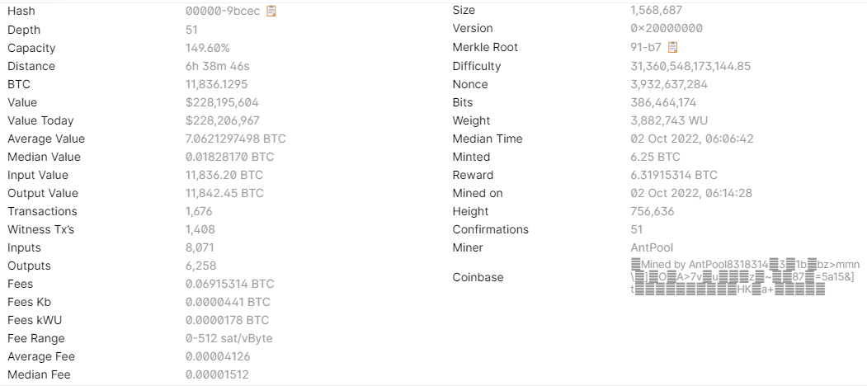

**Block #756,635**

|  |  |  |
| --- | --- | --- |
| **(i)** | **Hash(Block Hash)** | 00000000000000000002c41d6540d2b3c63411bb78fb7f7c28a7b15f1909d072 |
| **(ii)** | **Confirmations** | 56 |
| **(iii)** | **Timestamp** | 10/02/2022, 06:00:29 |
| **(iv)** | **Height** | 756,635 |
| **(v)** | **Miner x** | AntPool |
| **(vi)** | **Number of transactions** | 2,093 |
| **(vii)** | **Difficulty** | 31,360,548,173,144.85 |
| **(viii)** | **Merkle root** | 2f91141a3436bc628fce8f1f3b6a7ff51dbf66913ddfd04ec28129eaaeaa43a8 |
| **(ix)** | **Version** | 0x20e00000 |
| **(x)** | **Bits** | 386,464,174 |
| **(xi)** | **Weight** | 3,100,452 WU |
| **(xii)** | **Size** | 1,183,563 bytes |
| **(xiii)** | **Nonce** | 1,321,861,143 |
| **(xiv)** | **Transaction volume** | 11,928.69 BTC |
| **(xv)** | **Block Reward** | 6.32145779 BTC |
| **(xvi)** | **Fee Reward** | 0.07145779 BTC |

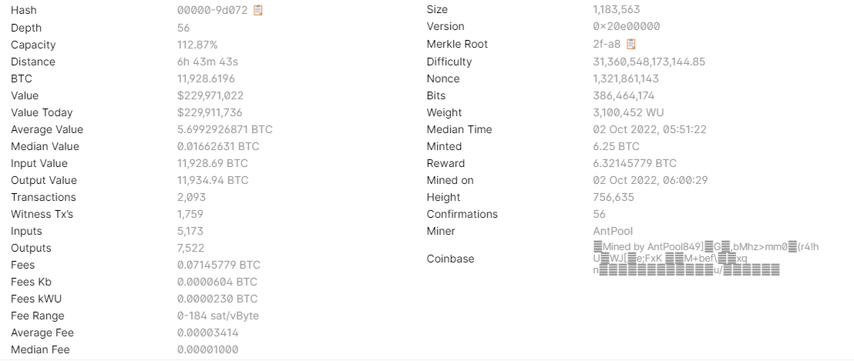

**Block #756,634**

|  |  |  |
| --- | --- | --- |
| **(i)** | **Hash(Block Hash)** | 00000000000000000002541a14f691e4a2807f8e9c20e4aad4a0a737190a4e2d |
| **(ii)** | **Confirmations** | 57 |
| **(iii)** | **Timestamp** | 10/02/2022, 05:44:00 |
| **(iv)** | **Height** | 756,634 |
| **(v)** | **Miner x** | AntPool |
| **(vi)** | **Number of transactions** | 788 |
| **(vii)** | **Difficulty** | 31,360,548,173,144.85 |
| **(viii)** | **Merkle root** | 3c235dd083adae7da010d49bc978fef189883001add380612e6438192bcbb000 |
| **(ix)** | **Version** | 0x20200000 |
| **(x)** | **Bits** | 386,464,174 |
| **(xi)** | **Weight** | 1,411,709 WU |
| **(xii)** | **Size** | 569,336 bytes |
| **(xiii)** | **Nonce** | 1,938,985,310 |
| **(xiv)** | **Transaction volume** | 1,208.89 BTC |
| **(xv)** | **Block Reward** | 6.27601306 BTC |
| **(xvi)** | **Fee Reward** | 0.02601306 BTC |

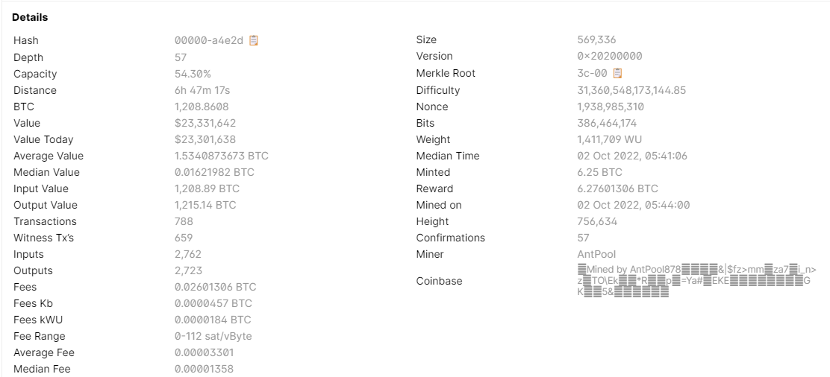

**Block #756,633**

|  |  |  |
| --- | --- | --- |
| **(i)** | **Hash(Block Hash)** | 000000000000000000023c76cc7cbee726cf56d7982336512fdb626b3483e751 |
| **(ii)** | **Confirmations** | 59 |
| **(iii)** | **Timestamp** | 10/02/2022, 05:38:41 |
| **(iv)** | **Height** | 756,633 |
| **(v)** | **Miner x** | AntPool |
| **(vi)** | **Number of transactions** | 1,540 |
| **(vii)** | **Difficulty** | 31,360,548,173,144.85 |
| **(viii)** | **Merkle root** | ca91c896c3e3b8a26a25ef105012d4f974f8c38cf339b379eaaaaebf4cee44cc |
| **(ix)** | **Version** | 0x3fff0000 |
| **(x)** | **Bits** | 386,464,174 |
| **(xi)** | **Weight** | 2,675,543 WU |
| **(xii)** | **Size** | 1,097,246 bytes |
| **(xiii)** | **Nonce** | 267,523,444 |
| **(xiv)** | **Transaction volume** | 2,046.66 BTC |
| **(xv)** | **Block Reward** | 6.27450173 BTC |
| **(xvi)** | **Fee Reward** | 0.02450173 BTC |

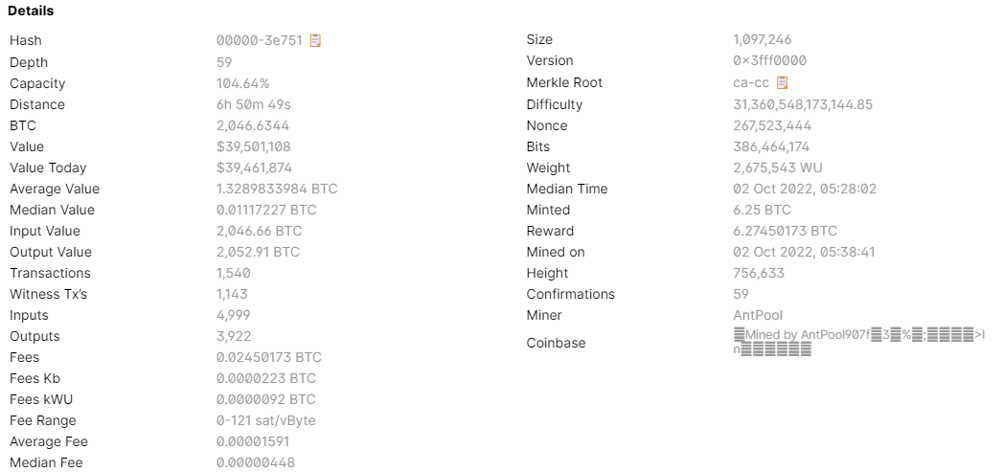

**Block #756,632**

|  |  |  |
| --- | --- | --- |
| **(i)** | **Hash(Block Hash)** | 00000000000000000006c9cc854fbb4b8dcd51f33474399fce4d8ec6e5301651 |
| **(ii)** | **Confirmations** | 60 |
| **(iii)** | **Timestamp** | 10/02/2022, 05:34:33 |
| **(iv)** | **Height** | 756,632 |
| **(v)** | **Miner x** | AntPool |
| **(vi)** | **Number of transactions** | 2,790 |
| **(vii)** | **Difficulty** | 31,360,548,173,144.85 |
| **(viii)** | **Merkle root** | 96881f6265e47e2af7860234bb572ca216da2643083b4d53d97f4d8799629488 |
| **(ix)** | **Version** | 0x200da000 |
| **(x)** | **Bits** | 386,464,174 |
| **(xi)** | **Weight** | 3,993,614 WU |
| **(xii)** | **Size** | 1,428,521 bytes |
| **(xiii)** | **Nonce** | 2,790,725,981 |
| **(xiv)** | **Transaction volume** | 26,660.79 BTC |
| **(xv)** | **Block Reward** | 6.37949546 BTC |
| **(xvi)** | **Fee Reward** | 0.12949546 BTC |

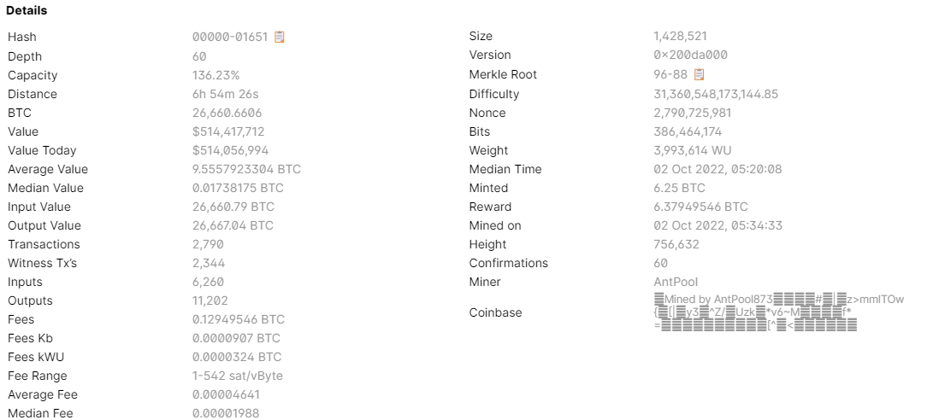

**Block #756,631**

|  |  |  |
| --- | --- | --- |
| **(i)** | **Hash(Block Hash)** | 0000000000000000000457218faf1677ba52120aa4eb8accb600be99113b8f7d |
| **(ii)** | **Confirmations** | 61 |
| **(iii)** | **Timestamp** | 10/02/2022, 05:06:14 |
| **(iv)** | **Height** | 756,631 |
| **(v)** | **Miner x** | ViaBTC |
| **(vi)** | **Number of transactions** | 586 |
| **(vii)** | **Difficulty** | 31,360,548,173,144.85 |
| **(viii)** | **Merkle root** | 36cd3f5f14ca136fcf191199862d139b7c7006ded6a3d0010057bc53f1d31360 |
| **(ix)** | **Version** | 0x20600000 |
| **(x)** | **Bits** | 386,464,174 |
| **(xi)** | **Weight** | 2,542,455 WU |
| **(xii)** | **Size** | 928,899 bytes |
| **(xiii)** | **Nonce** | 3,391,660,873 |
| **(xiv)** | **Transaction volume** | 812.24 BTC |
| **(xv)** | **Block Reward** | 6.30309723 BTC |
| **(xvi)** | **Fee Reward** | 0.05309723 BTC |

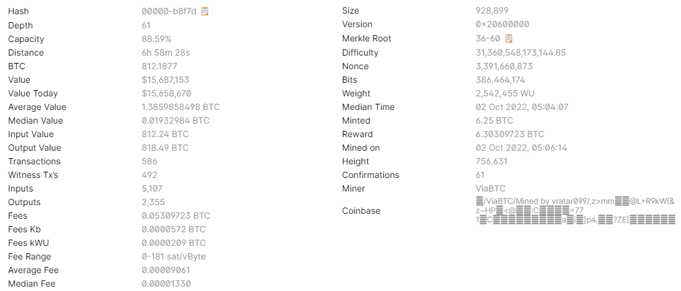

**[C] DRAW THE BLOCKCHAIN SHOWING HOW THESE BLOCKS ARE CHAINED BY PROVIDING ONLY THE REQUIRED FIELD INFORMATIONS IN THESE BLOCKS.**

In order to show how block chained together we used [Blockchain Data API](https://www.blockchain.com/api/blockchain_api). As you can see, hash of old block is same as prev_block indicated in the response of new block.

**BLOCK #756,636**

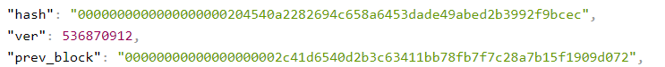

**BLOCK #756,635**

**BLOCK #756,634**

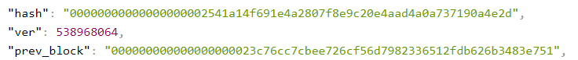

**BLOCK #756,633**

**BLOCK #756,632**



**BLOCK #756,631**

