**TASK-4**

**Name – J.DHANUSH**

**Roll No – 2420090042**

**Section - 2**

**Construction of Different VLANS and TRUNKING using Cisco Packet Tracer**

Step 1: Setting Up the Network Topology

Network Architecture

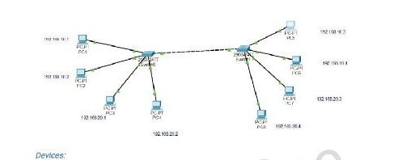

Devices:

* Switch 1 (S1)
* Switch 2 (S2)
* PCs (End Devices)
  + PC1 and PC2 connected to S1 (assigned to VLAN 10)
  + PC3 and PC4 connected to S1 (assigned to VLAN 20)
  + PC5 and PC6 connected to S2 (assigned to VLAN 10)
  + PC7 and PC8 connected to S2 (assigned to VLAN 20)

VLANs:

* VLAN 10: IP range 192.168.10.0/24
* VLAN 20: IP range 192.168.20.0/24

Trunk Ports:

* Fa0/24 on both S1 and S2

**Configuration Steps**

**Step 1: Setting Up the Network Topology**

1. **Add Devices in Packet Tracer:**
   * Drag and drop two switches (S1 and S2).
   * Add PCs and connect them to the switches using copper straight-through cables.
   * Connect Fa0/24 of S1 to Fa0/24 of S2 using a cross-over cable.

**Switch 0 Configuration**

Switch>enable

Switch#configure terminal

Enter configuration commands, one per line. End with CNTL/Z.

**Create VLAN 10**

Switch(config)#vlan 10

Switch(config-vlan)#name VLAN10

Switch(config-vlan)#exit

**Create VLAN 20**

Switch(config)#vlan 20

Switch(config-vlan)#name VLAN20

Switch(config-vlan)#exit

**Create VLAN 10**

Switch(config)#interface range fa0/1 - 4

Switch(config-if-range)#switchport mode access

Switch(config-if-range)#switchport access vlan 10

Switch(config-if-range)#exit

**Create VLAN 20**

Switch(config)#interface range fa0/5 - 8

Switch(config-if-range)#switchport mode access

Switch(config-if-range)#switchport access vlan 20

Switch(config-if-range)#exit

Set a Port to Trunk Mode: S0

Switch(config)#interface fa0/24

Switch(config-if)#switchport mode trunk

Switch(config-if)#exit

**Switch(config)#**

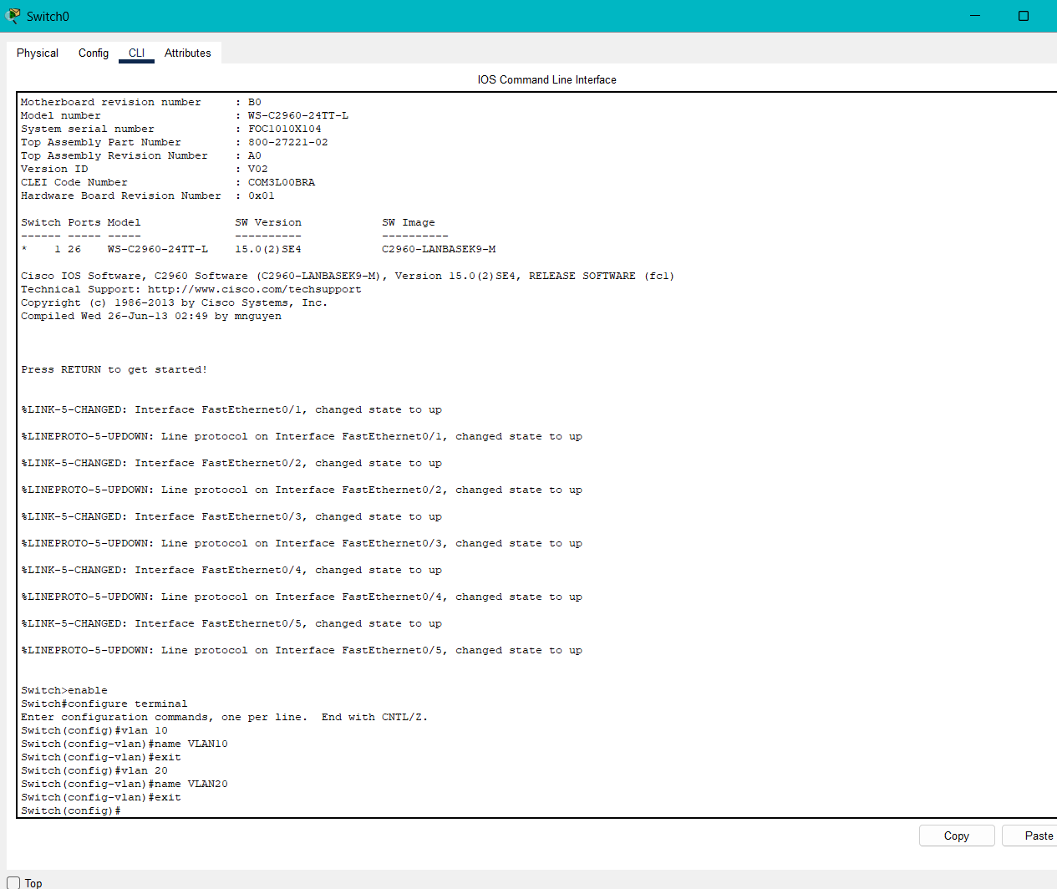

**Switch 1 configuration**

Switch>enable

Switch#configure terminal

Enter configuration commands, one per line. End with CNTL/Z.

**Create VLAN 10**

Switch(config)#vlan 10

Switch(config-vlan)#name VLAN10

Switch(config-vlan)#exit

**Create VLAN 20**

Switch(config)#vlan 20

Switch(config-vlan)#name VLAN20

Switch(config-vlan)#exit

**Create VLAN 10**

Switch(config)#interface range fa0/1 - 4

Switch(config-if-range)#switchport mode access

Switch(config-if-range)#switchport access vlan 10

Switch(config-if-range)#exit

**Create VLAN 20**

Switch(config)#interface range fa0/5 - 8

Switch(config-if-range)#switchport mode access

Switch(config-if-range)#switchport access vlan 20

Switch(config-if-range)#exit

**Assign Ports to VLAN 20:**

Switch(config)#interface range fa0/5 - 8

Switch(config-if-range)#switchport mode access

Switch(config-if-range)#switchport access vlan 20

Switch(config-if-range)#exit

**Configuring Trunking on Switch 1**

Switch(config)#interface fa0/24

Switch(config-if)#switchport mode trunk

Switch(config-if)#exit

Switch#

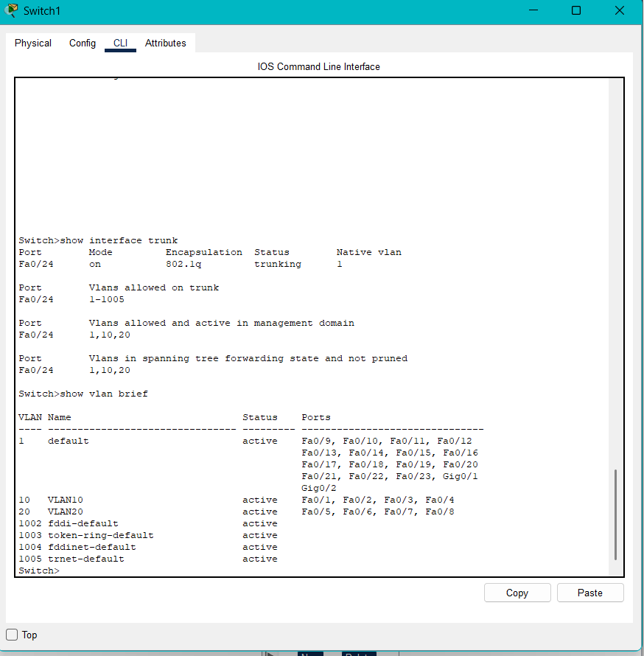

Verify Connectivity

* 1. Check Trunk Ports:

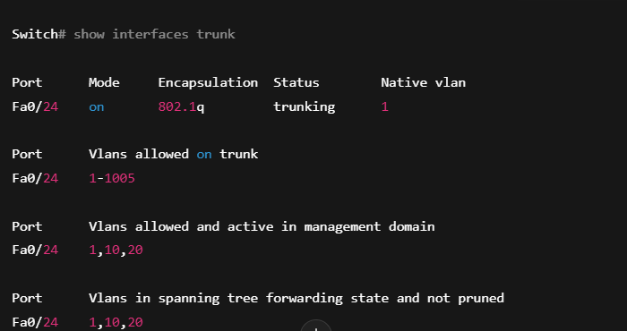

Check VLANs:

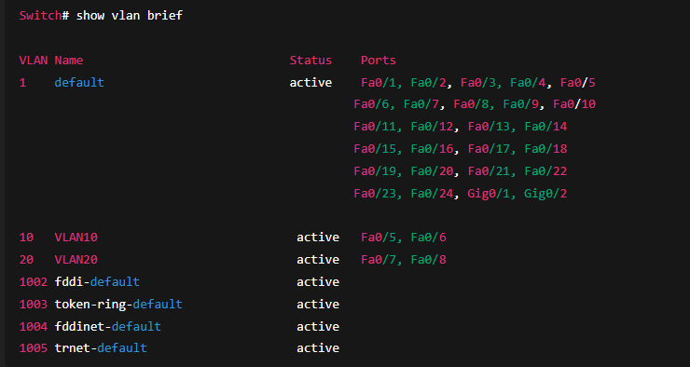

**Step 5: Configure End Devices**

1. **Assign IP Addresses to PCs:**

* PC1: 192.168.10.1/24
* PC2: 192.168.10.2/24
* PC3: 192.168.20.1/24
* PC4: 192.168.20.2/24
* PC5: 192.168.10.3/24
* PC6: 192.168.10.4/24
* PC7: 192.168.20.3/24
* PC8: 192.168.20.4/24

1. **Test Connectivity within VLANs:**

* Ping from PC1 to PC2 (both in VLAN 10)
* Ping from PC3 to PC4 (both in VLAN 20)
* Ping from PC5 to PC1 (both in VLAN 10, across switches)
* Ping from PC7 to PC3 (both in VLAN 20, across switches)

**3.Verify that PCs in different VLANs cannot communicate without a router:**

* Ping from PC1 to PC3 should fail (VLAN 10 to VLAN 20)
* Ping from PC7 to PC1
* 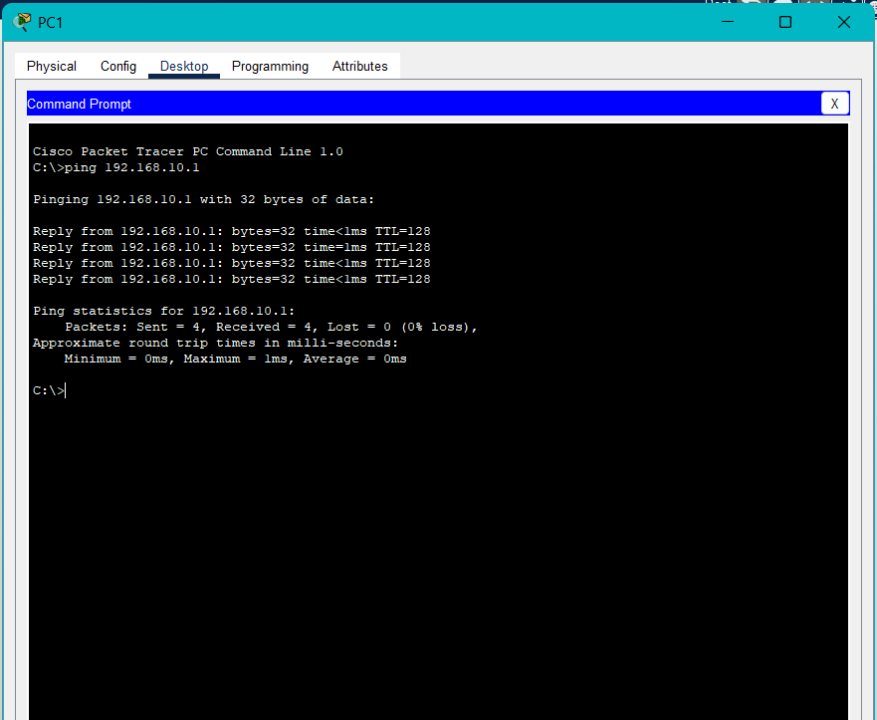

**Step 5: Configure End Devices**

1. **Assign IP Addresses to PCs:**

* PC1: 192.168.10.1/24
* PC2: 192.168.10.2/24
* PC3: 192.168.20.1/24
* PC4: 192.168.20.2/24
* PC5: 192.168.10.3/24
* PC6: 192.168.10.4/24
* PC7: 192.168.20.3/24
* PC8: 192.168.20.4/24

1. **Test Connectivity within VLANs:**

* Ping from PC1 to PC2 (both in VLAN 10)
* Ping from PC3 to PC4 (both in VLAN 20)
* Ping from PC5 to PC1 (both in VLAN 10, across switches)
* Ping from PC7 to PC3 (both in VLAN 20, across switches)

**3.Verify that PCs in different VLANs cannot communicate without a router:**

* Ping from PC1 to PC3 should fail (VLAN 10 to VLAN 20)
* Ping from PC7 to PC1

