**TASK-5**

**Name –** J.DHANUSH **Section -** 2

**Roll number:** 2420090042

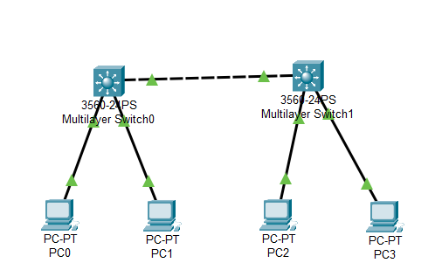

**Step-by-Step configuration:**

1. Open Cisco Packet Tracer in your Device.
2. Add 2 Switches**(Switch 3560-24PS)** and connect them using Copper cross-through wire.
3. Add 4 PC’s and connect PC-0,1 to switch-0 and PC-2,3 to switch-1 using Copper Straight- through wire.

**Configure VLAN on Switch:**

1. Access the Switch CLI:
2. Click on Switch-0
3. Navigate to CLI
4. Enter this in the CLI to Create VLAN’s, Assign ports to VLAN and Configure Trunk on Switch.

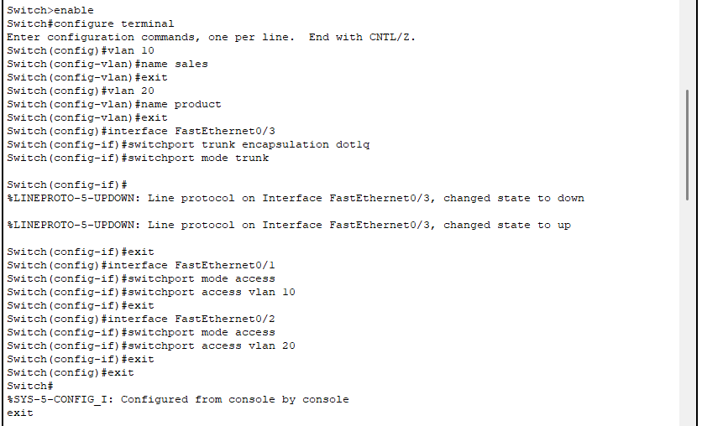

**Assign IP Addresses to PC’s:**

1. Click on PC-0 and enter this
2. IP configuration : 192.168.10.2
3. Subnet Mask : 255.255.255.0
4. Gateway : 192.168.10.1
5. Click on PC-1 and enter this
6. IP configuration : 192.168.20.2
7. Subnet Mask : 255.255.255.0
8. Gateway : 192.168.20.1

**Verify Configuration:**

1. Open CLI on Switch-0
2. Enter : show vlan brief

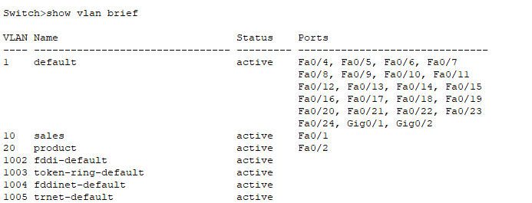

**Check Trunk Ports:**

1. Open CLI in Switch-0
2. Enter : show interfaces trunk

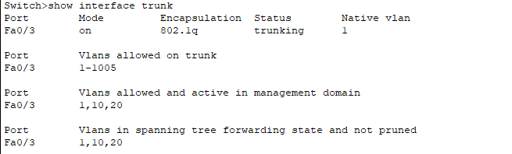

**Test Connectivity:**

1. Click on PC-0
2. Enter : ping 192.168.10.2

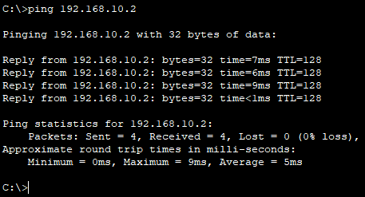

1. Click on PC-1
2. Enter : ping 192.168.20.2

