Polygon Puzzle User Manual
How to install 2
How to play 3
Reskin 4
Basic Game Settings 5
Setup your own bundle ID 5
Other game information 5
Advanced Scripts 5
Scripts Outline 5
Change piece sizes 6
How the Json Data works 6
Important API and functions 9
Make your own puzzle gallery 10
Ready enough materials 10
Cover the new created texture 10
Setup in the scripts 11
Scores 12
Switch game mode 12
Use as in-game puzzle 13
In app purchase 14
Localization 16
Ready your localization file 16
Add new language to system 16
Publish to appstore 18
Ready Dotween 18
If you are using plugin such as Ads. 18
Basic knowleage must know 20
build and submit a game on app store with unity. 20
build and apk on android platform 20
create iap on goolgeplay 20
create iap on apple console(please ignore code part) 20

How to install
Make sure the inspector panel include tags and layers which default project not have. Which means you have set up the project properly.
To test the game, search startscene by project panel of unity editor to found the scene file named startscene.
You can also found the scene files under
Assets/polypuzzle/gamelevel
Double click on it to active the scene. Then you can run the game correctly. Other scene files can running independently but you may not get correct level data for test without a correct initialization sequence.

Important!!!
As unity disallow uploading package including other package on store(even free).
If you want to upload your game to Apple appstore,
You should delete the minimal dotween dll and upload the full dotween package from official site manually.
Be easy. It is free. Just follow the steps
1.find …/scripts/tools/tweentool
there are 3 .dll files in it.
2.Delete this folder
3.download dotween from the official site or search dotween in asset store
4.Import dotween asset package
5.unity menu:"tools-dotween utility panel"
6 click setup dotween.

How to play
This was a classic game which you may already played in many places. The game rule were very clear even without a tutorial.
Drag the puzzle piece on below parts and try putting them upon to fill the board. When parts were intersected, you would not be able to put down the part. There would be a red frame flash under your grabbing piece which indicates the current rectangle area of your piece.

Reskin
The only thing you need to know about reskin is the unity sprite or the unity ui image. Find the referring picture sources by just click on the image/sprite component on each gameobject from editor window.
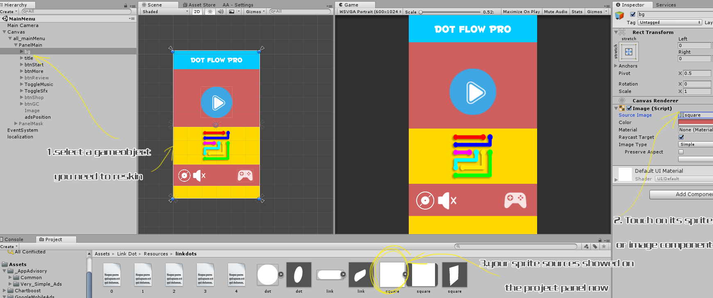
(zoom the picture by holding ctrl+mouse wheel)
All other resources were under
Assets/PolyPuzzle/Resources

Basic Game Settings

Setup your own bundle ID
Each game must have a different Bundle id. So you must made the id to fit the id you request from apple or gp.
File->build setting, open the build setting panel. Find and click player setting button.
On right inspector panel, touch other settings panels. Change buddle id in bundle identifier section.

Other game information
Type const.cs to search on project panel.
Pay attention for LEADER_BOARD_ID,appid.
These 2 relative your gamecenter id and your game app id.

Search and found
Application.OpenURL ("http://itunes.apple.com/WebObjects/MZSearch.woa/wa/search?submit=seeAllLockups&media=software&entity=software&term=
Change the url you need to be a more games link.

Advanced Scripts

Scripts Outline

Under Assets->PolyPuzzle->scripts folder. There are all scripts of the game. The major files’ detail were listed as below.
Const.cs: some parameters not for game but for your publish services like user id etc.
GameData.cs: Store the temporary variables of the game like score, level, time cost, etc. Can be called by Game.getInstance().xxx in any place of the game.
GameManager.cs: The most important file for initialize and process game controller service like music, advertisement, iap etc. Can be called by GameManager.getInstance().xxx in any place of the game.
LevelMenu: The level menu UI file. Attached on the UI root element of the levelmenu scene.
MainScript.cs: the game logical class. Attached on the gameobject of the game level scene. Process the game start ,retry,or the win or fail.
PanelMain.cs: Attached on the UI element of MainMenu (game title) Scene. Just deal with the things for game start, rate etc.
StartSplash.cs：File attached on the gameObject of startScene ,The start scene of the game. It initialize some forever exist object.
TipPanel.cs: process the UI events of the tip panel.Not used for this game yet.
Winpanel.cs:process the UI events of the game win panel.

Change piece sizes
in tangram.cs
int maxCol = 7;//how many pieces your want on a row mostly
float xgap = .2f;
float tShrink = 3f;
you can change these 3 parameters yourself.
The first depend on how many pieces you want mostly on a line. (exceed the count would change a row)
the xgap means the pieces gap on x
the tshrink is a zoom parameter. The lager it is, the smaller the pieces will be.
As the game got many levels. You can not make the blocks all "perfect" big with one same paramter.
So set a mid count or set different numbers refers to the pieces count as you wish.

How the Json Data works

For tangram game
The file 0-4.txt under polypuzzle/resources/tangram/
were all level data.
They are json data files.
Json was kind of a data format always be used for complicate data.

Let's open 0.txt first
See first line
{b:[{},{x:10},{x:10,y:10},{y:10},{}],p:[{o:{x:7,y:4},v:[{y:6},{},{x:3},{x:3,y:6},{y:6}],c:1,t:16,tr:{items:[0,3,2,2,1,0,0,0,0,0,0,0,0,0,0,0],size:6}},{o:{},v:[{},{x:10},{x:10,y:2},{x:5,y:2},{}],t:8,tr:{items:[0,3,2,2,1,0,0,0,0,0,0,0,0,0,0,0],size:6}},{o:{x:3,y:2},v:[{y:4},{x:2},{x:7},{x:7,y:2},{x:4,y:2},{x:4,y:4},{y:4}],c:3,t:2,tr:{items:[0,5,4,4,3,2,0,4,2,2,1,0,0,0,0,0],size:12}},{o:{y:6},v:[{y:4},{x:7,y:4},{x:7},{},{y:4}],c:2,tr:{items:[3,0,1,1,2,3,0,0,0,0,0,0,0,0,0,0],size:6}},{o:{},v:[{y:5},{},{x:5,y:2},{x:3,y:6},{y:6},{y:5}],c:4,t:3,tr:{items:[0,4,3,0,3,2,2,1,0,0,0,0,0,0,0,0],size:9}}]}

The 0.txt mean the easy difficulty and the first line(line 0)is level 1 in easy difficulty

These data were created by some kind of level editor but of course, right now I can't ask the game designer where it is.
So I only use its useful part.
So you see shit like tr:{items:[0,4,3,0,3,2,2,1,0,0,0,0,0,0,0,0],size:9}. They are deprecated data which not used for these games.
Then I think you could know the data much easier.

The json data is a nested list separated by tags.See level1 data by this way
{b:[{},{x:10},{x:10,y:10},{y:10},{}],
p:
[{o:{x:7,y:4},v:[{y:6},{},{x:3},{x:3,y:6},{y:6}],c:1,t:16,tr:{items:[0,3,2,2,1,0,0,0,0,0,0,0,0,0,0,0],size:6}},
{o:{},v:[{},{x:10},{x:10,y:2},{x:5,y:2},{}],t:8,tr:{items:[0,3,2,2,1,0,0,0,0,0,0,0,0,0,0,0],size:6}},
{o:{x:3,y:2},v:[{y:4},{x:2},{x:7},{x:7,y:2},{x:4,y:2},{x:4,y:4},{y:4}],c:3,t:2,tr:{items:[0,5,4,4,3,2,0,4,2,2,1,0,0,0,0,0],size:12}},
{o:{y:6},v:[{y:4},{x:7,y:4},{x:7},{},{y:4}],c:2,tr:{items:[3,0,1,1,2,3,0,0,0,0,0,0,0,0,0,0],size:6}},
{o:{},v:[{y:5},{},{x:5,y:2},{x:3,y:6},{y:6},{y:5}],c:4,t:3,tr:{items:[0,4,3,0,3,2,2,1,0,0,0,0,0,0,0,0],size:9}}]}

The first line, you see, x:10 y:10, means the game map is 10x10 grid boards.
then
You see, there are 5 "o" tags. So you can see 5 blocks in the game level1.
Then ,see first line
[{o:{x:7,y:4},v:[{y:6},{},{x:3},{x:3,y:6},{y:6}],c:1,t:16,tr:{items:[0,3,2,2,1,0,0,0,0,0,0,0,0,0,0,0],size:6}},
There are "o" and "v" 2 tags in this line then.
The "o" tag has only one element. It means block1 should be "placed at" 7,4(this not used for gameplay but tell you why the tip know where should put this block)
and the "v” tag described all coordinates around a polygon, this used to draw a polygon. The coordinates were all start from (0,0). If a data is like({})means the x and y are all 0.
The picture shows you what the data really did in the game.

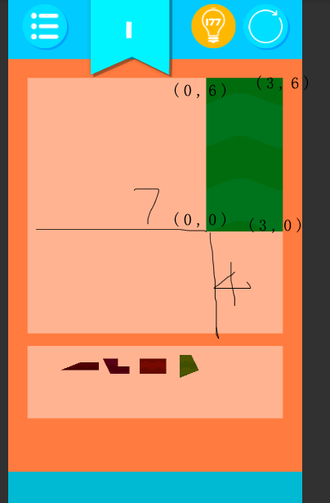

Important API and functions
Now all the functions and variables were commented in the script files and you can open each script to see. There is not much to say as most of them only describes the UI which all can be understand easily for a glance.

To play a music: Use GameManager.getInstance().playMusic(xxx);
To play a sound effect: Use
GameManager.getInstance().playSfx(xxx)
Remember to put your music and sound effect file into assets/polypuzzle/Resources/sound source folder. And for a background music you must start its name with text bg ,Like bg1,bg2,bgmusic.

Make your own puzzle gallery
The most important feature of the game was that you can easily add infinitive pictures for random puzzle. If you want the game not just a simple puzzle game, strongly recommend you to read this part.

Ready enough materials
Find under polypuzzle/resources/tangram/materials
You could see many textures with a material ball for each inside this folder.
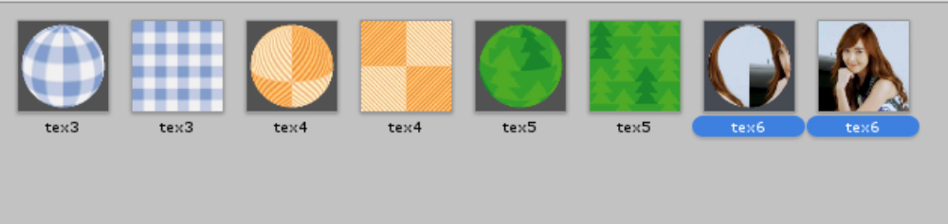
As you see, select a pair of a texture(means a texture with a material ball) hold and drag to duplicate a new texture and a new material.
The system would give the new texture a sequenced new name as tex7 and material tex7. Remember do not change the texture or material’s name as the system requires a unique name format of “tex” +”number”

Cover the new created texture
Let’s suppose the tex6 was your just duplicated texture. So ready a picture(no size limit) name exactly the same of this texture(here is tex6) and cover the origin one, you would found the tex6 material ball automatically changed also. Upon all, the ready work finishes.
Remember, the height/width radio is no limited. But for better looking, you need to give a same standard for every textures. Then make the chessboard frame in the same aspect radio of your textures.
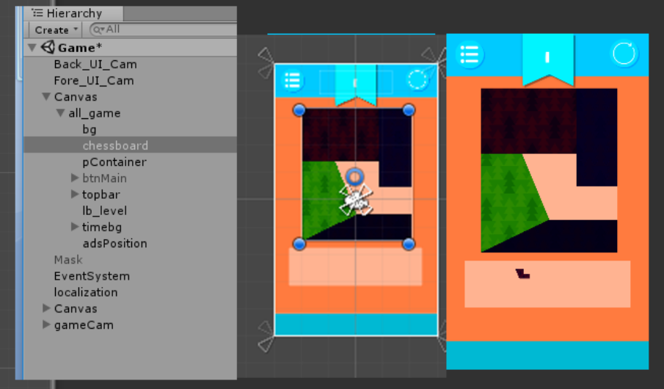
Example of change board aspect radio

Setup in the scripts
Find the script under polypuzzle/scripts/polypuzzle
Find Tangram.cs
Locate the script:
int tTextureNo = Random.Range(0, 6);//got 5 textures in materials folder total
Here set the number 6 to the total pictures you just duplicated included in the materials folder.
If you got 5 pairs of pictures, set the number to one larger (6) and so on.
So, in the game, each level would find a random picture from your texture folder when start or restart.
If you not want to be randomly, just make sure you have the existed number of textures for read.
For example, read a level refers to the level number:
int tTextureNo = GameData.intance.cLevel;

The other important thing is the UV size. If you want the finally completed picture the same of your origin texture image. You need to do the following:
Find the script under polypuzzle/scripts/polypuzzle
Find GameData.cs
Locate: public int uvZoom = 3;And set it to public int uvZoom = 1;

Scores
The game count the totalscore at starts.
Refresh scores when finish each level. Temporary, each level you finishes ,you will get 1 score.
Score is not used for this game yet, to get the score information, call the API at any places you want.
GameData.instance.bestScore

Switch game mode
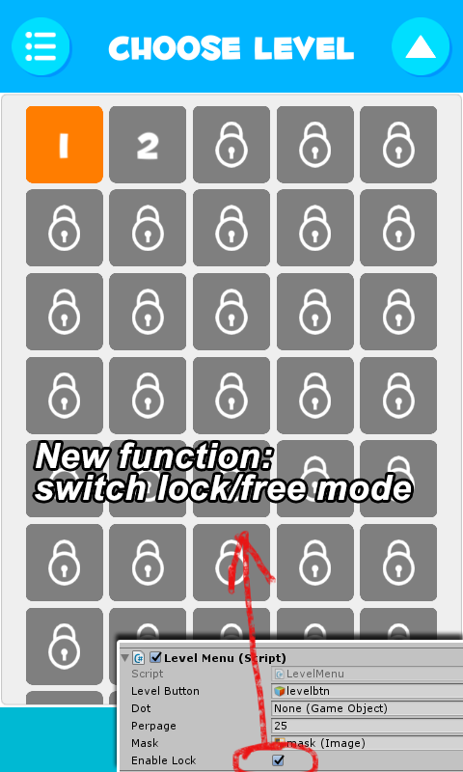
Active LevelMenu scene file. Select Canvas gameobject, on its inspector, the levelmenu script component, there is an enable lock checkbox. You can switch game mode by check on/off it for whether you want player to unlock the level one by one.

Use as in-game puzzle
Find the level file named 3dTest
The game prefab used for the minigame is under
Assets/polypuzzle/src/prefab
When use the game as a prefab widget, just drag and drop the polypuzzle prefab into your scene.
As the prefab elements were all uses the game layer and a depths only camera. Make sure your make scene camera does not include the same layer otherwise you would see duplicated game objects.
The example scripts for control is TestGame.cs
Open the script for detail with comment.
In Tangram.cs in the checkwin() function,locate:
GameObject.Find("3Dscene").BroadcastMessage("polyPuzzleWin");
This script fires a broadcast named polyPuzzleWin,
You could find this receive function in TestGame.cs.
If you want your own win inform message. Just change this script your self.

In app purchase
First make sure the service were updated to the lastest and being turned on. The services were all unity native function so they maybe update some files for different version. Just let unity do the job automatically and no worry about it.
Make sure the following services were on
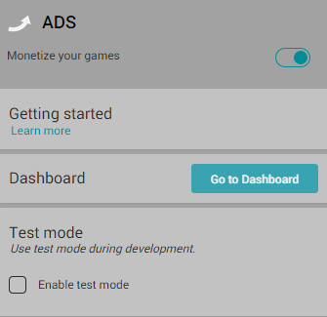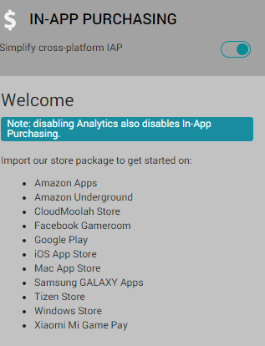

The in-app purchasing sometimes require a reimport, if the import button on service tab not works, find unitychannel and unitypurchasing these 2 package files under asset/plugin folder and double click them to import the packages manually.
Find Gamemanager.cs
Find
public const string CONSUMABLE0 = "20Coin";
public const string CONSUMABLE1 = "50Coins";
public const string CONSUMABLE2 = "100Coins";
Set these 3 id to your own product id, If you don’t know what is product id, please read apple or google development guide for in app purchase section.
I would not talk detail about this because this is not unity or game template issues.
The iap setting can be very very difficulty so make sure you are very familiar the process and have done all the job correctly yourself.
Here are 2 quick recommended tutorial
Learn basic about iap setting for IOS development
Learn basic about iap setting for googleplay

Remember, sometimes the iap service not work on test device before them active online because some development console requires test id or sandbox environment. You can not run the game just with normal users account.
By default, the game always returns true for any buy action. You must turn off this before you publish to a real store.
In Gamemanager.cs find
public bool test = true;//set it to false when you publish to test for real.
Set it to false.

Iap attached on a gameobject on music.cs
This music only start from startscene. So there maybe error if you start on other scene with test mode shut down.

Localization

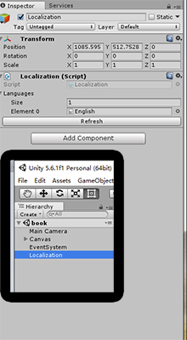
Ready your localization file
Find src/localization folder. Duplicate English.txt and rename it a new name like French.
Open the file, see like
btnBack = back
This means the btnBack key refers to the value of translation “back”
After your localization file were all ready, set the size of localization attribution to 2 or more and assign your language files.(see right picture)

Add new language to system
In GameData.cs,we see the function GetSystemLanguage().
This function get system language by switch branches.
You should add the language cases only when your localization file(txt) is ready. Otherwise if the system can not find the right translation file or the file does not include current translation phases, it would throw errors and break the game.

For default testing ,it is
public int GetSystemLaguage(){
int returnValue = 0;
switch (Application.systemLanguage) {
case SystemLanguage.Chinese:
returnValue = 1;
break;
case SystemLanguage.ChineseSimplified:
returnValue = 1;
break;
case SystemLanguage.ChineseTraditional:
returnValue = 1;
break;
default:
returnValue = 0;
break;
}
returnValue = 0;//test
return returnValue;
}
see returnValue = 0;//test
This line is uncommented. The language will always be English .If you may not have time to deal with your own native translation or you did not want a localization function for your game, just leave it uncommented. Otherwise, you should comment this line and make the system to decide which localization to choose.
The returnValue must be refer to the element order of localization Gameobject as I said upon.
Use localization in game
Just call like:
xxx.text = Localization.Instance.GetString("phasename");

Publish to appstore

Ready Dotween
As unity disallow uploading package including other package on store(even free).You should delete the minimal dotween dll and upload the full dotween package from official site manually.
Be easy,it is easy. Just follow the steps
1.find …/scripts/tools/tweentool
there are 3 dll files in it.
2.Delete this folder
3.download dotween from the url or search dotween in asset store
http://dotween.demigiant.com/ download.php
4.Import dotween asset package
5.unity menu:"tools-dotween utility panel"
6 click setup dotween.

If you are using plugin such as Ads.
Before reading this page. You required at least very familiar of how to publishing to appstore. Otherwise please read related tutorials by apple first.
When you compile the xcode project exported by unity. You should make sure the following frameworks were included in your project.
And here is the list, please require these following frameworks manually.
Select targets first,on Build phases-link binary with libraraies
Libsqlite3.tbd
Security.framework
Libz.1.2.5.tbd
Messengui.framework
Mobilecoreservices.framework
Glkit.framework
Adsupport.framework
Mediatoolbox.framework
All these can be find directly in xcode.
If you need admob download Admob framework and add GoogleMobileAds.framework
frame into project file first.
You can download here
The other thing is the bitcode. You need to turn it off before your achieve. In build settings , search Enable Bitcode , Set it to NO.

Admob Ads are not included in this asset. For simple job, you can download assets like “very simple ads” from asset store.

Basic knowleage must know

build and submit a game on app store with unity.
https://www.youtube.com/watch?v=C3izqF6h_aY

build and apk on android platform
https://www.youtube.com/watch?v=0eK3vPbYNqk

create iap on goolgeplay
https://www.youtube.com/watch?v=KBcOjMI6WVo

create iap on apple console(please ignore code part)
https://www.youtube.com/watch?v=YHGIij_stpk
How to get support
Contact to us E-mail
Remember attach your invoice otherwise there would not be my reply.
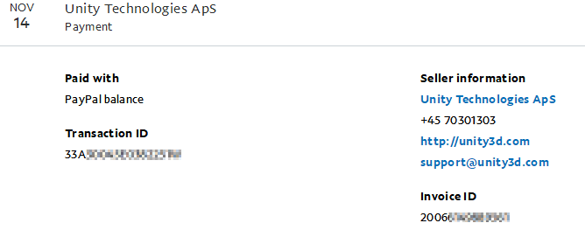
The invoice you can get from your paypal account records.
If you do not have a invoice. Grab some screenshot to confirm your buy successful flow is also ok.

If you want support our work or feel interested in other assets, take a look at More Games

