

**Cyprus International University**

Faculty of engineering

Department of Software Engineering

2021-2022 Spring semester

**Masked Face Recognition System (MFR)**

**Final Report**

**Project Supervisor**

Assist. Prof. Dr. Parvaneh ESMAİLİ

**Author**

Ahmad Jawabreh & Zaid Mohtaseb

V1

**Table of content**

**PROPOSAL**

1.0 STATEMENT OF PURPOSE ……………………………………….……….………….. 3

2.0 CPMPANY INFORAMTION ……………………………………………………………. 3

3.0 PRODUCT DESCRIPTION ….…………………………………………………………… 4

4.0 MAJOR DELIVERABLES …………………………………………………………………. 5

5.0 DELIVERY SCHEDULED …………………………………………………………………. 5

6.0 COST ESTIMATION …………………………….………………………………………… 6

7.0 REFERENCES ………………........................................................…………. 7

**WORK BREAKDOWN STRUCTURE**

1. STATEMENT OF PURPOSE ……………………………………….……….……………
2. WORK BREAKDOWN STRUCTURE ………………………………………………….

**WORK BREAKDOWN STRUCTURE DICTIONARY**

1. STATEMENT OF PURPOSE …………………………………………………………….. 3
2. WORK BREAKDOWN STRUCTURE DICTIONARY …………………………….. 3

**ACTIVITY LIST**

1. STATEMENT OF PURPOSE ……………................................................... 3
2. ACTIVITY DEFINITION …………….......................................................... 3
3. DEPENDENCIES ……………................................................................... 4
4. ACTIVITY DURATION ……………........................................................... 5
5. RESOURCES ASSIGNMENT …………….................................................. 5

**Activity resource assignment**

1. STATEMENT OF PURPOSE ……………................................................... 3
2. ACTIVITY DEFINITION …………….......................................................... 3
3. RESOURCE ASSIGNMENT …………….................................................... 5

**ACTIVITY DURATION ESTIMATE**

1. STATEMENT OF PURPOSE ……………................................................... 3
2. CRITICAL ASSUMPTIONS AND CONSTRAINTS ……………………………….. 3
3. Duration Estimate ……………............................................................... 4

**CAUSE AND EFFECT**

**GANT CHART**

**Activity List**

1.0 STATEMENT OF PURPOSE ………………………………………………………………………………………….5  
2.0 CRITICAL ASSUMPTIONS AND CONSTRAINTS …………………………………………………………….5  
3.0 COST ESTIMATE …………………………………………………………………………………………………………6

**Business Case**

1.0 REVISION HISTORY …………………………………………………………………………………………………….7  
2.0 STATEMENT OF PURPOSE ………………………………………………………………………………………….7  
3.0 BUSINESS OBJECTIVE …………………………………………………………………………………………………7  
4.0 CURRENT SITUATION AND PROBLEM/OPPORTUNITY STATEMENT ……………….………….8  
5.0 CRITICAL ASSUMPTIONS AND CONSTRAINTS …………………………………………………………….8  
6.0 ANALYSIS OF OPTIONS AND RECOMMENDATIONS …………….………………………………………9  
7.0 PRELIMINARY PROJECT REQUIREMENTS …………………………………………………………………10  
8.0 POTENTIAL RISKS …………………………………………………………….………………………………………12  
9.0 APPROVAL SIGNATURES ………………………………………………………………………………………….12

**Communication Metrtix**

1.0 STATEMENT OF PURPOSE ……………………………………………………………………………………….13

2.0 COMMUNICATION METRICS ………………………………………………………………………………………13

**Communication Plan**

1.0 Revision History 14

2.0 Statement of Purpose 14

3.0 Roles and Responsibilities 15

4.0 Stakeholder Analysis 16

5.0 Project Reports 17

6.0 Project Meetings 17

7.0 Project Information Accessibility 18

8.0 Communications Summary 18

9.0 Documentation 19

10.0 Communications Change Management Process 19

11.0 Plan Modification Rules 20

12.0 Approval Signatures 20

**Contract Agreement**

1.0 REVISION HISTORY……………………………………………………………………………………………………21

2.0 STATEMENT OF PURPOSE…………………………………………………………………………………………21

3.0 WORK RQUIRED ……………………………………………………………………………………………………….21

4.0 DELIVERY WORK ………………………………………………………………………………………………………21

5.0 INCENTIVES………………………………………………………………………………………………………………22

6.0 PENALTY……………………………………………………………………………………………………………….…22

7.0 CONTRACT CLOSURE ………………………………………………………………………………………………22

8.0 PAYMENT…………………………………………………………………………………………………………….……22

9.0 CHANGE MANAGEMENT PROCESS…………………………………………………………………………….22

10.0 APPROVAL SIGNATURES …………………………………………………………………………………………23

**Contact Management Plan**

1.0 Revision History 24

2.0 Statement of Purpose 24

3.0 Background Information 24

4.0 Contract Term 25

5.0 Pricing 25

6.0 Product/Service Standards 25

7.0 Roles and Responsibilities 26

8.0 Contract Conditions 26

9.0 Reporting Requirements 27

10.0 Contract Meetings 28

11.0 Contract Measurement 28

12.0 Implementation 28

13.0 Penalties 29

14.0 Contract Closure 29

15.0 Change Management Process 29

16.0 Plan Modification Rules 29

17.0 Approval Signatures 30

**Control Chart**

**Corrective Actions List**

1.0 Statement of Purpose 31

2.0 Corrective Actions List 31

**Risk Breakdown Structure**

1.0 Statement of Purpose 32

2.0 Risk Breakdown Structure 32

PETRO DIAGRAM………………………………………………………………………………………………………………3

RESOURCE HISTOGRAM……………………………………………………………………………………………………4

Human Resource Management Plan  
1.0 Revision History 6

2.0 Statement of Purpose 6

3.0 Project Overview 6

4.0 Project Organization 8

5.0 Resource Requirements 10

6.0 Resource Assignment 10

7.0 Resource Constraints 12

8.0 Contingency Plans 12

9.0 Training Requirements 12

10.0 Documentation 12

11.0 Human Resource Change Management Process 13

12.0 Plan Modification Rules 13

13.0 Approval Signatures 13

End Report  
1.0 Statement of Purpose 14

2.0 Achievement of Project Objectives 14

3.0 Project Performance 14

4.0 Approved Changes 15

5.0 Quality Analysis 15

6.0 Final Customer Acceptance 15

7.0 Contract Closure 15

8.0 Final Project Performance Report 16

9.0 Post Implementation Review 16

10.0 Project Archives 16

**Proposal**

**1.0 Statement of purpose**

When the Corona pandemic began to spread, governments issued laws requiring people to wear masks in public places, and this led to problems in face recognition systems, Where the systems can no longer identify the user’ s identity, which led to the suspension of all these systems, whether public facial recognition systems such as systems for opening and closing doors or personal systems such as Face ID in iPhone devices.

On the other hand, facial recognition systems in public places that are used in countries such as China, as these countries follow a political pattern, they track the movements of citizens through artificial intelligence systems that analyze and track the movements and actions of citizens and issue violations or orders to arrest or give rewards to citizens according to their behavior in public places and this system are based on the face recognition.

So, we decided to find a solution to this problem by creating a masked facial recognition system, where it makes it easier for people to use security systems. It is also based on the principle of (touchless) where you do not have to touch the device like fingerprint systems.



**2.0 Company Information**

Masked Face Recognition system – MFR project needs two types of work, hardware and software, the company employees are four persons so the team will be divided one of them for the hardware side and three of them for the software side.

**Ahmad Jawabreh**: Hardware work, Smart contract development, blockchain bridges, Dealing with the blockchain services providers and Database creation.

**Zaid Mohtaseb**: Software Development for the RFID system & MFR system.

**Ferhat Bal:** Software quality assurance and testing the system at all.

**3.0 Product Description**

The MFR project will use two methods for user identification, and all of these methods will be used for identification, which means that identification and analysis depends on a combination of these methods to ensure that the system works properly, and each of them has some negative points so we will remove this negative point of a method by covering it from Positive points of another method.

1-) MATCHING APPROACH:

This method based on training the system in advance by flooding it with a set of samples and images without a user mask, and the system automatically extracts the characteristics and measurements of the face, nose, mouth and eye, the distance between the eyes, the distance between the mouth and the nose, the distance between the mouth and the first eye and the second eye, and the distance between the nose and the first eye second.

2-) RESTORATION APPROACH:

According to the gallery, the covered portions in the sample faces are restored here. The covered areas are detected by threshing the 3D image profound map values. The main component analysis is then carried out (PCA). Several techniques rely on the assessment of the covered areas. The iteration close point (ICP) technique was utilized. A curve is used to control the covered regions using a statistical estimate of the curve. Partly observed curves are completed using the PCA- technical curve model.

**4.0 Major Deliverables**

* **Masked** **Face** **Recognition**: The system will be able to recognize the masked user face, and the system will be able to work in scenarios like public control.
* **Quality**: we chose hardware parts that simulate a real scenario to be able to simulate a real scenario
* **Security**: The system will not work in any way with a wireless connection, the connection to the network will be done through ethernet port.
* **Decentralization**: The validation step for the faces will not work any way with centralize server, The validation step will be done through high TPS blockchain to make the system literally not crackable. 

**5.0 Delivery Scheduled**

|  |  |
| --- | --- |
| **Task** | **Time (days)** |
| Order the hardware parts from Turkey | 7– 15 |
| Hardware Connecting | 5 |
| RFID coding | 1 |
| Face recognition coding | 3 |
| Masked Face Recognition | 4 |
| Database creation | 2 |
| Testing the hardware & software | 2 |
| Testing the system in many scenarios | 5 |
| EVMC Smart Contract coding | 3 |
| EVMC Smart Contract Testing | 2 |
| Chainlink to Kadena bridge | 2 |
| Testing the smart contract on the mainnet | 2 |
| **Total days** | **39 - 46** |

**6.0 Cost Estimation**

|  |  |  |  |
| --- | --- | --- | --- |
| **Hardware Part** | **Version** | **Piece** | **Price** |
| Microcontroller | Arduino UNO R3 Kit | 1 | 880 TL |
| Microchip ports Extenders | 74HC595 | 2 | 5.25 TL |
| Ethernet Port | ENC25J60 | 1 | 107.5 TL |
| LCD Screen | 1.8inch | 1 | 219 TL |
| Power Cable | GePro UM-85 | 1 | 34.2 TL |
| Red Led | Red Led Package | 1 | 3.5 TL |
| NFC Keychain | 13.56 MHz | 2 | 4.55 TL |
| RFID Card | 125 kHz | 2 | 4.55 TL |
| Breadboard | Normal | 3 | 21 TL |
| Battery | 9V | 1 | 9.45 TL |
| Ticket NFC | 13.56 MHz | 5 | 4.2 TL |
| Jumper Cable Kit | M-M | 2 | 19 TL |
| RFID Reader | RC522 | 1 | 31 TL |
| Green Led | Green Led Package | 1 | 3.5 TL |
| Resistors | Resistors Kit | 1 | 56.33 TL |
| Temperature Sensor | DH11 | 1 | 31.3 TL |
| Welding Gun | ZD 23 30W | 1 | 103 TL |
| Gas Sensor | MQ-2 | 1 | 28.4 TL |
| Double Faced Pertinax | 7*9 cm & 8*12 cm | 1 | 33 TL |
| Camera | ESP32-CAM | 1 | 157.5 TL |
| Soldering Tin | 1.60 mm 100 g | 1 | 75.7 TL |
| Multimeter | Marxlow DT-830D | 1 | 51 TL |

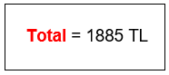

**7.0 References**

* ( Face Recognition , Facial recognition Is Everywhere , Wirecutter, 2020 ) - [Link](https://www.nytimes.com/wirecutter/blog/how-facial-recognition-works/)
* ( Face Recognition , Biometric Authentication Technology , veriff , 2022 ) - [Link](https://www.veriff.com/product/face-match?keyword=facial%20recognition%20system&utm_term=facial%20recognition%20system&utm_campaign=Search+-+Sales+-+Europe&utm_source=adwords&utm_medium=ppc&hsa_acc=1064629533&hsa_cam=11650241724&hsa_grp=117102876622&hsa_ad=508389613595&hsa_src=g&hsa_tgt=kwd-304881169581&hsa_kw=facial%20recognition%20system&hsa_mt=e&hsa_net=adwords&hsa_ver=3&gclid=Cj0KCQjwmPSSBhCNARIsAH3cYgb7O94RcuYedMHu7X7NwRnMMQZuNnTxIM48fF3YxS1LPPq1rg90D0YaAgGhEALw_wcB)
* ( Object Detection , Object Detection Guide , FRITZ AI , 2021 ) - [Link](https://www.fritz.ai/object-detection/)
* ( Object Detection , A Beginner's Guide to Object Detection , datacamp , 2018 ) - [Link](https://www.datacamp.com/community/tutorials/object-detection-guide?utm_source=adwords_ppc&utm_medium=cpc&utm_campaignid=16079068992&utm_adgroupid=&utm_device=c&utm_keyword=&utm_matchtype=&utm_network=x&utm_adpostion=&utm_creative=&utm_targetid=&utm_loc_interest_ms=&utm_loc_physical_ms=1003699&gclid=Cj0KCQjwmPSSBhCNARIsAH3cYgZFJAytrzKfaJ-r-xjbgY0PHPgPHwBBFduJK1ul9uQXcku-ylG6zM4aAuPqEALw_wcB)
* ( MFR , Face-mask recognition – better or worse , National Geographic , 2020 ) - [Link](https://www.nationalgeographic.com/science/article/face-mask-recognition-has-arrived-for-coronavirus-better-or-worse-cvd)
* ( MFR , Secure Authentication , ADS , 2020 ) - [Link](https://ui.adsabs.harvard.edu/abs/2020arXiv200811104A/abstract)
* ( Face Rebuild , Cropping and attention based approach for face recognition , Springer , 2021 ) - [Link](https://link.springer.com/article/10.1007/s10489-020-02100-9)
* ( Face Rebuild , 3D Face Reconstruction ,ScienceDirect ,2021 )-[Link](https://www.sciencedirect.com/science/article/pii/S2405896321003864)
* (Blockchain Bridges , What Are Blockchain Bridges and Why Do We Need Them? , Liquid , 2020 ) - [Link](https://blog.liquid.com/blockchain-cross-chain-bridge)
* (Blockchain Bridges, Blockchains Have a ‘Bridge’ Problem, and Hackers Know It , WIRED , 2022 ) - [Link](https://www.wired.com/story/blockchain-network-bridge-hacks/)
* (Blockchain Bridges , Types of blockchain bridges , CoinDesk , 2022 ) - [Link](https://www.coindesk.com/learn/what-are-blockchain-bridges-and-how-do-they-work/)

**Work breakdown structure**

**1.0 Statement of purpose**

The purpose of this document is to provide a record of the different tasks that need to be completed for MFR project. This document contains a list of these tasks arranged in a hierarchical order.



**2.0 Work breakdown structure**

1. Hardware connecting

1.1. RFID connecting

1.1.1. Connect the RFID Reader

1.1.2. Connect the LED’s t

1.1.3. Connect the alphanumeric LCD

1.1.4. Connect the micro servo motor

1.2. Masked face recognition connecting

1.2.1 Connect the camera

1.2.2 Connect the wavesshare LCD screen

1.3. Sensors connecting

1.3.1 Connect the distance sensors

1.3.2 Connect the gas sensor

1.3.3 Connect the flame sensor

1.3.4. Connect the speaker

1.4. Network connecting

1.4.1 Connect the ethernet port

1.5. Power and electricity connecting

1.5.1 Connect the 9V battery to the Arduino

1.5.2. Connect the power cable adapter to the Arduino

2. Coding

2.1. RFID Coding

2.2. Face recognition coding

2.3. Masked face recognition

3. Database creation

3.1. Database schema preparing

3.2. Database coding

3.3. Adding data to the database

3.4. Database connecting

4. Smart contract development

4.1. chainlink to Kadena blockchain bridge

4.2 Smart contract designing

4.3. Smart contract coding

4.4. Smart contract testing

4.4.1 Testing the system with the smart contract on testnet

4.4.2 Testing the system with the smart contract on mainnet

4.5 Deployment on mainnet

5. Testing

5.1. Testing the connection of hardware parts

5.2. Testing the system

5.2.1 RFID code testing

5.2.2 Face recognition code testing

5.2.3 Masked face recognition code testing

5.3. Testing the connection of the database

5.4. Testing the system with the smart contract on the test net

5.5 Testing the system with the smart contract on the mainnet

**Work breakdown structure dictionary**

**1.0 Statement of Purpose**

The purpose of this document is to provide a description of each of the tasks in the work breakdown structure (WBS) for **MFR project**. This document contains (a) the WBS item number, (b) the WBS item name, and (c) a description of the WBS item.



**2.0 Work breakdown structure dictionary**

|  |  |  |
| --- | --- | --- |
| **WBS NO** | **WBS Item Name** | **WBS Item Description** |
| 1 | Hardware connecting | Connect the all of the hardware parts that will be used for the system |
| 1.1 | RFID connecting | Connection of RFID parts to the Arduino which the alternative verification method |
| 1.1.1 | Connect RFID Reader | Connection of the RFID reader that will be used to detect the radio frequency |
| 1.1.2 | Connect the LED’s | Connect the LED’s to the Arduino that will be used as red led means close door and green led means opened door, blinking red led mean error and blinking green led means the door will be opened |
| 1.1.3 | Connect the alphanumeric LCD | Connect the alphanumeric LCD that will be used to show a message for the user (Hello message, Errors, etc.) |
| 1.1.4 | Connect the micro servo motor | Connect the micro servo motor that will be used to open and close the door (Moving the door lock in and out to open and close the door) |
| 1.2 | Masked face recognition connecting | Connecting the hardware parts that will be use in Masked face recognition  process |
| 1.2.1 | Connect the camera | Connecting the camera to the Arduino which will be used to scan the user face |
| 1.2.2 | Connect wavesshare LCD screen | Connecting the lcd screen that will be used to show the user face to let the user know if the camera detect his face or not |
| 1.3 | Sensors connecting | Connecting all of the sensors that will be used in the system |
| 1.3.1 | Connect the distance sensors | Connecting the distance sensor to the Arduino that will be used to detect if there is a object around the system trying to use it, if there is no object the system will tun off otherwise the system will turn on this supposed to help in energy saving |
| 1.3.2 | Connect the gas sensor | Connecting the gas sensor to the Arduino that will be used alongside the flame sensor to detect the fire and cigarettes |
| 1.3.3 | Connect the flame sensor | Connecting the flame sensor to the Arduino that will be used alongside the gas sensor to detect the fire |
| 1.3.4 | Connect the speaker | Connecting the speakers that will be used to make noise if the system detect fire |
| 1.4 | Network connecting | Connecting the hardware parts that will be used for the network side of the project |
| 1.4.1 | Connect the ethernet port | Connecting the ethernet port to the Arduino that will be used to connect the system to the network |
| 1.5 | Power and electricity connecting | Connecting the power supply hardware parts to the system |
| 1.5.1 | Connect the 9V battery | Connecting the 9v battery to the system which will be used as alternative power supply If there is a power outage |
| 1.5.2 | Connect the power cable | Connecting the power cable adapter that will be used as the main power supply for the system |
| 2 | Coding | Coding the system |
| 2.1 | RFID Coding | Writing the code for the RFID system |
| 2.2 | Face recognition coding | Writing the code for the face recognition system that will help us to build the code of the masked face recognition on it |
| 2.3 | Masked face recognition | Writing the code for the masked face recognition |
| 3 | Database creation | Creating the database that will be used to test the project before finalizing the smart contract on Kadena blockchain |
| 3.1 | Database schema preparing | Preparing the database schema that will help us to understand the entity relationship and the architecture of the database at all |
| 3.2 | Database coding | Coding the database |
| 3.3 | Adding data to the database | Adding the a real test data to the database that will be used to test the system |
| 3.4 | Database connecting | Connection the database to the system which for both main and alternative verification methods (MFR and RFID) |
| 4 | Smart contract development | Development of the Kadena smart contract that will be used basically to put out system in the blockchain which will help the project to be littarly not hackable because of the PoW consensus protocol (Decentralization) of Kadena network |
| 4.1 | chainlink to Kadena blockchain bridge | Preparing the bridge between chainlink blockchain which is the provider of the data for the smart contract and bridge it with Kadena blockchain |
| 4.2 | Smart contract designing | Designing the working mechanism of the smart contract and how it will interact with its entities and designing the Algorithm for out smart contract |
| 4.3 | Smart contract coding | Starting to write the smart contract code with Pact programming language then convert it to Solidity smart contract to make the code EVMC |
| 4.4 | Smart contract testing | Testing the smart contract by focusing on the bugs and the security issues (Called audit step in blockchain community) |
| 4.4.1 | Testing the system with the smart contract on testnet | Testing our smart contract on the test net using Truffle and ganache environment |
| 4.4.2 | Testing the system with the smart contract on mainnet | Testing the smart contract in a real scenario by testing it on the mainnet |
| 4.5 | Deployment on mainnet | Deploy the smart contract after testing it, the deployment here will be directly on Kadena mainnet |
| 5 | Testing | Testing the System at all |
| 5.1 | Testing the connection of hardware parts | Testing the connection of the hardware parts if there is any type of wrong connection or missing to connect some parts and testing if all of the parts are working or not |
| 5.2 | Testing the system | Testing the hardware parts codes |
| 5.2.1 | RFID code testing | Testing the RFID code to make sure there is no faults in the RFID system |
| 5.2.2 | Face recognition code testing | Testing the face recognition code to make sure there is no faults in the face recognition system |
| 5.2.3 | Masked face recognition code testing | Testing the masked face recognition code to make sure there is no faults in the masked face recognition system |
| 5.3 | Testing the connection of the database | Testing the connection of the database to make sure there is no faults in the connection between the database and the system |
| 5.4 | Testing the system with the smart contract on the test net | Testing the system at all on the testnet to make sure there is no faults in the system at all with the smart contract |
| 5.5 | Testing the system with the smart contract on the mainnet | Testing the system at all on the mainnet to make sure the system behaves as it supposed to behave with the smart contract on the mainnet |

**Activity List**

**1.0 Statement of purpose**

The purpose of this document is to record all activities that are included in the schedule for Masked Face Recognition System (MFR). This document provides information about each activity including its name, an identifier, its duration, any predecessors and successors, resource requirements, any leads or lags, who’s been responsible for the task, as well as whether the activity is a milestone.



**2.0 Activity Definition**

|  |  |  |
| --- | --- | --- |
| **Identifier** | **Name** | **Description** |
| 1 | Determining the idea | Determine the general idea of the project |
| 2 | Research | We need to search in books, scientific research and articles on previous similar projects to understand the working mechanism of the system. |
| 3 | System Analyzing | After understanding the working mechanism of the system, we will identify all the strengths and weaknesses of each work mechanism and try to integrate work mechanisms to raise the strengths and reduce weaknesses. |
| 4 | Order Hardware Parts | Determine the seller from whom we will buy the parts then order the hardware parts. |
| 5 | Database creation | Create database contains all of the authenticated user’s information such as their faces, masked faces, RF cards, etc... |
| 6 | RFID Hardware | Connect the RFID hardware parts. |
| 7 | RFID Programming | Coding the RFID reader and connect it with the dataset. |
| 8 | RFID Testing | Testing the RFID system after coding and make sure only authenticated users are able to use the system |
| 9 | Face Recognition Hardware | Connect the face recognition hardware parts such as the camera. |
| 10 | Face Recognition Programming | Coding the normal face recognition side and connect it with the dataset. |
| 11 | Masked Face Recognition Programming | Coding the masked face recognition side and connect it with the dataset. |
| 12 | Masked Face Recognition Testing | Testing the masked face recognition side to make sure it’s working correctly and the possibility of wrong identification is under the specification. |
| 13 | Testing the hardware & software | Testing the system at all, hardware testing and software testing. |
| 14 | Testing the system in many scenarios | Testing the system on our class mates as one of the scenarios to make sure the system is working correctly. |
| 15 | Consensus protocol programming | Preparing the consensus protocol that the system will use to validate the identity of users to increase the security of the system |
| 16 | Kadena smart contract programming | Coding the smart contract on KADENA Blockchain that will be used to validate the identity of users. |
| 17 | Kadena smart contract testing | Testing the smart contract and send it to a specialized auditing company (Certik) to ensure that there are no errors that allow the smart contract to be hacked |
| 18 | System test with smart contract | Testing the system at all with the smart contract and the consensus protocol |
| 19 | Deployment | Deployment |

**4.0 Activity Duration**

1. Estimated Work Hours Required: 15 - 20 hours weekly.
2. Start Date (MM/DD/YYYY): April / 2 / 2022
3. Finish Date (MM/DD/YYYY): May / 18 / 2022
4. Leads and Lags: Kadena bridge.



**5.0 Resource** **Assignment**

|  |  |  |
| --- | --- | --- |
| Resource | Unit_Cost/Salary | Cost |
| * RFID & Sensors Hardware   Arduino Uno Rev3  RF Reader  Ethernet Ports (ENC28J60)  Breadboard *2  Jumper cables (MM/FM)  Battery 9V & Battery Cable  RF card  RF NFC keychain  RF NFC ticket  Red lids & Green lids  Microchip ports Extenders  Power Cable  Resistors Kit  Welding Gun & Soldering Tin  Gas Sensor  Double Faced Pertinax  Multimeter | 880 TL  31 TL  107 TL  21 TL + 21 TL  19 TL + 19 TL  9.5 + 2 TL  4.55 TL  4.55 TL  4.55 TL  3.5 +3.5 TL  5.25 * 2 TL  34.2 TL  56.3 TL  103 + 51 TL  28.4 TL  33 TL  75.7 TL | Total Cost = 1483.75 TL |
| Face Recognition Hardware:  Arduino Uno Rev3  Red lids  Green lids  Ethernet Ports (ENC28J60)  Breadboard  Jumper cables (MM/FM)  Battery 9V  Battery Cable  Camera  Distance Sensor (HC-SR04) | 880 TL  3.5 TL  3.5 TL  107.5 TL  21 TL  19 TL +19 TL  9.5 TL  2 TL  157.5 TL  22 TL | Total Cost = 1244.5 TL |

**Activity resource assignment**

**1.0 Statement of purpose**

The purpose of this document is to record the resource requirements for all activities that are included in the schedule for masked face recognition (MFR) project. This document provides information about each activity including its name, an identifier, its definition, its resource requirements along with any assumptions made in estimating the resources needed for that activity.



**2.0 Activity Definition**

|  |  |  |
| --- | --- | --- |
| **Identifier** | **Name** | **Description** |
| 1 | Determining the idea | Determine the general idea of the project |
| 2 | Research | We need to search in books, scientific research and articles on previous similar projects to understand the working mechanism of the system. |
| 3 | System Analyzing | After understanding the working mechanism of the system, we will identify all the strengths and weaknesses of each work mechanism and try to integrate work mechanisms to raise the strengths and reduce weaknesses. |
| 4 | Order Hardware Parts | Determine the seller from whom we will buy the parts then order the hardware parts. |
| 5 | Database creation | Create database contains all of the authenticated user’s information such as their faces, masked faces, RF cards, etc... |
| 6 | RFID Hardware | Connect the RFID hardware parts. |
| 7 | RFID Programming | Coding the RFID reader and connect it with the dataset. |
| 8 | RFID Testing | Testing the RFID system after coding and make sure only authenticated users are able to use the system |
| 9 | Face Recognition Hardware | Connect the face recognition hardware parts such as the camera. |
| 10 | Face Recognition Programming | Coding the normal face recognition side and connect it with the dataset. |
| 11 | Masked Face Recognition Programming | Coding the masked face recognition side and connect it with the dataset. |
| 12 | Masked Face Recognition Testing | Testing the masked face recognition side to make sure it’s working correctly and the possibility of wrong identification is under the specification. |
| 13 | Testing the hardware & software | Testing the system at all, hardware testing and software testing. |
| 14 | Testing the system in many scenarios | Testing the system on our class mates as one of the scenarios to make sure the system is working correctly. |
| 15 | Consensus protocol programming | Preparing the consensus protocol that the system will use to validate the identity of users to increase the security of the system |
| 16 | Kadena smart contract programming | Coding the smart contract on KADENA Blockchain that will be used to validate the identity of users. |
| 17 | Kadena smart contract testing | Testing the smart contract and send it to a specialized auditing company (Certik) to ensure that there are no errors that allow the smart contract to be hacked |
| 18 | System test with smart contract | Testing the system at all with the smart contract and the consensus protocol |
| 19 | Deployment | Deployment |

**3.0 Resource Assignment**

|  |  |  |
| --- | --- | --- |
| Resource | Unit_Cost/Salary | Cost |
| * RFID & Sensors Hardware   Arduino Uno Rev3  RF Reader  Ethernet Ports (ENC28J60)  Breadboard *2  Jumper cables (MM/FM)  Battery 9V & Battery Cable  RF card  RF NFC keychain  RF NFC ticket  Red lids & Green lids  Microchip ports Extenders  Power Cable  Resistors Kit  Welding Gun & Soldering Tin  Gas Sensor  Double Faced Pertinax  Multimeter | 880 TL  31 TL  107 TL  21 TL + 21 TL  19 TL + 19 TL  9.5 + 2 TL  4.55 TL  4.55 TL  4.55 TL  3.5 +3.5 TL  5.25 * 2 TL  34.2 TL  56.3 TL  103 + 51 TL  28.4 TL  33 TL  75.7 TL | Total Cost = 1483.75 TL |
| Face Recognition Hardware:  Arduino Uno Rev3  Lids  Ethernet Ports (ENC28J60)  Breadboard  Jumper cables (MM/FM)  Battery 9V  Battery Cable  Camera  Distance Sensor (HC-SR04) | 880 TL  7.5 TL  107.5 TL  21 TL  19 TL +19 TL  9.5 TL  2 TL  157.5 TL  22 TL | Total Cost = 1244.5 TL |

**Activity Duration Estimate**

**1.0 Statement of purpose**

The purpose of this document is to provide an estimate of how long it would take to complete each activity in the work breakdown structure of masked face recognition (MFR) project. This document contains (a) a list of the activities in the work breakdown structure, (b) the duration estimate for each activity, (c) an estimated project duration, and (g) any assumptions made.



**2.0 Critical Assumptions and Constraints**

* Chainlink to Kadena bridge: We partnered with chainlink labs to be the data providers for our project (Providers for off-chain data) and to create bridge between chainlink blockchain and Kadena blockchain and the time estimation for the bridge creation is 2-3 weeks, we assumed we will not face any issues with chainlink labs and the bridge will be done during the estimated time.
* Delivery time: We assumed the hardware parts will arrive on time without any latencies or logistic problems.
* Weekly work time: We assumed we will not have any exams or projects for other courses, because having exams or other projects for other courses will reduce the time spent on this project.
* Testing: We assumed that the project's testing phase will reveal reasonable errors that we could solve in a timely manner

**3.0 Duration Estimate**

|  |  |
| --- | --- |
| **Task** | **Time (days)** |
| Order the hardware parts from Turkey | 7– 15 |
| Hardware Connecting | 5 |
| RFID coding | 1 |
| Face recognition coding | 3 |
| Masked Face Recognition | 4 |
| Database creation | 2 |
| Testing the hardware & software | 2 |
| Testing the system in many scenarios | 5 |
| EVMC Smart Contract coding | 3 |
| EVMC Smart Contract Testing | 2 |
| Chainlink to Kadena bridge | 2 |
| Testing the smart contract on the mainnet | 2 |
| **Total days** | **39 - 46** |

**Cause and effect**

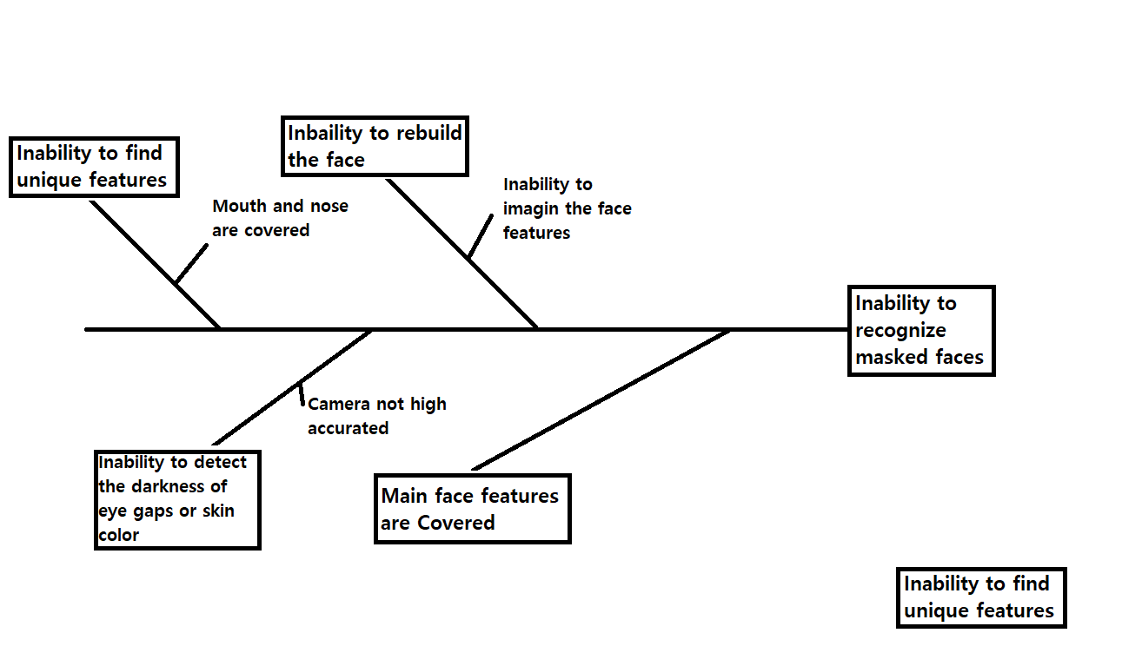

**Gant Chart**

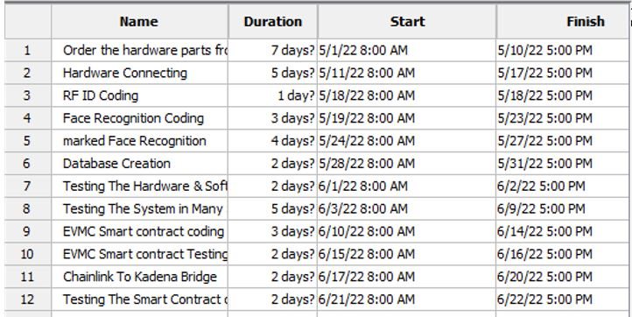

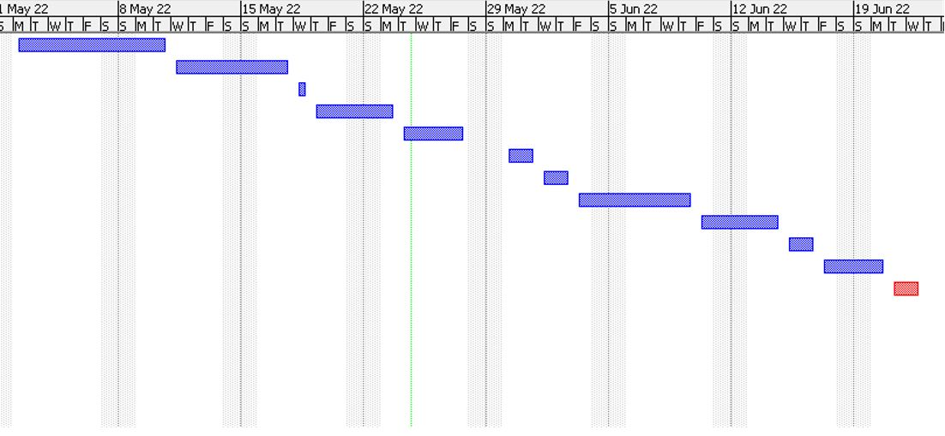

**Activity Cost Estimate**

**1.0 Statement of Purpose**

The purpose of this document is to provide an estimate of how much it would cost to complete each activity in the work breakdown structure of MFR project. This document contains (a) a list of the activities in the work breakdown structure (WBS) with the activity number in the WBS, (b) the different types of resources needed, (c) the resource units needed or the number of hours worked for each activity, (d) the cost of the resource per unit or hour, (e) the cost of each resource for each activity, (f) the total number of resource units needed or the number of hours worked, (g) the total costs for the different resources, (h) the total costs for completing each activity, (i) any reserves allowed, (j) a total cost for completing the project, and (k) any assumptions made.



**2.0 Critical Assumptions and Constraints**

1- Because of the war in Europe and the problems of the supply chain from China and many countries of the world, the prices of silicon chips have been rising for more than a year, we assumed that the prices would remain the same until we order them.

2- The dealer of the hardware parts is baying the parts from China with US dollar any they are selling it with Turkish lira, so if the exchange rate changed the price also will be changed, so we assumed the exchange rate will stay on 1USD = 14.75TL.

3- We assumed that we will not pay for any external services such as a programmers or electronic and electrical engineer, which the cost estimation table contains only the hardware parts.

**3.0 Cost Estimate**

|  |  |  |  |  |  |
| --- | --- | --- | --- | --- | --- |
| WBS Item Number | WBS Item |  | Resource Type 1 |  | Total |
| 1. | Hardware Parts | 32/1 | - | - | 1885 TL |
| 1.1. | RFID parts | 3/1 | - | - | 1136 TL |
| 1.1.1. | RFID | 1/1 | 31 TL/1H | 31TL | 31 TL |
| 1.1.2. | LED’s | 2/1 | 3.5 TL/1H | 3.5 TL | 7 TL |
| 1.1.3. | Alphanumeric LCD | 1/1 | 219 TL/1H | 219 TL | 219 TL |
| 1.2. | Masked face recognition parts | 2/1 | - | - | 376.5 TL |
| 1.2.1 | Camera | 1/1 | 157.5 TL/1H | 157.5 TL | 157.5 TL |
| 1.2.2 | LCD screen | 1/1 | 219 TL/1H | 219 TL | 219 TL |
| 1.3. | Sensors part’s | 4/1 | - | - | 137.9 TL |
| 1.3.1 | Distance sensor | 1/1 | 31.5 TL/1H | 31.5 TL | 31.5 TL |
| 1.3.2 | Gas sensor | 1/1 | 28.4 TL/1H | 28.4 TL | 28.4 TL |
| 1.3.3 | Flame sensor | 1/1 | 35 TL/1H | 35 TL | 35 TL |
| 1.3.4 | Speaker | 1/1 | 43 TL/1H | 43 TL | 43 TL |
| 1.4. | Network parts | 1/1 | - | - | 107.5 TL |
| 1.4.1 | Ethernet port | 1/1 | 107.5 TL/1H | 107.5 TL | 107.5 TL |
| 1.5. | Power and electricity parts | 2/1 | - | - | 43.47 TL |
| 1.5.1 | Battery | 1/1 | 9.45 TL/1H | 9.45 TL | 9.45 TL |
| 1.5.2 | Power Cable | 1/1 | 34.2 TL/1H | 34.2 TL | 34.2 TL |
| 2. | Coding | 0 | 0 | 0 | 0 |
| 3. | Database creation | 0 | 0 | 0 | 0 |
| 4. | Smart contract development | 0 | 0 | 0 | 0 |
| 5. | Testing | 0 | 0 | 0 | 0 |

**Business Case**

1.0 Revision History

No Changes



2.0 Statement of Purpose

The purpose of this document is to justify the commitment of resources to MFR project. This document describes (a) the business objective, (b) the current situation and problem, (c) a list of critical assumptions and constraints, (d) an analysis of possible solutions and recommendations, (e) the preliminary project requirements, (f) the budget estimates and financial analysis, (g) a schedule estimate, (h) a list of potential risks, (i) a section with approval signatures, and (j) an appendix section.



3.0 Business Objective

AZFCO. is a company started by three university students in North Cyprus, aims to create a technology similar to (God eye) based on high security network (Blockchain).

MFR project is little chunk of our system as the God eye technology based on the facial recognition and having a stable masked facial recognition as sub system worked within God eye system will increase the accuracy and efficiency of the system at all.

4.0 Current Situation and Problem/Opportunity Statement

Normal facial recognition systems have ability to recognize not covered faces, so this technology can be used as a personal security system such iPhone face ID, Lock and unlock the doors using face recognition, and etc.

If we need a system for public control like the systems that is used in China for public control, we need a system that is stable, accurate, and high efficiency but the current facial recognition technology is breakable because who want to make a crime will cover his/her face with a mask and the current technology is unable to recognize masked faces, so the criminal will simply get away with his crime, So we need a system meet this specifications and unbreakable, so using a masked facial recognition system will add this advantages to the main system and we will have a high accurate system and using the blockchain networks for the system communication will make the system unbreakable.

This masked face recognition technology can be used as a sub system within God eye technology using the blockchain networks for communicating and chainlink technology to collect off-chain data, here we are talking abut closing the gap of the security, accuracy and efficiency.



5.0 Critical Assumptions and Constraints

5.1 Critical Assumptions

* We assumed Chainlink – Kadena blockchain bridge will be ready in 1-2 weeks.
* One of the weak points of the system is the system smart contract we assumed the smart contract will be free bug, so no one can use these bugs to break the system.

5.2 Critical Constraints

* Chainlink technology: We are forced to use Chainlink technology which allow us to collect off-chain data and pass it through the blockchain to increase the security, we are forcing to use this service provider because they have the most mature technology for off-chain data.
* External dependencies: The system smart contract depends on having a bridge between Chainlink blockchain and Kadena blockchain.

6.0 Analysis of Options and Recommendations

The analysis of options depends on the scenario in which the customer wants to use the system. Using the system for public control is completely different from analyzing options if the system is used to open and close doors, so we will assume that the system will be used for public control.

6.1 Identification of Options

* Option 1: Enact laws prohibiting the wearing of masks and the winter hats that can be used to cover the face.
* Option 2: Using masked face recognition system with the normal internet networks.
* Option 3: Using normal face recognition system with the blockchain networks.
* Option 4: Using masked face recognition with the blockchain networks.

6.2 Comparison of Available Options

* Option 1: Cannot banned the medical masks due to the spread of viruses, also cannot banned the winter hates due to the low tempter in many counties such as Russia.
* Option 2: With this we have solved the problem of masked faces, but our system is still simply hackable (breakable).
* Option 3: This is how we solved the problem of safety, but we still have the problem of masked faces.
* Option 4: This is how we solved the problem of safety, and the problem of masked faces.

6.3 Recommended Option

Replacing old technology by a new one is easier than taking any actions or enact laws because the laws can be broken but the decentralization in god eye system or even MFR system (part of god eye system) is very hard to be broken (Closer to being unbreakable).

7.0 Preliminary Project Requirements

7.1 Target Benefits

* Masked Face recognition system for locking and unlocking the door
* Masked Face recognition system as part of god eye project for public control
* Masked Face recognition system can be used for face passport (Biometric passport)
* Solving the problem of inability to recognize masked faces which means solving of huge crimes.

7.2 Outputs

* Masked Face Recognition System
* Alternative authentication method, RFID system
* Blockchain connection to data transfer and validation

7.3 Stakeholders

|  |  |  |
| --- | --- | --- |
| Stakeholder | Document | Format |
| Ahmad Jawabreh | Project Status Report | Email (Protonmail) |
| Zaid Mohtaseb | Hardware connection maps | Hard Copy |
| Ferhat Bal | Project Source Code | GitHub |

7.5 Resources

|  |  |  |  |
| --- | --- | --- | --- |
| **Hardware Part** | **Version** | **Piece** | **Price** |
| Microcontroller | Arduino UNO R3 Kit | 1 | 880 TL |
| Microchip ports Extenders | 74HC595 | 2 | 5.25 TL |
| Ethernet Port | ENC25J60 | 1 | 107.5 TL |
| LCD Screen | 1.8inch | 1 | 219 TL |
| Power Cable | GePro UM-85 | 1 | 34.2 TL |
| Red Led | Red Led Package | 1 | 3.5 TL |
| NFC Keychain | 13.56 MHz | 2 | 4.55 TL |
| RFID Card | 125 kHz | 2 | 4.55 TL |
| Breadboard | Normal | 3 | 21 TL |
| Battery | 9V | 1 | 9.45 TL |
| Ticket NFC | 13.56 MHz | 5 | 4.2 TL |
| Jumper Cable Kit | M-M | 2 | 19 TL |
| RFID Reader | RC522 | 1 | 31 TL |
| Green Led | Green Led Package | 1 | 3.5 TL |
| Resistors | Resistors Kit | 1 | 56.33 TL |
| Temperature Sensor | DH11 | 1 | 31.3 TL |
| Welding Gun | ZD 23 30W | 1 | 103 TL |
| Gas Sensor | MQ-2 | 1 | 28.4 TL |
| Double Faced Pertinax | 7*9 cm & 8*12 cm | 1 | 33 TL |
| Camera | ESP32-CAM | 1 | 157.5 TL |
| Soldering Tin | 1.60 mm 100 g | 1 | 75.7 TL |
| Multimeter | Marxlow DT-830D | 1 | 51 TL |
| Total Cost |  |  | 1885 TL |

8.0 Potential Risks

|  |  |
| --- | --- |
|  | |
| Understand how the system algorithm exactly working. | If the people understood the exact working mechanism of the system they can cover the features that is used to recognize the masked face. |
| If the system will be used for public there is a risk to give wrong reports. | Using the system in public control and especially in countries such as China that all of the people there they share the same facial features so the system should be well trained on like this scenario. |
| Breaking the system bridge. | One of the weak point on the system is our smart contract so there is a possibility of breaking the system through the smart contract so we will use trusted auditing company (CertiK) to audit our smart contract |
| Understand how the system algorithm exactly working. | If the people understood the exact working mechanism of the system they can cover the features that is used to recognize the masked face. |
| . If the system will be used for public there is a risk to give wrong reports. | Using the system in public control and especially in countries such as China that all of the people there they share the same facial features so the system should be well trained on like this scenario. |



9.0 Approval Signatures

|  |  |  |  |  |  |  |  |  |  |  |  |  |  |
| --- | --- | --- | --- | --- | --- | --- | --- | --- | --- | --- | --- | --- | --- |
| *As project manager on MFR Project, I have reviewed the information contained in the Business Case and agree to its content.*   |  |  |  |  |  |  |  |  |  |  |  |  |  | | --- | --- | --- | --- | --- | --- | --- | --- | --- | --- | --- | --- | --- | | |  |  |  |  |  |  | | --- | --- | --- | --- | --- | --- | | Name | Position | | Signature |  | Date | | Ahmad Jawabreh | Hardware Specialist - Smart Contract Developer |  | |  | 12-05-2022 |   The signatures above represent stakeholders’ agreement and acknowledgement of the information contained in this document. | |

**Communication Matrix**

**1.0 Statement of Purpose**

The purpose of this document is to document each stakeholder involved in MFR project and their communication needs. The matrix includes (a) the name of the stakeholder, (b) the type of communication, (c) the method used for the communication, (d) the timing of the communication, and (e) who is responsible for the communication.



**2.0 Communication Matrix**

|  |  |  |  |  |
| --- | --- | --- | --- | --- |
| **Stakeholder** | **Type** | **Communication Medium** | **Frequency** | **Responsible Party** |
| Ahmad  Jawabreh | Work progress report | Email (Protonmail) | Every Day | Zaid  Mohtaseb |
| Ahmad Jawabreh | Software and code status | GitHub | Day after day | Zaid  Mohtaseb |
| Zaid Mohtaseb | Work progress report | Email (Protonmail) | Every Day | Ahmad Jawabreh |
| Zaid Mohtaseb | Hardware connection maps and documentation | GitHub | Day after day | Ahmad Jawabreh |
| Ahmad  Jawabreh | Work progress report | Email (Protonmail) | Every Day | Ferhat Bal |
| Zaid Mohtaseb | Code testing | GitHub | Day after day | Ferhat Bal |

**Communication plan**

1.0 Revision History

No Changes



2.0 Statement of Purpose

The purpose of this document is to describe the processes and the requirements that are in place to ensure the proper collection and distribution of data related to MFR project. This document includes (a) the roles and responsibilities of the project team in managing communications, (b) a stakeholder analysis, (c) a list of the different project reports, (d) a list of the differed project meetings to be held, (e) information about project information accessibility, (f) a communication summary, (g) how communication documentation will be conducted (h) the guidelines for managing changes in communications needs, (i) the plan modification rules, and (j) the stakeholders’ signatures.

3.0 Roles and Responsibilities

|  |  |
| --- | --- |
| Project Sponsor:  Team members | The Project Sponsor has the following responsibilities and authority in managing the contract:   * Suggest the contract closure conditions of the project and agree to any changes regarding the contract closure. * Suggest the price of the final product and agree to any changes regarding the price. * Suggest the penalty conditions of the project and agree to any changes regarding the penalty. |
| Project Manager | * Project Manager: Ahmad Jawabreh * Information about the details of the project and the contract. * Responsible to approve the changes to the management plan. * Project Management team: Zaid Mohtaseb and Ferhat Bal * Information about the details of the project. * Suggest changes on the management plan. |
| Project Members Assigned to Convey Information | * Project Management team: Zaid Mohtaseb and Ferhat Bal   Project members will be responsible to conveying information to the stakeholders |

4.0 Stakeholder Analysis

|  |  |  |  |
| --- | --- | --- | --- |
|  | Zaid Mohtaseb | Ahmad Jawabreh | Ferhat Bal |
| Role Project | * Project Sponsor * Software Engineer * Management team member | * Project Sponsor * Project Manager * Hardware Specialist * Smart contract developer | * Project Sponsor * Quality Assurance team * Management team member |
| Organization | AZFCO. | AZFCO. | AZFCO. |
| Contact Information | [Zaidmoh@protonmail.com](mailto:Zaidmoh@protonmail.com) | Jawabreh@protonmail.com | Ferhatbal@protonmail.com |
| Unique Facts | Prefers use GitHub for project code | Prefers use of email for project documents | Prefers use GitHub for project code and test sheets |
| Level of Interest | High | High | High |
| Level of Influence | High | High | High |
| Suggestions for managing relationships | Keep informed of all project progress | Keep informed of all project progress | Keep informed of all project progress |

5.0 Project Reports

|  |  |  |  |  |  |
| --- | --- | --- | --- | --- | --- |
|  | Data Needed | Frequency of Collection | Responsible Party for Data Collection & Analysis | Report Media & Format | Responsible Party for Distributing Report |
| Schedule Status | Tracking Gantt Chart | Weekly | Ahmad Jawabreh | Status Form | Ahmad Jawabreh |
| Work Progress | Tracking weakly achievements | Weekly | Zaid Mohtaseb | Work Progress form | Zaid Mohtaseb |
| Software quality audit | System code | Weekly | Ferhat Bal | Software quality form | Ferhat Bal |



6.0 Project Meetings

|  |  |  |  |  |
| --- | --- | --- | --- | --- |
|  | Purpose | Frequency | Attendees | Reporting Requirements |
| Work Progress | Discussing the work progress on the project | Weekly | * Ahmad Jawabreh * Zaid Mohtaseb * Ferhat Bal | Work Progress Report |
| Schedule Status | Following the schedule according to Gant chart | Weekly | * Ahmad Jawabreh * Zaid Mohtaseb * Ferhat Bal | Status Form |

7.0 Project Information Accessibility

According to our company aims, there will be no centralize storing of the data all of our documentations and data will be storing using file chain protocol (file coin protocol), which give us a protocol to use thousands of distributed nodes around the world to store our data encrypted and distributed.



8.0 Communications Summary

|  |  |  |  |  |
| --- | --- | --- | --- | --- |
| **Stakeholder** | **Type** | **Communication Medium** | **Frequency** | **Responsible Party** |
| Ahmad  Jawabreh | Work progress report | Email (Protonmail) | Every Day | Zaid  Mohtaseb |
| Ahmad Jawabreh | Software and code status | GitHub | Day after day | Zaid  Mohtaseb |
| Zaid Mohtaseb | Work progress report | Email (Protonmail) | Every Day | Ahmad Jawabreh |
| Zaid Mohtaseb | Hardware connection maps and documentation | GitHub | Day after day | Ahmad Jawabreh |

9.0 Documentation

|  |  |
| --- | --- |
| Communication Matrix | Ahmad Jawabreh: [Jawabreh@protonmail.com](mailto:Jawabreh@protonmail.com)  Zaid Mohtaseb: [Zaidmoh@protonmail.com](mailto:Zaidmoh@protonmail.com)  Ferhat Bal: [Ferhatbal@protonmail.com](mailto:Ferhatbal@protonmail.com) |
| Performance Report | Work that has been accomplished on <project name> during a certain period of time will be recorded. Information in this documentation helps in monitoring and controlling progress on MFR project |
| Meeting Ground Rules Report | The rules for ensuring that meetings will be run effectively over MFR project duration are included in this document. |
| Walkthrough Review Form | * The following information is included about walkthrough meetings that will be conducted: * Some suggestions include a checklist of the activities to be completed before the meeting. * A list of all participants along with their roles in the meeting. * The agenda of the meeting, and a list of the possible outcomes of the meeting. |
| Walkthrough Action List | This document lists the different issues that will be discussed in a walkthrough meeting and whether these issues have been resolved or not. |
| Lessons Learned Report | This report provides a repository of knowledge gained from experience so that future projects, and the organization may benefit. This document contains a project journal and the close-out discussion of lessons learned. |



10.0 Communications Change Management Process

There will be a special form for the employees to request a change and the communication basket with an explanation of the reason and hand it over to the project manager. Accordingly, a meeting will be held between the project manager and team members to discuss the alternative (the new means of communication) after which the employees will be given a form to fill out their IDs on the new communication medium.

11.0 Plan Modification Rules

project manager has the authority to change this plan, need to prepare a form for the employees to enter their IDs on the new platform (New communication platform).



12.0 Approval Signatures

|  |  |  |  |  |  |  |  |  |  |  |
| --- | --- | --- | --- | --- | --- | --- | --- | --- | --- | --- |
| Project Manager:  *As project manager on MFR project I have reviewed the information contained in the Communications Management Plan and agree to its content.*   |  |  |  |  |  | | --- | --- | --- | --- | --- | | Name | Position | Signature |  | Date | | Ahmad Jawabreh | Hardware Specialist - Smart Contract Developer |  |  | 12-05-2022 |   The signatures above represent stakeholders’ agreement and acknowledgement of the information contained in this document. |

**Contract Agreement**

1.0 Revision History

No Changes



2.0 Statement of Purpose

The purpose of this document is to provide a description of the agreements that comply the seller to provide certain products/services, as well as the specific clauses that are included to manage project risks. This document includes (a) a description of the work required, (b) the quality standards of the final product or service, (c) the date by which the work should be delivered, (d) any incentives that are available to the seller to provide high-quality products or services by or before the due date, (e) any penalties that would be applied should the product/service not meet the required standards, (f) the conditions that would lead to contract closure, (g) information about the payment option used, (h) the change management process, and (i) a section for approval signatures.



3.0 Work Required

Provide a description of what needs to be accomplished. Specify the format and specifications of each of the deliverables to be produced. Clear definitions will mitigate any risks associated with incomplete or poor definition of the scope.



4.0 Delivery of Work

Evaluation of system quality: according to the pass/fail percentage of tests

Delivery date: 31-05-2022

5.0 Incentives

* The customer will pay more 10% if the system done within 75% of contracted period
* The customer will pay more 25% if the system done within 50% of contracted period



6.0 Penalty

There will be 14 days grace period, and the seller will pay 3.5% for each day, and after that the seller will be forced to submit the product working correctly and fully evaluated with pass testing percentage.



7.0 Contract Closure

* If the product quality does not meet the standards
* If the work on the product finished after the grace period



8.0 Payment

Evaluation of system quality: according to the pass/fail percentage of tests

Delivery date: 31-05-2022



9.0 Change Management Process

Explain how changes in the contract will be addressed. This involves a description of how any changes in work required will be identified, addressed, communicated, and documented. Provide a list of the members of the Change Control Board who will be approving/rejecting any changes, as well as the procedures in place to request a change.

10.0 Approval Signatures

|  |  |  |  |  |  |  |  |  |  |  |  |  |  |  |  |  |  |  |  |  |
| --- | --- | --- | --- | --- | --- | --- | --- | --- | --- | --- | --- | --- | --- | --- | --- | --- | --- | --- | --- | --- |
| |  |  |  |  |  | | --- | --- | --- | --- | --- | | Name | Position | Signature |  | Date | | Ahmad Jawabreh | Hardware Specialist - Smart Contract Developer |  |  | 12-05-2022 | | Zaid Mohtaseb | Software Engineer |  |  | 12-05-2022 | | Ferhat Bal | Quality Assurance |  |  | 12-05-2022 |   The signatures above represent stakeholders’ agreement and acknowledgement of the information contained in this document. |

**Contract management plan**

1.0 Revision History

No Changes



2.0 Statement of Purpose

The purpose of this document is to outline how AZFCO. will manage the contract that was awarded to the selected seller for the product/service to be acquired. This document includes (a) some background information about the contract, (b) the term of the contract, (c) the total value of the contract, (d) the required standards for the product/service to be acquired, (e) the roles and responsibilities of the people involved in the management of the contract, (f) any contract conditions, (g) a list of the reports that the seller will provide, (h) the schedule of contract meetings, (i) an explanation of how the seller’s performance will be monitored, (j) a description of the implementation process, (k) any penalties that would be applied should the product/service not meet the required standards, (l) the conditions that would lead to contract closure, (m) the change management process, (n) the rules for modifying the contract management plan, and (o) the signature of key stakeholders.



3.0 Background Information

The purpose of the contract is:

* To guarantee the right of both parties.
* Determine the project delivery date.
* Determining the total cost of the project and the quality and prices of the parts used in the project in detail.
* Determine the evaluation method of the system.
* Specify the work required.
* Specify the incentives.
* Specify the penalty and grace period.
* Specify the payment method and the installments.

4.0 Contract Term  
Contract Date: 07-02-2022.  
Contract Duration: 4 months.  
Grace period: 14 days.



5.0 Pricing

* Total value of the contract:
* Total value of the contract is 1500 USD.
* Installment:
* 25% Before starting work
* 25% After finishing the masked face recognition system and the alternative authentication method (RFID).
* 25% After finishing the smart contract work.
* 25% After finishing the system at all.
* Incentive arrangements:
* The customer will pay more 10% if the system done within 75% of contracted period.
* The customer will pay more 25% if the system done within 50% of contracted period.



6.0 Product/Service Standards

* Software:
* All of the software work will be fully tested by our QA team, and the system will be evaluated as pass only if the system passes with 100% of software quality tests
* Hardware:
* Using only the contracted hardware parts
* Test the hardware parts and hardware connection status and the system will be evaluated as pass only if the system passes with 100% of hardware quality tests
* Smart contract:
* Test the smart contract by trusted auditing company (CertiK)

7.0 Roles and Responsibilities

|  |  |
| --- | --- |
| Project Sponsor:  Team members | The Project Sponsor has the following responsibilities and authority in managing the contract:   * Suggest the contract closure conditions of the project and agree to any changes regarding the contract closure. * Suggest the price of the final product and agree to any changes regarding the price. * Suggest the penalty conditions of the project and agree to any changes regarding the penalty. |
| Contract Manager: Ahmad Jawabreh | The Contract Manager will be the one responsible for handling any matters associated with the management of the contract. For instance, the contract manager will resolve any deviations from the plan when and if they happen. |
| Legal Staff Members: Ferhat Bal | The legal staff members provide assistance with the legal aspects of the contract. For example, they will be responsible for drafting the terms of the contract. |
| Technical writer: Zaid Mohtaseb | The technical write will help the stockholders to understand the issues that related to the technology directly that may affect in accepting the project and may affect the final price of the product. |



8.0 Contract Conditions

The customer and the company will using simple smart contract designed and audited by trusted company (CertiK), the customer will pay the installments on the time directly to the smart contract, and after meeting the smart contract conditions the contract will convert the money directly to the company, If the company dose not meet the conditions the smart contract will return the money to the customer.

9.0 Reporting Requirements

|  |  |  |  |
| --- | --- | --- | --- |
| Report | Format | Frequency | Source |
| Work progress | Each department will be responsible to send weakly report of what each team member did in this week | Weakly | AZFCO. |
| Software quality test | * Unit testing * Control flow testing * Dataflow testing * Domain testing * System integration testing * System functional test | * After finishing the software work. * After finishing the system at all. | AZFCO. |
| Hardware quality test | * Hardware working status * Hardware connection status | * After finishing the hardware work. * After finishing the system at all. | AZFCO. |
| Smart Contract auditing | * Audit Summary * Vulnerability Summary * Audit Scope | * After finishing the smart contract. * After finishing the system at all. | CertiK |

10.0 Contract Meetings

AZFCO. And the customer will meet two times to solve the contract issues first time will be done online to discuss the issues and the second time will be face to face with our lawyer to document the changes



11.0 Contract Measurement

* The performance of the seller will be monitored and any discrepancies or issues will be resolved through the weekly report that will be delivered to the customer by the management department.
* Key performance measures for the software and hardware is the testing reports that will be done by the quality assurance team.
* Our quality assurance team will audit the quality assurance for the hardware and the software, and CertiK company will audit the smart contract.



12.0 Implementation

According to out activity duration estimate we need 39-46 days to deliver the system, our team is well trained so starting work on the project will be done directly after signing the contract, the activity duration estimate is described as following

|  |  |
| --- | --- |
| **Task** | **Time (days)** |
| Order the hardware parts from Turkey | 7– 15 |
| Hardware Connecting | 5 |
| RFID coding | 1 |
| Face recognition coding | 3 |
| Masked Face Recognition | 4 |
| Database creation | 2 |
| Testing the hardware & software | 2 |
| Testing the system in many scenarios | 5 |
| EVMC Smart Contract coding | 3 |
| EVMC Smart Contract Testing | 2 |
| Chainlink to Kadena bridge | 2 |
| Testing the smart contract on the mainnet | 2 |
| **Total days** | **39 - 46** |

13.0 Penalties

There will be 14 days grace period, and the seller will pay 3.5% for each day, and after that the seller will be forced to submit the product working correctly and fully evaluated with pass testing percentage.



14.0 Contract Closure

* If the product quality does not meet the standards
* If the work on the product finished after the grace period



15.0 Change Management Process

Explain how changes in the contract will be addressed. This involves a description of how any changes will be identified, addressed, communicated, and documented. Provide a list of the members of the Change Control Board who will be approving/rejecting any changes, as well as the procedures in place to request a change



16.0 Plan Modification Rules

* Any changes on the contract need the contract manager.
* Changes related to the financial issues needs the approval of the finance department with the contract manager approval.
* Changes related to the hardware work needs the approval of the hardware department with the contract manager approval.
* Changes related to the software work needs the approval of the software department with the contract manager approval

17.0 Approval Signatures

|  |  |  |  |  |  |  |  |  |  |  |  |
| --- | --- | --- | --- | --- | --- | --- | --- | --- | --- | --- | --- |
| Contract Manager:  *As contract manager, I have reviewed the information contained in the Contract Management Plan and agree to its content.*   |  |  |  |  |  |  |  |  |  |  |  | | --- | --- | --- | --- | --- | --- | --- | --- | --- | --- | --- | | |  |  |  |  |  | | --- | --- | --- | --- | --- | | Name | Position | Signature |  | Date | | Ahmad Jawabreh | Hardware Specialist - Smart Contract Developer |  |  | 12-05-2022 |   The signatures above represent stakeholders’ agreement and acknowledgement of the information contained in this document. | |

**QUALITY CONTROL**

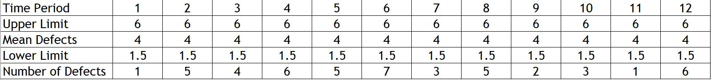

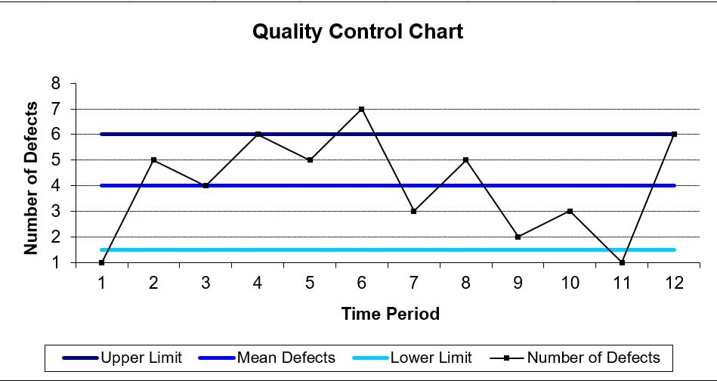

**Corrective Action List**

1.0 Statement of Purpose

The purpose of this document is to provide a list of the corrective actions that are needed to ensure defective products or processes comply with quality standards. This document includes (a) a description of the issue that needs corrective action along with a identification number, (b) a description of the corrective action, (c) the name of the person who is responsible for this corrective action, (d) the target date by which this corrective action should be implemented, (e) the status of the implementation of the corrective action, and (f) the metrics that will be used to determine whether the corrective action had the desired impact.



2.0 Corrective Actions List

|  |  |  |  |  |  |  |
| --- | --- | --- | --- | --- | --- | --- |
| **No.** | **Issues Description** | **Description of Corrective Action** | **Assigned To** | **Target Date** | **Status** | **Metrics** |
| 1 | Make the hardware parts order and missing to order some parts | Contacting with the supplier and dealing to send the missing parts correctly | Zaid Motasib | 22/04/2022 | Completed | Supplier sent the parts quickly |
| 2 | Very slow truffle environment | Contacting to Eng. Kostis Karantias in chainlink labs | Ahmad Jawabreh | 28/04/2021 | Completed | Sending the solution by chainlink labs |
| 3 | Hardware parts stuck in the airport customs | Contacting with the airport customs department and solve the issue | Ferhat Bal | 11/05/2022 | Completed | finishing the customs clearance quickly |

**Risk Breakdown Structure**

1.0 Statement of Purpose

The purpose of this document is to provide a record of the different risks that have been identified and will be managed for MFR project, arranged in a hierarchical order.



2.0 Risk Breakdown Structure

1. Understand how the system algorithm exactly working.

1.1. Break the face analyzing algorithm

1.1.1. Hide face feature that is important for the system

2. If the system will be used as (God eye) there is a risk to give wrong reports.

2.1. Give report to arrest peoples by wrong.

3. Breaking chainlink bridge.

3.1. Steal the user’s information that cross the bridge.

**Pareto Diagram**

|  |  |  |  |  |  |  |  |
| --- | --- | --- | --- | --- | --- | --- | --- |
| Quality Issue | 1 | 2 | 3 | 4 | 5 | 6 | Total |
| Number of Defects | 5 | 5 | 4 | 3 | 4 | 3 | 24 |
| % Occurrence | 20.83% | 20.83% | 16.67% | 12.50% | 16.67% | 12.50% | 100% |
| Cumulative % Occurrence | 20.83% | 41.67% | 58.33% | 70.83% | 87.50% | 95.83% |  |

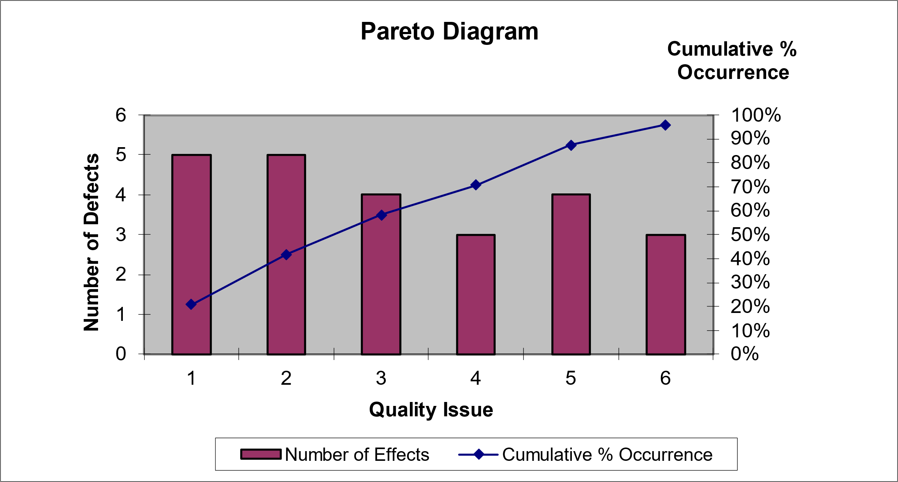

**Resource Histogram**

**Gant Chart**





**Human Resource Management Plan**

1.0 Revision History

There are no changes.



2.0 Statement of Purpose

The purpose of this document is to provide a description of when and how different individuals will be added to and removed from MFR project. This document includes (a) a project overview, (b) information about the project organization, (c) the resource requirements for MFR project, (d) the resource assignment to different tasks of the work breakdown structure, (e) any known constraints, (f) any contingency plans, (g) training requirements, if any, (h) how human resource documentation will be conducted, (i) guidelines for managing change to the resource needs, (j) the rules for modifying the human resource management plan, and (k) the signature of key stakeholders.



3.0 Project Overview

3.1 Overview of the Organization

AZFCO. is a company started by three university students in North Cyprus, Our goal is to focus on the AI project based on high security network using blockchain networks with PoW consensus protocol, MFR project is a one of the AI projects also its based on blockchain network (KADENA) with PoW consensus protocol which follows our company aims, Our aim is to create fully recognition system that can recognize users voice, masked face, palm, finger print without touch and create a god eye system connected to out fully recognition system.

3.2 Current Situation and Problem/Opportunity Statement

Normal facial recognition systems have ability to recognize not covered faces, so this technology can be used as a personal security system such iPhone face ID, Lock and unlock the doors using face recognition, and etc.

If we need a system for public control like the systems that is used in China for public control, we need a system that is stable, accurate, and high efficiency but the current facial recognition technology is breakable because who want to make a crime will cover his/her face with a mask and the current technology is unable to recognize masked faces, so the criminal will simply get away with his crime, So we need a system meet this specifications and unbreakable.

So using a masked facial recognition system will add this advantages to the main system and we will have a high accurate system and using the blockchain networks for the system communication will make the system unbreakable.

This masked face recognition technology can be used as a sub system within God eye technology using the blockchain networks for communicating and chainlink technology to collect off-chain data, here we are talking abut closing the gap of the security, accuracy and efficiency.

3.3 Project Objectives

Project outputs:

* Masked Face Recognition System
* Alternative authentication method, RFID system
* Blockchain connection to data transfer and validation

Project benefits:

* Masked Face recognition system for locking and unlocking the door.
* Masked Face recognition system as part of god eye project for public control.
* Masked Face recognition system can be used for face passport (Biometric passport).
* Solving the problem of inability to recognize masked faces which means solving of huge crimes.

4.0 Project Organization

4.1 Project Team

|  |  |  |  |
| --- | --- | --- | --- |
| Name | Role | Phone Number | Email Address |
| Ahmad Jawabreh | Project Manager  Hardware Specialist  Smart Contract Developer | +972592675704 | Ahmadjawabreh@protonmail.com |
| Zaid Mohtasib | Software Engineer | +97256937208 | [Zaidmoh@protonmail.com](mailto:Zaidmoh@protonmail.com) |
| Ferhat Bal | QA Specialist | +905338817935 | [ferhatbal@protonmail.com](mailto:ferhatbal@protonmail.com) |

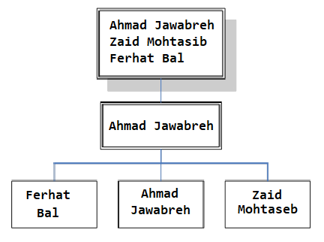

4.2 Key Stakeholders

Conduct a stakeholder analysis to identify key stakeholders, such as the project sponsor, project champion, as well as any external stakeholders, such as suppliers. Also include all pertinent information necessary to communicate with them.

|  |  |  |  |
| --- | --- | --- | --- |
|  | Zaid Mohtaseb | Ahmad Jawabreh | Ferhat Bal |
| Role Project | * Project Sponsor * Software Engineer * Management team member | * Project Sponsor * Project Manager * Hardware Specialist * Smart contract developer | * Project Sponsor * Quality Assurance team * Management team member |
| Organization | AZFCO. | AZFCO. | AZFCO. |
| Contact Information | [Zaidmoh@protonmail.com](mailto:Zaidmoh@protonmail.com) | Jawabreh@protonmail.com | Ferhatbal@protonmail.com |
| Unique Facts | Prefers use GitHub for project code | Prefers use of email for project documents | Prefers use GitHub for project code and test sheets |
| Level of Interest | High | High | High |
| Level of Influence | High | High | High |
| Suggestions for managing relationships | Keep informed of all project progress | Keep informed of all project progress | Keep informed of all project progress |

5.0 Resource Requirements

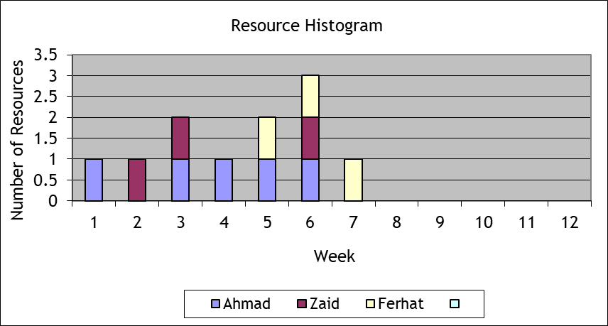



6.0 Resource Assignment

|  |  |  |
| --- | --- | --- |
| Task ID | Task | Team member |
| 1 | Hardware connecting | Ahmad (P) |
| 1.1 | RFID connecting | Ahmad (P) |
| 1.1.1 | Connect RFID Reader | Ahmad (P) |
| 1.1.2 | Connect the LED’s | Ahmad (P) |
| 1.1.3 | Connect the alphanumeric LCD | Ahmad (P) |
| 1.1.4 | Connect the micro servo motor | Ahmad (P) |
| 1.2 | Masked face recognition connecting | Ahmad (P) |
| 1.2.1 | Connect the camera | Ahmad (P) |
| 1.2.2 | Connect wavesshare LCD screen | Ahmad (P) |
| 1.3 | Sensors connecting | Ahmad (P) |
| 1.3.1 | Connect the distance sensors | Ahmad (P) |
| 1.3.2 | Connect the gas sensor | Ahmad (P) |
| 1.3.3 | Connect the flame sensor | Ahmad (P) |
| 1.3.4 | Connect the speaker | Ahmad (P) |
| 1.4 | Network connecting | Ahmad (P) |
| 1.4.1 | Connect the ethernet port | Ahmad (P) |
| 1.5 | Power and electricity connecting | Ahmad (P) |
| 1.5.1 | Connect the 9V battery | Ahmad (P) |
| 1.5.2 | Connect the power cable | Ahmad (P) |
| 2 | Coding | Zaid (P) |
| 2.1 | RFID Coding | Zaid (P) |
| 2.2 | Face recognition coding | Zaid (P) |
| 2.3 | Masked face recognition | Zaid (P) |
| 3 | Database creation | Zaid (P) |
| 3.1 | Database schema preparing | Zaid (P) |
| 3.2 | Database coding | Zaid (P) |
| 3.3 | Adding data to the database | Zaid (P) |
| 3.4 | Database connecting | Zaid (P) |
| 4 | Smart contract development | Ahmad (P) |
| 4.1 | chainlink to Kadena blockchain bridge | Ahmad (P) |
| 4.2 | Smart contract designing | Ahmad (P) |
| 4.3 | Smart contract coding | Ahmad (P) |
| 4.4 | Smart contract testing | Ferhat (P)  Ahmad (S) |
| 4.4.1 | Testing the system with the smart contract on testnet | Ferhat (P)  Ahmad (S) |
| 4.4.2 | Testing the system with the smart contract on mainnet | Ferhat (P)  Ahmad (S) |
| 4.5 | Deployment on mainnet | Ahmad (P) |
| 5 | Testing | Ferhat (P) |
| 5.1 | Testing the connection of hardware parts | Ferhat (P)  Ahmad (S) |
| 5.2 | Testing the system | Ferhat (P)  Ahmad (S)  Zaid (S) |
| 5.2.1 | RFID code testing | Ferhat (P)  Zaid (S) |
| 5.2.2 | Face recognition code testing | Ferhat (P)  Zaid (S) |
| 5.2.3 | Masked face recognition code testing | Ferhat (P)  Zaid (S) |
| 5.3 | Testing the connection of the database | Ferhat (P)  Zaid (S) |
| 5.4 | Testing the system with the smart contract on the test net | Ferhat (P)  Ahmad (S) |
| 5.5 | Testing the system with the smart contract on the mainnet | Ferhat (P)  Ahmad (S) |

7.0 Resource Constraints

Experts from Chainlink Labs have already been hired, who are responsible for creating the smart contract (bridge) that will connect the KADENA network with the Chainlink network, and the same experts have been asked to help the team to solve a problem that we encountered in the truffle environment.



8.0 Contingency Plans

15% of the company’s net profits will be continuously deducted and placed in the company’s treasury to serve as the company’s reserve in case we face any financial problem that requires liquidity.



9.0 Training Requirements

* Hardware Team:
* Bachelors Degree in Computer Engineering, Electrical and Electronic Engineering or a related technical discipline.
* Extensive experience with Arduino, RaspberryPi and Microcontrollers.
* Software Team :
* Bachelors Degree in Software Engineering, Computer Science or a related technical discipline.
* Extensive experience with Python.
* Smart contract team:
* Write well-documented, performant, clean, and re-usable Solidity code.
* Familiar with EVM environments
* Familiar with Pact and Plutus programming languages.

11.0 Human Resource Change Management Process

Changes will be overlooked carefully. But before the changes, it will be discussed as to why the change is needed and if that change is even enough to fix the main problem and we will also look for the risks revolving around the said change and then it will be implemented upon approval. The changes will be implemented in the simple following 4 steps:

* Preparing for Change
* Initiating Change
* Putting Change in Place
* Stabilizing Change



12.0 Plan Modification Rules

* Any changes on the plan need the project manager approval.
* Changes related to the financial issues needs the approval of the finance department with the project manager approval.
* Changes related to the hardware work needs the approval of the hardware department with the project manager approval.
* Changes related to the software work needs the approval of the software department with the project manager approval



13.0 Approval Signatures

|  |  |  |  |  |  |  |  |  |
| --- | --- | --- | --- | --- | --- | --- | --- | --- |
| Project Manager:  *As project manager on MFR project, I have reviewed the information contained in the Human Resource Management Plan and agree to its content.*   |  |  |  |  | | --- | --- | --- | --- | | Name | Position | Signature |  | | Ahmad Jawabreh | Hardware Specialist - Smart Contract Developer |  |  |   The signatures above represent stakeholders’ agreement and acknowledgement of the information contained in this document. |

**End Report**

1.0 Statement of Purpose

The purpose of this document is to provide a summary of the different project management methods and techniques that have been used over the life cycle of the project. This document includes (a) a statement indicating whether the project objectives were met, (b) an indication of whether the budget and schedule were as planned, (c) a list of the changes that were approved during the project life cycle, (d) an analysis of all the quality work performed, (e) a description of the customer acceptance process, (f) a description of how any contracts were terminated, (g) a summary of the project management plan, (h) an indication of when the post implementation review will be conducted, and (i) a list of the different project documents that will be archived.



2.0 Achievement of Project Objectives

Project objectives

* Find a solution to recognize masked faces.
* Find alternative authentication method based on touch less.
* Decentralization of processing the data.

Project outputs:

* Masked Face Recognition System.
* Alternative authentication method, RFID system.
* Blockchain connection to data transfer and validation



3.0 Project Performance

Cost: In the cost estimation was 1880TL but in face the project costs us 2127TL

Time: The project was done on the time without any changes

4.0 Approved Changes

One of the team members left the team, the tasks assigned to each team member were restructured by dividing the tasks of the member who left on the rest of the team members to complete the project within the specified time.



5.0 Quality Analysis

Since the start of the project, certain restrictions have been placed regarding the quality of the product so that the product is able to carry out its function with an error rate that does not exceed 10%.

Hardware parts have been carefully selected so that we have chosen original and high-quality parts to avoid errors in the system

The software team and the quality assurance team were working in perfect harmony to try to avoid any kind of errors in the code that could cause an increase in the error rate in obtaining the desired result.

The success rate of face recognition process is 95%, which is higher than the planned percentage.



6.0 Final Customer Acceptance

Due to the timely delivery of the product and the quality of the product, as the project was completed on time and with a system success rate higher than planned by the customer with the product, the meeting was attended by the project manager, contract manager, software engineer and quality assurance officer. The project delivery documents were signed and the customer paid the last payment.



7.0 Contract Closure

Regarding the main contract of the project, the contract was closed by delivering the project on time and within the required quality standards, as the client paid the last payment according to the project contract

9.0 Post Implementation Review

A review after implementation began with a comprehensive evaluation of the actual cost of the project compared to the Cost Estimation and a review of the reasons that led to an increase in the cost. The review also included an evaluation of the time, as the project was completed on time actually, and the last review was for the quality of the product and to ensure that the product can perform its function with the highest limit of permissible errors.



10.0 Project Archives

Project Research

Project Proposal

Work Breakdown Structure

Work Breakdown Structure Dictionary

Activity List

Activity Resource Requirement

Activity Duration Estimation

Cause and effect diagram

Gant Chart

Activity Cost Estimation

Business Case

Communication Matrix

Communication Plan

Contract Agreement

Contract Management

Control Chart

Corrective Actions List

Risk Breakdown Structure

Pareto Diagram

Resource Histogram

HR management plan

End Report