

**Cyprus International University**

Faculty of engineering

Department of Software Engineering

2021-2022 Spring semester

**Masked Face Recognition System (MFR)**

**Report 3**

**Project Supervisor**

Assist. Prof. Dr. Parvaneh ESMAİLİ

**Authors**

Ahmad Jawabreh & Zaid Mohtaseb

V1

**Table of Contents**

PETRO DIAGRAM………………………………………………………………………………………………………………3

RESOURCE HISTOGRAM……………………………………………………………………………………………………4

Human Resource Management Plan  
1.0 Revision History 6

2.0 Statement of Purpose 6

3.0 Project Overview 6

4.0 Project Organization 8

5.0 Resource Requirements 10

6.0 Resource Assignment 10

7.0 Resource Constraints 12

8.0 Contingency Plans 12

9.0 Training Requirements 12

10.0 Documentation 12

11.0 Human Resource Change Management Process 13

12.0 Plan Modification Rules 13

13.0 Approval Signatures 13

End Report  
1.0 Statement of Purpose 14

2.0 Achievement of Project Objectives 14

3.0 Project Performance 14

4.0 Approved Changes 15

5.0 Quality Analysis 15

6.0 Final Customer Acceptance 15

7.0 Contract Closure 15

8.0 Final Project Performance Report 16

9.0 Post Implementation Review 16

10.0 Project Archives 16

**Pareto Diagram**

|  |  |  |  |  |  |  |  |
| --- | --- | --- | --- | --- | --- | --- | --- |
| Quality Issue | 1 | 2 | 3 | 4 | 5 | 6 | Total |
| Number of Defects | 5 | 5 | 4 | 3 | 4 | 3 | 24 |
| % Occurrence | 20.83% | 20.83% | 16.67% | 12.50% | 16.67% | 12.50% | 100% |
| Cumulative % Occurrence | 20.83% | 41.67% | 58.33% | 70.83% | 87.50% | 95.83% |  |

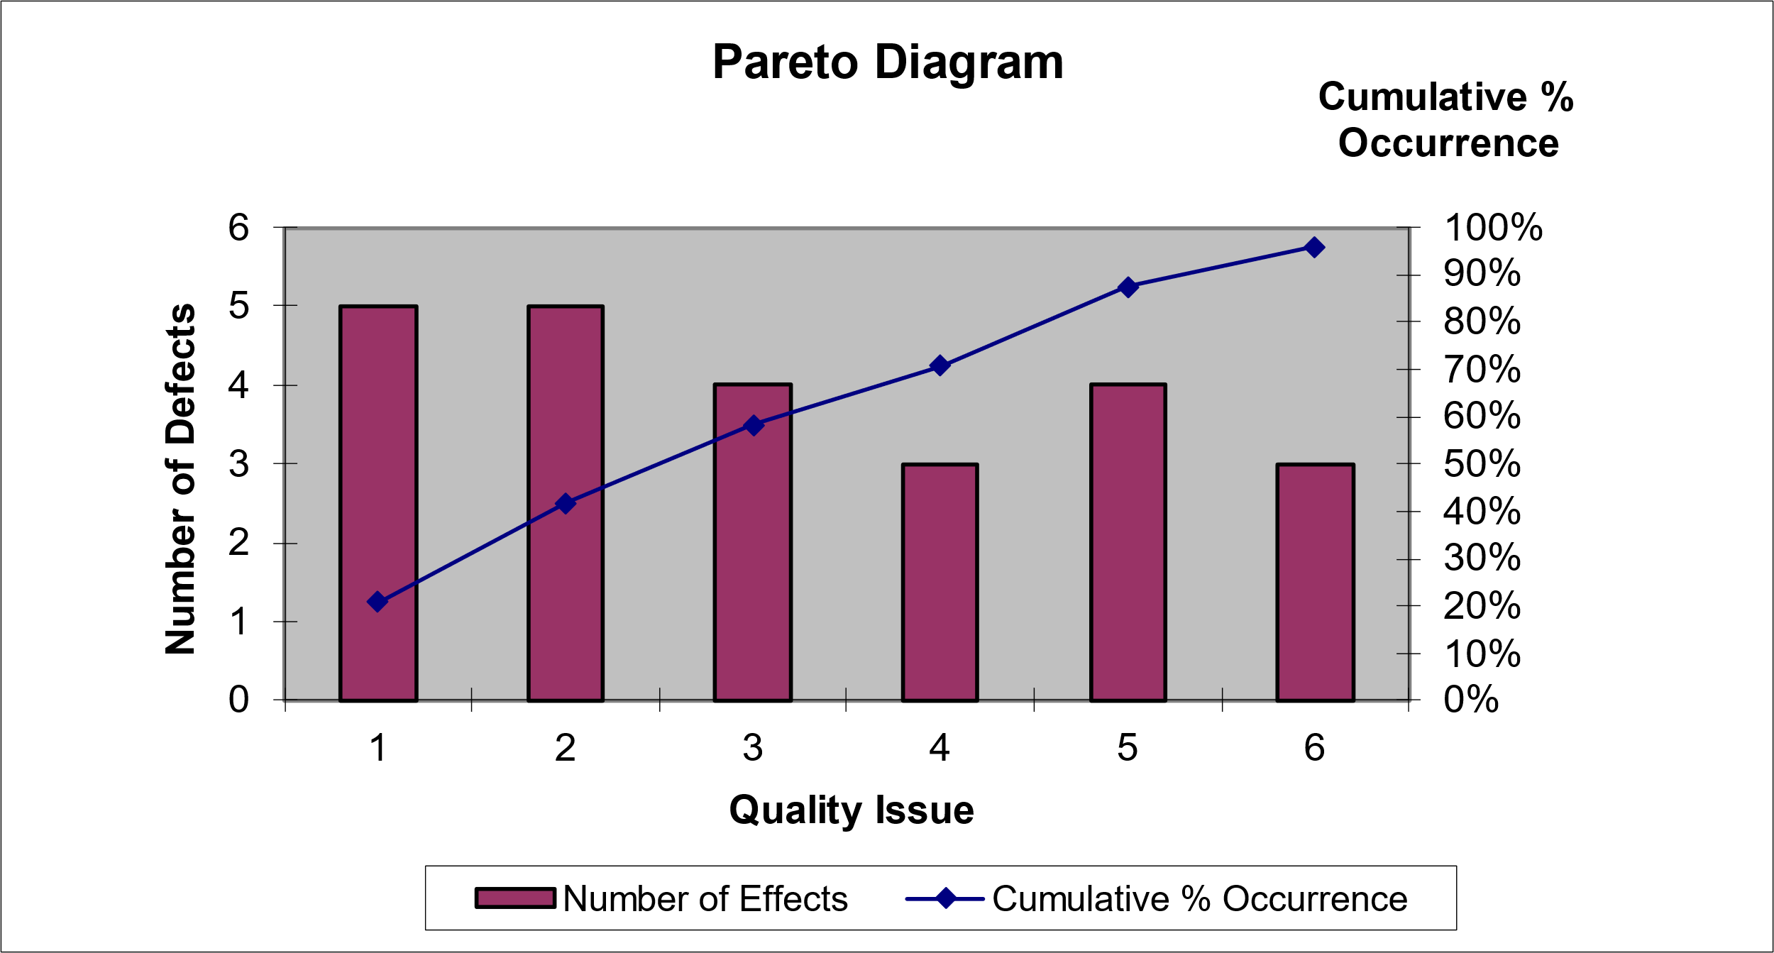

**Resource Histogram**

**Gant Chart**

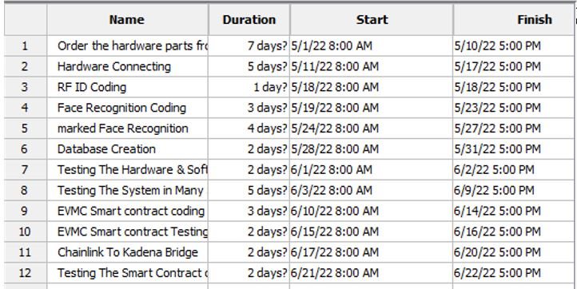

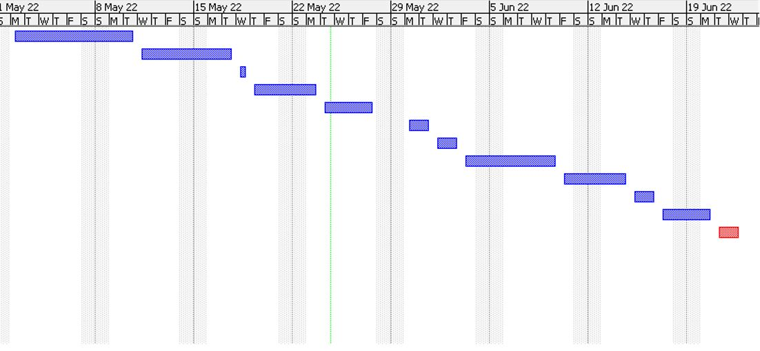

**Human Resource Management Plan**

1.0 Revision History

There are no changes.



2.0 Statement of Purpose

The purpose of this document is to provide a description of when and how different individuals will be added to and removed from MFR project. This document includes (a) a project overview, (b) information about the project organization, (c) the resource requirements for MFR project, (d) the resource assignment to different tasks of the work breakdown structure, (e) any known constraints, (f) any contingency plans, (g) training requirements, if any, (h) how human resource documentation will be conducted, (i) guidelines for managing change to the resource needs, (j) the rules for modifying the human resource management plan, and (k) the signature of key stakeholders.



3.0 Project Overview

3.1 Overview of the Organization

AZFCO. is a company started by three university students in North Cyprus, Our goal is to focus on the AI project based on high security network using blockchain networks with PoW consensus protocol, MFR project is a one of the AI projects also its based on blockchain network (KADENA) with PoW consensus protocol which follows our company aims, Our aim is to create fully recognition system that can recognize users voice, masked face, palm, finger print without touch and create a god eye system connected to out fully recognition system.

3.2 Current Situation and Problem/Opportunity Statement

Normal facial recognition systems have ability to recognize not covered faces, so this technology can be used as a personal security system such iPhone face ID, Lock and unlock the doors using face recognition, and etc.

If we need a system for public control like the systems that is used in China for public control, we need a system that is stable, accurate, and high efficiency but the current facial recognition technology is breakable because who want to make a crime will cover his/her face with a mask and the current technology is unable to recognize masked faces, so the criminal will simply get away with his crime, So we need a system meet this specifications and unbreakable.

So using a masked facial recognition system will add this advantages to the main system and we will have a high accurate system and using the blockchain networks for the system communication will make the system unbreakable.

This masked face recognition technology can be used as a sub system within God eye technology using the blockchain networks for communicating and chainlink technology to collect off-chain data, here we are talking abut closing the gap of the security, accuracy and efficiency.

3.3 Project Objectives

Project outputs:

* Masked Face Recognition System
* Alternative authentication method, RFID system
* Blockchain connection to data transfer and validation

Project benefits:

* Masked Face recognition system for locking and unlocking the door.
* Masked Face recognition system as part of god eye project for public control.
* Masked Face recognition system can be used for face passport (Biometric passport).
* Solving the problem of inability to recognize masked faces which means solving of huge crimes.

4.0 Project Organization

4.1 Project Team

|  |  |  |  |
| --- | --- | --- | --- |
| Name | Role | Phone Number | Email Address |
| Ahmad Jawabreh | Project Manager  Hardware Specialist  Smart Contract Developer | +972592675704 | Ahmadjawabreh@protonmail.com |
| Zaid Mohtasib | Software Engineer | +97256937208 | [Zaidmoh@protonmail.com](mailto:Zaidmoh@protonmail.com) |
| Ferhat Bal | QA Specialist | +905338817935 | [ferhatbal@protonmail.com](mailto:ferhatbal@protonmail.com) |

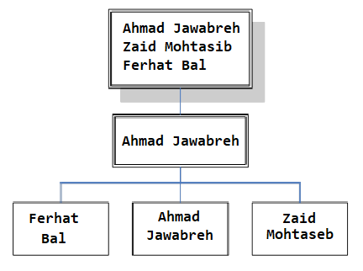

4.2 Key Stakeholders

Conduct a stakeholder analysis to identify key stakeholders, such as the project sponsor, project champion, as well as any external stakeholders, such as suppliers. Also include all pertinent information necessary to communicate with them.

|  |  |  |  |
| --- | --- | --- | --- |
|  | Zaid Mohtaseb | Ahmad Jawabreh | Ferhat Bal |
| Role Project | * Project Sponsor * Software Engineer * Management team member | * Project Sponsor * Project Manager * Hardware Specialist * Smart contract developer | * Project Sponsor * Quality Assurance team * Management team member |
| Organization | AZFCO. | AZFCO. | AZFCO. |
| Contact Information | [Zaidmoh@protonmail.com](mailto:Zaidmoh@protonmail.com) | Jawabreh@protonmail.com | Ferhatbal@protonmail.com |
| Unique Facts | Prefers use GitHub for project code | Prefers use of email for project documents | Prefers use GitHub for project code and test sheets |
| Level of Interest | High | High | High |
| Level of Influence | High | High | High |
| Suggestions for managing relationships | Keep informed of all project progress | Keep informed of all project progress | Keep informed of all project progress |

5.0 Resource Requirements

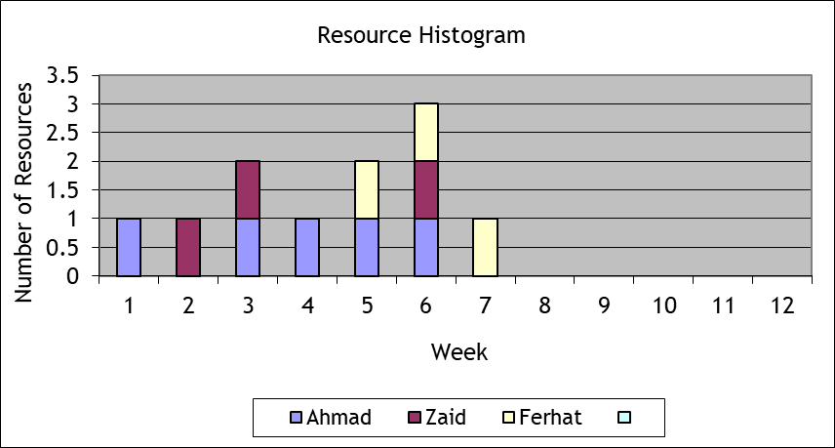



6.0 Resource Assignment

|  |  |  |
| --- | --- | --- |
| Task ID | Task | Team member |
| 1 | Hardware connecting | Ahmad (P) |
| 1.1 | RFID connecting | Ahmad (P) |
| 1.1.1 | Connect RFID Reader | Ahmad (P) |
| 1.1.2 | Connect the LED’s | Ahmad (P) |
| 1.1.3 | Connect the alphanumeric LCD | Ahmad (P) |
| 1.1.4 | Connect the micro servo motor | Ahmad (P) |
| 1.2 | Masked face recognition connecting | Ahmad (P) |
| 1.2.1 | Connect the camera | Ahmad (P) |
| 1.2.2 | Connect wavesshare LCD screen | Ahmad (P) |
| 1.3 | Sensors connecting | Ahmad (P) |
| 1.3.1 | Connect the distance sensors | Ahmad (P) |
| 1.3.2 | Connect the gas sensor | Ahmad (P) |
| 1.3.3 | Connect the flame sensor | Ahmad (P) |
| 1.3.4 | Connect the speaker | Ahmad (P) |
| 1.4 | Network connecting | Ahmad (P) |
| 1.4.1 | Connect the ethernet port | Ahmad (P) |
| 1.5 | Power and electricity connecting | Ahmad (P) |
| 1.5.1 | Connect the 9V battery | Ahmad (P) |
| 1.5.2 | Connect the power cable | Ahmad (P) |
| 2 | Coding | Zaid (P) |
| 2.1 | RFID Coding | Zaid (P) |
| 2.2 | Face recognition coding | Zaid (P) |
| 2.3 | Masked face recognition | Zaid (P) |
| 3 | Database creation | Zaid (P) |
| 3.1 | Database schema preparing | Zaid (P) |
| 3.2 | Database coding | Zaid (P) |
| 3.3 | Adding data to the database | Zaid (P) |
| 3.4 | Database connecting | Zaid (P) |
| 4 | Smart contract development | Ahmad (P) |
| 4.1 | chainlink to Kadena blockchain bridge | Ahmad (P) |
| 4.2 | Smart contract designing | Ahmad (P) |
| 4.3 | Smart contract coding | Ahmad (P) |
| 4.4 | Smart contract testing | Ferhat (P)  Ahmad (S) |
| 4.4.1 | Testing the system with the smart contract on testnet | Ferhat (P)  Ahmad (S) |
| 4.4.2 | Testing the system with the smart contract on mainnet | Ferhat (P)  Ahmad (S) |
| 4.5 | Deployment on mainnet | Ahmad (P) |
| 5 | Testing | Ferhat (P) |
| 5.1 | Testing the connection of hardware parts | Ferhat (P)  Ahmad (S) |
| 5.2 | Testing the system | Ferhat (P)  Ahmad (S)  Zaid (S) |
| 5.2.1 | RFID code testing | Ferhat (P)  Zaid (S) |
| 5.2.2 | Face recognition code testing | Ferhat (P)  Zaid (S) |
| 5.2.3 | Masked face recognition code testing | Ferhat (P)  Zaid (S) |
| 5.3 | Testing the connection of the database | Ferhat (P)  Zaid (S) |
| 5.4 | Testing the system with the smart contract on the test net | Ferhat (P)  Ahmad (S) |
| 5.5 | Testing the system with the smart contract on the mainnet | Ferhat (P)  Ahmad (S) |

7.0 Resource Constraints

Experts from Chainlink Labs have already been hired, who are responsible for creating the smart contract (bridge) that will connect the KADENA network with the Chainlink network, and the same experts have been asked to help the team to solve a problem that we encountered in the truffle environment.



8.0 Contingency Plans

15% of the company’s net profits will be continuously deducted and placed in the company’s treasury to serve as the company’s reserve in case we face any financial problem that requires liquidity.



9.0 Training Requirements

* Hardware Team:
* Bachelors Degree in Computer Engineering, Electrical and Electronic Engineering or a related technical discipline.
* Extensive experience with Arduino, RaspberryPi and Microcontrollers.
* Software Team :
* Bachelors Degree in Software Engineering, Computer Science or a related technical discipline.
* Extensive experience with Python.
* Smart contract team:
* Write well-documented, performant, clean, and re-usable Solidity code.
* Familiar with EVM environments
* Familiar with Pact and Plutus programming languages.

11.0 Human Resource Change Management Process

Changes will be overlooked carefully. But before the changes, it will be discussed as to why the change is needed and if that change is even enough to fix the main problem and we will also look for the risks revolving around the said change and then it will be implemented upon approval. The changes will be implemented in the simple following 4 steps:

* Preparing for Change
* Initiating Change
* Putting Change in Place
* Stabilizing Change



12.0 Plan Modification Rules

* Any changes on the plan need the project manager approval.
* Changes related to the financial issues needs the approval of the finance department with the project manager approval.
* Changes related to the hardware work needs the approval of the hardware department with the project manager approval.
* Changes related to the software work needs the approval of the software department with the project manager approval



13.0 Approval Signatures

|  |  |  |  |  |  |  |  |  |
| --- | --- | --- | --- | --- | --- | --- | --- | --- |
| Project Manager:  *As project manager on MFR project, I have reviewed the information contained in the Human Resource Management Plan and agree to its content.*   |  |  |  |  | | --- | --- | --- | --- | | Name | Position | Signature |  | | Ahmad Jawabreh | Hardware Specialist - Smart Contract Developer |  |  |   The signatures above represent stakeholders’ agreement and acknowledgement of the information contained in this document. |

**End Report**

1.0 Statement of Purpose

The purpose of this document is to provide a summary of the different project management methods and techniques that have been used over the life cycle of the project. This document includes (a) a statement indicating whether the project objectives were met, (b) an indication of whether the budget and schedule were as planned, (c) a list of the changes that were approved during the project life cycle, (d) an analysis of all the quality work performed, (e) a description of the customer acceptance process, (f) a description of how any contracts were terminated, (g) a summary of the project management plan, (h) an indication of when the post implementation review will be conducted, and (i) a list of the different project documents that will be archived.



2.0 Achievement of Project Objectives

Project objectives

* Find a solution to recognize masked faces.
* Find alternative authentication method based on touch less.
* Decentralization of processing the data.

Project outputs:

* Masked Face Recognition System.
* Alternative authentication method, RFID system.
* Blockchain connection to data transfer and validation



3.0 Project Performance

Cost: In the cost estimation was 1880TL but in face the project costs us 2127TL

Time: The project was done on the time without any changes

4.0 Approved Changes

One of the team members left the team, the tasks assigned to each team member were restructured by dividing the tasks of the member who left on the rest of the team members to complete the project within the specified time.



5.0 Quality Analysis

Since the start of the project, certain restrictions have been placed regarding the quality of the product so that the product is able to carry out its function with an error rate that does not exceed 10%.

Hardware parts have been carefully selected so that we have chosen original and high-quality parts to avoid errors in the system

The software team and the quality assurance team were working in perfect harmony to try to avoid any kind of errors in the code that could cause an increase in the error rate in obtaining the desired result.

The success rate of face recognition process is 95%, which is higher than the planned percentage.



6.0 Final Customer Acceptance

Due to the timely delivery of the product and the quality of the product, as the project was completed on time and with a system success rate higher than planned by the customer with the product, the meeting was attended by the project manager, contract manager, software engineer and quality assurance officer. The project delivery documents were signed and the customer paid the last payment.



7.0 Contract Closure

Regarding the main contract of the project, the contract was closed by delivering the project on time and within the required quality standards, as the client paid the last payment according to the project contract

9.0 Post Implementation Review

A review after implementation began with a comprehensive evaluation of the actual cost of the project compared to the Cost Estimation and a review of the reasons that led to an increase in the cost. The review also included an evaluation of the time, as the project was completed on time actually, and the last review was for the quality of the product and to ensure that the product can perform its function with the highest limit of permissible errors.



10.0 Project Archives

Project Research

Project Proposal

Work Breakdown Structure

Work Breakdown Structure Dictionary

Activity List

Activity Resource Requirement

Activity Duration Estimation

Cause and effect diagram

Gant Chart

Activity Cost Estimation

Business Case

Communication Matrix

Communication Plan

Contract Agreement

Contract Management

Control Chart

Corrective Actions List

Risk Breakdown Structure

Pareto Diagram

Resource Histogram

HR management plan

End Report