

Cyprus International University

Faculty of engineering
Department of Software Engineering
2021-2022 Spring semester

Masked Face Recognition System (MFR)
Human Resource Management Plan

Project Supervisor
Assist. Prof. Dr. Parvaneh ESMAİLİ

Authors
Ahmad Jawabreh & Zaid Mohtaseb

V1

Table of Contents
1.0 Revision History 2
2.0 Statement of Purpose 2
3.0 Project Overview 3
3.1 Overview of the Organization 3
3.2 Current Situation and Problem/Opportunity Statement 3
3.3 Project Objectives 3
4.0 Project Organization 3
4.1 Project Team 3
4.2 Key Stakeholders 4
5.0 Resource Requirements 5
6.0 Resource Assignment 6
7.0 Resource Constraints 6
8.0 Contingency Plans 6
9.0 Training Requirements 7
10.0 Documentation 7
11.0 Human Resource Change Management Process 7
12.0 Plan Modification Rules 7
13.0 Approval Signatures 8

1.0 Revision History
There are no changes.

2.0 Statement of Purpose
The purpose of this document is to provide a description of when and how different individuals will be added to and removed from MFR project. This document includes (a) a project overview, (b) information about the project organization, (c) the resource requirements for MFR project, (d) the resource assignment to different tasks of the work breakdown structure, (e) any known constraints, (f) any contingency plans, (g) training requirements, if any, (h) how human resource documentation will be conducted, (i) guidelines for managing change to the resource needs, (j) the rules for modifying the human resource management plan, and (k) the signature of key stakeholders.

3.0 Project Overview

3.1 Overview of the Organization
AZFCO. is a company started by three university students in North Cyprus, Our goal is to focus on the AI project based on high security network using blockchain networks with PoW consensus protocol, MFR project is a one of the AI projects also its based on blockchain network (KADENA) with PoW consensus protocol which follows our company aims, Our aim is to create fully recognition system that can recognize users voice, masked face, palm, finger print without touch and create a god eye system connected to out fully recognition system.

3.2 Current Situation and Problem/Opportunity Statement
Normal facial recognition systems have ability to recognize not covered faces, so this technology can be used as a personal security system such iPhone face ID, Lock and unlock the doors using face recognition, and etc.

If we need a system for public control like the systems that is used in China for public control, we need a system that is stable, accurate, and high efficiency but the current facial recognition technology is breakable because who want to make a crime will cover his/her face with a mask and the current technology is unable to recognize masked faces, so the criminal will simply get away with his crime, So we need a system meet this specifications and unbreakable.
So using a masked facial recognition system will add this advantages to the main system and we will have a high accurate system and using the blockchain networks for the system communication will make the system unbreakable.

This masked face recognition technology can be used as a sub system within God eye technology using the blockchain networks for communicating and chainlink technology to collect off-chain data, here we are talking abut closing the gap of the security, accuracy and efficiency.

3.3 Project Objectives
Project outputs:
- Masked Face Recognition System
- Alternative authentication method, RFID system
- Blockchain connection to data transfer and validation

Project benefits:
- Masked Face recognition system for locking and unlocking the door.
- Masked Face recognition system as part of god eye project for public control.
- Masked Face recognition system can be used for face passport (Biometric passport).
- Solving the problem of inability to recognize masked faces which means solving of huge crimes.

4.0 Project Organization

4.1 Project Team
Name | Role | Phone Number | Email Address
Ahmad Jawabreh | Project Manager  Hardware Specialist  Smart Contract Developer | +972592675704 | Ahmadjawabreh@protonmail.com
Zaid Mohtasib | Software Engineer | +97256937208 | Zaidmoh@protonmail.com
Ferhat Bal | QA Specialist | +905338817935 | ferhatbal@protonmail.com

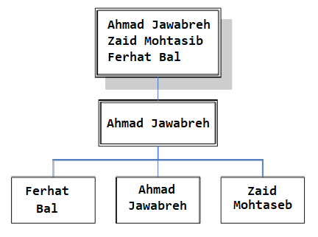

4.2 Key Stakeholders
Conduct a stakeholder analysis to identify key stakeholders, such as the project sponsor, project champion, as well as any external stakeholders, such as suppliers. Also include all pertinent information necessary to communicate with them.

 | Zaid Mohtaseb | Ahmad Jawabreh | Ferhat Bal
Role Project | - Project Sponsor  - Software Engineer  - Management team member | - Project Sponsor  - Project Manager  - Hardware Specialist  - Smart contract developer | - Project Sponsor  - Quality Assurance team  - Management team member
Organization | AZFCO. | AZFCO. | AZFCO.
Contact Information | Zaidmoh@protonmail.com | Jawabreh@protonmail.com | Ferhatbal@protonmail.com
Unique Facts | Prefers use GitHub for project code | Prefers use of email for project documents | Prefers use GitHub for project code and test sheets
Level of Interest | High | High | High
Level of Influence | High | High | High
Suggestions for managing relationships | Keep informed of all project progress | Keep informed of all project progress | Keep informed of all project progress

5.0 Resource Requirements
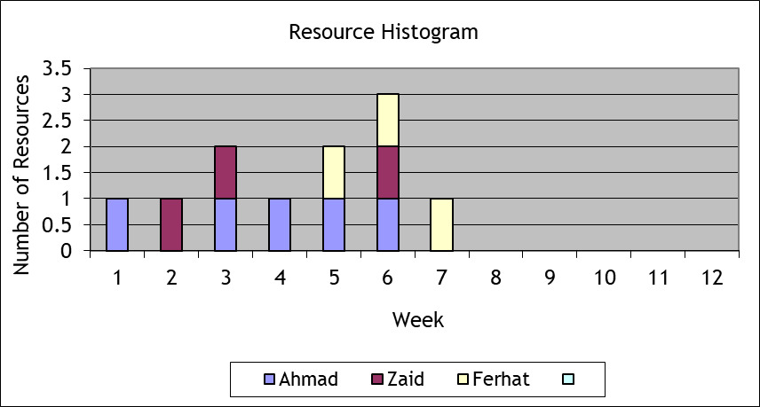

6.0 Resource Assignment
Task ID | Task | Team member
1 | Hardware connecting | Ahmad (P)
1.1 | RFID connecting | Ahmad (P)
1.1.1 | Connect RFID Reader | Ahmad (P)
1.1.2 | Connect the LED’s | Ahmad (P)
1.1.3 | Connect the alphanumeric LCD | Ahmad (P)
1.1.4 | Connect the micro servo motor | Ahmad (P)
1.2 | Masked face recognition connecting | Ahmad (P)
1.2.1 | Connect the camera | Ahmad (P)
1.2.2 | Connect wavesshare LCD screen | Ahmad (P)
1.3 | Sensors connecting | Ahmad (P)
1.3.1 | Connect the distance sensors | Ahmad (P)
1.3.2 | Connect the gas sensor | Ahmad (P)
1.3.3 | Connect the flame sensor | Ahmad (P)
1.3.4 | Connect the speaker | Ahmad (P)
1.4 | Network connecting | Ahmad (P)
1.4.1 | Connect the ethernet port | Ahmad (P)
1.5 | Power and electricity connecting | Ahmad (P)
1.5.1 | Connect the 9V battery | Ahmad (P)
1.5.2 | Connect the power cable | Ahmad (P)
2 | Coding | Zaid (P)
2.1 | RFID Coding | Zaid (P)
2.2 | Face recognition coding | Zaid (P)
2.3 | Masked face recognition | Zaid (P)
3 | Database creation | Zaid (P)
3.1 | Database schema preparing | Zaid (P)
3.2 | Database coding | Zaid (P)
3.3 | Adding data to the database | Zaid (P)
3.4 | Database connecting | Zaid (P)
4 | Smart contract development | Ahmad (P)
4.1 | chainlink to Kadena blockchain bridge | Ahmad (P)
4.2 | Smart contract designing | Ahmad (P)
4.3 | Smart contract coding | Ahmad (P)
4.4 | Smart contract testing | Ferhat (P)  Ahmad (S)
4.4.1 | Testing the system with the smart contract on testnet | Ferhat (P)  Ahmad (S)
4.4.2 | Testing the system with the smart contract on mainnet | Ferhat (P)  Ahmad (S)
4.5 | Deployment on mainnet | Ahmad (P)
5 | Testing | Ferhat (P)
5.1 | Testing the connection of hardware parts | Ferhat (P)  Ahmad (S)
5.2 | Testing the system | Ferhat (P)  Ahmad (S)  Zaid (S)
5.2.1 | RFID code testing | Ferhat (P)  Zaid (S)
5.2.2 | Face recognition code testing | Ferhat (P)  Zaid (S)
5.2.3 | Masked face recognition code testing | Ferhat (P)  Zaid (S)
5.3 | Testing the connection of the database | Ferhat (P)  Zaid (S)
5.4 | Testing the system with the smart contract on the test net | Ferhat (P)  Ahmad (S)
5.5 | Testing the system with the smart contract on the mainnet | Ferhat (P)  Ahmad (S)

7.0 Resource Constraints
Experts from Chainlink Labs have already been hired, who are responsible for creating the smart contract (bridge) that will connect the KADENA network with the Chainlink network, and the same experts have been asked to help the team to solve a problem that we encountered in the truffle environment.

8.0 Contingency Plans
15% of the company’s net profits will be continuously deducted and placed in the company’s treasury to serve as the company’s reserve in case we face any financial problem that requires liquidity.

9.0 Training Requirements
- Hardware Team:
- Bachelors Degree in Computer Engineering, Electrical and Electronic Engineering or a related technical discipline.
- Extensive experience with Arduino, RaspberryPi and Microcontrollers.

- Software Team :
- Bachelors Degree in Software Engineering, Computer Science or a related technical discipline.
- Extensive experience with Python.

- Smart contract team:
- Write well-documented, performant, clean, and re-usable Solidity code.
- Familiar with EVM environments
- Familiar with Pact and Plutus programming languages.

11.0 Human Resource Change Management Process
Changes will be overlooked carefully. But before the changes, it will be discussed as to why the change is needed and if that change is even enough to fix the main problem and we will also look for the risks revolving around the said change and then it will be implemented upon approval. The changes will be implemented in the simple following 4 steps:
- Preparing for Change
- Initiating Change
- Putting Change in Place
- Stabilizing Change

12.0 Plan Modification Rules
- Any changes on the plan need the project manager approval.

- Changes related to the financial issues needs the approval of the finance department with the project manager approval.

- Changes related to the hardware work needs the approval of the hardware department with the project manager approval.

- Changes related to the software work needs the approval of the software department with the project manager approval

13.0 Approval Signatures
Project Manager:

As project manager on MFR project, I have reviewed the information contained in the Human Resource Management Plan and agree to its content.

Name | Position | Signature
Ahmad Jawabreh | Hardware Specialist - Smart Contract Developer | 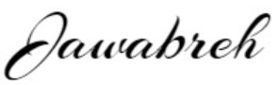

The signatures above represent stakeholders’ agreement and acknowledgement of the information contained in this document.

