DAY 4:  
  
On this day, several features were added and some errors were debugged   
  
 **FEATURES ADDED:  
  
Category-based searching and the dynamically rendered data was dealt.  
Global State management for Search bar component.  
Global State management for Cart  
Specific Product Page Component with dynamic data.**

**Dynamically rendered products listing**:  
  
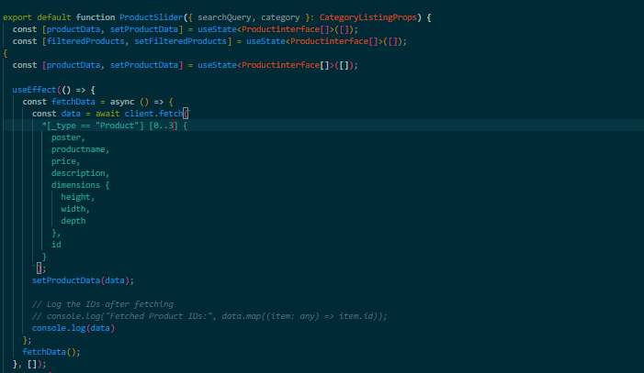  
  
**Then the specific product page by dynamic routes:**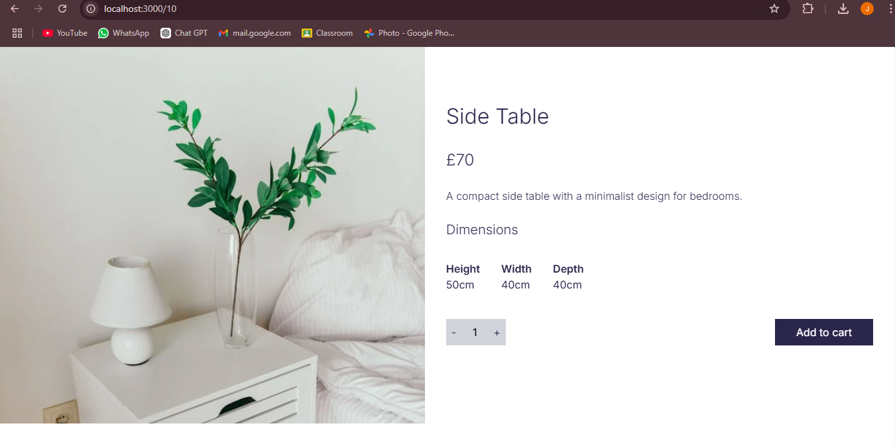

**Implemented the context API for globally managing the Cart:  
