Complete Case Study
Multi-Vendor E-commerce Platform
A MERN-stack marketplace with buyer, seller, and admin roles, Stripe checkout, and real-time buyer–seller messaging.
Source repository: github.com/Jawad-Ahmed-S/MULTI-VENDOR-ECOMMERCE

Overview
This platform is a full-stack, multi-vendor e-commerce marketplace built on the MERN stack (MongoDB, Express, React, Node.js), structured as three cooperating services: a REST API, a dedicated Socket.IO real-time server, and a React single-page application. It supports three distinct user roles — buyer, seller, and admin — each with a purpose-built dashboard, and covers the core marketplace loop end to end: store and product onboarding with admin approval, browsing and search, cart and checkout via Stripe, order lifecycle tracking, and direct buyer–seller chat.
The codebase separates concerns cleanly: the backend/ service exposes a versioned REST API (/api/v1/…) organized by domain (user, store, product, search, cart, order, payment, message, conversation, event); the socket/ service is a minimal, stateless real-time relay; and the frontend/ is a Vite-powered React 19 app with role-scoped routes and Redux Toolkit for state.

Goals of the Project
- Enable multiple independent sellers to run their own storefronts under one marketplace, without sellers needing separate infrastructure.
- Give administrators a moderation layer — stores and products enter as “pending” and require explicit admin approval before they go live.
- Provide buyers with a familiar, low-friction shopping flow: search/filter, cart, wishlist, secure checkout, and order tracking.
- Let buyers and sellers resolve questions directly through real-time chat, rather than only through order metadata.
- Give sellers visibility into their own performance — sales, order status breakdowns, and stock — through a dedicated analytics dashboard.
- Keep the system modular enough that the API, the chat server, and the client can be deployed, scaled, and iterated on independently.

System Architecture Overview
The system follows a lightweight, service-oriented split rather than a single monolith. Three Node.js processes cooperate: an Express REST API (port 8000) handling all CRUD and business logic against MongoDB; a separate Socket.IO server (port 7000) that only relays chat events and tracks who is currently online, entirely in memory; and the React client, which talks to the REST API over HTTPS and to the socket server over a persistent WebSocket connection. Authentication is JWT-based and stateless — the token carries the user's id, and role checks (isSeller, isAdmin) are re-verified against the database on each protected request rather than trusted from the token alone. Media (avatars, product images, store banners) is streamed through Multer directly to Cloudinary without ever touching local disk, and payments are handled by Stripe Checkout Sessions with an asynchronous webhook that is the actual source of truth for order creation.

System Architecture Diagram
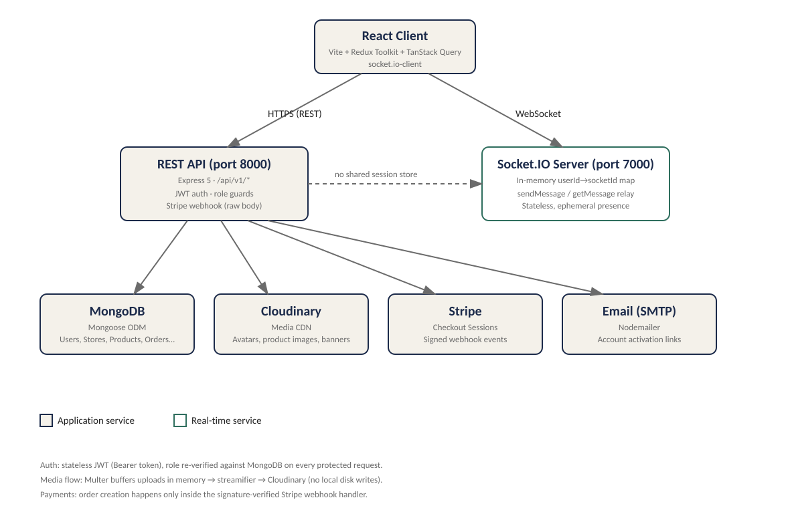
Figure 1 — High-level system architecture: client, API, socket server, and backing services.

Key Features

Multi-Role User System

Buyer
- Registers with email/password; the account is inactive until the user clicks an emailed activation link (a signed, short-lived JWT).
- Can browse products/stores, maintain a wishlist and cart on their user document, check out, track orders, and message sellers.

Seller
- Any authenticated user can create a Store, which starts in a pending approvalStatus until an admin approves it.
- Once approved, the seller can list products (which themselves also start pending and need approval), run time-boxed discount Events, fulfill orders, and chat with buyers.

Admin
- Role is a plain string field on the User document (role: "admin"), enforced by an isAdmin middleware that re-checks the database on every request.
- Reviews and approves/rejects pending stores and products (with a required rejection reason), and has platform-wide visibility into users, stores, products, and orders.

Product Management & Shopping

Product listings
- Products belong to a store and carry name, description, category, tags, original/discount price, stock, and an array of Cloudinary-hosted images.
- Every new product is created with approvalStatus: "pending" and only appears in public listings once an admin approves it — the same gate applied to stores.

Cart & checkout
- The cart lives as a sub-array on the User document (product reference + quantity); checkout reads it, builds a Stripe line-item list, and clears it only after the webhook confirms payment.
- Shipping is a simple flat-fee rule (free above a rupee/dollar threshold, a fixed fee below it) computed both at checkout-session creation and again inside the webhook.

Search & filtering
- A dedicated search endpoint runs a MongoDB aggregation pipeline (searchPipeline.js) that regex-matches name/description/category/tags, and — when no other filters are set — unions in matching stores as well, so a single search box can surface both products and storefronts.
- A separate, reusable ApiFeatures class (search/filter/pagination/sort) backs the plain product-listing endpoints, layering price-range, category, and “active sale” filters on top of keyword search.

Payment Processing

Multiple payment gateways
The current implementation integrates one gateway, Stripe, via Checkout Sessions, plus a Cash-on-Delivery (COD) option modeled directly in the Order schema's paymentInfo.method enum ("COD" | "Stripe"). The schema is deliberately structured to make adding further gateways (e.g. PayPal, local payment rails) a matter of extending that enum and the corresponding controller, rather than a schema redesign.

Secure transactions
- Checkout is server-authoritative: the client never sets prices — the backend recalculates line-item totals from the product documents before creating the Stripe session.
- Order creation happens only inside the Stripe webhook handler (signature-verified with STRIPE_WEBHOOK_SECRET), not on the client's success redirect, which prevents a user from spoofing a successful payment by hitting the success URL directly.
- A separate verify-session endpoint lets the frontend poll for the true payment/order status — accounting for the small race window between the redirect and the webhook finishing asynchronously.

Real-Time Messaging

Buyer ↔ Seller chat
- A Conversation document pairs one buyer with one store; Message documents reference it and carry sender, isSeller, text, and a soft-delete flag.
- The standalone Socket.IO server keeps an in-memory map of userId → socketId; on sendMessage it looks up the recipient's live socket and emits getMessage directly to them, while the REST API persists the message and increments an unread counter.

Notifications
- Per-conversation unread counts are tracked separately for buyer and seller (unreadCount.buyer / unreadCount.seller) and reset via a markConversationRead endpoint, giving each side an independent badge count.

Seller Dashboard Features

Sales tracking
- The store performance page aggregates the seller's own orders into a daily revenue time series and renders it with Recharts (area/bar charts).

Order management
- Sellers see orders scoped to their own store(s) only (SellerStoreOrdersPage, SellerAllOrdersPage) and can progress orderStatus through processing → confirmed → shipped → delivered.

Analytics
- Dashboard widgets surface order-status breakdowns, low-stock alerts (configurable threshold), and per-product performance — all computed client-side from the seller's own order/product data rather than a separate analytics service.

API Architecture
The backend exposes a single versioned REST namespace, /api/v1/, mounted in index.js as ten domain routers: payment, user, product, store, search, cart, order, message, conversation, and event. Each router delegates to a matching controller module, and cross-cutting concerns are handled by three middleware layers: isAuthenticated (verifies the Bearer JWT and attaches req.user), role guards (isSeller, isAdmin) that re-check the user's current role in the database, and a centralized errorHandlerMiddleware that normalizes thrown errorHandler instances into consistent JSON error responses. Async controllers are wrapped in a catchAsyncError higher-order function so route handlers can stay free of repetitive try/catch blocks. One route is a deliberate exception to the JSON-body pipeline: the Stripe webhook is mounted before express.json() and uses express.raw() instead, because Stripe's signature verification requires the untouched raw request body.

Brand Value Propositions

Scalability
- The REST API, the Socket.IO server, and the frontend are separate processes with independent package.json files, so each can be scaled or redeployed on its own (e.g. running multiple API instances behind a load balancer while a single socket server handles presence).
- MongoDB collections carry targeted indexes (e.g. Store on owner and approvalStatus/isActive, Product on store and approvalStatus) to keep the moderation and storefront queries fast as catalog size grows.

Security
- Passwords are hashed with bcrypt and excluded from query results by default (select: false); JWTs are short-lived where appropriate (e.g. 5-minute activation tokens).
- Role authorization is re-verified server-side per request rather than trusted from client state, and Stripe webhook signatures are cryptographically verified before any order is created.

Performance
- Search and catalog browsing use a MongoDB aggregation pipeline and indexed fields instead of scanning full collections; images are offloaded to Cloudinary's CDN rather than served from the app server.
- The client uses TanStack Query for request caching/deduplication alongside Redux Toolkit for local UI state, reducing redundant network calls.

Tech Stack

Backend

Frameworks & libraries
Component | Technology
Runtime & framework | Node.js, Express 5
Database & ODM | MongoDB, Mongoose
Authentication | jsonwebtoken (JWT), bcrypt (password hashing)
File uploads | Multer (in-memory buffer) → Cloudinary SDK + streamifier
Payments | Stripe SDK (Checkout Sessions + Webhooks)
Email | Nodemailer
Real-time | Socket.IO (separate service)
Dev tooling | Nodemon, ESLint

Frontend

Frameworks & libraries
Component | Technology
Framework & build tool | React 19, Vite
Routing | React Router v7
State management | Redux Toolkit + redux-persist
Server state / caching | TanStack Query (+ devtools)
Styling | Tailwind CSS 4
Charts / analytics UI | Recharts
HTTP client | Axios
Real-time client | socket.io-client
UI feedback & icons | react-hot-toast, lucide-react

File & Media Handling

Image uploads
- Multer buffers uploaded files in memory (no disk writes) and streams them to Cloudinary via streamifier, so the API server stays stateless.

Cloud storage
- Cloudinary stores avatars (face-cropped to 300×300), product images, and store banners, and returns both a secure_url and a public_id — the latter used later for clean deletion when a product/image is removed.

Real-Time Communication

WebSockets
- Socket.IO powers live chat delivery and an online-presence map; the API persists messages, the socket server only relays them to a connected recipient.

Push notifications
- Not yet implemented as browser/mobile push — “notification” today means an in-app unread-count badge per conversation, updated via the REST API and refreshed on socket events. This is a natural extension point (e.g. Web Push or FCM) rather than a current feature.

Development & Deployment Tools

CI/CD
No CI/CD pipeline (e.g. GitHub Actions) is present in the repository at this time. ESLint configs exist for both backend and frontend, which would be a natural first stage of a future pipeline.

Containerization
No Dockerfiles or container orchestration are present in the repository; the three services currently run as plain Node processes (npm run dev via Nodemon) against local .env configuration.

Challenges & Solutions
Payment/order consistency: a naive implementation might create the Order as soon as the client is redirected back from Stripe, which can be spoofed or can race the actual payment confirmation. Solution: order creation is moved entirely into the signature-verified Stripe webhook handler, and a separate verify-session endpoint lets the client safely poll for the real status (“processing” vs “success” vs “failed”).
Two-sided real-time delivery without a shared session store: the socket server needs to know which live connection belongs to which user, without sharing a database with the API. Solution: a simple in-memory userId → socketId map on the socket service, populated by an addUser event on connect and cleaned up on disconnect — intentionally ephemeral and horizontally simple, at the cost of not surviving a socket-server restart.
Trusting client-submitted roles: a JWT payload could, in principle, be replayed after a role change. Solution: isSeller/isAdmin middleware re-fetches the user from MongoDB on every protected request instead of trusting a role claim baked into the token.
Marketplace quality control: letting any seller publish instantly risks low-quality or fraudulent listings. Solution: both Store and Product schemas include an approvalStatus state machine (pending → approved/rejected) with a required rejectionReason, and public listing/search endpoints filter on approvalStatus: "approved" so unapproved content never reaches buyers.
Search across two different collections: buyers may be searching for a product or a whole storefront. Solution: the search aggregation pipeline runs a $unionWith between products and stores when no product-specific filters are active, returning a single ranked, mixed result set tagged with itemType.

Database Design
MongoDB (via Mongoose) is the single data store, with seven core collections. Relationships are modeled with ObjectId references and resolved with .populate() rather than embedding, which keeps documents small and avoids duplicating mutable data (like a product's current price) across collections.
Collection | Key fields & relationships
User | name, email, password (hashed, select:false), role, address[], wishlist[→Product], cart[{product→Product, quantity}]
Store | owner→User, name, description, banner, approvalStatus, rejectionReason, ratings
Product | store→Store, name, category, tags[], originalPrice, discountPrice, stock, images[], reviews[{user→User, rating, comment}], approvalStatus
Order | user→User, orderItems[{product→Product, store→Store, price, qty}], shippingAddress, paymentInfo{method, status}, orderStatus
Event | product→Product, store→Store, discountPercentage, startDate/endDate, status (running/ended)
Conversation | buyer→User, seller→Store, lastMessage, unreadCount{buyer, seller}
Message | conversation→Conversation, sender, isSeller, text, isDeleted (soft delete)

Indexing is applied where query filters are predictable: Store is indexed on owner and on the compound (approvalStatus, isActive) used by every public storefront query; Product is indexed on the compound (store, approvalStatus) used both by seller dashboards and public catalog pages.

Application Flow Diagram
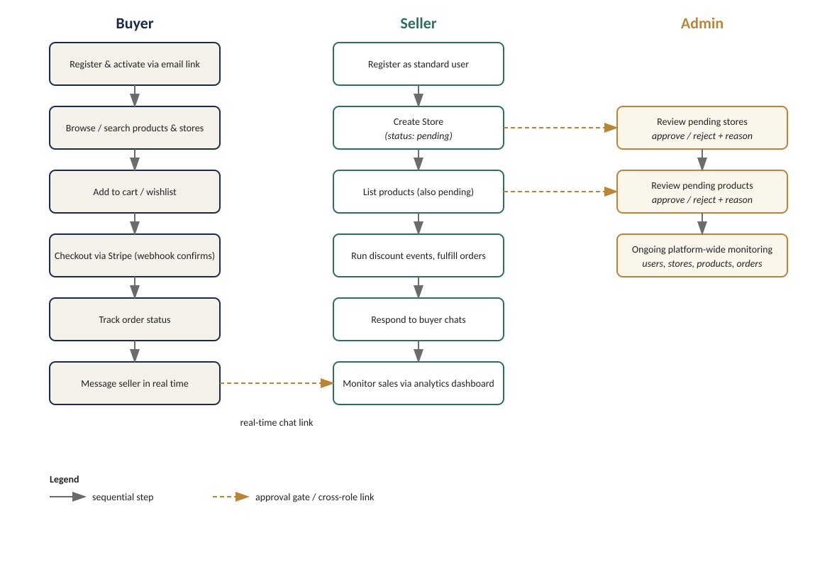
Figure 2 — Parallel flows for buyer, seller, and admin, with approval gates and the real-time chat link between buyer and seller.

User Flow
- Register → confirm identity via emailed activation link → browse/search products and stores → add items to cart or wishlist → checkout through Stripe → track order status and message the seller directly if needed.

Seller Flow
- Register as a standard user → create a Store (enters pending) → wait for admin approval → once approved, add products (each also enters pending) → once approved, products go live — seller can then run discount events, manage incoming orders, respond to buyer chats, and monitor sales through the analytics dashboard.

Admin Flow
- Review the queue of pending stores → approve or reject with a reason → review the queue of pending products → approve or reject with a reason → ongoing: monitor all users, stores, products, and orders platform-wide for policy or quality issues.

Best Practices

Authentication & Security

JWT / OAuth
- Stateless JWT authentication via a Bearer token, verified per-request by isAuthenticated middleware; no OAuth/social login is currently implemented.
- Short-lived JWTs are used for single-purpose actions (e.g. a 5-minute token embedding the full pending-user payload for email activation) rather than reusing the long-lived session token.

Data encryption
- Passwords are hashed with bcrypt before storage and never returned in queries by default (select: false on the schema field).
- Payment data itself is never stored or handled directly — Stripe Checkout takes card details out of the application's trust boundary entirely, and Stripe webhook payloads are signature-verified before being trusted.

Component Architecture

Reusable components
- The frontend/src/components tree is split by audience (buyer/, seller/, admin/, common/), so role-specific UI stays isolated while shared primitives (buttons, cards, layout chrome) live in common/ and are reused across all three roles.

Modular structure
- The backend mirrors this modularity by domain: every feature (user, store, product, order, payment, message, conversation, event, cart, search) has its own route, controller, and (where needed) model file, keeping each concern independently testable and easy to locate.
- Shared logic is factored into utils/ (catchAsyncError, errorHandler, apiFeatures, searchPipeline, cloudinary, sendMail, sendToken) instead of being duplicated across controllers.

Error Handling & User Experience

Friendly error messages
- A custom errorHandler class carries an HTTP status code and message; a single errorHandlerMiddleware at the end of the Express pipeline turns any thrown error into a consistent { success: false, message } JSON response the frontend can display via toast notifications (react-hot-toast).

Logging & monitoring
- Current logging is console-based (request tracing in auth middleware, debug logs in conversation lookups) — sufficient for development, but the codebase does not yet integrate a structured logging or monitoring service (e.g. Winston/Pino plus an APM), which is a reasonable next step before production deployment.

