**System Architecture**

**What pages are included?**

* Home
* Product Specific Page
* All Product Listing
* About Us
* Cart
* Checkout page
* Payment Page
* Tracking Page
* Live Location Page

**Description:**

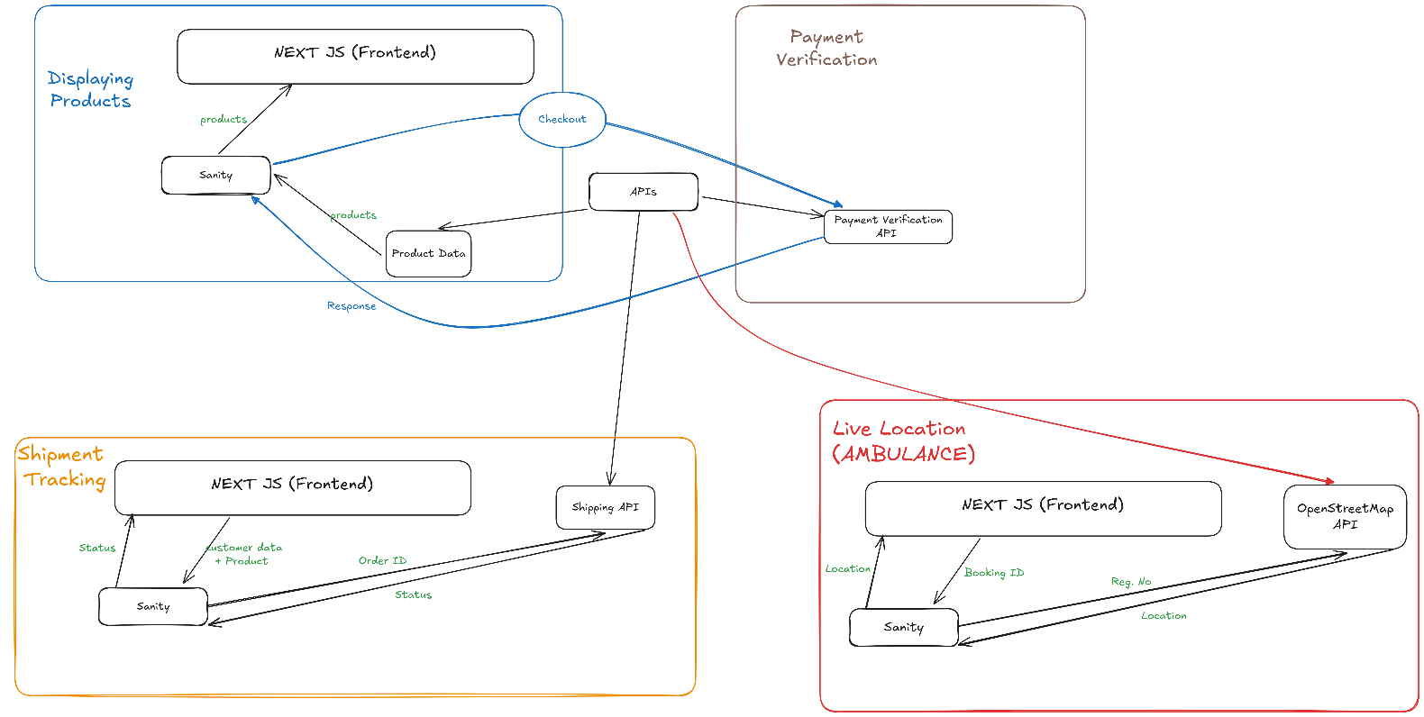This document will provide an overview of how marketplace will be working.  
  
  
  
**WORKFLOW:**

**Order Placing:**

1. **User Browses Items**  
   |
2. **User Adds Items to Cart**  
   |
3. **User Proceeds to Checkout**  
   |
4. **User Provides Shipping Info**  
   |
5. **User Confirms Order**  
   |
6. **Order Confirmed and Shipped**

**Ambulance Booking:**

* + **User Enters Pickup Location**  
    |
  + **User Selects Ambulance Type**  
    |
  + **Customize as Requirements**  
    |
  + **User Confirms Booking**  
    |
  + **Ambulance Arrives and Transports Patient**

**Order Tracking:**

* + **User Enters Order ID**  
    |
  + **System Fetches Order Status**  
    |
  + **User Views Shipping Status**  
    |
  + **User Tracks Estimated Delivery Time**

**Ambulance Location Tracking:**

* + **User Enters Ambulance ID**  
    |
  + **System Fetches Ambulance Location**  
    |
  + **User Tracks Ambulance Location on Map**  
    |
  + **Ambulance Arrives and Transports Patient**

**API Endpoints and Purpose:**

|  |  |  |  |
| --- | --- | --- | --- |
| **Endpoint** | **Method** | **Purpose** | **Response Example** |
| /products | GET | Fetches all product details | { "id": 1, "name": "Product A", "price": 100, "image": "url_to_image" } |
| /checkout | POST | Processes the order and initiates checkout | { "orderId": 123, "status": "success", "message": "Order placed successfully." } |
| /orderStatus/{orderId} | GET | Retrieves the current status of an order | { "orderId": 123, "status": "shipped", "estimatedDelivery": "2023-10-10" } |
| /{ambulanceID}/location | GET | Fetches the current location of the ambulance | { "ambulanceId": 456, "location": { "latitude": 12.345678, "longitude": 98.765432 } } **/** Map Format |

**Schema Definitions:**All the schema files are in the root of the repository.