PROGRAM NO: 1
DATE:

SUM AND AVERAGE OF A SET OF NUMBERS

AIM: Write a program to find the sum and average of a set of numbers.

PROGRAM CODE:

n = input("Enter the limit:")
n = int(n)
sum = 0
for i in range(1,n+1,1):
i=int(input("enter the numbers:"))
sum=sum+i
avg=sum/n
print("sum = ",sum,"average = ",avg)

RESULT: The program executed successfully.

OUTPUT:

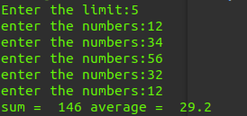

PROGRAM NO: 2
DATE:

PRIME, ARMSTRONG, PERFECT AND FIBONACCI NUMBERS

AIM: Write a program to identify prime number, Amstrong number, perfect number, Fibonacci numbers.

PROGRAM CODE:

n = int(input("Enter your number:"))
def prime(n):
if n > 1:
f = 0
for i in range(2, n):
if (n % i) == 0:
f = 1
if f == 0:
print(n," is prime")
else:
print(n," is not a prime")
def armstrong(n):
a = n
s = 0
while(n!=0):
d=int(n%10)
s=s+(d*d*d)
n=n/10
if a == s:
print(a," is armstrong")
else:
print(a," is not armstrong")
def perfect(n):
s = 0
for i in range(1,n):
if (n % i) == 0:
s = s + i
if s == n:
print(n,"is perfect number")
else:
print(n," is not a perfect number")
def fibonocci(n):
a = 0
b = 1
if (n == 0) or (n==1):
print(n,"is fibonocci number")
else:
c = a + b
if c == n:
printf(n,"is a fibonocci number")
else:
print(n," is not a fibonocci number")

print("1.prime\n2.armstrong\n3.perfect number\n4.fibonocci")
m=int(input("Enter your choice:"))
if(m == 1):
prime(n)
if(m == 2):
armstrong(n)
if(m == 3):
perfect(n)
if(m == 4):
fibonocci(n)

RESULT:
The program executed successfully.

OUTPUT:

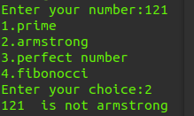

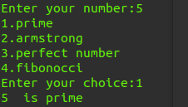

PROGRAM NO: 3
DATE:

REPLACING A WORD IN A GIVEN STRING

AIM: Develop a python program to accept a text string “hello student welcome to mes aimat give your details”& replace the word “student” in the text with the name accepted from the user.

PROGRAM CODE:

n = str(input("Hello Student Welcome To MES AIMAT \n Enter Your NAME::"))
print("\n Hello ",n,"Welcome To MES AIMAT")

RESULT: The program executed successfully.

OUTPUT:

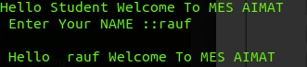

PROGRAM NO: 4
DATE:

LEAP YEAR

AIM: Write a program to read a year (4-digit integer) and tell whether the given year is a leap year.

PROGRAM CODE:

n = int(input("Enter the year::"))
a = n
f = 0
if(n % 400 == 0):
f = 1
if((n % 4 == 0)&(n % 100 != 0)):
f = 1
if(f):
print(a," is leap year")
else:
print(a," is not a leap year")

RESULT: The program executed successfully.

OUTPUT:

PROGRAM NO: 5
DATE:

ODD AND EVEN SUM OF AN INTEGER

AIM: Write a program to find odd and even sum of an integer.

PROGRAM CODE:

n = int(input("Enter the Number::"))
a = n
e = 0
o = 0
while(n > 0):
d = int(n % 10)
if(int(d % 2) == 0):
e = e + d
else:
o = o + d
n = int(n / 10)
print("Even sum of ",a," is ",e)
print("Odd sum of ",a," is ",o)

RESULT: The program executed successfully.

OUTPUT:

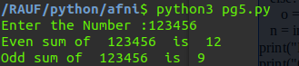

PROGRAM NO: 6
DATE:

VOWELS, CONSONANTS, DIGITS AND SPECIAL CHARACTERS

AIM: Write a program to find vowel, consonants, digit, special character in a string.

PROGRAM CODE:

n = input("Enter the string::")
V = []
C = []
d = []
S = []
for i in n:
if(i == 'a' or i == 'A' or i == 'e' or i == 'E' or i == 'i' or i == 'I' or i == 'o' or i == 'O' or i == 'u' or i == 'U'):
V.append(i)
elif(i.isdecimal()):
d.append(i)
elif((i >= 'A' or i <= 'Z')&(i >= 'a' or i <= 'z')):
C.append(i)
else:
S.append(i)
print("vowels in ",n," are:",V)
print("consonents in ",n," are:",C)
print("digits in ",n," are:",d)
print("special characters in ",n," are:",S)

RESULT: The program executed successfully.

OUTPUT:

PROGRAM NO: 7
DATE:

3-DIGIT COMBINATION

AIM: Demonstrate 3 digit combination in python.

PROGRAM CODE:

n = int(input("Enter first number:"))
m = int(input("Enter second number:"))
o = int(input("Enter third number:"))
d = []
d.append(n)
d.append(m)
d.append(o)
for i in range(0,3):
for j in range(0,3):
for k in range(0,3):
if(i != j or j !=k or k != i):
print(d[i],d[j],d[k])

RESULT: The program executed successfully.

OUTPUT:

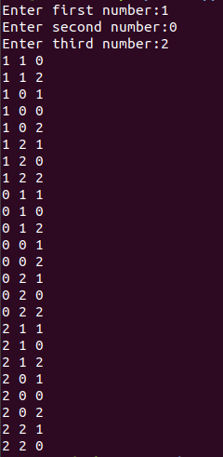

PROGRAM NO: 8
DATE:

STUDENT DETAILS AND GRADE

AIM: Write a program to enter name and degree of students and give the grade according to the mark.

PROGRAM CODE:

n = input("Enter Name:")
m = input("Enter Degree:")
m = int(input("Enter Mark:"))
print("Student Details\n")
print("Name:",n,"\nDegree:",m,"\nMark:",m,"\nGrade:")
if((m >= 90) & (m <=100)):
print("A+")
elif((m >= 80) & (m <=89)):
print("A")
elif((m >= 70) & (m <=79)):
print("B+")
elif((m >= 60) & (m <=69)):
print("B+")
elif((m >= 50) & (m <=59)):
print("B")
elif((m >= 40) & (m <=49)):
print("C")
elif((m >= 30) & (m <=39)):
print("D")
else:
print("Failed")

RESULT: The program executed successfully.

OUTPUT:

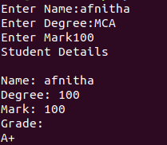

PROGRAM NO: 9
DATE:

PRINT CURRENT BILL USING IF OPERATION

AIM: Write a program to print current bill using if operation.

PROGRAM CODE:

u=int(input("please enter the number of units you consumed in a month:"))
if(u<=100):
Amount=u*1.5
charge=25.00
elif(u<=200):
Amount=(100*1.5)+(u-100)*2.5
charge=50.00
elif(u<=300):
Amount=(100*1.5)+(200-100)*2.5+(u-200)*4
charge=75.00
elif(u<=350):
Amount=(100*1.5)+(200-100)*2.5+(300-200)*4+(u-300)*5
charge=100.00
else:
Amount=0
charge=1500.00
print("\nElecticity bill:",Amount+charge)

RESULT: The program executed successfully.

OUTPUT:

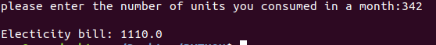

PROGRAM NO: 10
DATE:

STUDENT RECORD PROCESSING WITH TUPLE AND LIST

AIM: Write a program to implement student record processing with tuple and list application.

PROGRAM CODE:

n = int(input("Enter Roll Number:"))
name = input("Enter Name:")
degree = input("Enter Degree:")
clg = input("Enter College:")
m = []
for i in range(0,3):
mark = int(input("Enter mark:"))
m.append(mark)
student = (n,name,degree,clg,m)
print("-----student record-----\n")
print(student)

RESULT: The program executed successfully.

OUTPUT:

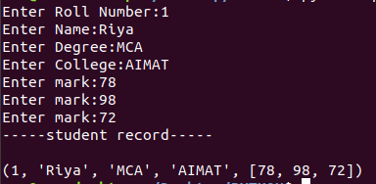

PROGRAM NO: 11
DATE:

4 SET OPERATIONS

AIM: Write a program to implement 4 set operations.

PROGRAM CODE:

n = int(input("enter limit of first set:"))
m = int(input("enter limit of second set:"))
X = set()
Y = set()
for i in range(0,n):
q = input("Enter Element of set1:")
X.add(q)
for i in range(0,m):
q = input("Enter Element of set2:")
Y.add(q)
print("set 1:",X)
print("set 2:",Y)
print("Union of the sets is:",X | Y)
print("intersection of the sets is:",X & Y)
print("difference of the sets is:",X - Y)
print("symmetric difference of the sets is:",X ^ Y)

RESULT: The program executed successfully.

OUTPUT:

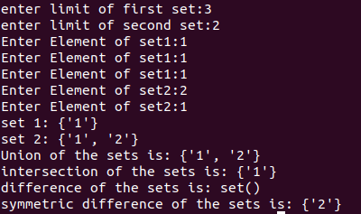

PROGRAM NO: 12
DATE:

DICTIONARY IMPLEMENTATION

AIM: Write a program to implement dictionary (create, add item, remove item, modify item).

PROGRAM CODE:

x = {}
def create():
print("Dictionary Successfully Created")
def add():
m = int(input("Enter limit:"))
for i in range(0,m):
a = input("Enter the key to insert:")
b = input("Enter the value to insert:")
x[a] = b
print("Dictionary after insertion:",x)
def remove():
u = input("enter the position of value to remove:")
x.pop(u)
print("Dictionary after deletion:",x)
def modify():
w = input("Enter the key/position to modify:")
y = input("Enter the value to modify:")
x[w] = y
print("Dictionary after modification:",x)
def exitt():
print("exiting...")
exit()
while True:
print("-----DICTIONARY-----")
print("\n1.create\n2.add item\n3.remove item\n4.modify item\n5.exit")
n = int(input("\nEnter your choice:"))
if(n == 1):
create()
if(n == 2):
add()
if(n == 3):
remove()
if(n == 4):
modify()
if(n == 5):
exitt()

RESULT: The program executed successfully.

OUTPUT:

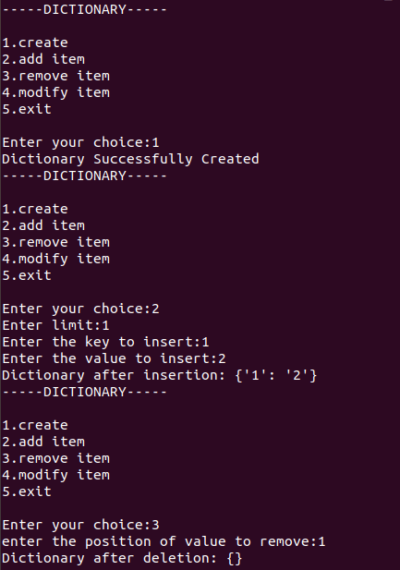

PROGRAM NO: 13
DATE:

MEAN, MEDIAN AND MODE USING FUNCTION

AIM: Write a program to implement a user defined function for calculating mean, median, mode.

PROGRAM CODE:

def mean(x,l):
b = 0
for i in range(0,l):
b = b + x[i]
mean = b/l
print("Mean:",mean)
def median(x,l):
if( n % 2 == 0):
m = int(l / 2)
p = int((l + 1)/2)
median = (x[m]+x[p])/2
else:
m = (l+1) / 2
median = x[m]
def mode(x,l):
m = max(set(x),key = x.count)
print("Mode:",m)
def exitt():
print("exiting...")
exit()
x = []
l = int(input("Enter limit:"))
for i in range(0,l,1):
m = int(input("Enter the number:"))
x.append(m)
while True:
print("\n1.Mean\n2.Median\n3.Mode\n4.exit")
n = int(input("\nEnter your choice:"))
if(n == 1):
mean(x,l)
if(n == 2):
median(x,l)
if(n == 3):
mode(x,l)
if(n == 4):
exitt()

RESULT: The program executed successfully.

OUTPUT:

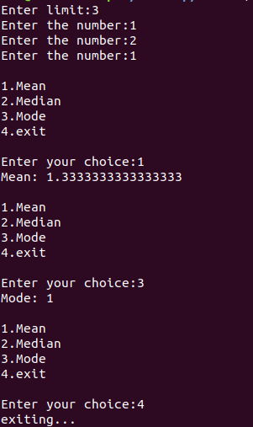

PROGRAM NO: 14
DATE:

STRING FUNCTIONS

AIM: Write a function which takes text as argument and calculate.
- how many words starts with letter ‘t’,
- calculate how many words end with letter ‘s’,
- calculate how many 6 words are appearing,
- calculate how many words are there in the text
PROGRAM CODE:

def letters(n):
s=n
t=0
sc=0
l=[]
s = s.split(' ')
n=n.split()
for word in s:
if(word.startswith("t")):
t=t+1
if(word.endswith("s")):
sc=sc+1
if(len(word)==6):
l.append(word)
print("The no of words in the string is:",len(n))
print("Number of words starts with letter ‘t’:",t)
print("Number of words ends with letter ‘s’:",sc)
print("6 letters words are appearing",l)

n=input("Enter the string:")
letters(n)

RESULT: The program executed successfully.

OUTPUT:

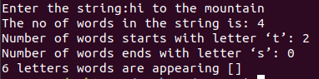

PROGRAM NO: 15
DATE:

AREA AND PERIMETER OF RECTANGLE AND CIRCLE

AIM: Write a function to find out the area and perimeter of rectangle and circle.

PROGRAM CODE:

print("......Rectange......")
l = int(input("Enter the lenght:"))
b = int(input("Enter the bredth:"))

def Rarea(l,b):
return(l*b)
def Rperimeter(l,b):
return(2*(l+b))

print("Area :",Rarea(l,b),"\nPerimeter :",Rperimeter(l,b))

print("......Circle......")
r = int(input("Enter the Radius:"))

def Carea(r):
return(3.14*r*r)
def Cperimeter(r):
return(2*3.14*r)

print("Area :",Carea(r),"\nPerimeter :",Cperimeter(r))

RESULT: The program executed successfully.

OUTPUT:

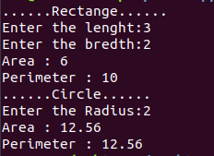

PROGRAM NO: 16
DATE:

CLASS VARIABLE AND INSTANCE VARIABLE

AIM: Write a program to implement class variable and instance variable using a pointer.

PROGRAM CODE:

class counter:
classtotal = 0
def __init__(self):
self.mytotal = 0
def increment(self):
counter.classtotal+=1
self.mytotal+=1

a = counter()
b = counter()

a.increment()
b.increment()
b.increment()

print(a.mytotal)
print(a.__class__.classtotal)
print(b.mytotal)
print(b.__class__.classtotal)

RESULT: The program executed successfully.

OUTPUT:

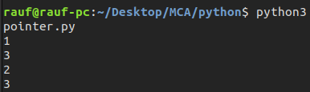

PROGRAM NO: 17
DATE:

IMPLEMENT CLASS RECTANGLE

AIM: Write a program to implement class rectangle.

PROGRAM CODE:

class Rectangle:

def __init__(self):
self.w = 0
self.l = 0
def setsize(self,width,length):
self.w = width
self.l = length
def perimeter(self):
return(2*(self.w+self.l))
def area(self):
return(self.w*self.l)

q = Rectangle()
width = int(input("enter the width"))
length = int(input("enter the length"))
q.setsize(width,length)
print("Perimeter:",q.perimeter())
print("Area:",q.area())

RESULT: The program executed successfully.

OUTPUT:

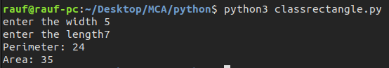

PROGRAM NO: 18
DATE:

PRINT EMPLOYEE DETAILS AND COUNT USING CLASS

AIM: Write a program to print employee details and total count using class.

PROGRAM CODE:

class Employee:
empcount = 0
def __init__(self,name,desig,sal):
self.name = name
self.desig = desig
self.sal = sal
Employee.empcount += 1

i = 1
count = 0
e = []
while i>0:
name = input("Enter name:")
desig = input("Enter Designation:")
sal = input("Enter salary:")
e.append(Employee(name,desig,sal))
i = int(input("Do you what to continue(1/0):"))
count += 1
n = 0
print("......Employee Details......")
while n < count:
print("\nName:",e[n].name,"\nDesignation:",e[n].desig,"\nSalary:",e[n].sal)
n += 1
print("Total number of Employees :",Employee.empcount)

RESULT: The program executed successfully.

OUTPUT:

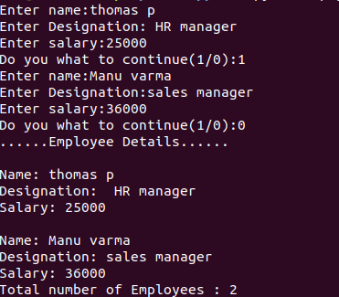

PROGRAM NO: 19
DATE:

LIBRARY FILE AND DIFFERENT FILE OPERATIONS

AIM: Create a file that stores details of library and perform different file operations for reading writing appending.

PROGRAM CODE:

file = open("liibrary.txt","x")
file.close()
file = open("library.txt","w")
file.write("........Book Details.......")
file.write("\nname\tAuthor\t publisher")
file.write("\nc++\tbalaguruswamy\tdc books")
file.write("\naadujeevitha\tbenyamin\tdc books")
file.close()
file = open("library.txt","r")
for line in file.readlines():
print(line)
file.close()
file = open("library.txt","a")
file.write("\nkayar\tthakazhi\tnew publishers")
file.close()
file = open("library.txt","r+")
for line in file.readlines():
print(line)
file.close()

RESULT: The program executed successfully.

OUTPUT:

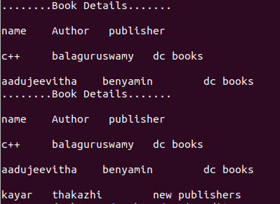

PROGRAM NO: 20
DATE:

COUNT THE GIVEN WORDS

AIM: Write a program to count the words ‘to’ and ‘the’

PROGRAM CODE:

f = open("file1.txt","x")
f.close()
f = open("library.txt","w")
f.write("India, officially the Republic of India (Hindi: Bhārat Gaṇarājya),[24] is a country in South Asia. It is the seventh-largest country by area, the second-most populous country, and the most populous democracy in the world. Bounded by the Indian Ocean on the south, the Arabian Sea on the southwest, and the Bay of Bengal on the southeast, it shares land borders with Pakistan to the west;[f] China, Nepal, and Bhutan to the north; and Bangladesh and Myanmar to the east. In the Indian Ocean, India is in the vicinity of Sri Lanka and the Maldives; its Andaman and Nicobar Islands share a maritime border with Thailand, Myanmar and Indonesia.")

f = open("library.txt","r")
data = f.read()
k = data.count("to")
print("Occurrences of the word 'to' is:",k)

f = open("library.txt","r")
data = f.read()
k = data.count("the")
print("Occurrences of the word 'the' is:",k)
f.close()

RESULT: The program executed successfully.

OUTPUT:

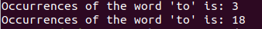

PROGRAM NO:21
DATE:
MODULE IN PYTHON

AIM: Write a program for modules.

PROGRAM CODE:

addition.py

def add(x,y):
return(x+y)

prgm_21.py

import addition

x = int(input("Enter Number1:"))
y = int(input("Enter Number2:"))
print(x,"+",y,"=",addition.add(x,y))

RESULT: The program executed successfully.

OUTPUT:

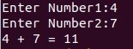

PROGRAM NO:22
DATE:

USER DEFINED EXCEPTION FOR STRING

AIM: Write a program to create a user defined exception function for handling the occurence of particular letter in an entered string.

PROGRAM CODE:

class myerror(Exception):
pass

t = input("Enter the letter to raise exception:")
str = input("Enter any string:")
try:
for k in str:
if k==t:
raise myerror
except myerror:
print("letter ",t," not allowed")
else:
print("String Entered is Valid")

RESULT: The program executed successfully.

OUTPUT:

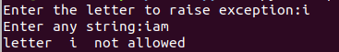
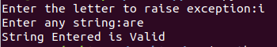

PROGRAM NO:23
DATE:

STACK IMPLEMENTATION WITH EXCEPTION HANDLING

AIM: Write a program to define a class stack that implement stack operations. The function push can throw only one exception i.e FULL if stack is full and function pop can throw only one exception i.e EMPTY if stack is empty.

PROGRAM CODE:

class Full(Exception):
def __init__(self):
print("can't insert any element,stack overflow!!")

class Empty(Exception):
def __init__(self):
print("can't delete any element,stack underflow!!")

class stack:
def __init__(self):
self.s = []
self.top = -1
self.n = int(input("Enter the size:"))
def push(self,item):
try:
if self.top >= self.n-1:
raise Full
except Full:
print(message)
else:
self.top += 1
self.s.append(item)
def pop(self):
try:
if self.top <= -1:
raise Empty
except Full:
print(message)
else:
print(self.s[self.top]," is poped")
self.s.pop()
def display(self):
if self.top >= 0:
print(self.s)
else:
print("stack is empty")

S = stack()
i = 1
while i>0:
print("\n......stack operations......")
print("\n1.push\n2.pop\n3.display\n4.exit")
m = int(input("Enter your choice:"))
if(m == 1):
item = input("Enter the item to push:")
S.push(item)
if(m == 2):
S.pop()
if(m == 3):
S.display()
if(m == 4):
i = 0

RESULT: The program executted successfully.

OUTPUT:

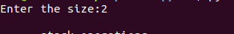
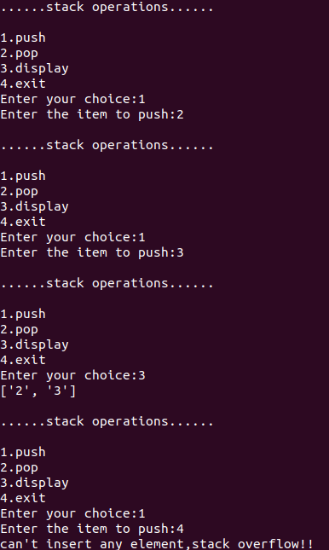
PROGRAM N0:24
DATE:

COMPUTATION OF TAX WITH USER DEFINED EXCEPTION

AIM: Write a program for the computation of tax with user defined exception.

PROGRAM CODE:

try:
income = int(input("Please enter your taxable income in india: "))
except ValueError:
print("Sorry,please enter taxable income as a number")
else:
if income <= 250000:
tax = 0
elif income <= 500000:
tax = (income - 250000) * 0.05
elif income <= 750000:
tax = (income - 500000) * 0.10 + 12500
elif income <= 1000000:
tax = (income - 750000) * 0.15 + 37500
elif income <= 1250000:
tax = (income - 1000000) * 0.20 + 75000
elif income <= 1500000:
tax = (income - 1250000) * 0.25 + 125000
else:
tax = (income - 1500000) * 0.30 + 187500
print("you have", tax, "Rupees in tax!")

RESULT: The program executed successfully.

OUTPUT:

PROGRAM N0:25
DATE:

DATABASE CONECTIVITY

AIM:create a database (student or employee) in mysql and perform operation of insertion,
selection, updating through cursor program.

PROGRAM CODE:

import mysql.connector
db=mysql.connector.connect(host="localhost",user="root",passwd="",db="PYTHON")
cursor=db.cursor()
# cursor.execute("create table student(rollno int primary key,name varchar(20),m1 int,m2 int,m3 int,tot int)")
n=int(input("enter the number of students: "))
for i in range(0,n):
rollno=int(input("enter the roll number: "))
name=input("enter the name: ")
m1=int(input("enter mark 1: "))
m2=int(input("enter mark 2: "))
m3=int(input("enter mark 3: "))
cursor.execute("Insert into student(rollno,name,m1,m2,m3) values('%d','%s','%d','%d','%d')"%(rollno,name,m1,m2,m3))
print ("Table Created Successfully")
sql="select * from student"
cursor.execute(sql)
result=cursor.fetchall()
for row in result:
r=row[0]
m1=row[2]
m2=row[3]
m3=row[4]
t=m1+m2+m3
cursor.execute("update student set tot='%d' where rollno='%d'"%(t,r))
cursor.execute("select * from student")
result=cursor.fetchall()
print ("Rollno\tName\tMark1\tMark2\tMark3\tTotal")
for row in result:
r=row[0]
n=row[1]
m1=row[2]
m2=row[3]
m3=row[4]
t=row[5]
print ("%d\t%s\t%d\t%d\t%d\t%d" %(r,n,m1,m2,m3,t))
db.commit()
db.close()

RESULT: The program executted successfully.

OUTPUT:

