E-commerce Platform Project Report
  - Technical Documentation & Architecture
Next.js Full Stack Application

1. Executive Summary
This document provides a comprehensive technical overview of the E-commerce platform project. The application is a modern, full-stack web application built to facilitate online browsing, purchasing, and management of products. It leverages the latest web technologies to ensure performance, scalability, and a seamless user experience.

2. Technology Stack
The project is built using the following core technologies:
Category | Technology | Purpose
Frontend Framework | Next.js 16 (App Router) | Server-side rendering, routing, API handling
UI Library | React 19 | Component-based UI architecture
Styling | Tailwind CSS v4 | Utility-first utility styling
Database | MongoDB | NoSQL document storage
ODM | Mongoose | Data modeling and validation
Authentication | JOSE / JWT | Stateless authentication & token management
Icons | Lucide React | Consistent iconography
Image Storage | Cloudinary | Media management and optimization

3. System Architecture
The application follows a modern monolithic architecture within the Next.js framework, integrating frontend and backend logic seamlessly.
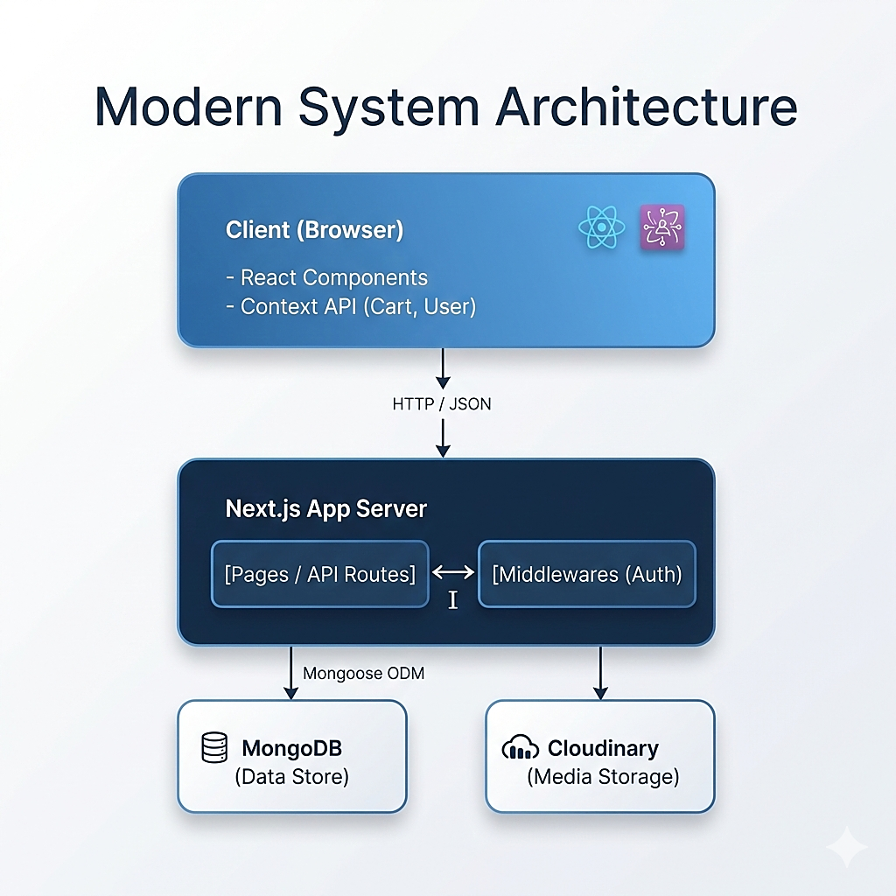

4. Database Schema Design
The data model is designed using Mongoose schemas. Below are the key entity definitions.

4.1 User Model
Field | Type | Description
name | String | Required, Max 60 chars
email | String | Required, Unique index
password | String | Hashed password string
role | String | Enum: ["user", "admin"], Default: "user"
createdAt | Date | Default: Date.now

4.2 Product Model
Field | Type | Description
name | String | Required, Product Title
description | String | Detailed product info
price | Number | Current selling price
oldPrice | Number | Original price (for discounts)
category | String | Product categorization
stock | Number | Inventory count
images | Array[String] | List of image URLs
featured | Boolean | Promoted product flag

5. Directory Structure
Key directories and their responsibilities:
ecommerce/
├── app/ # App Router (Pages & API)
│ ├── admin/ # Admin Dashboard Routes
│ ├── api/ # Backend API Endpoints (Auth, Products)
│ ├── cart/ # Shopping Cart Page
│ └── products/ # Product Listing & Details
├── components/ # Reusable UI Components
│ ├── common/ # Modals, Banners
│ ├── layout/ # Header, Footer
│ └── product/ # Product-specific components
├── context/ # Global State (Cart, User Context)
├── lib/ # Utilities (DB connection)
├── models/ # Mongoose Data Models
└── public/ # Static Assets (Images, Icons)

6. API Reference
POST /api/auth/signup - Register a new user
POST /api/auth/login - Authenticate user and set session
POST /api/auth/logout - Clear user session
GET /api/auth/me - Get current authenticated user info
GET /api/products - Fetch all products with filtering
GET /api/products/[id] - Fetch single product details
POST /api/products - Create new product (Admin only)

7. Setup & Installation
Steps to configure the development environment:
- Clone the repository to your local machine.
- Ensure Node.js and MongoDB are installed.
- Create a .env file with MONGODB_URI and other secrets.
- Run 'npm install' to install dependencies.
- Run 'npm run dev' to start the development server at localhost:3000.

