**Namal Institute Mianwali**

**Computer Science Department**

**Database Systems**

**Fall 21**

|  |  |  |  |
| --- | --- | --- | --- |
| Document: | Assignment Database Task | Date: | 06-05-2021 |
| Prepared by: | Jawad Ahmed  **BSCS201959** | Prepared for: | Sir Shafi Ullah Khan |
| Document Details: | This document contains the screenshots of authenticated login form and registration form application using MYSQL and Tkinter. | | |

**Task:**

**Extend the login application developed in Lab 1 and add signup functionality into it so that a new user can be registered (Program should not allow registering duplicate users). Previously we login users from the running program by checking users saved in variables. Now save all the new users registered by this ap into a database and when a user tries to login to this app then it should be authenticated from the database.**

**Solution:**

Following screenshots having short description has the solution of above task.

**Step 1:**

First of all connect the PyCharm with the database. And also make the schema in the database. Here is the screenshot of database having table name registration and columns names are username and password.

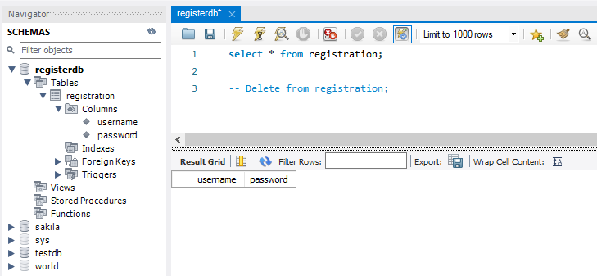

**Step 2:**

I make the window of choice that will lead us toward either login form or registration form as shown below:

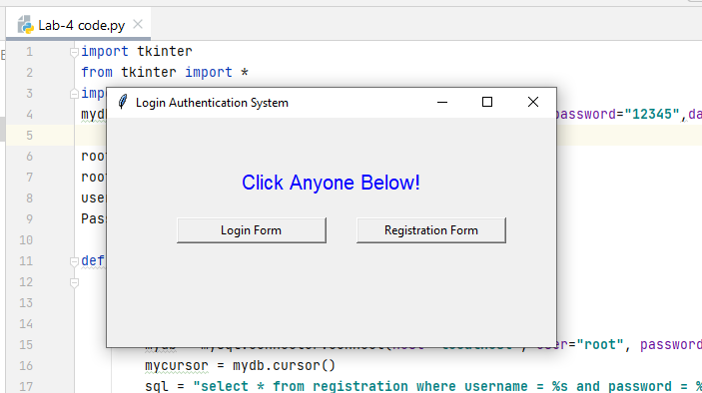

**Step 3:**

Here first of all I select registration form and register 2 names jawad and fayaz having some password as shown:

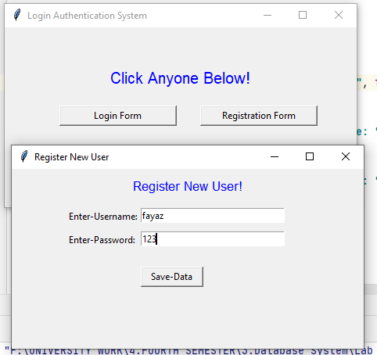

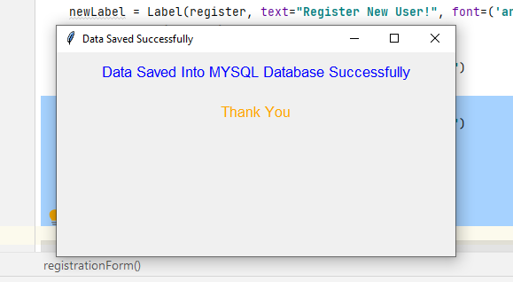

In order to check the data saved into the database, I also run the query into the database here is the screenshot.

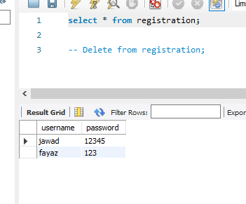

As we see above the data is successfully saved from the registration form into the database.

**Step 4:**

Now I open the Login form in order to check that the saved data is successfully logged in or not. When I entered the wrong data, it shows me the message of error which is correct. Here is the screenshot.

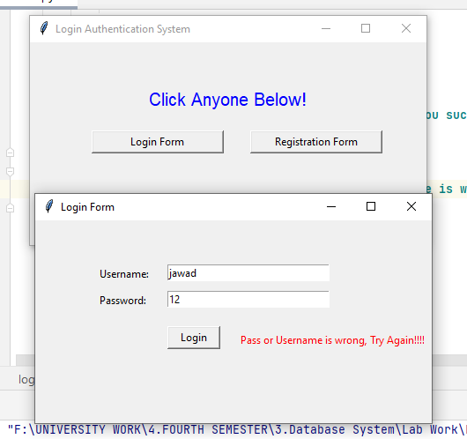

Now,

When I enter the correct data saved into the database it successfully logged in. Here is the screenshot.

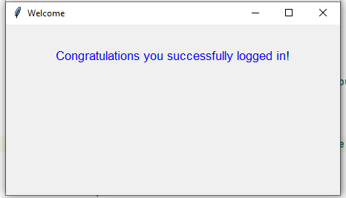

**Step 5:**

Again, I select registration form and want to save the similar data as I saved it previously into the database so it will show me the Error, as shown below:

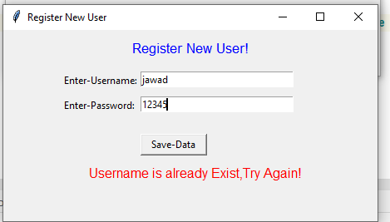

You can also run the program in order to check it work or not. Both database and python file will be there in the zip folder.

The program is Made By Jawad Ahmed