

**BAHRIA UNIVERSITY, (Karachi Campus)**

*Department of Software Engineering*

PROPOSAL

**Course Title:**   **Course Code**:

**Course Instructor: Class**: BSE- (5

B)

**Lab Instructor:** Engr. Asma Shaheen

PROJECT TITLE:

BANK NETWORKING SYSTEM

GROUP MEMBERS LIST:

SYEDA ANMOL ZAHRA (02-131212-060)

MUHAMMAD SARIM SHAIKH (02-131222-075)

JAWAD SALEEM (02-131222-048)

Submission Date**: __________________**

Contents

**1.** **INTRODUCTION:** 3

**2.** **PROJECT SCOPE:** 3

**3.** **PROJECT ABSTRACT:** 3

**4.** **PROJECT FUNCTIONALITIES:** 3

**5.** **FLOW DIAGRAM:** 3

**6.** **MODULE DISTRIBUTION:** 3

**7.** **REFRENCES:** 3

# **INTRODUCTION**

This project is about designing and implementing a network for Radeon Company Ltd., which is opening its first branch in Nairobi, Kenya. The building has four floors, and each floor will have specific departments. Our job is to design the network to ensure all devices can connect, communicate, and operate securely and smoothly. The network will include routers, switches, VLANs, DHCP servers, and other essential configurations to meet the company’s needs.

# **PROJECT SCOPE**

The scope of this project includes:

* Setting up a reliable and secure network infrastructure for the company.
* Ensuring devices can communicate within and across departments.
* Providing internet access and supporting core services like email and HTTP.
* Designing a system that supports both wired and wireless users.
* Implementing security measures to protect the network from unauthorized access.
* Creating a scalable design to handle future growth.

# **PROJECT ABSTRACT**

Radeon Company Ltd. is expanding its operations to Africa, starting with its first branch in Nairobi, Kenya. The network we will design will support around 60 users in each department, both wired and wireless. Each floor of the building will have its own router connected to departmental switches, and OSPF will be used for routing between floors.

The network will use VLANs to keep each department separate and secure while allowing necessary communication between them. IP addresses will be managed automatically through a central DHCP server in the server room. Important services like HTTP and email will be hosted on servers, and remote access to routers will be secured using SSH. To prevent unauthorized access, port security will be applied on all switches.

Our design will follow a hierarchical approach with three layers—core, distribution, and access. This ensures the network is organized, scalable, and reliable.

# **PROJECT FUNCTIONALITIES**

The network will include the following features:

1. **Routing and Connectivity:**
   * Each floor will have its own router, connected to switches.
   * OSPF will be configured to ensure efficient routing between floors.
   * Devices in the network will be able to communicate within the same VLAN and across different VLANs.
2. **Dynamic Addressing:**
   * A DHCP server will provide automatic IP addresses to all devices.
3. **Wireless Access:**
   * Each department will have a secure wireless network for its users.
4. **Security:**
   * SSH will be configured on routers for secure remote management.
   * Port security with sticky MAC addresses and shutdown mode will prevent unauthorized devices from connecting.
5. **Core Services:**
   * HTTP and email servers will be set up to support company operations.
6. **Testing:**
   * We will test communication within VLANs and between VLANs to ensure the network functions properly.

# **WORKFLOW DIAGRAM**

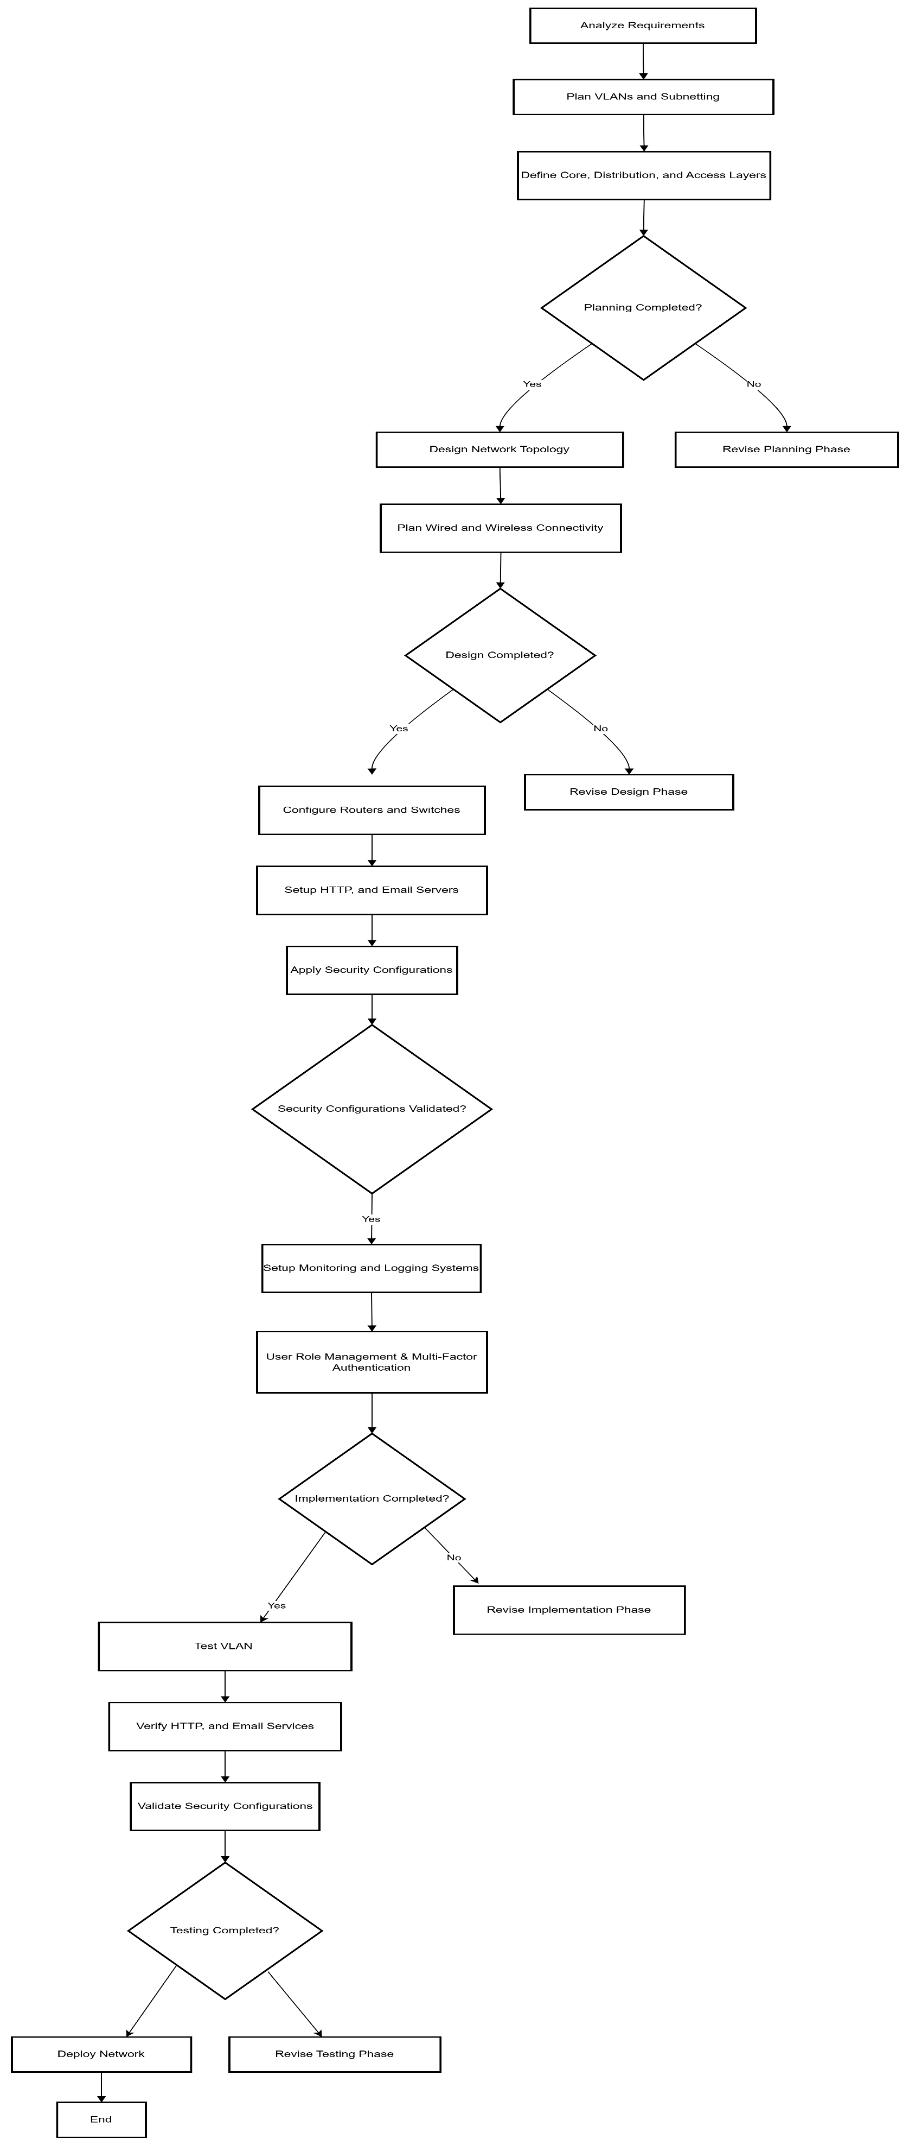

Plan VLANs

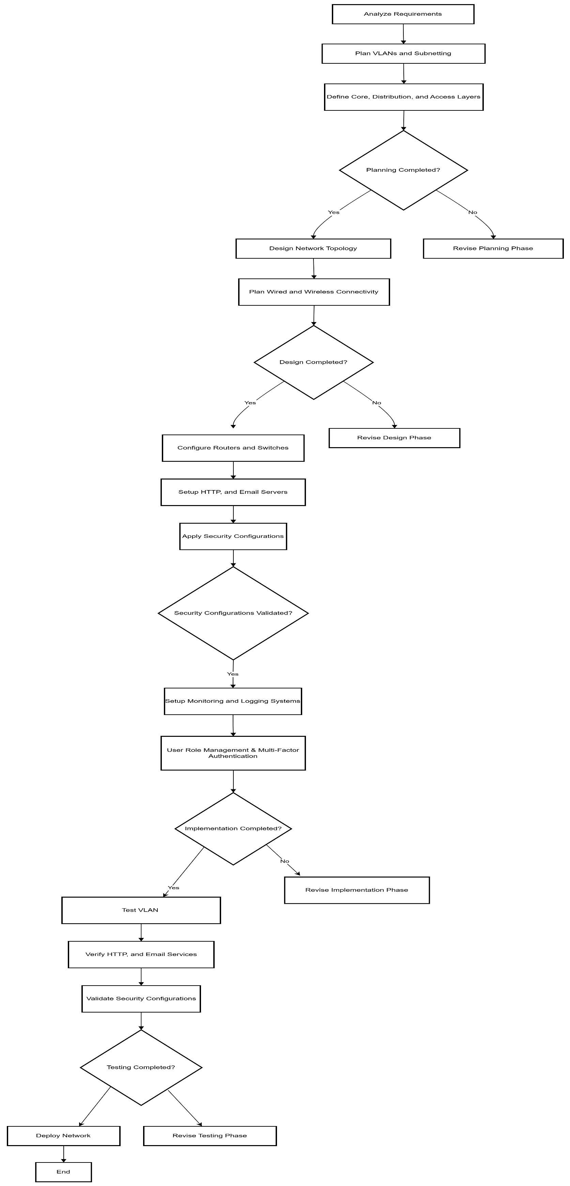

# **NETWORK DIAGRAM**

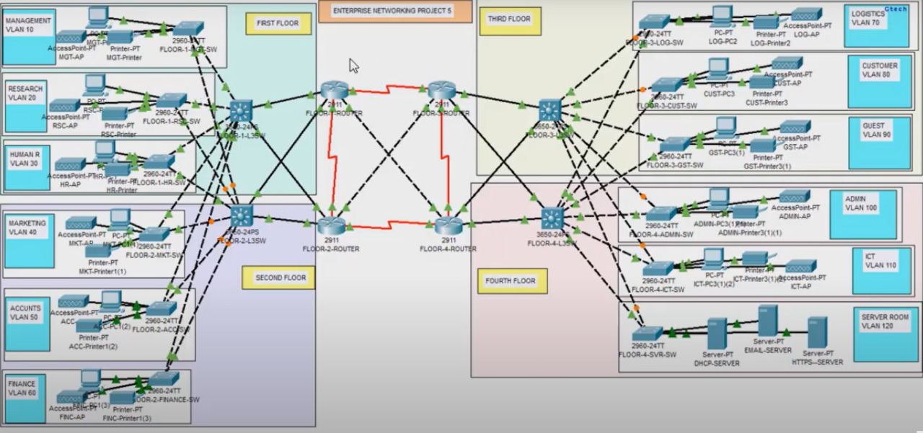

<<

# **REFRENCES**

• Cisco Networking Guide

• Official OSPF Documentation

• Subnetting and IP Planning Best Practices

• Port Security Implementation Guide

**Teacher Signature**: ______________________________________________

**Remarks**: ______________________________________________

**Submission Date**: ______________________________________________