

**BAHRIA UNIVERSITY, Karachi Campus**

*Department of Software Engineering*

**REPORT**

**Course Title:**   **Course Code**:

**Course Instructor: Class**: BSE-5B

**Lab Instructor:** Engr. Asma Shaheen

PROJECT TITLE:

Bank Networking System

GROUP MEMBERS LIST:

|  |  |  |  |
| --- | --- | --- | --- |
| S.NO | Enrollment | Name | Email |
| 1 | 02-131222-048 | Jawad Saleem | jawadsaleem932@gmail.com |
| 2 | 02-131222-075 | Sarim Sheikh | sheikhsarim52@gmail.com |
| 3 | 02-131212-060 | Anmol Zahra | anmolzehra07@gmail.com |
|  |  |  |  |

**30th-Dec-2024**

**Submission Date: __________________**

**Table of Content**

**1.** **INTRODUCTION** 4

**1.1.** **Introduction** 4

**1.2.** **Problem Statement** 4

**1.3.** **Proposed Solution** 4

**2.** **DESIGN** 4

**2.1.** **Workflow Diagram** 4

**2.2.** **User Interfaces (Packet tracer, Physical View)** 4

**2.3.** **Network Diagram (Packet tracer, Logical View)** 4

**3.** **METHODOLOGY** 4

**3.1** **Technologies Used** 4

**3.1.1.** **Networking Devices:** 4

**3.1.2.** **Protocols:** 4

**3.1.3.** **Configuration Tools:** 4

**3.1.4.** **Additional Concepts:** 4

**3.2.** **Network Communication Methodology** 4

**3.3.** **Commands** 4

**4.** **CONCLUSIONS AND FURTHER WORK** 4

**5.** **REFERENCES** 4

# **ABSTRACT**

This project delivers a robust and scalable network solution tailored for the specialized requirements of banking and insurance operations. Utilizing Cisco Packet Tracer, the network incorporates advanced design principles to ensure security, efficiency, and reliability. Key features include the deployment of VLANs for logical segmentation, OSPF for optimized routing, and secure remote access through SSH. Dynamic IP allocation via DHCP streamlines device connectivity, while dedicated servers manage critical services like HTTP and email. The hierarchical network topology fosters organized communication, seamless scalability, and improved fault tolerance across four departmental floors. This comprehensive design not only meets the immediate operational needs of the bank but also establishes a framework for future expansion and enhanced security. By integrating state-of-the-art networking technologies, the solution addresses critical challenges such as data integrity, resource optimization, and inter-departmental collaboration, paving the way for a high-performing, secure, and adaptable network environment.

# **INTRODUCTION**

## **1.1.** **Introduction**

This project provides a comprehensive networking solution for a bank's operations, addressing the communication needs of multiple departments across four floors. The aim is to ensure secure, dynamic, and seamless data exchange, leveraging advanced networking technologies to achieve operational efficiency.

## **. Problem Statement**

The bank requires an optimized network architecture to facilitate wired and wireless communication between departments while maintaining data security, scalability, and effective resource utilization. Key challenges include:

* Limited inter-departmental communication.
* Inefficient resource allocation.
* Absence of secure remote management options

## **1.3. Proposed Solution**

A hierarchical network design is implemented using VLANs for departmental segregation, OSPF for efficient routing, and DHCP for dynamic IP allocation. Security features such as SSH and port security ensure data integrity and confidentiality. The design includes:

* VLANs for isolating traffic and improving efficiency.
* OSPF for fast, reliable routing.
* DHCP servers to automate IP address allocation.
* Centralized servers for HTTP and email services.
* Remote management via SSH with encrypted communication.

# **DESIGN**

## **Workflow Diagram**

## 

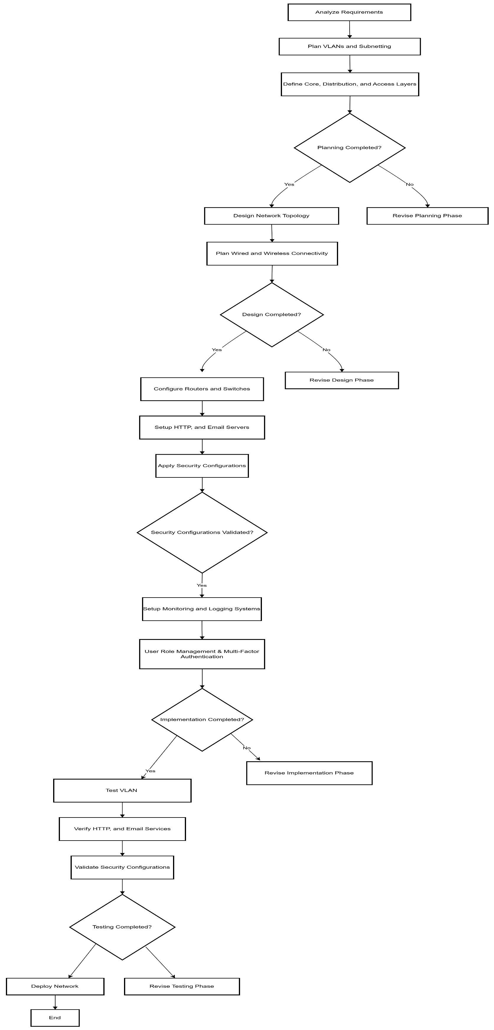

## **User Interfaces (Packet tracer, Physical View)**

## **Network Diagram (Packet tracer, Logical View)**

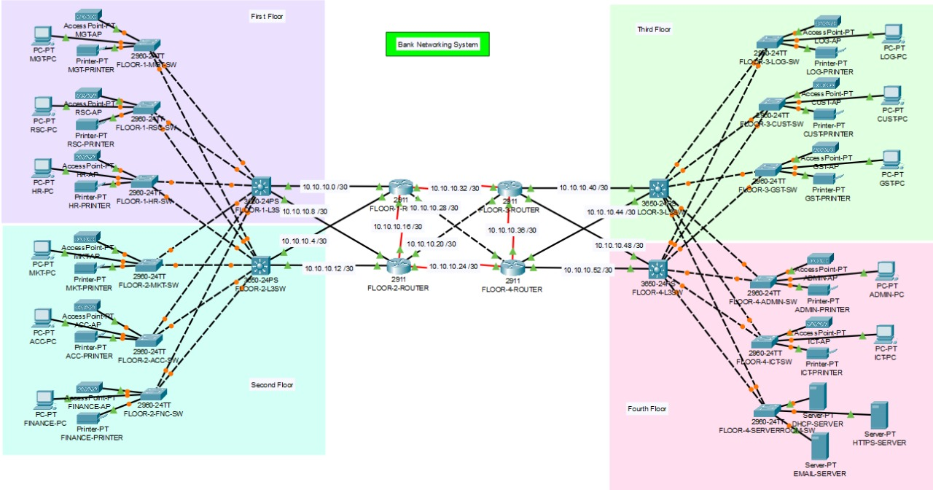

# **METHODOLOGY**

## **3.1. Technologies Used:**

|  |  |
| --- | --- |
| **Category** | **Details** |
| Networking Devices | Routers, switches, access points, servers |
| Protocols | OSPF, SSH, HTTP, SMTP |
| Configuration Tools | Cisco Packet Tracer |
| Additional Concepts | VLANs, port security, hierarchical design |

## **3.2. Network Communication Methodology**

The network’s communication flow includes:

1. Devices dynamically obtain IP addresses from the DHCP server.
2. Inter-VLAN routing via a multilayer switch facilitates seamless communication.
3. HTTP and email services are managed by dedicated servers.
4. Secure remote access to routers is enabled via SSH.

## **3.3. Commands:**

**Basic Router Setup**

# 

**VLAN Configuration**

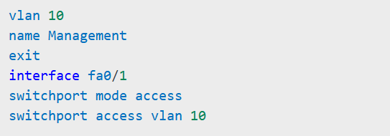

# **CONCLUSIONS AND FURTHER WORK**

This project successfully implements a hierarchical and secure network for a banking environment. Benefits include improved communication, enhanced security, and scalability. Future enhancements may include:

* Integrating firewalls for robust security.
* Expanding the network for additional branches.
* Deploying advanced monitoring tools for real-time diagnostics.

# **REFERENCES**

Projects’ GitHub Link:

<https://github.com/JawadAly/CCNProject>

**<<END>>**