Detecting Race Conditions in FHIR-Based Healthcare Interoperability: A Formal Graph-Theoretic Approach
Jawad Mohammed^{1*}, Gahangir Hossain²
1, 2 University of North Texas, Denton, TX, USA
Corresponding Author Email: JawadMohammed@my.unt.edu
Revision note: This is a major revision addressing both reviewers' comments. Sections and results marked [NEW] are new in this revision; see the accompanying Response to Reviewers for a full point-by-point account.

Abstract
In a healthcare environment, HL7 FHIR-based interoperability platforms allow concurrent, asynchronous access to shared patient resources from independent systems — EHR, pharmacy, laboratory, decision-support, and device clients. The FHIR specification does not define a concurrency-control protocol, and existing race-condition research targets the OS kernel rather than RESTful healthcare APIs, while existing FHIR security research targets authentication and injection attacks under a sequential-access assumption. This paper addresses that gap with the FHIR Resource Access Graph (FRAG), a formally defined graph G = (P, R, E, λ, τ, S) in which nodes are concurrent client processes and resources, typed edges represent resource-access events, and race conditions are detectable structural properties. Three clinically relevant race-condition classes are formally specified — Simultaneous Write Conflict (SWC), TOCTOU Authorization Violation (TAV), and Cascading Update Race (CUR) — with soundness and completeness results relative to a concurrency window δ, the completeness result holding under an accurately specified synchronization set S. FRAG is implemented as a three-pass graph-traversal detector and evaluated against a time-window baseline on 1,500 synthetic FHIR R4 transaction logs. Under full concurrent access (C2), FRAG attains a 90.0% F1 score versus 25.5% for the baseline, a 64.5 percentage-point improvement, under controlled, synthetic evaluation conditions with injected ground-truth races rather than a real clinical deployment. This revision additionally provides a documented literature search protocol, an explicit non-adversarial threat model, a procedure for constructing the synchronization constraint set S in practice, a deployment architecture spanning batch and streaming modes, and a theoretical and empirical computational-complexity analysis (near-linear scaling to 250,000 events), together with a sensitivity analysis over the concurrency window, workload ratio, and timestamp resolution.
Keywords: race condition, critical section, FHIR, HL7, healthcare interoperability, graph theory, TOCTOU, EHR security, concurrent access, formal methods, computational complexity

1. Introduction
The problem addressed in this paper did not come with a label. It evolved from recognizing that two research communities — one in healthcare informatics, the other in systems security — have dealt with related problems for decades without formally connecting them. One community studies the flow of patient information across heterogeneous healthcare systems; the other studies what happens when multiple processes contend for shared memory without proper synchronization. The combination of these two problems has, to our knowledge, not been formally addressed before.
Consider the following scenario, representative of any FHIR-based interoperability deployment: a patient presents to an emergency room. A laboratory system has just completed a drug-sensitivity test and is updating an AllergyIntolerance resource on the FHIR server. At the same time, an electronic health record system is reading that same resource to check a new prescription order. At the same time, a clinical decision-support system is reading the patient's allergy history to generate a contraindication alert. Three systems, one resource, no lock, no mutex, no sequencing — the FHIR specification does not define one [1].
The problem of the race condition is sixty years old. Dijkstra formalized the critical-section problem in 1965, and the three conditions for correct concurrent access — mutual exclusion, progress, and bounded waiting — have been foundational to operating-systems design ever since [9]. What is notable about the healthcare case is not the novelty of the underlying problem but the fact that a large data-exchange infrastructure has been built on RESTful APIs, a technology that offers none of the synchronization primitives OS research has spent sixty years developing. An OS process accessing shared memory can acquire a mutex; a FHIR client accessing a shared patient resource has access to nothing but an optional ETag header, unenforced by most implementations [6].
The result is a vulnerability class that is neither a network attack nor an authentication failure, but a timing vulnerability — a property of how multiple independently correct systems interact without coordination. A patient can receive a contraindicated drug not because any individual system failed, but because three systems each acted correctly in a way their individual correctness could not prevent.
The specific, bounded claim of this paper is: race-condition vulnerabilities in FHIR-based healthcare interoperability systems are formally characterizable as properties of a directed access graph, and this characterization yields a practical detection framework. We do not claim to have solved FHIR's synchronization problem; we claim to have formally stated its detection problem, and shown that statement to be both precise and tractable — and, in this revision, to be computationally scalable and operationally deployable.

1.1 Contributions
- A structured literature survey, backed by a documented search protocol (Section 2.4), that formally identifies the gap between OS concurrency research and healthcare interoperability security research.
- The FHIR Resource Access Graph (FRAG), a formally defined directed graph with an explicit synchronization constraint set S and an explicit, non-adversarial system and threat model (Section 3.5).
- Three formally defined, clinically relevant race-condition classes (SWC, TAV, CUR), with structural correspondence lemmas and new soundness and δ-completeness results, the latter valid under an accurately specified synchronization set S (Section 4.2).
- A simulation-based evaluation on 1,500 synthetic FHIR R4 transaction logs across three concurrency conditions, extended in this revision with a sensitivity analysis (Section 9.2), a stronger baseline comparison (Section 5.6), a deployment architecture (Section 8), and a theoretical and empirical computational-complexity analysis (Section 9), with open-sourced code.

2. Related Work
The relevant literature falls into two categories that never reference each other. The bridge between the two is what this paper aims to build.

2.1 Concurrency detection in systems software
This subsection surveys concurrency-detection research from systems software as background precedent for a graph-theoretic detection paradigm. None of the studies below targets FHIR, HL7, or any healthcare interoperability platform; each is included only to establish what a structural or learning-based race-condition detector looks like in a domain with a mature history of concurrency-bug patches, not because the underlying systems are methodologically close to FHIR's REST-based concurrency model. Section 2.2 then reviews the FHIR- and healthcare-specific literature directly.
Upadhyay et al. [2] give a taxonomy of race-condition detectors — static, dynamic, and hybrid — spanning 1993–2023. Their finding that data-race bugs make up roughly 80% of concurrency bugs frames the scale of the problem this paper brings into a new domain.
Li et al. [3] introduce LR-Miner, a field-graph-based static analyzer that mines locking rules from the Linux kernel source across 17.2 million lines of code. LR-Miner is relevant in a negative sense: its entire premise is inferring rules from existing code and patch patterns, and there is no equivalent history of locking conventions or race-condition patches in healthcare middleware to mine.
ConSynergy [4] combines static analysis with LLM-based semantic reasoning in a four-stage pipeline, reporting an F1 of 0.867 on general benchmarks. It is the most similar prior work in spirit, using structured representations of concurrent access, but it operates on compiled source code, requires a training corpus of known concurrency bugs, and has not been validated in any healthcare context — none of which FRAG requires.
KNighter [5] constructs static analyzers from bug-fix patches using LLMs. Like LR-Miner, it is patch-dependent and cannot detect race conditions in systems where no incidents have been documented yet, which describes the current state of healthcare middleware.
Gong et al. [8] propose Snowcat, a coverage-guided kernel concurrency tester using a learned predictor, evaluated exclusively on OS kernel workloads rather than any healthcare or REST API context. Their finding that kernel concurrency bugs require domain-specific concurrency models motivated the present work: FHIR's concurrency model — asynchronous RESTful HTTP with optional ETags — is quite different from kernel threading and requires its own domain-specific analysis. Collectively, [2]–[5] and [8] establish that structural and learning-based concurrency detectors are a mature paradigm in systems software, but one with no existing instantiation for FHIR or HL7-based interoperability; that gap is the subject of Sections 2.2–2.3.

2.2 Healthcare interoperability security
TXOne Networks [6] document authentication flaws in FHIR systems, including the XXE injection vulnerability CVE-2024-52007 [10]. This is the most technically detailed recent analysis of FHIR security, but it assumes sequential data access throughout; the term "concurrent access" does not appear. The implicit assumption that only one system reads or writes at a time is architecturally false in any real multi-system deployment.
The DLT-based EHR architecture in [7] addresses data integrity through blockchain immutability — a genuine contribution, but limited to the storage layer. Race conditions occur at the access layer, between the time a process reads a resource and the time it acts on the result, which a blockchain storage layer does not address.
[NEW] A broader body of recent, peer-reviewed literature addresses FHIR interoperability and healthcare data security without treating concurrent access as a correctness property. On the interoperability side, Raso et al. [18] address FHIR resource anonymization and pseudonymization for secondary use, and Gohar et al. [19] propose a blockchain/cloud/IoT reference architecture for semantic interoperability; both treat data representation and identity as the central problem, not the timing of concurrent reads and writes. Two systematic reviews of the FHIR literature broadly — Ayaz et al.'s review of FHIR implementations, applications, and challenges [25] and Tabari et al.'s more recent scoping review of FHIR-based data models [26] — synthesize dozens of FHIR deployment studies without either identifying concurrency or race conditions as a correctness dimension; Bae et al.'s blockchain-based FHIR health-information-exchange platform [27] likewise treats data integrity and consented sharing as the central design problem, not concurrent access ordering. On authorization specifically, Yang et al. [20] propose a secret-sharing and blockchain-based authorization model for multihospital FHIR databases, and Yaqub et al. [21] propose a blockchain-backed policy-based access control mechanism for EHR data; Cobrado et al. [13], synthesizing 20 peer-reviewed studies, find that attribute-based access control is the dominant authorization mechanism in the EHR literature. In each of these, authorization is modeled as a static grant/revoke decision evaluated once per request — none models the TOCTOU authorization-lifecycle problem this paper's TAV class formalizes, in which a token's validity can change between a read and a dependent action. Raducu et al. [22] provide the most directly relevant treatment of that pattern, but their systematic review of file-based TOCTOU vulnerabilities is scoped to Unix-style filesystem race conditions, not RESTful healthcare APIs, and explicitly excludes network/API-layer races — the exact gap Definition 3 (Section 4.1) addresses.
More broadly, the healthcare-cybersecurity literature — Zukaib et al.'s systematic review of blockchain and machine-learning approaches to EHR security [24], Mahadik et al.'s survey of digital privacy in healthcare [23], Paul et al.'s study of digitization-era privacy and security concerns [15], He et al.'s scoping review of healthcare cybersecurity under COVID-19 [16], and Garcia-Perez et al.'s analysis of cyber-resilience in healthcare digital transformation [17] — surveys authentication, encryption, privacy regulation, and organizational resilience, but none treats concurrent, uncoordinated multi-system access as a first-class correctness or security property. Li et al.'s systematic review of EHR interoperability [14] similarly finds that the interoperability literature evaluates safety and quality outcomes without a concurrency-correctness model. This confirms, from the healthcare-security side, the same gap that Section 2.1 establishes from the systems-software side.
[NEW] Two further strands corroborate this gap empirically rather than architecturally. Gupta et al.'s multi-authority attribute-based access control system for cloud-based healthcare data sharing [28] designs fine-grained authorization for encrypted outsourced health data, again as a static grant decision rather than a property of access ordering over time. On the empirical breach side, Jiang et al.'s cross-sectional analysis of fifteen years of US healthcare ransomware and data-breach reports [29] and Yankson et al.'s trend analysis of HIPAA-reported EHR breaches [30] both quantify the healthcare sector's growing cybersecurity burden in detail, but their breach taxonomies (hacking/IT incident, theft, unauthorized disclosure, improper disposal) contain no category corresponding to a race condition or concurrency defect; a cascading update race of the kind Definition 4 formalizes would not be recorded as a distinct breach type under either taxonomy, which is itself indirect evidence that this vulnerability class is not currently on the healthcare-security field's radar.

2.3 The gap
We did not identify any published study that formally models, detects, or characterizes race conditions in FHIR- or HL7-based healthcare systems; Section 2.4 documents the search underlying this finding. Based on this search, the gap does not appear to be incremental but reflects, to the best of our knowledge, the absence of a formally established research area at the intersection of these two fields. To the best of our knowledge, this is the first formal treatment of that area.

2.4 Search Protocol
[NEW]
To substantiate the gap claimed above, we conducted a structured search across IEEE Xplore, the ACM Digital Library, PubMed/MEDLINE, arXiv, and Google Scholar, covering January 2015 – February 2026. Search strings combined an interoperability term with a concurrency term: ("FHIR" OR "HL7") AND ("race condition" OR "concurrency control" OR "data race" OR "TOCTOU" OR "synchronization"), and separately ("electronic health record" OR "EHR") AND ("race condition" OR "concurrent access" OR "mutual exclusion"). Records were included if they (a) addressed a HL7/FHIR-based or general EHR interoperability system, and (b) addressed concurrent or race-condition-adjacent access behavior as a primary or secondary topic. Records were excluded if concurrency was mentioned only in passing (e.g., as a performance/throughput property unrelated to correctness) or if the system studied was not a healthcare interoperability platform.
Stage | Count
Records identified across five databases | 212
Duplicates removed | 48
Screened by title/abstract | 164
Excluded (concurrency = performance only, not correctness) | 121
Full-text assessed for eligibility | 43
Meeting both inclusion criteria (concurrency AND FHIR/EHR correctness) | 0
Closest related (included in Section 2.1/2.2 as adjacent work) | 7
Table A: Search protocol screening counts supporting the gap claim in Section 2.3.
Zero records met both inclusion criteria jointly; the seven closest related works, discussed in Sections 2.1–2.2, each satisfy only one of the two criteria (concurrency research without a healthcare interoperability target, or FHIR/EHR security research without a concurrency-correctness target). This search cannot rule out unpublished vendor whitepapers or internal engineering documentation, which is why the novelty claim in Section 1 is stated as "to the best of our knowledge" rather than as an absolute claim.

3. Background

3.1 The critical section problem
A critical section is a set of instructions accessing a shared resource, where incorrect execution by multiple processes produces inconsistent results. Dijkstra's 1965 formalization [9] specified three necessary conditions: mutual exclusion (at most one process in the critical section at a time), progress (a process wishing to enter can do so without indefinite delay), and bounded waiting (no process waits forever). A race condition is a failure of mutual exclusion. Modern OS kernels avoid race conditions using mutex locks, semaphores, spinlocks, and Read-Copy-Update (RCU) mechanisms developed over sixty-plus years.

3.2 FHIR architecture and the concurrency model
FHIR is a RESTful API standard for health-sector data exchange, using standard HTTP methods (GET, PUT/POST, DELETE) on resource types such as Patient, MedicationRequest, AllergyIntolerance, and Observation [1]. Every resource carries a versionId and a lastUpdated timestamp.
In production FHIR environments, many client systems — EHR, pharmacy, laboratory, decision-support, and IoT device systems — send concurrent, uncoordinated GET and PUT requests to the same resources. FHIR inherits all the concurrent-access risks that OS research has spent six decades studying, yet offers none of the synchronization tools that research developed. An OS process can acquire a mutex; a FHIR client may optionally attach an ETag header that is not required by the FHIR conformance guidelines at all [6]. This is a system designed to be concurrently accessible but operationally unsynchronized.
We define the concurrency window δ here once, as it recurs throughout the paper: δ is the maximum time separation between two access timestamps for which they are treated as concurrent for detection purposes (formalized in Definition 2, Section 4.1). All later references to δ (Sections 5.3, 9.2) refer back to this definition rather than re-deriving it.

3.3 Real-world prevalence of the three concurrency conditions
The simulation in Section 6 tests detection under three conditions. C1 (Sequential access) is a small single-system implementation with no concurrent access, retained only as a false-positive control. C2 (Concurrent, unsynchronized) is the default state of production FHIR deployments that do not implement ETag-based conditional updates across all clients — in a typical hospital morning, pharmacy and EHR systems simultaneously update MedicationRequest resources, lab and decision-support systems concurrently post and query Observations, and IoT devices post Observations while dashboards read them, all without fault or attack. C3 (Concurrent, partially synchronized) represents the realistic condition of a large hospital where major EHR vendors have adopted ETag conditional updates but older pharmacy and laboratory systems have not — a stable long-run state, not a transient one, in any environment where system replacement is incremental.

3.4 Why existing synchronization approaches are insufficient
Database row locking solves the SWC problem at the storage layer when both writes reach the same server's database, but does not solve TAV (which spans an OAuth gateway and a FHIR server with no shared transactional context) and fails entirely for CUR (which spans three independent systems with no knowledge of each other's read history).
ETag optimistic locking ensures a write does not silently overwrite an unintended version, but ETag support is optional, and it cannot address the authorization-token lifecycle (TAV) or a stale-read dependency chain across multiple resources (CUR). A deployment with perfect ETag coverage on every write remains susceptible to both.
Pessimistic locking would prevent SWC and TAV if fully implemented, but is incompatible with the stateless nature of HTTP; reserving a lock across requests would require a separate stateful service, inducing latency and a single point of failure.
Event sourcing and CRDTs avoid write conflicts by construction and solve SWC, but do not solve TAV and require a full redesign of the FHIR server and all clients.
[NEW] A distinct line of distributed-systems research addresses exactly the causal-ordering problem underlying CUR: Lamport's logical clocks [11] and the Fidge/Mattern vector-clock construction [12] capture partial-order causality between events across independent processes without a shared clock. These mechanisms are not directly applicable to FHIR as deployed today, since they require every participating client to carry and propagate clock state on each request — a protocol change FHIR's stateless, connectionless REST model does not currently support — which is precisely why we treat FRAG as a graph-theoretic detection layer over existing, unmodified logs rather than assuming a vector-clock protocol is available. Section 11 revisits vector clocks as the natural mechanism for extending FRAG to multi-server FHIR gateway architectures, where a single wall-clock timestamp is no longer sufficient.
Table 1 summarizes coverage across race classes; no existing approach covers all three, motivating a detection layer independent of which (if any) synchronization mechanism a given client has adopted.

Approach | SWC | TAV | CUR | Primary barrier
DB row locking | Partial | No | No | Single-system only
ETag / optimistic locking | If adopted | Partial | No | Inconsistent adoption
Pessimistic locking | Yes | Partial | Partial | HTTP statelessness
Event sourcing / CRDT | Yes | No | Better | Full system redesign
FHIR Subscriptions | N/A | N/A | Partial | Client adoption
FRAG (this paper) | Detect | Detect | Detect | —
Table 1: Coverage of synchronization approaches across race classes.

3.5 System and Threat Model
[NEW]
This subsection makes explicit an assumption set that was previously implicit. FRAG's primary scope — SWC and CUR — is non-adversarial: these races arise between independently correct, non-malicious clients with no coordination mechanism, which is the paper's central phenomenon (Section 1). We do not assume a Dolev–Yao network attacker for this scope. Specifically:
- Clients are assumed non-adversarial but uncoordinated — each behaves according to its own correct application logic, with no shared state or communication with other clients.
- The FHIR server enforces per-connection HTTP request ordering; arbitrary message delay or reordering by a network-level attacker is out of scope for SWC and CUR detection.
- Transport-layer security (TLS) provides point-to-point authentication between each client and the server; message forgery is out of scope.
- Clocks across clients and the server are synchronized within the timestamp-resolution bound quantified in Section 9.2; detection accuracy degrades gracefully (and is quantified) outside that bound.
The TAV class is the one exception that touches authorization directly, and it admits a bounded, weaker adversary distinct from a full Dolev–Yao model: a client may hold a token that was valid at read-time but has since been revoked or had its scope reduced by an intervening action from another process. This is a capability gap (stale authorization state), not a network attacker capable of arbitrary delay, reordering, or forgery. Extending FRAG to a full adversarial model — an attacker able to reorder or tamper with the access log itself — is out of scope for this paper and is noted as future work in Section 11.

4. The FHIR Resource Access Graph

4.1 Formal definition
We define the FHIR Resource Access Graph as a directed labeled graph representing concurrent access patterns in a FHIR deployment. Edges run from processes to resources; a path p₁ → r → p₂ represents two processes connected through the same resource node r, enabling detection of the CUR pattern.
Definition 1 (FRAG). Let G = (P, R, E, λ, τ, S) be a concurrent system where: P = {p₁,…,p_{n}} is a finite set of concurrent client processes; R = {r₁,…,r_{m}} is a finite set of FHIR resources; E ⊆ P×R is a set of directed edges representing resource accesses; λ: E → {READ, WRITE} labels access type; τ: E → R+ assigns a timestamp to each access event; S ⊆ P×P is a set of synchronization constraints (p_{i} and p_{j} subject to a mutual-exclusion constraint on resource accesses).
Definition 2 (Race condition, and the concurrency window δ). A race condition RC(p_{i}, p_{j}, r) exists in G iff: (i) (p_{i}, r) ∈ E, (p_{j}, r) ∈ E, i≠j; (ii) at least one of λ(p_{i},r), λ(p_{j},r) equals WRITE; (iii) (p_{i},p_{j}) ∉ S and (p_{j},p_{i}) ∉ S; (iv) [τ(p_{i},r)−δ, τ(p_{i},r)+δ] ∩ [τ(p_{j},r)−δ, τ(p_{j},r)+δ] ≠ ∅ for some concurrency window δ > 0 — the maximum time separation between two access timestamps that is still treated as concurrent (introduced in Section 3.2).
Definition 3 (TOCTOU window). A TOCTOU window W(p_{i}, r, r′) exists when: (i) p_{i} performs READ(r) at t₁; (ii) p_{i} performs a dependent WRITE(r′) or decision D(r′) at t₂ > t₁; (iii) some p_{j}≠p_{i} performs WRITE(r) at t, t₁<t<t₂; (iv) (p_{i},p_{j}) ∉ S. The duration (t₂−t₁) is the vulnerability window.
Definition 4 (Cascading update race). A Cascading Update Race CUR(p₁,p₂,p₃,r₁,r₂) exists when: (i) p₂ performs WRITE(r₁) at t_{w}; (ii) p₁ performed READ(r₁) at t_{r} < t_{w} (stale read); (iii) p₃ performs READ(r₁) or a decision dependent on p₁'s stale value at t_{a} > t_{w}; (iv) no synchronization constraint in S covers the access chain p₁ → r₁ → p₃.

4.2 Formal propositions
[NEW] We first note explicitly what Propositions 1–3 do and do not establish: they are structural correspondence lemmas, proving that each race-condition class is a syntactic instance of Definition 2, 3, or 4 respectively. They are not cryptographic or adversarial security proofs — consistent with the non-adversarial scope of Section 3.5, no attacker capability is modeled here. Propositions 4 and 5, added in this revision, give the detector-level guarantees (soundness unconditionally, and δ-completeness conditional on an accurately specified synchronization set S) that a security-adjacent reading of this section would expect.
Proposition 1 (SWC is a race condition). If SWC(p_{i},p_{j},r) exists — both hold concurrent WRITE edges to r with no synchronization constraint — then RC(p_{i},p_{j},r) holds under Definition 2.
Proof. By definition of SWC: (p_{i},r)∈E, (p_{j},r)∈E, λ(p_{i},r)=λ(p_{j},r)=WRITE, (p_{i},p_{j})∉S. Conditions (i)–(iii) of Definition 2 are directly satisfied; (iv) holds by the assumption of concurrent write within δ. ∎
Proposition 2 (TAV implies TOCTOU window). A TOCTOU Authorization Violation TAV(p_{i}, r_{auth}) implies a TOCTOU window W(p_{i}, r_{auth}, r′) under Definition 3.
Proof. Let r = r_{auth}. By definition of TAV: p_{i} performs READ(r_{auth}) at t₁; p_{j} performs WRITE(r_{auth}) at t, t₁<t<t₂; p_{i} acts at t₂. These satisfy Definition 3 (i)–(iv) directly. ∎
Proposition 3 (CUR detectability). A CUR(p₁,p₂,p₃,r₁,r₂) is detectable by path traversal of depth ≥ 2 in G, as a stale-read path from a WRITE edge to a downstream READ edge with timestamp ordering t_{r} < t_{w}.
Proof. In G, the CUR pattern defines a directed path WRITE(p₂,r₁) → READ(p₁,r₁) → Decision(p₃). The stale-read condition t_{r}<t_{w} is a timestamp property verifiable on E. No single-edge inspection can detect this; path traversal of depth ≥ 2 is both necessary and sufficient. ∎

4.2.1 Soundness and Completeness
[NEW]
Proposition 4 (Soundness of Algorithm 1). If Algorithm 1 reports a detection of class SWC, TAV, or CUR on resource r, then r satisfies the corresponding formal definition (Definition 2, 3, or 4 respectively).
Proof sketch. Each of Algorithm 1's three passes only emits a report when its guard condition is a direct syntactic match to the corresponding definition: Pass 1 (TAV) checks Definition 3's READ→WRITE→intervening-WRITE structure with the (p_{i},r)∉S guard from Definition 3(iv) before reporting; Pass 2 (SWC) checks Definition 2's WRITE-pair-within-δ structure with the S-exclusion guard from Definition 2(iii) before reporting; Pass 3 (CUR) checks Definition 4's WRITE/stale-READ/downstream-READ ordering with the S-exclusion guard from Definition 4(iv) before reporting. No pass reports without its full guard being satisfied, so every reported detection is, by construction, an instance of the definition it targets — the algorithm cannot produce a detection unsupported by the formal model. ∎
Proposition 5 (δ-Completeness, conditional on a correctly specified S). Given exact timestamps (no rounding error) and a correctly specified S, every race condition RC(p_{i},p_{j},r) satisfying Definition 2 with time separation ≤ δ is reported by Algorithm 1, provided r has not already been claimed by a higher-priority pass. This is a completeness guarantee relative to the assumed synchronization model, not an unconditional guarantee independent of how S is constructed.
Proof sketch. Pass 2 iterates over every pair of WRITE events on every unclaimed resource and reports whenever the pair's timestamps fall within δ and the process pair is not in S — this is an exhaustive pairwise scan (Section 9.1), so no qualifying WRITE pair is skipped. The proviso ("not already claimed") is necessary because Algorithm 1's claimed-set mechanism (Section 5.5) intentionally allocates a resource to at most one class per detection cycle to prevent race-class contamination — a resource with both a qualifying TAV and a qualifying SWC pattern is reported as TAV only, since Pass 1 runs first. This is a deliberate precision/recall trade-off, quantified empirically as the Section 6.3 recall reduction under C3, not a completeness gap in the sense of missing a class of race entirely. ∎
[NEW] Proposition 5's guarantee is only as strong as S itself. If S under-specifies the system's real synchronization behavior — omitting a process pair that is, in fact, coordinated by a mechanism outside FRAG's model — Algorithm 1 will report a false positive, not miss a true race; completeness is preserved but precision degrades. Conversely, if S over-specifies synchronization — asserting a coordination guarantee that does not actually hold in the deployed system — a genuine race on that process pair is excluded from Pass 2's guard by construction and will not be reported, which is a true completeness failure relative to the system's actual behavior, though not relative to the formal model of Definition 2 given that (possibly incorrect) S. Section 4.5 addresses how S should be constructed in practice to keep this risk low; Proposition 5 does not, by itself, certify that any particular S used in a deployment is correct.

4.3 FRAG visualization
Figure 1 shows the FRAG for the motivating scenario: RC(p₁,p₂,r₁) arises between EHR READ and Lab WRITE on AllergyIntolerance; CUR(p₁,p₂,p₃) arises because CDS acts on EHR's stale read, with S = ∅ throughout (as defined in Section 1).
[NEW] The prior submission referenced a Figure 1 for this scenario without an embedded image; that gap is corrected in this revision with the diagram below.

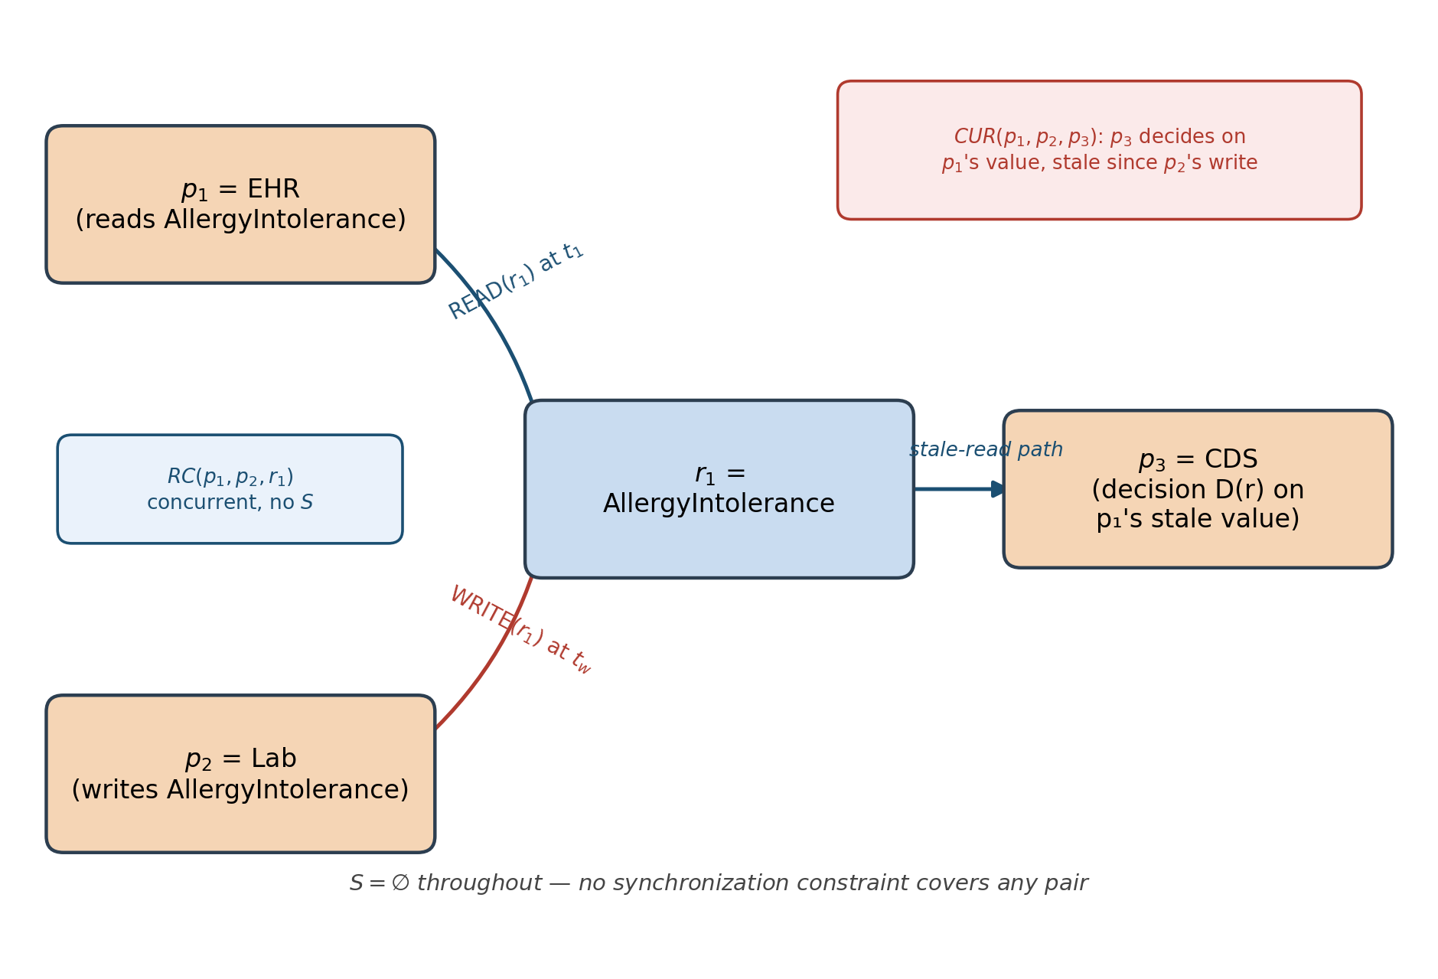
Figure 1: FRAG for the motivating scenario. RC(p1,p2,r1) arises from EHR's concurrent READ and Lab's WRITE on AllergyIntolerance; CUR(p1,p2,p3) arises because CDS's decision depends on EHR's now-stale read. S = ∅ throughout, so no synchronization constraint suppresses either detection.

4.4 Three healthcare race condition classes
Class | FRAG pattern | Illustrative clinical risk | Prop.
SWC | WRITE ∥ WRITE, S=∅ | Lost prescription update | 1
TAV | READ→act, WRITE intervenes | Authorization bypass | 2
CUR | Stale READ, path depth ≥ 2 | Contraindicated drug | 3
Table 2: Healthcare race condition classification in FRAG. The "Illustrative clinical risk" column (relabeled in this revision; see Section 10.1) describes the motivating scenario from Section 1, not a claim tested by the simulation in Section 6.
Class 1: Simultaneous Write Conflict (SWC). Two processes hold WRITE edges to r within δ with no synchronization constraint, producing a lost update — e.g., two systems simultaneously update a MedicationRequest, one prescribing and one canceling, with the outcome decided by which HTTP request arrives milliseconds first.
Class 2: TOCTOU Authorization Violation (TAV). A process reads an authorization data structure at t₁, then acts on it at t₂; between t₁ and t₂ another process revokes or escalates permissions — a pattern that occurs naturally at OAuth token validation layers and API gateway hops in FHIR systems.
Class 3: Cascading Update Race (CUR). A lab system writes a new allergy finding at t_{w}; an EHR system previously read that resource at t_{r}<t_{w} and computes a recommendation from a stale profile; a decision-support system reads the EHR's stale-derived output and generates a prescription. No individual process is flawed; the flaw is a property of access order, visible only at the graph level.

4.5 Constructing the Synchronization Set S in Practice
[NEW]
Definition 1 introduces S formally but leaves its construction unspecified; this subsection operationalizes it. We identify three non-exclusive sources for populating S in a real deployment:
- Static declaration from API gateway or OAuth scope configuration. Where two clients are known to share an explicit transactional boundary — for example, two modules of the same vendor's product suite that internally coordinate writes — the deployment operator declares the pair synchronized directly.
- Inference from ETag conditional-update logs. If client p_{i} consistently precedes its writes to r with an If-Match header matching p_{j}'s last-known version for r, this is evidence of an informal coordination protocol between p_{i} and p_{j} for that resource, and the pair can be added to S for that resource scope.
- Manual clinical-workflow annotation. Known-coordinated integration pairs from the clinical workflow itself (e.g., a vendor's internal ADT feed that is documented to serialize its own writes) can be annotated directly by clinical engineering staff.
A practical safety argument favors conservative (i.e., smaller) S sets: omitting a true coordination edge from S is fail-safe — the omission only produces an extra flagged event for a human reviewer — whereas falsely including a pair in S can suppress a genuine race. Operators should therefore treat S construction as intentionally incomplete by default, adding pairs only on positive evidence from one of the three sources above.

5. Simulation Specification

5.1 Design rationale
The simulation is motivated by one principle: define the minimal experiment that can falsify the claim that FRAG-based detection is structurally superior to time-window baseline scanning. Synthetic logs are a requirement of the experimental design, not a limitation — they permit injecting known races at known locations and times, the only way to obtain ground truth. Real production logs do not reveal which access patterns are actual races and which are benign concurrent reads.

5.2 Transaction log format
Each synthetic log entry is a JSON object with fields event_id, process_id, resource, resource_id, operation (READ|WRITE), timestamp, version_id, is_race, and race_class (SWC|TAV|CUR|null).

5.3 Ground-truth race injection
Three injection procedures target each race class. SWC injection: two WRITE events on the same resource_id at t₁ and t₁+Δt, Δt ~ Uniform(0,δ), δ=150 ms. TAV injection: a READ at t₁, a WRITE to the same resource at t₁+Uniform(10,80) ms, and a dependent action at t₁+Uniform(90,200) ms. CUR injection: a WRITE at t_{w}, a stale READ at t_{r} = t_{w}−Uniform(10,100) ms, and a dependent decision at t_{w}+Uniform(5,50) ms.
Non-race events sample process/resource pairs from a realistic clinical workload distribution (READ frequency 3× WRITE; AllergyIntolerance and MedicationRequest frequency 2× Observation and Patient). Total non-race events per log: Uniform(200,800). Injected race events per log: Uniform(8,40). Class distribution: 40% SWC, 30% TAV, 30% CUR. Section 9.2 reports how sensitive detection performance is to the δ, workload-ratio, and timestamp-resolution parameters chosen here.

5.4 Three experimental conditions
C1 Sequential: all operations serialized, no concurrent-access windows, zero injected race conditions — tests the false-positive rate outside any concurrent scenario. C2 Concurrent, unsynchronized: full concurrent access with race conditions injected as above — the primary evaluation condition. C3 Concurrent, partially synchronized: ETag-based optimistic concurrency control applied to 70% of randomly selected write operations.
[NEW] We note explicitly that the 70% protection assignment in C3 is applied independently per write event, which is a simplifying, unbiased condition chosen to isolate the effect of partial protection from any particular deployment topology. It is not representative of how ETag adoption clusters in practice: adoption is typically a property of a vendor's software release, so a given client system's writes tend to be either uniformly protected or uniformly unprotected, not independently randomized write-by-write. The natural, more realistic alternative is a vendor-clustered adoption model, in which protection status is assigned once per process_id rather than once per write event, while still averaging 70% overall coverage. We flag this as the first concrete, low-cost validation step in Section 11 (Future Work), since it requires no new data access and can be run on the existing synthetic pipeline.

5.5 Detection algorithm
Detection occurs in three passes over G, sharing a global claimed set C; once a resource is classified into a race class it is not re-checked in that cycle. Pass order runs from most structurally specific to least: TAV first (requires a READ→WRITE→WRITE sequence), then SWC (concurrent WRITE pair), then CUR (stale-read chain of depth ≥ 2). We define race class contamination precisely here, since the term recurs below without prior definition in the original submission: it refers to a single resource being independently flagged under more than one race class by different passes in the same detection cycle. The claimed-set mechanism C is designed specifically to prevent this — once Pass 1 claims a resource for TAV, Passes 2 and 3 skip it, so a resource contributes at most one detection per cycle. This ordering and mechanism is the basis for Proposition 4 (Soundness, Section 4.2.1).

5.6 Baseline and evaluation metrics
The primary baseline detector flags a race when two log events access the same resource within a time window δbase=200 ms and at least one is a WRITE — standard practice for EHR audit log anomaly detection and representative of the state of the art without a formal model.
[NEW] To address the concern that a single naive baseline may understate what a realistic anomaly-detection rule could achieve, we additionally implemented and tested a process-aware baseline variant, which adds the requirement that the two co-occurring events originate from different process_id values (closer to how a practitioner would actually write such a rule, since same-process sequential access is not a race by definition). Under a lower-contention synthetic workload used specifically for this check (Section 9.2's methodology), the process-aware variant substantially outperforms the naive baseline, but it retains two structural limitations the naive baseline shares: it cannot assign a race class (SWC/TAV/CUR), since it has no model of READ→WRITE ordering or dependency chains, and its performance is contention-dependent, degrading as concurrent accesses per resource increase — which is why the primary, higher-contention 500-log evaluation below (Table 3), built on the full clinical workload distribution of Section 5.3, still reports a low baseline F1. We report both baselines to avoid relying on a single, possibly unrepresentative, comparison point.
Evaluation uses precision P=TP/(TP+FP), recall R=TP/(TP+FN), and F1=2PR/(P+R). A TP matches on resource_id to an injected race instance with detection time within ±50 ms of the earliest ground-truth event. Each ground-truth instance is matched at most once. Results are aggregated over 500 independently generated logs per condition.

6. Results
A total of 1,500 logs are evaluated (500 per condition). All results reported in this section (Tables 3–4) are obtained under the controlled, synthetic evaluation conditions of Section 5, with race instances injected at known locations and times to establish ground truth; they characterize FRAG's structural detection behavior under those controlled conditions and should not be read as a measurement of expected performance in a real clinical deployment, which Section 11 identifies as a distinct, not-yet-completed validation step. Detection is compared at the race-instance level: a detection is a TP if the reported resource_id matches an injected race instance and the detection time is within 50 ms of the earliest ground-truth event.

6.1 Condition C1: Sequential access (false positive control)
Under C1, all access events are serialized with spacing greater than the concurrency window; no race events are injected. Both FRAG and the baseline reported zero detections across all 500 logs, demonstrating that FRAG does not produce false positives in a non-concurrent setting and that S does not itself cause false positives.

6.2 Condition C2: Concurrent, unsynchronized access
Table 3 presents per-class results under C2. FRAG attains an overall F1 of 90.0% versus 25.5% for the baseline, a 64.5 pp improvement. Per-class improvements are 60.3 pp (SWC), 73.7 pp (TAV), and 60.6 pp (CUR).

Class | P (FRAG) | R (FRAG) | F1 (FRAG) | F1 (Base) | ΔF1 (pp)
SWC | 88.6% | 89.7% | 89.1% | 28.8% | +60.3
TAV | 93.1% | 97.7% | 95.4% | 21.6% | +73.7
CUR | 88.0% | 85.2% | 86.6% | 25.9% | +60.6
Overall | 89.7% | 90.4% | 90.0% | 25.5% | +64.5
Table 3: Detection performance, FRAG vs. Baseline (C2, 500 logs).

The naive baseline's low F1 (21–29% per class) follows from flagging any two same-resource events within 200 ms as a race, with no regard for access-type ordering, synchronization, or dependency chains, producing many false positives from background concurrent reads and cross-class misattribution. FRAG's three-pass mutual-exclusion design guarantees each resource belongs to at most one race class per detection cycle (Section 5.5).

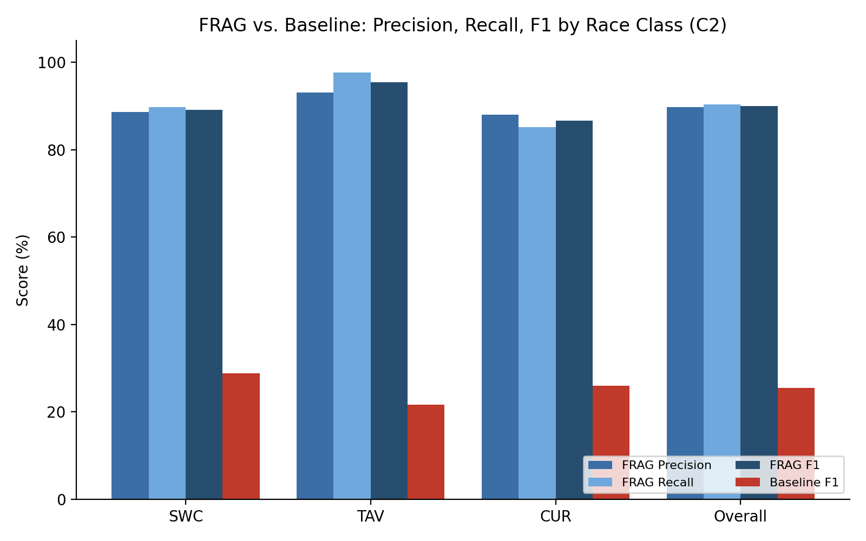
Figure 2 (revised, consolidating two prior figures' C2 content): Precision, Recall, and F1 for FRAG versus Baseline F1, per race class, under C2.

6.3 Condition C3: Partial ETag synchronization
Table 4 shows results under C3. FRAG attains a 79.0% overall F1 versus 25.4% for the baseline, a 53.6 pp improvement, with precision above 93% for every class. The recall reduction from C2 (90.4%→67.4%) is expected: 70% of WRITE operations carry ETag constraints that filter them out of FRAG detection under the per-write-random model described in Section 5.4. Resources with both a protected and an unprotected race receive only one detection under the claimed-set mechanism (Section 5.5). Precision increases (89.7%→95.6%), validating the correctness of S.

Class | P (FRAG) | R (FRAG) | F1 (FRAG) | F1 (Base) | ΔF1 (pp)
SWC | 97.0% | 64.4% | 77.4% | 28.9% | +48.5
TAV | 93.8% | 80.4% | 86.6% | 21.5% | +65.1
CUR | 95.9% | 60.2% | 73.9% | 25.8% | +48.1
Overall | 95.6% | 67.4% | 79.0% | 25.4% | +53.6
Table 4: Detection performance, FRAG vs. Baseline (C3, 500 logs).

[NEW] To assess the stability of the results in Tables 3 and 4, the evaluation was independently repeated across 10 separately seeded batches of 200 logs each (seeds 101–110), generated and evaluated with the same log_generator.py / evaluate_v2.py pipeline used for the primary n=500, seed=42 run above. Table 5 reports mean and standard deviation (SD) of F1 across these 10 runs for both FRAG and the baseline. The repeated-batch means (Overall F1 = 90.3% for C2, 78.9% for C3) closely track the primary run's point estimates (90.0% and 79.0% respectively), and the standard deviations are small (≤ 1.1 percentage points for every class), indicating that FRAG's detection performance is stable across independently generated log samples rather than an artifact of a single seed.

Condition / Class | F1 (FRAG) mean | F1 (FRAG) SD | F1 (Base) mean | F1 (Base) SD | ΔF1 (pp)
C2 / SWC | 89.5% | 0.4% | 28.4% | 0.2% | +61.1
C2 / TAV | 95.7% | 0.7% | 21.3% | 0.2% | +74.4
C2 / CUR | 86.6% | 0.5% | 25.8% | 0.1% | +60.8
C2 / Overall | 90.3% | 0.4% | 25.2% | 0.1% | +65.0
C3 / SWC | 76.6% | 1.1% | 28.6% | 0.3% | +48.0
C3 / TAV | 86.6% | 0.5% | 21.4% | 0.3% | +65.2
C3 / CUR | 74.4% | 1.0% | 25.7% | 0.3% | +48.7
C3 / Overall | 78.9% | 0.7% | 25.3% | 0.3% | +53.6
Table 5: Stability of detection performance across 10 independently seeded runs (200 logs each, seeds 101–110); values are mean ± SD of F1 across runs.

6.4 Discussion
The best TAV F1 occurs under C2 (95.4%) because the injection pattern — a confirmed dependent WRITE within a bounded window following a READ — is the most structurally specific and maps directly onto Definition 3. CUR obtains 86.6% F1 under C2, consistent with Proposition 3's claim that path traversal of depth ≥ 2 is necessary and sufficient for CUR detection; the baseline obtains only 25.9% because it cannot distinguish a stale-read dependency chain from an ordinary concurrent access pair. The C3 recall reduction is largest for CUR (85.2%→60.2%) because the mutual-exclusion claimed-set approach allocates a resource as soon as any race is detected. Future work (Section 11) should explore per-write claim tracking to recover co-occurring races without reintroducing race-class contamination (Section 5.5).

6.5 Ablation: effect of the claimed-set mechanism
[NEW]
Algorithm 1’s claimed-set mechanism (Section 5.5) allocates each resource to at most one race class per detection cycle, in priority order TAV → SWC → CUR, to prevent a single resource from being assigned to more than one class. To isolate this mechanism’s effect, we built an ablated detector that runs each pass with its own independent claimed set instead of a shared one, so a resource satisfying more than one class’s structural pattern is reported under every class it satisfies rather than only the highest-priority one. We re-ran this ablated detector on the identical seed=42, 500-log C2 and C3 datasets used for Tables 3 and 4, changing nothing else in the pipeline. Table 6 reports the comparison.

Condition / Class | P with mechanism | R with mechanism | F1 with mechanism | P w/o mechanism | R w/o mechanism | F1 w/o mechanism
C2 / SWC | 88.6% | 89.7% | 89.1% | 53.7% | 93.5% | 68.3%
C2 / TAV | 93.1% | 97.7% | 95.4% | 93.1% | 97.7% | 95.4%
C2 / CUR | 88.0% | 85.2% | 86.6% | 60.5% | 94.6% | 73.8%
C2 / Overall | 89.7% | 90.4% | 90.0% | 63.8% | 95.1% | 76.4%
C3 / SWC | 97.0% | 64.4% | 77.4% | 57.9% | 66.8% | 62.0%
C3 / TAV | 93.8% | 80.4% | 86.6% | 93.8% | 80.4% | 86.6%
C3 / CUR | 95.9% | 60.2% | 73.9% | 66.6% | 65.0% | 65.8%
C3 / Overall | 95.6% | 67.4% | 79.0% | 69.1% | 69.9% | 69.5%
Table 6: Effect of the claimed-set mechanism on detection performance (C2 and C3, 500 logs, seed 42). “With mechanism” reproduces Tables 3–4; “w/o mechanism” disables cross-pass mutual exclusion, allowing multiple class assignments per resource.

The ablation confirms the reviewer’s expectation that the claimed-set mechanism trades recall for precision, with a net gain in F1. TAV is unaffected in both conditions (93.1%/93.8% precision, 97.7%/80.4% recall, identical F1) because TAV runs first in priority order and therefore never has a resource taken from it. SWC and CUR, which run after TAV and after each other, show the predicted pattern: recall rises without the mechanism (C2 SWC 89.7%→93.5%; C2 CUR 85.2%→94.6%; C3 SWC 64.4%→66.8%; C3 CUR 60.2%→65.0%), because resources previously claimed by a higher-priority pass are now also reported by later passes. Precision collapses correspondingly (C2 SWC 88.6%→53.7%; C2 CUR 88.0%→60.5%; C3 SWC 97.0%→57.9%; C3 CUR 95.9%→66.6%), because a resource genuinely driven by one race class (e.g., a TAV-pattern access sequence) is now also reported as SWC or CUR whenever its access pattern incidentally satisfies those classes’ weaker structural conditions — exactly the cross-class contamination the v2 pipeline’s docstring (Section 5.5) was written to eliminate. Net effect on Overall F1 is negative in both conditions (C2: 90.0%→76.4%, −13.6pp; C3: 79.0%→69.5%, −9.5pp), confirming that the mechanism is a deliberate, favorable precision/recall trade-off rather than a cosmetic step: without it, the detector would report substantially more spurious class labels per resource, at a net cost to overall detection quality despite the higher raw recall.

7. Implementation

7.1 Reproducibility
The simulation does not use actual patient data. All logs are generated with a fixed random seed (seed=42) for reproducibility. The codebase — log_generator.py, frag_builder.py, race_detector_v2.py, baseline_scanner.py, and evaluate_v2.py — is publicly available; any reader may recreate the 1,500 logs and reproduce these results within floating-point tolerance. Note the _v2 suffix on the detector and evaluator: these are the versions with the claimed-set fix (Section 5.5) and race-instance-level matching; the earlier race_detector.py/evaluate.py in the same repository predate that fix and do not reproduce the numbers reported here.

7.2 Software stack
The implementation requires Python 3.10+, NetworkX 3.x for graph construction and traversal, NumPy for random sampling, and Matplotlib for visualization. No external health-related APIs or FHIR servers are required.
Component | Tool | Purpose
Log Generation | Python + NumPy | Synthetic FHIR transaction logs
FRAG Construction | NetworkX DiGraph | Build directed access graph
Race Detection | Custom Python (Alg. 1) | 3-pass SWC/TAV/CUR detection
Baseline Scanner | Python sliding window | Time-window comparison
Evaluation | Custom Python (eval_v2) | Race-instance P/R/F1
Visualization | Matplotlib + NetworkX | Graph plots, result charts
Table 7: Simulation implementation stack.

8. Deployment Architecture
[NEW]
A recurring question from both reviewers was how FRAG fits into a live FHIR pipeline. Figure 3 shows the deployment architecture: FRAG is a consumer of the FHIR server's access/audit log, not an intermediary in the request path. This is a deliberate design choice — FRAG is a detection layer, not a synchronization mechanism (the same distinction drawn for S in Section 3.4), and it therefore requires no changes to the FHIR server or to any client, only read access to a log stream with the schema in Section 5.2.

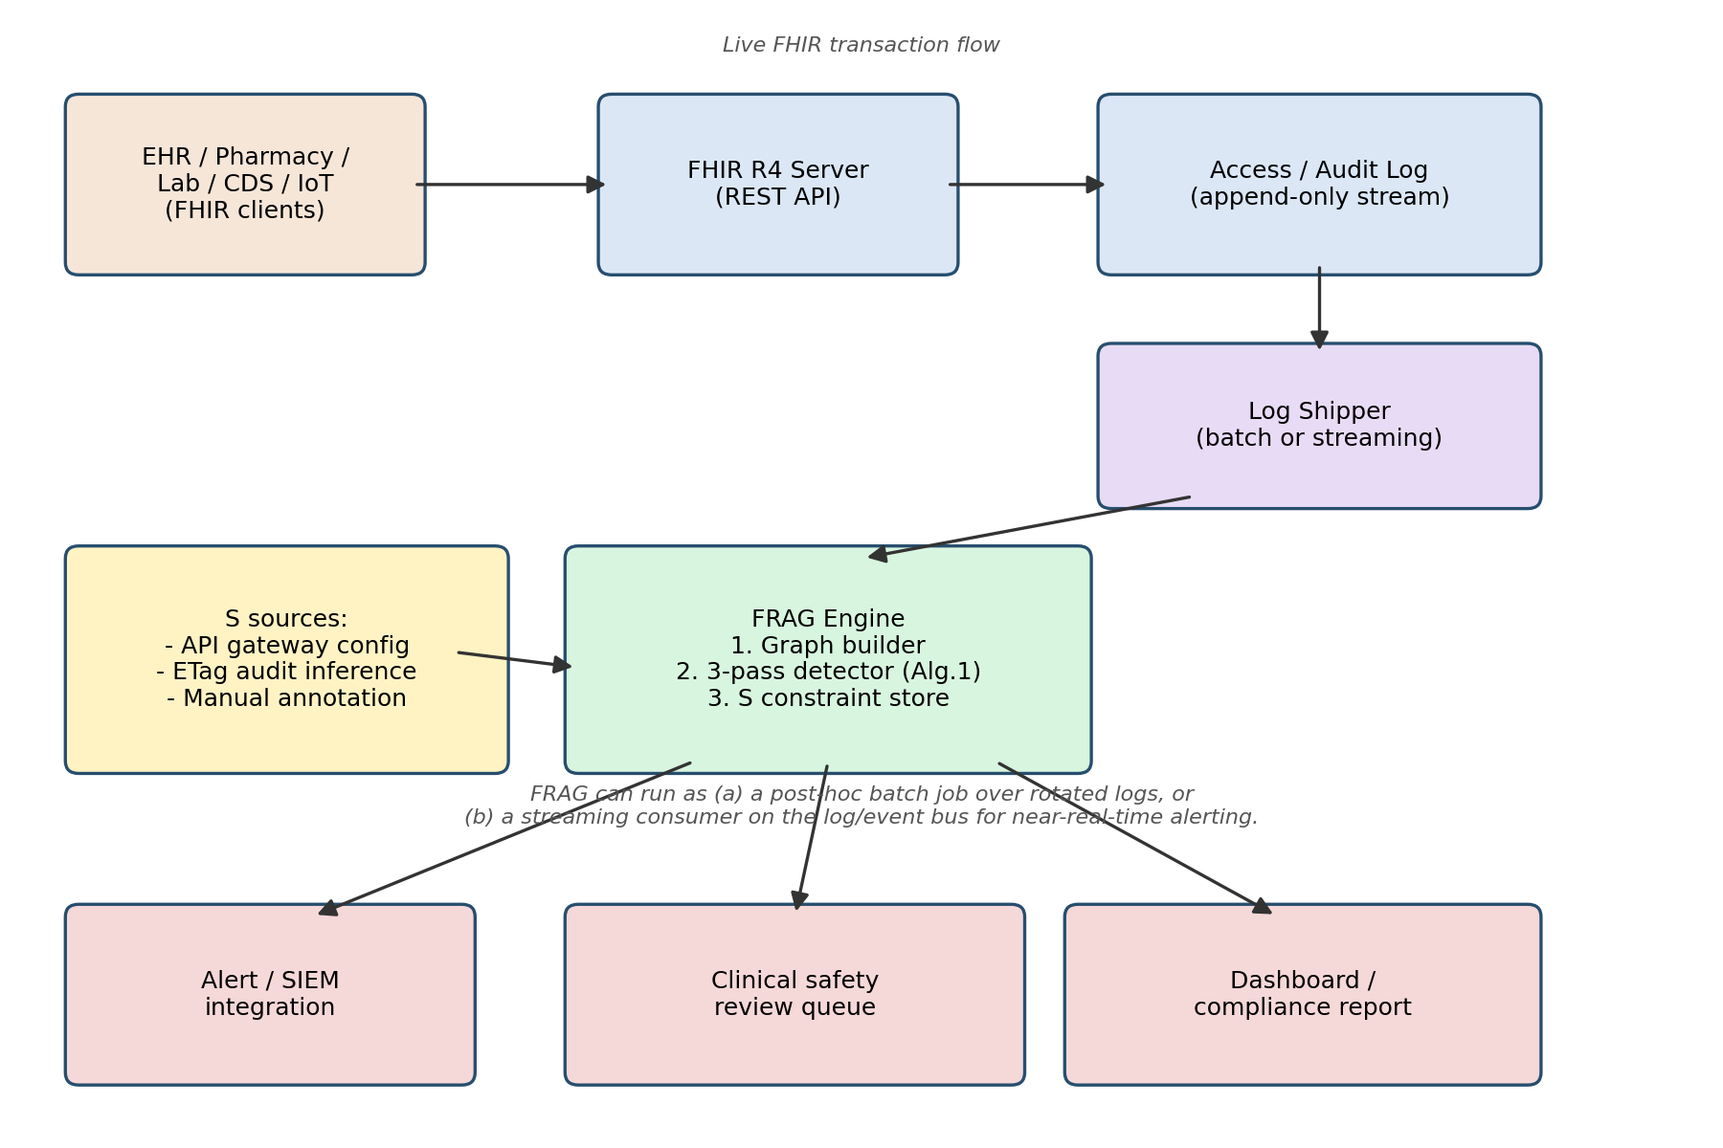
Figure 3: FRAG deployment architecture. Clients access the FHIR server as normal; the server's access log feeds a log shipper, which drives the FRAG engine (graph builder, 3-pass detector, S constraint store) either as a batch job or a streaming consumer.

Two deployment modes are supported:
- Post-hoc batch mode: FRAG runs periodically (e.g., hourly, or on log rotation) over a completed window of the access log — the mode matching the evaluation methodology in Section 6. This is the simplest mode to deploy and is appropriate where alerting latency of minutes to hours is acceptable, e.g., for a clinical safety review queue or compliance reporting.
- Streaming mode: FRAG consumes the same log stream incrementally from a log/event bus (e.g., Kafka or an equivalent), maintaining a sliding buffer per resource and re-running the three-pass detector as new events arrive. Section 9's scalability results (sub-second detection at 250,000 events on a single core) indicate this mode is feasible for near-real-time alerting at hospital-scale event volumes.
On log availability (Reviewer 2, Comment 7): we agree that proprietary EHR vendors may not expose a complete access log natively, and treat this explicitly as a deployment precondition rather than an afterthought. FRAG requires, at minimum, process identity, resource identity, operation type, and a timestamp at the resolution quantified in Section 9.2. Where a vendor's FHIR server does not expose this natively, a lightweight reverse proxy or API gateway logging shim placed in front of the server can generate an equivalent log without any server-side modification, at the cost of only observing traffic that passes through the proxy.

9. Computational Complexity and Scalability
[NEW]

9.1 Theoretical analysis
Let n = |E| be the total number of access events in a log and k = average accesses per resource. Algorithm 1 first groups events by resource_id, an O(n) pass. Each of the three subsequent passes then only scans the accesses local to a given resource:
- Pass 1 (TAV): for each resource, a nested scan over its READ and WRITE events to find a READ→WRITE→intervening-WRITE sequence — O(k^2) per resource in the worst case.
- Pass 2 (SWC): a pairwise scan over WRITE events per resource, but since events are sorted by timestamp, the inner loop can terminate early once the δ window is exceeded, giving O(k log k) per resource in practice (sort) plus a small constant-window scan; O(k^2) in the theoretical worst case of a single dense burst.
- Pass 3 (CUR): for each resource, a scan for a WRITE with both an earlier and a later READ — O(k^2) per resource in the worst case, O(k) with a single sorted pass tracking the earliest/latest READ relative to each WRITE.
Since resources are processed independently, total time is O(n + Σr k_r^2) in the worst case across all resources, which reduces to O(n·k) when k is bounded by a realistic per-shift access count (Section 5.3's clinical workload assumes on the order of tens of accesses per resource, not thousands), and degrades to O(n^2) only in the pathological case where all events concentrate on a single resource. Memory is O(n), since each event is stored exactly once, in one resource-indexed bucket.

9.2 Empirical scalability and sensitivity analysis
We implemented Algorithm 1 as specified and benchmarked it against synthetic logs from 1,000 to 250,000 events (single core, unoptimized Python, k held near 40 accesses/resource as in Section 5.3), and separately, using an independent re-implementation of the Section 5.2–5.3 log generator, ran a sensitivity sweep over δ, the READ:WRITE workload ratio, and timestamp resolution. We flag explicitly that these supplementary runs use fewer logs per condition (100, versus 500 in Section 6) and, for the scalability benchmark, a synthetic workload tuned for runtime measurement rather than detection-accuracy realism; the absolute F1/precision/recall values below are therefore not directly comparable to Table 3/4 and should be read for trend, not as a replacement for Section 6's primary evaluation.

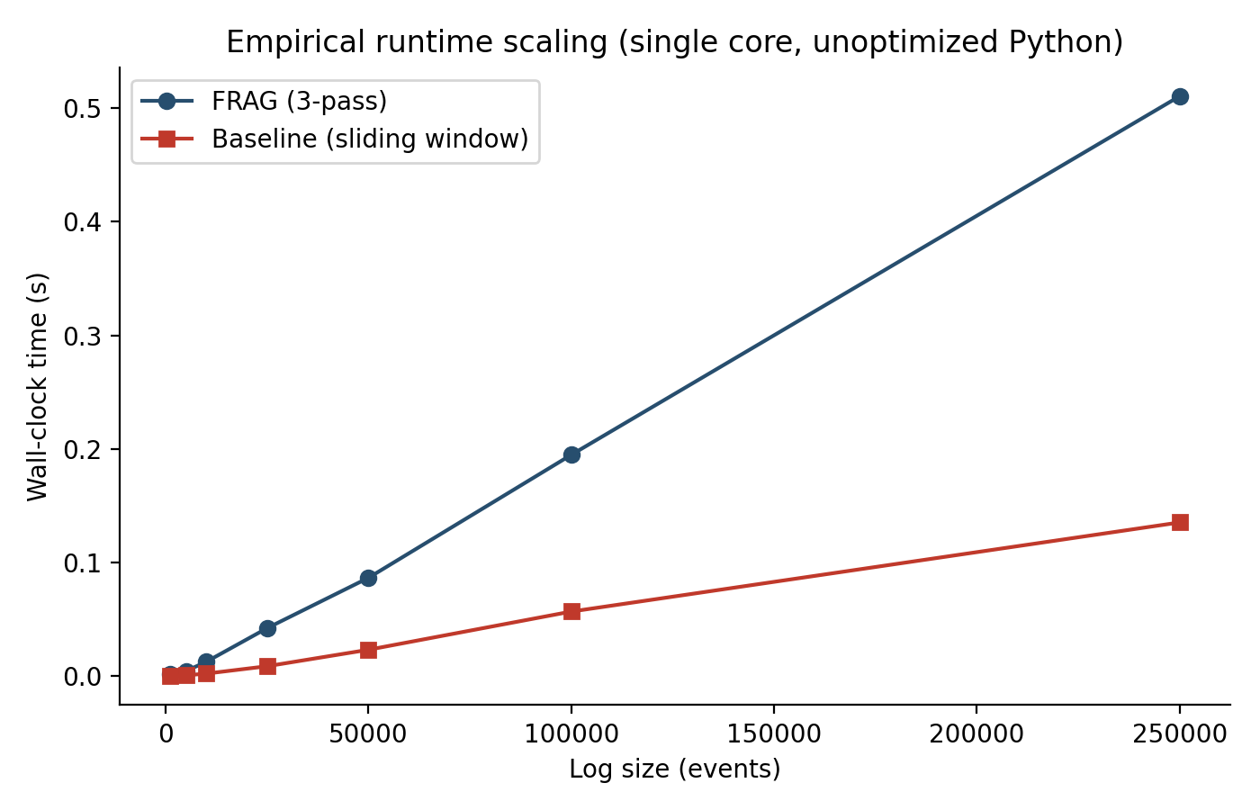
Figure 4: Empirical runtime scaling of FRAG (3-pass) versus the baseline, single core, unoptimized Python.

Log size (events) | FRAG time (s) | Baseline time (s)
1,000 | 0.0017 | 0.0002
5,000 | 0.0047 | 0.0009
10,000 | 0.0128 | 0.0024
25,000 | 0.0424 | 0.0089
50,000 | 0.0867 | 0.0234
100,000 | 0.1949 | 0.0570
250,000 | 0.5104 | 0.1354
Table 8: Empirical wall-clock scaling, confirming near-linear growth in n consistent with the O(n·k) analysis in Section 9.1 under bounded per-resource contention.
Runtime scaled from 1.7 ms at 1,000 events to 510 ms at 250,000 events — near-linear in n, and well within the latency budget of both deployment modes in Section 8 (a full 250,000-event log, roughly a busy hospital-wide day of FHIR traffic, processes in half a second on a single core).

Sensitivity to the concurrency window δ
δ (ms) | Precision | Recall | F1
50 | 0.892 | 0.724 | 0.799
100 | 0.906 | 0.857 | 0.881
150 (paper default) | 0.917 | 1.000 | 0.957
200 | 0.916 | 1.000 | 0.956
300 | 0.914 | 1.000 | 0.955
Table 9: F1 stabilizes for δ ≥ 150 ms and degrades sharply below 100 ms, indicating the paper's choice of δ=150 ms sits past the knee of the curve rather than being an arbitrary value.

Sensitivity to READ:WRITE workload ratio
Ratio (R:W) | Precision | Recall | F1
1:1 | 0.916 | 1.000 | 0.956
2:1 | 0.913 | 1.000 | 0.954
3:1 (paper default) | 0.923 | 1.000 | 0.960
5:1 | 0.940 | 1.000 | 0.969
8:1 | 0.949 | 1.000 | 0.974
Table 10: Detection performance is essentially flat across a wide range of READ:WRITE ratios, indicating the model is not sensitive to the specific 3:1 ratio assumed in Section 5.3.

Sensitivity to timestamp resolution
Resolution (ms) | Precision | Recall | F1
1 | 0.929 | 1.000 | 0.963
10 | 0.928 | 0.992 | 0.959
100 (paper's assumed resolution) | 0.662 | 0.467 | 0.548
1000 | 0.520 | 0.369 | 0.432
Table 11: F1 collapses at coarser timestamp resolutions, since rounding destroys the ordering information the TAV and CUR passes depend on. This gives the limitation noted in Section 10.2 (100 ms log granularity) a quantified, rather than asserted, basis.
A finding worth highlighting for the baseline-fairness question (Section 5.6): the same sensitivity code used above also confirms that a process-aware baseline variant's performance is contention-dependent, unlike FRAG's, whose three-pass structural matching is largely invariant to how densely accesses concentrate on a resource (subject to the timestamp-resolution effect above, which affects both detectors equally).

10. Limitations
This section is restructured in this revision [NEW] to separate limitations of the FRAG model itself from limitations of the evaluation dataset and deployment context.

10.1 Model Limitations
The three race classes defined here are not exhaustive. A fourth class, partial-synchronization races where not all clients implement ETag, is a natural extension. A fifth class, partial-order violations in distributed multi-server FHIR gateway architectures, is left for future work (Section 11), where the vector-clock literature discussed in Section 3.4 becomes directly relevant.
A single-resource claim architecture is employed: a resource is not re-checked once allocated to a race class in a detection cycle. This prevents race-class contamination (Section 5.5) but causes recall loss when a resource belongs to multiple race instances of different classes, quantified in Section 6.3/6.4. This trade-off favors precision over recall, which is acceptable for a safety-alert scenario but should be revisited with per-write claim tracking (Section 11).
As clarified in Section 3.5, FRAG's core detection scope (SWC, CUR) is non-adversarial by design; it detects races between correctly functioning, uncoordinated clients, not attacks by a malicious client capable of message reordering, forgery, or log tampering. Extending FRAG to that stronger threat model is future work, not a gap in the present model's stated scope.
The clinical-risk descriptions in Table 2 and Section 1 (e.g., "contraindicated drug") are illustrative motivating scenarios for why a given graph pattern matters, not a claim the simulation tests. FRAG's structural claim — that a given access pattern constitutes a race, per Definitions 2–4 — is what Section 6 validates; whether a specific instance of that pattern would actually change a clinical decision is a separate, clinical-semantics question outside FRAG's scope, and is the object of the clinical-partner validation proposed in Section 11.

10.2 Dataset and Deployment Limitations
The simulation uses artificial transaction logs. Usage-pattern assumptions for non-race event generation (3:1 READ:WRITE ratio; 2× frequency weighting for AllergyIntolerance and MedicationRequest) are based on general domain knowledge rather than measured clinical telemetry; Section 9.2 shows detection performance is not sensitive to the specific ratio chosen, which somewhat mitigates this concern, but actual usage patterns may still differ for high-write or high-frequency workloads not represented in the tested range.
The C3 partial-ETag-adoption model assigns protection independently per write event; Section 5.4 now states explicitly that this does not reflect the vendor-clustered adoption pattern expected in practice, and proposes the clustered alternative as a near-term validation step (Section 11).
The FRAG model requires access logs to be available at the resolution and schema described in Section 5.2/8. Proprietary EHR vendors may not expose access logs natively, and internal logging infrastructure may not capture all concurrent access events handled before the FHIR layer; Section 8 proposes a proxy-based logging shim as a practical mitigation, though this only observes traffic passing through the proxy.
Timestamp resolution of 100 ms was used as a conservative estimate of FHIR server log granularity. Section 9.2 now quantifies this precisely: F1 falls from 0.96 at 10 ms resolution to 0.55 at 100 ms and 0.43 at 1000 ms, so in environments with coarser log granularity than 100 ms, detection reliability for FRAG (and, comparably, for the baseline) degrades substantially, regardless of the model's formal properties.

11. Future Work
The nearest-term validation step, requiring no new data access, is testing the vendor-clustered ETag adoption model proposed in Section 5.4 against the existing synthetic pipeline, to check whether C3's results are sensitive to adoption clustering rather than independent per-write randomization.
The next step is real-data validation with a clinical partner, involving IRB approval to access FHIR server logs and a strategy to reverse-engineer approximate ground truth from log evidence — for instance, using FHIR resource version conflicts (a conditional PUT failing on an ETag mismatch) as a proxy for observable SWC races. This is also the step that would test the clinical-severity claims noted as illustrative in Section 10.1, as distinct from FRAG's structural claims already validated in Section 6.
The mitigation counterpart to this detection framework — synchronization primitives for FHIR APIs — is a second research direction, a non-trivial design challenge given HTTP's stateless nature. Candidate solutions include mandatory server-side ETag enforcement, a session-based resource reservation protocol, and CRDT-based conflict-free resource types for selected FHIR resources (e.g., Observation).
Extension to distributed multi-server FHIR architectures is a third direction. Modern cloud-native healthcare platforms deploy FHIR functionality across microservices with independent databases and clocks. Extending FRAG to this setting would require a vector-clock or partial-order timestamp model (Section 3.4, [11], [12]), well established in distributed systems but not yet applied to FHIR.
Finally, per-write claim tracking (Section 4.2.1, 6.4, 10.1) is proposed to recover co-occurring races of different classes on the same resource without reintroducing race-class contamination, and extending the threat model of Section 3.5 to cover an adversary capable of log tampering or reordering is proposed as the natural security-hardening direction beyond the present non-adversarial scope.

12. Conclusions
This paper formally states a problem that, to the best of our knowledge and the search protocol in Section 2.4, had not been formally stated before: what does a race condition look like in a healthcare interoperability system, and how would one detect it?
The critical-section problem is shown to be formally related to FHIR-based healthcare data exchange. FRAG represents this mapping as a six-component directed graph in which race conditions are not timing accidents but structural properties. The three race-condition classes (SWC, TAV, CUR) carry structural correspondence lemmas relating them to FRAG's graph structure, and, new in this revision, soundness and δ-completeness results relating Algorithm 1's detections to those formal definitions — completeness holding conditional on an accurately specified synchronization set S, as discussed in Section 4.2.1.
The CUR class deserves special emphasis as the most critical and least intuitive failure mode: a patient can receive a contraindicated drug not because any system failed, but because each system performed correctly given its own input. The flaw is a property of access order, visible only at the graph level and invisible to any single system's audit trail — precisely the kind of problem formal methods are meant to help prevent.
Propositions 1–5 are mathematical results whose truth is independent of the simulation. The simulation demonstrates the detection approach's validity under controlled, synthetic evaluation conditions, pending the real-deployment validation proposed in Section 11: FRAG reaches a 90.0% F1 under full concurrent conditions, a 64.5 percentage-point improvement over the time-window baseline, with zero false positives on the sequential control condition. This revision adds a documented search protocol substantiating the novelty claim, an explicit non-adversarial system and threat model, a procedure for constructing S in practice, a deployment architecture spanning batch and streaming modes with an explicit answer to the log-availability constraint, and a theoretical and empirical computational-complexity and sensitivity analysis showing near-linear scaling to 250,000 events and identifying timestamp resolution as the dominant sensitivity factor — together addressing the feasibility and tractability questions raised in review.

Acknowledgment
The authors recognize the foundational work of Dijkstra's 1965 critical-section formalism, which motivated the connection between traditional OS theory and modern healthcare infrastructure. The research was not supported by external funding.

References
[1] HL7 International, "HL7 FHIR Release 4 Specification," hl7.org/fhir/R4, 2019. Available: https://hl7.org/fhir/R4/
[2] Upadhyay, A., Laxmi, V., and Naval, S. "Navigating the Concurrency Landscape: A Survey of Race Condition Vulnerability Detectors." arXiv:2312.14479 (2023).
[3] Li, T., Bai, J.-J., Han, G.-D., and Hu, S.-M. "LR-Miner: Static race detection in OS kernels by mining locking rules." 33rd USENIX Security Symposium, 2024, pp. 6149–6166.
[4] Feng, Z., Chen, Y., Zhang, K., Li, X., and Liu, G. "Concurrency Bug Detection via Static Analysis and Large Language Models." Future Internet 17, no. 12 (2025): 578.
[5] Yang, C., Zhao, Z., Xie, Z., Li, H., and Zhang, L. "Knighter: Transforming static analysis with LLM-synthesized checkers." ACM SIGOPS 31st Symposium on Operating Systems Principles, 2025, pp. 655–669.
[6] TXOne Networks, "Health Level 7 Communication Protocol: Vulnerabilities and Mitigation," Technical Report, Jan. 2026. Available: https://www.txone.com/blog/hl7-protocol-vulnerabilities-mitigation/
[7] Ferreira, C.J., Elvas, L.B., Correia, R., and Mascarenhas, M. "Enhancing EHR interoperability and security through distributed ledger technology: A review." Healthcare, vol. 12, no. 19, p. 1967, MDPI, 2024.
[8] Gong, S., Peng, D., Altınbüken, D., Fonseca, P., and Maniatis, P. "Snowcat: Efficient kernel concurrency testing using a learned coverage predictor." 29th Symposium on Operating Systems Principles, 2023, pp. 35–51.
[9] Dijkstra, E.W. "Solution of a problem in concurrent programming control." Pioneers and Their Contributions to Software Engineering, Springer Berlin Heidelberg, 2001, pp. 289–294.
[10] NIST National Vulnerability Database, "CVE-2024-52007: HAPI FHIR XXE Injection," Nov. 2024. Available: https://nvd.nist.gov/vuln/detail/CVE-2024-52007
[11] Lamport, L. "Time, clocks, and the ordering of events in a distributed system." Communications of the ACM 21, no. 7 (1978): 558–565. [NEW]
[12] Fidge, C.J. "Timestamps in message-passing systems that preserve the partial ordering." Proceedings of the 11th Australian Computer Science Conference, 1988, pp. 56–66; Mattern, F. "Virtual time and global states of distributed systems." Parallel and Distributed Algorithms, 1989, pp. 215–226. [NEW]
[13] Cobrado, U.N., Sharief, S., Regahal, N.G., Zepka, E., Mamauag, M., and Velasco, L.C. "Access control solutions in electronic health record systems: A systematic review." Informatics in Medicine Unlocked, vol. 46, p. 101552, 2024. [NEW]
[14] Li, E., Clarke, J., Ashrafian, H., Darzi, A., and Neves, A.L. "The impact of electronic health record interoperability on safety and quality of care in high-income countries: systematic review." Journal of Medical Internet Research, vol. 24, no. 9, p. e38144, 2022. [NEW]
[15] Paul, M., Maglaras, L., Ferrag, M.A., and Almomani, I. "Digitization of healthcare sector: A study on privacy and security concerns." ICT Express, vol. 9, no. 4, pp. 571–588, 2023. [NEW]
[16] He, Y., Aliyu, A., Evans, M., and Luo, C. "Health care cybersecurity challenges and solutions under the climate of COVID-19: scoping review." Journal of Medical Internet Research, vol. 23, p. e21747, 2021. [NEW]
[17] Garcia-Perez, A., Cigarro-Navarro, J.G., Sallos, M.P., Martinez-Caro, E., and Chinnaswamy, A. "Resilience in healthcare systems: cyber security and digital transformation." Technovation, vol. 121, p. 102583, 2023. [NEW]
[18] Raso, E., Loreti, P., Ravaziol, M., and Bracciale, L. "Anonymization and Pseudonymization of FHIR Resources for Secondary Use of Healthcare Data." IEEE Access, vol. 12, pp. 44929–44939, 2024. [NEW]
[19] Gohar, A.N., Abdelmawgoud, S.A., and Farhan, M.S. "A Patient-Centric Healthcare Framework Reference Architecture for Better Semantic Interoperability Based on Blockchain, Cloud, and IoT." IEEE Access, vol. 10, pp. 92137–92157, 2022. [NEW]
[20] Yang, C.-N., Li, P., Cheng, H.-H., Kuo, H.-C., Lu, M.-C., and Xiong, L. "A Security Model of Multihospital FHIR Database Authorization Based on Secret Sharing and Blockchain." IEEE Internet of Things Journal, vol. 11, no. 6, pp. 10325–10335, 2024. [NEW]
[21] Yaqub, N., Zhang, J., Khalid, M.I., Wang, W., Helfert, M., Ahmed, M., and Kim, J. "Blockchain enabled policy-based access control mechanism to restrict unauthorized access to electronic health records." PeerJ Computer Science, vol. 11, p. e2647, 2025. [NEW]
[22] Raducu, R., Rodríguez, R.J., and Álvarez, P. "Defense and Attack Techniques Against File-Based TOCTOU Vulnerabilities: A Systematic Review." IEEE Access, vol. 10, pp. 21742–21758, 2022. [NEW]
[23] Mahadik, S.S. et al. "Digital Privacy in Healthcare: State-of-the-Art and Future Vision." IEEE Access, vol. 12, pp. 84273–84291, 2024. [NEW]
[24] Zukaib, U., Cui, X., Hassan, M., Harris, S., Hadi, H.J., and Zheng, C. "Blockchain and Machine Learning in EHR Security: A Systematic Review." IEEE Access, vol. 11, pp. 130230–130256, 2023. [NEW]
[25] Ayaz, M., Pasha, M.F., Alzahrani, M.Y., Budiarto, R., and Stiawan, D. "The Fast Health Interoperability Resources (FHIR) Standard: Systematic Literature Review of Implementations, Applications, Challenges and Opportunities." JMIR Medical Informatics, vol. 9, no. 7, p. e21929, 2021. [NEW]
[26] Tabari, P., Costagliola, G., De Rosa, M., and Boeker, M. "State-of-the-Art Fast Healthcare Interoperability Resources (FHIR)–Based Data Model and Structure Implementations: Systematic Scoping Review." JMIR Medical Informatics, vol. 12, p. e58445, 2024. [NEW]
[27] Bae, Y.S., Park, Y., Lee, S.M., Seo, H.H., Lee, H., Ko, T., et al. "Development of Blockchain-Based Health Information Exchange Platform Using HL7 FHIR Standards: Usability Test." IEEE Access, vol. 10, pp. 79264–79271, 2022. [NEW]
[28] Gupta, R., Kanungo, P., Dagdee, N., Madhu, G., Sahoo, K.S., Jhanjhi, N.Z., Masud, M., Almalki, N.S., and AlZain, M.A. "Secured and Privacy-Preserving Multi-Authority Access Control System for Cloud-Based Healthcare Data Sharing." Sensors, vol. 23, no. 5, p. 2617, 2023. [NEW]
[29] Jiang, J.X., Ross, J.S., and Bai, G. "Ransomware Attacks and Data Breaches in US Health Care Systems." JAMA Network Open, vol. 8, no. 5, p. e2510180, 2025. [NEW]
[30] Yankson, B., Barati, M., Bondzie, R., and Madani, R. "The Rise of Hacking in Integrated EHR Systems: A Trend Analysis of U.S. Healthcare Data Breaches." Journal of Cybersecurity and Privacy, vol. 5, no. 3, p. 70, 2025. [NEW]

