White Ops

1.Photo and Stream Photo:

When we select only photo option in settings menu. Only one picture take and save internal storage of device.
Same as when we select Photo and stream option
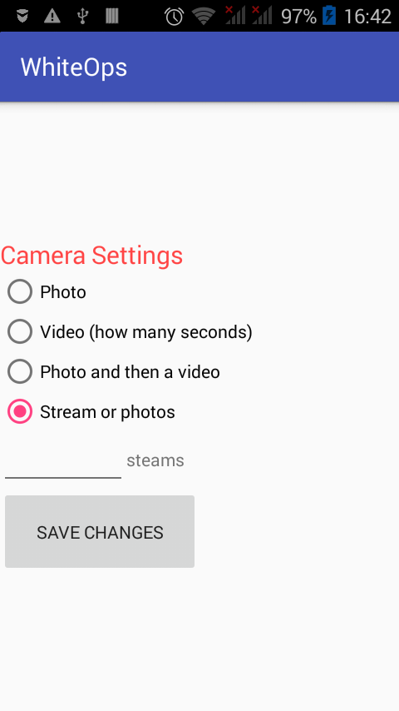

we can insert no of images in textBox that take using burst camera mode (continuous images) . And press save button. When we press save button all information is save in SharedPreference name camera_settings

void save(){
editor.putString("Initial", "false");
editor.putString("CameraType", CameraType);
editor.putString("SteamNumbers", steamNumbers);
editor.putString("VideoSecond", VideoSecond);
editor.putString("Initial", "false");
editor.commit();
}
and finish(); setting activity.
This is the first part of white Ops application .
Other and main part is capture images and video using volumne and power button.
When we press volumne button BackgroundService call
onCreate() method of Background Service have three statements.
1. pass StartIntent value.
2. Call “VolumeContentObserver” registerVolumeEventReciever method in which volume content observer get volume click event values.

VolumeContentObserver mVolumeContentObserver = new VolumeContentObserver(this.getApplicationContext(), new Handler());
this.getApplicationContext().getContentResolver().registerContentObserver(
android.provider.Settings.System.CONTENT_URI, true,
mVolumeContentObserver);

3. and last call “ScreenReceiver” registerScreenEventReciever() method in which call power button click settings

IntentFilter filter = new IntentFilter( Intent.ACTION_SCREEN_ON );
filter.addAction( Intent.ACTION_SCREEN_OFF );
registerReceiver(new ScreenReceiver(), filter);

VolumeContentObserver class is extend from Content Observer class which have two overrided method.
deliverSelfNotifications() :- which return boolean value.
onChange(boolean selfChange) :- take boolean value.
All setting related to the audio are set in onChange() method and check and verify also by using this code.
@Override
public void onChange(boolean selfChange) {
int currentMusicVolume = audioManager.getStreamVolume(AudioManager.STREAM_MUSIC);
int currentAlarmVolume = audioManager.getStreamVolume(AudioManager.STREAM_ALARM);
int currentRingVolume = audioManager.getStreamVolume(AudioManager.STREAM_RING);
if (currentAlarmVolume != BackgroundService.lastAlarmVolume || currentMusicVolume != BackgroundService.lastMusicVolume || currentRingVolume != BackgroundService.lastRingVolume) {
BackgroundService.lastMusicVolume = currentMusicVolume;
BackgroundService.lastRingVolume = currentRingVolume;
BackgroundService.lastAlarmVolume = currentAlarmVolume;
BackgroundService.startIntent.openApplication();
}
}

Screen Shots of Photo and Stream:-
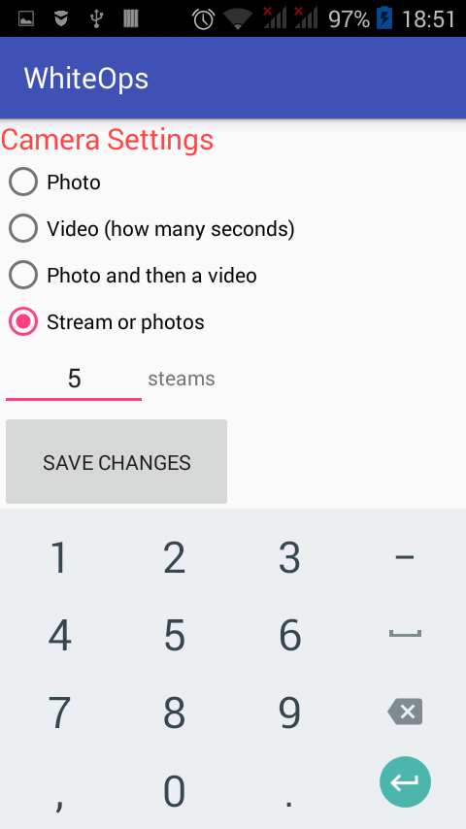
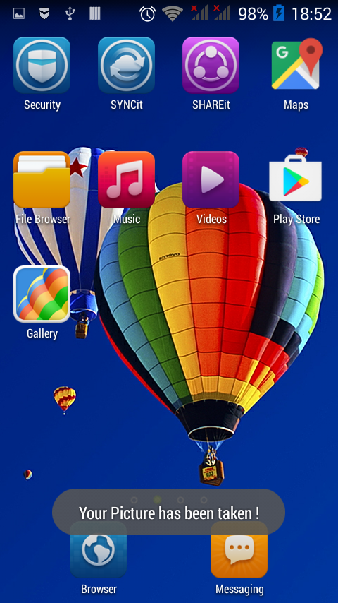
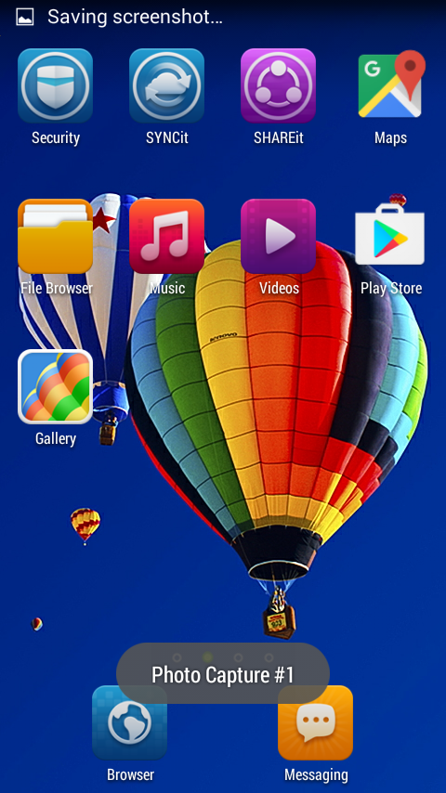

→ Goto the whiteOps folder in internal storage. Folder contains 5 photos.
This process will be continue if we press volumn button again and power button

Background Service:
A Service is an application component representing either an application's desire to perform a longer-running operation while not interacting with the user or to supply functionality for other applications to use. Each service class must have a corresponding <service> declaration in its package's AndroidManifest.xml. Services can be started with Context.startService() and Context.bindService().
In background service we get option value that was selected in camera settings
call chooseOtions(String option) method for different options functionality

private void chooseOptins(String option) {
CameraService.byteArrayList.clear();
CameraService.rotationArrayList.clear();
switch (option) {
case "0":
Intent front_translucent = new Intent(getApplication().getApplicationContext(), CameraService.class);
front_translucent.putExtra("Front_Request", false);
front_translucent.putExtra("Photo_Numbers", getPhotoNumbers());
getApplication().getApplicationContext().startService(front_translucent);
break;
case "1":
Intent intent = new Intent(getApplication().getApplicationContext(), RecorderService.class);
intent.putExtra("VideoSecs", getVideoSecs());
getApplication().getApplicationContext().startService(intent);
break;
case "2":
long start = System.currentTimeMillis();
// Java statements
Intent front_translucent1 = new Intent(getApplication().getApplicationContext(), CameraService.class);
front_translucent1.putExtra("Front_Request", false);
front_translucent1.putExtra("Photo_Numbers", getPhotoNumbers());
getApplication().getApplicationContext().startService(front_translucent1);
long diff = System.currentTimeMillis() - start;
String str = intToString(diff, 3);
System.out.println();

final Handler handler = new Handler();
handler.postDelayed(new Runnable() {
@Override
public void run() {
//Do something after Video Recording Complete
Intent intent1 = new Intent(getApplication().getApplicationContext(), RecorderService.class);
intent1.putExtra("VideoSecs", getVideoSecs());
getApplication().getApplicationContext().startService(intent1);
}
}, Integer.parseInt(str));
break;
default:
break;
}
}

In case “2” we select both photo and video option it is difficult to operate camera for both photo and video at same time , the requirement is to take picture first and then video. For this purpose first we get system current time in milliseconds and then call photo Camera service and after image taken get system current time in milliseconds and find difference between start and end time of Camera Service.

long start = System.currentTimeMillis();

//Call Camera Service

long diff = System.currentTimeMillis() - start;
String str = intToString(diff, 3);

This time is a wait time of recoder service for call.

Camera Service:
Camera Service is a child service of Background service. All information and settings related to camera are set in this service.

Camera Service Class methods
Camera  OpenFrontFacingCameraGingerbread() | This method open front camera
void  setBesttPictureResolution() | This method set best picture resolution
getBiggesttPictureSize | Camera.Size getBiggesttPictureSize(Camera.Parameters parameters)  get camera parameters and return camera size
checkCameraHardware | boolean checkCameraHardware(Context context)  Check if this device has a camera
checkFrontCamera | boolean checkFrontCamera(Context context)  Check if this device has front camera
takeImage | synchronized void takeImage(Intent intent)  Take image pass current application context and all methods regarding camera characteristics call in this method.

Recorder Service:

Same as Photo but when we select Video in setting Background service call RecorderService which is also inherited with Service class android and implement SurfaceHolder.Callback

Recorder Service Class Methods
onCreate() | On create method Start foreground service to avoid unexpected kill. Create new SurfaceView, set its size to 1x1, move it to the top left corner and set this service as a callback.
surfaceCreated(SurfaceHolder surfaceHolder) | surfaceCreated(SurfaceHolder surfaceHolder)  Method called right after Surface created (initializing and starting MediaRecorder)  all camera setting done in this method.

