**COMPLETED SITES INVERTER INSTALLATION PROGRESS REPORT**

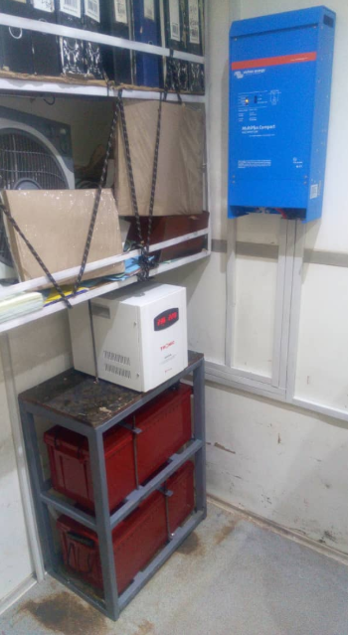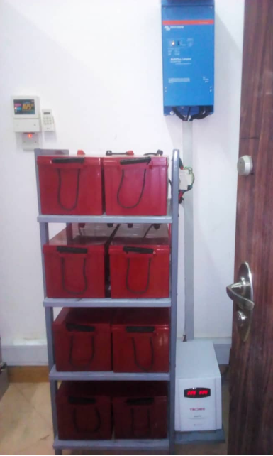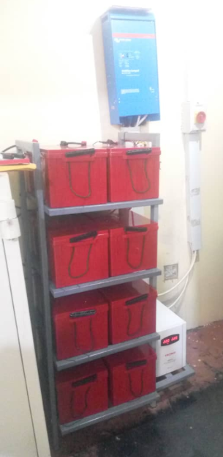

**1.MTWANGO BRANCH 2. NAMTUMBO BRANCH 3. TURIANI MOBILE 21**

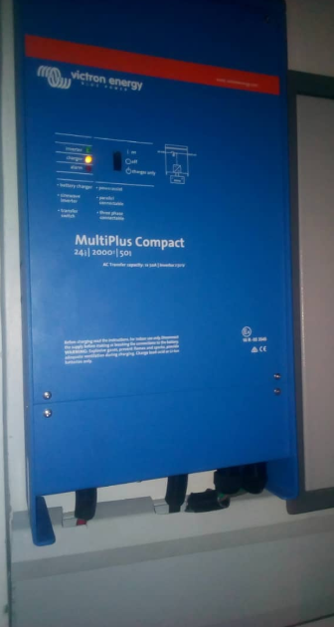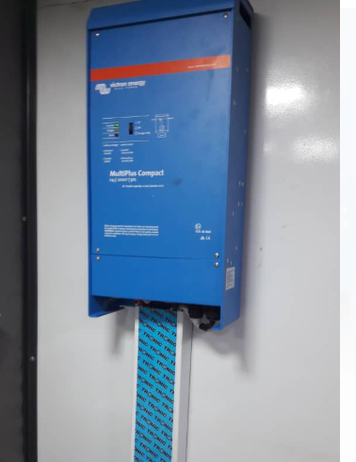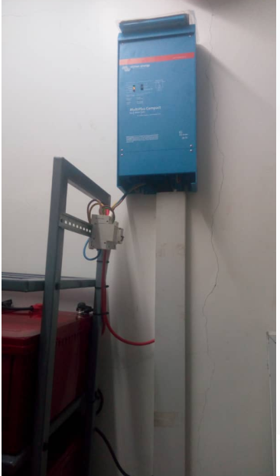

**4. UNILIVER BRANCH 5.MOBILE 3 STIGLERS GORGE 6.NGAMIANI BRANCH**

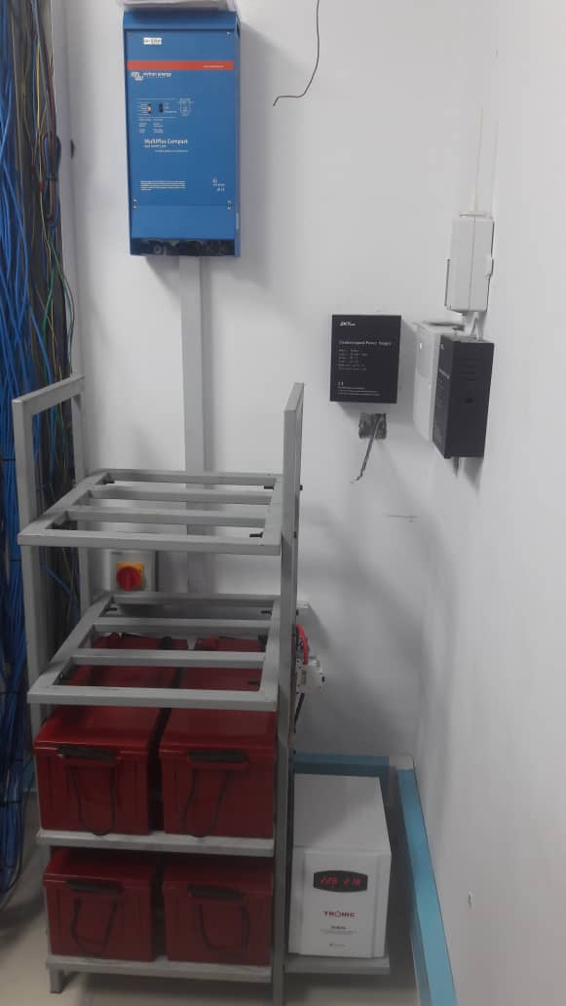 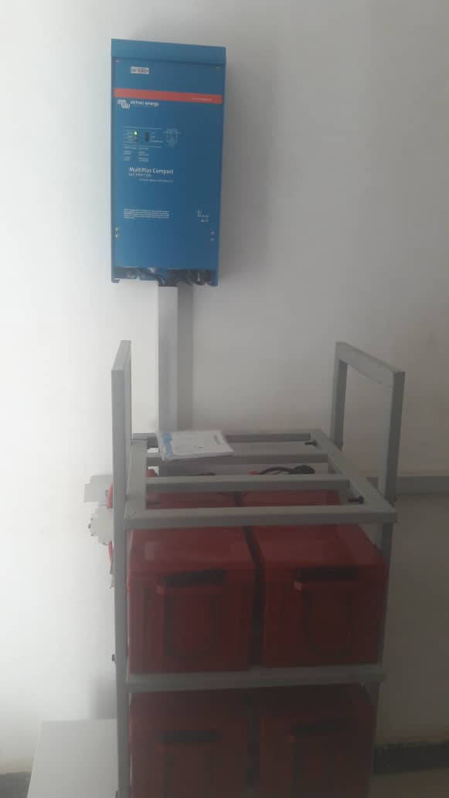 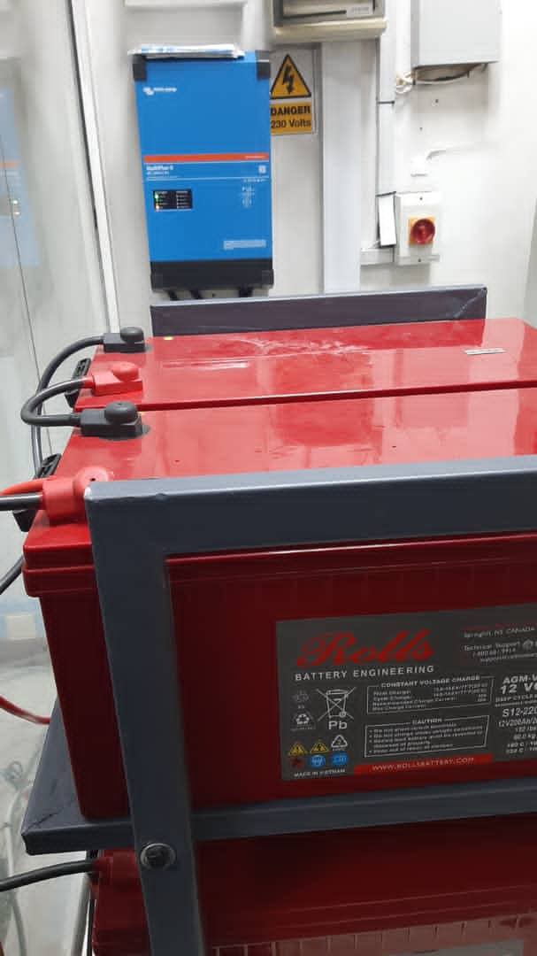

**7. CHAMWINO BRANCH 8. IHUMWA ATM 9. KIJITONYAMA BRANCH**

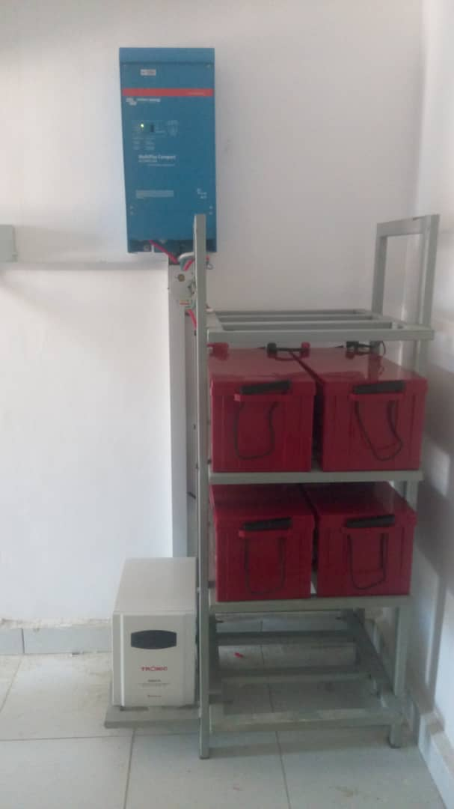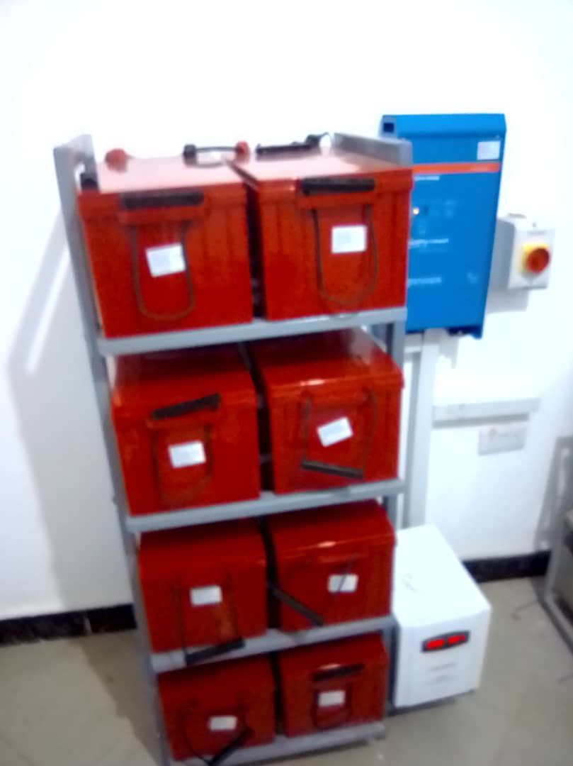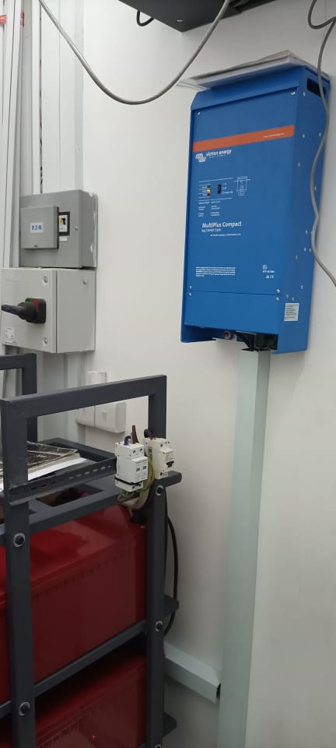

**10.ROYAL VILLAGE ATM 11.NYEHUNGE ATM 12. KINYEREZI BRANCH**

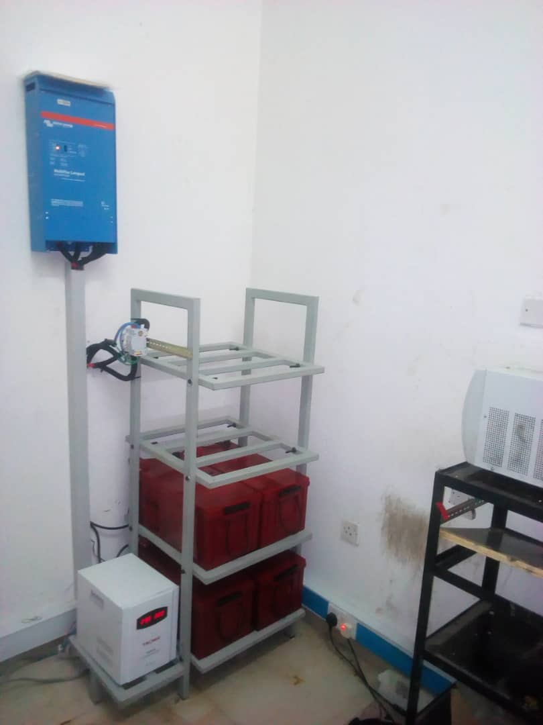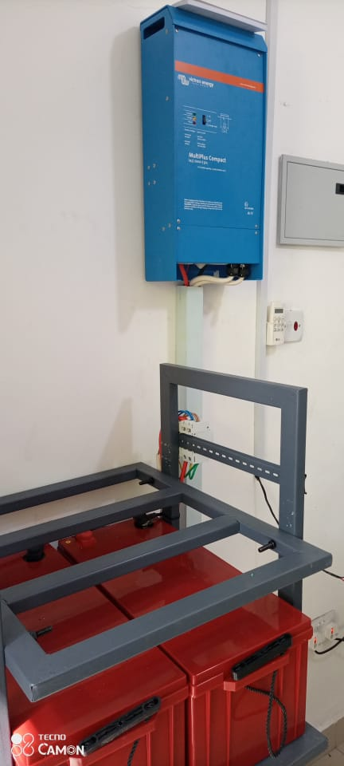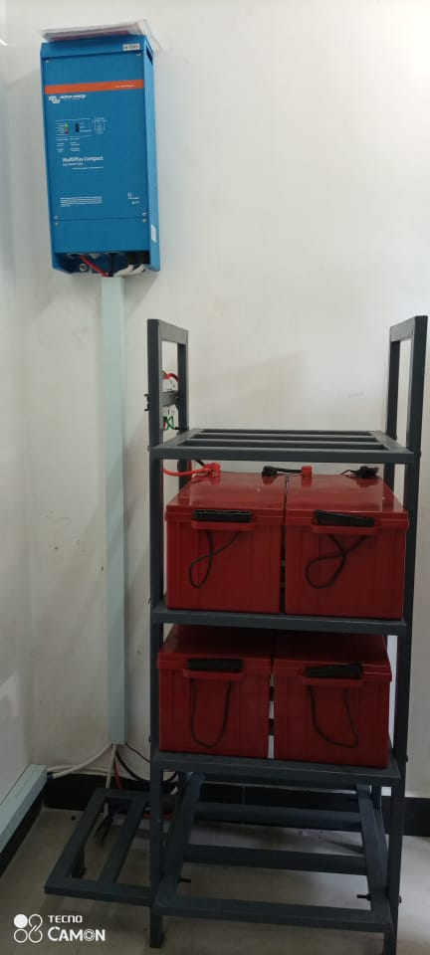

**13. MLANDEGE ZANZIBAR ATM 14.NATIONAL MUSEUM ATM 15. KIVUKONI ATM**

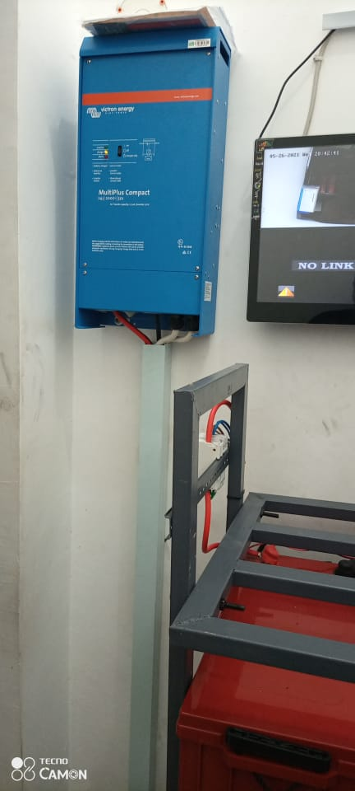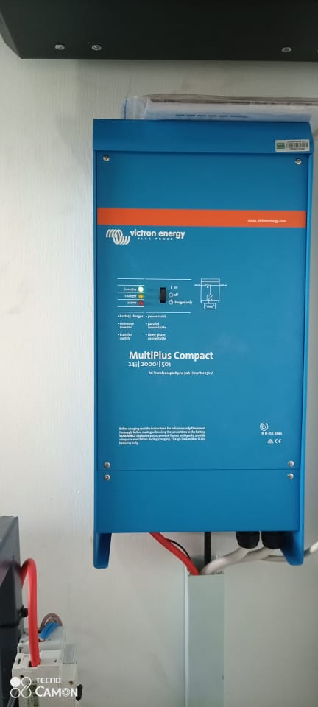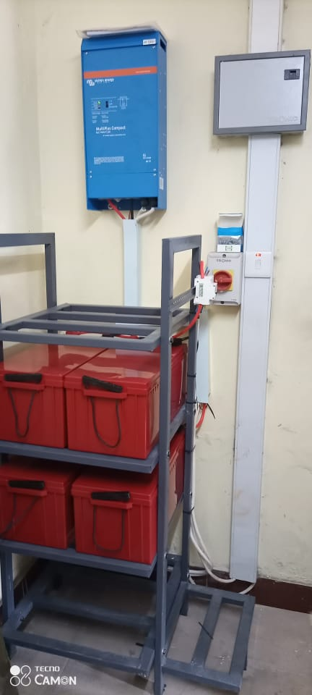

**16 . SHOPPERZ PLAZA MBEZI BEACH 17. FIRE ATM 18. SINZA KIJIWENI ATM**

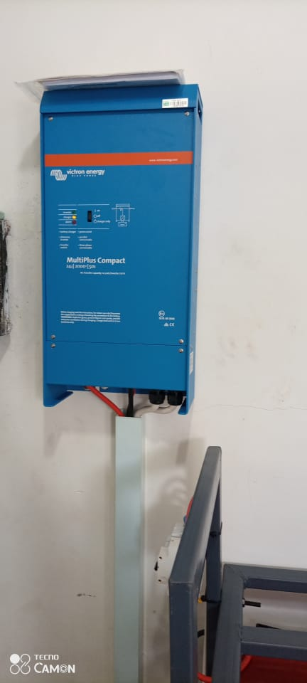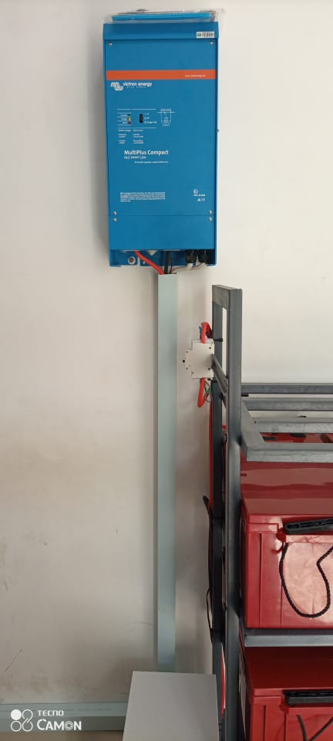 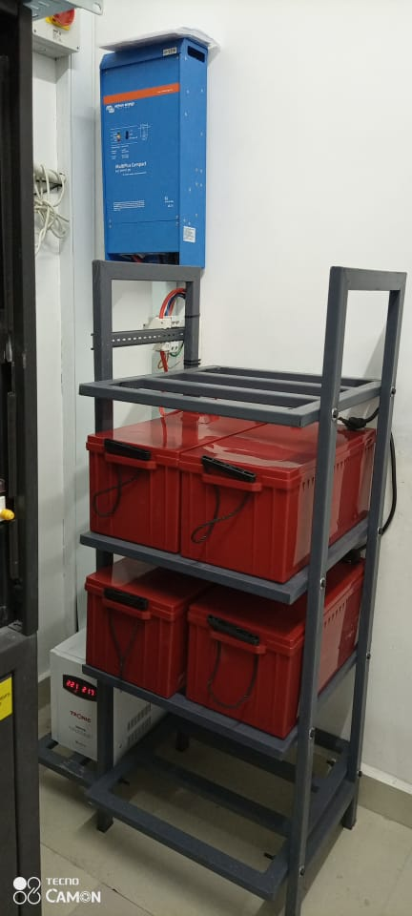

**19. IMMAGRATION ATM 20. TIA ATM 21. KURASINI ATM**

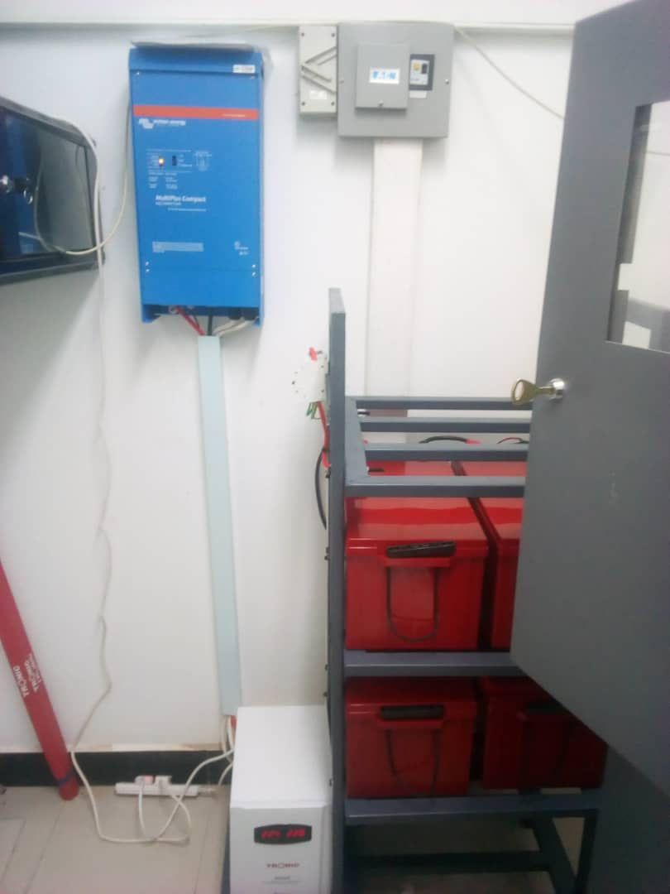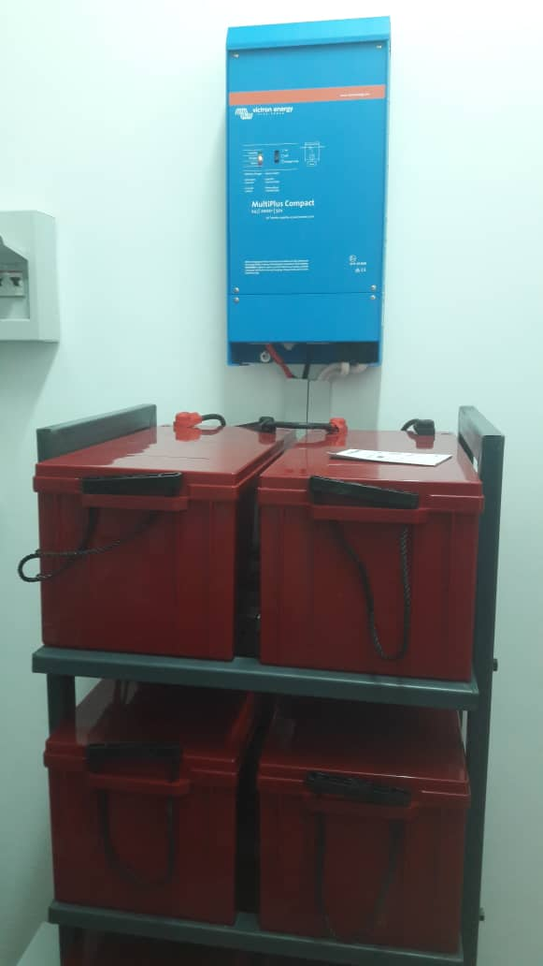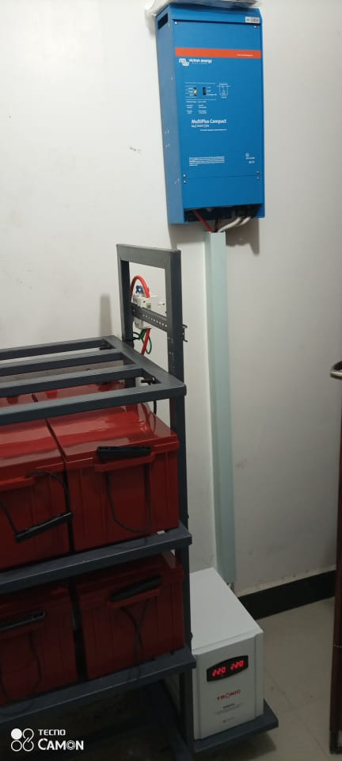

**22. KAMPALA KIU ATM 23. SAKINA SERVICE CENTRE 24. UKONGA ATM**

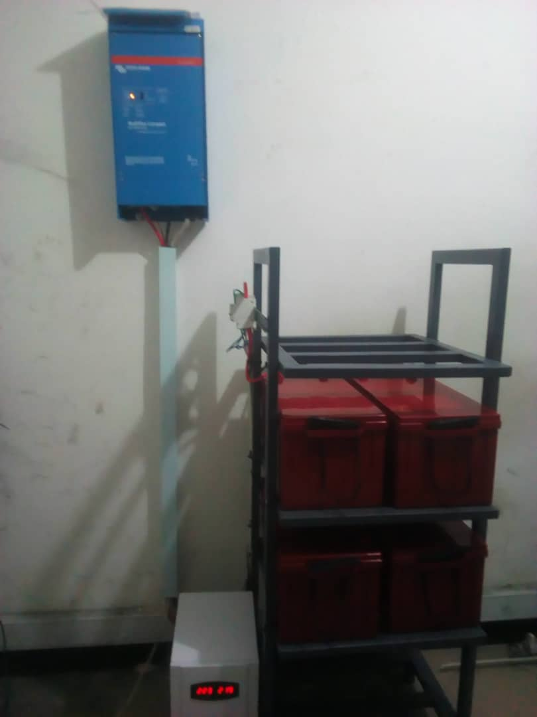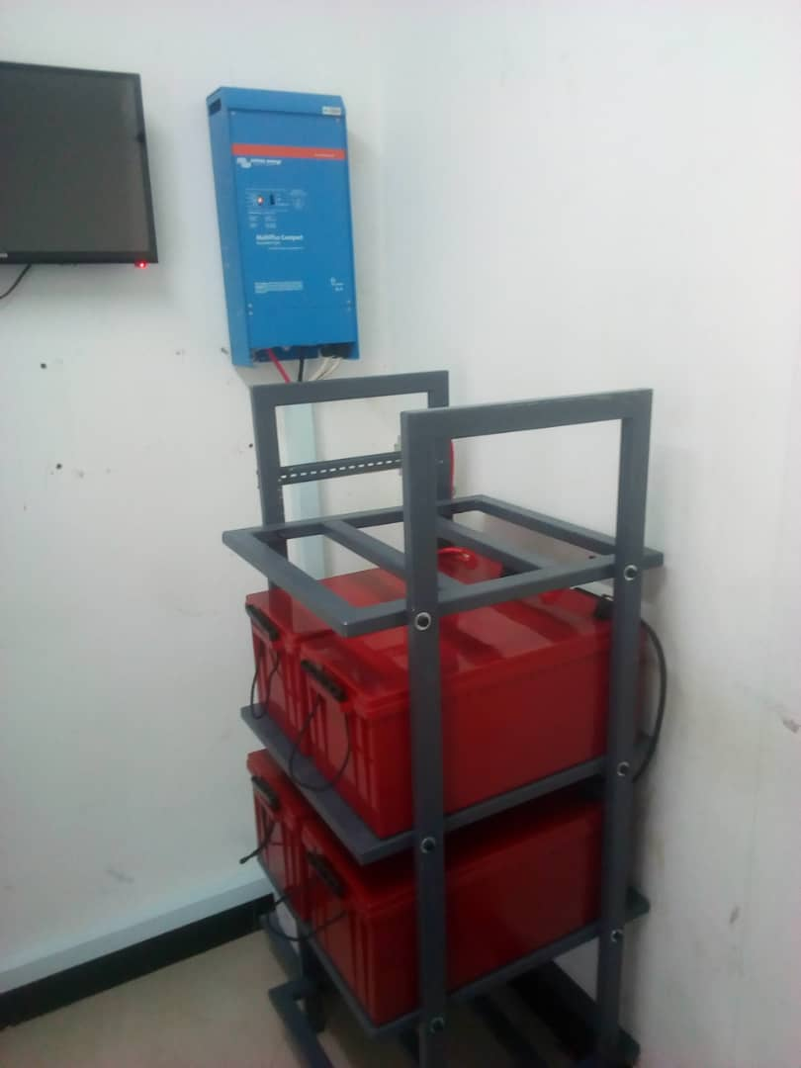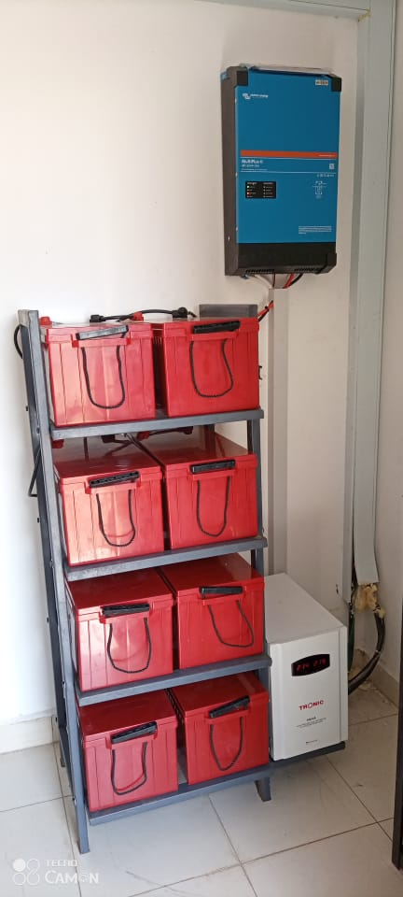

**25. TAZARA ATM 26. TUMBI ATM 27. KAHAMA BRANCH**

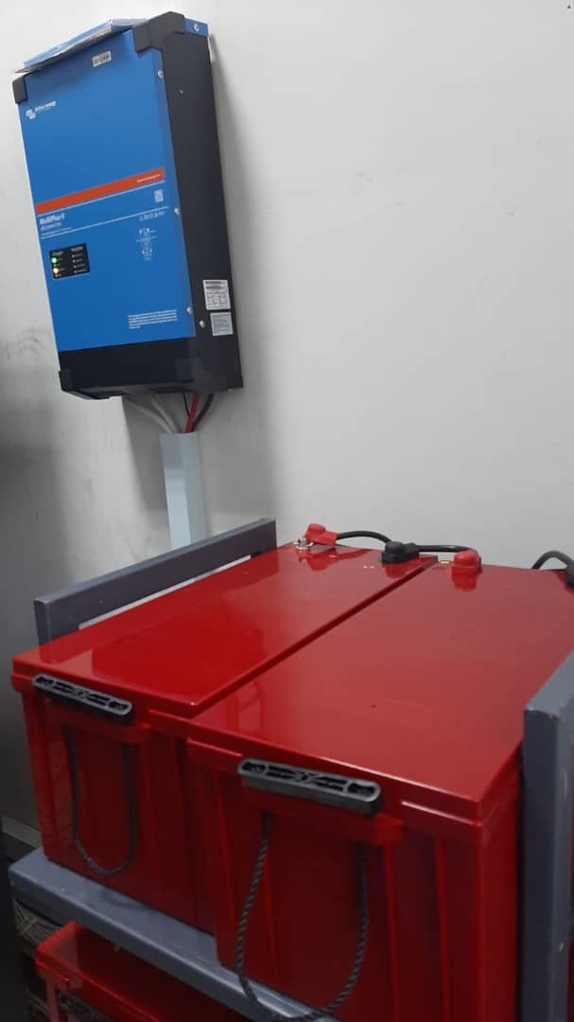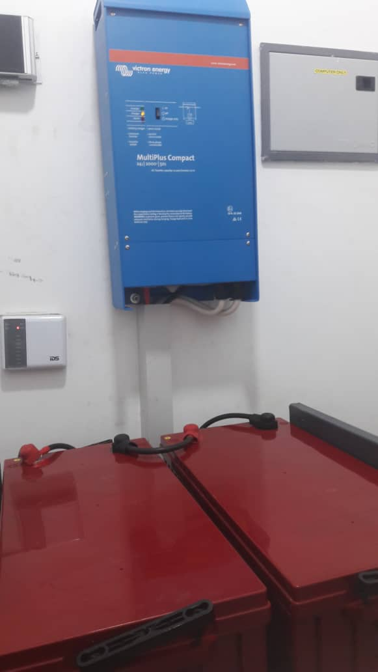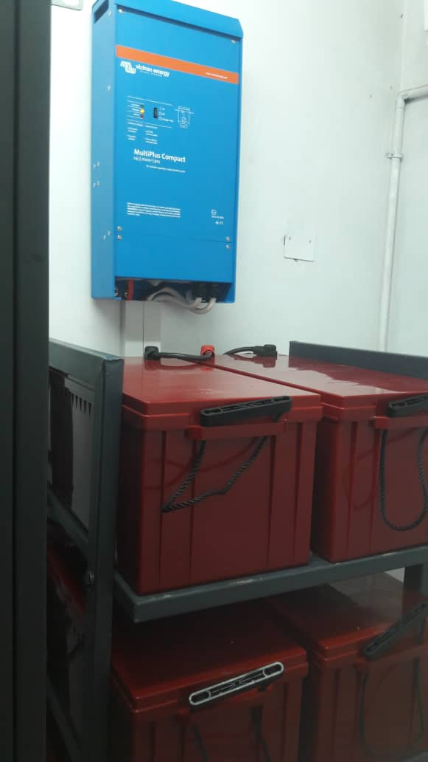

**28. MBAGALA BRANCH 29. MLOWO BRANCH 30. SUMBAWANGA ATM**

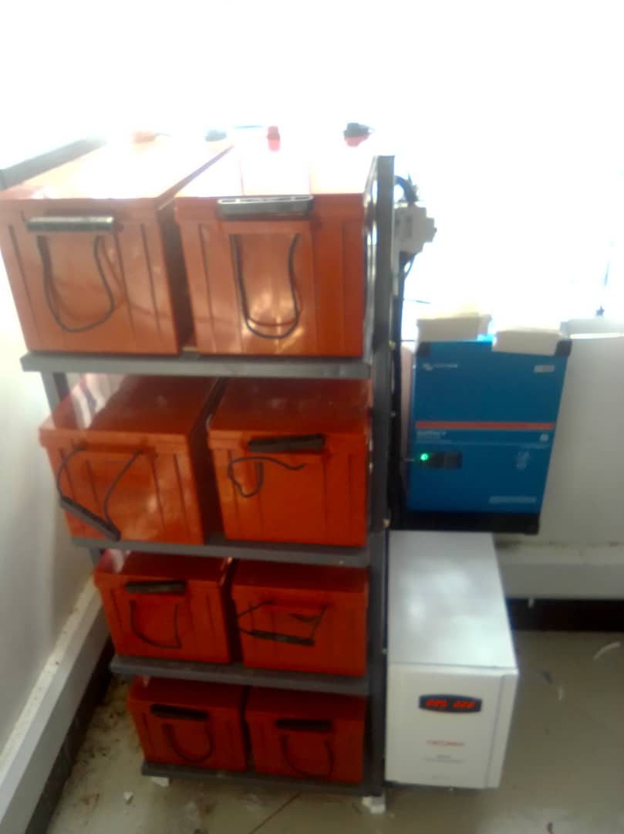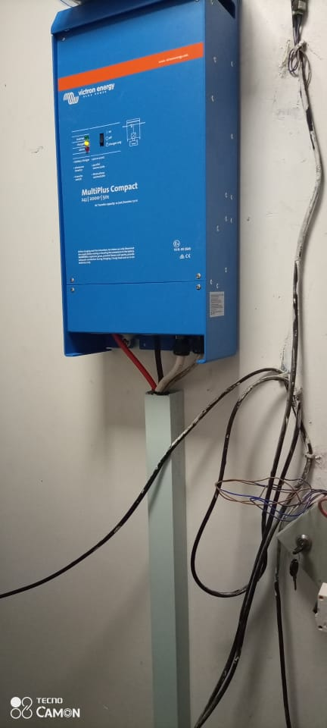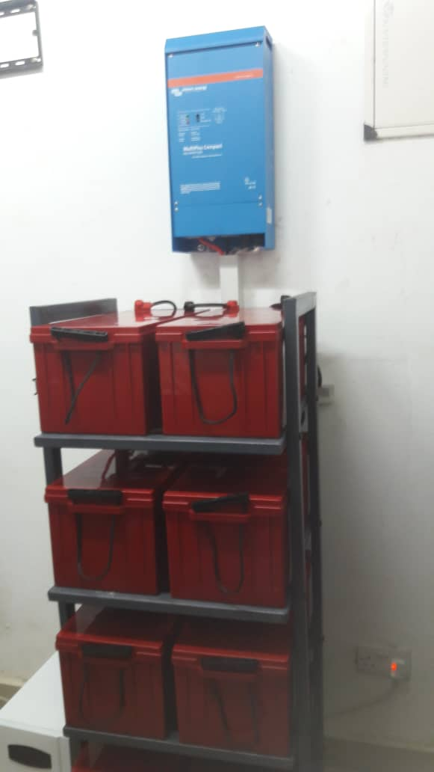

**31. BARIADI BRANCH 32. TABATA LAKE OIL ATM 33. ANTIQUE ATM**

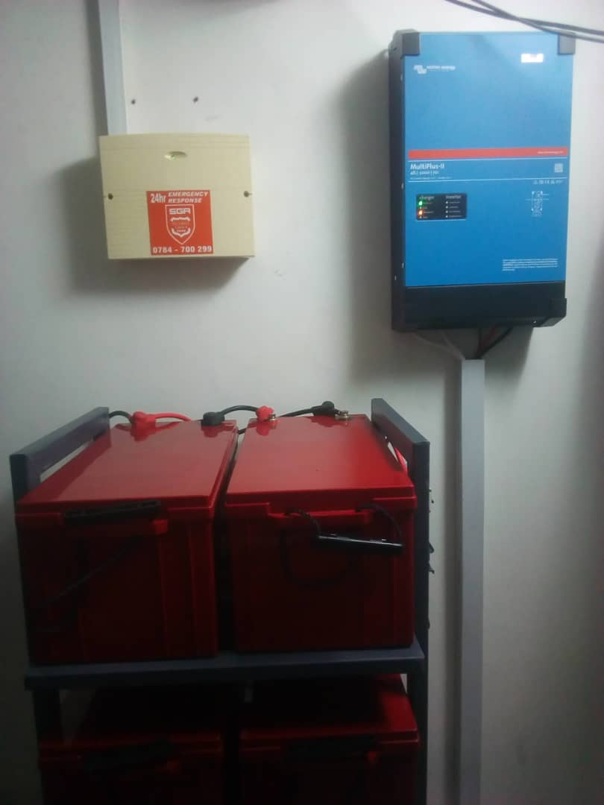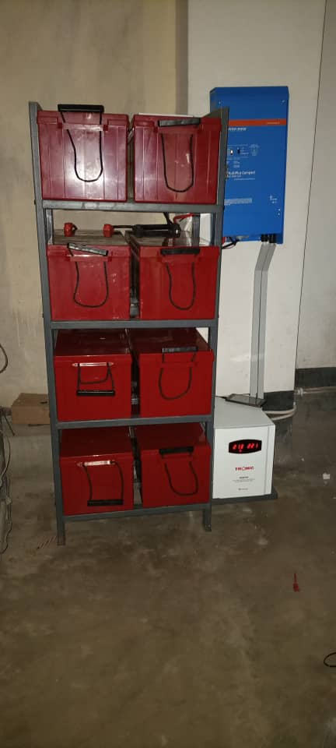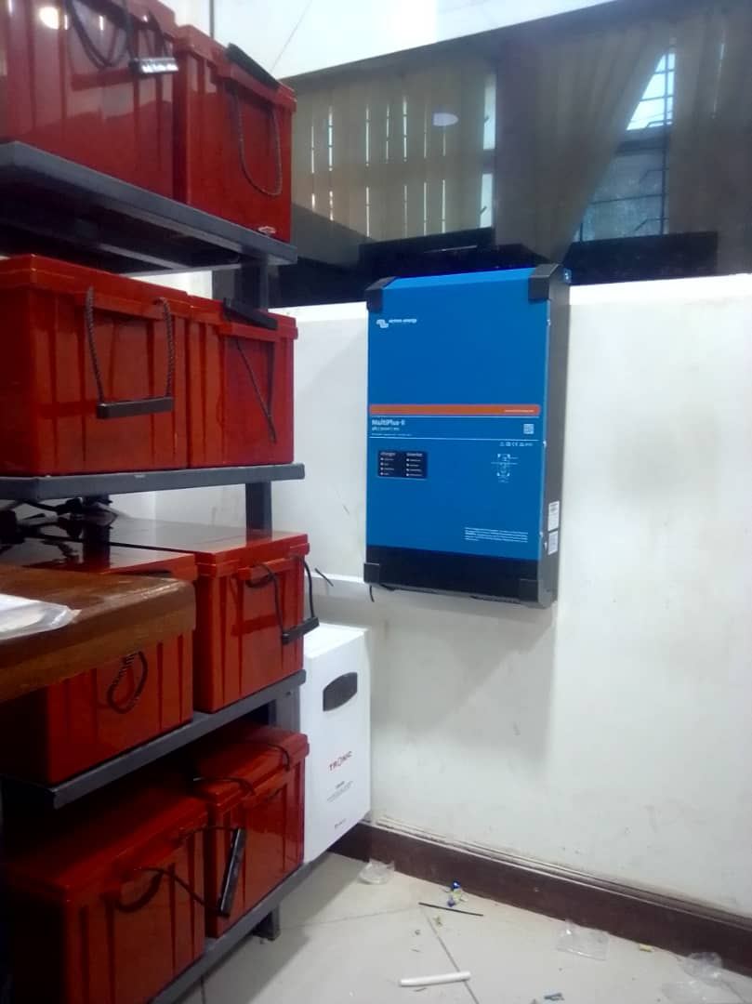

**34. TEGETA BRANCH 35. MAGU TPC BRANCH 36. MUSOMA BRANCH**

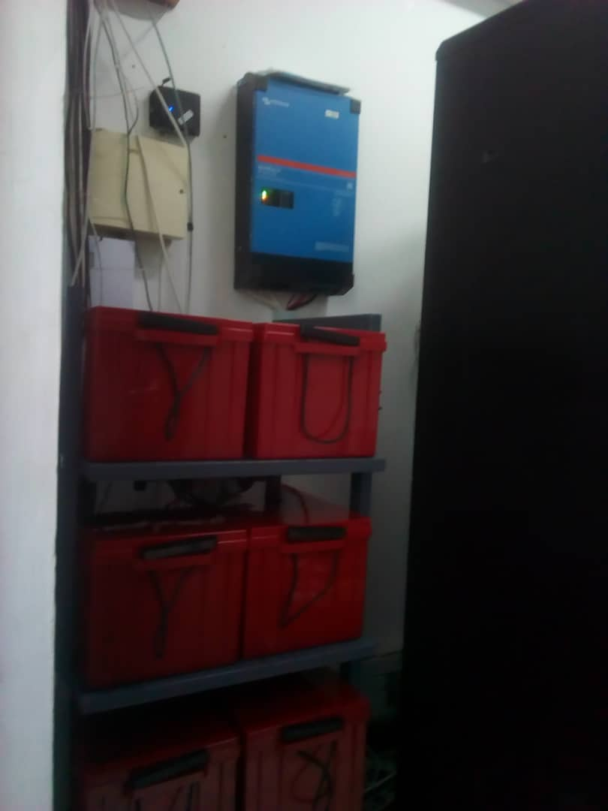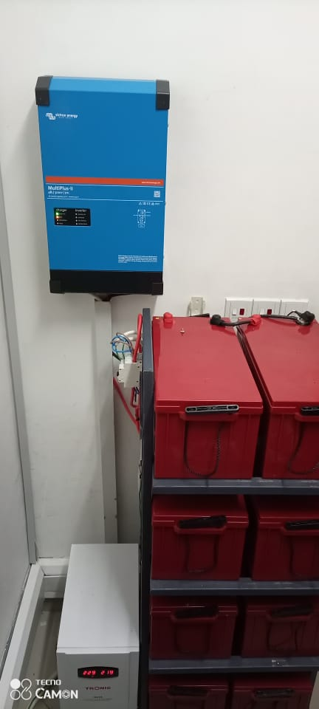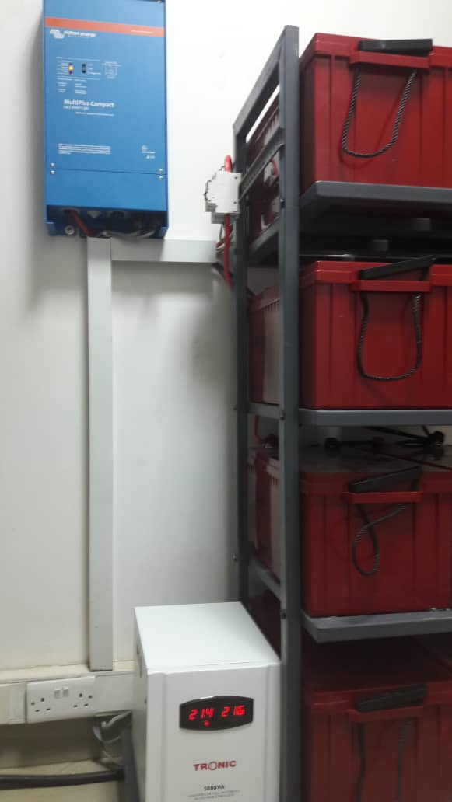

**37. UDSM BRANCH 38. TABORA BRANCH 39. KILOSA BRANCH**

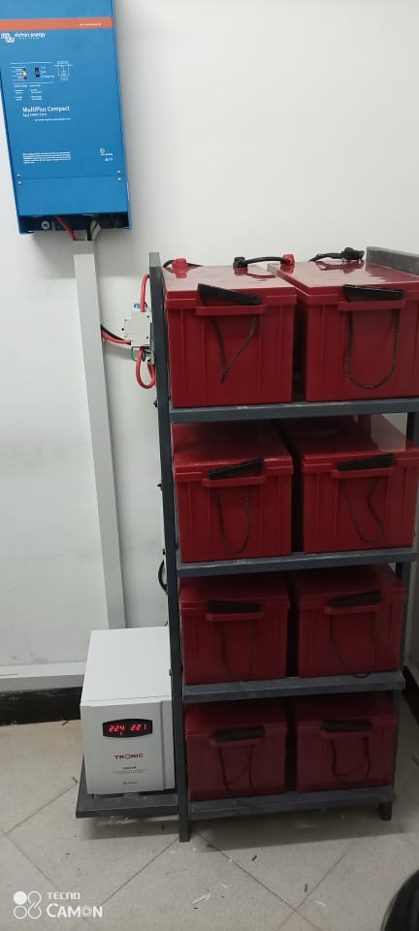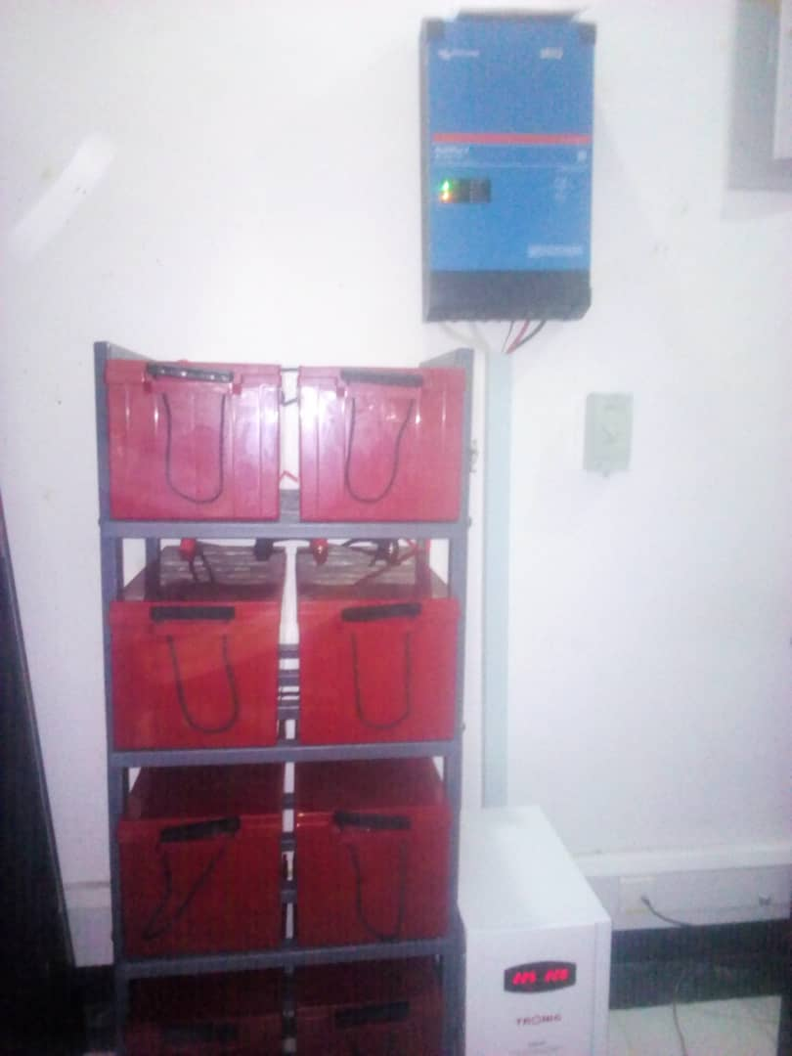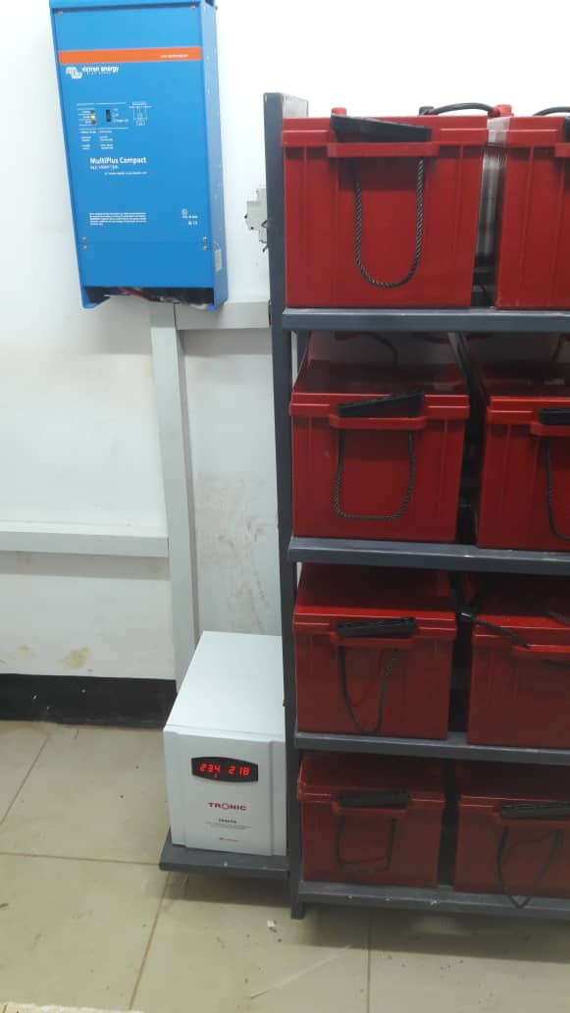

**40. SINGIDA ATM 41. TEMEKE BRANCH 42. KILOSA FARM**

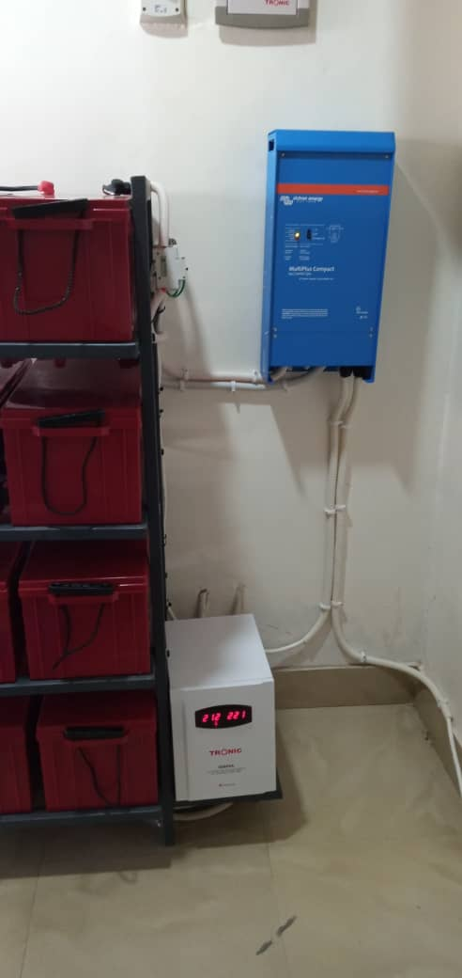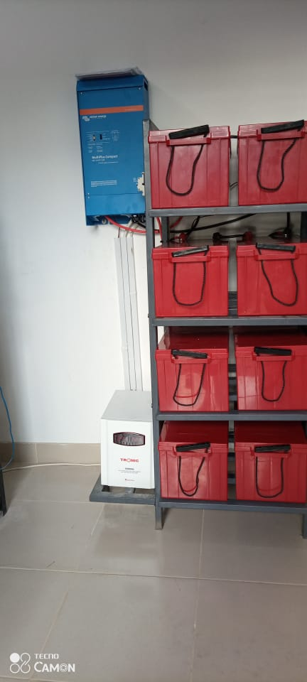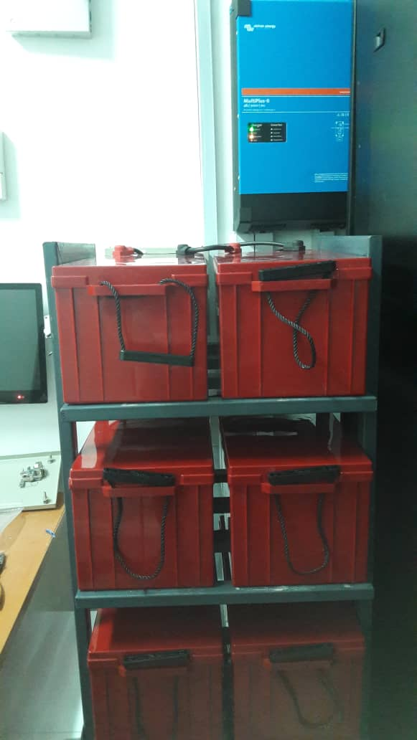

**43. MAGEREZA ATM 44. ST JOHN ATM 45. UDOM BRANCH**

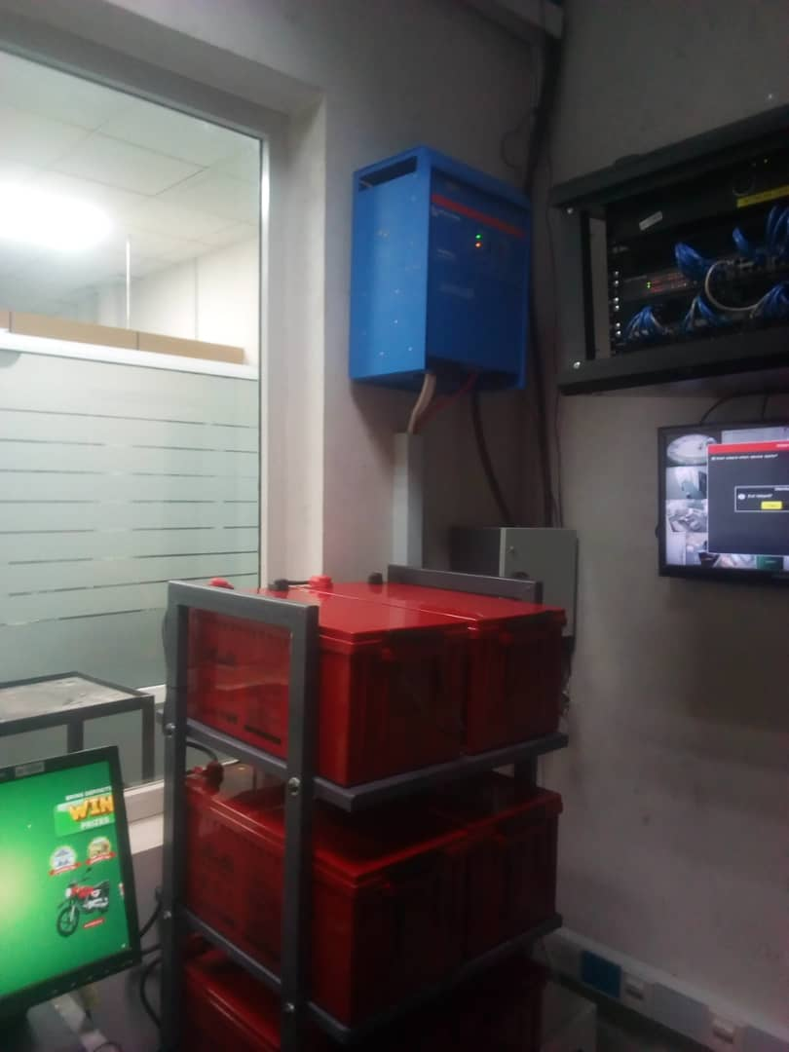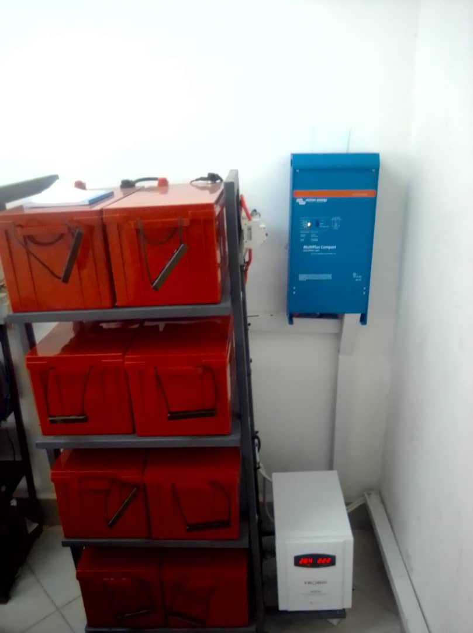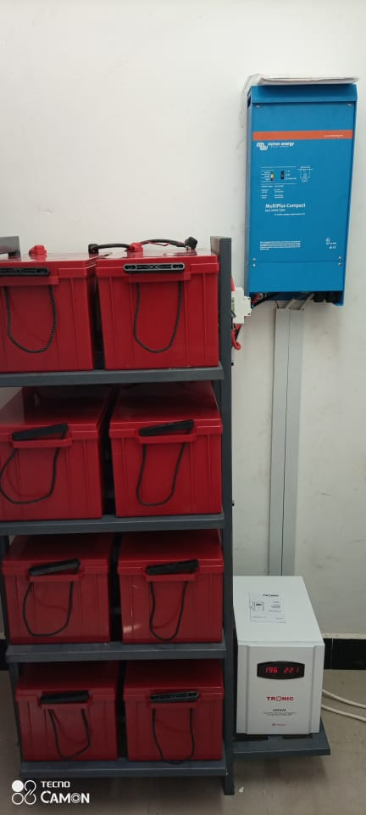

**46. PUGU BRANCH 47. ORXY ATM 48. KIZOTA CHAMWINO ATM**

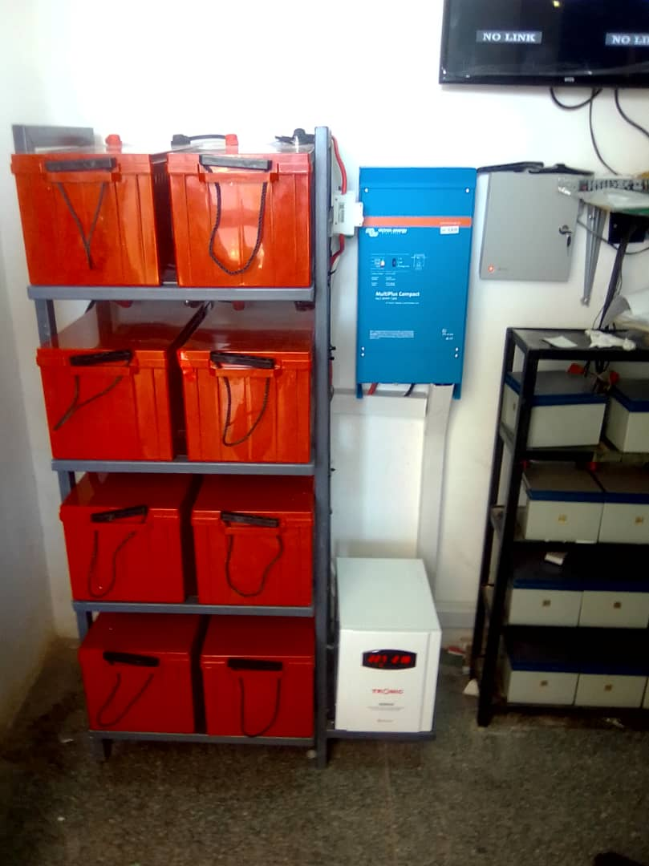

**49. ILEMELA ATM**

**----------------------26 SITES TO GO---------------------**