DEMO FOR TEST

# Create Class:

Following picture explain that we must enter class code (white spaces will be removed using php trim function at backend), Class Name, Maximum Students and Description (Not Necessary).

# Update/View Class:

Following Picture that all the classes records are in the table list, Click the edit button to update the record appear in the update form. Just change the desired field you want to update and submit.

# Create Student:

Following picture explain that we must enter first name, last name, Class Name (Select Menu of Created Class), Date of Birth. This action will created student, check the max student limit of class and update the status of class from open to close.

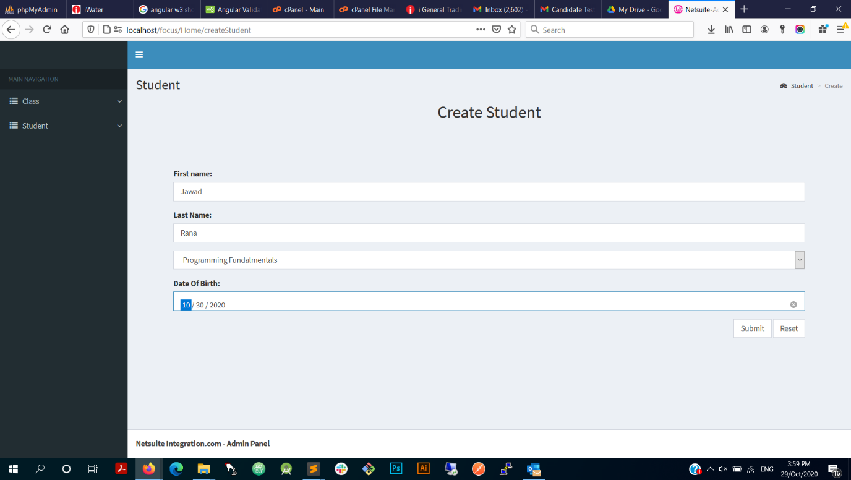

# Update/ View Student:

Following Picture that all the student’s records are in the table list, Click the edit button to update the record appear in the update form. Just change the desired field you want to update and submit.

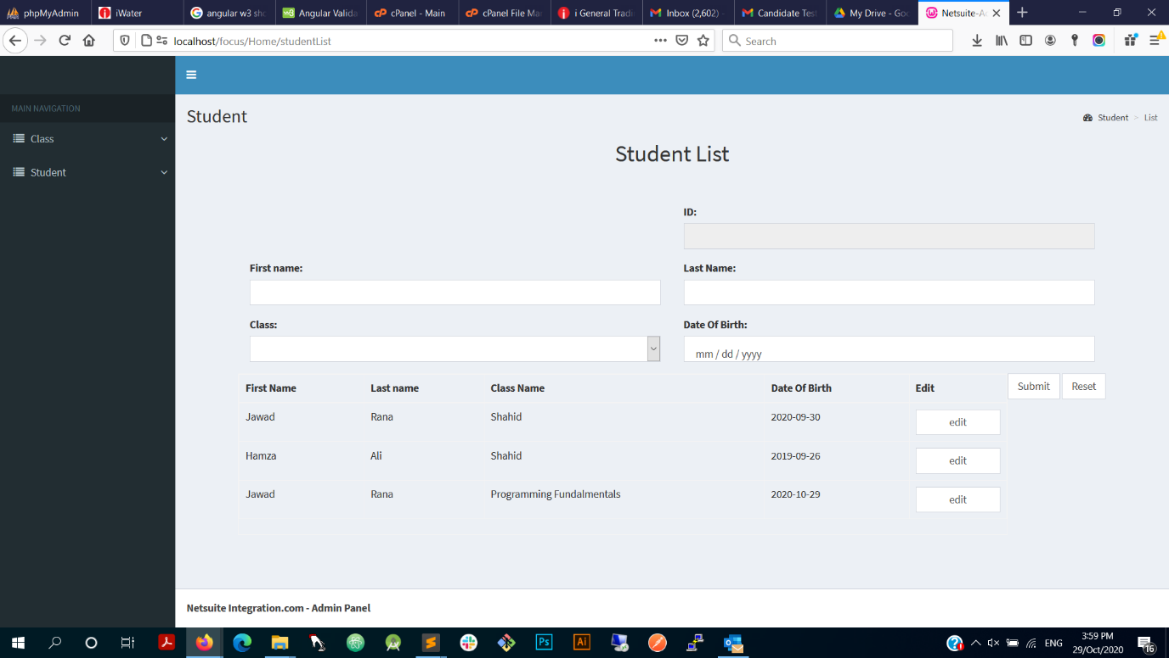

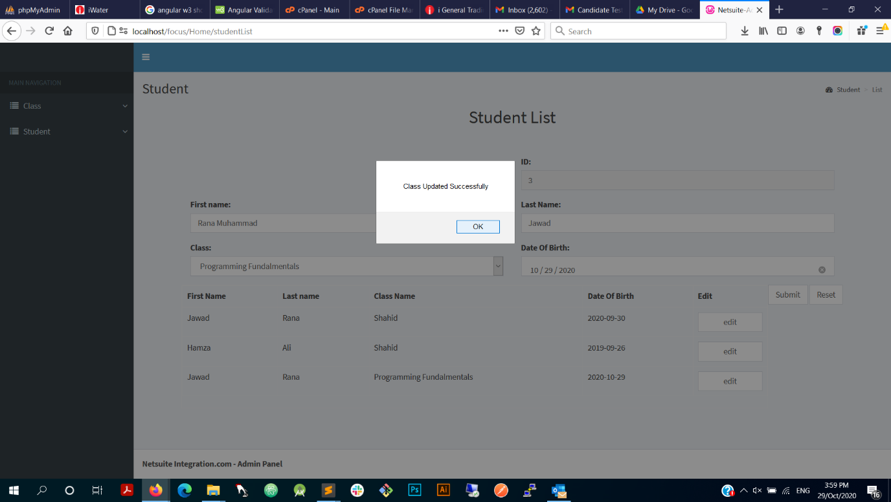

# Technical Explanation:

Following pictures shows the database with desired tables in the test.

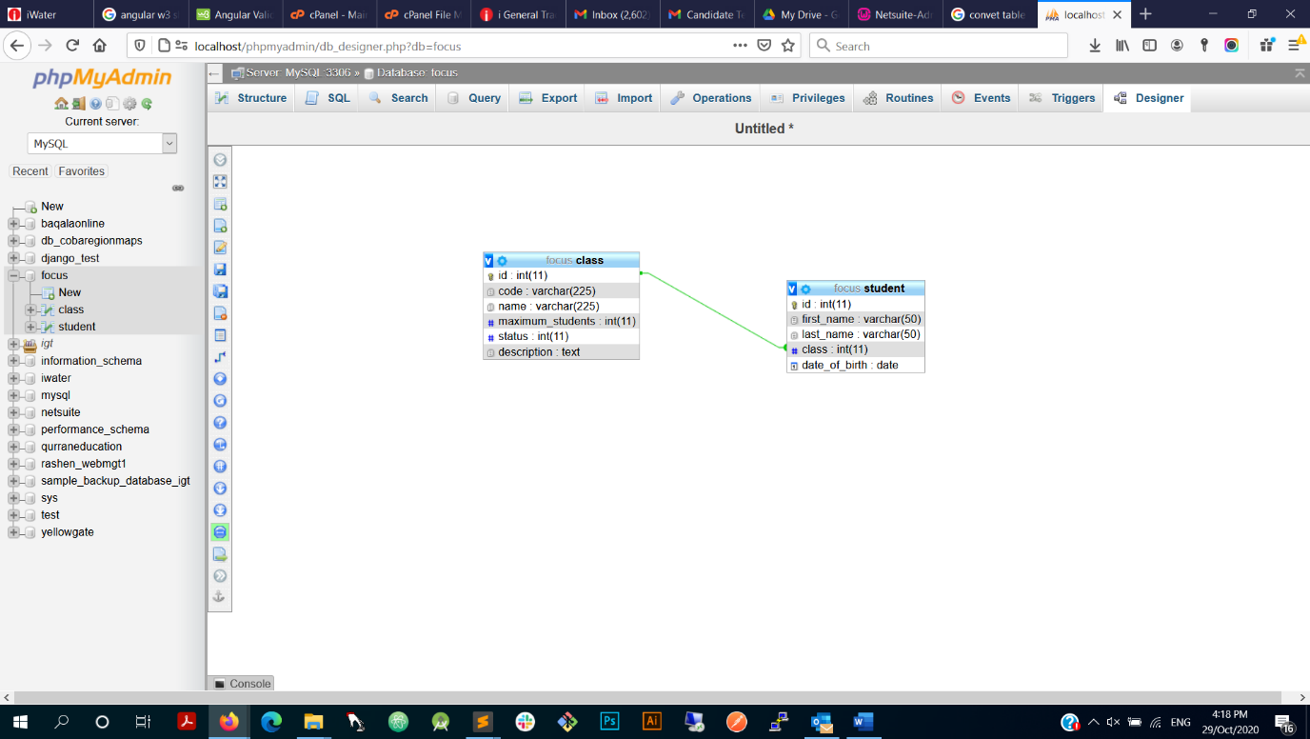

# Update/View Class Angular Code:

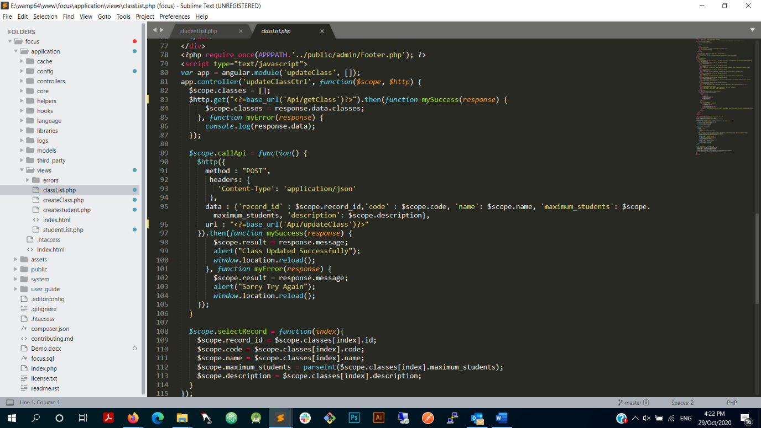

# Create Cass Angular Code:

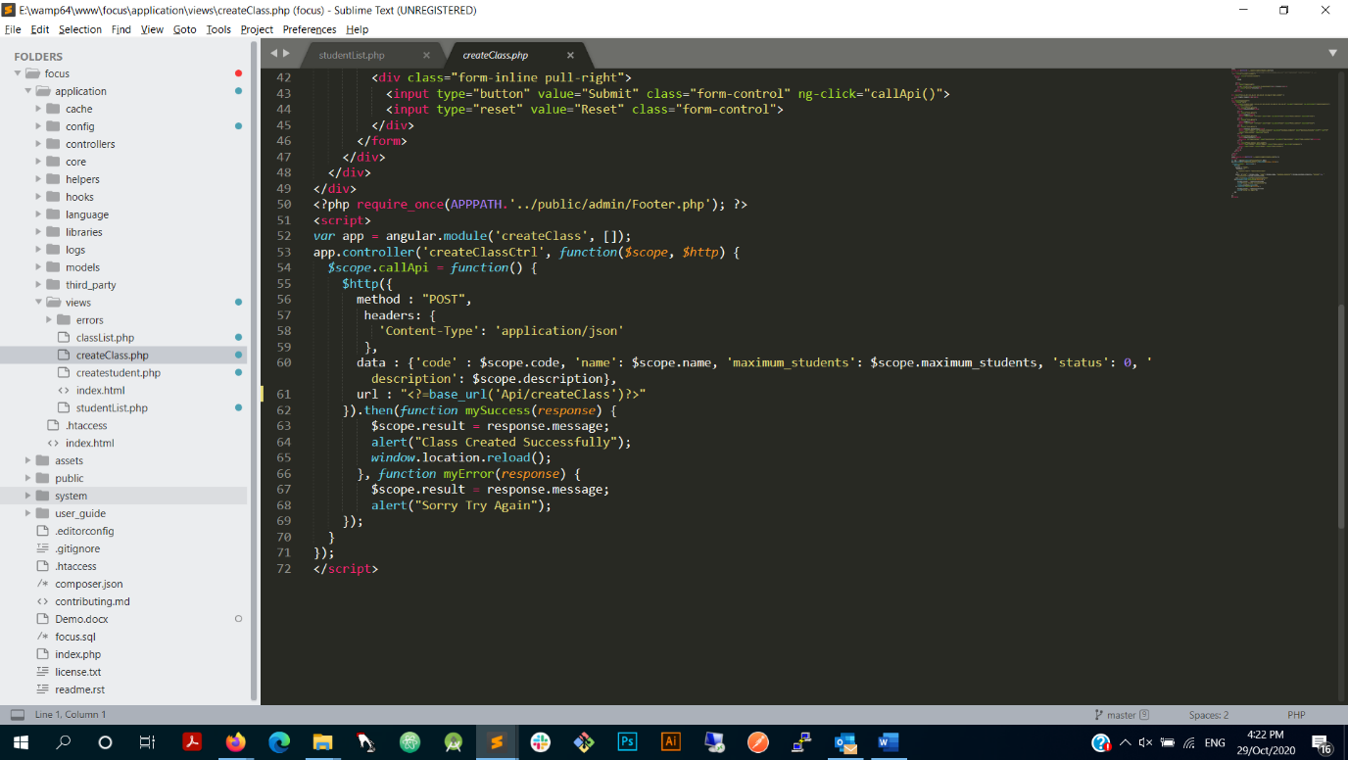

# Create Student Angular Code:

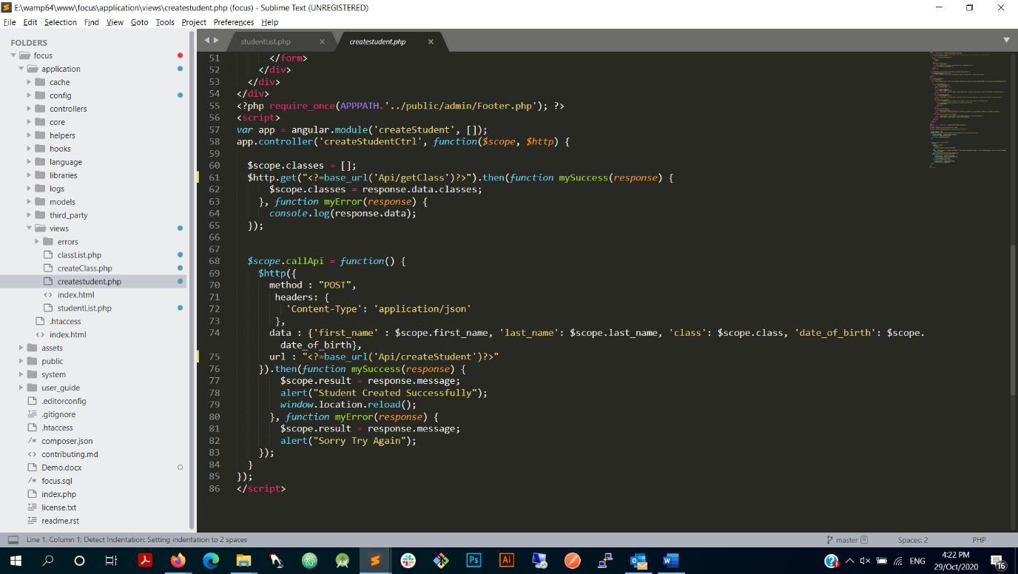

# Update Student Angular Code:

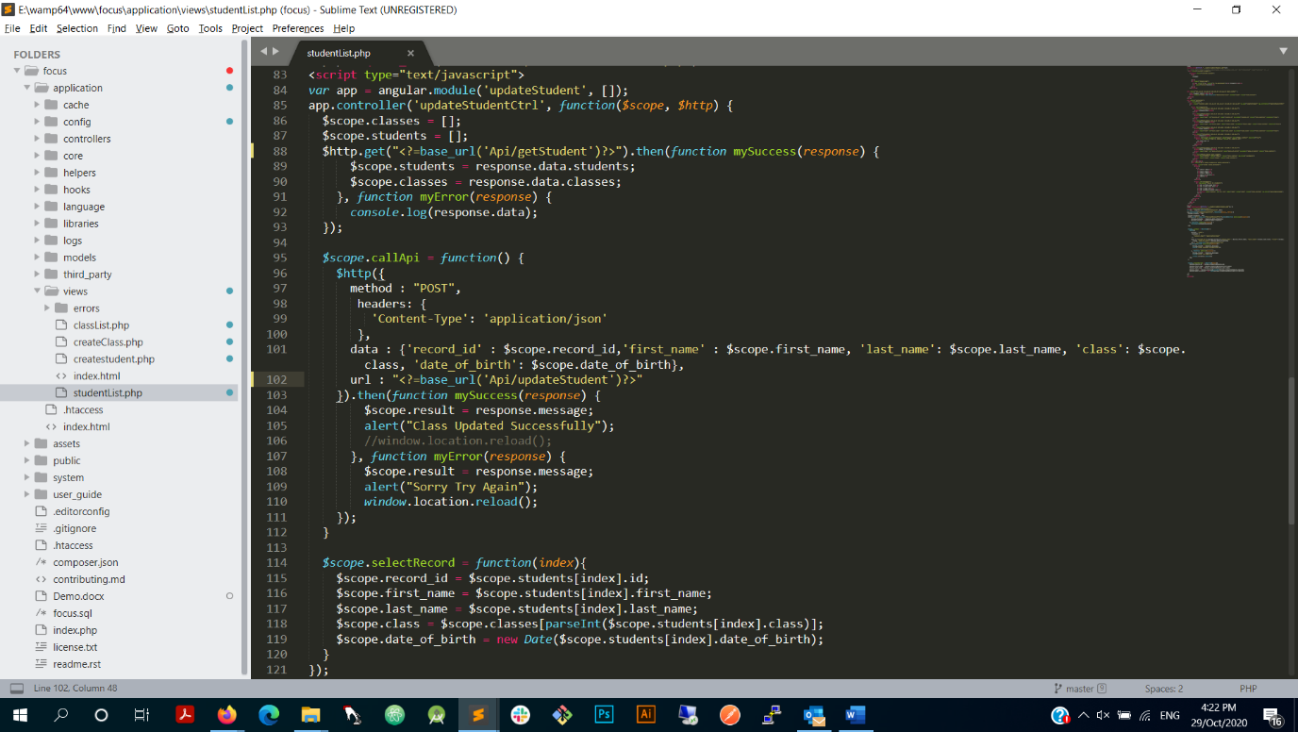

# API Interface PHP CodeIgniter:

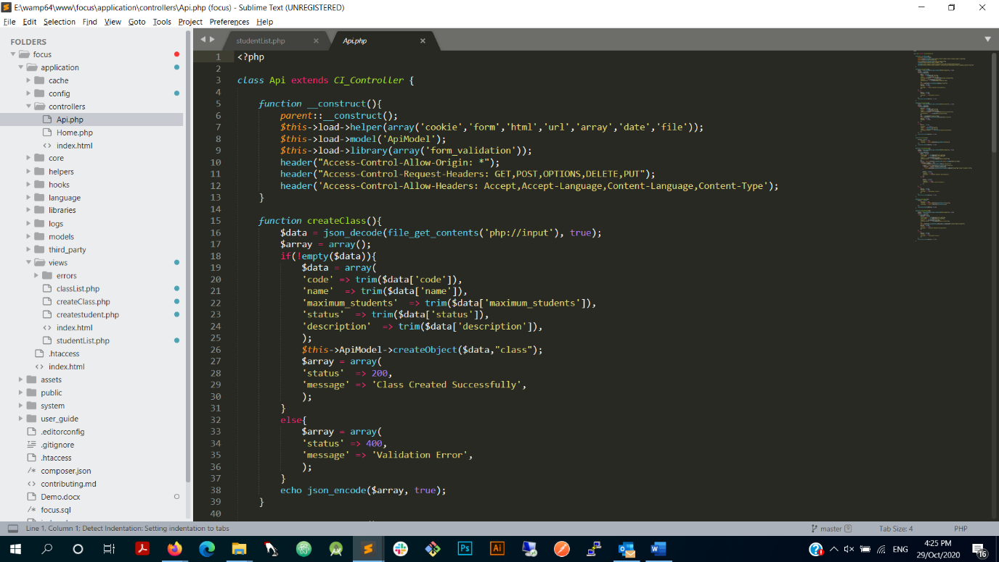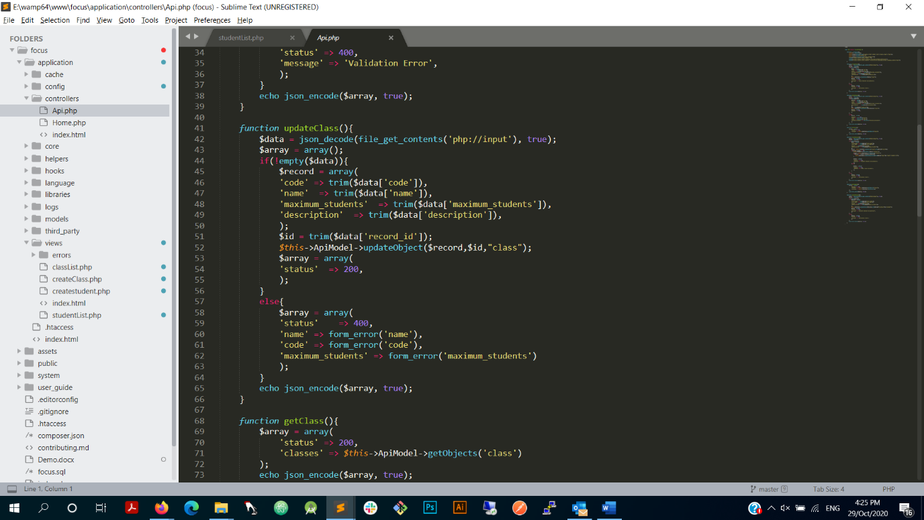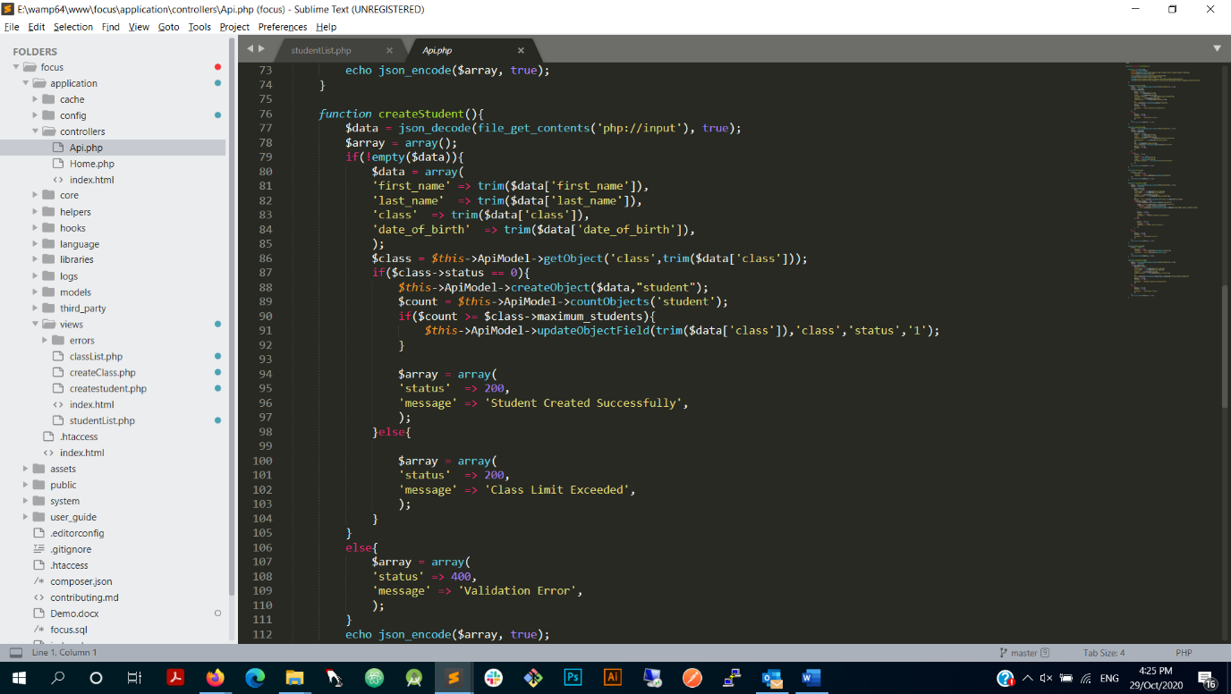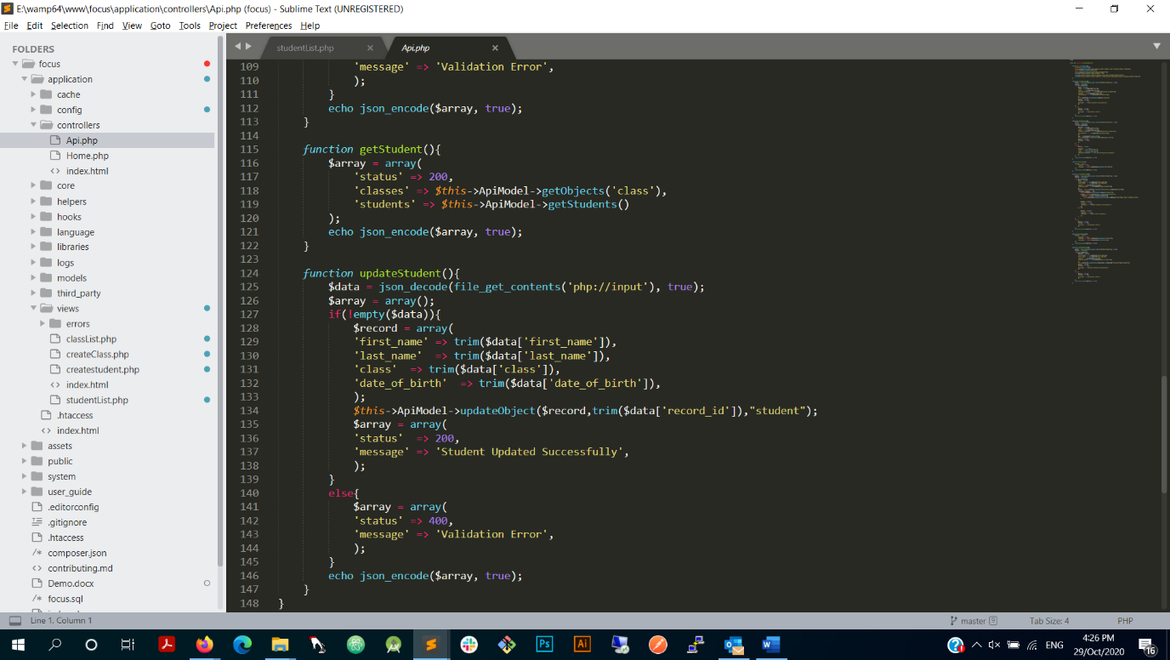

# Views Rendering Controller:

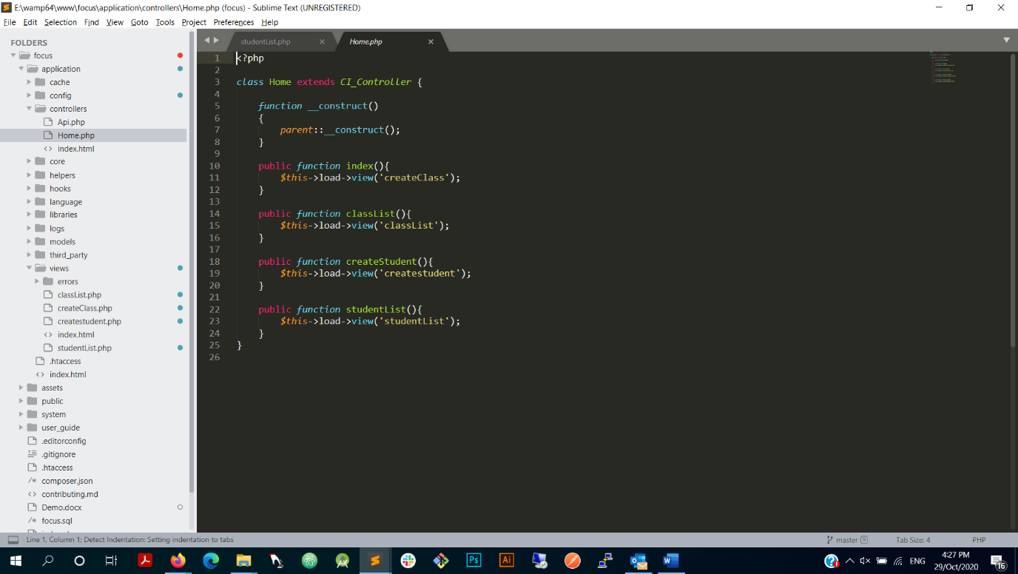

Note: For the test I use MySQL database as backend, PHP CodeIgniter for managing the backend and launching the views in interactions of views to database using angular and CodeIgniter rest API’s.