1. **Question 1: **
2. **Question 2: **
3. **Question 3:** [**https://github.com/JawadShaib/devopscourse-2812-jawad**](https://github.com/JawadShaib/devopscourse-2812-jawad)
4. **Question 4:** 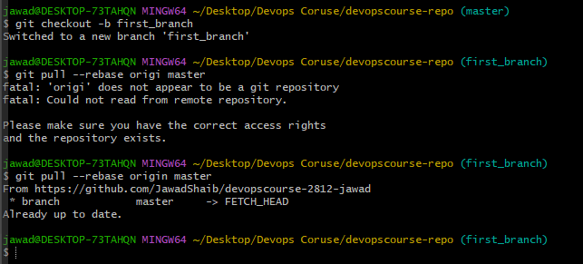
5. **Question 5: creating a conflict** 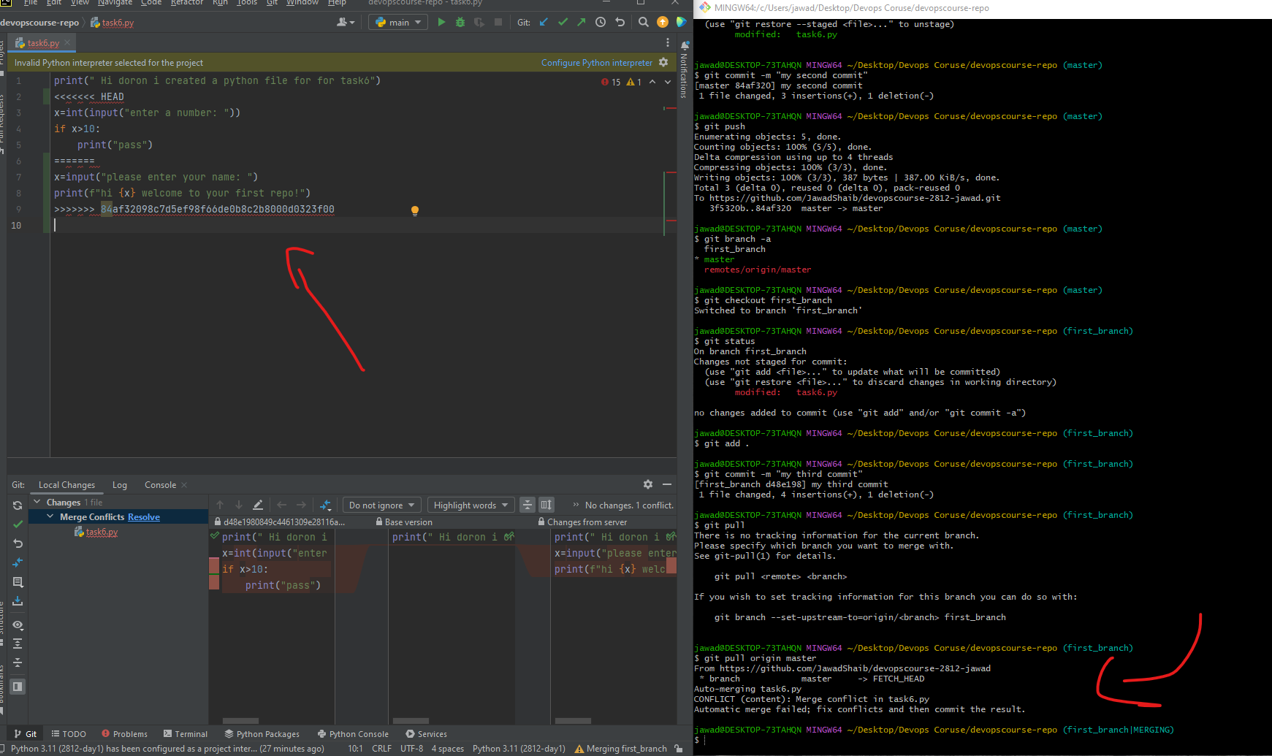
6. **Question 6:** 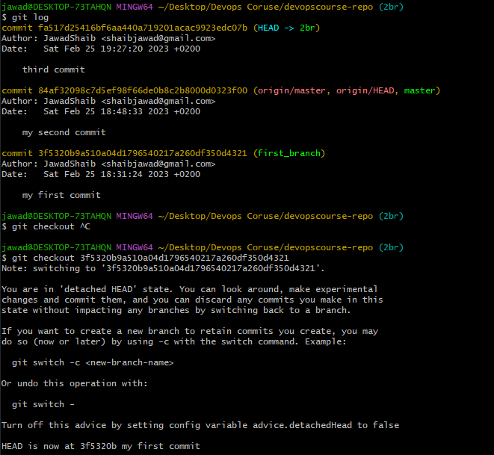
7. **Question 7:** 