Task 9

EX1:

1. 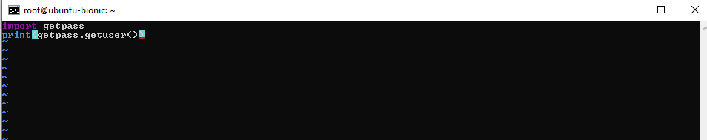0

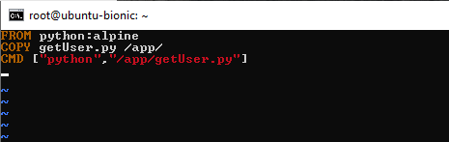



EX2:

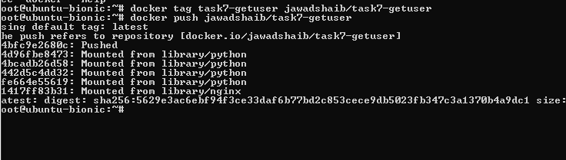

[Image Layer Details - jawadshaib/task7-getuser:latest | Docker Hub](https://hub.docker.com/layers/jawadshaib/task7-getuser/latest/images/sha256:5629e3ac6ebf94f3ce33daf6b77bd2c853cece9db5023fb347c3a1370b4a9dc1)