Task 10

1.

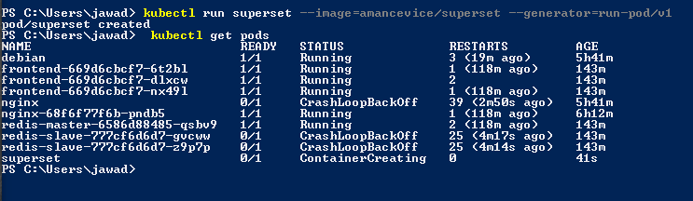

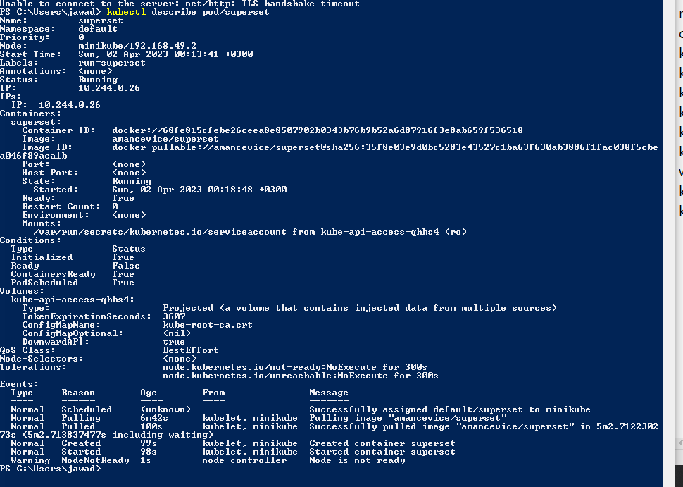2

2. 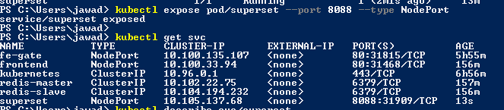

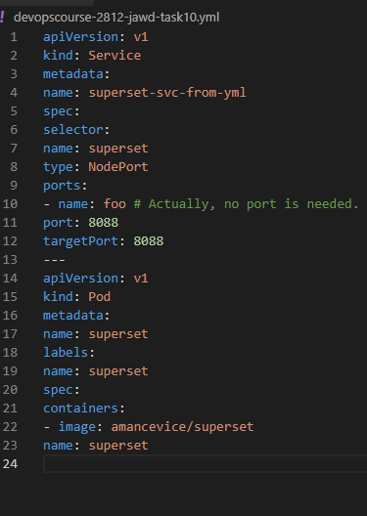3. kubectl apply -f devopscourse-2812-jawd-task10.yml

**4.**

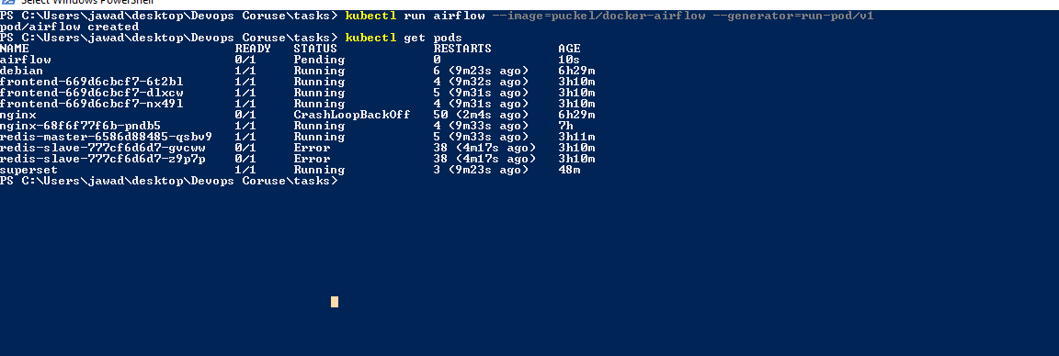

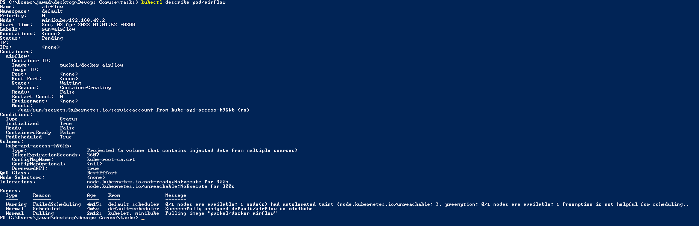

**5**

Exposing airflow pod:

