Algonquin College Logo

# SCHOOL OF ADVANCED TECHNOLOGY

### ICT - Applications & Programming

### Computer Engineering Technology – Computing Science



A11

Game Interface

Team:

[Jawad Awada] - Id: [041032551

Game Proposal - Picross

***This template is suggested (not mandatory) to answer A11 Specification.***

|  |  |
| --- | --- |
| **Part**  **1** | **GUI Definition** |

**EXPLANATION**

*The purpose of this assignment is to define the elements of the GUI application to be used in your game implementation.*

* ***Example (Prof. suggestion)****:*

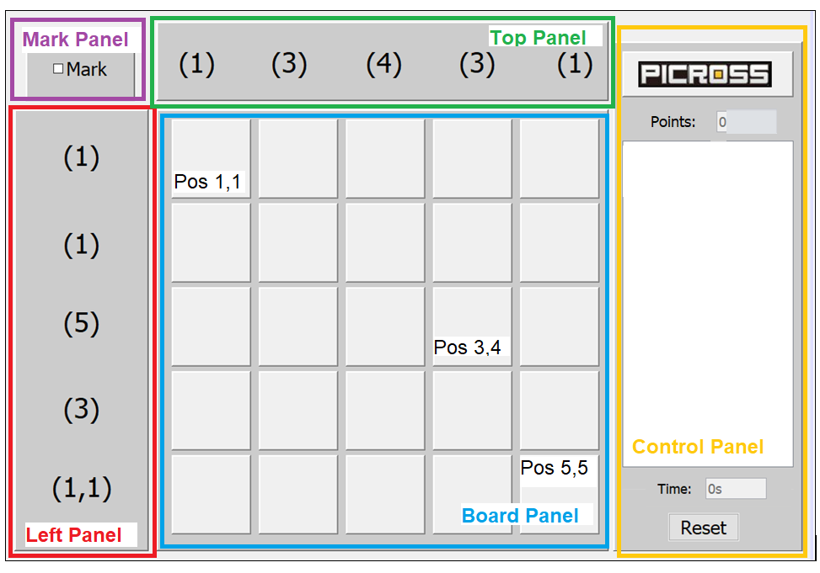

* ***Note****: The professor interface is also a proposal. It means that your own implementation can be different. What does matter is that the game functionality will be respected.*
  1. **Defining the Components**

**List of component sand Functionalities and Behaviors (combined them)**

GridLayout: To arrange the grid of buttons on the game board.

Button: Used to symbolise each grid cell on the gaming board.

Event Listeners: To handle button clicks and other user interactions with the buttons.

To handle mouse events like clicks, use a mouse adapter.

Timer: I want to include a timer

Create a menu bar with options like "New Game," "Exit," and "Restart" using JMenuBar, JMenu, and JMenuItem.

JLabel: To make the JPanel visible: to put together various game elements, such as the playing field and the information display as well as display score

**Languages**

English

The second language (Arabic) will be chosen, since this is my natural (birthplace) language.

**Details**

*Drawn your interface (ex: in an image from Paint / Powerpoint slide, or any sketch tool)*

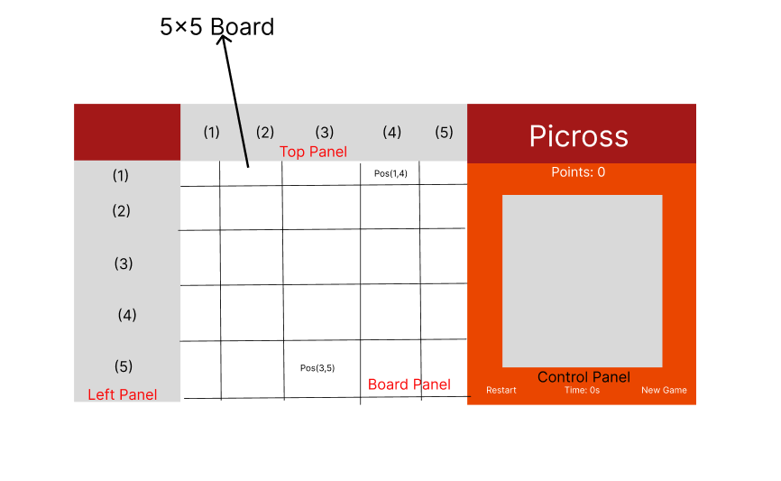

* 1. **User Manual**

**Basic cycle**

*Create a brief description about how your game can be used.*

1. Recognize the Picross rules: The game's goal is to fill up a grid of squares in accordance with the numbers provided at the top and side of the grid. These values specify the number of squares that should be filled in per row or column.
2. Pick a puzzle to play: Most Picross games provide a selection of puzzles of various sizes and degrees of difficulty.
3. Analyze the data: In order to determine which squares, need to be filled in, look at the numbers provided at the top and side of the grid.
4. Use Xs to indicate which squares need to be filled in with right click
5. Fill in the blanks: After determining which squares need to be filled in, fill them in with the left click
6. Verify your work: Verify that the numbers in all the rows and columns match the ones provided.
7. In order to finish the problem, repeat steps 3-6.
8. Enjoy the finished product you have produced.

**FINAL SUGGESTIONS**

*Here some ideas to think about your language....*

* *Try to create a game whose execution can be very intuitive (easy to be played).*
* *Remember that this game will be in fact implemented only in the next assignment.*

**References**

*[Include eventual references used here]*

* ***NOTE****: Even if you use one specific tool (ex: ChatGPT), report it here.*
* ***Figma to draw the diagram***

Algonquin College

Winter, 2023