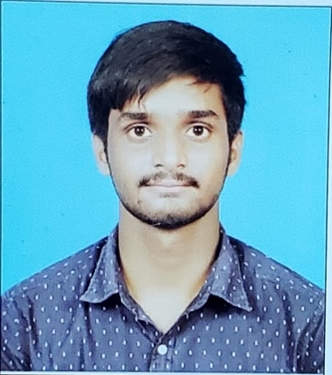
GANIVADA JAWAHAR NAIDU

GRADUATE
jawaharn246@gmail.com
7032736359

Degree/Specialization | College/University | Location | Year | Percentage/CGPA
B.Tech/BE – Spl. | GITAM University | Vizag | 2023 | 8.32
12th Std | Sri Chaitanya Junior College | Vizianagaram | 2019 | 90.06
10th Std | Sri Chaitanya School | Vizianagaram | 2017 | 90.25

- Software Engineering
- Python, C languages
- SQL
- Relation database
My Work DNA
- 1stop.ai| Data Anaylst | Function where you interned
  - Worked and learned about Mean Stack. Developed a Major Project on Movie Ticket Booking which Facilitates the users to enquire about the recent movies available.

My Tech Lab
- C Language
- Python (Coursera)
- SQL/Database Management Essentials (Coursera)
- Web Development/Introduction to Web Development (Coursera)

My Personal Projects
- Hotel Churn Rate Prediction
- Performed Exploratory Data Analysis
- Predicted whether the hotel room is Canceled or not using the Naive Bayesian Classifier
- Deep Learning for Real Estate Price Prediction
- Predict real estate prices with deep learning
- Predicted home sale prices in a region using several features such as number of bedrooms, bathrooms, view, and square footage.

My Superpowers
- Time management
- Learning new Skills
- Content Creation
- Problem Solving
I Am Green Blooded because…
This opportunity to work in Deloitte is really exciting so that I will be able to learn in the industry I am passionate about.

