Experiment Report: Rheological Study of Honey and Sugar Syrup Mixtures

## Objective:

The objective of this experiment was to investigate the rheological properties of pure honey and its mixtures with sugar syrup, aiming to understand how the addition of sugar affects the viscosity and shear rate.

## Materials and Methods:

### Sample Preparation:

* *Two sugar syrup samples were created: 20 wt% and 5 wt%.*
* *We made the 20 wt% sugar syrup by adding 10 grams of sugar with 40 ml of water.*
* *The half of the 20 wt% syrup was diluted by adding 75 ml of water to obtain a 5 wt% sugar syrup.*
* *This gives us a 20 ml of 20 wt% sugar syrup and 95 ml of 5 wt% sugar syrup.*
* *The honey was mixed with the 20 wt% and 5 wt% sugar syrups in the ratios of 2:3.*
* *To prepare the final mixtures we added 9 ml of pure honey to 6 ml of the sugar syrups [Both 20 wt% and 5 wt% separately].*

## We conducted rheological measurements using a rheometer (MCR301) with a measuring system (PP40-SN85713) and a measuring geometry of d=1 mm.

## Procedure:

1.)Setted up the rheometer for shear rate analysis.

2.)Loaded a small amount of Honey onto the measuring geometry [Parallel plate], ensuring it covers the entire surface.

3.)Recorded data points for shear stress, viscosity, speed, and shear rate for Honey.

4.)Repeated the measurements for honey mixed with 20% w/w sugar syrup and honey mixed with 5% w/w sugar syrup.

5.)Analyzed and plotted the collected data to observe the rheological properties of each sample at different shear rates.

Here we have taken the parallel plate geometry in the rheometer because the viscosity of honey we know is very high and for a highly viscous food material we prefer parallel plate geometry because it’s area is relatively more than the cone plate geometry due to which parallel plates provide a more uniform stress distribution across the sample compared to cone-plate configurations. This can be important for accurately measuring the rheological properties of highly viscous materials.

## Results:

### Pure Honey:

The viscosity of pure honey decreased with increasing shear rate, demonstrating typical shear-thinning behavior. As the shear rate increased, the viscosity steadily decreased from 9 Pa·s at the lowest shear rate (0.1 1/s) to 6.02 Pa·s at the highest shear rate (1,000 1/s).

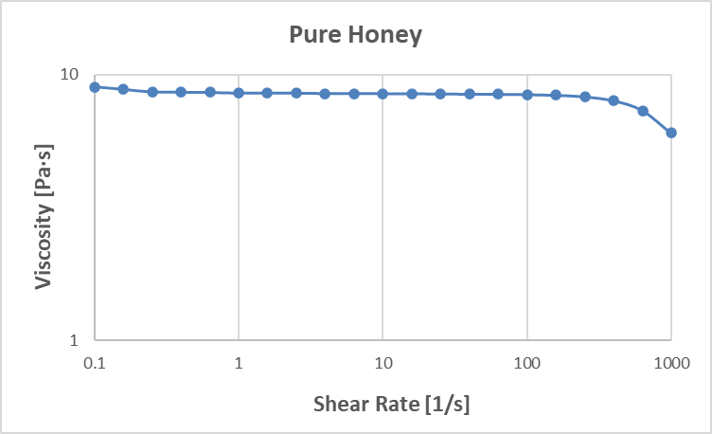

### Honey + 20% w/w Sugar Syrup:

We can expect the viscosity of this sample mixture to decrease when compared to the pure honey for the same shear rates.  
  
1.)The primary reason honey has a high viscosity is because of its high sugar content, mainly fructose and glucose. These sugars create a dense network that contributes to the viscosity by hindering the flow of the liquid. When you add the 20wt% sugar syrup to honey in which the water content is higher, you are essentially diluting this sugar network. The water molecules insert themselves between the sugar molecules, breaking up the interactions that contribute to the viscosity. As a result, the viscosity decreases, and the mixture sample becomes less thick and flows more easily.  
  
2.)We can even expect that at higher shear rates the viscosity will become constant and behave as a newtonian fluid.As the shear rate increases, the applied force disrupts the internal structure of the honey, causing the long-chain polymers to align and flow more easily. This results in a decrease in viscosity. Once the structure is sufficiently disrupted, further increases in shear rate may not have a significant impact on viscosity, and the viscosity levels off or becomes constant.

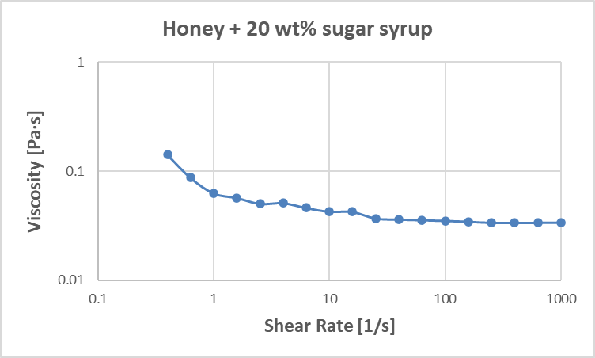

### Honey + 5% w/w Sugar Syrup:

Similarly, the addition of 5% w/w sugar syrup led to changes in rheological properties. The mixture displayed a more fluid-like behavior compared to the 20% mixture because the water content is even more in it and in this case too we can even expect that at higher shear rates the viscosity will become constant and behave as a newtonian fluid due to the same reason explained.

## Microstructure:

Here b is the microstructure of honey.

## Conclusion:

This rheological study provides valuable insights into the viscosity and shear rate behavior of honey and its mixtures with sugar syrup. Based on this experiment we can conclude that trying to increase the sugar content in the honey by adding sugar syrup in the ratio of 3:2 will lead us to more diluted samples which resulted in decreasing the viscosity of the samples. If we would have taken a different sample ratio we could expect different results.

Comparing Observed Data with Data from a research paper about adulterated Honey.  
  
From research paper:-

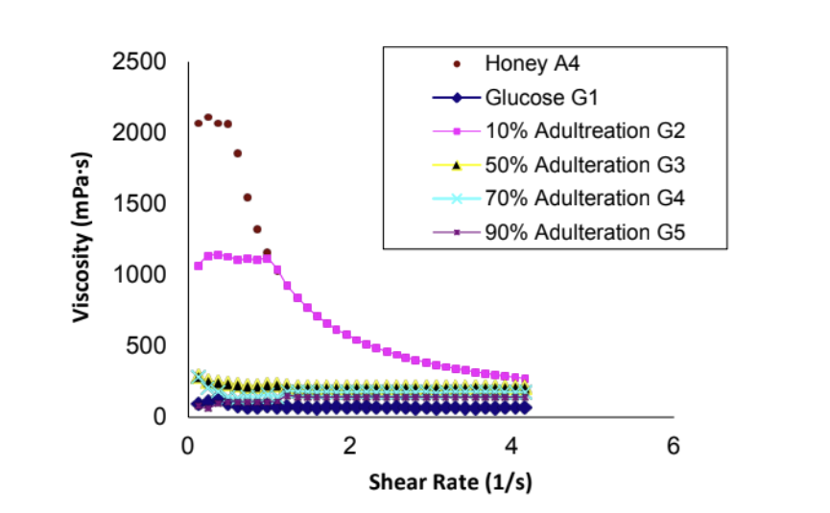

The addition of glucose can disrupt the natural molecular structure and interactions within the honey. Glucose molecules can interfere with the formation of the sugar network responsible for the non-Newtonian behavior. **Glucose, being a simpler sugar, may not contribute to the network in the same way as the more complex sugars present in honey. As a result, the viscosity decreases rapidly.**  
As the level of adulteration increases, the honey may reach a point where the original sugar network is sufficiently disrupted. **At around 70% adulteration, the honey may exhibit Newtonian behavior, indicating a constant viscosity irrespective of shear rate.** This could be because the addition of glucose has diluted the honey to a degree where the original non-Newtonian characteristics are no longer prominent.

## Graph from observed data:

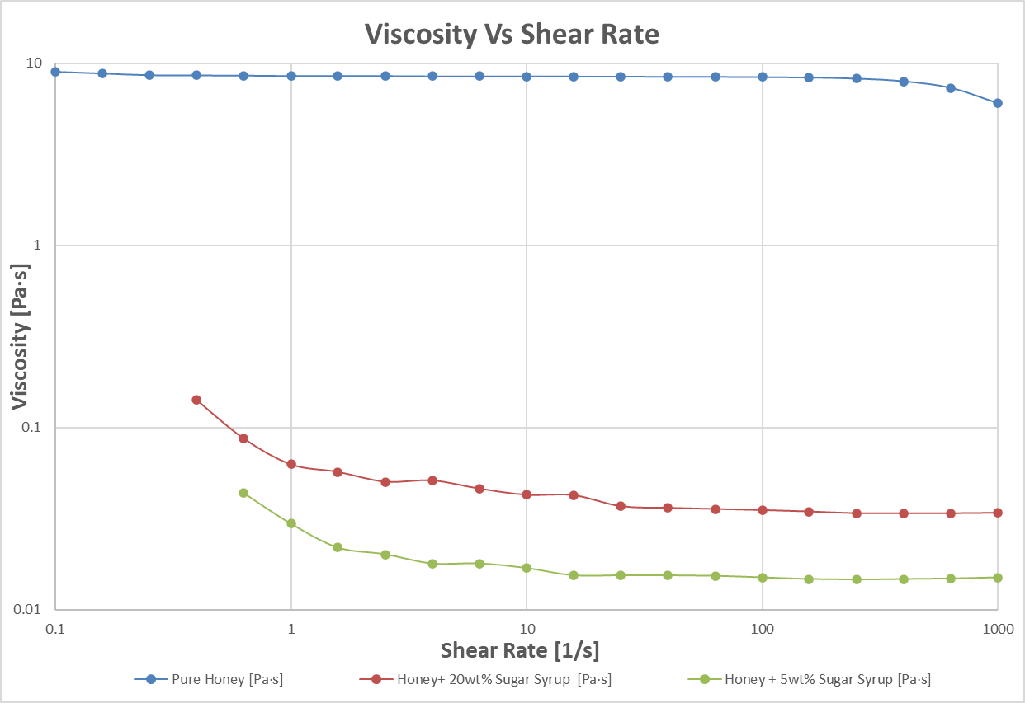

Which is similar to the graph from the research paper.

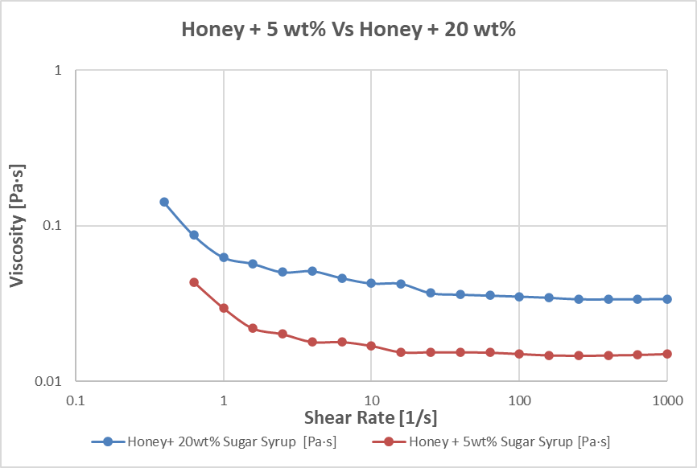

## Recommendations:

## Further investigations could explore the impact of different sugar concentrations on the rheological properties of honey-sugar mixtures. Additionally, exploring the temperature dependence of these mixtures would provide a comprehensive understanding of their behavior under various conditions. References:

#### *Rheological Modeling of the Effects of Adulteration on Nigerian Honey, Open Journal of Fluid Dynamics* *link*

A Novel Technique to Characterize and Quantify Crystalline and Amorphous Matter in Complex Sugar Mixtures [link](https://doi.org/10.1007/s12161-020-01789-1)

## Data from Rheometer:

| *Data Series Information* |  |  |  |  |  |  |
| --- | --- | --- | --- | --- | --- | --- |
| *Name:* |  |  | *Honey_FC_1 1* |  |  |  |
| *Number of Intervals:* |  |  | *1* |  |  |  |
| *Application:* |  |  | *RHEOPLUS/32 Service V3.62 21000071-33086* |  |  |  |
| *Device:* |  |  | *MCR301 SN000000; ID81076673; FW3.41D110330; Adj4223d* |  |  |  |
| *Measuring Date/Time:* |  |  | *11/17/2023; 3:56 PM* |  |  |  |
| *Measuring System:* |  |  | *PP40-SN85713; [d=1 mm]* |  |  |  |
| *Accessories:* |  |  | *TU1=P-PTD200-SN81077229* |  |  |  |
|  |  |  |  |  |  |  |
| *Calculating Constants:* |  |  |  |  |  |  |
| *- Norm. Csr [min/s]:* |  |  | *2.0921541* |  |  |  |
| *- Norm. Css [Pa/mNm]:* |  |  | *79.833463* |  |  |  |
| *- Start Delay Time [s]:* |  |  | *13.559* |  |  |  |
| *- Substance Density [rho]:* |  |  | *1,000* |  |  |  |
| *- Measurement Type:* |  |  | *1* |  |  |  |
| *- Motor Correction Factor:* |  |  | *1* |  |  |  |
| *- Axial Compliance [m/N]:* |  |  | *5.90E-07* |  |  |  |
|  |  |  |  |  |  |  |
| *Interval:* |  |  | *1* |  |  |  |
| *Number of Data Points:* |  |  | *21* |  |  |  |
|  |  |  |  |  |  |  |
| *Time Setting:* |  |  | *21 Meas. Pts.* |  |  |  |
| *Measuring Profile:* |  |  |  |  |  |  |
| *Shear Rate* |  |  | *d(gamma)/dt = 0.1 ... 1,000 1/s log; |Slope| = 5 Pt. / dec* |  |  |  |
|  |  |  |  |  |  |  |
| *Meas. Pts.* | *Shear Rate* | *Shear Stress* | *Viscosity* | *Speed* | *Torque* | *Status* |
|  | *[1/s]* | *[Pa]* | *[Pa·s]* | *[1/min]* | *[µNm]* | *[]* |
| *1* | *0.1* | *0.9* | *9* | *0.0478* | *11.3* | *Sdy,Dy_* |
| *2* | *0.158* | *1.4* | *8.81* | *0.0757* | *17.5* | *Sdy,Dy_* |
| *3* | *0.251* | *2.16* | *8.61* | *0.12* | *27.1* | *Sdy,Dy_* |
| *4* | *0.398* | *3.42* | *8.59* | *0.19* | *42.8* | *Sdy,Dy_* |
| *5* | *0.631* | *5.41* | *8.57* | *0.302* | *67.7* | *Sdy,Dy_* |
| *6* | *1* | *8.52* | *8.52* | *0.478* | *107* | *Sdy,Dy_* |
| *7* | *1.58* | *13.5* | *8.53* | *0.757* | *169* | *Sdy,Dy_* |
| *8* | *2.51* | *21.4* | *8.52* | *1.2* | *268* | *Sdy,Dy_* |
| *9* | *3.98* | *33.8* | *8.49* | *1.9* | *423* | *Sdy,Dy_* |
| *10* | *6.31* | *53.6* | *8.49* | *3.02* | *671* | *Sdy,Dy_* |
| *11* | *10* | *84.8* | *8.48* | *4.78* | *1,060* | *Sdy,Dy_* |
| *12* | *15.8* | *134* | *8.47* | *7.57* | *1,680* | *Sdy,Dy_* |
| *13* | *25.1* | *212* | *8.46* | *12* | *2,660* | *Sdy,Dy_* |
| *14* | *39.8* | *336* | *8.44* | *19* | *4,210* | *Sdy,Dy_* |
| *15* | *63.1* | *532* | *8.43* | *30.2* | *6,660* | *Sdy,Dy_* |
| *16* | *100* | *841* | *8.41* | *47.8* | *10,500* | *Sdy,Dy_* |
| *17* | *158* | *1,320* | *8.36* | *75.7* | *16,600* | *Sdy,Dy_* |
| *18* | *251* | *2,070* | *8.25* | *120* | *26,000* | *Sdy,Dy_* |
| *19* | *398* | *3,170* | *7.97* | *190* | *39,700* | *Sdy,Dy_* |
| *20* | *631* | *4,630* | *7.33* | *302* | *57,900* | *Sdy,Dy_* |
| *21* | *1,000* | *6,020* | *6.02* | *478* | *75,400* | *Sdy,Dy_* |

| *Data Series Information* |  |  |  |  |  |  |
| --- | --- | --- | --- | --- | --- | --- |
| *Name:* |  |  | *Honey+20wt%sugar_FC 1* |  |  |  |
| *Number of Intervals:* |  |  | *1* |  |  |  |
| *Application:* |  |  | *RHEOPLUS/32 Service V3.62 21000071-33086* |  |  |  |
| *Device:* |  |  | *MCR301 SN000000; ID81076673; FW3.41D110330; Adj4223d* |  |  |  |
| *Measuring Date/Time:* |  |  | *11/17/2023; 4:11 PM* |  |  |  |
| *Measuring System:* |  |  | *PP40-SN85713; [d=1 mm]* |  |  |  |
| *Accessories:* |  |  | *TU1=P-PTD200-SN81077229* |  |  |  |
|  |  |  |  |  |  |  |
| *Calculating Constants:* |  |  |  |  |  |  |
| *- Norm. Csr [min/s]:* |  |  | *2.0921541* |  |  |  |
| *- Norm. Css [Pa/mNm]:* |  |  | *79.833463* |  |  |  |
| *- Start Delay Time [s]:* |  |  | *6.933* |  |  |  |
| *- Substance Density [rho]:* |  |  | *1,000* |  |  |  |
| *- Measurement Type:* |  |  | *1* |  |  |  |
| *- Motor Correction Factor:* |  |  | *1* |  |  |  |
| *- Axial Compliance [m/N]:* |  |  | *5.90E-07* |  |  |  |
|  |  |  |  |  |  |  |
| *Interval:* |  |  | *1* |  |  |  |
| *Number of Data Points:* |  |  | *21* |  |  |  |
|  |  |  |  |  |  |  |
| *Time Setting:* |  |  | *21 Meas. Pts.* |  |  |  |
| *Measuring Profile:* |  |  |  |  |  |  |
| *Shear Rate* |  |  | *d(gamma)/dt = 0.1 ... 1,000 1/s log; |Slope| = 5 Pt. / dec* |  |  |  |
|  |  |  |  |  |  |  |
| *Meas. Pts.* | *Shear Rate* | *Shear Stress* | *Viscosity* | *Speed* | *Torque* | *Status* |
|  | *[1/s]* | *[Pa]* | *[Pa·s]* | *[1/min]* | *[µNm]* | *[]* |
| *4* | *0.398* | *0.0566* | *0.142* | *0.19* | *0.709* | *Sdy,Dy_* |
| *5* | *0.631* | *0.0549* | *0.087* | *0.302* | *0.687* | *Sdy,Dy_* |
| *6* | *1* | *0.0626* | *0.0627* | *0.478* | *0.785* | *Sdy,Dy_* |
| *7* | *1.58* | *0.0903* | *0.057* | *0.757* | *1.13* | *Sdy,Dy_* |
| *8* | *2.51* | *0.126* | *0.0503* | *1.2* | *1.58* | *WMa,Dy_* |
| *9* | *3.98* | *0.203* | *0.0511* | *1.9* | *2.55* | *Sdy,Dy_* |
| *10* | *6.31* | *0.291* | *0.0461* | *3.02* | *3.64* | *Sdy,Dy_* |
| *11* | *10* | *0.426* | *0.0426* | *4.78* | *5.33* | *Sdy,Dy_* |
| *12* | *15.8* | *0.673* | *0.0424* | *7.57* | *8.42* | *Sdy,Dy_* |
| *13* | *25.1* | *0.926* | *0.0369* | *12* | *11.6* | *Sdy,Dy_* |
| *14* | *39.8* | *1.44* | *0.0361* | *19* | *18* | *Sdy,Dy_* |
| *15* | *63.1* | *2.24* | *0.0356* | *30.2* | *28.1* | *Sdy,Dy_* |
| *16* | *100* | *3.51* | *0.0351* | *47.8* | *44* | *Sdy,Dy_* |
| *17* | *158* | *5.46* | *0.0345* | *75.7* | *68.4* | *Sdy,Dy_* |
| *18* | *251* | *8.48* | *0.0337* | *120* | *106* | *Sdy,Dy_* |
| *19* | *398* | *13.4* | *0.0337* | *190* | *168* | *Sdy,Dy_* |
| *20* | *631* | *21.3* | *0.0337* | *302* | *267* | *Sdy,Dy_* |
| *21* | *1,000* | *33.9* | *0.0339* | *478* | *425* | *Sdy,Dy_* |

| Data Series Information |  |  |  |  |  |  |
| --- | --- | --- | --- | --- | --- | --- |
| Name: |  |  | Honey+5wt%sugar_FC 1 |  |  |  |
| Number of Intervals: |  |  | 1 |  |  |  |
| Application: |  |  | RHEOPLUS/32 Service V3.62 21000071-33086 |  |  |  |
| Device: |  |  | MCR301 SN000000; ID81076673; FW3.41D110330; Adj4223d |  |  |  |
| Measuring Date/Time: |  |  | 11/17/2023; 4:35 PM |  |  |  |
| Measuring System: |  |  | PP40-SN85713; [d=1 mm] |  |  |  |
| Accessories: |  |  | TU1=P-PTD200-SN81077229 |  |  |  |
|  |  |  |  |  |  |  |
| Calculating Constants: |  |  |  |  |  |  |
| - Norm. Csr [min/s]: |  |  | 2.0921541 |  |  |  |
| - Norm. Css [Pa/mNm]: |  |  | 79.833463 |  |  |  |
| - Start Delay Time [s]: |  |  | 5.336 |  |  |  |
| - Substance Density [rho]: |  |  | 1,000 |  |  |  |
| - Measurement Type: |  |  | 1 |  |  |  |
| - Motor Correction Factor: |  |  | 1 |  |  |  |
| - Axial Compliance [m/N]: |  |  | 5.90E-07 |  |  |  |
|  |  |  |  |  |  |  |
| Interval: |  |  | 1 |  |  |  |
| Number of Data Points: |  |  | 21 |  |  |  |
|  |  |  |  |  |  |  |
| Time Setting: |  |  | 21 Meas. Pts. |  |  |  |
| Measuring Profile: |  |  |  |  |  |  |
| Shear Rate |  |  | d(gamma)/dt = 0.1 ... 1,000 1/s log; |Slope| = 5 Pt. / dec |  |  |  |
|  |  |  |  |  |  |  |
| Meas. Pts. | Shear Rate | Shear Stress | Viscosity | Speed | Torque | Status |
|  | [1/s] | [Pa] | [Pa·s] | [1/min] | [µNm] | [] |
| 5 | 0.631 | 0.0274 | 0.0435 | 0.302 | 0.344 | Sdy,Dy_ |
| 6 | 1 | -0.00631 | 0.0296 | 0.478 | -0.079 | WMa,Dy_ |
| 7 | 1.58 | 0.0106 | 0.0219 | 0.757 | 0.133 | WMa,Dy_ |
| 8 | 2.51 | 0.0399 | 0.0201 | 1.2 | 0.499 | WMa,Dy_ |
| 9 | 3.98 | 0.0822 | 0.0179 | 1.9 | 1.03 | WMa,Dy_ |
| 10 | 6.31 | 0.0887 | 0.0179 | 3.02 | 1.11 | WMa,Dy_ |
| 11 | 10 | 0.169 | 0.0169 | 4.78 | 2.12 | WMa,Dy_ |
| 12 | 15.8 | 0.244 | 0.0154 | 7.57 | 3.06 | WMa,Dy_ |
| 13 | 25.1 | 0.387 | 0.0154 | 12 | 4.84 | Sdy,Dy_ |
| 14 | 39.8 | 0.612 | 0.0154 | 19 | 7.67 | Sdy,Dy_ |
| 15 | 63.1 | 0.962 | 0.0153 | 30.2 | 12.1 | Sdy,Dy_ |
| 16 | 100 | 1.5 | 0.015 | 47.8 | 18.8 | Sdy,Dy_ |
| 17 | 158 | 2.33 | 0.0147 | 75.7 | 29.1 | Sdy,Dy_ |
| 18 | 251 | 3.66 | 0.0146 | 120 | 45.9 | Sdy,Dy_ |
| 19 | 398 | 5.85 | 0.0147 | 190 | 73.3 | Sdy,Dy_ |
| 20 | 631 | 9.32 | 0.0148 | 302 | 117 | Sdy,Dy_ |
| 21 | 1,000 | 15 | 0.015 | 478 | 188 | Sdy,Dy_ |