|  |  |  |
| --- | --- | --- |
| American University of SharjahCollege of Engineering Dept of Computer Science & Engg  P. O. Box 26666  Sharjah, UAE |  | Instructors: Dr. Rana Ahmed **Lab Instructor:** Eng. Sameer Alawnah  **Office:** EB2-101  **Phone**: +971551562794  **e-mail**: salawnah@aus.edu  **Semester**: Summer 2016 |

**CMP 120L– Introduction to Computer Science I Lab**

**Lab 10**

**Exercise 1:**

We need to write a function to compute the area of a rectangle, with the following prototype declaration.

**double area (double length, double width=1.0);**

// function for area of a rectangle; default value of width is 1.0

Test the above functions by writing an appropriate main() program, by calling area() function twice, first with only one argument, and then with two arguments. All printouts should be done in main().

***Sample Session: (Values in Red are entered by the user).***

Enter length for rectangle: 2.0

With default value of width, area of rectangle =2.0;

Enter length for rectangle: 2.0

Enter width for rectangle: 3.0

Area of rectangle = 6.0

#include <iostream>

using namespace std;

double area(double length, double width = 1.0);

void main()

{

double length, width, a;

cout << "Enter length for rectangle: ";

cin >> length;

a = area(length);

cout << "With default value of width, area of rectangle =" << a << endl;

cout << "Enter length for rectangle: ";

cin >> length;

cout << "Enter width for rectangle: ";

cin >> width;

a= area(length, width);

cout << "Area of rectangle =" << a << endl;

}

double area(double length, double width)

{

double a;

a = length*width;

return (a);

}

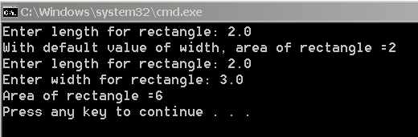

**Exercise 2:**

Write a program that declares an array of five integers, and initializes its elements by the user’s input. The program then prints the sum of all elements in the array.

**Sample Session: *(Values in Red are entered by the user).***

Enter five integers for array:

10

50

30

40

10

Sum : 140

#include <iostream>

using namespace std;

void main()

{

int x[5], n, i;

cout << "Enter five integers for array:" << endl;

n = 0;

for (i = 0; i < 5; i++)

{

cin >> x[i];

n = x[i] + n;

}

cout << "Sum : " << n << endl;

}

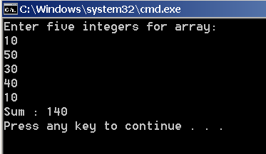

**Exercise 3:**

Write a program that declares an array of five characters, and initializes its elements by the user’s input. The program then prints characters entered by the user in the reverse order.

**Sample Session: *(Values in Red are entered by the user).***

Enter five characters for array:

C

D

X

Z

P

The characters in the reverse order are:

P

Z

X

D

C

#include <iostream>

using namespace std;

void main()

{

char x[5];

int i;

cout << "Enter five integers for array:" << endl;

for (i = 0; i <5; i++)

{

cin >> x[i];

}

cout << "The characters in the reverse order are:" <<endl;

for (i = 4; i >= 0; i--)

{

cout << x[i] << endl;

}

}

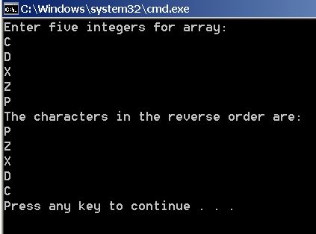

**Exercise 4:**

Write a C++ function **int f1 (int x[ ], int N);** that accepts an integer array **x** of size **N**, and returns the number of odd integers present in the array **x**. For example, if in main(), we have,

int p[5]= {11,3,20,9,11};

then f1(p,5) should return 4.

Test the above function by writing an appropriate main() program. All printouts should be done in main().

#include <iostream>

using namespace std;

int f1(int x[], int N);

void main()

{

int p;

int x[5] = { 11, 3, 20, 9, 11 };

p = f1(x, 5);

cout << "The number of odd integers is: " <<p<< endl;

}

int f1(int x[], int N)

{

int p = 0;

for (int i = 0; i < 5; i++)

{

if (x[i] % 2 != 0)

{

p++;

}

}

return (p);

}

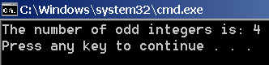

**Exercise 5:**

Write a function that takes the following prototype:

**bool f2(int a[], int N, int target);**

The function tests whether the *target* appears in the integer array **a** (of size **N**) *at least* one time. If yes, the function returns true; otherwise, it returns false.

Test the function with a main program that defines an array of five integers and initializes them within the main program, calling the function f2() and displaying appropriate message based on the return value of f2().

***Sample Session:***

/*

In main(); declare and initialize the following array:

int x[5]= {10,20,10,40,50};

Make two calls to the function f2() in main to check whether 10 and 11 appear in the array **x**, and print the appropriate messages in the main.

*/

#include <iostream>

using namespace std;

bool f2(int a[], int N, int target);

void main()

{

char p;

int x[5] = { 10, 20, 10, 40, 50 };

p= f2(x, 5, 10);

if (p == true)

{

cout << "Integer exists" << endl;

}

else

{

cout << "Integer doesn't exist" << endl;

}

p = f2(x, 5, 11);

if (p == true)

{

cout << "Integer exists" << endl;

}

else

{

cout << "Integer doesn't exist" << endl;

}

}

bool f2(int a[], int N, int target)

{

for (int i = 0; i < 5; i++)

{

if (a[i] == target)

{

return (true);

}

}

return (false);

}

