|  |  |  |
| --- | --- | --- |
| American University of SharjahCollege of Engineering Dept of Computer Science & Engg  P. O. Box 26666  Sharjah, UAE |  | Instructors: Dr. Rana Ahmed **Lab Instructor:** Eng. Sameer Alawnah  **Office:** EB2-101  **Phone**: +97165152974  **e-mail**: salawnah@aus.edu  **Semester**: Summer 2016 |

**CMP 120L– Introduction to Computer Science I Lab**

**Lab 15**

**Exercise 1:**

Write a C++ program that performs the following tasks in this sequence:

1. Open the file **input.txt** for reading. This file is provided as a separate attachment and it contains unknown numbers of integers. Check for the successful access for this file.
2. Read the integers from the file and count the number of even integers present in the file. Print this count.
3. Close the file input.txt.
4. Re-open the file **input.txt** for reading again. Count and print the number of odd integers present in the file.
5. Close the file.

#include <iostream>

#include <fstream>

using namespace std;

void main()

{

ifstream in("input.txt");

if (in.fail())

{

cout << "File open failed" << endl;

exit(1);

}

int x, y = 0;

in >> x;

while (!in.eof())

{

if (x % 2 == 0)

{

y++;

}

in >> x;

}

cout << "The number of even integers is: " << y << endl;

in.close();

in.open("input.txt");

if (in.fail())

{

cout << "File open failed" << endl;

exit(1);

}

y = 0;

in >> x;

while (!in.eof())

{

if (x % 2 != 0)

{

y++;

}

in >> x;

}

cout << "The number of odd integers is: " << y << endl;

in.close();

}

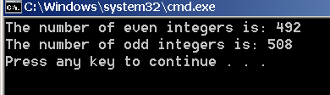

**Exercise 2:**

Create two text files **f1.txt** and **f2.txt** and populate them with some 5 integers each.

Write a C++ program that produces an output file named, **fout.txt**, such that it contains the contents of **f1.txt** followed by that of **f2.txt**. In other word, file **fout.txt** should join **f1.txt** and **f2.txt** (in this order).

#include <iostream>

#include <fstream>

using namespace std;

void main()

{

ifstream in;

ofstream out("fout.txt");

in.open("f1.txt");

int x;

in >> x;

while (!in.eof())

{

out << x << endl;

in >> x;

}

in.close();

in.open("f2.txt");

while (!in.eof())

{

out << x << endl;

in >> x;

}

in.close();

out.close();

}

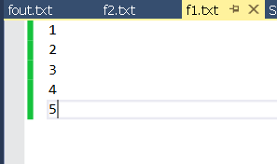

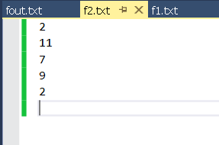

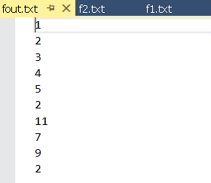

**Exercise 3:**

Write a C++ function **int f1 (int x[], int N, int K);** that accepts an integer array **x** of size **N**, and returns the number of odd integers smaller than **K** present in the array **x**. For example, if in main(), we have int x[4]= {11,2,3,9}; then the call f1(x, 4, 10) returns 2.

Write an appropriate main() for the above-mentioned example to test the working of f1().

#include <iostream>

int f1(int x[], int N, int K);

using namespace std;

void main()

{

int m;

int x[4] = { 11, 2, 3, 9 };

m =f1(x, 4, 10);

cout << "The number of odd integers that are less than 10 = " << m << endl;

}

int f1(int x[], int N, int K)

{

int i,m=0;

for (i = 0; i < N; i++)

{

if (x[i] % 2 != 0 && x[i]<K)

{

m++;

}

}

return (m);

}

