|  |  |  |
| --- | --- | --- |
| American University of SharjahCollege of Engineering Dept of Computer Science & Engg  P. O. Box 26666  Sharjah, UAE |  | Instructors: Dr. Rana Ahmed **Lab Instructor:** Eng. Sameer Alawnah  **Office: EB2-101**  **Phone**: +97165152794  **e-mail**: salawnah@aus.edu  **Semester**: Summer 2016 |

**CMP 120L– Introduction to Computer Science I Lab**

**Lab 7**

**Exercise 1:**

Write a complete C++ program that asks the user to enter 6 integers, one by one. The program counts the positive integers (excluding zeros), negative integers, and zeros entered by the user. The program also sums all positive integers entered by the user. The program then prints the three counts and the sum on the screen.

***Sample Session 1: (Values in Red are entered by the user).***

Enter next integer: -1

Enter next integer: 0

Enter next integer: 2

Enter next integer: 10

Enter next integer: 8

Enter next integer: -12

Number of positive numbers (excluding 0s) entered: 3

Number of negative numbers entered: 2

Number of zeros entered: 1

Sum of all positive numbers: 20

#include <iostream>

using namespace std;

void main()

{

int a, b, c, d, e, x;

a = 0;

b = 0;

c = 0;

d = 0;

e = 0;

while (a < 6)

{

cout << "Enter next integer: ";

cin >> x;

if (x > 0)

{

b = b + 1;

e = e + x;

}

else if (x < 0)

{

c = c + 1;

}

else

{

d = d + 1;

}

a = a + 1;

}

cout << "Number of positive numbers (excluding 0s) entered: " << b << endl;

cout << "Number of negative numbers entered: " << c << endl;

cout << "Number of zeroes entered: " << d << endl;

cout << "Sum of all positive numbers: " << e << endl;

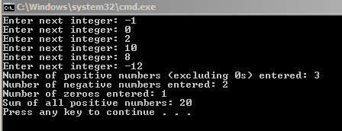

**Exercise 2:**

Write a program that computes and prints the factorials of integers from 2 to 8 inclusive. The program should use nested ***for*** loops structure.

***Sample Output:***

**2 ! = 2**

**3 ! = 6**

**4 ! = 24**

**5 ! = 120**

**6 ! = 720**

**7 ! = 5040**

**8 ! = 40320**

#include <iostream>

using namespace std;

void main()

{

int x, y;

x = 2;

for (y=1; x <= 8; x++)

{

for (y = 1; x <= 8; x++)

{

y = x*y;

cout << x <<" ! = "<<y<< endl;

}

}

}

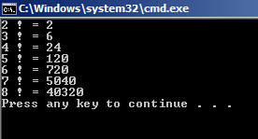

**Exercise 3:**

Write a C++ program that keeps on asking the user to enter positive integers, one by one. However, when the user enters a negative integer, the program stops asking for the number afterwards. It then prints the sum of all positive numbers entered by the user so far. Use any looping structure, and break statement.

***Sample Session: (Values in Red are entered by the user).***

*Enter next integer: 9*

*Enter next integer: 4*

*Enter next integer: 3*

*Enter next integer: 2*

*Enter next integer: -5*

*Sum of positive integers= 18*

#include <iostream>

using namespace std;

void main()

{

int x, y;

y = 0;

while (1)

{

cout << "Enter next integer: ";

cin >> x;

if (x >= 0)

{

y = y + x;

}

else break;

}

cout << "Sum of positive integers= " << y << endl;

}

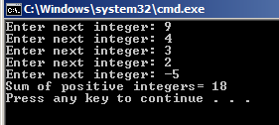

**Exercise 4:**

Write a complete C++ program that generates a table showing the angle θ (in radians), from 0 to 2π in the step of π/8, and the corresponding values for sin(θ).

**Sample Output:**

theta sin(theta)

0 0

0.392699 0.382683

0.785398 0.707107

1.1781 0.92388

1.5708 1

1.9635 0.92388

2.35619 0.707107

2.74889 0.382683

3.14159 1.22465e-016

3.53429 -0.382683

3.92699 -0.707107

4.31969 -0.92388

4.71239 -1

5.10509 -0.92388

5.49779 -0.707107

5.89049 -0.382683

#define _USE_MATH_DEFINES

#include <iostream>

#include <cmath>

using namespace std;

void main()

{

long double x, y;

x = 0;

cout << "theta" << " " << "sin(theta)" << endl;

while (x <= (2*(M_PI)))

{

y = sin(x);

cout << x << " " << y << endl;

x = x + ((M_PI) / 8);

}

}

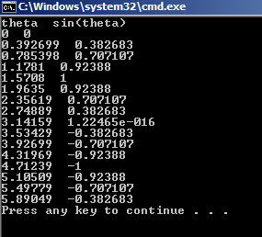

**Exercise 5:**

Write a complete C++ program that generates a table showing the a double number x, from 0 to 5 (both limits included) in the step of 0.5, and the corresponding values for **e-3x**.

**Sample Output:**

x exp(-3x)

0 1

0.5 0.22313

1 0.0497871

1.5 0.011109

2 0.00247875

2.5 0.000553084

3 0.00012341

3.5 2.75364e-005

4 6.14421e-006

4.5 1.37096e-006

5 3.05902e-007

#include <iostream>

#include <cmath>

using namespace std;

void main()

{

long double x, y;

x = 0;

cout << "x" << " " << "exp(-3x)" << endl;

while (x <= 5)

{

y = exp(-3*x);

cout << x << " " << y << endl;

x = x + 0.5;

}

}

