|  |  |  |
| --- | --- | --- |
| #includeAmerican University of SharjahCollege of Engineering Dept of Computer Science & Engg  P. O. Box 26666  Sharjah, UAE |  | Instructors: Dr. Rana Ahmed **Lab Instructor:** Eng. Sameer Alawnah  **Office: EB2-101**  **Phone**: 971-65152974  **e-mail**: salawnah@aus.edu  **Semester**: Summer 2016 |

**CMP 120L– Introduction to Computer Science I Lab**

**Lab 8**

**Exercise 1:**

Write the function **double average(double x, double y);** that returns the average of two double numbers **x** and **y**. Write a main program to test the working of your function. The main() program asks the user to input two double numbers, and then it calls the function **average**. The printing of final result should be done in main().

***Sample Session 1: (Values in Red are entered by the user).***

Enter two double numbers:

4.0

7.0

Average is: 5.5

#include <iostream>

using namespace std;

double average(double x, double y);

void main()

{

double x, y, i;

cout << "Enter two double numbers: " << endl;

cin >> x;

cin >> y;

i = average(x, y);

cout << "Average is: " << i << endl;

}

double average(double x, double y)

{

double i;

i = ((x + y) / 2);

return (i);

}

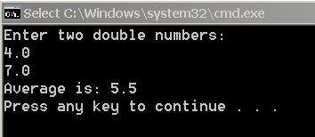

**Exercise 2:**

Write the function **int max2(int x, int y);** that returns the largest value of **x** and **y**.

Write a main program to test the working of your function. The main() program asks the user to input two integers, and then it calls the function **max2**. The printing of final result should be done in main().

***Sample Session 1: (Values in Red are entered by the user).***

Enter two integers:

4

7

Largest is: 7

#include <iostream>

using namespace std;

int max2(int x, int y);

void main()

{

int x, y, m;

cout << "Enter two integers: " << endl;

cin >> x;

cin >> y;

m = max2(x, y);

cout << "Largest is: " << m << endl;

}

int max2(int x, int y)

{

if (y > x)

{

return (y);

}

else

{

return (x);

}

}

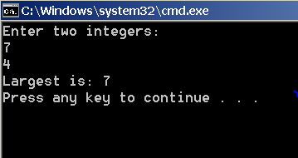

**Exercise 3:**

Write the function **void message(double x);** that works as follows. If the double number **x** passed to the function is positive (including 0), the function computes and prints the square root of **x** and returns to main(). However, if the number **x** passed to the function is negative, it prints an error message, and the program terminates.

Write a main program to test the working of your function. The main() program asks the user to input an integer, and then it calls the function **message**.

Hint: Use the library function **exit**.

***Sample Session 1: (Values in Red are entered by the user).***

Enter a double number: 4.0

Result is: 2.0

***Sample Session 2: (Values in Red are entered by the user).***

Enter an integer: -4.0

Error: You have entered a negative number. Program terminating..

#include <iostream>

#include <cmath>

#include <CertExit.h>

using namespace std;

void message(double x);

void main()

{

double x, y;

cout << "Enter a double number: ";

cin >> x;

message(x);

}

void message(double x)

{

double y;

if (x >= 0)

{

y = sqrt(x);

cout << "Result is: " << y << endl;

}

else

{

cout << "Error: You have entered a negative number. Program terminating" << endl;

exit(1);

}

}

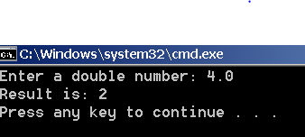

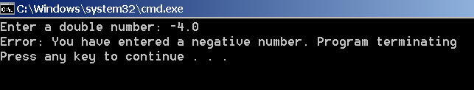

**Exercise 4:**

Write and test C++ function with the following prototype/ declaration:

**bool is_even (int N);**

The function returns true only if **N** is an even number; otherwise, it returns false. Write the main program to test the function . The main program read the value for the number from the user, calls **is_even()** function, and prints an appropriate message based on the return value from the **is_even()** function. All printouts should be done in the main().

**Sample Session (1): *(Values in Red are entered by the user).***

Enter the value for Number: 4

Number is even.

**Sample Session (2):**

Enter the value for Number: 7

Number is odd.

#include <iostream>

using namespace std;

bool is_even(int N);

void main()

{

int N;

cout << "Enter the value for Number: ";

cin >> N;

is_even(N);

if (is_even(N) ==true)

{

cout << "Number is even" << endl;

}

else

{

cout << "Number is odd" << endl;

}

}

bool is_even(int N)

{

if (N%2==0)

{

return(true);

}

else

{

return (false);

}

}

