|  |  |  |
| --- | --- | --- |
| American University of SharjahCollege of Engineering Dept of Computer Science & Engg  P. O. Box 26666  Sharjah, UAE |  | Instructors: Dr. Rana Ahmed **Lab Instructor:** Eng. Sameer Alawnah  **Office: EB2-101**  **Phone**: 971-6-5152974  **e-mail**: salawnah@aus.edu  **Semester**: Summer 2016 |

**CMP 120L– Introduction to Computer Science I Lab**

**Lab 9**

**Exercise 1:**

Write and test C++ function with the following prototype/ declaration:

**double minmax2 (double var1, double var2, char choice);**

If the choice character is ‘G’ or ‘g’, the function returns largest of var1 and var2. If the choice char is ‘S’ or ‘s’, then the function returns the smallest of var1 and var2. Write the main program to test the function. All printouts should be done in the main().

**Sample Session (1): *(Values in Red are entered by the user).***

Enter the value for var1: 2.5

Enter the value for var1: 10.5

Enter your choice: G

Result is 10.5

**Sample Session (2):**

Enter the value for var1: 2.5

Enter the value for var1: 10.5

Enter your choice: s

Result is 2.5

#include <iostream>

using namespace std;

double minmax2(double , double , char );

void main()

{

double var1, var2;

char choice;

double x;

cout << "Enter the value for var1: ";

cin >> var1;

cout << "Enter the value for var2: ";

cin >> var2;

cout << "Enter your choice: ";

cin >> choice;

x = minmax2( var1, var2, choice);

cout << "Result is " << x << endl;

}

double minmax2(double var1, double var2, char choice)

{

if ((var1 > var2) && (choice == 'G') || (choice == 'g')) return (var1);

else if ((var1 < var2) && ((choice == 'S') || (choice == 's'))) return (var1);

else

{

return (var2);

}

}

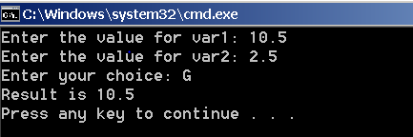

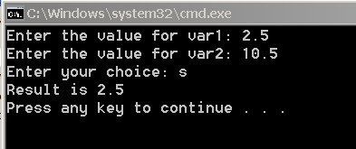

**Exercise 2:**

Write a function that takes the following prototype:

**void f1(int& x);**

The function accepts an integer reference variable x, and updates the variable by the value computed by expression x2 +1. For example, if we have int z = 2; in main(), then after a call f1(z) in the main(), z should be 5. Test the function with a main program. All printouts should be done in the main().

***Sample Session: (Values in Red are entered by the user).***

Enter the value for z: 2

Before calling f1(), z = 2

After calling f1(), z = 5.

#include <iostream>

using namespace std;

void f1(int& x);

void main()

{

int x;

cout << "Enter the value for z: ";

cin >> x;

cout << "Before calling f1(), z = " << x << endl;

f1(x);

cout << "After calling f1(), z = " << x << endl;

}

void f1(int& x)

{

x = (x*x) + 1;

}

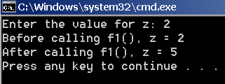

**Exercise 3:**

Write a function that takes the following prototype:

**void swap(int& x, int& y);**

The function accepts two integer reference variable x and y, and interchanges (swaps) their values.

Write a main() function to test the working of f1(). All printouts should be done in the main().

***Sample Session: (Values in Red are entered by the user).***

Enter the value for z: 3

Enter the value for w: 6

Before calling f1(), z = 3 w=6

After calling f1(), z = 6 w=3

#include <iostream>

using namespace std;

void swap(int& x, int& y);

void main()

{

int x, y;

cout << "Enter the value for z: ";

cin >> x;

cout << "Enter the value for w:";

cin >> y;

cout << endl;

cout << "Before calling f1(), z = " << x << " " << "w = " << y << endl;

swap(x, y);

cout << "After calling f1(), z = " << x << " " << "w = " << y << endl;

}

void swap(int&x, int&y)

{

int t = x;

x = y;

y = t;

}

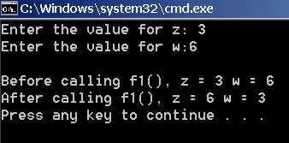

**Exercise 4:**

Write a function that takes the following prototype:

**double f1(int& x, int& y);**

The function accepts two integer reference variable **x** and **y**, increments **x** by 1 and decrements **y** by 1, and returns the square root of the updated value of **x** as a double number.

Write a main() function to test the working of f1(). All printouts should be done in the main().

***Sample Session: (Values in Red are entered by the user).***

Enter the value for z: 3

Enter the value for w: 6

Before calling f1(), z = 3 w=6

After calling f1(), z = 4 w=5

Result= 2.0

#include <iostream>

#include <cmath>

using namespace std;

double f1(int& x, int& y);

void main()

{

int x, y;

double r;

cout << "Enter the value for z: ";

cin >> x;

cout << "Enter the value for w:";

cin >> y;

cout << endl;

cout << "Before calling f1(), z = " << x << " " << "w = " << y << endl;

r=f1(x, y);

cout << "After calling f1(), z = " << x << " " << "w = " << y << endl;

cout << "Result= " << r << endl;

}

double f1(int&x, int&y)

{

double r;

x = x++;

y = y--;

r = sqrt(x);

return (r);

}

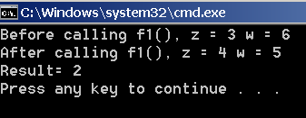

**Exercise 5:**

We need to write two overloaded functions to compute the areas of circle and rectangle, with the following prototype declarations.

**double area (double radius );** // overloaded function for circle

**double area (double length, double width);** // overloaded function for rectangle

Test the above functions by writing an appropriate main() program. All printouts should be done in main().

***Sample Session: (Values in Red are entered by the user).***

Enter value for radius: 2.1

Enter length for rectangle: 2.0

Enter width for rectangle: 3.0

Area of circle = 13.8544

Area of rectangle = 6.0

#include <iostream>

#include <cmath>

using namespace std;

double area (double raduis);

double area(double length, double width);

const double PI = 3.14159;

void main()

{

double raduis, length, width, ar, ac;

cout << "Enter value for raduis: ";

cin >> raduis;

cout << "Enter value for rectangle:";

cin >> length;

cout << "Enter width for rectangle: ";

cin >> width;

ac=area(raduis);

cout << "Area of circle = " << ac << endl;

ar=area(length, width);

cout << "Area of rectangle = " << ar << endl;

}

double area(double raduis)

{

return (PI * pow(raduis, 2));

}

double area(double length, double width)

{

return (length*width);

}

