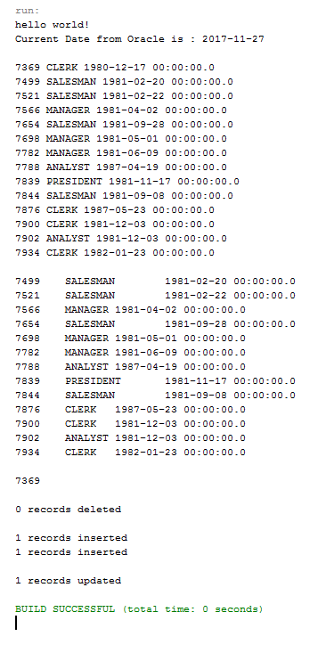

/*

* To change this license header, choose License Headers in Project Properties.

* To change this template file, choose Tools | Templates

* and open the template in the editor.

*/

package oraclejdbc;

import java.sql.Connection;

import java.sql.Date;

import java.sql.DriverManager;

import java.sql.ResultSet;

import java.sql.Statement;

/**

*

* @author waboukhreibe

*/

public class OracleJDBC {

/**

* @param args the command line arguments

*/

public static final String DBURL = "jdbc:oracle:thin:@coeoracle.aus.edu:1521:orcl";

public static final String DBUSER = "g00061542";

public static final String DBPASS = "g00061542";

public static void main(String[] args) {

// TODO code application logic here

// TODO code application logic here

System.out.println("hello world!");

try{

// Load Oracle JDBC Driver

Class.forName("oracle.jdbc.driver.OracleDriver");

// Connect to Oracle Database

Connection con = DriverManager.getConnection(DBURL, DBUSER, DBPASS);

// make the result set scrolable forward/backward updatable

Statement statement = con.createStatement(ResultSet.TYPE_SCROLL_INSENSITIVE,ResultSet.CONCUR_UPDATABLE);

/** result set returns one field */

// Execute a SELECT query on Oracle Dummy DUAL Table. Useful for retrieving system values

// Enables us to retrieve values as if querying from a table

ResultSet rs = statement.executeQuery("SELECT SYSDATE FROM DUAL");

if (rs.next()) {

Date currentDate = rs.getDate(1); // get first column returned

System.out.println("Current Date from Oracle is : " + currentDate);

System.out.println();

}

/** result set returns three fields, multiple rows **/

rs = statement.executeQuery("SELECT empno, job, hiredate FROM emp");

while(rs.next()){

System.out.println(rs.getInt(1) + " " + rs.getString(2) + " " + rs.getString(3));

}

System.out.println();

// go backward to first row

rs.first();

while(rs.next()){

System.out.println(rs.getInt("empno") + "\t" + rs.getString("job") + "\t" + rs.getString("hiredate"));

}

System.out.println();

// go to first row

rs.absolute(1);

System.out.println(rs.getInt(1));

System.out.println();

// delete row(s)

Statement myStmt = con.createStatement();

int result = myStmt.executeUpdate("delete from emp where empno in (33, 44)");

System.out.println(result + " records deleted");

System.out.println();

// insert row(s)

result = myStmt.executeUpdate("insert into emp (empno, ename, sal) values(33,'Sameer',4500)");

System.out.println(result + " records inserted");

result = myStmt.executeUpdate("insert into emp (empno, ename, sal) values(44,'Sami',5000)");

System.out.println(result + " records inserted");

System.out.println();

// update row(s)

result = myStmt.executeUpdate("update emp set ename='Ahmad',sal=7000 where empno=33");

System.out.println(result + " records updated");

System.out.println();

rs.close();

statement.close();

con.close();

} catch (Exception e) {System.out.println(e);

}

}

}