The University of Azad Jammu and Kashmir, Muzaffarabad



Department of Software Engineering
Digital Image Processing Lab

Lab Task 03: Image Enhancement and Intensity Transformations

Name | Jawahir Ali
Roll No | 2024-SE-34
Session / Semester | 2024-28 (SE), Fifth Semester
Lab Instructor | Engr. Fahad Nisar
Assigned / Due | November 02, 2026 / November 09, 2026, 11:59 PM

1. Objective
To calculate, implement and compare grayscale intensity transformations (brightness, contrast, negative, gamma), histogram enhancement (global equalization and CLAHE) and thresholding (fixed, Otsu and adaptive Gaussian), while preventing overflow and interpreting the effect of each operation.

2. Input Image


Properties printed by the notebook:
shape = (800,800), dtype = uint8, min = 0, max = 255.

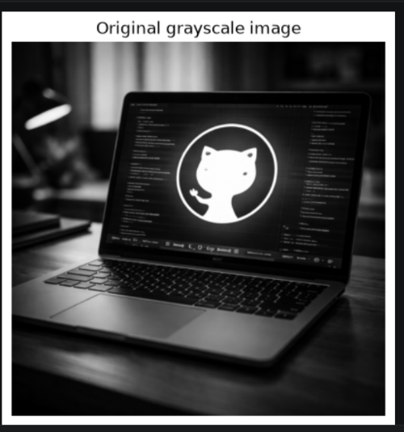
The image was loaded as 8-bit grayscale and kept unchanged (set read-only); every operation creates a new array. Arithmetic is done in int32/float64, the result is clipped to 0–255 and only then converted to uint8, which truncates any fraction. All grayscale figures use vmin = 0 and vmax = 255.

3. Dry Runs, Results and Observations
Each dry run below shows the hand calculation (raw values, clipping, final values). Every one of them was also verified in Python in the notebook.

Dry Run 1: Brightness adjustment
Formula: s = r + β, with β = +40 and β = −40. The sum is computed in a wider type (int), clipped to 0–255, then converted to uint8.
r | r+40 (raw) | Clipped | uint8 | r−40 (raw) | Clipped | uint8
30 | 70 | 70 | 70 | -10 | 0 | 0
80 | 120 | 120 | 120 | 40 | 40 | 40
128 | 168 | 168 | 168 | 88 | 88 | 88
180 | 220 | 220 | 220 | 140 | 140 | 140
240 | 280 | 255 | 255 | 200 | 200 | 200

Lost detail: 240 + 40 = 280 exceeds 255, so it is clipped to 255; 30 − 40 = −10 falls below 0, so it is clipped to 0. After clipping, every input ≥ 215 becomes 255 with β = +40, and every input ≤ 40 becomes 0 with β = −40. Different original values merge into the same output value, and this detail cannot be recovered. Without clipping, uint8 arithmetic would wrap around (280 → 24, −10 → 246), which would turn bright pixels dark and vice versa.
Python verification: np.clip(r.astype(int) + 40, 0, 255).astype(np.uint8) gives [70, 120, 168, 220, 255]; with −40 it gives [0, 40, 88, 140, 200]. Both match the table.
Notebook output:
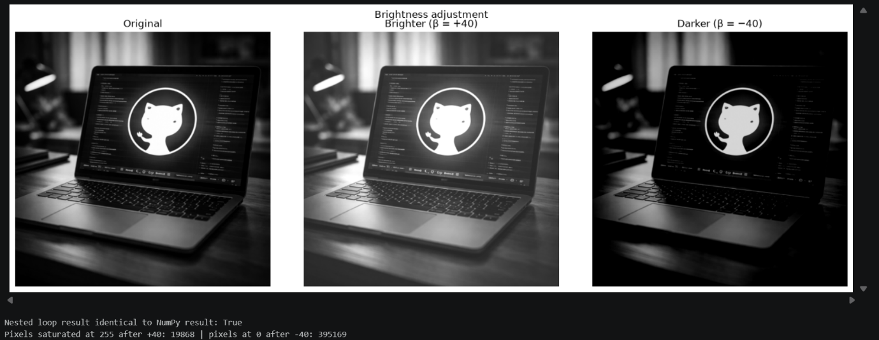
Observation: Adding +40 shifts the whole histogram right and clips values ≥ 215 to 255; −40 shifts it left and clips values ≤ 40 to 0. The nested-loop result matched the NumPy result exactly.

Dry Run 2: Linear contrast from zero (α = 1.5, β = 0)
Formula: s = 1.5·r. Clip to 0–255, then truncate the fractional part.
r | 1.5·r | Clipped | Truncated uint8 | Saturated?
30 | 45 | 45 | 45 | No
80 | 120 | 120 | 120 | No
128 | 192 | 192 | 192 | No
180 | 270 | 255 | 255 | Yes
240 | 360 | 255 | 255 | Yes

Saturated pixels: 180 (→ 270) and 240 (→ 360) both become 255, so highlights are clipped and their difference is lost. Dark pixels (30 → 45, 80 → 120) are only mildly brightened, and the whole image becomes brighter, not just higher in contrast, because the scaling is centered at 0.
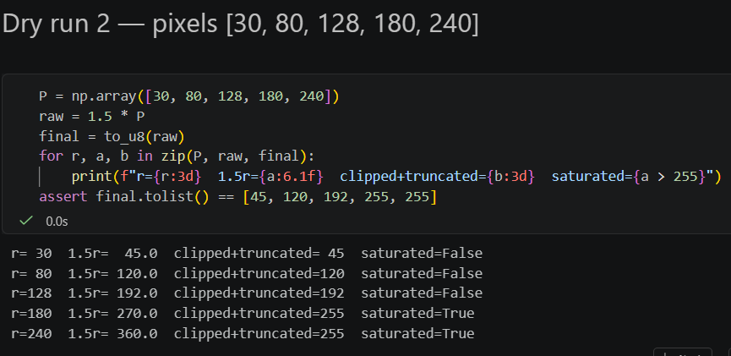
Notebook output:

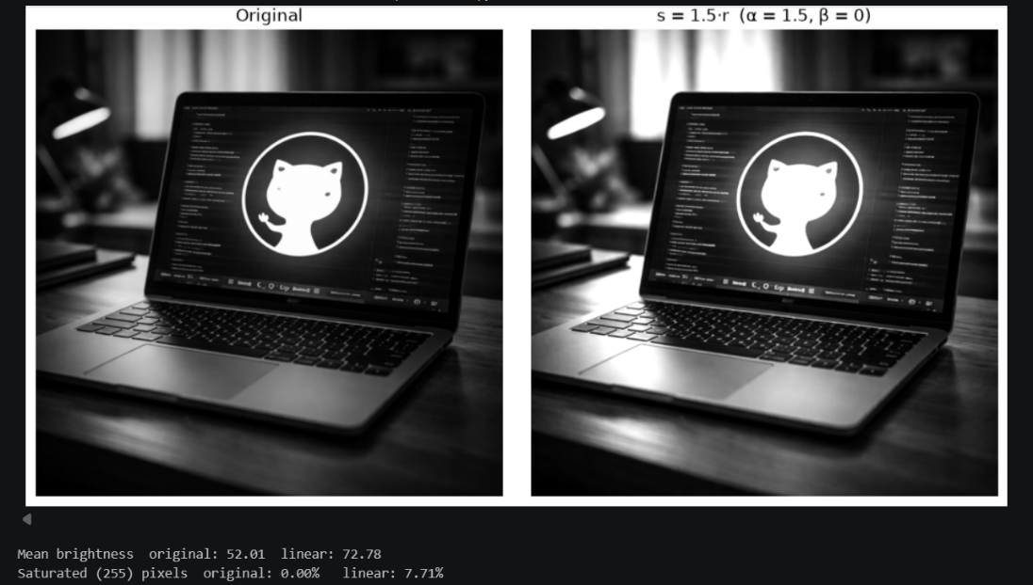
Observation: Multiplying by 1.5 from zero makes the image brighter overall and saturates every pixel with r ≥ 170, so highlight detail is lost.

Dry Run 3: Contrast centered at 128
Formula: s = (r − 128)·α + 128, with α = 1.5 and α = 0.5.
α = 1.5
r | r − 128 | ×1.5 | +128 (raw) | Clipped | Truncated uint8
30 | -98 | -147 | -19 | 0 | 0
80 | -48 | -72 | 56 | 56 | 56
128 | 0 | 0 | 128 | 128 | 128
180 | 52 | 78 | 206 | 206 | 206
240 | 112 | 168 | 296 | 255 | 255

α = 0.5
r | r − 128 | ×0.5 | +128 (raw) | Clipped | Truncated uint8
30 | -98 | -49 | 79 | 79 | 79
80 | -48 | -24 | 104 | 104 | 104
128 | 0 | 0 | 128 | 128 | 128
180 | 52 | 26 | 154 | 154 | 154
240 | 112 | 56 | 184 | 184 | 184

Result at r = 128: (128 − 128)·α + 128 = 128 for every α. The value 128 is the pivot (fixed point) of this transform, so mid-gray never changes. With α = 1.5 values move away from 128 (30 → 0 after clipping and 240 → 255 after clipping), so contrast increases; with α = 0.5 they move toward 128 (30 → 79, 240 → 184), so contrast decreases.
Comparison with Dry Run 2: s = 1.5r also stretches the values but pushes the whole range upward (mean brightness increases and highlights saturate), while the centered version keeps the middle tone fixed and stretches both dark and bright sides symmetrically.
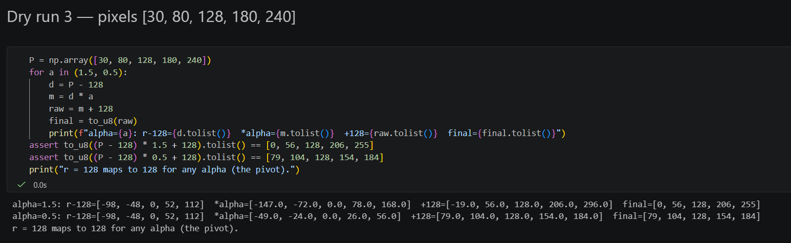
Notebook output:
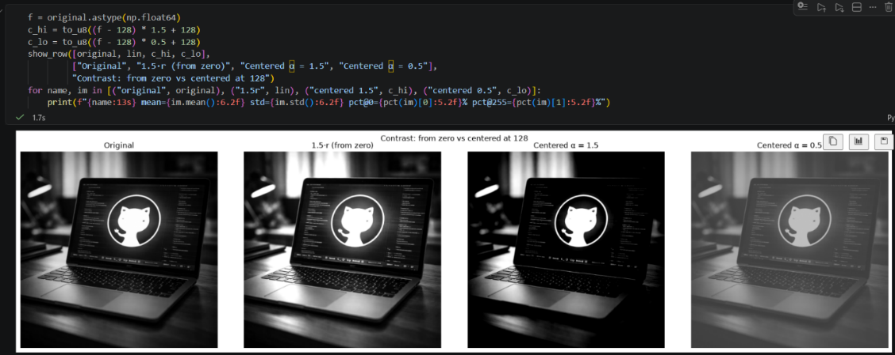

Observation: Centering at 128 keeps mid-gray fixed: α = 1.5 increases contrast on both sides (some clipping), α = 0.5 reduces contrast. Compared with 1.5r it does not raise overall brightness.

Dry Run 4: Image negative
r | s = 255 − r | Negative again: 255 − s | Equals original?
30 | 225 | 30 | Yes
80 | 175 | 80 | Yes
128 | 127 | 128 | Yes
180 | 75 | 180 | Yes
240 | 15 | 240 | Yes

Applying the negative twice returns the original exactly, because 255 − (255 − r) = r. The transform is its own inverse and loses no information.
Notebook output:
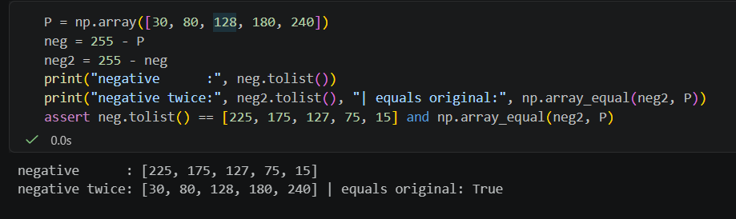

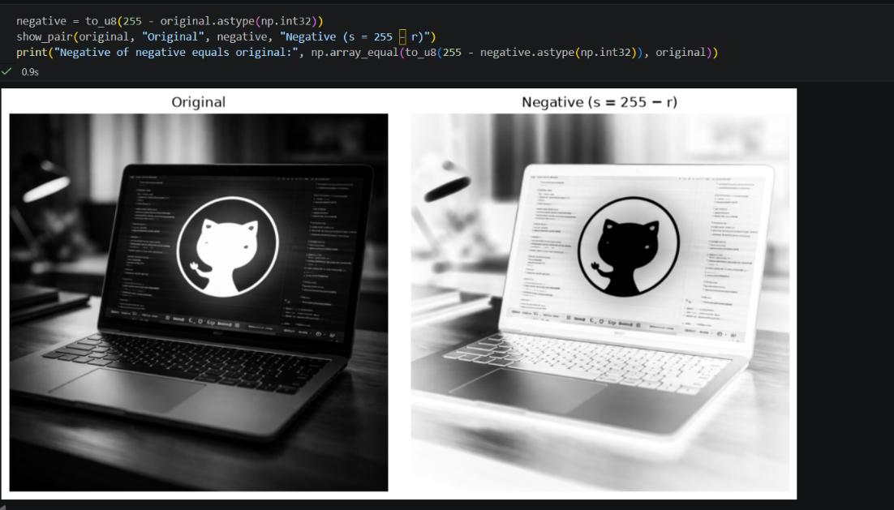

Observation: The negative inverts all intensities and applying it twice restores the original. It helps inspection when faint dark detail on a dark background (e.g. X-ray structures) must be seen.

Dry Run 5: Gamma correction
Formula: s = 255·(r/255)^γ. Full precision is kept in every step; only the final result is truncated.
γ = 0.5
r | Normalized r/255 | Power ^0.5 | ×255 | Truncated uint8
0 | 0 | 0 | 0 | 0
64 | 0.25098 | 0.500979 | 127.7498 | 127
128 | 0.501961 | 0.708492 | 180.6654 | 180
192 | 0.752941 | 0.867722 | 221.2691 | 221
255 | 1 | 1 | 255 | 255

γ = 2.0
r | Normalized r/255 | Power ^2.0 | ×255 | Truncated uint8
0 | 0 | 0 | 0 | 0
64 | 0.25098 | 0.062991 | 16.0627 | 16
128 | 0.501961 | 0.251965 | 64.251 | 64
192 | 0.752941 | 0.56692 | 144.5647 | 144
255 | 1 | 1 | 255 | 255

Observation: with γ = 0.5 the dark and mid values are lifted (64 → 127, 128 → 180), so dark regions become brighter. With γ = 2.0 they are pushed down (64 → 16, 128 → 64), so the image becomes darker. The end points stay fixed in both cases (0 → 0 and 255 → 255) because 0^γ = 0 and 1^γ = 1.
Difference from the rounded slide example: a slide that rounds the normalized value first (e.g. 64/255 ≈ 0.25, √0.25 = 0.5, 0.5 × 255 = 127.5 ≈ 128) can show a value that is 1 higher than the full-precision computation. With full precision, 64/255 = 0.250980…, √ = 0.501975…, × 255 = 127.7498, and truncation gives 127. Early rounding and rounding versus truncation account for the 1-level difference.

Notebook output:
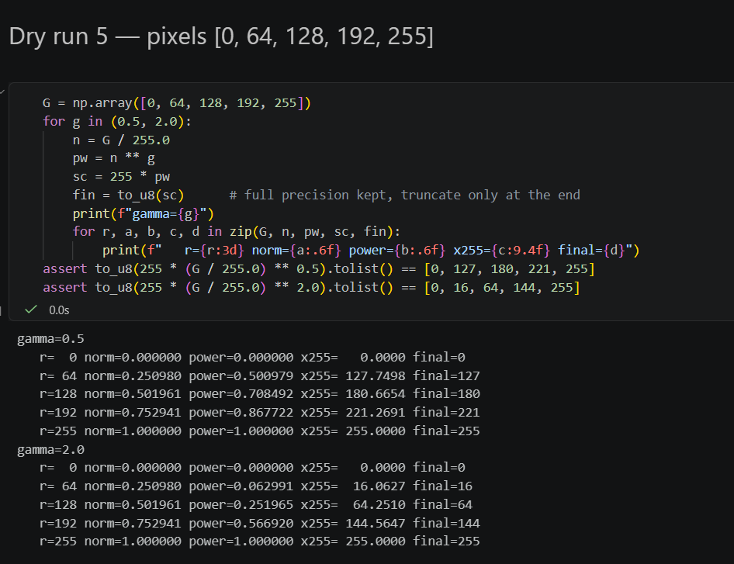

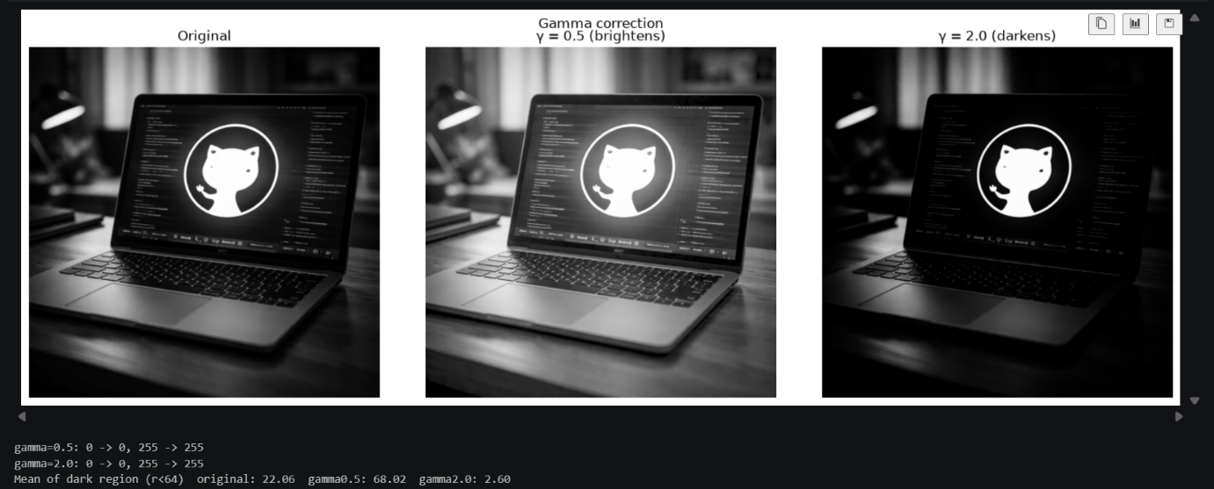
Observation: γ = 0.5 brightens and expands dark regions, γ = 2.0 darkens and compresses them. 0 and 255 remain fixed for every γ.

Dry Run 6: Grayscale histogram
Intensity | Frequency | Probability | Decimal
0 | 1 | 1/8 | 0.125
50 | 2 | 2/8 | 0.25
100 | 2 | 2/8 | 0.25
150 | 1 | 1/8 | 0.125
200 | 1 | 1/8 | 0.125
255 | 1 | 1/8 | 0.125

Total pixel count = 8 (the frequencies sum to 8 and the probabilities sum to 1). All other 250 intensity bins have frequency 0.
A histogram counts how many pixels have each intensity, so it throws away the positions. For example, the arrangement [[255, 200, 150, 100], [100, 50, 50, 0]] has exactly the same histogram as A but is a different image.
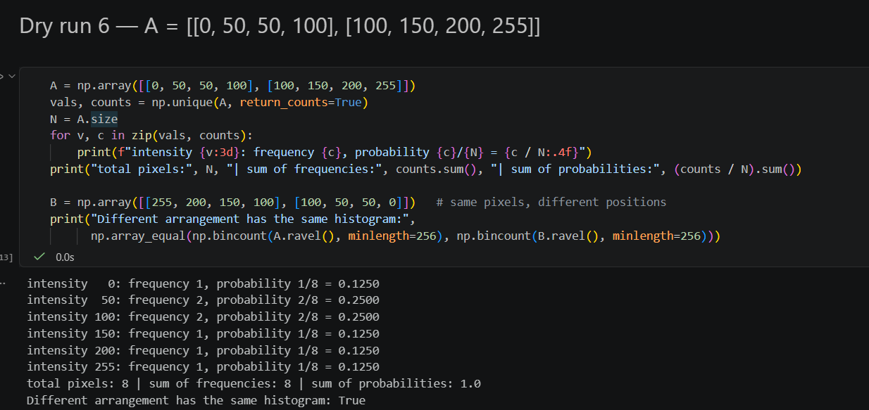
Notebook output
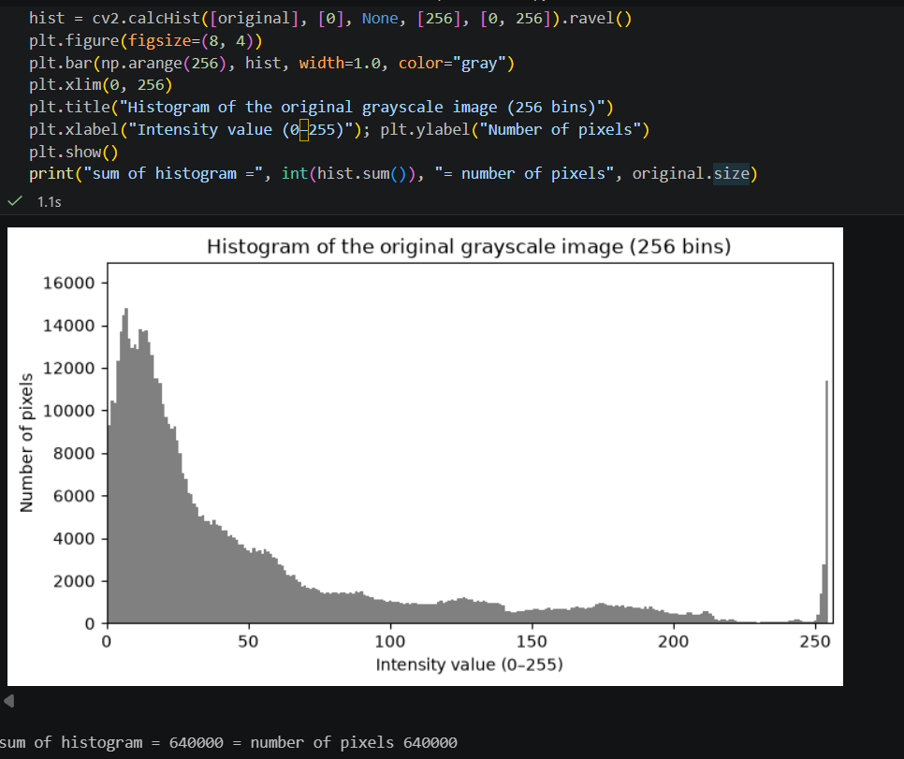
Observation: Describe where the peaks of our histogram are, and whether the image is dark, bright, low-contrast or well spread (two sentences).

Dry Run 7: Global histogram equalization
r | Freq | Cumulative | CDF | 255×CDF | Rounded | 255×(CDF−CDFmin)/(1−CDFmin) | Rounded
50 | 2 | 2 | 2/4 = 0.5 | 127.5 | 128 | 0 | 0
100 | 1 | 3 | 3/4 = 0.75 | 191.25 | 191 | 127.5 | 128
150 | 1 | 4 | 4/4 = 1 | 255 | 255 | 255 | 255

CDFmin = 0.5 (the lowest nonzero CDF, at intensity 50). Rounding is to the nearest integer with .5 rounded upward.
Output list, method 1 (255 × CDF): [128, 128, 191, 255].
Output list, method 2 (255 × (CDF − CDFmin)/(1 − CDFmin)): [0, 0, 128, 255].
OpenCV check: cv2.equalizeHist on [50, 50, 100, 150] returns [0, 0, 128, 255], which matches method 2. OpenCV subtracts the CDF minimum, so the darkest level maps to 0 and the brightest to 255, using the full output range. Method 1 does not map the darkest level to 0.

Notebook output:
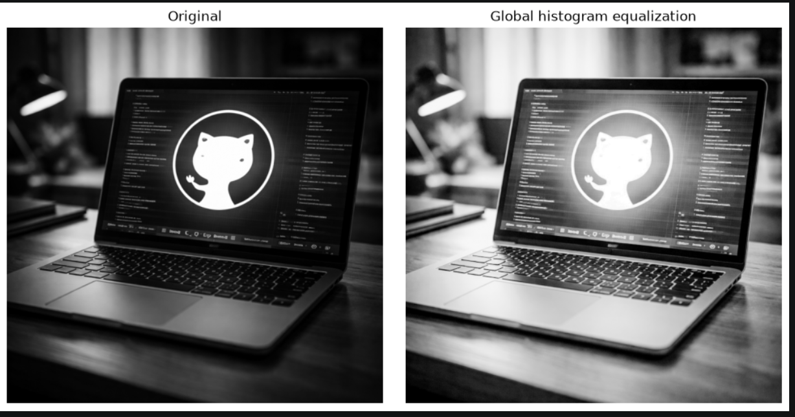
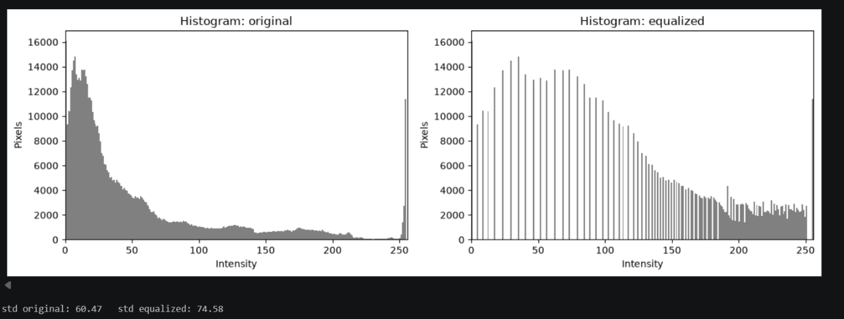
Observation: Describe whether detail improved in YOUR image after equalization and whether noise/flat areas became stronger or over-stretched.

Dry Run 8: CLAHE (simplified model)
Bin | Original | After cap 4 | + redistributed | New count | Cumulative | New CDF | 255 × CDF
0 | 6 | 4 | 0.5 | 4.5 | 4.5 | 0.5625 | 143.44
1 | 2 | 2 | 0.5 | 2.5 | 7 | 0.875 | 223.12
2 | 0 | 0 | 0.5 | 0.5 | 7.5 | 0.9375 | 239.06
3 | 0 | 0 | 0.5 | 0.5 | 8 | 1 | 255

Steps: (1) Clip counts above the cap of 4: bin 0 goes from 6 to 4, so the excess is 2. (2) Redistribute the excess equally over 4 bins: 2/4 = 0.5 per bin (fractions allowed). (3) The new histogram is [4.5, 2.5, 0.5, 0.5], still totalling 8. (4) The cumulative counts are [4.5, 7, 7.5, 8], so the new CDF is [0.5625, 0.875, 0.9375, 1.0].
Effect: without clipping, the CDF would be [0.75, 1, 1, 1], so the 6 pixels in bin 0 would grab 75% of the output range. Clipping flattens the steepest part of the CDF, which limits contrast amplification (and noise amplification) in that region.
Interpolation: CLAHE computes a separate mapping for every tile. A pixel near the border between two tiles would get a visibly different output depending on which tile's mapping was used, causing blocky seams. So each pixel is mapped using the mappings of the nearest tile centres and the results are blended by bilinear interpolation.
Note: this simplified model differs from OpenCV, which redistributes integer counts, and the absolute cap of 4 here is not the same thing as the clipLimit parameter (which is a multiple of the average bin count).
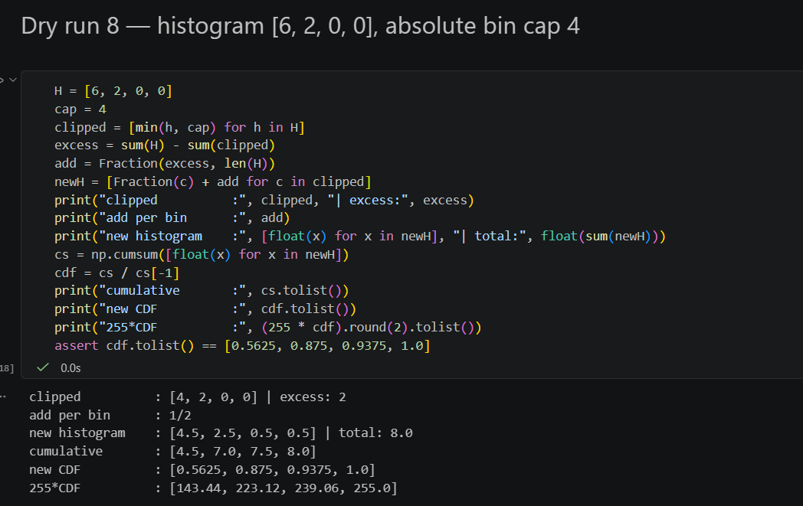
Notebook output:
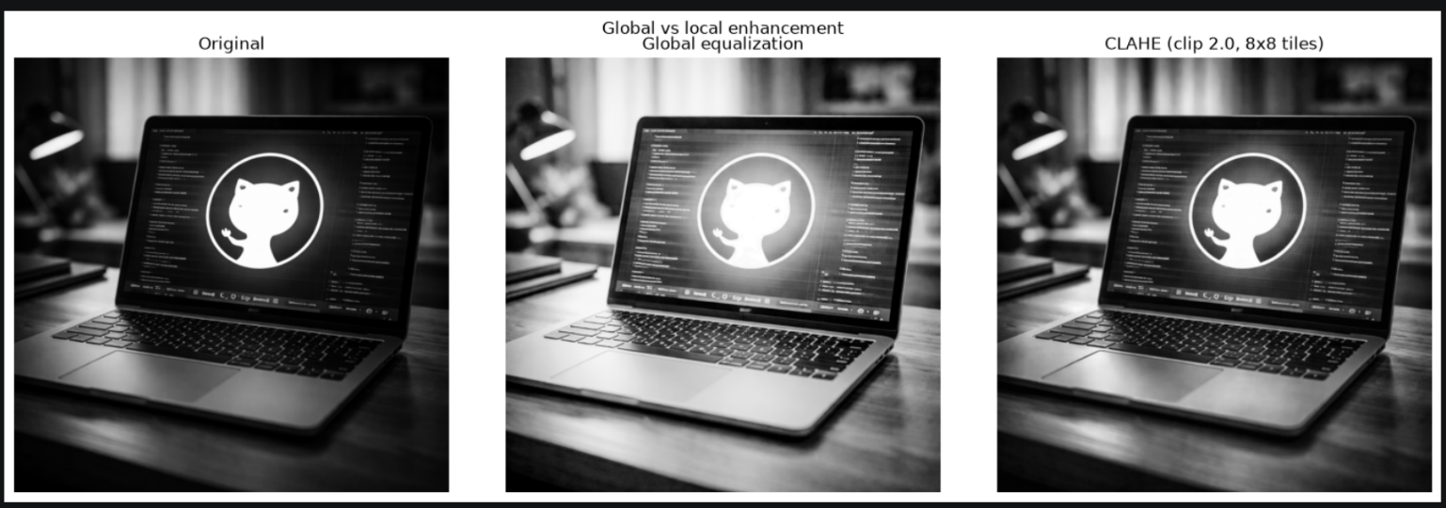
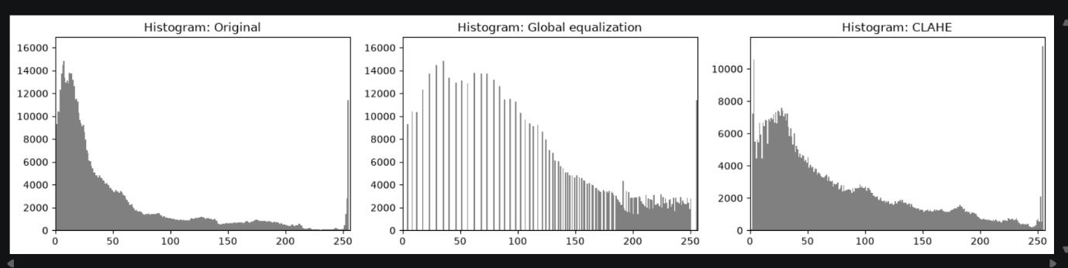
Observation: Compare CLAHE with global equalization on our image, especially in unevenly lit areas. Note that (8, 8) is the number of tiles, not pixels per tile.

Dry Run 9: Fixed binary thresholding
r | Test (T = 127) | Output | Test (T = 180) | Output
0 | 0 > 127 → false | 0 | 0 > 180 → false | 0
80 | 80 > 127 → false | 0 | 80 > 180 → false | 0
127 | 127 > 127 → false | 0 | 127 > 180 → false | 0
128 | 128 > 127 → true | 255 | 128 > 180 → false | 0
180 | 180 > 127 → true | 255 | 180 > 180 → false | 0
255 | 255 > 127 → true | 255 | 255 > 180 → true | 255

White-pixel count: T = 127 gives 3 white pixels (128, 180, 255); T = 180 gives 1 white pixel (255 only). The value 127 is not white for T = 127 because the rule is strictly r > T, and 180 is not white for T = 180 for the same reason. Raising T makes the output darker and keeps fewer pixels.
Notebook output:
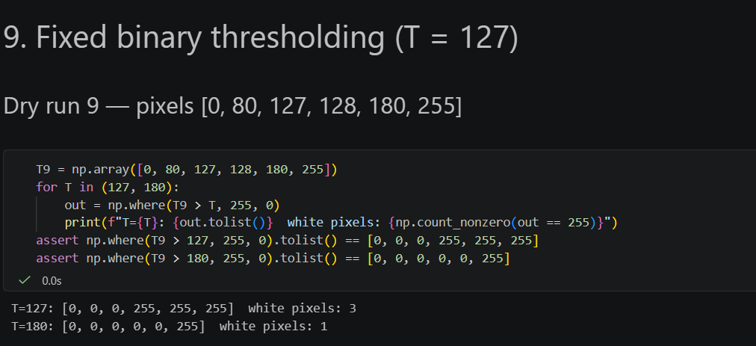
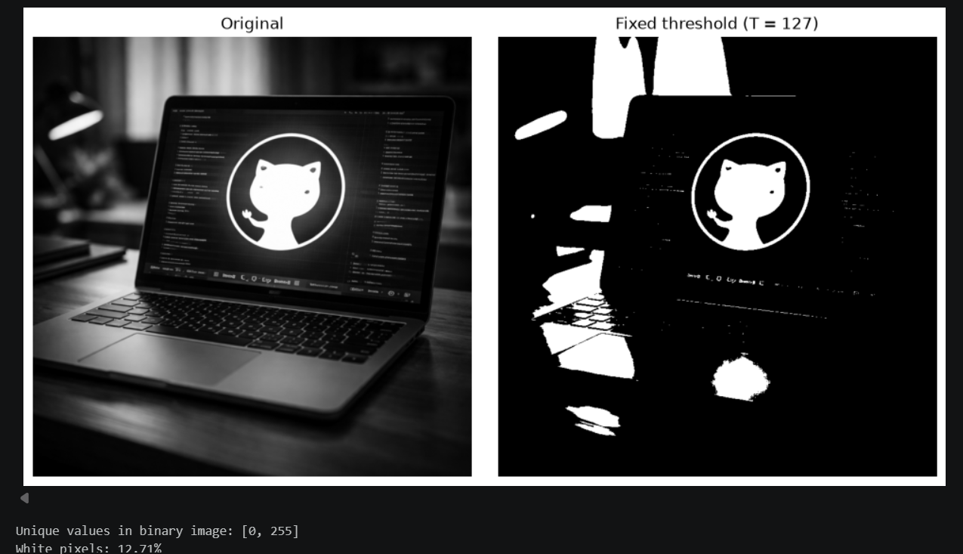

Observation:
The binary image contains only the unique values 0 and 255. State the percentage of white pixels for YOUR image.

Dry Run 10: Otsu thresholding
T | Class 0 (r ≤ T) | Class 1 (r > T) | w0 | w1 | μ0 | μ1 | w0·w1·(μ0−μ1)²
0 | {0} | {1, 4, 5} | 0.25 | 0.75 | 0 | 3.3333 | 2.0833
1 | {0, 1} | {4, 5} | 0.5 | 0.5 | 0.5 | 4.5 | 4
2 | {0, 1} | {4, 5} | 0.5 | 0.5 | 0.5 | 4.5 | 4
3 | {0, 1} | {4, 5} | 0.5 | 0.5 | 0.5 | 4.5 | 4
4 | {0, 1, 4} | {5} | 0.75 | 0.25 | 1.6667 | 5 | 2.0833

The maximum between-class variance is 4, tied at T = 1, 2 and 3 (no pixel has value 2 or 3, so those splits are identical). Choosing the smallest tied T gives T = 1.
Predicted mask (r > 1): [0, 0, 255, 255], i.e. pixels 0 and 1 become 0, and pixels 4 and 5 become 255.
OpenCV check: cv2.threshold(..., 0, 255, THRESH_BINARY + THRESH_OTSU) returns threshold 1 and mask [0, 0, 255, 255], matching the prediction.

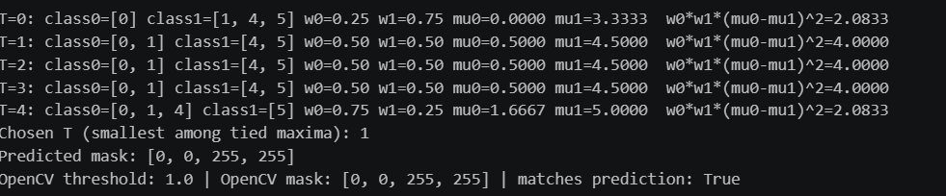
Notebook output:

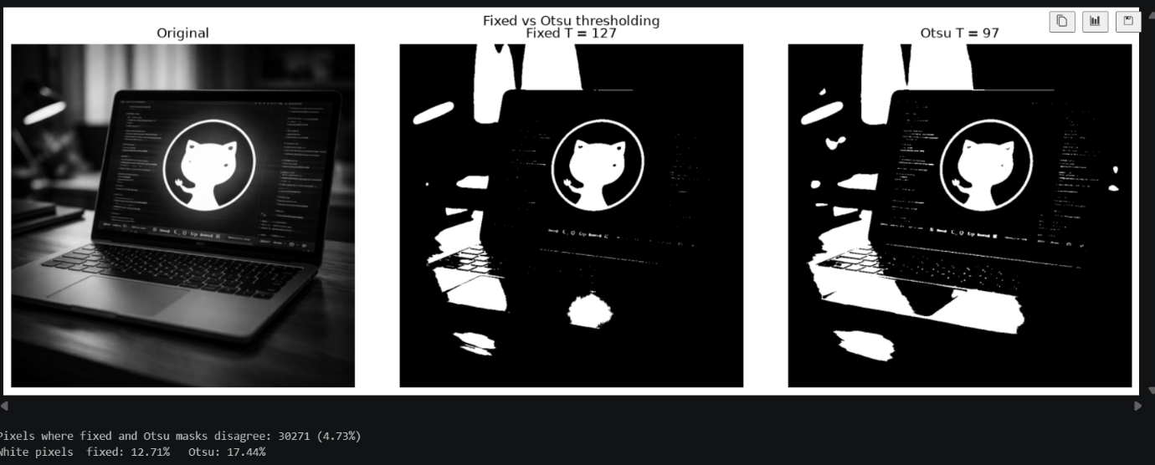

Observation: State the threshold returned by cv2.THRESH_OTSU for YOUR image and how many pixels differ from the T = 127 mask.

Dry Run 11: Adaptive Gaussian thresholding
Position | Value | Weight | Value × weight numerator | Contribution
(0,0) | 100 | 1/16 | 100 | 6.25
(0,1) | 100 | 2/16 | 200 | 12.5
(0,2) | 100 | 1/16 | 100 | 6.25
(1,0) | 100 | 2/16 | 200 | 12.5
(1,1) | 120 | 4/16 | 480 | 30
(1,2) | 140 | 2/16 | 280 | 17.5
(2,0) | 140 | 1/16 | 140 | 8.75
(2,1) | 140 | 2/16 | 280 | 17.5
(2,2) | 140 | 1/16 | 140 | 8.75

Weighted sum = 1920/16 = 120. Threshold T = mean − C = 120 − 2 = 118.
Center pixel = 120. Test 120 > 118 is true, so the output is 255 (white). A pixel exactly equal to T (118) fails the test 118 > 118, so it becomes 0 (black), because the rule is strictly greater than.
In the image task the same idea is applied with an 11 × 11 Gaussian-weighted neighbourhood, so every pixel has its own local threshold. This helps when illumination is uneven (shadows, gradients), where a single global T would turn one whole region white or black.
Notebook output:
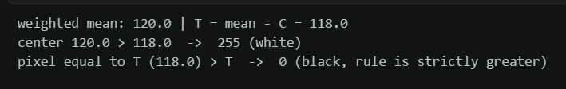

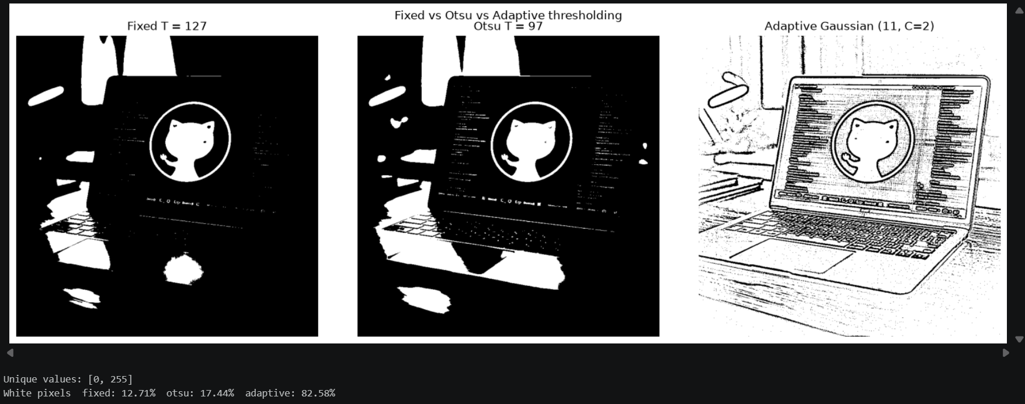

Observation: Compare adaptive Gaussian (blockSize 11, C = 2) with the fixed and Otsu masks on YOUR image, and say when a local threshold helps (uneven illumination).

4. Concepts
Clipping: Clipping forces values outside the valid range to the nearest limit (below 0 becomes 0, above 255 becomes 255). It prevents wrap-around, but different input values become the same output value, so that detail is permanently lost (e.g. 215 and 240 both become 255 after +40).
Overflow: An 8-bit unsigned integer can only hold 0–255 and wraps modulo 256 (240 + 40 = 24, 30 − 40 = 246), which turns bright pixels dark and vice versa. To avoid it, the arithmetic is done in int32 or float64, the result is clipped to 0–255, and only then converted to uint8.
Brightness versus contrast: Brightness adds a constant β to every pixel and shifts the histogram without changing its spread. Contrast multiplies by α and changes the spread: α > 1 expands, α < 1 compresses. Multiplying around 128, s = (r − 128)α + 128, changes contrast while leaving mid-gray unchanged; s = αr also changes the overall brightness.
Gamma convention: Here s = 255·(r/255)^γ. Values are normalised to 0–1 first, so 0 and 1 stay fixed. γ < 1 brightens (expands dark values), γ > 1 darkens (compresses dark values). The opposite convention, s = 255·(r/255)^(1/γ), swaps these directions, so the formula in use must always be stated.
Global versus local enhancement: Global histogram equalization and a fixed or Otsu threshold use one mapping for the entire image: they are fast and work well when the lighting is even, but fail with shadows or gradients and can amplify noise in flat regions. Local methods (CLAHE, adaptive thresholding) compute a mapping or threshold per neighbourhood, which handles uneven illumination and reveals local detail; CLAHE limits noise amplification with the clip limit, while adaptive thresholding can still produce noise in flat areas.

